

9B19C032

A note on leader character and organizational culture

Professor Lucas Monzani wrote this note solely to provide material for class discussion. The author does not intend to provide legal, tax, accounting or other professional advice. Such advice should be obtained from a qualified professional.

This publication may not be transmitted, photocopied, digitized, or otherwise reproduced in any form or by any means without the permission of the copyright holder. Reproduction of this material is not covered under authorization by any reproduction rights organization. To order copies or request permission to reproduce materials, contact Ivey Publishing, Ivey Business School, Western University, London, Ontario, Canada, N6G 0N1; (t) 519.661.3208; (e) cases@ivey.ca; www.iveycases.com. Our goal is to publish materials of the highest quality; submit any errata to publishcases@ivey.ca. i1v2e5y5pubs

Copyright © 2020, Ivey Business School Foundation Version: 2020-02-06

**OVERVIEW**

The history of great firms is the history of great leaders. Great leaders propel their firms forward while improving the social context in which their firms operate. However, regardless of leaders’ influence or the transformative power of their change initiatives, unless they “cement” their principles into their organizations’ culture, their vision will eventually fade away.[1] Moreover, because organizations are similar to living organisms, in that they are continuously developing, even a culture of excellence might eventually erode unless key organizational-level components are aligned to support the new culture of excellence. This note relies on two solid conceptual frameworks: Crossan, Seijts, and Gandz’s framework of leader character (see Exhibit 1) and Galbraith’s STAR model of organizational design (see Exhibit 2). Together, these frameworks provide a detailed account of how leaders can (1) shape a culture of excellence and (2) and redesign their organizations to support constructive cultural change.

First, this note describes what character and organizational culture are (and what they are not). Second, this note provides a step-by-step approach by which leaders can activate their character dimensions to shape a culture of excellence. Third, this note explains how leaders can apply 11 character dimensions to inform organizational development decisions that support five critical organizational-level constructs (i.e., strategy, structure, processes, people, and rewards). In this way, by embedding character in organizational design decisions, leaders can shape and support a culture of excellence.

**What Is Character?**

Character is an amalgam of traits, values, and adaptive behaviours that embody human excellence.[2] Hence, not all traits, values, or adaptive behaviours express strength of character—only those that positively impact people’s lives, their organizations, or society at large. In other words, character can also be understood as a habit of being that empowers individuals to bring out the best of themselves across contexts.

*Traits* are individual attributes that vary across individuals and influence their behaviour. Traits such as *conscientiousness* or *extraversion* are believed to be either genetically inherited or developed at an early age. Because they remain stable across a person’s lifespan, traits are useful to predict the “default mode” that guides a person’s behaviour. For example, *conscientious* people pay great attention to quality and detail, and persist in a task until it is finished. *Extraverts* excel inleveraging social situations to their advantage (e.g., building a vast network of business contacts). Traits can also influence managerial styles. For example, in the software development sector, all other things being equal, a *conscientious* manager will be more likely to produce high-quality work on time, whereas *extraverted* managers will be natural motivators. A survey involving 797 engineers at Microsoft Corporation revealed that engineers scoring high in conscientiousness and extraversion were more likely to occupy managerial positions. Yet, when managers were asked about the strategies they adopted in order to be more productive, *extraverted* managers preferred listening to music, whereas *conscientious* managers preferred designing their own software tools.[3]

*Values* are general “rules of conduct” that people gradually adopt as their own.[4] People rely on their personal values to guide and evaluate their behaviour. Unlike traits, personal values are “learned”—that is, they are transmitted through social institutions (e.g., family, school, church, the army, corporations). Similar to traits, personal values remain relatively stable across social contexts. However, because people learn from diverse social institutions, personal values might, at times, seem to be at odds with each other. For example, people might learn the value of *co-operation* from their family and the value of *results-orientation* from their sports coach.So, when faced with the dilemma of helping a direct report with a task or using that same time to move another project forward, managers who value *co-operation* above *results-orientation* will be more likely to help their direct report rather than focusing on their own tasks (and vice versa). Firms tend to pay more attention to the personal values of their employees when making promotion decisions because, as traits, personal values are good predictors of leaders’ behaviour. However, whereas organizations have no moral authority to dictate which values a person should adopt, they can assess whether someone’s existing personal values align with the values that the organization collectively holds as being important.

*Adaptive behaviours* are those behaviours that are in coherence with, and respectful of, the norms of a given context. More importantly, the adjective *adaptive* refers to the ability to shift one’s behaviours when the context norms change. For example, Bob Knight, a renowned and highly successful college basketball coach at the University of Indiana was (in)famous for his highly confrontational and authoritarian leadership style. Despite being hugely successful in his leadership position, when the University of Indiana passed an anti-harassment policy, Knight failed to adapt his management style to comply with the new policy and was asked to resign.[5] The ability to be situationally aware and adjust one’s behaviours accordingly is an attribute that firms also increasingly desire. As social and technological changes increase disruption across multiple aspects of the work environment, only those managers who can proactively adapt to change will thrive and create wealth for their firms.

Character is more than a mere collection of traits, personal values, and adaptive behaviours. For example, by itself, *persistence* (an element of the trait of *conscientiousness*), tells us little about a person’s character. Leaders might persist in a wrong course of action merely because they lack the humility to accept they were wrong. Similarly, celebrating and rewarding the achievement of work goals (as per the value of *result-orientation*) does not provide evidence of someone’s character. Leaders might encourage their followers to attain results by any means, without displaying any accountability for the existing norms and policies. Finally, the ability to regulate one’s behaviour is not necessarily proof of good character. “Chameleonic” leaders who engage in political manoeuvring to advance their personal agendas instead of the common good can be highly destructive to a firm.[6]

The framework suggested by Crossan, Seijts, and Gandz suggests that without support from the other character elements, neither traits, values, nor adaptive behaviours are genuinely reflective of a leader’s character.[7] Instead, when traits, values, and behaviours become interconnected and mutually inform each other, they blend into larger character dimensions. For example, the traits of being *vigorous* and *passionate*, the values of *results-oriented* and *excellence*, and the adaptive behaviour of *demonstrating initiative* blend into the character dimension of *drive*. Further, true character develops as a habit of being, which strengthens the interconnection between character elements (and dimensions). In other words, developing character is not an easy task; it is a journey of self-discovery that may take months, years, or even decades. To guide such journey, Crossan, Seijts, and Gandz identified 11 dimensions of character that enable effective leadership and sustained organizational excellence. Great leaders will not only incorporate these character elements and dimensions into their leadership but also cement them within their organizations’ culture.

**What Is an Organization’s Culture?**

Schein’s now classic definition of *organizational culture* describes

a pattern of basic assumptions that a given group has invented, discovered, or developed in learning to cope with its problems of external adaptation and internal integration, and that have worked well enough to be considered valid, and, therefore, to be taught to new members as the correct way to perceive, think and feel in relation to those problems.[8]

The first part of Schein’s definition refers to “a pattern of basic assumptions that a given group has invented, discovered, or developed in learning to cope with its problems.” Such patterns conform to an organization’s *underlying basic assumptions*. The adjective *underlying* signals that such assumptions tend to drop out of the organization’s collective awareness as people become busy with their day-to-day activities. In other words, *underlying basic assumptions* refers to an organization’s default mode, by which the members of an organization deal with everyday issues.

An organization’s underlying assumptions may become obsolete over time. For example, after 100 years of market leadership in the photography industry, the Eastman Kodak Company (Kodak) struggled financially in the 1990s, as a result of declining sales of its photographic film. Kodak’s slow response in transitioning to digital photography aggravated the company’s decline. The irony is that Kodak was the first company to develop a digital camera in 1975, but dropped the product for fear it would threaten the company’s photographic film business. Back in the 1970s, Kodak’s assumption that the photographic film business “was the way to go” blinded its leadership to the inevitable end of photographic film. Rigid underlying assumptions led to poor judgment calls that made Kodak’s business model obsolete.[9]

The second part of Schein’s definition speaks about “the correct way to perceive, think and feel” toward the organization. *Organizational values* are the somewhat explicit social norms that inform the members of a collective regarding its views of the appropriateness or inappropriateness of various actions, choices, and behaviours. For example, Google’s underlying basic assumption that “Google is not a conventional company” reflects its organizational values. Google’s principles reflect the company’s aspirations: “great just isn’t good enough” (the pursuit of excellence), “the need for information crosses all borders” (interconnectedness), and “you can make money without doing evil” (social responsibility).[10] More importantly, Google is famous worldwide for how it transmits its cultural values to new employees. Early in their onboarding process, newcomers learn to assess whether a given work-related behaviour is “Googley” enough.[11] In short, being “Googley” refers to alignment with Google’s organizational values. The strength of Google’s culture is such that newcomers who fail to incorporate such values into their everyday routines are likely to have short careers at Google.

In addition to adopting values, organizations also create *cultural artifacts*. Here, *artifact* does not solely refer to tangible items such a poster on the wall; cultural artifacts can also be abstract and invisible, such as concepts or processes. An example is the logo that appears in Google’s search page (i.e., “the doodle”), which changes every day to illustrate a particularly meaningful event. Whereas other tech companies aim to capture their corporate identity through a static logo and reinforce it through repeated exposure, Google does the absolute opposite. The daily changing of Google’s “doodle” signals to stakeholders that, unlike Kodak, Google is a dynamic company that constantly changes with the times.

A healthy culture elevates organizational members, whereas a toxic culture diminishes them. Moreover, a healthy culture empowers its members to evaluate its leaders’ behaviours against the organization’s values. When Diane Greene, a senior vice-president at Google, secured a contract with the United States Department of Defense, a company-wide revolt followed.[12] In short, Project Maven intended to weaponize Google’s artificial intelligence infrastructure to analyze drone footage and identify potential human targets. More than 4,000 employees signed a petition demanding “a clear policy stating that neither Google nor its contractors will ever build warfare technology.”[13] The rationale behind the petition was that Project Maven would violate one of Google’s core principles (“You can make money without doing evil”). The petition created such a grassroots momentum within Google that its senior leaders ditched Project Maven, losing between $9 million[14] and $15 million of potential profits, and closing the door to larger defence contracts. As Greene found out the hard way, for better or worse, a strong culture will resist misaligned strategic initiatives. Hence, Peter Drucker’s dictum, “Culture eats strategy for breakfast.”[15]

Finally, another critical component of an organization’s culture is the people who are held up as organizational heroes. Through the lens of organizational culture, the term *heroes* refer to those individuals who are valued by the organization and whose deeds are celebrated by its members. Whereas not all organizational heroes are leaders, most organizations hold their senior leaders as heroes (e.g., Elon Musk at Tesla, or Warren Buffet at Berkshire Hathaway). It is essential to note, though, that one person’s hero may be another person’s villain. For example, it is well-known that while some Apple employees saw Steve Jobs as a visionary hero, others considered him to be a corporate bully. Firms are increasingly concerned about who occupies a hero status because organizational heroes tend to become role models and thus shape the way organizational members think, and therefore how they tackle everyday problems.

**Using Character to Shape a Culture of Excellence**

Leaders’ character reflects in the culture of the organizations they lead.[16] Organizational stakeholders (e.g., shareholders and employees) entrust leaders with the challenging task of protecting and managing the organization’s culture. The tangible benefits of a healthy culture include reduced turnover and absenteeism,[17] increased productivity, employee satisfaction, increased innovation, and learning.[18] Thus, striving for a culture of excellence is not just nice, it is a good business practice.

Mapping the Underlying Assumptions of the Existing Culture

The first step in shaping a culture of excellence is *mapping the underlying assumptions of the existing culture*. To this end, leaders rely on the character elements of *intuition* and *insight* (i.e., judgment) to identify signals that evidence the organization’s underlying assumptions. Leaders can also use their analysis, critical thinking, and cognitive complexity to map such assumptions and make them explicit. In this way, leaders can generate a language that enables organizational members to regain awareness of the organization’s basic assumptions and discuss them openly.[19] Finally, great leaders will rely on their *situational awareness* and *adaptability* to contrast the underlying assumptions with the market/environment in which the organization operates. For example, had Kodak’s leaders realized that their assumptions regarding the firm’s core business were obsolete, they might have taken decisive action to renew their organization, leverage their digital camera technology, and lead the digital revolution into the 21st century.

Anchoring Organizational Values within Universal, Virtuous Values

The second step is *anchoring organizational values within universal, virtuous values*. If character embodies the best of human potential, then the universal values contained in its facets prescribe behaviours that will enable an organization’s members to sustain constructive interactions across the organization’s hierarchy. Again, the framework proposed by Crossan, Seijts, and Gandz[20] provides a road map to rethink organizational values and distinguish universal, virtuous values from mundane, non-virtuous values. For example, the character dimensions of transcendence, justice, humanity, temperance, and courage capture universal values that have been regarded as virtues for centuries in diverse cultures across the globe.[21] However, although some organizations might choose to elevate and embed Crossan, Seijts, and Gandz’s 11 character dimensions into their organizational values, it is unrealistic to expect all organizations to follow suit. Instead, the 11 leader character dimensions can act as a frame of reference when (re)developing organizational values. In this way, leaders can ensure that their organization’s culture truly empowers its members to live up to their true potential, and yet remain flexible to define organizational values in their terms. For example, Aecon, a Canadian construction firm, redesigned its organizational values using Crossan, Seijts, and Gandz’s framework as a guide but used its own language to articulate the company’s values. Aecon’s new values were well accepted by its members, from the boardroom to the front lines.

Bringing Values to Life

The third step is *bringing values to life* by creating cultural artifacts that embody the 11character dimensions proposed by Crossan, Seijts, and Gandz. Cultural artifacts are necessary because it is morally questionable to attempt to impose organizational values onto individuals. Instead, organizational members who willingly internalize organizational values as their own are likely to align their actions with those values. To facilitate the internalization process, leaders can create “flagship projects” that signal the organization’s new expectations of its members.

For example, Nelson Mandela invested a great deal of time in developing the leadership of the Springboks (i.e., the South African national rugby team), even when he had more pressing strategic matters at hand (e.g., inflation, recession, and the social divide). Mandela understood that the new Springboks were essential to signal to the South African public that his administration would honour the values he envisioned.[22] As per Mandela’s suggestion, the Springboks adopted a new motto: “One country, one team.” This cultural artifact enabled the citizens of South Africa to connect with Mandela’s vision through rugby. Similarly, Mandela used his team of bodyguards as a cultural artifact; Mandela selected former Special Branch Forces and African National Congress supporters, who in the past had been bitter enemies. With such a diverse team of bodyguards, Mandela signalled to his audience that he was living up to his vision of a united South Africa—precisely by trusting his life to the men who had previously imprisoned him. Such a consistent display of character is what made “Madiba” a hero, even in the eyes of his former enemies.[23]

**Sustaining a Culture of Excellence**

Shaping a culture of excellence is a necessary but not a sufficient condition to create positive change in society. To sustain a culture of excellence, leaders must align the new culture with five core organizational-level components: strategy, structure, processes, rewards, and people.[24] The ability to support a culture of excellence in these five core components will distinguish firms that grow strong, flourish, and endure market pressures from “shooting stars” firms—that is, companies with great promise that eventually wither and disappear.

Strategy

In Galbraith’s words, strategy is “the company’s formula for winning.”[25] When properly defined, an organization’s strategy sets the company’s basic direction. Among other things, it involves a mission statement (“why we are doing this”), a vision (“what success looks like”), and the overarching goals and objectives that will enable the organization to accomplish the mission (“how we will achieve our vision of success”). An organization’s strategy is related to, but distinct from, culture, in the sense that strategy is formalized in a plan, is explicit and quickly available to organizational stakeholders, and changes with disruptions in the market and business environment. By comparison, culture develops organically, is implicit, and is available only to those who map it using their intuition and insight. In other words, whereas strategy can be compared with the visible facet of an iceberg, culture is its underwater, invisible base. When culture and strategy align, goals, objectives, and decisions support the underlying culture, and not vice versa. In our earlier discussion about Google’s Project Maven, the strategic direction suggested by Greene was misaligned with Google’s strong cultural values, which led to the subsequent resistance from Google’s members to pursuit such a strategy (i.e., a lack of common direction).

Strategy is the organizational-level component over which leaders have more immediate leverage. To infuse character into their strategic planning, leaders can activate the character elements of *inspiration*, *purpose*, and *future-orientation* (i.e., transcendence) to (re)formulate a compelling vision and an inspiring mission that energizes the members of the organization. Activating transcendence enables leaders to detect not only shortcomings in the way things are (i.e., the status quo) but also how the things could be (i.e., the vision). Similarly, activating the character elements of *compassion*, *magnanimity*, and *consideration* (i.e., humanity) anchors an organization’s strategic goals within the larger universal virtues collected in the character framework and is highly motivating to organizational members.[26] Finally, besides *transcendence* and *humanity*, great leaders also rely on *courage* and *drive* to (1) challenge the current status quo and, literally, (2) drive change. For example, if we try to make sense of Elon Musk’s vision, as grounded in transcendence, humanity, drive, and courage, we can see how Tesla Energy fits as a critical component in the Tesla Inc. mission (i.e., by improving society by mitigating the effects of climate change; attained by making a fossil fuel-based economy obsolete; and enabled by harnessing the power of renewable energies).[27]

Structure

The notion of structure captures the formal ways by which work is accomplished in the organization. Structure is related to, but different from culture, in that structure establishes the formal way in which work is organized. Galbraith distinguishes four attributes that describe an organization’s structure, but for modern firms, three are critical: shape, specialization, and distribution of power.[28]

*Shape* refers to the number of levels in an organization’s hierarchy. For example, some organizations comprise multiple layers of management positions, in which a chain of command is explicitly specified (e.g., firefighters, police, army). Other organizations prefer “flat” structures with fewer hierarchical levels (e.g., employees, middle management, and upper management).

*Specialization* refers to the number of job specialties required to complete a task. In an organization with highly specialized employees, employees will perform only the tasks outlined in their job description (e.g., X-rays or anaesthesiology). In organizations with low specialization, employees might rotate among different job positions as part of their work routine (e.g., food and beverage employees).

*Distribution of power* refers to the degree of centralization in an organization. In *centralized* organizations, senior managers make most decisions, whereas middle managers execute on those decisions. By comparison, in decentralized organizations, middle managers and employees are empowered to deal with operational issues. Finally, in organizations that adopt a “matrix” design approach, employees report not only to their “functional manager” as per their job description but also to a “project manager”—that is, someone who leads the project in which the employee is working most of the time.

There is no *a priori* best organizational structure; it all depends on the environmental conditions in which the organization operates. It is up to the organization’s leadership to make judgment calls regarding the best structure to address the mission of the organization. If structure is not aligned with the organization’s core values and its strategy, resources will likely not be used effectively, execution will suffer, and hence opportunities for competitive advantage will be lost.

Great leaders (re)shape an organization’s structure to support a culture of excellence by activating the character dimensions of *humility*, *collaboration*, and *temperance* to inform their decision-making regarding structural issues. For example, the more hierarchical levels an organization has, the more likely that (1) its senior leadership will be isolated from the action, (2) critical information will be lost along the chain of command, and (3) leaders will suffer cognitive biases (e.g., self-confirmation biases).[29] If leaders do not remain *modest* and *respectful*, they will likely lose touch with their collaborators at the base of the hierarchy, who in turn can provide crucial information through informal communication channels, and hence enhance leaders’ decision-making. When organizations embark on complex projects—that is, projects that require multiple subject matter experts working integratively—great leaders must be *humble* enough to understand that no single person can cope with all the facets of a complex project (bounded rationality). Thus, remaining *continuous learners*, but also *flexible* and *collegial* enables power to move (temporally) to those who have the expertise to solve an issue and enhance the project’s overall execution.

For example, the systems engineer (SE) position at the European Space Agency (ESA) has a job description, a pay grade, and fixed salary, and yet, engineers spend most of their time working in cross-functional teams. In the past, an SE would tackle each step of a project sequentially. However, when the project made it to the financial specialist, the resulting design was often found to be entirely out of budget, delaying the project. Today, an SE produces designs concurrently with other subject matter experts (SMEs), external stakeholders (e.g., government officials), and industry partners (e.g., Thales Alenia Space or European Aeronautics*,* Space, Defense and Security). ESA’s leadership developed the concurrent design approach to deal with competing demands from a diverse group of stakeholders; it is enabled by a technological solution, the concurrent design facility (CDF).[30] Under the concurrent design approach, a project leader orchestrates the design effort, by “giving the floor” to the SE or SME who has the critical information to solve the issue being discussed. As a result, ESA’s CDF division reduced costs significantly by improving critical information exchange and reducing communication inefficiencies that led to inflated budgets.[31] The CDF is a structural choice that illustrates well how structure can support ESA’s culture, which values equal participation, co-operation, and respect among its partner states and external stakeholders for the peaceful exploration of space.

Processes (Information Flow and Decision-Making)

Galbraith defines decision processes as the way an organization functions, distinguishing vertical processes from horizontal processes.[32] *Vertical* processes involve managerial decisions and actions regarding the allocation of resources (e.g., business planning and budgeting) and talent (e.g., the creation and staffing of projects). By comparison, *horizontal* processes refer to workflow and operations (e.g., from the moment a purchase order enters the organization until it is satisfied). We updated the term *processes* to include “information flow and decision-making” because 21st-century decision-makers cannot make proper decisions without data analytics. Thus, ensuring that information flows adequately both vertically and horizontally ensures that (1) the optimal amount of information is available, and (2) operations use data to streamline workflow. Information flow is related to, but distinct from culture, in the sense that information systems are explicit, somewhat rigid, and formalized through information technology (e.g., databases). In contrast, culture is implicit, flexible, and organic, and thus tends to evolve as the organization develops.

Even in the age of “big data,” no system can adequately capture all the contingencies that an organization might face. Thus, aligning information systems with the organization’s culture is critical to ensure that decision-makers not only have the data but can make sense of such data. If information systems are vertically or horizontally misaligned with the organization’s culture, two outcomes will result. First, vertical misalignment will lead to decision-makers basing their decisions on an incomplete set of assumptions (due to their lack of awareness of the underlying assumptions), thereby increasing the risk of inefficient execution. Second, when information systems are *horizontally* misaligned, operations will suffer (e.g., production cycles may increase). Moreover, the organization will miss opportunities for synergies through cross-boundary collaboration (e.g., unrealistic expectation regarding scaling capabilities).

Furthermore, databases and analytics alone cannot determine the quality of organizational decisions. Social processes significantly impact how information is shared, interpreted, and applied. Great leaders understand the potential of both machine and social information systems to support a culture of excellence. More precisely, great leaders can rely on their *cognitive complexity, analysis,* and *critical thinking* to incorporate multiple sources of data into their decision-making process and prevent cognitive biases from interfering with their sense-making process. These more analytical components of the character dimension of *judgment* complement *insight* and *intuition*, in the sense that they enable the use of data to determine whether their organization’s underlying cultural assumptions are obsolete or not.

Again, one might argue that Kodak’s poor decision of focusing on the photographic film industry lacked not only insight but also data regarding future market trends to support (or reject) their underlying assumptions regarding industry trends. Similarly, the character dimension of *humility* can prevent decision-makers from engaging in cognitive biases, such as self-confirmation biases, which occur when individuals use data to support their pre-established assumptions toward a given topic, instead of using data to make realistic assumptions.[33] Similarly, the virtuous character dimension of *collaboration* might become a vice that leads to groupthink, which is a collective bias, in which some individuals withhold expressing their opinion when it contradicts a given majority in a group decision-making process.[34] Groupthink has been associated with many accidents and fiascos, including the Challenger shuttle explosion.[35] In consequence, great leaders enhance their judgment and decision-making process using character dimensions to make character-infused judgment calls.

Rewards

An organization’s reward system ensures that the effort (or the lack thereof) that organizational members apply to their tasks is appropriately measured and acknowledged. Rewards can be tangible (e.g., money, bonuses, profit sharing, stock options, benefits, or promotions) or intangible (e.g., public recognition or hero status). Tangible rewards are usually captured in a salary policy, and assessed through specific metrics (e.g., monthly sales or units per hour), whereas intangible rewards are more challenging to measure because they derive from social consensus within the organization. The reward system differs for culture: whereas behaving in alignment with an organization’s culture (e.g., being “Googley”) will likely result in intangible rewards, attaining operational and strategic goals will result in tangible rewards.

Empirical research shows that there is no one best salary policy; it all depends on the nature and mission of the organization. However, linking rewards to challenging but attainable goals is a proven way to energize employees.[36] A key point to understanding rewards systems is that the energizing effect of rewards depends on whether the organizational reward system is perceived as being *fair*. If organizational members believe that the system is rigged, or find ways to “game the system,” then, instead of motivating employees, rewards will have the opposite effect.[37] Moreover, for individuals, tangible rewards lose their energizing effect after individuals reach a certain income level. After such a threshold, intangible rewards become a stronger energizing factor than tangible rewards.[38] In other words, “throwing money at people” can take you only so far; great leaders understand that, to energize their organization for excellence, they need to create a compelling narrative to inspire their high-potential performers. If the reward system does not support a culture of excellence, counterproductive employee behaviours will likely appear (e.g., social loafing, free-riding, and increased absenteeism and turnover).

Great leaders ensure that their organization’s reward system supports a culture of excellence by activating not only the character elements of *fairness, equitability* (justice) but also *transparency* and *consistency* (integrity). More precisely, great leaders understand that the reward must match the nature of the effort. For example, if the organization’s culture values collaboration, but its rewards system acknowledges only individual effort, organizational members will likely attempt to free-ride on the efforts of others. Further, if no clear performance logic exists, or it is not transparently communicated to its members, employees will very likely feel that “there is nothing they can do” to receive high rewards. Great leaders also activate the character elements of *purpose*, *inspiration*, and *optimism* (transcendence) to promise (and deliver) intangible rewards to its collaborators. Saint-Exupery captured this character dimension in his now famous quote: “If you want to build a ship, don’t drum up the men to gather wood, divide the work and give orders. Instead, teach them to yearn for the vast and endless sea.”[39]

People/Human Resource Management

Galbraith’s framework defines *people* as the organizational-level component that comprises the recruitment, selection, rotation, training, and development of talented individuals. Like the previous organizational-level components, *people* is related to, but distinct from *culture*. Whereas the role of the people/human resource management (HRM) function is to determine a candidate’s requirements for a given job position and make those requirements explicit in a job description, an organization’s culture collects the implicit expectations that are not written in the job description but are essential to career progression within an organization. For example, being “Googley” is unlikely to be an explicit component of Google’s job descriptions, but it can have a significant effect on a career inside Google (or the lack thereof). Similarly, whereas the HRM function can provide organizational members with formal onboarding and on-the-job training, it is the organization’s culture that transmits the “correct” way to perceive, think and feel in relation to everyday problems.

When people/HRM training procedures are not in line with the organization’s culture, employees will likely deviate from standard procedures and practices and follow the tacit practices dictated by the organization’s culture. The negative consequences of a misalignment between people/HRM practices and the organization’s culture include reduced employee satisfaction, ineffective use of human resources, and increased employee turnover. Great leaders understand that people *truly* are an organization’s greatest asset and not just a nice phrase to say to their employees. Recruiting the right people and leading them effectively generates *human capital resources,* defined as a higher-level unit or firm capabilities that arise from the effective combination of individual-level capabilities.[40]

The ways in which people work together to implement and improve work processes to execute on initiatives are critical to achieving a firm’s strategic goals. Human capital resources also have the potential to drive competitive advantage because the informal relationships, social sharing of information, and development of tacit knowledge are difficult for competitors to copy easily. Thus, fostering a culture of excellence is critical to ensuring that the resources invested in attracting talent do not become wasted by the negative influence of cultural misalignment.

The people/HRM function is essential to the firm and can support a culture of excellence in several ways. First, the people/HRM function can increase the likelihood that the new talent who enter the organization are an appropriate cultural fit. Ensuring such fit requires that organizations embed character into their HR practices.[41] Regarding recruitment and selection, the usual practice of most firms is to select based on intelligence (e.g., through grade point average scores),[42] personality traits[43] (e.g., conscientiousness and emotional stability), and competencies. However, a study following the lifespan of identical twins revealed that inherited traits explained only 24 per cent of what led people to attain leadership roles, with the remaining 76 per cent linked to socio-cultural factors.[44] Consequently, incorporating competencies into a firm’s selection strategy reduces the risk of a “bad hire” because, more than intelligence or traits, competencies are learned and supported by an individual’s intelligence and social environment. Competencies are usually defined as the sets of knowledge, skills, and abilities (KSAs) that enable individuals to perform effectively in a given job. Unfortunately, given that each organization needs to define its own “competencies dictionary,” the competencies learned in one firm might not translate, or may even be irrelevant, in other firms. Thus, even selecting on inherited traits and competencies might still not represent the optimal solution. Instead, given the universal, virtuous nature of the character dimensions proposed by Crossan, Seijts, and Gandz, incorporating character dimensions into hiring decisions, alongside competencies, would reduce the risk of a bad hire, as the stronger a leader’s character, the more likely the leader’s competencies will be directed toward the betterment of society. Warren Buffet once said: “In looking for people to hire, you look for three qualities: integrity, intelligence, and energy. And if you don’t have the first, the other two will kill you. You think about it; it’s true. If you hire somebody without Integrity, you really want them to be dumb and lazy.”[45]

The second duty of the people/HRM function to support a culture of excellence is to identify and develop talent. Again, given that inherited characteristics remain stable over time, organizations can do little to develop those characteristics. Instead, healthy organizations can develop character in their employees through the habitual exercise of virtue when dealing with everyday problems. In other words, the decisions that individuals make when tackling an issue will develop their character. Firms from both the private and public sectors are showing interest in developing character alongside developing competencies in their formal training programs, as a way to (re)shape a culture of excellence. Recent examples involve Manulife, the Canada Revenue Agency, Aecon, and General Dynamics.

One way that great leaders can develop character in their collaborators is through vicarious learning.[46] Vicarious learning, also known as role modelling, refers to insights and intuitions that derive from indirect sources, such as hearing or observation, rather than direct, hands-on, instruction. Senior leaders are a pristine source of vicarious learning because, as mentioned above, organizational members tend to observe in great detail what their senior leaders say, but more importantly how they behave. As a result of such vicarious learning, collaborators are likely to (1) imitate their leaders’ behaviours, (2) incorporate their leader’s personal values as their own, and ideally (3) start developing their own character. For example, Mandela had a positive influence on his collaborators, by enacting character on a day-to-day basis. Not surprisingly, Mandela’s close collaborators started adopting his vision for South Africa as their own, even those bodyguards who initially perceived him as a terrorist.[47] Mandela’s example highlights the importance for leaders of displaying all the eleven dimensions of character as a true “habit of being.”

The third duty of the people/HRM function is to combine the KSAs and other qualities (e.g., diversity of background and perspective) of organizational members to create valuable unit- and firm-level capabilities that constitute excellence in executing on the organization’s mission. In a dynamic global economy, a key capability of the organization is the ability to learn, which involves proactively developing new processes and improving the existing systems to maintain competitiveness as the environment changes. Great leaders rely on their character to foster organizational learning in two ways: feedforward and feedback.

First, as suggested by Crossan, Seijts, and Gandz,[48] great leaders will rely on the character elements of *intuition*, *insight*, and *situational awareness* (judgment) and the character elements of *continuous learning* and *reflection* (humility) to transform individual’s learning experiences, first, into a collective learning experience, and then into corporate policies, in what Crossan, Seijts, and Gandz termed “the feedforward loop.” More precisely, given their unique position in an organization’s hierarchy, great leaders can use information available to the upper echelons of the organization to make sense of what is going on, and then communicate that information to their close collaborators. Similarly, great leaders activate the character elements of *modesty* and *vulnerability* (humility) to listen to, and incorporate the insights of, lower-level employees, who are more likely to be in touch with key factors such as customer views or operational bottlenecks that senior leaders don’t see. Second, great leaders rely on the character elements of *collegiality*, *co-operation*, and *flexibility* (collaboration) to facilitate a dialogue and interpretation of a specific learning event, now in the light of the additional information that derived from leaders’ personal intuitions and insights. Great leaders will also rely on the character elements of *ownership* (accountability), *initiative*, and *striving for excellence* (drive) to institutionalize the collective learnings that emerge from the dialogues occurring in teams across the organization into corporate policies.

Once such learning is institutionalized, a second sequence of events start to occur, which Crossan, Seijts, and Gandz labelled “the feedback loop.” More precisely, the newly minted corporate policies become organizational inputs that inform teams’ collective behaviours (group processes) and shared mental models (cognitive emerging state). The shared mental models inform new team members about the “correct” way to perceive, think and feel towards the organization. For example, the never-ending record of similar catastrophic failures are evidence of the National Aeronautics and Space Administration’s (NASA’s) inability to learn as an organization. Without great leaders who rely on character to build organizational capabilities through learning, organizations such as NASA forfeit the intuitions and insights of their highly competent employees. Until NASA starts learning from its collective errors, the top management teams at NASA might change names, but it is unlikely that the number of systemic issues (and catastrophic failures) will decrease. Last, but not least, combining character with the aforementioned organizational learning process might be particularly relevant to identify and manage “silent” organizational issues (e.g., covert discrimination, workplace aggression, or even sexual harassment). Once leaders become aware of such silent issues, the character elements of *responsibility* (accountability), *empathy* (humanity), and *social responsibility* (justice) should energize great leaders to ensure the safety and well-being of their collaborators, thus preventing the emergence of a toxic culture by supporting the culture with the appropriate human resources policies.

**Conclusion**

This note aims to provide (future) managers with guidelines for using character to (re)shape a culture of excellence and using organizational-level components to support a culture of excellence. From several frameworks of leadership and organizational design, we have chosen two well-established frameworks that provide insights regarding how leaders can create a lasting impact that can enhance the overall functioning of their firms by sustaining a culture of excellence.

**Exhibit 1:** The Leader Character framework

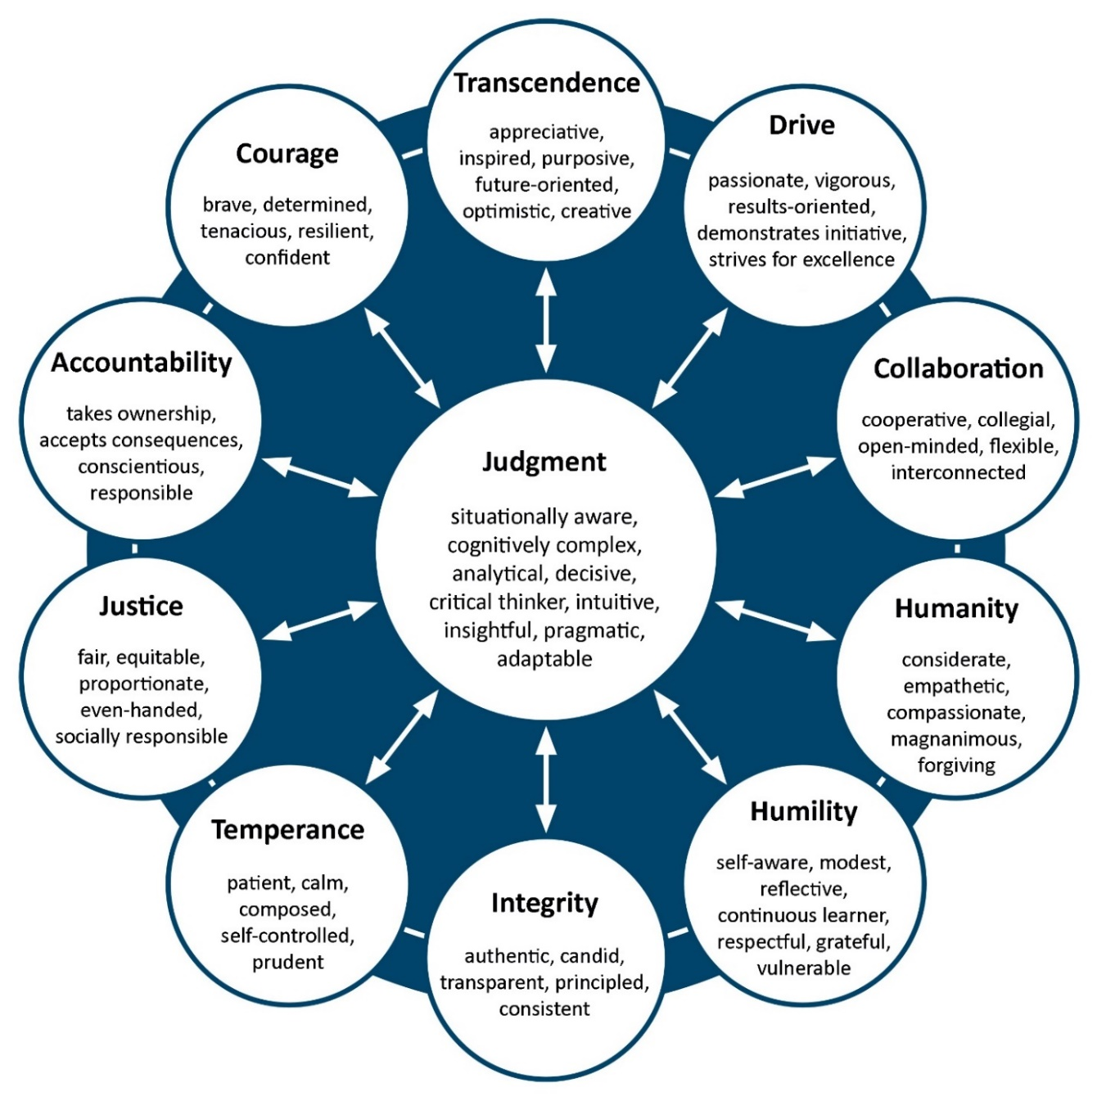

Source: Mary M. Crossan, Alyson Byrne, Gerard H. Seijts, Mark Reno, Lucas Monzani, and Jeffrey Gandz, “Toward a Framework of Leader Character in Organizations,” *Journal of Management Studies* 54, no. 7 (2017): 986–1018.

Exhibit 2: An adapted version of Galbraith’s Star Model

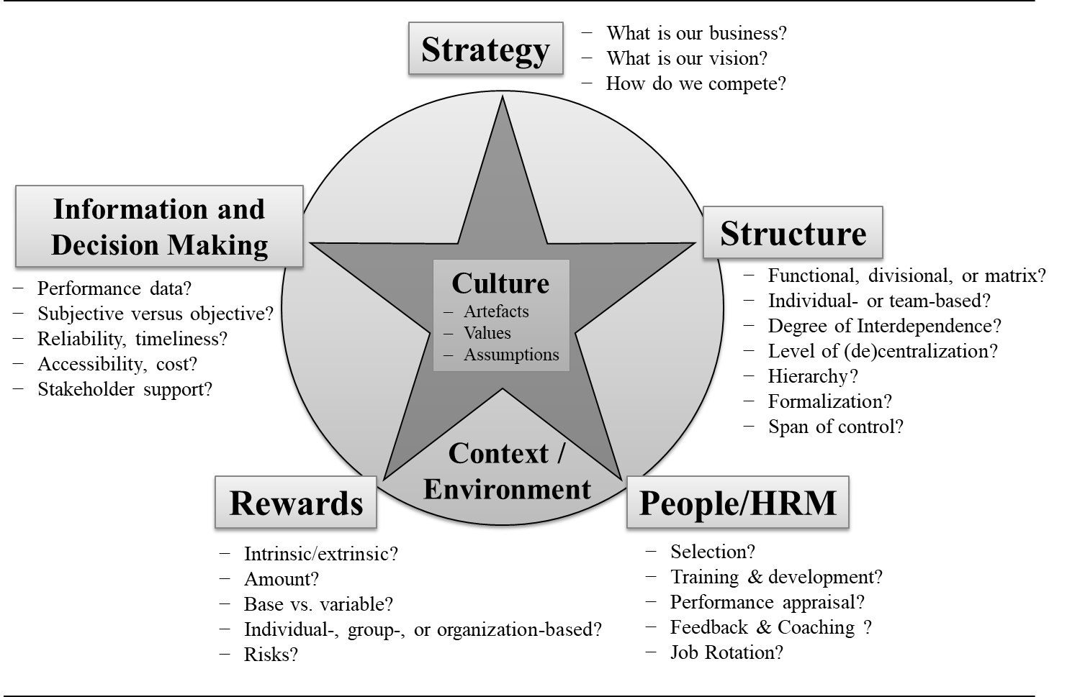

Note: HRM = human resource management

Source: Created by the case author based on Galbraith’s Star Model; Jay R. Galbraith, “The Star Model,” accessed July, 15, 2018, www.jaygalbraith.com/images/pdfs/StarModel.pdf.

Endnotes

1. Gerard H. Seijts and Jeffrey Gandz, “Transformational Change and Leader Character,” *Business Horizons* 61, no. 2 (2018): 239–249. Available from Ivey Publishing, product. no. BH884.
2. Mary M. Crossan, Alyson Byrne, Gerard H. Seijts, Mark Reno, Lucas Monzani, and Jeffrey Gandz, “Toward a Framework of Leader Character in Organizations,” *Journal of Management Studies* 54, no. 7 (2017): 986–1018.
3. Edward K. Smith, Christian Bird, and Thomas Zimmermann, *Beliefs, Practices, and Personalities of Software Engineers*, 15–18, Proceedings of the 9th International Workshop on Cooperative and Human Aspects of Software Engineering (CHASE ’16) (New York, NY: ACM Press, 2016).
4. Steven Hitlin, “Values as the Core of Personal Identity: Drawing Links between Two Theories of Self,” *Social Psychology Quarterly* 66, no. 2 (2003): 118–137.
5. Timothy M. Roberts, “Bob Knight: a Latter-Day MacArthur?,” Origins, Ohio State University and Miami University, accessed August 26, 2019, <https://origins.osu.edu/history-news/bob-knight-latter-day-macarthur>.
6. Arthur G. Bedeian and David V. Day, “Can Chameleons Lead?”, *The Leadership Quarterly* 15, no. 5 (2004): 687–718.
7. Mary M. Crossan, Gerard H. Seijts, and Jeffrey Gandz, *Developing Leadership Character* (New York, NY and London, UK: Routledge, 2016).
8. Edgar Schein, “Coming to a New Awareness of Organizational Culture,” *Sloan Management Review* 25, no. 2 (1984): 3–14.
9. “History of Kodak,” 1ink.com, March 13, 2017, accessed August 26, 2019, <https://www.1ink.com/blog/history-of-kodak-a-brief-look-with-1inkcom/>.
10. “Google’s 10 Core Values, Google, Novemeber 16, 2015, accessed August 26, 2019, <https://element-360.com/googles10corevalues/>.
11. Ben Mulholland, “Why Google’s Onboarding Process Works 25% Better Than Everyone Else’s,” Process.st, August 3, 2018, accessed August 26, 2019, <https://www.process.st/onboarding-process/>.
12. Greg Sandoval, “Google’s Employee Uproar Has Forced Cloud Boss Diane Green to Ditch a Lucrative Business—And Amazon Must Be Loving It,” Business Insider, June 11, 2018, accessed July, 15, 2018, www.businessinsider.com/google-svp-diane-greene-wanted-to-sell-to-the-military-2018-6.
13. Daisuke Wakabayashi and Scott Shane, “Google Will Not Renew Pentagon Contract That Upset Employees,” *New York Times*, June 1, 2018, accessed July, 15, 2018, www.nytimes.com/2018/06/01/technology/google-pentagon-project-maven.html.
14. All currency amounts are in US$ unless otherwise specified.
15. Andrew Cave, “Culture Eats Strategy for Breakfast. So What’s for Lunch?,” *Forbes*, November 9, 2017, accessed July, 15, 2018, www.forbes.com/sites/andrewcave/2017/11/09/culture-eats-strategy-for-breakfast-so-whats-for-lunch/#49464a6f7e0f.
16. Amy Swenson, “Leadership Character Reputation Is the 21st Century Competitive Edge,” June 13, 2018, *Ethics & Compliance Matters* (blog), NAVEX Global, accessed July, 15, 2018, www.navexglobal.com/blog/leadership-character-reputation-21st-century-competitive-edge.
17. Abraham Carmeli, “The Relationship between Organizational Culture and Withdrawal Intentions and Behavior,” *International Journal of Manpower* 26, no. 2 (2005): 177–195.
18. Brian T. Gregory, Stanley G. Harris, Achilles A. Armenakis, and Christopher L. Shook, “Organizational Culture and Effectiveness: A Study of Values, Attitudes, and Organizational Outcomes,” *Journal of Business Research* 62, no. 7 (2009): 673–679; Su-Chao Chang and Ming-Shing Lee, “A Study on Relationship among Leadership, Organizational Culture, the Operation of Learning Organization and Employees’ Job Satisfaction,” *The Learning Organization* 14, no. 2 (2007): 155–185.
19. Mary M. Crossan, Henry W. Lane, and Roderick E. White, “An Organizational Learning Framework: From Intuition to Institution,” *Academy of Management Review* 24, no. 3 (1999): 522–537.
20. Mary M. Crossan, Gerard H. Seijts, and Gandz, op. cit.
21. Mary M. Crossan, Daina Mazutis, Gerard H. Seijts, “In Search of Virtue: The Role of Virtues, Values and Character Strengths in Ethical Decision Making,” *Journal of Business Ethics* 113, no. 4 (2013): 567–581.
22. John Carlin, *Playing the Enemy: Nelson Mandela and the Game That Made a Nation* (New York, NY: Penguin Books, 2009).
23. “Ex-Bodyguard Remembering Madiba,”YouTube video, 11:25, posted by “eNCA,” December 6, 2013, accessed July, 15, 2018, www.youtube.com/watch?v=qviWz7wlMPo.
24. Jay R. Galbraith, “The Star Model,” accessed July, 15, 2018, www.jaygalbraith.com/images/pdfs/StarModel.pdf.
25. Ibid.
26. A study by Schwartz and Bardi found that universal values such as “altruism,” which speaks to the character dimension of “humanity,” is among the most preferred universal values worldwide; Shalom H. Schwartz and Anat Bardi, “Value Hierarchies across Cultures: Taking a Similarities Perspective,” *Journal of Cross-Cultural Psychology* 32, no. 3 (2001): 268–290.
27. “Tesla Introduces Tesla Energy,” YouTube video, 17:57, posted by “Tesla,” May 2, 2015, accessed July, 15, 2018, www.youtube.com/watch?v=NvCIhn7_FXI.
28. Galbraith, op. cit.
29. William Hart, Dolores Albarracín, Alice H. Eagly, Inge Brechan, Matthew J. Lindberg, and Lisa Merrill, “Feeling Validated versus Being Correct: A Meta-Analysis of Selective Exposure to Information,” *Psychological Bulletin* 135, no. 4 (2009): 555–588, https://doi.org/10.1037/a0015701.
30. European Space Agency, “Concurrent Design Facility,” accessed July, 15, 2018, www.esa.int/Our_Activities/Space_Engineering_Technology/CDF/What_is_the_CDF.
31. M.Bandecchi, B. Melton, and B. Gardini, “The ESA/ESTEC Concurrent Design Facility,” September 1999, accessed August 26, 2019, www.esa.int/Our_Activities/Space_Engineering_Technology/CDF/What_is_the_CDF.
32. Jay R. Galbraith, op. cit.
33. European Space Agency, op. cit., xxii.
34. Irving Janis, *Victims of Groupthink: A Psychological Study of Foreign Policy Decisions and Fiascos* (Boston, MA: Houghton Mifflin, 1982).
35. Elizabeth Howell, “Challenger: The Shuttle Disaster That Changed NASA,” Space.com, May 1, 2019, accessed August 26, 2019, https://www.space.com/18084-space-shuttle-challenger.html.
36. Edwin A. Locke and Gary P. Latham, *New Developments in Goal Setting and Task Performance* (New York, NY: Routledge, 2013).
37. Nathan P. Podsakoff, Philip M. Podsakoff, and Valentina V. Kuskova, “Dispelling Misconceptions and Providing Guidelines for Leader Reward and Punishment Behavior,” *Business Horizons* 53, no. 3 (2010): 291–303. https://doi.org/10.1016/j.bushor.2010.01.003
38. Daniel Kahneman and Angus Deaton, “High Income Improves Evaluation of Life but Not Emotional Well-Being,” *Proceedings of the National Academy of Sciences* 107, no. 38 (2010): 16,489–16,493. https://doi.org/10.1073/pnas.1011492107.
39. Quote Investigator, accessed August 26, 2019, www.quotationspage.com/ quotes/Antoine_de_Saint-Exupery.
40. Robert E. Ployhart and Thomas P. Moliterno, “Emergence of the Human Capital Resource: A Multilevel Model,” *Academy of Management Review* 36, no. 1 (2011): 127–150.
41. Gerard Seijts, Mary Crossan and Erica Carleton, “Embedding Leader Character into HR Practices to Achieve Sustained Excellence, *Organizational Dynamics* 46, no. 1 (2017): 30–39.
42. Frank L. Schmidt and John E. Hunter, “Select on Intelligence,” in *The Blackwell Handbook of Principles of Organizational Behavior*, ed. Edwin Locke (Oxford, UK: Blackwell Publishing Ltd., 2003), 1–14.
43. Murray R. Barrick and Michael K. Mount, “Select on Conscientiousness and Emotional Stability,” in *The Blackwell Handbook of Principles of Organizational Behavior*, ed. Edwin Locke (Oxford, UK: Blackwell Publishing, 2003), 15–28. https://doi.org/http://dx.doi.org/10.1111/b.9780631215066.2003.x.
44. Jan-Emmanuel De Neve, Slava Mikhaylov, Christopher T. Dawes, Nicholas A. Christakis, and James H. Fowler, “Born to Lead? A Twin Design and Genetic Association Study of Leadership Role Occupancy,” *The Leadership Quarterly* 24, no. 1 (2013): 45–60; Wen-Dong Li, Nan Wang, Richard D. Arvey, Richie Soong, Seang Mei Saw, and Zhaoli Song, “A Mixed Blessing? Dual Mediating Mechanisms in the Relationship between Dopamine Transporter Gene DAT1 and Leadership Role Occupancy,” *The Leadership Quarterly* 26, no. 5 (2015): 671–686.
45. “Integrity” || Warren Buffett ||,” YouTube video, 3:46, posted by “II Knowledge Wealth II,” March 26, 2017, accessed August 26, 2019, www.youtube.com/watch?v=tpmY1aK3jP8.
46. Albert Bandura, “Self-Efficacy: Toward a Unifying Theory of Behavioral Change,” *Psychological Review* 84, no. 2 (1977): 191–215. doi:10.1037/0033-295X.84.2.191.
47. Ibid.
48. Mary M. Crossan, Alyson Byrne, Gerard H. Seijts, Mark Reno, Lucas Monzani, and Jeffrey Gandz, op. cit.