

9B19D001

MICA DINING HALL: debottlenecking OPERATIONS

[Subrat Sarangi](https://iveypubs.my.salesforce.com/003A0000025xN5y) and [Sudiksha Patil](https://iveypubs.my.salesforce.com/0031J00001S2fiX) wrote this case solely to provide material for class discussion. The authors do not intend to illustrate either effective or ineffective handling of a managerial situation. The authors may have disguised certain names and other identifying information to protect confidentiality.

This publication may not be transmitted, photocopied, digitized, or otherwise reproduced in any form or by any means without the permission of the copyright holder. Reproduction of this material is not covered under authorization by any reproduction rights organization. To order copies or request permission to reproduce materials, contact Ivey Publishing, Ivey Business School, Western University, London, Ontario, Canada, N6G 0N1; (t) 519.661.3208; (e) cases@ivey.ca; www.iveycases.com. Our goal is to publish materials of the highest quality; submit any errata to publishcases@ivey.ca. i1v2e5y5pubs

Copyright © 2019, Ivey Business School Foundation Version: 2019-03-04

The 2018 academic year had just begun, and the campus at MICA, a higher education institution for strategic marketing and communication, was buzzing with students. On July 20, 2018, Dr. Subrat Sarangi, a MICA faculty member from the business management area, was called to the president and director’s office. Earlier in the week, a student named Shivani had raised an issue to the MICA Council for Student Affairs (MCSA) regarding the long queues and wait time at the main dining hall during lunch hours. The resulting delays were sometimes in excess of 30 minutes, and this made students late for class, which in turn led to them missing out on their attendance. The issue was so grave that two students (Shivani was one of them) had already lost attendance for two classes and were just one session away from facing a grade penalty. Another five students had missed a surprise test, as they were denied entry into the class for being more than ten minutes late. The MCSA had no option left but to take up the matter with higher authorities; the students wanted immediate remedial measures to be taken, and the matter was reported by the MCSA to the president and director of MICA, Dr. Shailendra Raj Mehta. Realizing that the matter was grave, Dr. Mehta instructed Dr. Sarangi to study the situation at hand and suggest a countermeasure to address it. Dr. Sarangi took up the challenge without delay and promised that he would present his findings by August 7, 2018.

MICA and ITS Programs

MICA, formerly the Mudra Institute of Communications, Ahmedabad, was a marketing and communications institute situated in Ahmedabad, Gujarat—a state in western India. A.G. Krishnamurthy had founded the institute in 1991. The institute offered residential and online postgraduate programs in the fields of communications, marketing, management, and advertising. MICA’s postgraduate programs were advanced programs that students could enrol in after completing undergraduate degrees. For the academic year 2017–18, MICA had 426 students spread over three residential programs (see Exhibit 1) including a postgraduate diploma in management communications (PGDM-C), a postgraduate certificate program in crafting creative communications (CCC), and a fellow program in management communications (FPM-C). In addition, MICA also offered management development programs (MDPs) for business executives, which varied in terms of the length of time and number of participants. MDPs were offered in various fields and industries. MICA also had a Centre for Development Management and Communication (CDMC) that conducted various training sessions for government employees and social sector organizations. Apart from conducting training sessions and on-campus programs, the centre helped various government and non-governmental organizations with research, consulting, and advisory services and other related initiatives based on mutual agreement.

**Postgraduate Diploma in Management Communications**

PGDM-C was MICA’s flagship two-year program; a maximum of 180 students enrolled each year. The program had six trimesters, divided equally over the two-year period. Each class was for a period of 75 minutes. The students had both core (compulsory for all) and elective (optional) courses. The first year of the program consisted entirely of core courses; the second year consisted of eight core courses, and the remaining were elective courses. During the second year of PGDM-C, students had to take a minimum of 44 credits and a maximum of 48.5 credits. Each credit was equivalent to eight sessions of 75 minutes each. Students had to choose subjects from four main specialization areas: advertising and brand management, marketing analytics, media and entertainment management, and digital communications management.

**Postgraduate Certificate Program in Crafting Creative Communications**

CCC was a 10-month creative program offered at MICA. The CCC program consisted of nine core subjects spread over the span of 10 months, with classes scheduled Monday to Friday and occasionally on Saturday.

**Fellow Program in Management Communications**

The FPM-C program was a three-year doctoral-level interdisciplinary program. In the first and second years, students had classes after 2:00 p.m., as they provided teaching assistance to professors on campus during the day. The duration of each class was 90 minutes. In the third year, students focused on their research and dissertation writing.

**Management Development Programs**

The duration of MDPs varied from institution to institution. In the academic year 2017–18, there were five MDP cohorts trained on campus. Each cohort had a different number of participants, ranging from 15 to 30. The program length varied from one to 15 days.

Centre for Development Management and Communication

The CDMC conducted social sector initiatives for government and non-governmental organizations. In total, there were three cohorts of capacity strengthening programs on campus in the academic year 2017–18. The number of participants in each cohort ranged from 12 to 40.

Although the CDMC and MDPs added to the occupancy in the student dining hall and spiked the peak load, their presence was infrequent. Besides, special arrangements were also made by adding more seats for group sizes of greater than 20 participants.

“Food, Glorious Food”

The campus had three food outlets where students could eat: Chhota Canteen, MICAFE, and the main dining hall. The three eateries were spread over the campus (see Exhibit 2). Chhota Canteen operated 24/7 and rarely closed its operations during the year. It sold snacks and fast food items such as sandwiches, noodles, chips, stuffed *parathas* (a type of Indian bread), and beverages. MICAFE was a smaller Nescafé outlet where students could buy coffee and other beverages, noodles, and a few baked items. Located near the classrooms, it was open from 9:00 a.m. to 8:00 p.m. every day. Students had to pay for what they purchased at both Chhota Canteen and MICAFE. As all programs were residential, students stayed on campus and were provided with three meals (breakfast, lunch, and dinner) and high tea in the main dining hall (see Exhibit 3). During breakfast hours, the dining hall was often only at half the occupancy as compared to lunch (see Exhibit 4). This was a result of students staying up late and working on their assignments and projects and preparing for their exams. Lunch was the busiest time for the kitchen staff, as students would come in, have their lunch, and rush off to class. During lunch, the kitchen catered not only to the students but also to MICA employees, including research associates, research assistants, faculty members, and non-academic staff. A small fraction of employees utilized the dining hall for lunch (see Exhibit 5), and eight to ten of them brought their own food. Though they did not buy food from the dining hall, they utilized seats and added to the capacity utilization of the seating space.

The dining hall consisted of two sections: the main dining hall and the extended dining hall. The seating in the main dining hall was made up of tables and benches with a mix of four- and six-seater tables (see Exhibits 6 and 7). The extended dining hall, which was adjacent to the main dining hall, consisted of plastic tables and chairs (see Exhibits 7 and 8). Special arrangements were made for MDPs and CDMC programs: these included reserving one or more tables, setting up more tables and chairs, and opening additional service counters, depending on the number of participants; therefore, adequate arrangements were made during the special programs so as not to affect the regular dining hall operations. The main dining hall had a total seating capacity of 182 seats and two service counters, whereas the extended dining hall had a total seating capacity of 103 seats and one service counter (see Exhibits 9 and 10, respectively). The facilities in the main and extended dining halls differed. The main dining hall was well equipped with drinking water taps, electric insect zappers, air conditioners, ceiling fans, and crates and racks for soiled plates (see Exhibit 11). On the other hand, the extended dining hall was partially open at the side walls and was equipped with one service counter, a wash basin, and two air coolers—only one of which was operational (see Exhibit 12). While there were no issues surrounding hygiene and cleanliness in the extended dining hall (i.e., there were electric insect zappers), it was quite uncomfortable to sit in this hall, especially during the summer months (early March until the end of August). Its proximity to the desert region in the west of India made Ahmedabad’s climate hot and dry, with peak temperatures as high as 48 degrees Celsius.

The lunch facilities in the dinner hall were open to the MICA community (i.e., students and employees) from 12:30 p.m. to 3:00 p.m. Student lunch breaks were staggered by 15 minutes between cohorts. First-year PGDM-C students had their lunch break from 12:15 p.m. to 1:30 p.m., while second-year PGDM-C students and CCC students would break for lunch from 12:45 p.m. to 2:00 p.m. Classes were scheduled immediately after lunch, and based on the respective class schedules, students had to attend classes in the seminar halls (SH) (see Exhibit 2). FPM-C students did not have a set lunch time and could break at their convenience. Even though employees had flexible lunch times, they usually came for lunch at around 1:00 p.m. The lunch menu was fixed every Friday for the coming week by the Student Mess Committee and was shared by email with the MICA community. The lunch menu usually consisted of salad, *papad* (pappadum, made from a mixture of flour and water), two curries, *roti* (a type of Indian bread), rice, *dal* (an Indian dish made with pulses), and curd. Occasionally, southern Indian food was also served (see Exhibit 13). Cutlery and plates were kept at the beginning of the counter, followed by the salad, papad*,* curries*,* dal*,* rice, roti*,* curd, and bowls.In the main dining hall, salt, pepper, sugar, pickles, and *masala* (Indian spices) were kept between the two service counters. There were specific counters for water at the two edges of the main dining hall (see Exhibits 6 and 7). Meals were served buffet-style, and the dining hall staff would operate the counters at all times to assist the diners.

**SERPENTINE QUEUES—THE STUDY IN ACTION**

**Day One**

On July 26, 2018, Dr. Sarangi and Sudiksha, a research assistant, went to the dining hall to record their observations. Prior to the commencement of the study, both of them had spent close to two full working days debating the various constraints that could have been causing the delays. They had involved two additional faculty members who were regular visitors to the dining hall to capture their concerns and have a greater understanding of the situation. Based on their preliminary investigation, they felt that the waiting period for the rotis was a bottleneck. Dr. Sarangi immediately entered the kitchen, visited the automated roti-making section, and enquired with the kitchen staff as to how many rotis were kept in each service container. The answer puzzled Dr. Sarangi, as his hypothesis turned out to be wrong. There were 50 rotis stocked in the container at any point in time, and hot rotiswere constantly being refilled in the service container. This was validated, and researchers’ concerns further increased.

As time went by, the team realized that not only the rotis but also all the other food items were constantly being refilled without delay. Tables were being cleaned when needed, as they would not get dirty very quickly. Two kitchen staff would stand behind each service counter, and whenever an item needed to be refilled, one would go and refill while the other stood behind the counter in case someone needed something else. In addition, the dining hall manager, Mr. Prafulla, was constantly monitoring the operations and guiding the team on the ground. However, while conducting a preliminary observation on day one of the study, Dr. Sarangi and Sudiksha noticed crowding between service counters 1 and 2 (see Exhibits 6 and 7). Further, they also observed that a few bags were occupying seats in the dining hall, as some students had placed their bags on the tabletops and benches. Even though students would see the extended dining hall empty, everyone would enter from the main dining hall and first hunt for a seat, regardless of whether or not it was busy inside. This intrigued Dr. Sarangi, who felt it was necessary to find out the reasons for this behaviour. The dining hall reached its peak at 12:45 p.m., and when the crowd subsided at around 1:30 p.m., the duo came back to Dr. Sarangi’s office, where they discussed the day’s observations and recorded notes. They were wondering why there was a crowd between service counters 1 and 2. Dr. Sarangi was haunted the entire evening about why the extended dining hall had remained barely occupied. Wanting to probe further and find answers to their queries, he and Sudiksha decided to continue observing the dining hall at lunch hours for the next few days.

**Day Two**

On July 27, 2018, dosas(southern Indian pancakes made from rice flour and ground pulses) and *idlis* (southern Indian steamed rice cakes) were served for lunch. Instead of the usual three service counters, as on a regular day, there were four service counters that day. The fourth was a special counter for CDMC program participants. Dr. Sarangi had planned to include this in the study so as to assess the impact of the additional load, and he had instructed Sudiksha to gather prior information from CDMC on their upcoming programs. Both were confident that results from July 27 would give them a fair assessment of the peak load at the dining halls during any given time of the year. Sudiksha, as usual, first visited the service counters and took stock of the number of dosas and idlis at each serving station. She was satisfied to see that there were 50 dosas and 240 idlis in the hot cases, with more being rolled out in the kitchen.She and Dr. Sarangi began to observe possible reasons for crowding between service counters 1 and 2. It appeared that movement was being slowed down by students helping themselves to salt, pickles, and dressings (for curd), which were stationed between service counters 1 and 2 (see Exhibits 6 and 7). Some of them, in fact, came back a second time to help themselves to the pickle and salt counter after occupying their seats. This was definitely slowing down operations and creating crowding. In the midst of this hullabaloo, Sudiksha noticed a strange activity: some students who had reached the end of service counters 1 and 2 were passing bowls to their friends in the queue behind them. She also noted that some who would get a hold of the bowls at the end of service counters 1 and 2 would stretch their arms across hands or go back to take an extra helping of dal or curry. This not only increased the queue wait time but also added to the confusion. It was definitely a concern and needed to be addressed as a part of the findings.

**General Observations**

A pattern was observed in the inflow of students, faculty, and staff into the dining hall during the study period. On an average day, the first person entered the dining hall at 12:25 p.m. (see Exhibit 14). By 12:45 p.m., students started streaming in, and traffic in the dining hall slowly increased. Based on this, the third service counter was opened by the kitchen staff by around 12:45 p.m. Each person took approximately three to four minutes to serve themself and about 15 to 20 minutes to have their lunch. Each counter was operated by at least two staff members, who helped serve and replenish food. On most days, the peak load at the dining hall would be at around 12:50 p.m., with an average of about 45 people standing in the three service counter queues. The peak time continued until about 1:05 p.m., with an average of about 26 people standing in queues across the three service counters. The minimum queue length observed on all days was at service counter 3 in the extended dining hall.

One critical observation that the team recorded pertained to student behaviour. On all days of the study, students did not come directly from their classes to the dining halls; instead, they went to their hostel rooms to stow their bags, went to the washroom or caught up with their friends, and came to the dining hall for lunch as a group. Staff and faculty members would also finish their pending work before lunch and join in small groups between 1:00 p.m. and 1:10 p.m. By 1:10 p.m., the crowd subsided, and by 1:20 p.m., service counter 3 barely had any queue. Commotion in the dining halls was almost nil by 1:30 p.m., except for some FPM-C, postgraduate program second year students, and CCC students who joined at their leisure, depending on their post-lunch class schedules (see Exhibit 14).

The seats in the dining halls were occupied not only by students but also by the bags that students carried with them. At around 1:00 p.m. there were, on average, about 15 bags that occupied seats—and this was during the peak lunch time. This behaviour was reducing the available seating capacity in the dining halls and needed attention. However, the extended dining hall provided enough capacity to absorb the rush. Study findings showed that capacity utilization in the extended dining hall was abysmally low on all days. Even though there was ample space in the extended dining hall, those who took food from service counter 3 wanted to sit in the main dining hall, which was crowded, and so they would hunt for suitable space, even though it took an extra minute or two. Dr. Sarangi and Sudiksha also observed a strange behaviour exhibited by dining room occupants while occupying seats in the dining halls: even when the main dining hall was about 90 per cent occupied, there were still tables left unoccupied. The unutilized tables were those perceived as occupied by research assistants, research associates, staff, and faculty members, as well as the table near the water counter, where the after-dinner mints and the register were kept (see Exhibits 6 and 7). A register was kept in the dining hall for MICA employees to note the meals they had in the dining hall. Dr. Sarangi mentioned to Sudiksha that there was a great need to get these free capacities better utilized, especially during peak hours and on days when MDPs or CDMC programs were held.

On August 1, 2018, Sudiksha noticed that the dining hall was not as busy compared to previous days. She went to the extended dining hall to specifically record why people preferred not to sit there. As she was walking around, she noticed that the extended dining hall was very hot, as it was partially open, and one could feel the hot breeze passing by. Besides, she also noticed that one of the two air coolers that were installed was dysfunctional, and on further examination, Sudiksha determined that it had been out of order for more than two months. She could really feel the heat in the extended dining hall and noticed that the students who were having their food there also felt it. She immediately reported this to Dr. Sarangi, who had already observed this phenomenon, as he had discussed with some of the students the reason behind not occupying the seats in the extended dining hall. He knew that this had to be discussed with Dr. Mehta if they desired to increase the utilization of the extended dining hall.

Similar observations and recordings were made the following days until August 7, 2018. Students were still crowding over bowls and the section between service counters 1 and 2. People were still standing in long queues at service counters 1 and 2, even when there was no queue at service counter 3. Food was being refilled immediately, and there were idle tables. The extended dining hall continued to be scarcely utilized, and special arrangements were made with a separate menu and service counter set up in the extended dining hall when there were MDPs or CDMC programs. Dr. Sarangi and Sudiksha had mixed feelings. On the one hand, they were happy that they had a strong assessment of the situation at the dining halls and had done good ground work; on the other hand, they still had to work on the different constraints that were creating bottlenecks and present their suggestions to Dr. Mehta.

**D-DAY—AUGUST 7, 2018**

The day had arrived, and Dr. Sarangi had to present the findings and proposed countermeasures to Dr. Mehta. With confidence and excitement, he waited outside the president and director’s office, eager to discuss the results of a study that had commenced when the issue was brought to his notice on July 20, 2018. Just then, the secretary stepped out of the chamber and called upon Dr. Sarangi. The meeting went on for close to 45 minutes. Dr. Sarangi presented the method of data collection, the bottlenecks causing delays, and their criticality. Dr. Mehta was pleased with Dr. Sarangi’s findings and appreciative of the manner in which the study had been conducted. He was particularly pleased with the detailing of the measures that were presented and the budget that was proposed by Dr. Sarangi to address the immediate concerns (see Exhibit 15). Dr. Mehta immediately went ahead and asked his secretary to sanction the budget amount of ₹37,500[1] to Dr. Sarangi for commencing the execution phase. Dr. Sarangi left Dr. Mehta’s chamber delighted, and he mentally prepared to chalk out an action plan for implementing the recommendations.

EXHIBIT 1: NUMBER OF STUDENTS IN EACH program, ACADEMIC YEAR 2018–19

|  |  |
| --- | --- |
| **Program** | **Number of Students** |
| PGDM-C, first year | 180 |
| PGDM-C, second year | 182 |
| CCC certificate program | 48 |
| FPM-C, first year | 6 |
| FPM-C, second year | 3 |
| FPM-C, second year | 4 |
| FPM-C, fourth year | 5 |
| **TOTAL** | **426** |

.

Note: PGDM-C = postgraduate diploma in management communications; CCC = crafting creative communications; FPM-C = fellow program in management communications.

Source: MICA.

EXHIBIT 2: MAP OF THE MICA CAMPUS

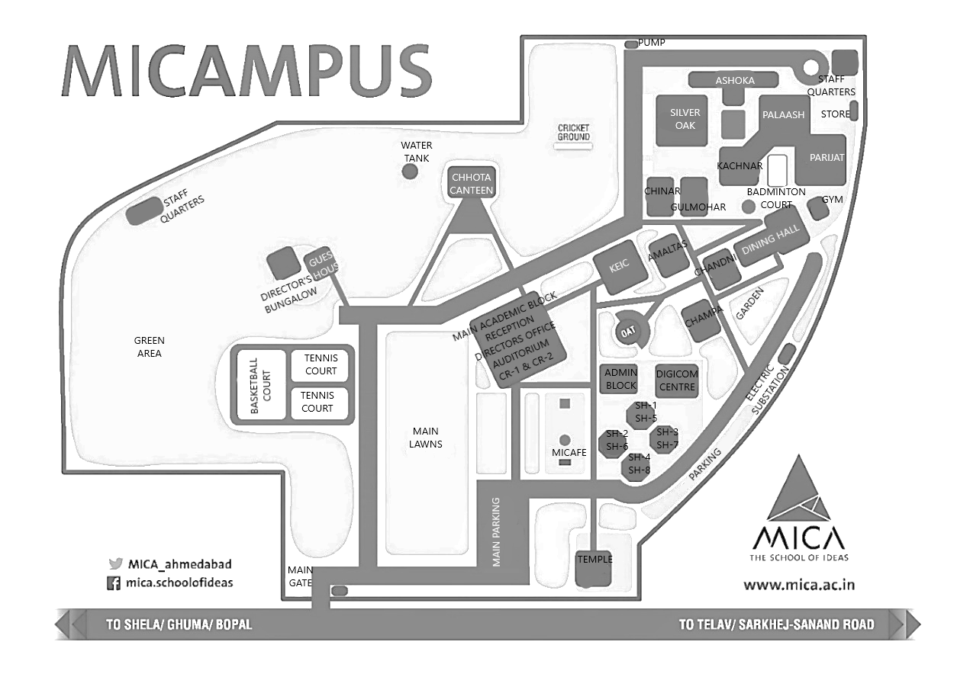

Note: Scale is 1:85,000.

Source: MICA.

**EXHIBIT 3: MEALTIMES**

|  |  |
| --- | --- |
| **MEAL** | **TIME** |
| Breakfast | 7:30 a.m. – 9:30 a.m. |
| Lunch | 12:30 p.m. – 3:00 p.m. |
| Snacks | 5:00 p.m. – 6:00 p.m. |
| Dinner | 8:00 p.m. – 10:00 p.m. |

Source: MICA.

EXHIBIT 4: Number OF PLATES CONSUMED DURING BREAKFAST,

JULY 26, 2018 – AUGUST 7, 2018

|  |  |
| --- | --- |
| **DATE** | **NO. OF PLATES CONSUMED** |
| July 26, 2018 | 80 |
| July 27, 2018 | 90 |
| July 30, 2018 | 97 |
| July 31, 2018 | 82 |
| August 1, 2018 | 75 |
| August 2, 2018 | 86 |
| August 3, 2018 | 74 |
| August 6, 2018 | 87 |
| August 7, 2018 | 85 |
| **Total Plates consumed** | **756** |

Note: Data for Saturday and Sunday not provided in the table above.

Source: Created by the authors based on institution information.

**EXHIBIT 5: THE TOTAL NUMBER OF EMPLOYEES AT MICA IN 2018**

|  |  |  |
| --- | --- | --- |
| Employee | No. of Employees | Average No. of Employees Who Came to the Dining Hall for Lunch |
| Faculty | 28 | 10 |
| Non-academic | 44 | 30 |
| Research Associates & Research Assistants | 26 | 15 |
| **TOTAL** | **98** | **55** |

Note: As of July 2018.

Source: Created by the authors based on institution information.

EXHIBIT 6: LAYOUT OF THE MAIN DINING HALL

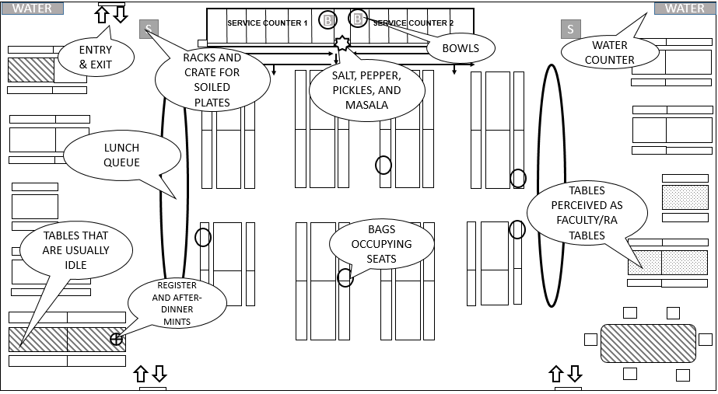

Note: Scale is 1:60; RA = Research Associates/Research Assistants.

Source: Created by the authors.

exhibit 7: Legend for the Dining Hall Layouts

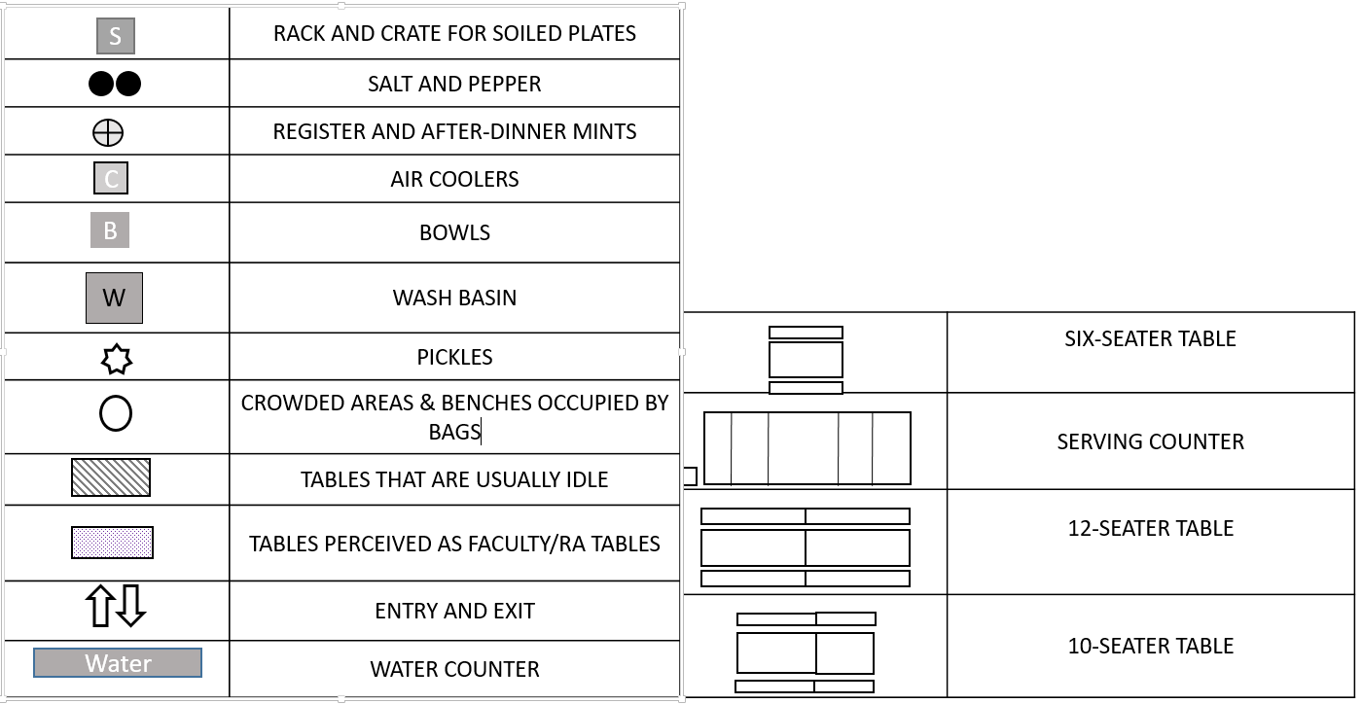

Source: Created by authors based on institution information.

EXHIBIT 8: LAYOUT OF THE EXTENDED DINING HALL

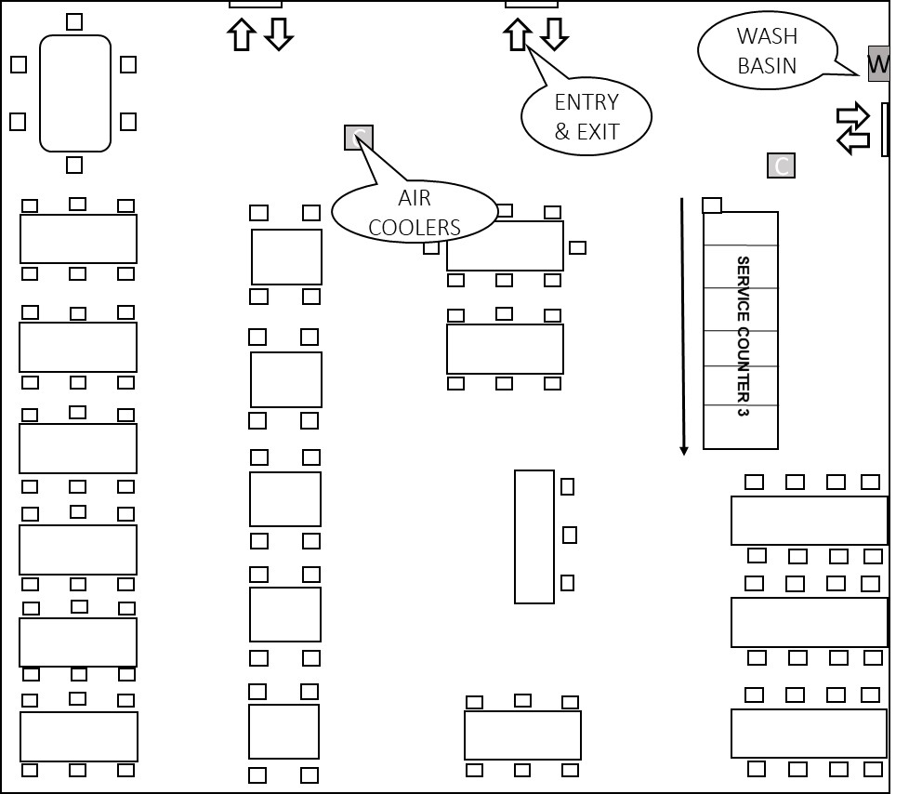

Note: Scale is 1:60; see Exhibit 7 for map legend.

Source: Created by the authors.

EXHIBIT 9: TOTAL SEATING CAPACITY IN THE MAIN DINING HALL

|  |  |  |  |  |
| --- | --- | --- | --- | --- |
| Total Number of Tables | Sizes | Number of Tables | Number of Seats per Table | Total |
| 33 | Four-Seater | 8 | 4 | 32 |
| Six-Seater | 25 | 6 | 150 |
| **Total Seating Capacity** | | | | **182** |

Source: Created by the authors.

**EXHIBIT 10: TOTAL SEATING CAPACITY IN THE EXTENDED DINING HALL**

|  |  |  |  |  |
| --- | --- | --- | --- | --- |
| Total Number of Tables | Sizes | Number of Tables | Number of Seats per Table | Total |
| 18 | Three-Seater | 1 | 3 | 3 |
| Four-Seaters | 5 | 4 | 20 |
| Six-Seaters | 8 | 6 | 48 |
| Eight-Seaters | 4 | 8 | 32 |
| **Total Seating Capacity** | | | | **103** |

Source: Created by the authors.

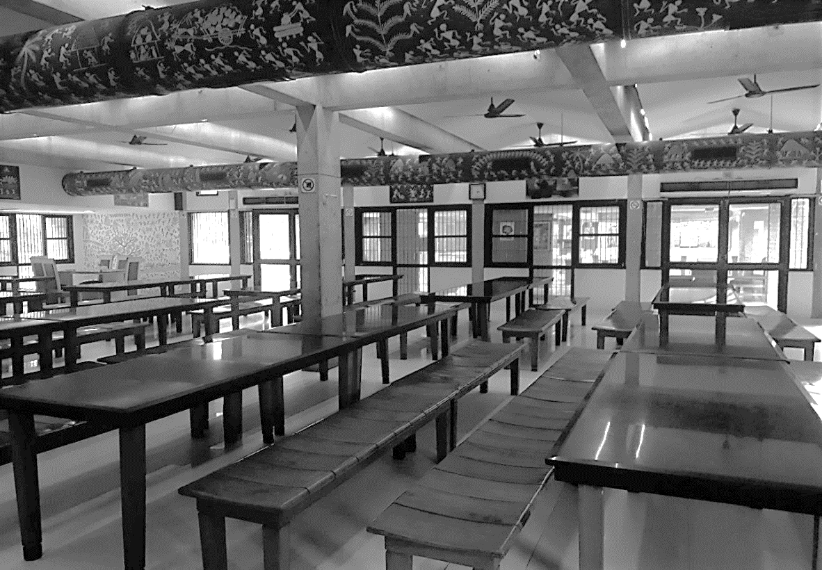**EXHIBIT 11: PHOTO OF THE MAIN DINING HALL**

Source: MICA.

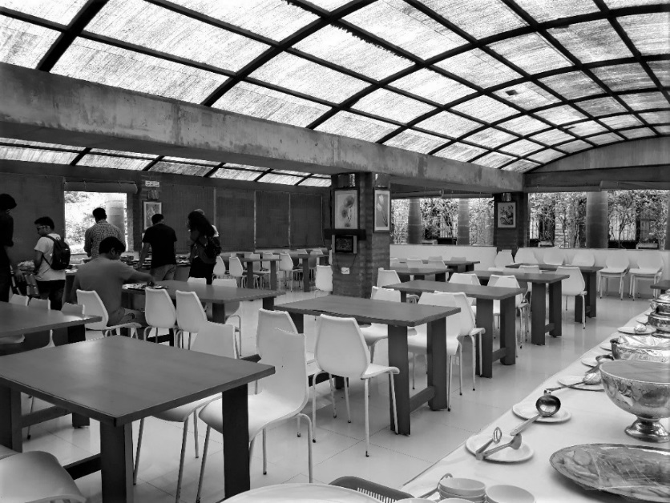**EXHIBIT 12: PHOTO OF THE EXTENDED DINING HALL**

Source: MICA.

EXHIBIT 13: LUNCH MENU, JULY 23, 2018 – JULY 27, 2018

|  |  |  |  |  |  |
| --- | --- | --- | --- | --- | --- |
| **Day** | **Monday** | **Tuesday** | **Wednesday** | **Thursday** | **Friday** |
| **Date** | **23-Jul-18** | **24-Jul-18** | **25-Jul-18** | **26-Jul-18** | **27-Jul-18** |
| **Breakfast** | Gobi Paratha | Onion Paratha | Poha | Aloo Paratha | Upma |
| **Lunch** | Bhindi Do Pyaza | Paneer Makhanwala | Gobi | Paneer Bhurji | Idli |
| Ghoogni | Capsicum Masala | Rajma Masala | Kurkure Aloo | Masala Dosa |
| Toor Dal | Dal Fry | Masoor Dal | Dal Makhani | Sada Dosa |
| Plain Rice | Mint Rice | Roti | Tandoori Roti | Mysore Chutney |
| Roti | Roti | Rice | Rice | Coconut Chutney |
| Papad/Pickle | Pickle/Curd | Papad/Pickle | Papad/Pickle | Sambar |
| Salad | Papad | Curd | Curd | Rasam |
| Curd | Salad | Salad | Buttermilk | Salad/Pickle |
| **Snacks** | Spring Rolls | Dahi Vada | Samosa | Bhel | Aloo Matar Grilled Sandwich |
| **Dinner** | Saada Bati | Aloo Paratha | Sweet Corn Soup | Pindi Chole | Vegetable Hot and Sour Soup |
| Masala Bati | Tomato Chutney and Dhaniya Chutney | Kadhai Chicken | Mixed Vegetable Rice | Egg Biryani |
| Panchrangi Daal | Lehsun Daal | Kadhai Paneer | Poori | Vegetable Biryani |
| Gatte Ki Sabji | Jeera Rice | Dal Fry | Cucumber Salad | Vegetable Curry |
| Makai Ki Roti | Papad | Tandoori Roti | Kadhi | Egg Curry |
|  | Plain Rice | Plain Rice | Pickle | Salad |
|  | Pickle | Curd | Boondi Raita | Papad |
|  |  | Salad | Salad |  |
| Churma | Lassi | Ice Cream | Rasgulla | Sprite/Coke |

Source: MICA.

**EXHIBIT 14: CHRONOLOGY OF EVENTS AT THE DINING HALL, JULY 27, 2018 – AUGUST 7, 2018**

|  |  |
| --- | --- |
| **Time** | **Observations**  (The counts of the queue lengths at each service counter were an average of the study period.) |
| 12:25 p.m. | * First person came in. |
| 12:30 p.m. | * People slowly started to come in. * Number of people standing in the service counter queues:   + - * Service counter 1= 2       * Service counter 2 = 5 |
| 12:45 p.m. | * People started to stream in. * The kitchen staff started setting up service counter 3. * Number of people standing in the service counter queues:   + - * Service counter 1 = 12       * Service counter 2 = 12       * Service counter 3 = 8 |
| 12:50 p.m. | * Service counters were constantly being refilled. * Number of people standing in the service counter queues:   + - * Service counter 1 = 20       * Service counter 2 = 15       * Service counter 3 = 10 |
| 12:55 p.m. | * More people started to come in. * Eleven bags were occupying seats. * Number of people standing in the service counter queues:   + - * Service counter 1 = 17       * Service counter 2 = 13       * Service counter 3 = 10 |
| 1:00 p.m. | * Faculty, staff, and RAs came in. * In the extended dining hall, staff occupied the six-seater table, and one six-seater table was occupied by students. * Twenty-five bags were occupying seats. * Number of people standing in the service counter queues:   + - * Service counter 1 = 14       * Service counter 2 = 13       * Service counter 3 = 7 |
| 1:05 p.m. | * Two six-seater tables were occupied in the extended dining hall. * Traffic in the dining hall was reduced. * Number of people standing in the service counter queues:   + - * Service counter 1 = 11       * Service counter 2 = 11       * Service counter 3 = 4 |
| 1:10 p.m. | * CCC certificate program students started coming in. * Number of people standing in the service counter queues:   + - * Service counter 1 = 8       * Service counter 2 = 7       * Service counter 3 = 2 |

EXHIBIT 14 (CONTINUED)

|  |  |
| --- | --- |
| 1:15 p.m. | * Service counter 3 was still operational. * Number of people standing in the service counter queues:   + - * Service counter 1 = 3       * Service counter 2 = 5       * Service counter 3 = 0 |
| 1:20 p.m. | * Number of people standing in the service counter queues:   + - * Service counter 1 = 3       * Service counter 2 = 3       * Service counter 3 = 0 |
| 1:25 p.m. | * Service counter 3 was closed, as things had quieted down. * Number of people standing in the service counter queue   + - * Service counter 1 = 2       * Service counter 2 = 3       * Service counter 3 = 0 |
| 1:30 p.m. | * There was no rush, and tables were empty. * The second door was closed. * Number of people standing in the service counter queue   + - * Service counter 1 = 3       * Service counter 2 = 2       * Service counter 3 = 0 |

Note: RAs = Research Associates/Research Assistants

Source: Created by the authors.

exhibit 15: proposed budget

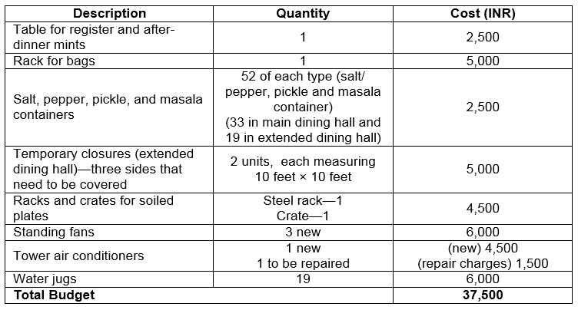

Source: Created by the authors.

1. ₹ = INR = Indian rupee; US$1 = ₹68.63 on August 7, 2018.