|  |  |
| --- | --- |
| **Ivey Publishing logo** | Temple University, Fox School of Business logo |

9B19D002

TUCKER COMPANY WORLDWIDE: DELIVERING VALUE IN LOGISTICS SERVICES

Neha Mittal, Roman Szewczuk, and Subodha Kumar wrote this case solely to provide material for class discussion. The authors do not intend to illustrate either effective or ineffective handling of a managerial situation. The authors may have disguised certain names and other identifying information to protect confidentiality.

This publication may not be transmitted, photocopied, digitized, or otherwise reproduced in any form or by any means without the permission of the copyright holder. Reproduction of this material is not covered under authorization by any reproduction rights organization. To order copies or request permission to reproduce materials, contact Ivey Publishing, Ivey Business School, Western University, London, Ontario, Canada, N6G 0N1; (t) 519.661.3208; (e) [cases@ivey.ca](mailto:cases@ivey.ca); www.iveypublishing.ca. Our goal is to publish materials of the highest quality; submit any errata to publishcases@ivey.ca. i1v2e5y5pubs

Copyright © 2019, Ivey Business School Foundation Version: 2019-03-20

Mike Mellencamp, carrier sales manager at Tucker Company Worldwide Inc. (TCW), a privately owned third-party logistics (3PL) company based in Haddonfield, New Jersey, could detect the determination and firmness in the voice of the company’s president and chief operating officer (COO), Jim Tucker: “Mike, it is not just about being cheap, fast, and easy,” Tucker said. “We have an obligation to provide the best logistical solution to our customer for each of their shipment requirements.” Mellencamp was working on a bid to provide logistics support to Bell Oil, a refinery based in Reading, Pennsylvania. Winning this contract would further TCW’s establishment as a leader in the 3PL industry. As Mellencamp walked out of Tucker’s office, he realized that preparing the bid would not be as straightforward as he had thought it would be. The proposal would need to effectively showcase TCW’s value, address all practical transport options, and remain consistent with the company’s core practice. Above all, Mellencamp had only that day, Friday, June 1, 2018, to bring it all together.

**HISTORY OF Tucker Company Worldwide**

TCW, a third-generation, family-held corporation, was founded in 1961 by Jacob Tucker. The company provided logistical services to shippers and their customers, helping companies efficiently execute freight hand-offs; saving them time; and eliminating the hassles of paperwork, billing, audits, training, staffing, and optimization. It acted as an intermediary both between shippers and receivers and between shippers and carriers. Through its market knowledge and subject expertise, it often helped its clients open new market opportunities, receive volume discounts, lower overhead costs, and achieve timely service.

After Jacob’s sudden death, his son, Bill Tucker, took over the business. For the next 32 years, Bill immersed himself in the business and industry. His two sons, Jeff and Jim, worked for their father for over 10 years and later took over the business; they shared a passion for the business and the industry. Jeff served as the chief executive officer, overseeing sales and marketing, as well as industry participation and leadership. Jim served as the president and COO, managing the carrier side, credit, collections, and accounting.

Over the years, Jeff and Jim had built an outstanding reputation in the 3PL industry. TCW was ISO certified in 2008, and it held ISO 9001:2015 certification as well. In all their business interactions, the brothers strove to uphold their core values: customer focus, integrity, safety, quality, and advocacy.

**Services Offered by Tucker Company Worldwide**

As a non-asset-based company (i.e., it owned no trucks but worked with fleet operators), TCW provided supply chain solutions to companies in industries such as oil and gas, life sciences and health care, high-value and high-security goods, and food. It also provided services to government entities, for example, providing relief work during national emergencies such as forest fires, hurricanes, and terrorist attacks; freight services for the U.S. Mint; and helicopters and boats for the military. TCW utilized an array of transportation modes—including truck, rail, ocean, and air—to arrange logistics all over the world. It offered truckload (TL), intermodal, flatbed, and specialized equipment for transporting freight. It specialized in freight transportation that required higher service needs—that is, where the risk of shipment delays or cargo theft was high, where the delay consequences were high, and where there was visible corporate behaviour dysfunction.

TCW also provided real-time tracking and tracing (through a customer portal), quarterly business reviews (for existing customers), scorecards (based on shipping characteristics), and technology options that included visual performance statistics. Customers appreciated these analyses by TCW and considered them to be value-added services.

One thing that had set TCW apart from its competition was its investment in establishing strong communication and visibility channels between its customers and service providers, including truck, air, and ship carriers. This helped TCW create the right logistical solutions for its customers. Results from an internal customer survey showed that TCW was one of the most dependable and reliable partners for most of its clients.

**The Request For Proposal**

On Friday, June 1, 2018, Bell Oil, a large refinery in Reading, Pennsylvania, sent out a request for proposal (RFP) soliciting bids to transport multiple products from multiple origins to multiple destinations. The refinery solicited local and regional 3PL companies to submit bids for three unique transportation needs. The first requirement was to ship a highly critical, 67-kilogram (148-pound) gasket from Houston, Texas, to Reading, Pennsylvania. The second requirement was to transport a large 102,058‑kilogram (225,000-pound) tank from Houston, Texas, to Wilmington, Delaware. The third was a small (90-kilogram [200-pound]) but highly valuable $48,600 computer server containing sensitive company information, which was to be transported across the country, from Herndon, Virginia, to San Jose, California.

According to the RFP, each component could use a combination of transport modes, but the best solution should offer the best service in terms of transit time, reliability, damage rate, insurance, and, of course, cost.

Jim Tucker saw the call and asked his manager, Mellencamp, to begin working on the bid right away. However, preparing the bid was not easy, and TCW had a set of challenges to overcome.

**TCW’s Challenge**

Customers typically preferred solutions that were fast, easy, and cheap; they assume that the right vehicle with the desired transit time, reliability, insurance terms, and damage rates would be available. This last-minute attitude increased the overall transportation costs for most customers and became the enemy of corporate savings. They would often not realize how sharply logistics costs rose in the absence of their own advance planning and clear communication and examination of needs. TCW knew that overcoming this attitude would be its first challenge. It could not provide the lowest-cost option to its customer if the customer waited until the very last moment.

Jim Tucker wanted to prepare a bid that exceeded expectations for customer service and satisfaction—a solution that provided the lowest-cost option while maintaining the required reliability and service to successfully transport the shipments. He knew that an overly expensive option would jeopardize TCW’s chances of winning the bid.

Tucker and Mellencamp recognized that they were competing with other 3PL companies in the region on this bid. They understood the market and were aware of the different strategies their competition might use—and they were afraid the competition might present a low-ball offer that might be attractive to the customer. At the same time, they were confident that the competition could not deliver the experience and service that TCW could offer.

Tucker was aware of several past instances where a competitor 3PL had bid on and lost a deal because of a lack of communication and feasibility analysis from the trucking company and driver. Conversely, TCW had seen competitor 3PLs win business but then fail to follow through and meet customer expectations, leading to aggravated customers. Tucker and Mellencamp discussed their strong communication channel, which kept all involved parties in touch at all times, as well as their forensic dispatch[1] practice, which had been successful over the years. They were confident that a careful examination of the available options and clear communication of the customer’s needs would enable TCW to provide the best logistical solution for the Bell Oil refinery.

**TCW’s Transport Options**

To prepare the bid, Mellencamp carefully examined all shipping options for serving the refinery’s three specific needs. He prepared three different tables for the three different scenarios and shared these with Tucker. Together, they needed to create a bid that not only minimized transport costs but also maximized reliability and customer satisfaction.

**Shipment Requirement 1: Ship a 67-kilogram (148-pound) gasket from Houston, Texas, to Reading, Pennsylvania.**

In this requirement, the customer wanted to move a 67-kilogram gasket which was critical to the normal operation of the refinery. If the gasket were needed, a delay of one day in receiving it could result in millions of dollars in losses for the refinery. Mellencamp evaluated the different shipping options and prepared a table that compared the different components of each option (see Exhibit 1).

**Shipment Requirement 2: Ship a 102,058-kilogram (225,000-pound) tank from Houston, Texas, to Wilmington, Delaware.**

In the second requirement, the customer wanted to move a 102,058-kilogram tank from Texas to Delaware. Mellencamp considered four different transport options to move this oversize load across state boundaries:

Option 1 was to pick up the vessel from the manufacturer and move it on a 19-axle trailer over-the-road (OTR) to its final destination (see Exhibit 2).

Option 2 was to pick up the vessel from the manufacturer and move it OTR to the rail ramp in Houston, then transload and move it on rail to the customer site via a local rail line. Finally, the vessel would be transloaded and delivered to the final location on a 19-axle trailer.

Option 3 involved picking up the vessel from the manufacturer and moving it OTR to the port in Houston, then transloading it onto a barge and barging it to the port in New Castle, Delaware. Finally, it would be transloaded to a 19-axle trailer and moved OTR to its final destination.

Option 4 was to pick up the vessel from the manufacturer and move it OTR to the port in Houston, then transload it onto a barge and barge it directly to the customer’s site. (This option would require site improvement on the customer’s end.) Finally, the vessel would be transloaded and delivered to the installation site.

Mellencamp prepared a table listing all the feasible transport options to carry out this oversize load transportation (see Exhibit 3).

**Shipment Requirement 3: Ship an estimated 90-kilogram (200-pound) computer server valued at $48,600 from Herndon, Virginia, to San Jose, California. The shipper believed the dimensions were roughly 36 × 36 × 40 inches.**

Under the third and the last requirement, the customer required a computer server with very sensitive corporate information to be transported coast to coast. Mellencamp developed a set of feasible solutions to successfully carry out this transportation (see Exhibit 4).

**THE DECISION**

Based on the choices he had developed, the challenge for Mellencamp was to come up with a decision for each shipment requirement that would become part of the final bid. He wondered how he should go about making the right logistical decision. What strategy should he use to prepare TCW’s bid?

Exhibit 1: Options for Transporting a 67-kilogram Gasket  
from Houston, Texas, to Reading, Pennsylvania

|  |  |  |  |  |  |  |
| --- | --- | --- | --- | --- | --- | --- |
| **Mode** | **Availability for Same Day** | **Transit Time (days)** | **Reliability** | **Damage** | **Insurance** | **Cost**  **(US$)** |
| LTL | 99.9% | 5.0 | 85.00% | 6.00% | No | 150 |
| LTL-Expedited | 99.9% | 4.0 | 88.00% | 6.00% | No | 200 |
| 2-Day Air | 98.0% | 2.0 | 99.00% | 1.50% | No | 1,300 |
| 1-Day Air | 98.0% | 1.0 | 99.00% | 0.20% | No | 1,750 |
| TL | 93.0% | 3.0 | 95.00% | 1.50% | Yes | 1000 |
| TL-Team | 92.0% | 2.0 | 95.00% | 1.50% | Yes | 1,500 |
| TL-Expedited | 96.0% | 2.0 | 98.00% | 1.50% | Yes | 4,500 |
| Airplane Charter | 100.0% | 0.2 | 99.99% | 0.10% | No | 25,000 |

Notes: The data in the table (modes, related parameters, and costs) has been disguised; LTL = less than truckload (freight companies that consolidated a large volume of small shipments from multiple parties and carried them in a truck); LTL-Expedited = freight moved by the same method as standard LTL, but with some level of money-back guarantee; 2-Day or 1-Day Air = freight moved by an air cargo service, with rates dependent on the transit times and dimensions of specific freight; TL = truckload (freight companies that moved shipments in 48-foot or 53-foot trailers where the shipper was allowed the full trailer; rates charged for this service were not dependent on weight or how much space was used on the trailer); TL-Team = the same as TL shipping but with two drivers instead of one (when one took the wheel, the other rested, cutting transit time to half of standard TL times); TL-Expedited = expedited service offered by freight companies who specialized in attracting highly reliable drivers by paying them above market rates (TL-Expedited often moved by either TL or TL-Team, but was a more expensive option); Airplane Charter = the most expensive option, in which an unscheduled flight was chartered (i.e., the shipper rented the entire aircraft and dictated the departure/ arrival locations and times).

Source: Company documents.

Exhibit 2: Illustration of a 102,058-kilogram tank on a 19-axle trailer

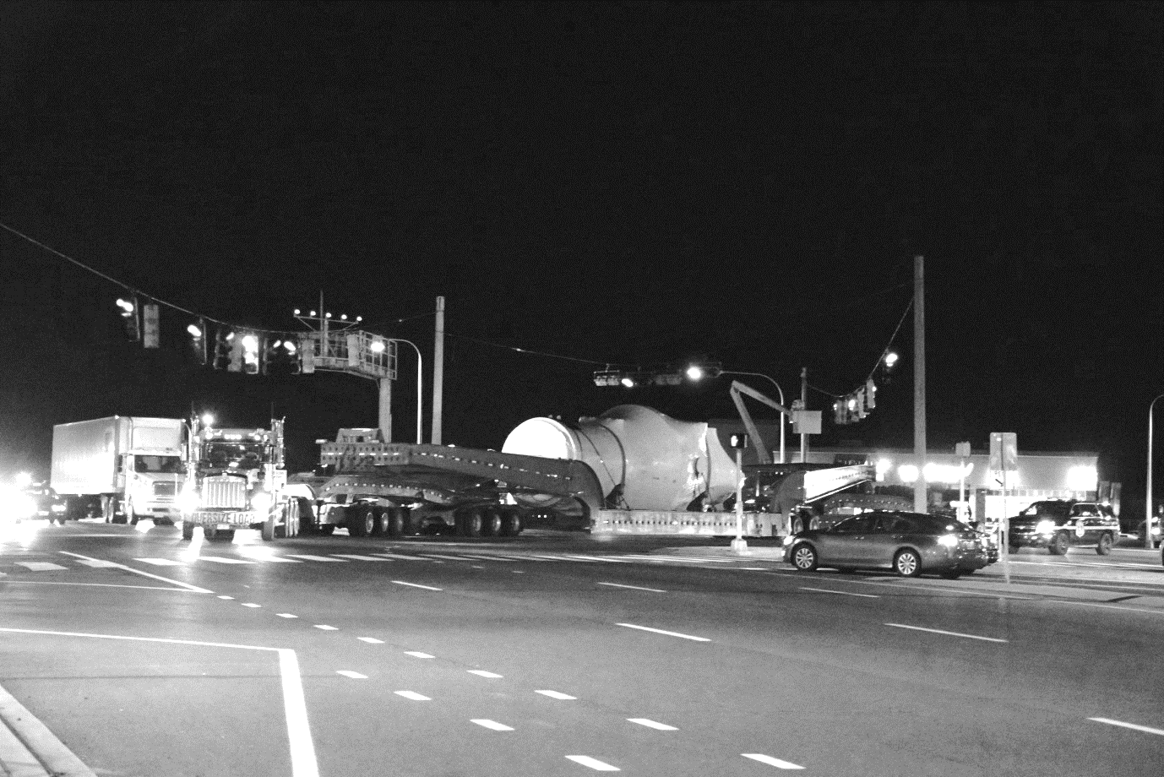

Source: Company documents.

Exhibit 3: Transport Options for Shipping a 102,058-KILOGRAM Tank  
from Houston, Texas, to Wilmington, DElaware

|  |  |  |  |  |  |  |  |  |  |  |  |  |
| --- | --- | --- | --- | --- | --- | --- | --- | --- | --- | --- | --- | --- |
|  | **Estimated Cost** | **Likelihood of Additional Costs** | **Estimated Transit Time** | **Planning Time Required** | **Survey(s) Required** | **Escorts Required** | **Police Involvement** | **Additional Cranes** | **Route Complexity** | **Likelihood of Transit Delay** | **Likelihood of Freight Damage** | **Additional Insurance Required** |
| 1 | $175,000 | High | 8–10 Business Days | 2 Months | Road | Road & Utilities | Extreme | None | Highly Complex | High | Moderate | None |
| 2 | $135,000 | Low | 2–3 Months | 4 Months | Road & Rail | Limited Road | Limited | +1 Lift | Simple | Low | Limited | None |
| 3 | $410,000 | Moderate | 3 Weeks | 4 Months | Road | Road & Utilities | Moderate | +2 Lifts | Moderate | Moderate | Moderate | Maritime |
| 4 | $390,000 | High | 3 Weeks | 6 Months–1 Year | Road & Water | Limited Road | Limited | +1 Lift | Simple | Low | Limited | Maritime |

Note: Data in the table (modes, related parameters, and costs) is disguised.

Source: Company documents.

Exhibit 4: Transport Options for Moving a 90-kilogram Computer Server Coast to Coast

|  |  |  |  |  |  |  |  |  |
| --- | --- | --- | --- | --- | --- | --- | --- | --- |
| **Mode** | **Required Time to Schedule (Hours)** | **Weight Change Affects Cost?** | **Dimension Change Affects Cost?** | **Transit Time (Days)** | **Reliability** | **Likelihood of Damage** | **Insurance Coverage (in US$)** | **Cost (in US$)** |
| LTL | 1 | Yes | No | 7 | 75.0% | 6.00% | $1,000 | $362 |
| Next Day Air | 4 | Yes | Yes | 1 | 90.0% | 0.20% | $200 | $5,800 |
| Cargo Van (no Air Ride) | 8 | No | Maybe | 5 | 95.0% | 3.00% | $48,600 | $3,000 |
| Team Cargo Van (no Air Ride) | 8 | No | Maybe | 3 | 98.5% | 3.00% | $48,600 | $3,645 |
| Air Ride | 8 | No | No | 6 | 95.0% | 1.25% | $48,600 | $4,000 |
| Team Air Ride | 24 | No | No | 3 | 98.0% | 1.25% | $48,600 | $5,200 |
| High-Value Air Ride with Security Safeguards | 24–48 | No | No | 6 | 95.0% | 1.25% | $48,600 | $4,200 |
| Team High-Value Air Ride with Security Safeguards | 24–48 | No | No | 3 | 98.0% | 1.25% | $48,600 | $6,500 |
| Brinks-Type Armed Escort Transport | 165 (1 Week) | No | No | 6 | 99.0% | 0.50% | $48,600 | $15,500 |
| Charter Airplane | 4 | No | No | 1/4 | 99.9% | 0.10% | $200 | $44,235 |

Note: Data in the table (modes, related parameters, and costs) is disguised; Cargo Van (no Air Ride) = small van-sized trailers with standard spring suspension systems; Team Cargo Van (no Air Ride) = two drivers, instead of one, riding in a small van with standard spring suspension system; Air Ride = trailers with air suspension system to reduce the vibration and likelihood of product damage inside the trailer; Team Air Ride = two drivers, instead of one, riding in a trailer with air suspension system; Brinks-Type Armed Escort Transport = highly secured logistics solution that entailed superior technology and communication systems, often including locked doors, geo-fencing or camera-enabled trailers, and armed drivers.

Source: Company documents.

1. Forensic dispatch was a practice where the company called truck drivers before they picked up each load in order to gauge the driver’s readiness, awareness of both shipment- and customer-specific requirements, and ability to make the pickup and delivery on time.