

9B19D003

BUTTERFLY EDUFIELDS: DIFFERENT SHADES OF CAPACITY

[Kalyana C. Chejarla](https://iveypubs.my.salesforce.com/0031J00001SkAEW), Sourabh Bhattacharya, and [Siddhartha Modukuri](https://iveypubs.my.salesforce.com/0031J00001SkAEb) wrote this case solely to provide material for class discussion.

The authors do not intend to illustrate either effective or ineffective handling of a managerial situation. The authors may have disguised certain names and other identifying information to protect confidentiality.

This publication may not be transmitted, photocopied, digitized, or otherwise reproduced in any form or by any means without the permission of the copyright holder. Reproduction of this material is not covered under authorization by any reproduction rights organization. To order copies or request permission to reproduce materials, contact Ivey Publishing, Ivey Business School, Western University, London, Ontario, Canada, N6G 0N1; (t) 519.661.3208; (e) cases@ivey.ca; www.iveycases.com. Our goal is to publish materials of the highest quality; submit any errata to publishcases@ivey.ca. i1v2e5y5pubs

Copyright © 2019, Ivey Business School Foundation Version: 2019-03-07

On April 2, 2017, Sharat Chandra, the founder, director, and chief executive officer of Butterfly Edufields Pvt. Ltd. (Butterfly Edufields), was on his customary Sunday bicycle ride, reflecting on his company’s results for the financial year that had just ended.[1] Butterfly Edufields designed and manufactured do-it-yourself kits for school children in grades one to 10 in its research and development (R&D) and manufacturing unit in Hyderabad, a city in the southern state of Telangana, India. Chandra was happy with what his company had achieved in the last year and in the decade since its inception. He thought of its modest beginnings, conducting science-centred summer schools to keep young children in grades four through seven busy with interesting science projects. As he pedalled the last leg of his ride, he began to reflect on his company’s current challenges. Butterfly Edufields was swamped with orders from existing schools, the ever-zealous sales team was adding new schools, and orders from the newly introduced online ordering site were accelerating. While this was a good marketing problem for his start-up to have, the operation was bursting at the seams. The company’s products were made from everyday low-tech materials, its production processes were manual, its capacity utilization was at peak, and the competition was close on his heels with imitation products. He felt that the only way for his company to win was to identify quick, low-cost sources of additional capacity. As he hoisted his bike onto the stand on his car, he decided to call a meeting of his operations team on Monday and pose this challenge.

COMPANY BACKGROUND

One of the key challenges in the primary education system in most developing countries was achieving the right balance between teaching and doing. While learning through doing enhanced retention and promoted creative thinking among students, opportunities to learn through doing were sorely missing in the majority of schools, perhaps due to a lack of awareness or a lack of available, affordable options.

Chandra, a maverick young graduate of one of the premier business schools in India, founded Butterfly Edufields in 2008 in order to meet this challenge head-on. One of the earliest businesses of its kind in India, Butterfly Edufields produced affordable products that demonstrated various mathematics and science concepts. Students applied these concepts using hands-on materials and concept books that were part of Butterfly Edufields’ kits. The company developed individual kits to demonstrate specific learning concepts such as magnetism, sound, light, and pressure. Each product design was backed by substantial R&D and innovation to ensure that the learning concept became intuitively apparent for the student. Butterfly Edufields had kits for all science subjects from grade one to 10. Owing to Chandra’s steadfast efforts in building awareness and to positive feedback from parents, these kits had quickly become part of the curriculum in many well-known schools across the nation. By March 2017, Butterfly Edufields had sold its kits to 6,500 schools in 60 cities within 11 states in India. Given its innovativeness and social impact and the quality of its products, Butterfly Edufields had won numerous accolades, such as appreciation from the former president of India, Dr. A.P.J. Kalam. It had also been ranked among the top 100 small businesses in 2010 by Ernst & Young[2] and was chosen by the All India Management Association as the top case study in the category of Inclusive Innovation in 2011[3] and as winner of the National Education Excellence Award in 2017.[4] As the learning value of its product was appreciated by schools and parents, the demand for the kits was poised to grow significantly in the coming years—and so was the competition.

planning and PRODUCTION

As in the majority of small- and medium-scale enterprises, all the production operations at Butterfly Edufields (see Exhibit 1) were manual. The company’s product planning, demand forecasting, procurement and production planning, production process, and procurement and storage processes were as outlined below.

Product Planning

The products for different science and mathematics concepts were designed according to the learning abilities of students of different grades. Since its inception, Butterfly Edufields had spent more than 300,000 hours in product conceptualization and R&D, indicating the importance the company gave to product innovativeness and usability. A list of sub-components required for each kit was developed and documented, along with the technical specifications, as a bill of materials.

Demand Forecasting

In April every year, annual demand was estimated based on the previous year’s data, a tentative production plan was made, and production was initiated. In June, when schools reopened and placed annual orders, the actual demand was known, and the production plan was adjusted to arrive at the net production plan for July to January. The delivery schedule was spread from June through January, depending on each school’s teaching plan (see Exhibit 2).

Procurement and Production Planning

Procurement of components was initiated a month prior to the production dates. Components were procured based on considerations of economic order quantities, price, discounts, and lead time. Budgeting was initiated based on the procurement plan, and purchase orders for components were sent to pre-approved vendors.

Production plans for kits were developed on a monthly, weekly, and daily basis, based on the monthly shipping schedule of the orders to schools.

Production Process: Pre-processing and Kitting

Ethylene vinyl acetate (EVA), a flexible, rubber-like sheet material, was used as the base on which most of the kits were assembled. EVA was pre-processed in three steps: cutting, punching, and screen printing. In the first step, EVA from large sheets was cut into smaller pieces of the required size. Next, the cut EVA was punched against wooden board dies to get the desired shapes required for various items or stock-keeping units. Finally, instructions and diagrams were printed on each of the cut and punched EVA shapes using stencilled ink and screen printing. Screen printed EVA shapes took about 30 minutes to dry in the open air before they could be used for kitting. The punching die and screen print template for each kit was made by the R&D department.

Workers assembled kits at table-top workstations (see Exhibit 3). First, the components procured from vendors were converted into sub-components with suitable shapes, sizes, and features. Components and sub-components were stored in separate bins next to the workers. Two to three workers typically sat on each side of the workstation and put these sub-components and an instruction manual into each zip-lock bag to make a kit.

Procurement and Storage Processes

Butterfly Edufields purchased 450 components from vendors; 160 of these components were converted into 600 sub-components. The remaining components were used directly in kitting. Each of the sub-components was given a unique part code based on the finished product in which it would be used. Out of 900-odd stored product-specific sub-components, 126 kits were assembled, and each was given a unique identification number (see Exhibit 4).

At the stores, the sub-components were stored product-wise, resulting in 900 sub-components location combinations. For example, 5-centimetre (2-inch) lengths of straw were used in two different finished products, so these were stored in two different locations.

Given that most of the components used in the kits were quite ordinary, day-to-day items, they were procured in lot sizes based on vendor minimums. For example, plastic beads were procured in one lot to cover the year-long demand rather than in smaller lots, since a single lot was easy to transport and this allowed the company to negotiate better prices.

Facility Layout

Butterfly Edufields’ production facility consisted of two halls of about 372 square metres (4,000 square feet) each, separated by a wall. Both halls belonged to a single owner, who had leased the facility to Butterfly Edufields for 20 years. The first hall was used for EVA storage and pre-processing, sub-component storage, and kitting. The second hall, accessed through an outside door, was used for finished goods storage and EVA screen printing (see Exhibits 5 and 6).

CHALLENGE AHEAD

Having shipped close to 500,000 kits in the fiscal year ending 2017, Chandra and his operations team were now worried about meeting the projected demand for 700,000 units in 2018. Chandra was well aware of the looming competition, which was fast catching up with similar products and limited Butterfly Edufields’ ability to price its products flexibly. He asked Sandhya, the head of production and stores, to evaluate the existing production processes and capacity and present various capacity improvement options for the senior management meeting, scheduled in a week. Having managed intense pressure to produce 500,000 kits last year with a full workforce, Sandhya was worried whether there was any capacity available to increase production by 200,000 more kits. She was also aware that her suggestions should not require any major capital investments. She decided to collect data on production of the magnetic levitation kit (see Exhibit 7) as a sample for her study.

MAGNETIC LEVITATION KIT

The magnetic levitation kit was one of the most popular of Butterfly Edufields’ products. Conversion and kitting of this product was done in batches of 100 on one workstation by four workers. EVA pre-processing had sufficient capacity, so it was not considered in Sandhya’s analysis.

Conversion

Conversion involved five tasks: cutting aluminum strips, cutting iron strips, cutting Styrofoam, filling yellow lid bottles with magnets, and cutting straw. These tasks were performed in parallel, and each batch took between 10 and 20 minutes (see Exhibit 8).

Kitting

After conversion, the batch was processed into kits by the four workers (A, B, C, and D) at the workstation (see Exhibit 9).

CAPACITY OPTIONS

In order to understand the current capacity utilization, Sandhya and her team classified all 126 kits into four categories (simple, medium, moderately complex, and complex) based on their standard production rate (see Exhibit 10). There were currently three kitting tables with four workers each. After the initial capacity analysis, Sandhya and her team came up with the several options for product mix, partnering with vendors, and altering facility layout to enhance capacity.

Product Mix

Capacity could be enhanced by altering the product mix offered. Sandhya considered evaluating the effects of product mix on capacity and investigating ways to shift more demand toward products with lower cycle times.

Partnering with Vendors

Butterfly Edufields partnered with a few vendors who directly supplied sub-components that were ready to be kitted. This eliminated the conversion process. For the magnetic levitation kits, the vendors agreed to perform all tasks except filling the yellow lid bottles with magnets (see Exhibit 7). As a result, this step and kitting were performed in-house.

Altering Facility Layout

Sandhya believed that the current layout of the production facility involved a lot of criss-crossing material movement, which contributed to an overall increase in cycle time, and hence, a lower capacity. She wanted to evaluate alternate layouts that could improve material movement and process visibility and could eventually lead to improved capacity.

Sandhya and her team began considering each of the options, carefully documenting the underlying assumptions, the range of the possible capacity increase, the ease of implementation, and the alignment with the company’s overall strategy. This comparative analysis would be the core of a detailed presentation to be made to senior management in the following week.

Exhibit 1: KEY PRODUCTION TERMS AND DEFINITIONS

|  |  |
| --- | --- |
| **Term** | **Definition** |
| Kits | Kits were built by packing sub-components, along with instruction manuals, into zip-lock bags. The instruction manual contained instructions to help students assemble and demonstrate the concepts being taught. |
| Kitting | Kitting was the process of sorting, performing necessary operations, and packing the sub-components and the instruction manual into a zip-lock bag. |
| EVA | Ethylene vinyl acetate (EVA) was a polymer popular for its use in the footwear industry and in making yoga mats. EVA was a flexible, mutable, rubber-like material and was used as a base for most of the kits produced by Butterfly Edufields. |
| Components | Components were the parts supplied by the vendors. |
| Sub-Components | Components, when processed into the necessary size, shape, and volume required for individual kits, were called sub-components. In other words, sub-components were ready-to-be kitted parts. |

Source: Butterfly Edufields Private Limited and case authors.

Exhibit 2: ANNUAL PRODUCTION PLANNING CYCLE

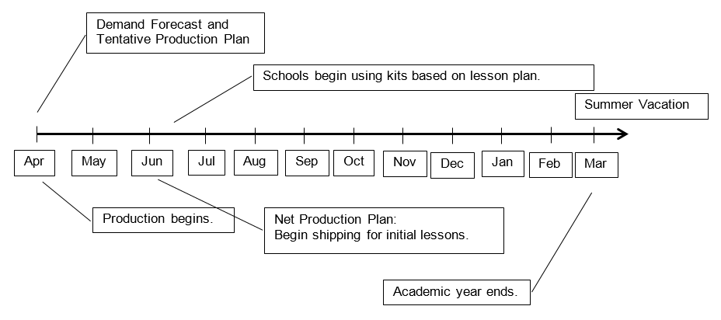

Source: Butterfly Edufields Private Limited and case authors.

Exhibit 3: typical kitting workstation with workers seated on both sides

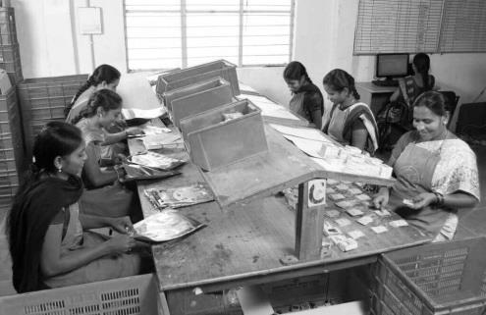

Note: Each table accommodated no more than six workers (three on each side). However, one or two tables with six resources could be used to enhance capacity. The bins on top of the table contained sub components for a particular kit. Bins beside the workers contained components issued from the stores based on the day’s production plan.

Source: Butterfly Edufields Private Limited and case authors.

Exhibit 4: ITEM MANAGEMENT

Procurement: 120+ Vendors

(~10% Outstation)

Stores

Conversion & Kitting

Dispatch

EVA Preprocessing

(Drilling, Cutting, Screen Printing, etc.)

470+ Components

900+ Sub-components

126 SKUs

160+ Components

600+ Sub-Components

Note: EVA = ethylene vinyl acetate; SKU = stock-keeping unit

Source: Butterfly Edufields Private Limited and case authors.

Exhibit 5: CURRENT FACILITY LAYOUT AND MATERIAL MOVEMENT PATHS

5

8

8

9

10

10

10

4

1

13

3

6

7

2

12

14

11

Hall 1

Hall 2

Gate (G)

G

G

G

Approach Road

Note: The order of areas above = the general sequence of operations for a typical product, with block arrows indicating the movement of material at that particular section of the facility.

Source: Butterfly Edufields Private Limited and case authors.

Exhibit 6: LIST OF AREAS IN CURRENT LAYOUT

|  |  |  |  |
| --- | --- | --- | --- |
| 1 | EVA Procurement and Storage | 8 | Stores: Component Inventory |
| 2 | EVA Die Making | 9 | Stores: Fast-Moving Inventory (Used in More than Five UINs) |
| 3 | Drilling and Cutting | 10 | Kitting Tables |
| 4 | Storage of Dies for EVA Processing | 11 | Seating Area, Computer |
| 5 | EVA Cutting Board | 12 | Carton Box Storage |
| 6 | EVA Screen Printing | 13 | Finished Goods Inventory |
| 7 | Stencils for Screens | 14 | Dispatch Counter |

Note: EVA = ethylene vinyl acetate; UIN = unique identification number

Source: Butterfly Edufields Private Limited and case authors.

Exhibit 7: MAGNETIC LEVITATION KIT

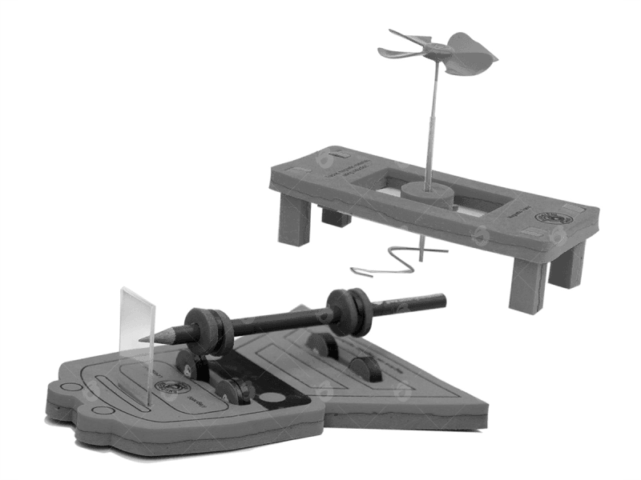

Source: Butterfly Edufields Private Limited and case authors.

Exhibit 8: CONVERSION TIMES FOR MAGNETIC LEVITATION KIT

|  |  |
| --- | --- |
| **Parallel Tasks** | **Pre-processing Time (Minutes per Batch of 100)** |
| Cutting Aluminium Strips | 20 |
| Cutting Iron Strips | 20 |
| Cutting Styrofoam | 10 |
| Filling Yellow Lid Bottles with Six Magnets | 20 |
| Cutting Straw | 10 |

Source: Butterfly Edufields Private Limited and case authors.

Exhibit 9: KITTING TIMES FOR MAGNETIC LEVITATION KIT

|  |  |
| --- | --- |
| **Workers** | **Kitting Time (in Minutes)** |
| A | 20 |
| B | 40 |
| C | 35 |
| D | 40 |

Note: Worker A, the team leader, used 20 minutes for packing and 20 minutes for quality assurance; worker C was a floating resource and deliberately under-utilized to act as buffer capacity against process variabilities.

Source: Butterfly Edufields Private Limited and case authors.

Exhibit 10: KIT CLASSIFICATION BASED ON PRODUCTION RATES

|  |  |  |
| --- | --- | --- |
| **Category** | **Number of Products** | **Standard Production Rate (Units per Hour)** |
| Simple | 44 | 125 |
| Medium | 44 | 100 |
| Moderately Complex | 19 | 80 |
| Complex | 19 | 60 |

Source: Butterfly Edufields Private Limited and case authors.

1. The company’s fiscal calendar ran from April 1 to March 31.
2. “Major Awards & Recognitions,” Butterfly Edufields, accessed January 9, 2019, https://www.butterflyfields.com/about-us/.
3. Ibid.
4. Ibid.