

9B19D006

Northwestern Memorial Hospital: Smoothing Material Flow THROUGH THE RECEIVING AREA

[John Nicholas](https://iveypubs.my.salesforce.com/003A000001CqYoa), [Hussam Bachour](https://iveypubs.my.salesforce.com/0031J00001RZ5hk), and [Paul Suett](https://iveypubs.my.salesforce.com/0031J00001RZ5hp) wrote this case solely to provide material for class discussion. The authors do not intend to illustrate either effective or ineffective handling of a managerial situation. The authors may have disguised certain names and other identifying information to protect confidentiality.

This publication may not be transmitted, photocopied, digitized, or otherwise reproduced in any form or by any means without the permission of the copyright holder. Reproduction of this material is not covered under authorization by any reproduction rights organization. To order copies or request permission to reproduce materials, contact Ivey Publishing, Ivey Business School, Western University, London, Ontario, Canada, N6G 0N1; (t) 519.661.3208; (e) cases@ivey.ca; www.iveycases.com. Our goal is to publish materials of the highest quality; submit any errata to publishcases@ivey.ca. i1v2e5y5pubs

Copyright © 2019, Ivey Business School Foundation Version: 2019-04-26

Paul Suett was hired in 2016 as supply chain performance manager at Northwestern Memorial Hospital (NMH). Included among his responsibilities were management oversight of the in-patient inventory, operating room inventory, linen supplies, mailroom, hospital’s central store and internal warehouse, and receiving area. Suett had previously worked for many years in operational excellence at the University of Chicago’s Medicine and Biological Sciences Division and the Jaguar Land Rover’s car manufacturing plant in the United Kingdom; at both places, he had applied lean production methods for continuous process improvement as originated in the Toyota Motor Corporation (Toyota) production system (TPS). Developed originally for automobile manufacturing, the concepts and methods of TPS had proven universally applicable for managing all kinds of operations, including health care.

Despite considerable experience and having seen all sorts of situations, nothing prepared Suett for his first encounter with the receiving area—the hospital’s central point of receipt for all packaged deliveries. Stacked high everywhere were piles of boxes and packages in what appeared to be a random fashion, with the area’s team members bustling about, trying to keep up with arriving delivery trucks. Packages from the trucks would be unloaded in the receiving area’s outer dock and readied for transfer to the area’s inner room for processing. Due to long lead times in processing packages through the receiving area, a large excess inventory of supplies and packages had accumulated and were sometimes held there for long periods. Although intended as a place to receive and sort incoming packages, it had de facto become a warehouse—with elevated quality, service, safety, and financial risks to packages detained there.

As Suett observed, the receiving area was very congested—just the kind of situation that resulted in handling mistakes, misplaced and lost items, and repeat orders for items urgently needed but held up in processing. Packages arriving at the hospital required an average of three days to move through the receiving area and to final destinations. Due to the uncertainty regarding date of delivery and the long lead times caused by the inefficient process, hospital staff in all areas tended to over-order supplies and carry large safety stocks valued in the hundreds of thousands or even millions of dollars.

Suett recognized the severity of the situation and urgent need to do something to improve operations in the receiving area and shorten the lead time from package arrival to final delivery. He felt that reducing the lead time from three days to one day would reduce or eliminate many of the problems, and it seemed a reachable goal. As supply chain performance manager, straightening out the receiving area mess would be his first official challenge, and he intended to approach it using lean production practices he had successfully employed elsewhere.

ORGANIZATION Background

NMH was a 900-bed academic medical centre in the heart of downtown Chicago. It was but one element of the downtown campus that spanned six city blocks and contained several other facilities, including Prentice Women’s Hospital and Maternity Center, Olson Pavilion, Galter Pavilion, Arkes Family Pavilion, and Lavin Family Pavilion.

The hospital served virtually every medical specialty, as represented by its 1,600 on-site physicians, and was awarded Magnet status—the gold standard for nursing excellence and quality care from the American Nurses Credentialing Center. NMH partnered in teaching and service with Northwestern University’s Feinberg School of Medicine to provide patient access to innovative clinical trials and research. The hospital also provided educational seminars, wellness classes, and events oriented toward community health. Some ratings placed it at the top of Illinois’ hospitals.[1]

Managing the material supply for such a large institution was no simple matter, and these challenges had been exacerbated by dramatic changes in U.S. health care. Patients were living longer, and Medicare/Medicaid[2] costs were rising. At the same time, performance-based payment systems were delimiting revenues, and patients were clamouring for the best possible health care experience and service. To address these demands, hospitals such as NMH constantly endeavoured to perform better. Within their supply chains, this meant placing increased emphasis on getting the right medical supplies to the right place, in the right quantity, at the right time, and at the lowest cost possible—the concept of just-in-time (JIT).

To contend with the problem of tracking and managing its large inventory of medical supplies, in 2012 the hospital began deploying radio frequency identification technology to track items that were expensive or had a short shelf life, or both.[3] This lowered costs through reduced losses from unused and expired items and increased the charge capture (i.e., billing patients for items used during their stay), yet it provided almost no benefit in expediting the flow of materials through the hospital internal supply chain—especially the flow of packages from the receiving area to supply rooms located throughout the hospital and other points of use. The receiving area was the central point of receipt for supplies and equipment, and every day it received and processed over 500 packages for delivery to some 765 locations in the hospital and the Prentice, Feinberg, and Olson Pavilions.

Internal supply chain

Material flow in the hospital’s internal supply initiated with deliveries from manufacturers and distributors to the hospital receiving area (see the left side of Exhibit 1), and then continued from the receiving area to the central store and to the “floors,” or “par locations” (supply rooms on hospital floors where inventory was stocked) and individual requestors. Information flow in the hospital’s internal supply chain started with order requisitions from floor parties (see the right side of Exhibit 1) and went to the central store or, via the hospital’s enterprise resource planning (ERP) system, directly (via electronic data interchange) to manufacturers and distributors.

Central to the supply chain was the receiving area, where, throughout the day, trucks arrived, most of them from three sources—United Parcel Service (UPS), FedEx, and Cardinal Health. In most cases, these sources delivered supplies within a day of receiving a purchase order.

The receiving area processed over 132,000 receipts a year. A receipt represented delivery for a single purchase order, and each receipt included one or more packages. That meant that the receiving area processed and distributed to the hospital and other facilities at least 500 packages each day.

When Suett started as manager, the average time for packages to be delivered to their destinations was three days after arrival at the receiving area. Consequently, supplies often arrived at the floors later than needed, which sometimes resulted in shortages. The problem was compounded by clinicians who, fearing shortages, tended to over-order, which resulted in overstocked par locations. The amount of overstock hospital-wide was estimated at 30 per cent (i.e., 30 per cent above expected demand). Because of the overstock, there would often be no space for newly arrived items at their intended par locations, and those items had to be stored temporarily wherever space was available—such as in hospital corridors. The value for items held in these temporary locations was estimated at US$5 million.[4]

Beyond cluttering corridors, the temporary storage of supplies caused another problem: as items were not logged into the hospital’s inventory system until they were stocked at par locations, supplies held in temporary locations were off the record, making them provisionally “lost” and difficult to find. Clinicians who needed items but were unable to find them were often forced to send repeat orders, sometimes on a rushed overnight delivery basis.

At any given time, the hospital stocked about 71,000 different items at 765 par locations—or about 93 different items at each location. When all par locations were stocked to the maximum par level,[5] the estimated value of stocked items was $34,269,500 (about $44,796 per par location). This value did not include items held in overstock and temporary locations.

To meet urgent demand, orders sometimes had to be expedited to bypass the receiving area and were shipped directly to the floors. (These deliveries are not indicated in Exhibit 1 but would be represented by direct arrows from distributors and manufacturers to floors.) This caused two problems: As the items bypassed the receiving area, they would not be registered into the ERP system, and order versus receipt records would not be reconciled. Additionally, expedited items, especially overnight delivery items, cost more because they incurred additional freight costs. As many as 200 items per day were delivered in this way.

The Challenge

As Suett had initially surmised, the situation in the receiving area led to problems and costs throughout the hospital including overstock, temporary storage, misplaced items, expedited orders, and inaccurate inventory records. Ideally, supplies arriving at the hospital should move quickly through the receiving area and to their designated destinations with no delays, mistakes, stagnation, or overt or hidden problems (this is what “smooth material flow”—a goal of supply chain management—referred to), and they would arrive when needed—JIT. Taking on-average three days, the 2016 dock-to-stock process hardly met the definitions of smooth flow and JIT. The challenge to Suett and the receiving area team was to identify and remove barriers that prevented smooth flow and to reduce the lead time.

Intervention

Value Stream Mapping

To better understand the workings of the receiving area and the dock-to-stock process, Suett’s first action was to orchestrate a team-oriented kaizen[6] event and to create a value stream map (VSM) of the process. The purpose of creating the map was to develop a complete understanding of the steps followed in processing packages through the receiving area—from the dock to final destinations—and to identify problematic or wasteful steps, as well as opportunities for improvement.

Suett organized a team of seven members chosen from the receiving area’s work staff. The team created a charter stating that the kaizen event’s purpose was to “reduce the dock-to-stock lead time to one day”—in other words, the team aimed to enable same-day delivery from the receiving area for every item, every day. Over the course of 12 days, the team devoted one hour per day to scrutinizing the receiving area process and assessing steps in the package-processing value stream—from package arrival at the outer dock to package delivery to par locations. The team “walked the process”: it made observations, interviewed employees, and took photos and timed measurements. From the data collected, the team created a VSM. Later, it performed additional kaizen events to investigate the receiving area’s facility layout and to modify the area’s handling process and facility layout to reduce non-value-added steps (i.e., wastes).

The actual VSM the team created showed package flow from arrival at the receiving dock to delivery to par locations (see Exhibit 2). The map displayed many details about the process, starting with the four major sources of packages and ending with “delivery to floor.” The map showed the 13 steps in the process and details about each step. For example, 12 minutes (denoted as the cycle time or C/T) was required to load up a pallet with packages in step 1; four minutes was required to move the pallet inside the receiving area in step 2; eight to 24 hours of waiting time was required for the pallets in step 3; and 173 seconds was required for processing each package in step 4. Each step also indicated the number of full-time employees as FTE, and the defect rate, which referred to the average number of mistakes made each day. The “explosion” symbols on the map summarized problems and wastes identified by the team.

The process flow worked as described below (also see the numbered steps in Exhibit 2).

Value Stream Map, Steps 1–3: Package Receipt at Dock

Packages arrived throughout the day from various sources by courier, UPS, FedEx, and Cardinal Health. The packages were unloaded from trucks at the receiving area outside dock and placed on pallets (step 1), and the pallets were moved to the inside receiving room (step 2), where they waited to be processed (step 3).

Truck deliveries were scheduled to occur in designated time windows—although occasionally they occurred outside the windows. When multiple deliveries occurred in quick sequence, the dock team was unable to process all the packages, and to compensate, it had to work overtime or stockpile packages for processing the next day. Despite an average of 220 overtime hours per month, many packages were not delivered to their destinations by the close of business on Friday; because the receiving area did not process packages on weekends, those packages would have to wait until Monday for delivery. This meant that some items arriving at the dock Wednesday might not reach their destinations until Monday—five days later. In other words, not only was the long average lead time problematic, but so was the lead time variability. No one could say for certain how long a package delivery would take—two days, three days . . . five days?

During the kaizen event, the team noted numerous problems associated with steps 1–3. These problems included packages requiring refrigeration not being identified early, and therefore, sometimes spoiling; packages being loaded onto pallets, and the pallets not being moved until they were full (thereby delaying processing); packages waiting overnight to be processed; and packages piled so high on pallets that they were unsafe (see Exhibit 3). The team also noted that every pallet was repositioned around the receiving area multiple times, and at any given time there were six to eight pallets waiting to be processed.

Value Stream Map, Steps 4–6: Package Processing in the Receiving Room

In step 4, pallets were moved to whatever workstations had available space and staff. The mandate was to try to “get the pallets into the receiving room and find space for them—somewhere, anywhere.” Workstations and the receiving room were cluttered with pallets and packages, supplies, old equipment, and unused items, all of which contributed to poor workflow and processing delays.

Step 4 involved determining the package’s destination and entering the package description and destination into the ERP system, printing the delivery form, writing the destination on the package, folding and inserting the form into a plastic packet, and taping the packet to the package (see Exhibit 4). This process was performed for individual packages but in batches of up to eight packages at a time, meaning that eight packages were removed from the pallet, scanned, sorted, and then placed onto another pallet (step 5). After that, full pallets were moved to another area of the room, where packages were placed on racks to await delivery (step 6).

The kaizen team scrutinized the steps of the process and assessed the wastes associated with each (see Exhibit 4). The waste categories—originally conceived by Toyota and represented by the acronym DOWNTIME—were Defects, Overproduction, Waiting, Non-utilized human talent, Transportation, Inventory, Motion, and Excess processing. The team estimated that, in its current state, only 38 per cent of the processing time represented value-added activities. Although one could argue that many of the steps contributing to the 62 per cent non-value-added activities were “necessary,” the team felt that these steps could be addressed more effectively in other ways. These steps did not add value, and were therefore wasteful.

In scrutinizing the big delay at step 3, the team identified its source—step 4: it took about three minutes to move a package through step 4, which meant, theoretically, that it took 24 hours to process the average 500 daily packages. This was likely the cause of the 8-to-24-hour package buildup at step 3.

During the kaizen event, the team also created a spaghetti diagram to show typical worker movements in processing each package (see Exhibit 5). These movements were repeated 25 to 30 times a day by each of the receiving area’s nine team members. The diagram also showed typical inventory in the area and the many tables used as places to stack packages (i.e., to hold more inventory).

The team noted many problems in steps 4–6, including (a) limited communication among receiving area team members; (b) many pallets being stored in the work area; (c) packages awaiting delivery, sometimes overnight; (d) packages mislaid, causing repeated searches and frustration; (e) high motion waste (bending, reaching, stretching, walking); (f) delays due to missing product information; and (g) the team being unable to process incoming items because they were preoccupied with looking for missing or misplaced items. The process also involved inordinate processing, such as printing multiple delivery forms for each package and printing information on forms as well as writing it on packages by hand. In addition, there were no metrics to track the performance of the receiving area.

Value Stream Map, Steps 7–13: Package Delivery to Par Locations

Packages were sorted and placed on pallets for delivery to designated par locations (step 7), loading each pallet with as many packages as would fit, and then delivered to par locations (step 8), where they were unloaded from the pallets, scanned, and stocked (step 9). Empty pallets then waited for elevators (step 10), were returned to the receiving area (step 11), and waited to be reloaded (step 12). Pallets were then reloaded (step 13), and the process repeated (returned to step 7).

There was no systematic way to track packages or know when every package destined for a par location would be delivered. Packages were loaded on delivery pallets in ad hoc fashion and delivered when the pallet was full—not according to a schedule. Items from a particular purchase order would arrive at their destinations in dribs and drabs and over multiple trips. Although the vast majority of packages were destined to be delivered to four floors in the hospital, all packages going anywhere in the medical campus were treated in the same way, regardless.

The kaizen team assessed the wastes associated with each step of the delivery process (see Exhibit 6). The team estimated that 97 per cent of the delivery process consisted of non-value-added steps. Again, this was assessed from a lean perspective, where so-called “necessary” steps were considered waste.

From their observations, the team noted many problems, including packages awaiting delivery; poorly managed batch sizes; multiple inspections; safety and quality concerns; staff wasting time picking up and placing packages; pallets waiting for elevators; and a lack of space in par locations to accept newly arriving items (which had to be stored in temporary locations or returned to the receiving area). They also noted an absence of defined delivery routes, standard processes for drop-offs, and visual management.[7] As with other steps in the process, there were no metrics or means to track performance or quality.

Customer Satisfaction

Most customers wanted everything they ordered to be delivered at the same time and to get it when they wanted it and where they wanted it. But hospital internal customers—clinicians and staff—had grown accustomed to expecting almost the opposite: infrequent and late deliveries, partial deliveries, and misplaced packages. Throughout the day, they called the receiving area to inquire about undelivered packages, which could be located anywhere—in a temporary area or in the receiving area on pallets, racks, tables, or the floor. Sometimes they would go to the receiving area themselves to search for packages, or they would reorder the items, with the expenses for doing so charged to the receiving area.

Low expectations among clinicians and staff about the area’s performance led to overstocking, over-ordering, hoarding, and rush reordering, all in the hope of not running short (see Exhibit 7 for a summary of the impact of the receiving area’s performance, based on data collected by the kaizen team).

Looking ahead

Suett suspected that a major contributor to the receiving area’s dysfunction and average three-day delivery time was its batch-oriented approach to processing packages. Virtually every step in the process involved the handling and transport of batches of multiples packages on loaded pallets. In fact, with the exception of step 4, every step in the dock-to-stock process involved the batching of packages on pallets. He had seen similar impacts of large-batch processing in manufacturing. If the receiving area could reduce the package-processing batch sizes—or, better yet, process each package moving through the receiving area one at a time (called “single-piece flow”), he felt that most of the problems stemming from the receiving area could be substantially reduced or even eliminated. Suett set a goal of reducing the average lead time from three days to one day—a goal that he believed was readily achievable by moving the receiving area process closer to single-piece flow.

Exhibit 1: Northwestern Memorial Hospital’s internal supply chain

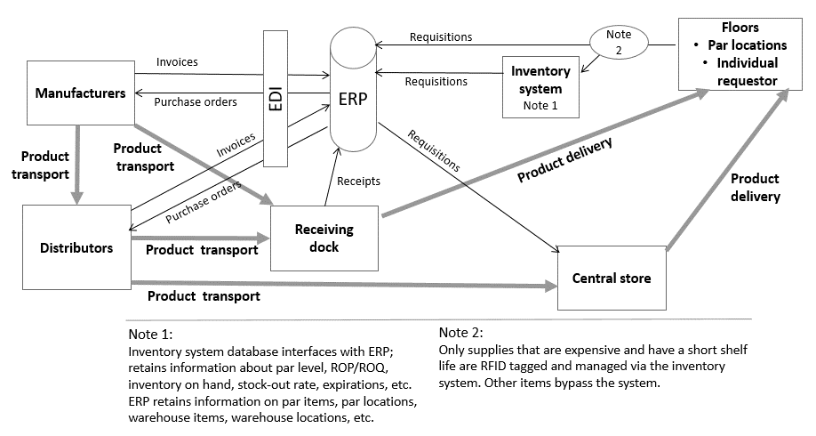

EDI = electronic data interchange; ERP = enterprise resource planning; ROP = reorder point; ROQ = reorder quantity; RFID = radio-frequency identification

Source: Created by the authors based on organization files.

Exhibit 2: value stream map for receiving area process—Package receipt, processing, and delivery

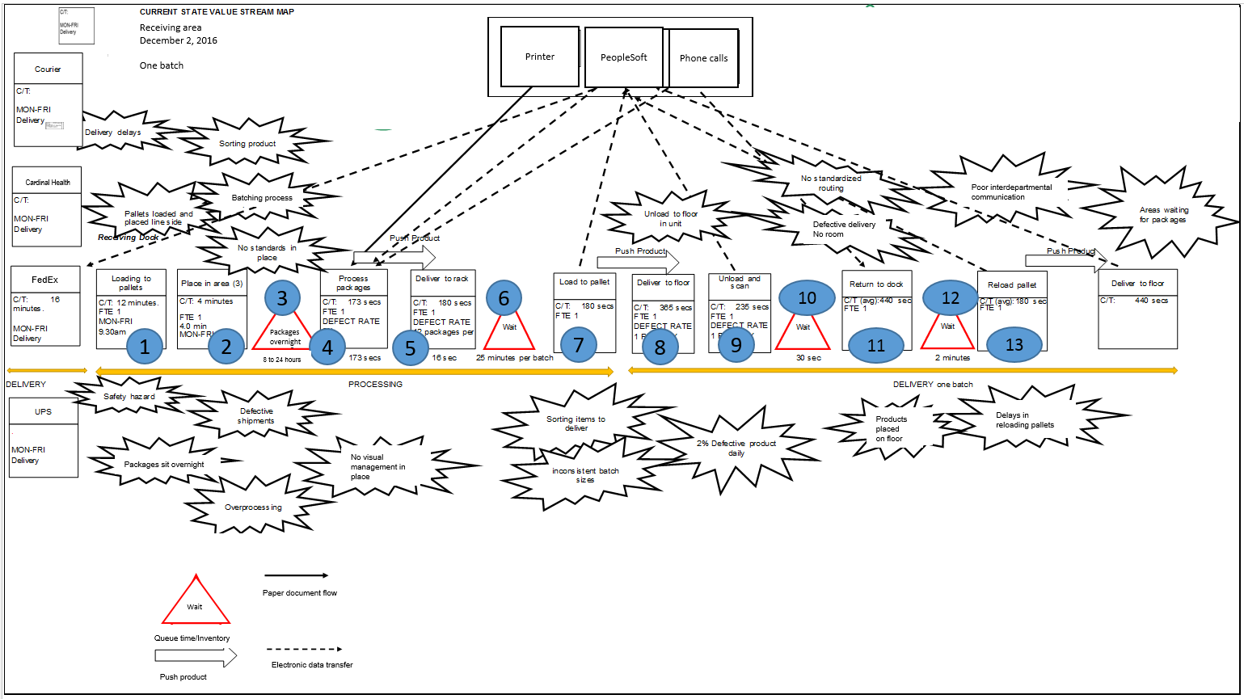

Notes: C/T = cycle time; FTE = full-time employee; 5S = Kaizen intervention to reorganize workplace

Source: Adapted by the authors from organization files.

Exhibit 3: Pallets waiting in receiving area

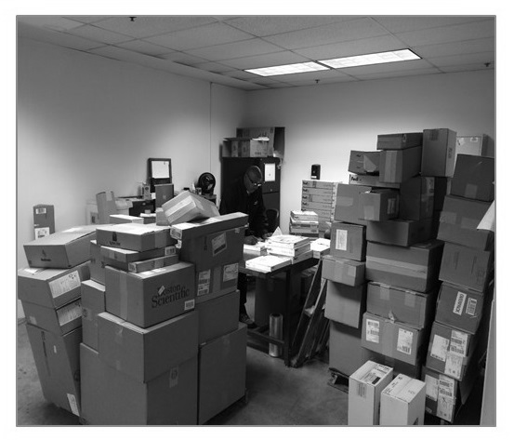

Source: Organization files.

Exhibit 4: STEP 4—Package processing, assessment of value stream map

|  |  |  |  |  |  |
| --- | --- | --- | --- | --- | --- |
| **Process step** | **Time (seconds)** | **Waste**  **type** | **Value-added activity?** | **Potential safety hazard?** | **Opportunity to optimize?** |
| Open package; pull out packing slip | 41 | M, E | No | No | Yes |
| Enter purchase order number into PeopleSoft | 65 | E, O, D | Yes | No | Yes |
| Print receipt and detailed delivery report (two copies) | 22 | E, M, O, T | No | No | Yes |
| Staple packing slip to copy #1; separate | 10 | O, W, M, E | No | No | Yes |
| Write area and/or room number on package | 10 | E, D | No | No | Yes |
| Fold and place in envelope; attach to package | 25 | I, M, E | No | No | Yes |
| Total process time | 173 |  |  |  |  |
| Overall total cycle time (excluding pallet load) | 2 minutes, 53 seconds |  | 38% VA, 62% NVA Pallet time: 16 minutes, 100% NVA |  |  |

Note: M = Motion; E = Excess processing; O = Overproduction; D = Defects; T = Transportation; I = Inventory; VA = value-added activity; NVA = non-value-added activity.

Source: Organization files.

Exhibit 5: Spaghetti diagram for package receiving process

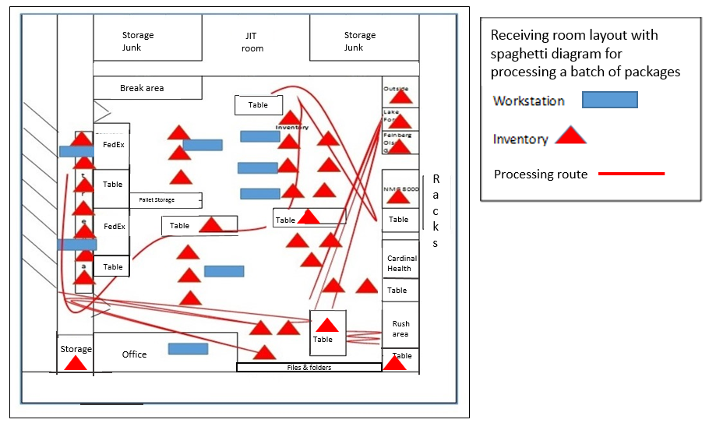

Note: JIT = just-in-time.

Source: Adapted by the authors from organization files.

Exhibit 6: Steps 7–12—Delivery process

|  |  |  |  |  |  |
| --- | --- | --- | --- | --- | --- |
| **Process step** | **Time (seconds)** | **Waste**  **type** | **Value-added activity?** | **Potential safety hazard?** | **Opportunity to optimize?** |
| Load product to pallet | 265 | T, W, I, M, D, N | No | Yes | Yes |
| Take product to floor | 365 | T, I, M, N | No | Yes | Yes |
| Scan product | 40 | M | Yes | No | No |
| Review product and accept | 75 | O, W, I | No | No | No |
| Unload and place in unit | 235 | M, I, E | No | Yes | Yes |
| Sign off | 20 | E | No | No | No |
| Return to dock (elevator wait) | 440 | W, T, M | No | No | No |
| Total process time | 1,440 |  |  |  |  |
| Overall total cycle time | 24 minutes |  | 3% VA  97% NVA |  |  |

Note: T = Transportation; W = Waiting; I = Inventory; M = Motion; D = Defects; N = Non-utilized human talent;   
O = Overproduction; E = Excess processing; VA = value-added activity; NVA = non-value-added activity.

Source: Organization files.

Exhibit 7: Receiving area performance and problems

|  |  |  |  |  |
| --- | --- | --- | --- | --- |
| **Customer impact and satisfaction** | **Occurrences** | **Receiving area staff, lost time (daily)** | **Reordering (potential for)** | **Receiving area charged (potential for)** |
| Customer complaints | 2 per day |  |  |  |
| Phone calls for missing product | 20 per day | 40 minutes | Yes | Yes |
| Visits to receiving area to search | 4 per day | 20 minutes | Yes | Yes |
| Reordering of product | 3 per day | 15 minutes | Yes | Yes |
| Lost packages | 1 per day | 20 minutes (search) | Yes | Yes |
| Staff searching receiving area for packages | 4 per day | 30 minutes (search) | Yes | Yes |
| Overtime | 220 hours per month |  |  |  |
| Total lost time (receiving area staff) |  | 2 hours, 5 minutes (125 minutes) |  |  |

Source: Organization files.

1. Lisa Schencker, “Northwestern Ranked Illinois’ Top Hospital, according to U.S. News,” *Chicago Tribune*, August 7, 2017, www.chicagotribune.com/business/ct-illinois-hospital-rankings-0808-biz-20170807-story.html.
2. Medicare and Medicaid are two social insurance programs run by the U.S. government, created to serve older and lower-income Americans unable to buy private health insurance.
3. Emerson Electric Company, *Metro® and ARC Healthcare Technologies Work Together to Provide Northwestern Memorial Hospital with an Unparalleled Inventory and Storage Management System* (Wilkes-Barre, PA: InterMetro Industries Corporation, 2014), accessed April 8, 2019, https://archlt.com/pdf/nmh-case-study.pdf.
4. All currency amounts are in US$ unless otherwise specified.
5. Par level was designated as maximum par and minimum par. Maximum par was the specified maximum quantity of an item to be stocked. Minimum par was the minimum quantity, below which an item was automatically reordered. Maximum par was computed as Minimum par + Order quantity – Minimum consumed during lead time. Minimum par was computed as Usage × Lead time × Safety stock factor, or D × L × (1 + SS). The safety stock factor accounted for potential spikes in demand and lead time.
6. *Kaizen* was a Japanese business philosophy of the continuous improvement of working practices and processes.
7. Visual management was the ability to manage everything visually. It enabled anyone to know the current status of a process (production, delivery, machines, etc.) almost immediately. Visual indicators were located in places that enabled everyone to know the process they should be doing versus what they were actually doing.