

9B19D007

LYFEN: Building a Supply Chain to Create Competitive Advantage

Professor Haitao Yin, Ruiyu Zhu, and Professor P. Fraser Johnson wrote this case solely to provide material for class discussion. The authors do not intend to illustrate either effective or ineffective handling of a managerial situation. The authors may have disguised certain names and other identifying information to protect confidentiality.

This publication may not be transmitted, photocopied, digitized, or otherwise reproduced in any form or by any means without the permission of the copyright holder. Reproduction of this material is not covered under authorization by any reproduction rights organization. To order copies or request permission to reproduce materials, contact Ivey Publishing, Ivey Business School, Western University, London, Ontario, Canada, N6G 0N1; (t) 519.661.3208; (e) cases@ivey.ca; www.iveycases.com. Our goal is to publish materials of the highest quality; submit any errata to publishcases@ivey.ca. i1v2e5y5pubs

Copyright © 2019, Ivey Business School Foundation Version: 2019-05-17

As Ruifen Yu, founder and president of Laiyifen Company Limited (LYFEN), sat at her desk in her Shanghai office, she began to prepare for her meeting the following week with Yonglei Shi, the company’s chairman. It was Monday January 7, 2019, and LYFEN had celebrated its eighteenth year of operation. A leading snack food chain brand in China, LYFEN had achieved steady growth since its inception, with record revenues of ¥3.9 billion[1] in 2018. Yu reflected on the current situation:

LYFEN’s supplier management capabilities have contributed significantly to the company’s success. We treat suppliers as if they are part of the organization, an approach that is unique to our industry. However, we have high expectations. LYFEN provides a premium product, and our suppliers are required to meet or exceed the current industry standards for quality and food safety, without compromising cost or delivery performance. We also expect suppliers to work closely with us in areas such as new product development. LYFEN understands the important role that our suppliers play in supporting company growth going forward.

The company’s strategy for 2019 included expansion into new regions and the introduction of new products. Initiatives were also underway to promote the company’s brand and explore new distribution channels, such as online sales. During her meeting with Shi the following Wednesday, Yu was planning to provide an update on LYFEN’s supplier management activities, discuss opportunities for improvements, and identify initiatives aimed at supporting the company’s strategic objectives.

**The Chinese Snack Food Industry**

Snack foods offered consumers ready-to-eat, small portions outside of regular meals. A shift in modes of food consumption, as a result of greater mobility, busy consumer life styles; and a desire for greater convenience, contributed to the growth of the snack food market segment. Generally, snack food products were classified into nine broad categories: nuts, meat, preserves, cakes, soy, aquatic, dried fruit and vegetables, chocolate candies, and puffed foods.

The upstream industries in the supply chain included agriculture and aquaculture, and food processing and packaging. Suppliers included large international brands such as General Mills Inc., PepsiCo, Inc., and Mondelez International, Inc., as well as small regional food processors, ingredient manufacturers, and distributors. Snack foods were sold to consumers through a variety of sales channels, such as food stores, supermarkets, convenience stores, vending machines, and online shops.

The snack food market in China was approximately ¥485 billion in 2017, up from ¥393 billion in 2013 (see Exhibit 1). Industry forecasts called for similar growth over the next five years. Rising consumer disposable income was cited as one factor contributing to the expansion of the Chinese snack food market. The industry had two notable features:

First, competition was intense and brand concentration was relatively low. China’s vast geographic territory contributed to a wide range of eating habits and preferences across the country. As a result, many snack food companies had a regional presence, specializing in a segment (e.g., flavour) within a snack food category (e.g., meat or nuts).

Second, as spending on snack foods grew, expectations for product quality were increasing. Consumers were looking for healthy alternatives and wanted to understand what was in the food, how it came from the farm to the table, and whether or not it was produced in a socially and environmentally responsible manner. Therefore, supply chain transparency and traceability were becoming increasingly important. However, few firms were able to adequately address these consumer expectations. For example, a survey by the Beijing Bureau of Investigation of the National Bureau of Statistics found that the satisfaction level of urban residents in Beijing on the safety of snack food in 2017 was 70.6 per cent, the lowest among all food categories.[2]

**LYFEN**

Established in 2002, LYFEN was one of the largest snack food retailers in China, with annual revenues of nearly ¥3.9 billion in 2018. It had nearly 2,700 stores located in 19 provinces and employed more than 9,000 people. The majority of LYFEN sales were through brick-and-mortar stores (company-owned and franchises), which accounted for approximately 85 per cent of 2018 revenues. In contrast, online sales accounted for approximately 9 per cent of revenues. Exhibit 2 provides a summary of LYFEN’s financial results for fiscal years 2014–2018.

With more than 1,400 active stock keeping units (SKUs), LYFEN products included a wide variety of snack foods, including roasted nuts, dried meats, and preserved fruits. Its brand symbolized snack foods that were “healthy, delicious, fresh, and high quality.” LYFEN snack foods were premium products that were sold at a higher price compared to the competition.

**LYFEN Initial Public Offering (IPO)**

In 2012, LYFEN prepared for its IPO on the Shenzhen Stock Exchange. However, five days after the company released its IPO prospectus, China Central Television ran a story about questionable operational practices, including unsanitary production operations and excessive food additives at one of LYFEN’s suppliers, a firm that produced a preserved plum snack. Although the investigation by the Administration for Industry and Commerce was unable to substantiate the report, LYFEN sales were negatively affected. On July 27, 2012, the China Securities Regulatory Commission cancelled the LYFEN IPO.[3]

Following the incident, the company management made significant changes to its supplier management processes, placing increasing focus on controlling product quality and ensuring food safety from the origin (e.g., farmers) to the end consumer. LYFEN increased supplier certification and inspection standards; including tracing key raw materials from their origin from 2012. Yu explained:

In the past 18 years, LYFEN has been engraving “conscience” as emphasized in Chinese culture into corporate value. LYFEN always advocates that the food industry is a conscience business and an ethical industry. The realization of product quality ultimately depends on all the operators and producers. We issued our 3.0 strategy centred on love and happiness to help nearly 10,000 employees develop better business ethics in 2018. We also strengthened the concept and value of high standards of business ethics in our supplier training, which is an enhancement of artisan spirit. Although the 2012 report was unfounded, it drove us to do more to ensure food safety. We paved the way for a “transparent factory” for our consumers and the media. At the same time, we introduced new technology from the United States to test the content of food additives. We want to make sure that LYFEN snacks are safe and healthy.

LYFEN was listed on the Shanghai Stock Exchange on October 12, 2016 and became the first snack food company listed on the A-share main board, issuing 60 million shares at an issue price of ¥11.67.[4] Exhibit 3 provides information on LYFEN’s stock prices.

**LYFEN Supply Chain**

The selection and management of suppliers was the combined responsibility of the product development centre, the supplier management department, and the quality management department. LYFEN had more than 200 suppliers, with 15 per cent accounting for about 50 per cent of the total value of purchases and 40 per cent accounting for about 80 per cent of the total value of purchases. Supplier selection was handled by the procurement department, which worked with existing and potential suppliers for the development of new products. This group handled the commercial arrangements with suppliers, including contracting and pricing. The supplier management department was responsible for the day-to-day supplier relationship management activities.

New suppliers were carefully evaluated before being approved. The process began with a preliminary review—with the supplier completing a self-assessment—and testing of product samples. The self-assessment included a review of the company’s quality systems, business licenses, and production operations. Provided that the self-assessment satisfied LYFEN’s requirements, a production site assessment was conducted, which involved a thorough evaluation of the supplier’s food safety processes, production operations; health and safety practices, and inventory management practices. An important part of the supplier selection process included an assessment of the alignment of organization cultures, as described by Yu:

Alignment of corporate cultures is an essential when choosing a new supplier. We have a great deal of ongoing contact with our suppliers at all levels of the organization, including top management, managers, and cross-functional project teams. A good working relationship anchored in share values is critical. These values include a dedication to food safety and product quality.

LYFEN actively managed multiple tiers of the supply chain. Raw material specifications and sources of supply were set by LYFEN for its suppliers, and documented in the material control list. The company’s objective was to control product quality from origin to final sale.

**Supplier Relationship Management**

Supplier relationship management activities involved multiple layers of engagement. First, each supplier was audited by LYFEN annually, and more than half of the suppliers were audited twice per year. The LYFEN supplier audit was based on the principles of ISO 9001, ISO 22000, and the Hazard Analysis and Critical Control Points food safety management system. These audits focused on quality management systems—including food safety—and also included a comprehensive review of management practices in areas such as supply-chain management, production operations, and health and safety. Second, LYFEN supplemented supplier audits with other methods of supplier monitoring, including independent third-party audits, real-time video surveillance of supplier facilities, and flight inspections. Third, an important element of LYFEN’s supplier-relationship management practices was supplier training. ChengPeng Zhao, the supplier management department manager, explained the company’s approach to supplier training:

Most of our key suppliers have been with us for more than 10 years. More than 10 years ago, many suppliers started as small companies with only a few employees and have grown considerably as LYFEN expanded. We work closely with suppliers to simultaneously improve quality and food safety, reduce costs, and increase capacity to keep up with our growth. This involves two levels.

First, to achieve LYFEN’s objective of world-class quality and food safety standards, we benchmark food companies on a global basis. To demonstrate best practices to senior management at our supplier companies, we organize plant visits with groups of executives from our supplier community to food manufacturers in locations such as Japan and South Korea, to show what is possible to achieve. We organize six or seven such events each year. It is important that our suppliers do not get complacent. For example, one of our key suppliers has set a target for this year to increase capacity by 10 per cent, while reducing costs by 25 per cent through process improvements and investments in automation, and without compromising quality or safety.

The second aspect of supplier training is operational. We help suppliers develop programs to improve their quality management and supply chain systems, including running workshops to train employees in areas such as quality control and food safety. For suppliers who require working capital to fund improvements in their operations and quality systems, we help by providing early payment terms.

In the course of our 18 years of development, LYFEN has promoted the continuous improvement of the snack food industry by formulating standards that are higher than national standards and establishing a “health industry community.” Mrs. Yu was selected by the China Food Industry Association as a recipient of an entrepreneurship award at a ceremony to commemorate the 40th anniversary of China’s reform and opening-up.

**Quality Management**

In order to ensure maximum quality, LYFEN created 24 measures to ensure food safety. Each incoming shipment to LYFEN distribution centres included supplier quality control reports that were reviewed by the quality management department. Using random sampling, two types of inspections were performed: visual and chemical. Visual inspection included examining labelling, packaging size and colour, and food taste. Chemical inspection tested for potential contaminants to ensure food safety and quality.

In 2017, LYFEN started an initiative in which product packaging included a quick response (QR) code that customers could scan with their cell phones in the store to provide access to product information. This information included the name and location of the supplier, when the product was produced, when it was shipped from the supplier to LYFEN, when it was delivered to the store, and the expiry date (see Exhibit 4). The QR code also provided the customer with access to a real-time video of the supplier plant operation that allowed the customer to see how the product was manufactured, including the working conditions within the plant (see Exhibit 5). Zhao commented on the objectives of this initiative:

We want to provide the customer with transparency to our product quality, including how and where it was produced. The ability to see the supplier plants allows us to showcase our suppliers’ operations and reinforce to the consumer that LYFEN sells only products of very high quality. I am confident that many of our competitors would not want to share this information about their supply chain. Today, this QR code technology is used on about two-thirds of our SKUs, and we expect to have it available for 80 per cent of our SKUs by the end of 2019.

**Competition**

As the builder of a Chinese snack food chain business model, LYFEN had two main competitors—Three Squirrels and Bestore. In recent years, the two companies had grown rapidly, supported by the development of the Chinese e-commerce market, and were accelerating their IPOs. Exhibit 2 provides financial information on these companies, and Exhibit 6 shows prices for nine products from LYFEN, Three Squirrels, and Bestore.

Three Squirrels

Founded in 2012, Three Squirrels was an online retailer selling products through a variety of online platforms, such as Tmall.com and Alibaba.com, that accounted for more than 50 per cent of its total sales. Three Squirrels used a series of supplier-management and quality control measures, including assessment of new suppliers, and including a preliminary qualification review, on-site audit, and integrity assessment. Three Squirrels provided training to existing suppliers on delivery processes and the operation of the company’s information platform. The company conducted at least one routine and one unscheduled supplier inspection each year, and used real-time video surveillance at key production facilities of major suppliers. Three Squirrels also conducted sample testing for each batch of products, wherein unqualified products were returned.[5]

Bestore

Bestore opened its first store in Wuhan, Hubei Province, on August 28, 2006. Its product range included meat products, nuts, candies, instant food, and other varieties. The sales channels of Bestore included company-owned stores, franchise stores, and online shops. In 2018, online revenue accounted for approximately 40 per cent of sales. Bestore developed the “Supplier Introduction Process,” which described its supplier screening process. The company’s quality management centre conducted regular and random supplier evaluations, including inflight evaluations. The receiving inspection process involved sample testing of the products, and unqualified products were returned.[6]

**Preparing for the Meeting**

As Yu prepared for her meeting with Shi, she contemplated the opportunities for LYFEN:

Most of our competitors focus on brand management. In contrast, supply chain management is a core competency at LYFEN that we feel provides a competitive advantage. Our attention to quality and food safety is a key differentiator, and we are able to use information technology to help demonstrate the product quality to our customers.

We have plans to grow LYFEN to 10,000 retail locations over the next five years, which will include expanding our number of distribution channels and the geographic footprint to cover the entire country. This will put pressure on our suppliers to maintain quality and delivery performance, while simultaneously increasing capacity. This growth should provide greater purchasing power and economies of scale, enabling us to reduce costs. Our success has also been our suppliers’ success—it is like a commonwealth, where we treat them as part of our organization. During the meeting next week we need to discuss our priorities going forward and opportunities for the supply chain organization to support LYFEN’s strategic objectives.

**Exhibit 1: Growth in the Chinese Snack Food Market**



Source: “Report on the Market Competition Pattern and Future Development trend of China’s Snack Food Industry in 2018–2024,” Zhiyan Consulting Group, May 2018, accessed January 7, 2019, www.chyxx.com/research/201805/641975.html.

**Exhibit 2: Key Financial Information for LYFEN, Three Squirrels, and Bestore**

**(In Millions ¥)**



Sources: Laiyifen Co. Ltd., “2018 Performance Express Announcement;” Laiyifen Co., Ltd. *2016 and 2017 Annual Reports*; Laiyifen Co., Ltd., *Initial Public Offering Prospectus*, June 30, 2015; Three Squirrels Inc., *GEM Initial Public Offering Prospectus*, October 27, 2017; Bestore Co., Ltd., *Initial Public Offering Prospectus*, December 28, 2018.

**Exhibit 3: LYFEN Stock Price**

|  |  |
| --- | --- |
| **Date** | **Stock Price** |
| October 12, 2016 (issue price) | 11.67 |
| January 3, 2017 | 38.39 |
| January 2, 2018 | 19.09 |
| January 2, 2019 | 9.81 |

Note: Prices in CNY

Source: “Equities: Shanghai Laiyifen Co Ltd,” *Financial Times*, accessed January 21, 2019, https://markets.ft.com/data/equities/tearsheet/historical?s=603777:SHH.

**Exhibit 4: Example of LYFEN QR Code with Product Information**

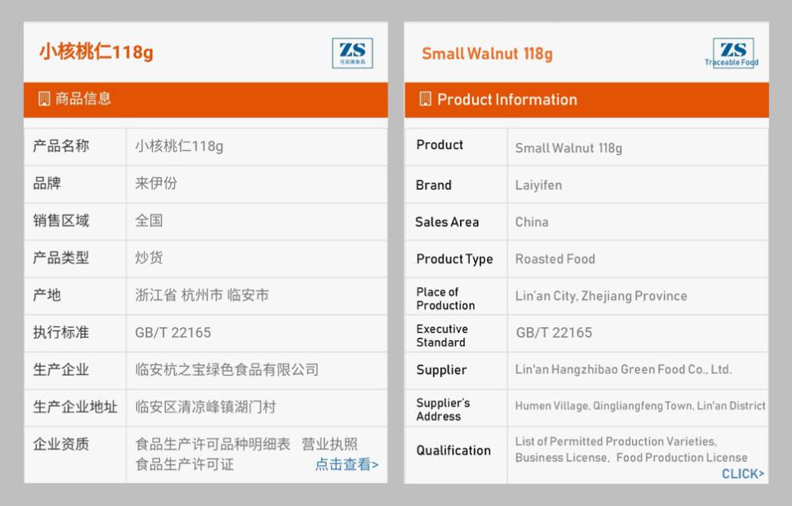

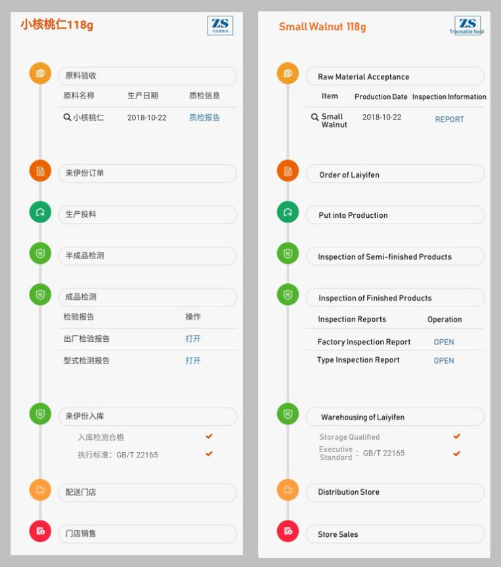

Source: Company files.

**Exhibit 5: Example of LYFEN QR Code with Supplier Production Information**

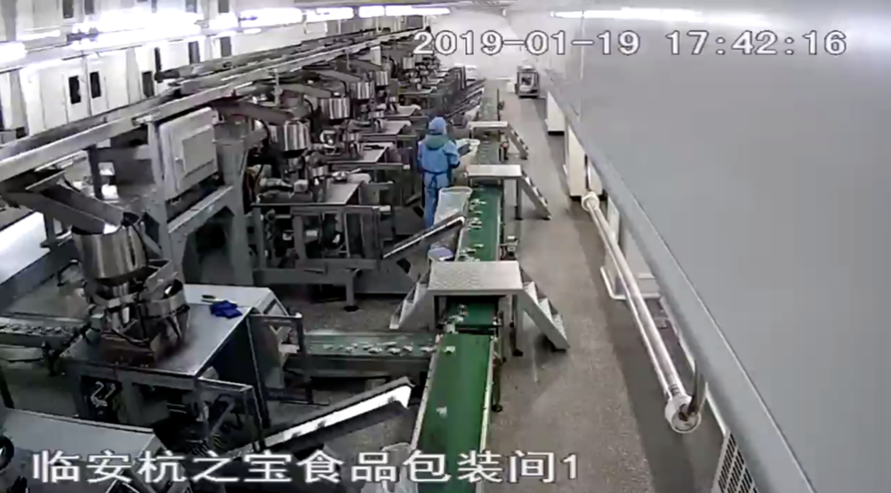

Source: Company files.

**Exhibit 6: Price Comparison for LYFEN, Three Squirrels, and Bestore**



Notes: * P/W = price/weight; All weights in grams; Prices in ¥

Sources: LYFEN, accessed December 16, 2018, https://laiyifen.tmall.com/view_shop.htm?spm=a220m.1000858.0.0.3fb379

46pR4Nxq&shop_id=67843549&scm=1048.1.1.12&rn=d1e79c323b1856de467b4ef509dcdbaa; Three Squirrels, accessed December 16, 2018, https://sanzhisongshu.tmall.com/view_shop.htm?spm=a220m.1000858.0.0.98314d04CP6GA5&shop_

id=71720200&rn=22b5357a3df19427cabae7bec9ecee3d; Bestore, accessed December 16, 2018, https://liangpinpuzi.tmall.

com/view_shop.htm?spm=a220m.1000858.0.0.25eb7422buMcFP&shop_id=63552270&rn=d1993cb566289802fc910c118535c3e7.

1. ¥ Chinese yuan; ¥1 = CA$0.50 as of April 2019. All currency amounts are in ¥ unless otherwise indicated.
2. “National Bureau of Statistics Survey Beijing Food Safety Results Show Overall Stability,” Hexun, January 1, 2019, accessed January 19, 2019, <http://news.hexun.com/2019-01-01/195728404.html>.
3. “Decision on not Approving Shanghai Laiyifen Co., Ltd. Initial Public Offering of Shares,” China Securities Regulatory Commission, August 3, 2012, accessed January 3, 2019, www.csrc.gov.cn/pub/zjhpublic/G00306202/201209/t20120912_2

   14718.htm.
4. Yicai, “LYFEN to List on Shanghai Stock Exchange,” YICAI Global, October 11, 2016, accessed January 7, 2019, www.yicaiglobal.com/news/laiyifen-list-shanghai-stock-exchange.
5. Three Squirrels, *GEM Initial Public Offering Prospectus*, October 27, 2017.
6. Bestore, *Initial Public Offering Prospectus*, December 28, 2018.