

9B19D018

St. Henry’s General Hospital: Sterilization of surgical instruments

Brittney MacKinnon wrote this case under the supervision of Professor David Wood solely to provide material for class discussion. The authors do not intend to illustrate either effective or ineffective handling of a managerial situation. The authors may have disguised certain names and other identifying information to protect confidentiality.

This publication may not be transmitted, photocopied, digitized, or otherwise reproduced in any form or by any means without the permission of the copyright holder. Reproduction of this material is not covered under authorization by any reproduction rights organization. To order copies or request permission to reproduce materials, contact Ivey Publishing, Ivey Business School, Western University, London, Ontario, Canada, N6G 0N1; (t) 519.661.3208; (e) cases@ivey.ca; www.iveycases.com. Our goal is to publish materials of the highest quality; submit any errata to publishcases@ivey.ca. i1v2e5y5pubs

Copyright © 2019, Ivey Business School Foundation Version: 2019-09-18

Nicole Bohdi, director of Surgical Services[1] at St. Henry’s General Hospital (SHGH) in Chicago, was excited about the plans to build a new Medical Device Reprocessing Department (MDRD). The MDRD was responsible for the cleaning, sterilizing, and sorting of surgical instruments for the entire hospital. The project was to begin in May 2018, approximately one year later. The new MDRD was to be built where the current department was located. Bohdi needed to secure a temporary source of sterilized surgical instruments while the MDRD was out of commission during the reconstruction.

St. Henry’s General Hospital BACKGROUND

SHGH was opened in the late 1800s by a small group of nuns to care for the poor and for the sickest patients in the heart of downtown Chicago. Over time, SHGH became a teaching hospital focused on trauma, neurosurgery, orthopaedics, and complex cardiac care. SHGH was a busy, acute care hospital with 500 adult inpatient beds, over 30,000 surgeries annually, over 7,000 staff, and 1,000 physicians.

MEDICAL DEVICE REPROCESSING

The MDRD was located in the basement of the hospital with elevators connecting the MDRD directly to the operating rooms (ORs) to transport materials. The MDRD was made up of four zones that designated the operations of the zone: decontamination, preparation and packaging, sterilization, and sterile storage (see Exhibit 1). Instruments came into MDRD from the OR, inpatient and critical care units, and over 30 clinics. The vast majority of the instruments came from the OR, with each surgical case requiring two to six surgical containers; for complex orthopaedics cases, SHGH could require six to 20 surgical containers.[2] Due to the wide variety of surgical cases, including neurosurgery, orthopaedics, cardiovascular, gynaecology, and minimally invasive surgery, there was little standardization of the containers or instruments. Typically, the MDRD processed 320 containers daily for all of SHGH’s needs. The majority of the surgical cases took place during the regular business hours of the ORs, from 8 a.m. to 6 p.m. Because SHGH was a trauma hospital, the OR had to be prepared for an unplanned trauma case at any hour; therefore, the MDRD operated continuously (i.e., 24 hours per day, seven days per week).

The unionized MDRD technicians worked eight-hour shifts, with start times at 7 a.m., 3 p.m., and 11 p.m., and took a one-hour break during each shift. MDRD technicians were required to have a high school education coupled with certification in a recognized Medical Device Reprocessing program. Technicians were paid US$23[3] per hour, on average, throughout the Greater Chicago Area. Typically, the MDRD employed 38 full-time technicians and a pool of casual technicians to fill any gaps in schedules. The number of technicians varied each shift. The evening shift had the highest number of technicians because the majority of surgeries were completed by 3 p.m. (see Exhibit 2). Technicians were assigned to one of the four zones; however, Bohdi required the technicians to cover the breaks of staff at the bottleneck in order to keep up with demand. Management estimated that, in total, the MDRD spent almost $2.9 million each year on labour, benefits, supplies, and utilities to clean all the surgical instruments used each year at SHGH.

Decontamination

Soiled surgical instruments were brought into the decontamination area in the same containers they had been in when they left the MDRD. This practice not only ensured the efficiency of repacking the containers at the end of the MDRD process, but also was part of a safety measure in the ORs to ensure all instruments were accounted for before ending the surgery. The decontamination started with sorting the instruments for pre-clean at the four workstations, which included a sink and a work surface. Here, four technicians first soaked the instruments from one container in the sinks with a specified amount of detergent and water, then manually disassembled and scrubbed the instruments at the workstation. The process took seven minutes in total.

The next step for the technicians in decontamination was to place one container’s worth of instruments into one of the four ultrasonic cleaning systems to clean, flush, lubricate, and dry the instruments during a 10-minute cycle. The pre-cleaned instruments were then placed into barcoded baskets and onto a wash cart that held 16 containers. A full wash cart was then loaded into one of the four washers, which took an average of 20 minutes to run. The time to load and unload the container into the ultrasonic cleaner and washers averaged two minutes per container.

Preparation and Packaging

To prevent cross contamination with the soiled instruments, cart washers were built into the wall that separated the decontamination area from the preparation area. The cart washers opened into the preparation area where the instruments were tested and reassembled on the preparation and packaging workstations; instruments were regrouped onto containers as they were used in the OR. Six technicians worked in preparation and packaging. The containers were then locked, given an indicator label,[4] and signed off by the technician.Instrument containers were stacked onto a transfer cart by the preparation and packaging technicians before being passed to the sterilization technician. The time for preparation and packaging was typically 25 minutes per container.

Sterilization

The sterilization technician loaded the transfer carts with 16 containers into the sterilizers. The sterilizer ran for one hour and each sterilizer held one transfer cart. The four sterilizers again followed a one-way workflow and opened onto the sterile storage area.

Sterile Storage

The extremely hot carts were removed from the sterilizers to the designated cooling area. The transfer carts and all their containers cooled for one hour before being taken to the sterile storage area. Before unloading the containers onto the sterile storage shelving, technicians completed a visual inspection to confirm that the indicator label on each transfer cart verified that the instruments were sterile. It was extremely rare that containers were not successfully sterilized, but if so, the entire cart went back into the sterilizer for another cycle. The containers were then left in sterile storage until they were to be used for a surgical case. Three technicians were responsible for storage and pulling sterile containers to assemble the case carts for the next day based on the surgical schedule for that day. Bohdi estimated that each technician spent an average of five minutes per container.

St. Henry’s REDEVELOPMENT PROJECT

After nearly a decade of planning and advocating, SHGH was prepared to break ground on the latest redevelopment—a new wing plus renovations throughout the existing 2 million square feet (186,000 square metres) of space. The wing included new in-patient beds, critical care beds, clinic spaces, and operating rooms. Renovations of the existing spaces included a new Emergency Department (ED), upgrades to infrastructure, and a new MDRD. The equipment and associated infrastructure for the MDRD was nearing the end of its useful life and Infection Prevention and Control standards had been updated since the existing MDRD’s construction several years earlier; therefore, the surgical services team was excited about the opportunity to rebuild a state-of-the-art space. Because the hospital had to continue to operate during the renovations, a highly detailed sequencing plan was developed.

The new MDRD would be located in the same space as the existing MDRD, with some expansion into an adjacent area to allow for the much-needed growth. In order to demolish, rebuild, and install new equipment, the MDRD had to move out of its space during the construction phase and none of the equipment could be reused. A large amount of inventory had to be held on site, but this space was no longer available due to the renovations.

ALTERNATIVES

Bohdi and her team had to identify an interim solution to continue providing this critical service to the hospital during the six-month construction. Quality was the most important factor for the MDRD operation; however, cost was also important in the decision since Bohdi had a limited budget. Bohdi reviewed the possibility of outsourcing the entire MDRD operation for the duration of the renovations.

Bohdi also knew that she could convert some of the product to disposables or one-time-use only products. Historically, SHGH did not go with disposables because they were a higher cost than the current internal cost to reprocess in the MDRD; however, this was an opportunity to review the prices again.

Lastly, Bohdi knew that SHGH could continue to run the majority of the operation on site with the use of an external MDRD located in a trailer. The trailer came fully outfitted with MDRD equipment, but SHGH still needed substantial storage space for soiled and sterile instruments. However, this option would keep the MDRD staff employed.

Outsourcing Sterilization

The preferred vendor who offered MDRD services in the Greater Chicago Area was located 30 kilometres from SHGH. In order to have enough surgical instruments on site at SHGH, in transport to and from the supplier, and in process at the vendor, SHGH needed to at least triple its existing inventory of surgical instruments. Management estimated that currently they had $2.3 million worth of surgical instruments at SHGH. After the six-month construction period, SHGH would not have any use for this increased inventory and would not have anywhere to store it. Bohdi estimated that she could resell the instruments after the construction for about 15 per cent of the original price. The preferred vendor could assume the full volume of SHGH’s operation. At 320 containers daily, the cost was estimated to be triple the current operating costs.

Outsourcing the MDRD functions would change the flow of the instruments. Rather than coming from the OR to the decontamination in the basement, the instruments would have to be brought to a soiled holding room adjacent to the loading dock. The containers would then be grouped and placed on enclosed transfer carts as they were in the MDRD. When the truck entered the loading dock, the soiled instruments would be loaded into the truck for transportation to the vendor. Upon their return, the sterile transfer carts of instruments would be unloaded into the new sterile storage room to wait to be pulled as needed. Bohdi was unsure as to how the vendor tracked the instruments during the cleaning process. She assumed that her staff would have to inventory the products as they left SHGH and as they returned, to ensure everything was accounted for and to check for damage to products during reprocessing and transportation. In total, Bohdi estimated she would need two full-time people for shipping and receiving during regular business hours, in addition to the existing sterile storage staff, to inspect and store the surgical instrument containers around the clock. Any employees not needed under the outsourcing option had to be laid off.

Although this seemed like a relatively easy option, Bohdi was concerned about how she would continue to ensure quality of the operation without having control over all of the steps. The sterile tags would have to be checked upon arrival of the product at SHGH, but other than that, Bohdi would be relying entirely on the supplier. Should there be a problem with the cleaning of instruments, Bohdi was not sure where the accountability would lie. It would be challenging to identify whether the instrument was contaminated off site, in transit, or at SHGH.

However, Bohdi knew that other hospitals had been able to overcome some of the challenges associated with outsourcing critical sterile services. She knew that some hospitals in the Greater Chicago Area had first started outsourcing health care linens as early as the 1960s and continued to do so successfully.

Building a Temporary MDRD

Bohdi reviewed the option of installing a temporary MDRD along an existing wing of the hospital that would be untouched in this phase of the redevelopment. This could be achieved by leasing a trailer that included the equipment for the full decontamination, preparation, and sterilization portions of the MDRD operation. Bohdi needed to begin conversations with the vendor shortly because the vendor required four to six months to reserve the trailer and to ensure the trailer could be tailored to SHGH’s needs. Further, in order to operate the trailer, the MDRD required spaces to be constructed for a temporary soiled holding room and a temporary sterile storage. The investment in this temporary space would be $450,000. It would take approximately three months to build the space and ensure it met quality requirements and infection control standards. The installation of the trailer would take approximately six months due to the infrastructure demands for the MDRD and strict infection prevention standards. The requirements for utilities, including electricity, steam, and water, would be the same as the existing MDRD in the hospital. The monthly rental fee for the trailer, including all of the equipment, was $125,000 plus a one-time cost of installation of $28,000 per trailer.

The materials would enter and exit the temporary MDRD in nearly the same way they did in the existing MDRD. The soiled instruments would return from the OR and be held in the soiled room until they could be reprocessed, at which time they would enter the trailer through the soiled entrance to the decontamination. The process of decontamination, preparation and packaging, and sterilization would be identical to the current process employed at SHGH. However, capacity of the trailer was a concern as the expected output would be determined by the amount of equipment and technician space available in the trailer. While there were four sinks for the soak/scrub step of decontamination, there were only two ultrasonic cleaners and two washers. Preparation and packaging was limited in the trailer to four technicians. There were also only two sterilizers in the trailer, but each had a capacity of two carts or 32 containers. All other components of the process and their capacities remained the same as the existing MDRD (see Exhibit 3).

Purchase Disposable Instruments

A final solution that Bohdi reviewed was the option to purchase disposable instruments for the construction period. This option had to be combined with either outsourcing or the trailer solutions because many instruments were not available in a disposable format. Only about 30 per cent of the instruments the MDRD processed were eligible to be converted to a disposable format. Bohdi was also concerned about cost because disposable instruments were roughly double the cost of those processed internally at the MDRD.

CONCLUSION

Bohdi reviewed the outsourcing, trailer, and disposable options available to her, knowing she had to make a recommendation in the next couple of weeks. She knew that whatever option she recommended would have substantial impact on the MDRD staff, the OR staff, surgeons, and others around the hospital. She wanted to select the option with the least impact on the OR and still guarantee the quality of the MDRD processing. But she also had to be conscious of the cost.

Exhibit 1: Medical device reprocessing department Floor Plan

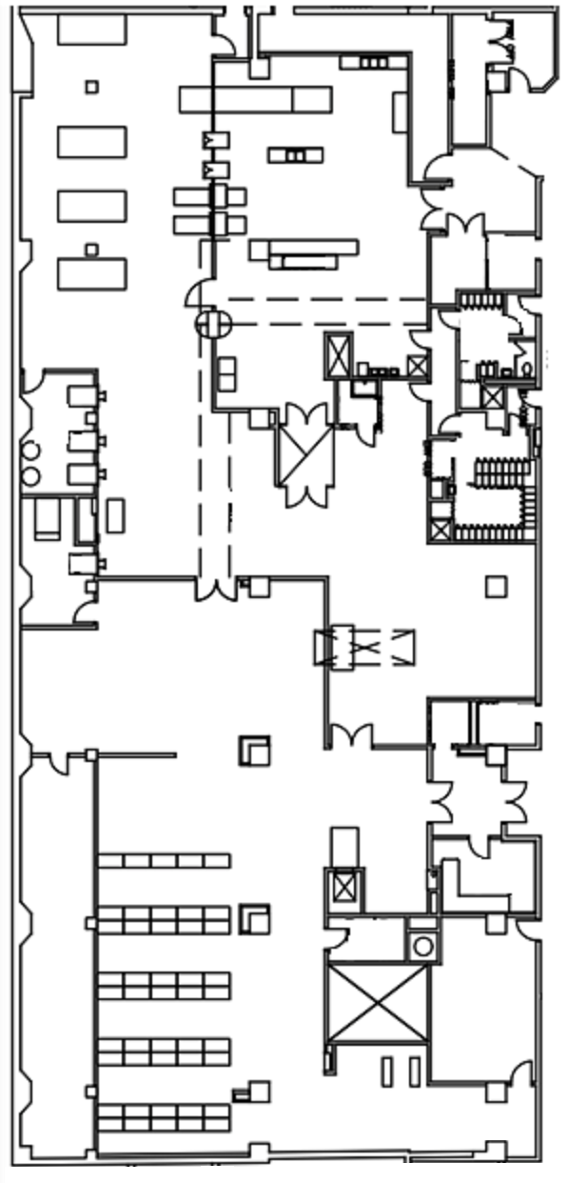

Legend

1. Decontamination
2. Preparation and Packaging
3. Sterilization
4. Storage

**4**

**3**

**2**

**1**

Source: Company files.

Exhibit 2: Medical device reprocessing department Work Schedule

|  |  |  |  |
| --- | --- | --- | --- |
|  | **Day Shift** | **Afternoon Shift** | **Evening Shift** |
| **Decontamination** | 3 | 3 | 4 |
| **Preparation and Packaging** | 6 | 6 | 6 |
| **Sterilization** | 1 | 1 | 1 |
| **Storage** | 3 | 2 | 2 |

Source: Company files.

Exhibit 3: Trailer Floor Plan

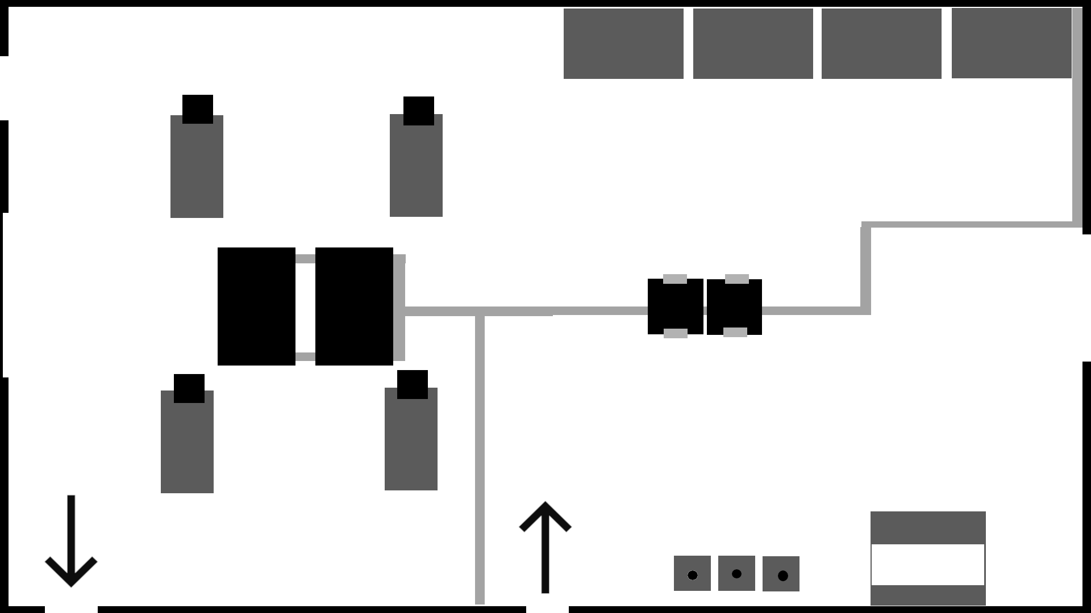

**6**

**6**

**5**

**5**

**5**

**5**

**4**

**4**

**4**

**4**

**3**

**2**

**1**

**Equipment:**

|  |  |  |  |
| --- | --- | --- | --- |
| 1 | Three Reprocessing Sinks | 2 | Two Ultrasonic Cleaners |
| 3 | Two Washers/Disinfectors | 4 | Preparation and Packaging Tables |
| 5 | Transfer Cart | 6 | Sterilizer |

Source: Company files.

1. Surgical Services included all the services in the surgical program, including pre-operative and post-operative spaces, ORs, and the MDRD.
2. A surgical container was a container that held the instruments required to perform surgery.
3. All currency amounts are in US$ unless otherwise specified.
4. A chemical indicator label confirmed that a container of instruments had been exposed to a sterilant (steam) and changed colour to indicate that the instruments met the sterilization parameters of time, temperature, and pressure.