

9B19E001

SNAPPER FUTURE TECH: land records AND REGISTRATION USING BLOCKCHAIN

[Poonam Garg](https://iveypubs.my.salesforce.com/003A000001Zv3gX), [Rashmi Kumar Aggarwal](https://iveypubs.my.salesforce.com/003A000001EUF8j), [Shashank Raj](https://iveypubs.my.salesforce.com/0031J00001RXFIa), and [Ashish Garg](https://iveypubs.my.salesforce.com/0031J00001RXFIf) wrote this case solely to provide material for class discussion. The authors do not intend to illustrate either effective or ineffective handling of a managerial situation. The authors may have disguised certain names and other identifying information to protect confidentiality.

This publication may not be transmitted, photocopied, digitized, or otherwise reproduced in any form or by any means without the permission of the copyright holder. Reproduction of this material is not covered under authorization by any reproduction rights organization. To order copies or request permission to reproduce materials, contact Ivey Publishing, Ivey Business School, Western University, London, Ontario, Canada, N6G 0N1; (t) 519.661.3208; (e) cases@ivey.ca; www.iveycases.com. Our goal is to publish materials of the highest quality; submit any errata to publishcases@ivey.ca. i1v2e5y5pubs

Copyright © 2019, Ivey Business School Foundation Version: 2019-03-01

In the late evening of October 10, 2017, Prashant Surana, founder of Snapper Future Tech Private Limited (Snapper), and his co-founder and mentor, Naresh Jain, were discussing the solutions they had proposed at the Blockchain Business Conference at Fintech Valley Vizag (an initiative of the state government of Andhra Pradesh). The summit had been an eclectic assembly of technology (tech) elites, and the initiative envisaged digital solutions for smooth land registration, adding transparency, accountability, and good governance at every stage of the process.

There were numerous competitive challenges for Surana and Jain from various tech giants. This was the first time they felt anxious about their proposal, which was the result of a year of research and various experiments endeavouring to provide excellent solutions to current processes by using blockchain. Surana and Jain were able to develop a proof of concept for land records on a private blockchain in a cloud-based environment. Their live demonstration of the proposal was well received by the conference attendees. The challenge was whether the government of Andhra Pradesh would consider the solution and engage on a long-term basis with the company for blockchain solutions in land registrations. The government was critically analyzing the challenges and outcomes of implementing the proposed solutions. Would Snapper’s journey be acknowledged in the annals of the country’s digital revolution?

**SNAPPER FUTURE TECH private limited**

Promoted by Surana, Jain, and Avnish Gupta, Snapper was incorporated as a private limited company in 2017, with its registered office in Pune, Maharashtra. In 2017, the magazine *CIO Review* assessed it as “one of the most promising start-ups in blockchain technology” for having significantly contributed to the implementation of blockchain since 2016.[1] Snapper deployed expertise from diverse industries and created a niche in delivering solutions that were easy to integrate, with minimal disruption to existing systems. It thereby delivered high-performance, efficient, scalable, and secured solutions. The company built numerous products and solutions across various industries such as insurance, health care, and supply chain, and had forayed into the execution of e-governance (see Exhibit 1).

The company’s ethos was centred on a strong conviction about blockchain enforcement; it considered blockchain to be as competitive and innovative as the Internet itself. One underlying premise of commercial transactions was the sanctity of agreements made by the parties in mutual trust and good faith. These voluntary obligations were actionable promises or sets of promises. The proposed technology brought participating parties into secured settings through blockchain. The company’s solutions were driven towards contributing to a secure, transparent, efficient, and automated future through futuristic technologies embedded in the contracts.

**BACKGROUND**

Situated in the southeast of India, Andhra Pradesh was the eighth largest of India’s 29 states and had the second-longest coastline in the country.[2] As of the 2011–2012 census, the state had a literacy rate of 67.35 per cent and an urban population of 29.47 per cent out of a total population of 9.67 million. In 2017, the total land under non-agricultural use was 2.03 million hectares. From 2012 to 2017, the state registered a growth rate of 13.33 per cent against 7.1 per cent of the national gross domestic product.[3]

The state had worked toward reconstruction to create an information technology-enabled, state-of-the-art infrastructure. In furtherance of this, the state government framed three different policies on information technology, electronics and innovation, and start-ups.[4] The main objectives and thrust of these policies were to create renewed infrastructure, incentives, and human resource development and to nurture good governance. The state government of Andhra Pradesh also gave the utmost attention to generating positive investor sentiments by creating high-quality infrastructure and enabling a business environment through the ease of doing business. In 2016, it ranked first in the “Ease of Doing Business Rankings”[5] in India, which led to further investments in technological advancement and reforms in both the public and the private sector.

Of the 13 districts of Andhra Pradesh, Visakhapatnam (popularly called “Vizag”), the second-largest city in the state with an area of 550 square kilometres, was a popular site for hosting business conferences. Vizag was fondly called the “Jewel of the East Coast” for its location on the eastern shore of India, nestled among the hills of the Eastern Ghats and facing the Bay of Bengal to the east.[6] In October 2017, the government of India’s Ministry of Electronics and Information Technology hosted the Blockchain Business Conference in Vizag.[7] The invitees included blockchain experts, start-ups, corporations, leading executives, regulators, entrepreneurs, policy-makers, and academics from around the world. The agenda was aimed at blockchain technology, its application, and its impact on the financial services industry.

The conference offered one-of-a-kind opportunities for the invitees to demonstrate innovations led by blockchain technology and its imperative role in bridging gaps among current processes and prominent contemporary global technological advancements. According to Nara Lokesh, cabinet minister of information technology in Andhra Pradesh, “In recent years, we have seen new business models in different sectors questioning the established way of doing businesses. Blockchain technology is the disruptive platform that will provide a new model of doing business across the verticals.”[8]

Representatives from the departments of banking and insurance, trade finance, capacity building and research and development, supply chain logistics, ports and logistics, governance, and regulations participated in invited sessions and focus group discussions, and exchanged views on applications and proofs of concept. The conference provided various opportunities, such as round tables, start-up challenges, start-up showcases, investor connections, customer connections, and student workshops, for participants so that they might understand, implement, and prototype different problem-solving methods and techniques using this disruptive technology.

**EXISTING LAND REGISTRATION PROCESS IN INDIA**

The land record data and its maintenance were administered by the National Informatics Centre. The executive authority was the registrar, an official of the state government, who supervised and controlled all land registration processes. These processes relied completely on the assumption that the seller and buyer had a fiduciary relationship (i.e., a relationship of good faith and trust). All negotiations between the participating parties on the area of land being offered for sale, the price per square unit of area, and the date of transaction/ownership transfer were agreed upon privately.

Thereafter, if a consensus was reached on all terms and conditions, the participating parties entered into an agreement to sell. The agreement matured into a sale when the aspiring buyer registered him/herself and raised a “request of purchase” on the government online portal for land purchases and sales. He or she also had to pay the fiscal stamp duties and registry fees online through either e-stamping or obtaining a physical paper to be stamped. Once the formalities and duty payments were concluded, the aspiring buyer and seller had to schedule an appointment for their visit together at the sub-registrar office for physical verification, biometric verification, and photographic recording of the data. Following the verifications and documentation, a token for their appointment with the registrar was generated. At the registrar’s office, also called the *tehsil* office, another round of manual verification in the presence of a minimum of two witnesses was executed. Finally, the ownership transfer certificate was generated (see Exhibit 2).

There were civic departments such as development authorities, municipal corporations, the electricity department, and the water supply department that functioned daily to facilitate development, infrastructure, and civil processes. Once ownership was transferred to the new owner, the buyer was required to file applications with all these departments separately and proceed to transfer the title in their records. This required further documentation and verification.

**GAPS IN THE LAND REGISTRATION PROCESS**

The land registry process required the participation of land registry executives, who were vested with discretionary powers to decide on whether titles could be transferred. At times, these interventions led to malpractice, abuse of power, corruption, and inefficiency in the system.[9]

Land transactions assumed that all averments made by the participating parties were done in good faith and trust. Buyers checked the sellers’ ownership claims through a process of due diligence. This was generally an expensive exercise, as lawyers had to verify the documents by submitting applications in the registrar’s office for authentication of land record data. The onus was on the buyer to ensure that the seller’s title was valid. Similarly, third parties such as banks, non-banking financial institutions, and retail lenders also faced similar issues of due diligence when approving loans for a property. Banks also engaged legal advisors and scrutinizers to check the authenticity and validity of land ownership. The cost and effort to ensure a perfect, bona fide financial transaction was high.

Furthermore, under the current system, land records could not be retrieved in the case of natural calamities. The land registry processes were paper-based and fragmented, making transactions costly and inefficient, and requiring double registration that was vulnerable to tampering. There was no synchronization of the land registry processes among the various departments.

As per reports on fraud in India, real estate and infrastructure was the sector perceived as most vulnerable to fraud and losses in India, after financial services.[10] The development of a robust, leak-proof, and authentic process was required—a system that could lead to accountability, auditability, availability, and integrity of the data it recorded.

**BLOCKCHAIN**

A blockchain was an electronic ledger that was distributed over a business network to facilitate the recording of transactions and the tracking of assets. The transactions and assets in this tech chain could range widely—from tangible assets such as land, money, and cars to intangible assets such as smart contracts. The concept of blockchain came into existence in early 2009 in the form of Bitcoin; the first bitcoin was “mined”[11] by Satoshi Nakamoto.[12] In 2008, Nakamoto stated in an email, “I have been working on a new electronic cash system that is fully peer-to-peer, with no trusted third party.”[13] At its core, blockchain was a combination of existing cryptography tools and known computer science to develop a network in which parties could interact directly with each other, without any trust between them. Blockchain developed a structure in which to store data in blocks, which were combined in a chronological chain. Each block was linked with another block cryptographically (see Exhibit 3). In short, blockchain could be defined as an enabler for authentication and authorization in the digital world that prohibited the need for many centralized administrators.

Blockchain could be further classified into public and private chains. The public blockchain network was not limited in its management, and anyone could participate.[14] It could be maintained by anyone with enough computational power. The main drawbacks to such chains were privacy and scalability; therefore, “private blockchains” were introduced. These were based on a trusted, permissioned network. They were efficient networks in terms of scalability and compliance with regulatory requirements, and helped organizations to improve efficiency and security. They also helped to reduce costs and time, and enhance trust. Private blockchains enabled organizations to share selected data with each other; in this structure, the organizations were termed “nodes.” Though secure and efficient, private blockchains may have been vulnerable to manipulation due to their centralized governance.[15]

Hyperledger Fabric was the foundation for private blockchain-developed applications. Through projects hosted by the Linux Foundation, Hyperledger Fabric enabled confidentiality, scalability, and security in business environments. It also provided a “permissioned network,” which enabled membership processes and access rights. It confirmed the possibility of low-cost confidential transactions and computations. Finally, it helped in automated business processes by leveraging the embedded business logic in smart contracts across the network. According to the Gartner Hype Cycle for Emerging Technologies, 2018, blockchain would take five to 10 years to mature and deliver transformative changes.[16]

**INNOVATIVE SOLUTION PROPOSED BY SNAPPER**

Snapper had proposed a blockchain solution for land registrations (see Exhibit 4). It provided a cloud-based architecture using private blockchain.

Before the blockchain could be applied, most applications included the creation of digital property data. The proposal emphasized creating awareness of this digitalization among the public, and put forth the creation of blockchain-enabled records that included various fields such as usernames; unique identification numbers; mobile phone numbers of the land owners; and boundaries marked with latitude and longitude coordinates for neighbouring plots, roads, and so on. This created consolidated data of all the properties owned by an individual and stored in the cloud, including their personal and government identification (ID) for each property. A block, to which a unique hash was assigned, represented and contained this data for each property.

For a blockchain-enabled title transfer process, Snapper proposed that the seller could share the details (i.e., area, address, etc.) of the property with an interested buyer through a common online portal (see Exhibit 5). This portal facilitated interactions through a unique personal ID allotted to its registered users. Once the details were shared, a notification was generated at the buyer’s side of the portal, where he or she could then quote a price for the property after reviewing the details. The seller could accept or decline the offer or begin a bargaining process. Once payment terms were agreed upon and finalized, the buyer could request transfer of ownership from the government registry. Based on the land circle rate (i.e., the minimum rate set by the state government on which sale or transfer of property could be agreed) and property size, fiscal stamp duty rates associated with the property were automatically filled in by the system. Upon payment of these fees, a token code, generated as an indication of all successful payments and agreements, was viewed by the registrar and other officials.

The buyer and seller were required to make only a single visit to the registrar’s office at the scheduled date and time. The property title was stored in a smart contract, which was locked with the private keys of both the current owner and the government registrar. An agreement by both parties (i.e., the buyer and the seller) was required for initiating the transfer of ownership of the property. The registrar would then capture the biometrics of the seller (i.e., the current owner) and enter their own private key into the system to initiate the process of transfer, as per smart contract norms. Thereafter, by taking the biometrics of the buyer, a new owner would then be added to the property’s history in the form of a new block added to the chain.

The newly added block would have an updated hash and a smart contract; this, in turn, would be locked by the new owner’s (i.e., buyer’s) biometrics and the government’s private key. This locking of the smart contract constituted a proof of ownership transfer. As ownership and title of the property were transferred, the details of the new ownership automatically triggered real-time updates to the records of various departments such as water, municipal, tax, and other civic bodies.

**the BENEFITS OF USING THE BLOCKCHAIN-BASED SOLUTION**

The real advantage of using blockchain was that it provided a level of safety to the user in carrying out transactions with other anonymous parties in the network without relying on third parties such as banks and the government. This innovation could drastically reduce the cost of trust by providing a decentralized approach to transactions. For example, prior to the 2008 economic crisis, banks and government bodies played the role of a trusted third party between transactions. But banks paid out hundreds of billions of dollars to cover their losses, thus contributing to the economic meltdown. This is an extreme portrayal of the cost of trust. Blockchain challenged the entire concept of for-profit intermediaries.

Blockchain provided safe inroads for due diligence about the proof of existence (at a point in time), proof of process (linkage to other documents), and proof of audit (verification of changes) for digitally encrypted recorded documents. As a result, it improved record keeping and data management and helped to eliminate corruption in the transfer of titles. Apart from this, significant cost cutting was possible in that blockchain minimized back office and administrative costs.

The automated and simplified processes enabled the integration of various departments, so time delays, redundant data entry, and reworking could be avoided. It provided a one-stop shop for all property-related transactions so that inefficiency and data discrepancies were avoided. This led to easy verification of property by banks for loans on property or for purchasing property, which currently required various verifications by the banks to ensure the authenticity and integrity of land records. Data was consolidated, and the transaction history of a property was fully trackable in the blockchain ledgers. With blockchain implementation, an owner could share the public key with the banks so that it could be used for authentication. Since data was stored on the distributed ledger with a biometric key, land disputes were minimized, and impersonation was avoided. As blockchain prevented data tampering, conflict resolution would be easy. The decreased cost on legacy land registry processes required huge transaction costs due to the presence of various intermediaries. Blockchain could remove these intermediaries, thereby reducing the cost of the title registry. To illustrate, farmers had to pay a document writer ₹5,000[17] or more to prepare registration papers. With the implementation of this technology, the digital documentation cost would be reduced dramatically, as all registry documents would be generated automatically after the registration was completed. One window would lead to the next, and after authentication, the ledgers would automatically close and lead to new blockchains. Blockchain stored accurate identities, locations, property boundaries, and so on at all departmental locations, so clean title records could be provided to avoid land disputes.With the implementation of this technology, land owners would have a durable and tamper-proof registry of data on the cloud with multiple backups, which would be unaffected by any kind of natural or human-imposed calamity.

**THE DILEMMA**

After the successful completion of the Blockchain Business Conference, Surana wondered whether the government of Andhra Pradesh would consider the suggestions they had made on land records and registration using blockchain-enabled technology. A bigger question for Snapper was whether it should consider other dimensions of technology acceptance (like creating awareness in people, and training the users) in its proposal or if it should continue to remain technology specific only? Were business, government, and society ready for a new technology disruption? Were the assurances of safe, secure, and transparent land registrations convincing enough for the government to consider blockchain implementation?

**exhibit 1: Snapper future tech Solutions portfolio**

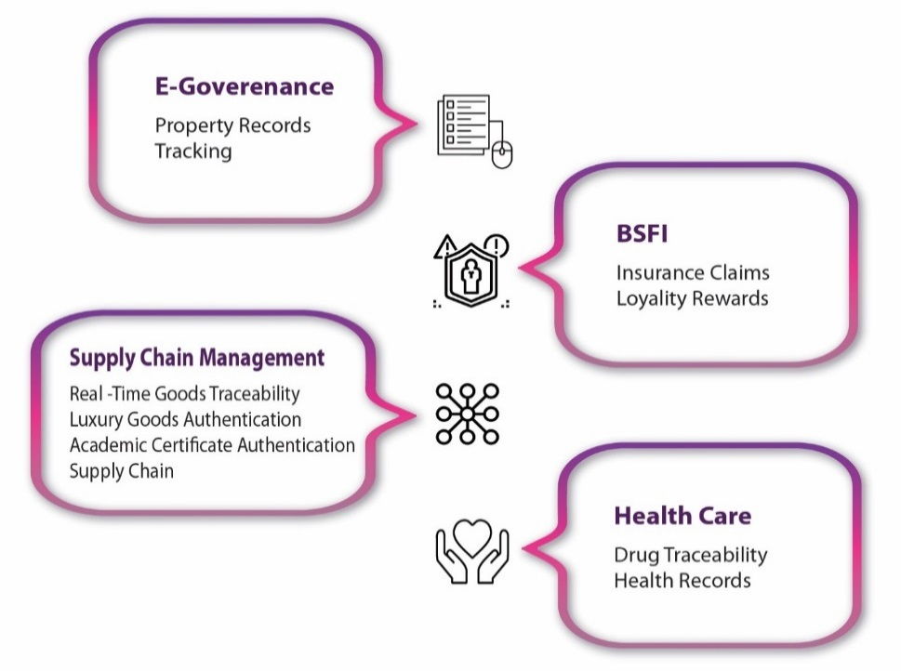

Note: BSFI = Banking, Financial Services, and Insurance.

Source: Snapper Future Tech (website), accessed January 15, 2019, <http://snapperfuturetech.com/index.php?#about>.

**exhibit 2: Schematic diagram of existing LAnd registration process**

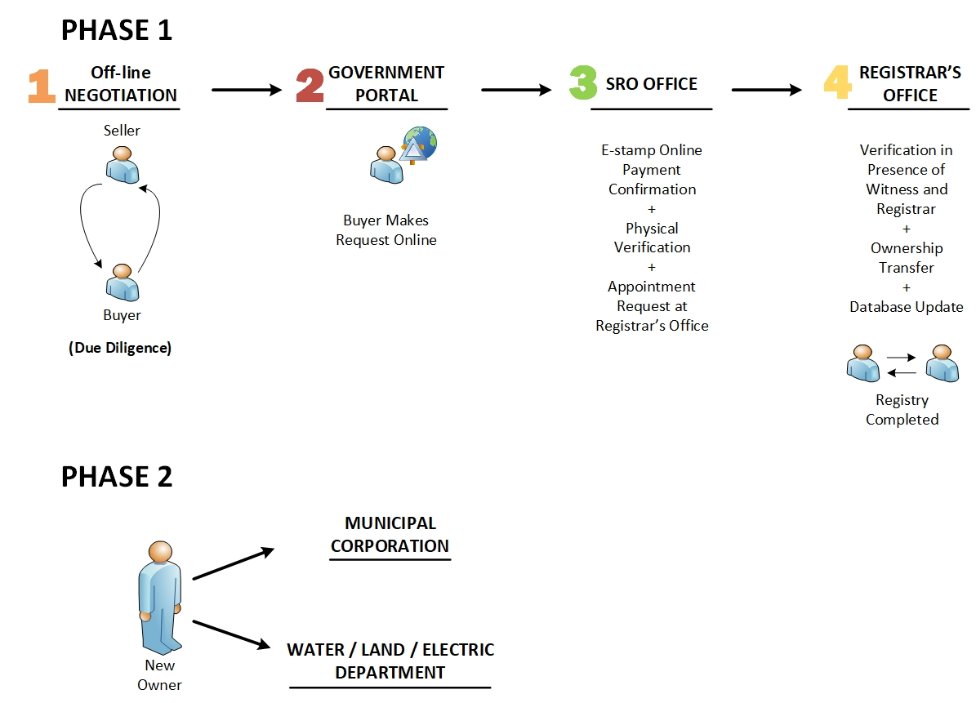

Note: SRO = sub-registrar’s office.

Source: Created by the case authors.

**exhibit 3: How Blockchain works**

Source: Created by the case authors.

**exhibit 4: proposed blockchain-enabled Solution of Land record and REGISTRATION**

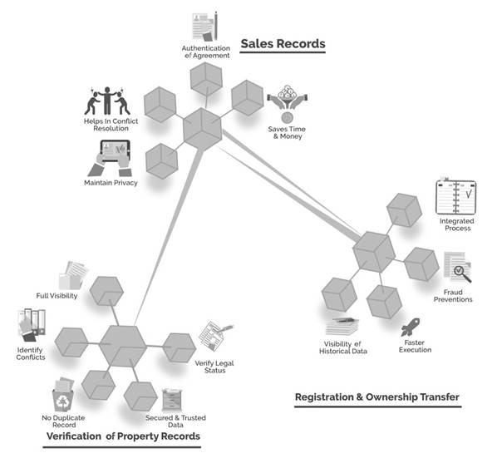

Source: “Property Records Registration,” Snapper Future Tech, accessed January 15 2019, [www.snapperfuturetech.com/index.php?#media](http://www.snapperfuturetech.com/index.php?#media).

**exhibit 5: Schematic diagram of blockchain-enabled Land Registration process**

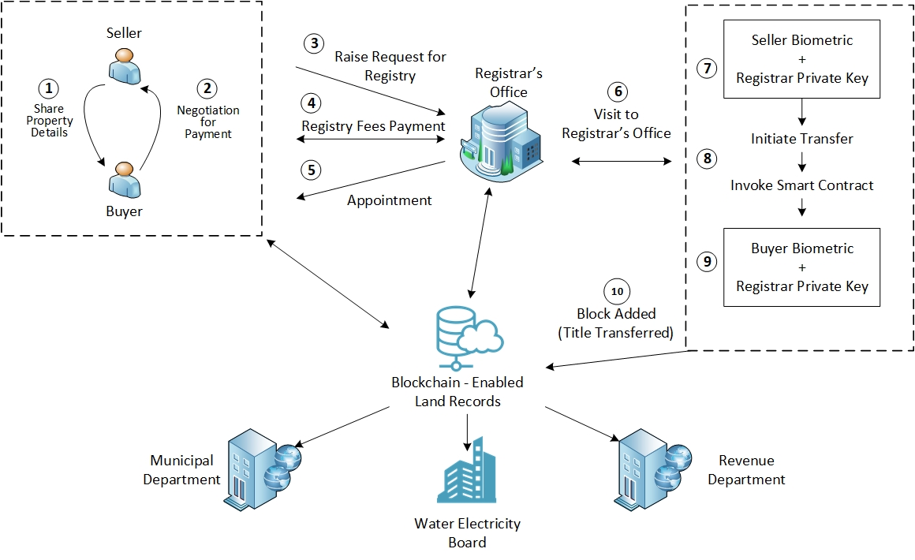

Source: Created by the case authors.

1. “Snapper Technologies – Transforming the Business Ecosystem through Blockchain Technology,” *CIO Review India*, accessed September 25, 2018, https://blockchain-technology.cioreviewindia.com/vendor/2017/Snapper_Technologies.
2. “Which State Has the Longest Coastline in India?,” Maps of India, July 13, 2018, accessed September 25, 2018, www.mapsofindia.com/answers/india/which-state-has-the-longest-coastline-in-india.
3. “Industrial Development & Economic Growth in Andhra Pradesh,” India Brand Equity Foundation, July 13, 2018, accessed September 25, 2018, www.ibef.org/states/andhra-pradesh-presentation.
4. Information Technology, Electronics & Communications Department, Government of Andhra Pradesh, *Booklet on ITE&C Department Policies, 2014–2020*, accessed September 25, 2018, www.apiic.in/wp-content/uploads/2015/07/AP-IT-Policy-2014-2020.pdf.
5. “Snapper Technologies – Transforming the Business Ecosystem through Blockchain Technology,” op. cit.
6. “AP State Portal,” accessed September 25, 2018, www.ap.gov.in/?page_id=243/vishakhapatnam/.
7. #BlockchainVizag (website), accessed September 25, 2018, https://blockchainbusinessconference.com.
8. Suprita Anupam, “Vizag Blockchain Conference 2017: Andhra Pradesh Chief Minister NC Naidu Terms Vizag as Future Fintech Capital of India,” Inc42, October 10, 2017, accessed September 25, 2018, https://inc42.com/buzz/vizag-blockchain-fintech-naidu/.
9. Alexandru Oprunenco and Chami Akmeemana, “Using Blockchain to Make Land Registry More Reliable in India,” United Nations Development Program, May 1, 2018, accessed September 25, 2018, www.undp.org/content/undp/en/home/blog/2018/Using-blockchain-to-make-land-registry-more-reliable-in-India.html.
10. Deloitte Touch Tohmatsu Limited, *Deloitte India Fraud Survey, Edition I*, December 2014, accessed September 25, 2018,

    www2.deloitte.com/in/en/pages/finance/articles/india-fraud-survey-edition-1.html.
11. Mining as a process added previous transaction records to Bitcoin’s public ledger, called a blockchain. The ledger of preceding transactions was a chain of blocks and thus called blockchain. These chains confirmed and verified preceding transactions and added them to the rest of the network.
12. Girish BVS, Sasken Technologies Limited, *Blockchain Technology: Concepts*, May 2018, accessed September 25, 2018, www.sasken.com/sites/default/files/files/white_paper/Sasken%20-%20Whitepaper%20-%20Blockchain%20Technology.pdf.
13. [Clark Moody Bitcoin](https://bitcoin.clarkmoody.com/), “The Bitcoin Whitepaper after Ten Years,” October 31, 2018, accessed November 25, 2018, https://bitcoin.clarkmoody.com/posts/bitcoin-whitepaper-ten-years.
14. boromir_katz, “Public Chain vs Private Chains,” DelegateCall (online forum), accessed September 25, 2018, https://delegatecall.com/questions/public-chain-vs-private-chainsf454bd75-1c7e-4191-90af-a49a1b4b96de.
15. James Bennett, “Public vs Private Blockchain Protocols: What’s the Difference?,” Brave New Coin, March 18, 2018, accessed September 25, 2018, <https://bravenewcoin.com/news/public-vs-private-blockchain-protocols-whats-the-difference/>.
16. Susan Moore, “Top Trends from Gartner Hype Cycle for Digital Government Technology, 2018,” *Smarter with Gartner* (blog), September 3, 2018, accessed September 25, 2018, www.gartner.com/smarterwithgartner/top-trends-from-gartner-hype-cycle-for-digital-government-technology-2018.
17. ₹ = INR = Indian rupee; ₹1 = US$0.02 on October 10, 2017.