

9B19E004

City of London Water: Predicting Electricity Prices and Optimizing Operations[1]

[Kira Wenbo Xue](https://iveypubs.my.salesforce.com/003A000002527TP), [Ernesto Arandia](https://iveypubs.my.salesforce.com/003A000002527TU), and [Joe Naoum-Sawaya](https://iveypubs.my.salesforce.com/003A000001mPkuK) wrote this case solely to provide material for class discussion. The authors do not intend to illustrate either effective or ineffective handling of a managerial situation. The authors may have disguised certain names and other identifying information to protect confidentiality.

This publication may not be transmitted, photocopied, digitized, or otherwise reproduced in any form or by any means without the permission of the copyright holder. Reproduction of this material is not covered under authorization by any reproduction rights organization. To order copies or request permission to reproduce materials, contact Ivey Publishing, Ivey Business School, Western University, London, Ontario, Canada, N6G 0N1; (t) 519.661.3208; (e) cases@ivey.ca; www.iveycases.com. Our goal is to publish materials of the highest quality; submit any errata to publishcases@ivey.ca. i1v2e5y5pubs

Copyright © 2019, Ivey Business School Foundation Version: 2019-03-29

As the manager of Water Operations at the City of London, Ontario, Tina Soltani[2] was always seeking new opportunities to improve the efficiency of the city’s water distribution. Starting early in 2015, Water Operations in London was consistently experiencing higher operational costs, with electricity bills accounting for up to 30 per cent of direct costs.[3] While exploring options to reduce this cost, Soltani read the *Energy Efficiency in Water and Wastewater Facilities* report that was published by the U.S. Environmental Protection Agency in 2013 and was delighted to read that the City of Columbus, Georgia, had managed to achieve 25 per cent energy costs savings by eliminating pump inefficiencies at water pumping stations.[4] Soltani wondered whether she could replicate this success at the City of London.

Given that the city’s electricity bill was consistently increasing due to rising electricity costs,[5] the possibility of reducing electricity usage was even more appealing. Soltani knew that in the short term, there was little possibility for improvements to infrastructure for efficiency gains; however, she wondered whether hourly water pumping could be scheduled during off-peak electricity periods when prices were lower. Soltani began to explore hourly electricity prices and wondered whether the pricing schedule could be accurately predicted 24 hours in advance. She knew that creating an accurate prediction model would be critical to optimizing pumping schedules and therefore reducing electricity usage and costs.

London’s Water System

London received its water from two main sources: Lake Huron and Lake Erie (see Exhibit 1). These water sources were administered by the Lake Huron Primary Water Supply System and the Elgin Area Primary Water Supply System, respectively.[6] There were also two backup emergency wells: the Fanshawe well field and the Hyde Park well field.[7] In 2015, London Water bought 44.3 billion litres of water from the supply systems for a total cost of CA$21.5 million.[8] To move water from the lakes and into its final treated form at individual households, London had a complex distribution system of treatment plants, reservoirs, pumping stations, and 1,550 kilometres of pipes (see Exhibits 2 and 3).[9]

Water Pumping Operation

In determining the optimal pumping schedules, London Water needed to address three priorities: meeting demand quantities, maintaining water quality, and meeting pressure needs.

Meeting Demand Quantities

Reservoirs needed to meet both peak water consumption demands and unexpected demands. For example, many cities maintained capacity for extraneous demands such as firefighting needs. In 2015, London’s average daily water demand was 120.33 million litres. The largest daily amount pumped in 2015 was 151.45 million litres on July 28, 2015.[10]

Maintaining Water Quality

Pumping schedules impacted the age of water in reservoirs and thus affected the water quality.

Meeting Pressure Needs

A minimum quantity of water also needed to be maintained in reservoirs to ensure adequate water pressure to deliver water through London’s network of pipes.

Meeting the priorities

To meet these priorities, reservoir levels needed to be maintained between a maximum capacity and a minimum required level. Accordingly, over a 24-hour planning period, pumping operations were scheduled at low-price hours as long as the key priorities were met. The potential for cost savings by optimizing pump scheduling was thus significant. Soltani believed that London Water was filling the water tanks too early in the day and not benefiting from periods of low energy prices. By efficiently scheduling pumping operations and operating at lower levels throughout the day, she estimated that electricity costs could typically be reduced by 10–15 per cent.[11]

Energy costs accounted for up to 80 per cent of the processing and distribution costs of drinking water.[12] This wide range existed because the costs included multiple factors, in addition to pump scheduling. For example, the water pumping cost was much higher in Toronto, where the topography forced the distribution system to mostly pump water upstream, which required much more energy than in London, where 80 per cent of the city was fed by gravity.[13] The efficiency of water infrastructure also had a large impact, especially when leaks in the pipes led to water loss. Construction and maintenance costs also varied for different utilities. In regions with colder climates, pipes needed to be installed further underground to reduce the likelihood of frozen watermains, which made any infrastructure upgrades or repairs very expensive.

Despite the benefits of optimizing pumping schedules using predictive and algorithmic methods, most pumping schedules were managed manually by water operators. In general, however, increasing energy costs and water constraints necessitated that all water utilities consider various methods to optimize their efficiency and reduce costs.

Electricity Markets

Electricity markets were managed and operated by independent system operators (ISOs). The ISO that operated the Ontario market was the Independent Electricity System Operator (IESO). By balancing supply and demand of real-time electricity, the IESO determined the hourly Ontario electricity price (HOEP), which was the market price of wholesale electricity in Ontario.

The Hourly Ontario Electricity Price[14]

Large electricity consumers that used more than 250,000 kilowatt-hours (kWh) of electricity paid the wholesale electricity price, or the HOEP.[15] The IESO determined the HOEP by forecasting demand 24 hours in advance and accepting supply offers from generators and electricity importers. Supply price offers were mostly affected by fuel and generation costs, such as the cost of natural gas for a generator converting natural gas into electricity, and fixed costs, such as ongoing operating costs.

After supply offers were received, a small number of large consumers (local distribution companies, or LDCs) bid on the price they were willing to pay for a certain amount of electricity. LDCs determined their bid by forecasting the demand that they expected from their customers, which ranged from individual households and private businesses to public utilities such as London Water. Demand was primarily impacted by weather, business needs, and general usage efficiency.

Apart from supply and demand factors, inefficiencies in the transmission grid and in the network of high-voltage power lines impacted the transportation and delivery of energy and, subsequently, the actual clearing prices of electricity.

The IESO collected supply offer and demand bids up to two hours in advance of actual energy use. It stacked all supply offers from the lowest-priced offer to the highest, purchasing through the stack until energy demands were met. The HOEP was the average of these market clearing prices in any given hour. An additional operating reserve price was set, which paid suppliers to have on-call electricity generation capabilities in the case of a demand surge or supply shortage (such as a generation breakdown).

Global Adjustment[16]

In addition to the HOEP, electricity consumers were also charged a global adjustment (GA) fee. The GA fee was the discrepancy between the HOEP and any predetermined IESO contract prices with specific conservation generators, such as renewable-energy generators. For example, the feed-in tariff for on-shore wind electricity generation was $0.128/kWh, meaning that IESO guaranteed a price floor of $0.128 for electricity from these generators. When the HOEP went below this price, the GA fee was increased to account for the cost of covering the feed-in tariff.

The GA was calculated and charged on a monthly basis. To incentivize consumers to reduce electricity demand during peak hours, Class A electricity users (defined as having an average hourly peak demand of greater than or equal to 5 megawatts) were charged for their portion of the electricity demand during the five highest annual demand peaks. For example, if on an annual basis, a consumer accounted for 2 per cent of total electricity demand during peak hours, the GA rate would be 2 per cent of the total GA cost.

The Data

Soltani collected the HOEPs from 2003 to 2015 (see Exhibit 4 and Student Spreadsheet, [Ivey product no. 7B19E004]). The data provided the date, hour (using the 24-hour clock), and the corresponding hourly prices.

Impact and Decision

With such large potential electricity savings, Soltani knew that optimizing the schedules of pumping operations would hold significant merit. Because few other water utilities had adopted such methods, London had the opportunity to become an innovation leader and present a best-practice scenario. To make this decision, however, Soltani first needed to find an accurate way of predicting the electricity prices 24 hours in advance for any given day. Because cost savings were predicated on lower electricity prices, determining the best prediction model was critical to addressing any questions about future optimization.

After making a large cup of Persian tea, Soltani sat down to contemplate how she should proceed.

EXHIBIT 1: Sources of Water for the City of London

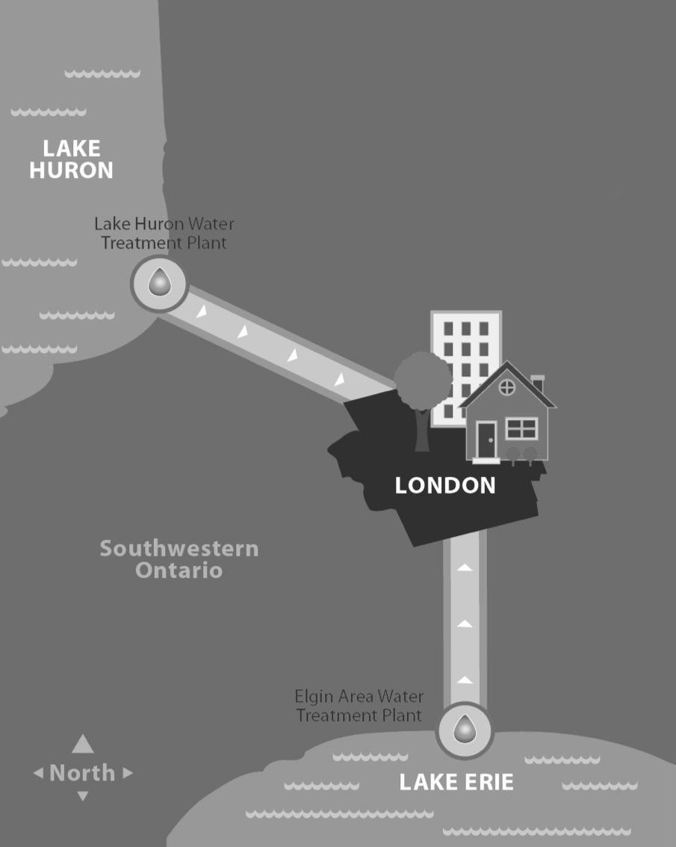

Source: *Water Treatment and Distribution in London: The Teaching Toolkit*, slide 3, City of London, Canada, accessed October 19, 2017, www.london.ca/residents/Water/Teacher-Resources/Pages/Water.aspx. Used with permission.

EXHIBIT 2: london’s Water distribution Network

Pumping Stations

Water Treatment Plants

Households

Public Utilities

Businesses

Reservoirs

Source: Created by the case writer based on *London’s Water Supply System: Teacher Resource Notes*, City of London, Canada, accessed September 17, 2018, www.london.ca/residents/Water/Teacher-Resources/Documents/Water/London%2 7s%20Water%20Supply%20System%20-%20Teacher%20Notes.pdf.

EXHIBIT 3: The City of London Water System

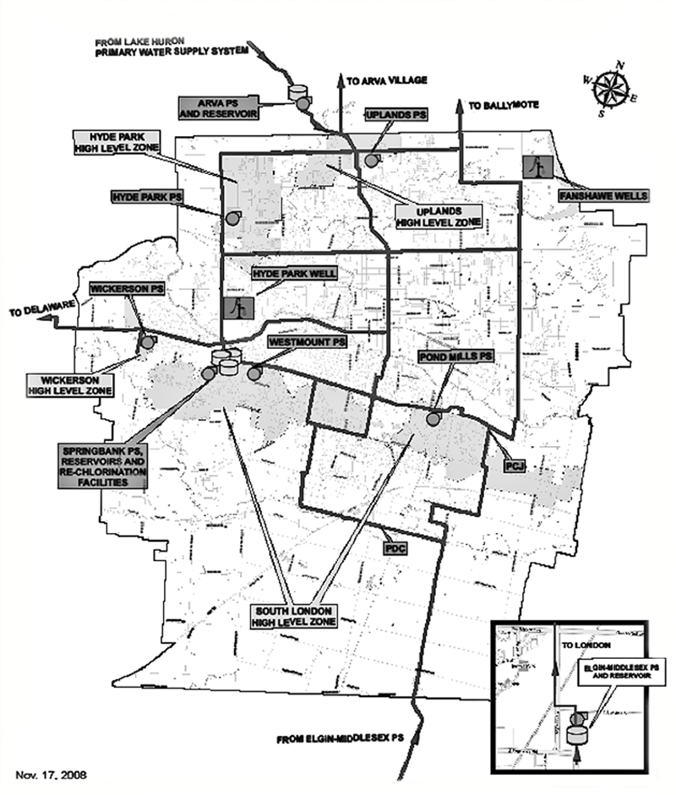

Source: *Water Treatment and Distribution in London: The Teaching Toolkit*, slide 14, City of London, Canada, accessed October 19, 2017, www.london.ca/residents/Water/Teacher-Resources/Pages/Water.aspx. Used with permission.

EXHIBIT 4: Selected Historical Electricity Prices in london (IN CA$)

|  |  |  |
| --- | --- | --- |
| **Date** | **Hour\*** | **HOEP** |
| May 1, 2002 | 0:00 | 22.97 |
| May 1, 2002 | 1:00 | 23.27 |
| May 1, 2002 | 2:00 | 24.54 |
| May 1, 2002 | 3:00 | 15.17 |
| May 1, 2002 | 4:00 | 23.59 |
| … | … | … |
| … | … | … |
| … | … | … |
| May 1, 2002 | 21:00 | 28.93 |
| May 1, 2002 | 22:00 | 27.55 |
| May 1, 2002 | 23:00 | 24.22 |
| May 2, 2002 | 0:00 | 18.75 |
| May 2, 2002 | 1:00 | 18.89 |
| May 2, 2002 | 2:00 | 23.30 |
| May 2, 2002 | 3:00 | 20.56 |
| … | … | … |
| … | … | … |
| … | … | … |
| Dec 31, 2015 | 9:00 | 5.11 |
| Dec 31, 2015 | 10:00 | 5.87 |
| Dec 31, 2015 | 11:00 | 5.91 |
| Dec 31, 2015 | 12:00 | 5.89 |
| Dec 31, 2015 | 13:00 | 5.84 |
| Dec 31, 2015 | 14:00 | 5.77 |
| Dec 31, 2015 | 15:00 | 5.48 |
| Dec 31, 2015 | 16:00 | 7.27 |
| Dec 31, 2015 | 17:00 | 5.89 |
| Dec 31, 2015 | 18:00 | 7.36 |
| Dec 31, 2015 | 19:00 | 4.52 |
| Dec 31, 2015 | 20:00 | 1.29 |
| Dec 31, 2015 | 21:00 | 0 |
| Dec 31, 2015 | 22:00 | 0 |
| Dec 31, 2015 | 23:00 | 0.38 |

Note: * Hour is based on the 24-hour clock where 13 = 1:00 p.m., and so on; HOEP = hourly Ontario electricity price.

Source: Created by the case author based on “Data Directory: Price: Hourly Ontario Energy Price (HOEP),” Independent Electricity System Operator, accessed October 29, 2018, www.ieso.ca/en/Power-Data/Data-Directory.

1. This case has been written on the basis of published sources only. Consequently, the interpretation and perspectives presented in this case are not necessarily those of City of London Water or any of its employees.
2. Tina Soltani is a fictitious name, assumed for the purpose of the case.
3. *Multi-Year Budget for the City of London 2016–2019: Water and Wastewater & Treatment*, draft, City of London, Canada, January 11, 2016, accessed September 17, 2018, www.london.ca/city-hall/budget-business/budget/Documents/2016-2019%20Water%20and%20Wastewater%20Treatment%20Budget.pdf.
4. *Energy Efficiency in Water and Wastewater Facilities*, U.S. Environmental Protection Agency, 2013, accessed January 13, 2019, www.epa.gov/sites/production/files/2015-08/documents/wastewater-guide.pdf.
5. *Multi-Year Budget for the City of London 2016–2019*, op. cit.
6. *London’s Water Supply System: Teacher Resource Notes*, City of London, Canada, accessed September 17, 2018, www.london.ca/residents/Water/Teacher-Resources/Documents/Water/London%27s%20Water%20Supply%20System%20-%20Teacher%20Notes.pdf.
7. “Source Water Protection,” City of London, Canada, accessed October 30, 2018, www.london.ca/residents/Water/Water-Conservation/Pages/Source-Water-Protection.aspx.
8. All currency amounts are shown in CA$.
9. *City of London 2015 Drinking Water Summary Report*, City of London, Canada, February 2016, accessed September 17, 2018, www.london.ca/city-hall/master-plans-reports/reports/Documents/2015%20Summary%20Annual%20Report%2 0Full%20Appendices%20FINAL.pdf.
10. Ibid.
11. Joe Naoum-Sawaya, Bissan Ghaddar, Ernesto Arandia, and Bradley Eck, “Simulation-Optimization Approaches for Water Pump Scheduling and Pipe Replacement Problems,” *European Journal of Operational Research* 246, no. 1 (2015): 293–306, accessed September 17, 2018 www.sciencedirect.com/science/article/pii/S0377221715003215.
12. *Energy Efficiency in Water and Wastewater Facilities*, op. cit.
13. *Toronto 2017 Budget: Operating Program Summary*, City of Toronto, Canada, March 31, 2017, accessed September 17, 2018, www.toronto.ca/wp-content/uploads/2017/12/93eb-FINAL-2017-Toronto-Water-Public-Book-Operating-Progra m-Summary.pdf; *London’s Water Supply System*, City of London, Canada, accessed January 13, 2019,www.london.ca/residents/Water/Water-System/Pages/Water-System.aspx.
14. “Hourly Ontario Energy Price (HOEP),” Independent Electricity System Operator, accessed January 13, 2019 www.ieso.ca/en/Power-Data/Price-Overview/Hourly-Ontario-Energy-Price.
15. *London’s Water Supply System*, op. cit.
16. “Global Adjustment,” Independent Electricity System Operator, accessed January 13, 2019, www.ieso.ca/power-data/price-overview/global-adjustment.