|  |  |
| --- | --- |
|  |  |

9B19E009

DRINKS-UP!: THE PITFALLS OF DIGITAL INNOVATION

Professors Steven Sclarow and Munir Mandviwalla wrote this case solely to provide material for class discussion. The authors do not intend to illustrate either effective or ineffective handling of a managerial situation. The authors may have disguised certain names and other identifying information to protect confidentiality.

This publication may not be transmitted, photocopied, digitized, or otherwise reproduced in any form or by any means without the permission of the copyright holder. Reproduction of this material is not covered under authorization by any reproduction rights organization. To order copies or request permission to reproduce materials, contact Ivey Publishing, Ivey Business School, Western University, London, Ontario, Canada, N6G 0N1; (t) 519.661.3208; (e) cases@ivey.ca; www.iveycases.com. Our goal is to publish materials of the highest quality; submit any errata to publishcases@ivey.ca. i1v2e5y5pubs

Copyright © 2021, Ivey Business School Foundation Version: 2021-10-22

Steve Sclarow sat in a crowded Philadelphia bar sipping cocktails with some friends. It was Saturday, July 16, 2016, and a typical night out in town. However, Sclarow was ignoring the banter; he was preoccupied with digital innovation. Earlier that evening he had shared the Drinks-Up! Inc. (Drinks-Up!) mobile application (app) prototype with friends who were enthusiastic about the concept. His friends, a group of young professionals, thought an app like Drink’s-Up! should already be in widespread use. Sclarow was considering his next move. He had a proposal in-hand from Shah Investors, LLC, a local venture capitalist interested in developing Drinks-Up! In one week, the Drinks-Up! team would have a conference call to review the proposal.

The app prototype was based on Sclarow and his team’s entry into the local university’s Innovative Business Pitch Competition (IBPC) on March 16. Although the entry did not win, the positive feedback the app idea received reinforced the team’s conviction to go ahead with development. Sclarow declared, “The IBPC experience inspired us to pursue our idea with increased determination. We believed that we had a viable digital innovation and, with the right funding, the market was ready for Drinks-Up!” As Sclarow stepped up to patiently wait for his turn to order drinks, he wondered what he should do next.

BACKGROUND

Drinks-Up!—“creating a better bar experience”—was the evolution of an idea Sclarow had developed with Maxx Kauffman, an art director and 18-year veteran of the video gaming industry, while they were living in California in 2012 (see Exhibit 1). Sclarow picked up the project again after joining the local university business school’s executive master of business administration (EMBA) program, which included a capstone requirement focusing on entrepreneurship, in December 2014.

Drinks-Up!, which focused on the digital transformation of the bar experience, was submitted to the IBPC by Sclarow and his classmates Paul Abrams, Chris Casella, and Mike Weiblinger. The IBPC website noted that “this innovative business plan competition encouraged students, alumni, faculty, and staff to discover all aspects of entrepreneurship, networking, and how to write strategic business plans.”[1]

THE DIGITAL INNOVATION

Identifying the Opportunity

Enjoying a cocktail or beer at a bar or nightclub with friends was a favourite American pastime that contributed to a US$26 billion industry.[2] Whether they catered to people going out for happy hour, watching a sporting event, or a just out for a night on the town, the establishments—which varied in size, style, and demographics—all had one thing in common: as soon as they became crowded, ordering, paying for, and picking up drinks was a challenge. Patrons typically resorted to diving into the wave of people congregating around the bar. Once a patron had finished swimming upstream to place their order and leave a credit card, they had to turn around and swim back through the crowd, drinks in hand, to meet their friends. Along the way, they may have inadvertently spilled a drink, bumped someone or been bumped into, and may have forgotten their credit card at the bar. The solution to the problem of navigating the bar scene’s ebb and flow was Drinks-Up! (www.drinks-up.net), a mobile app for ordering drinks.

* **Value Proposition**—**Customer** (the bar): Using the Drinks-Up! app would increase revenue and patronage, enhance efficiency, reduce product waste and staff time, while providing real-time data analytics for inventory management, marketing, and consumer trends.
* **Value Proposition**—**Patron** (the app user): Using the Drinks-Up! app would enhance user experience by providing a simpler and faster way to order drinks.

Market research undertaken to better understand the local demographics showed that the core bar patrons and potential app users were millennials (defined as ages 19 to 35 in 2016): “Philadelphia’s millennial population is increasing fastest among the 10 largest U.S. cities.”[3] An online survey of Philadelphia’s millennial market showed that this group went to bars one to three times per week, with an average spend of $20–$60 (see Exhibit 2).

The Product

Drinks-Up! aimed to transform the traditional bar experience by providing faster and simpler access for customers using smartphones, offering them the following benefits: Employing the app would reduce or eliminate waiting in line as all orders would be submitted digitally. Cashless payment and tipping systems were seamlessly integrated; with credit cards on file, transactions would be simpler and more secure, reducing the threat of identity theft. Customized drink special notifications would be pushed to patrons, who would receive the specials based on their purchase history. Cover-charge discounts and passes would be included. Priority would be given to patrons using the app.

Drinks-Up! would make it easier for the bar to increase revenues, as well as track revenues and expenses by maximizing purchase opportunities during peaks hours and potentially capturing new market share during off-peak hours; it would make it easier for the bar to decrease costs by reducing waste; and it would generate valuable analytics. The app’s phase I capabilities included tracking orders and social sentiments. Bars would be able to create drink specials, advertise upcoming events, and create a rewards program for preferred and repeat customers.

In phase II, the app would analyze patrons’ spending habits and drink preferences and frequency at each location. Drinks-Up! would also integrate social media into the bar experience. For example, if friends were connected to the Drinks-Up! social network, a patron could pay for their friends’ drinks and have them delivered.

Systems Thinking

To understand the core problems of drink ordering and to help explain the value proposition, the team applied the “systems thinking” concept from the EMBA class on information systems. One aspect of systems thinking was identifying the underlying processes involved in a task. The traditional approach to ordering drinks included nine processes (see Exhibit 3): (1) wait in line at the bar, (2) get the bartender’s attention, (3) place the drink order, (4) wait for the bartender to bring drinks, (5) pay for drinks, (6) wait for a receipt or change, (7) leave a tip, (8) pick up drink(s), and (9) return to friends.

The Drinks-Up! system’s model included five processes (see Exhibit 4): (1) find a space in the bar; (2) place a drink order, pay, and tip with Drinks-Up!; (3) within minutes, receive an alert from Drinks-Up! when the drink is ready; (4) pick up drink(s) at a designated bar area; and (5) return to friends.

INDUSTRY

Overview

The bar and nightclub industry in the United States included approximately 69,000 establishments, including single-location companies and branches of multi-location companies, with a combined annual revenue of roughly $26 billion and an annual growth rate of about 1.4 per cent. National companies did not dominate the landscape because varying state and local liquor laws complicated the marketplace.[4] Philadelphia was home to over 1,800 cocktail bars, pubs, and nightclubs.[5] No company appeared to have claimed control over the market, nor was there an application available that dominated the mobile drink ordering space.[6]

Millennials were a digitally connected generation. The average millennial checked their phone 43 times a day, and they had expectations for instant communication and response.[7] According to the IBISWorld [Bar Business and Nightclub Business Industry Report](http://www.ibisworld.com/industry/default.aspx?indid=1685), households with members under age 35 (i.e., ages 21**–**34) spent the greatest percentage of available funds on beer, wine, and liquor—spending from 51**–**58 per cent more than the average household on beer and 66 per cent more than the national average on liquor.[8]

National Market

By 2016, national casual restaurant chains were adopting digital ordering of food and drinks. In 2014, Applebee’s began using E la Carte Inc.’s Presto system, which offered tableside ordering through a tablet- and cloud-based system that interfaced with many point-of-service (POS) systems. Tableside ordering promoted a 30 per cent faster table turn, offered pop-ups for upselling extras, and allowed guests to pay or split bills.[9] Starbucks was an early adopter, releasing its mobile app in January 2011.[10] Ordering was based on store location, and the app provided users with options specific to the venue.

Local Market

Tableside tablet ordering systems were also showing up in Philadelphia. Tria Taproom provided customers with customized iPads to access the bar menu and search beer and wine availability on tap. The Drinks-Up! team researched the Android and iOS app stores and did not identify any active third-party apps for drink ordering in the Philadelphia region. By moving quickly, Drinks-Up! could have a competitive advantage in a concentrated market.

COMPETITIVE LANDSCAPE

**TAPPR:** This app gave users the ability to order drinks from their phones, buy drinks for friends from any location, and check in to let friends know their location; it included a newsfeed about friends. TAPPR provided bar owners with an iPad. The consumer app, which was available on iTunes in 2012, charged a $0.15 service fee on all transactions. Before closing—the app’s last update was March 2013—it was available in 10 locations in the Milwaukee area.[11]

**BarEye:** Based out of Tallahassee, with a heavy emphasis on the college scene, BarEye was a drink-ordering app launched in the fall of 2012. BarEye gave users the ability to buy drinks for friends through Facebook or anyone checked into the bar. BarEye charged bars $200 to use the service, with the goal of franchising the app. A franchisee would manage about 100 bars in a given location.[12]

**Preo:** Originally headquartered in New York City, Preo provided a mobile drink-ordering service similar to TAPPR but provided bars with printers for drink receipts rather than tablets. Preo charged venues a monthly service fee of $24.99 per printer, per month, and a credit card processing fee match. The app was free for customers.[13]

FINANCIALS

The Drinks-Up! team analyzed the pros and cons of these competitors’ business models and eventually settled on a revenue model for the app, based on three growth phases (see Exhibit 5).

In the first phase, it would charge a flat 10 per cent fee on all transactions. This fee would allow Drinks-Up! to apply 3 per cent to cover credit-card processing fees, 1 per cent to sales representative commissions, 1 per cent to marketing costs, and 5 per cent to profit.

In the second phase, it would offer the bar periodic analytics packages. These packages would track utilization and waste and provide real-time data to create efficiencies and reduce par levels. The packages also included strategic marketing campaigns, centred on lower peak periods, which would generate more revenue.

In the third and final phase, it would expand the technology into adjacent areas such as sports and concert venues, as well as restaurants that used a kiosk ordering platform. Because kiosks incurred capital costs and upkeep charges, Drinks-Up! was a more efficient software solution and provided a better experience with significant overhead reduction.

Marketing

Drinks-Up! initially focused on three target bar patron groups. The first group included business professionals who visited bars after the workday for weekday happy hours. The second target group included late-night and weekend customers. This group consisted of customers who spent many hours at the bar to socialize and drink. Lastly, there was the craft-beer connoisseur. This customer group was looking for high-quality craft beers.

Abrams led the marketing vision and created a program that would incentivize new users. For example, the program offered a 10 per cent discount for the first two years. The intent was to create a unique offering to drive interest and increase the frequency of Drinks-Up! purchases and bar patronage.

His plan for attracting bars was to create 20 territories, each with its own sales manager. Together, the sales managers would manage independent contractors and would benefit directly by growing their territories. The sales manager’s primary goal was to create, retain, and grow Drinks-Up! bar patrons’ loyalty. The average bar booked about $200,000 in revenue a year. The proposal to the bars was for the app owners to take 10 per cent of the total revenue booked on the app.

Territory managers would visit their bars, building relationships and gaining commitments to using the app. Bar owners would receive live demonstrations displaying Drinks-Up!’s benefits. Upon commitment, bars would receive an iPad and a Drinks-Up! pick-up station bar mat. A training session would focus on the speed, efficiency, and positive revenue realized—including a projected revenue and tips increase of close to 20 per cent. Bars would be encouraged to dedicate individual bartenders for the Drinks-Up! app. On the night of each launch, territory managers would work the room to encourage patrons to download and try the app.

PROOF OF CONCEPT—PRELIMINARY PROTOTYPE

After some demonstrations and sales conversations, it became clear to the team that they needed a more functional prototype to demonstrate proof-of-concept and highlight the hassle-free ordering process. However, development costs and ease and speed of use quickly became primary constraints. After reviewing various options, the team selected iBuildApp.com to create the prototype. iBuildApp offered free app templates and provided a platform for iOS and Android implementation (see Exhibit 6 for screenshots of the prototype.)

DEVELOPMENT AND THE OFFER

Development

The IBPC feedback was positive, and the team was committed, so the next step was to form a company and explore options to build the app.

Forming the company was remarkably straightforward. Sclarow and Abrams were concerned about legal protection of the Drinks-Up! concept and brand, and they learned that the most effective path to protection was to create a corporation. Their research led them to LegalZoom.com Inc. (LegalZoom), which, according to Sclarow, was “not that expensive and provides us with protection. The LegalZoom economy package is only $310.” The team agreed, and Abrams submitted the appropriate documentation to LegalZoom and established Drinks-Up! Inc. as a Pennsylvania corporation on March 8, 2016. Casella left the team shortly after graduation to focus on his family and full-time career. Sclarow, Abrams, and Weiblinger eagerly took the reins of Drinks-Up! and set out to build the app.

The Drinks-Up! team did not have the technical capabilities to develop the app and its underlying infrastructure, so they contacted various developers, including GeekyAnts Software Pvt. Ltd.[14] and Chariot Solutions LLC[15] for initial consultations and quotes. Preliminary pricing ranged from $30,000 to $100,000 with a turnaround time of 12–48 weeks. Said Sclarow, “The sticker shock caught us by surprise as well as the wide variance in quotes. Our initial hope was a budget of about $20,000–$25,000. We were unwilling to spend $100,000, so we decided to tap into our university network for guidance and looked to hire student workers.”

The team contacted Munir Mandviwalla, who reviewed the plan and responded, “Your cost will be higher than normal, and this will be a more difficult app than typical. This is because you will need both ease of use AND high-speed responsiveness. The app will need to work well in a high-traffic, high-transaction environment. This means custom work by experienced developers, not students.”

This guidance made sense to the team, but it also left them in a quandary about how to proceed. What was the digital innovation here—the idea or the development? Even if they invested in the initial development, how would they design and envision the next version?

Initial Meeting with an Angel Investor

On Monday, July 11, 2016, Sclarow received a text from Lars Handago, a fellow student in the EMBA program. Handago had recently signed on with an angel investor to develop his own app idea and was eager for Sclarow to meet his investor, Sadeeq Shah. Sclarow immediately called his business partners, Abrams and Weiblinger, to tell them about this potential opportunity. This was especially exciting because Shah was also offering to build the app. Was an angel investment the key to building and launching the app? How much time and “sweat equity” was this really going to take? While sitting in the Uber with Handago on the way to meet Shah, Sclarow practiced his “elevator pitch” and pondered “what if?” scenarios.

Sclarow and Handago walked into West Philadelphia’s Aloosh Hookah Bar & Restaurant and found Shah at a corner table surrounded by his associates. Handago greeted Shah with a big bear hug. Moments later, Shah flagged down a server and ordered a round of cocktails. After meeting the rest of the party, Sclarow used the bar’s delay in drink delivery to speak about Drinks-Up!

Sclarow presented his pitch and showed Shah the prototype. Shah expressed interest in learning more. Over the second round of drinks, Shah discussed his own start-up success and told them that he was now in the business of finding and investing in new digital innovations. It was nearing 11:00 p.m., and another round of drink orders was underway. It was getting late, and Sclarow had to leave—it was a weeknight, after all. Sclarow refused to let Shah pay for drinks and left more than enough cash to cover the two rounds. Sclarow was eager to get home and talk to his partners about the night’s meeting.

Conference Call

The Drinks-Up! team spoke that evening and decided to schedule a call with Shah for Wednesday, July 13, 2016. The call was brief and productive; the Drinks-Up! team outlined their plans and the immediate goal of developing a working app. Shah’s enthusiasm was clear, and he ended the call with a promise to submit a proposal the following day.

The Proposal

After months of research, cold calls, and correspondence with developers and potential investors (see Exhibit 7), the Drinks-Up! team received a proposal on Thursday afternoon, July 14, 2016. The proposal included a plan for app development and a partnership opportunity from Shah’s company, Shah Investors, LLC (see Exhibits 8 and 9). The team discussed the proposal extensively, revisiting the expert feedback they had received over the past few months. The conversation focused on three strategic questions: Was this the right option to develop Drinks-Up!? If not, how much time and “sweat equity” was this really going to take? Was Drinks-Up! truly a disruptive innovation that was worth the risk?

EXHIBIT 1: INITIAL CONCEPT CORRESPONDENCE WITH MAXX KAUFMAN

Steve Sclarow <x@gmail.com> Fri, Aug 31, 2012 at 8:57 PM

To: Maxx Kaufman <x@gmail.com>

Maxx,

It was great seeing you Tuesday night and thanks again for getting the first round.

I've been giving lots of thought to the bar/nightclub app we've been discussing and wanted to outline some ideas for our meeting next week. Listed below are a few application name ideas:

idrink

drinksup

mydrink

lastcall

myround

I did a little bit of research and these domain names are mostly taken, but that doesn’t necessarily mean we couldn’t use some iteration for an app. We still need to find out how the order gets sent to the bartender. My idea for drink delivery is that there are designated pick-up stations for the person ordering to go and grab their drink(s). Payment would be made through a PayPal or credit card account when the order is placed. What do you think the app should cost if at all? Maybe we should get a cut of each drink ordered. I also think that drink orders should include the bartender’s tip in the cost of the drink; this would eliminate wait staff reluctance to work with the app.

Listed below are two articles for similar products:

http://consumerist.com/2010/09/phillies-fans-order-food-delivery-from-your-seat-with-iphone-app.html

http://www.businessweek.com/articles/2012-05-01/may-the-tablet-take-your-order

I look forward to getting together next week to discuss the app.

Have a great weekend in Las Vegas!

Steve

Steven E. Sclarow, AIA

Maxx Kaufman <x@gmail.com> Wed, Sep 5, 2012 at 12:31 PM

To: Steve Sclarow x@gmail.com

Hey Steve,

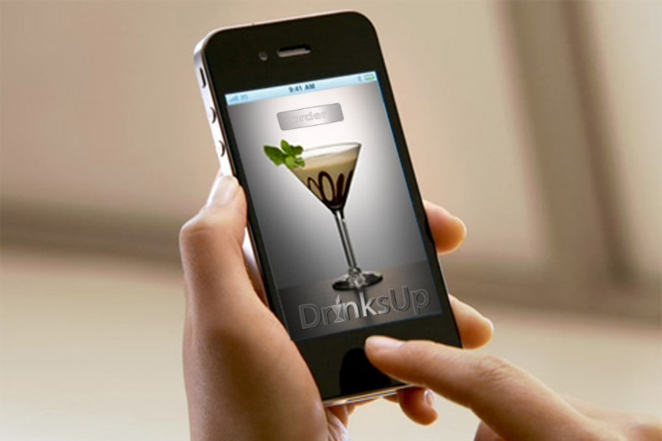I have been slammed. I like the names.

DrinksUp is cool.

What do you think the app should cost if at all? This is a tough question for an app like this. I think it should be free for the first couple of months with a small customization cost. Then after two months it should be a flat monthly fee?? but not expensive we should go for volume.

We need to make it where they will see the need and try it. We need to really sell it as a service where they can be more efficient and sell more drinks. If it is cost effective it will be easy for them to justify having the system plus we could advertise on the app to add to our revenue.

Very very quick mockup

Source: Company files.

EXHIBIT 2: MARKET-RESEARCH SURVEY

Drinks-Up! conducted a market-research survey utilizing SurveyMonkey to learn more about the 21–34-year-old millennial market in Philadelphia. The millennials we surveyed were going to bars an average of one to three times per week, and we obtained the following data:

|  |
| --- |
|  |
| Nightly Spending |
|  |
| Payment Methods |
|  |
| Payment Problems |

Source: Company files.

EXHIBIT 3: TRADITIONAL FLOW

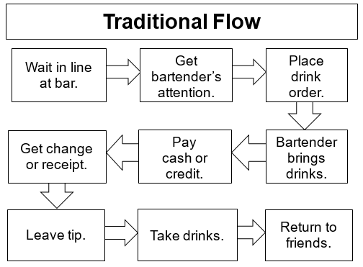

Source: Company files.

EXHIBIT 4: SYSTEMS THINKING FLOW

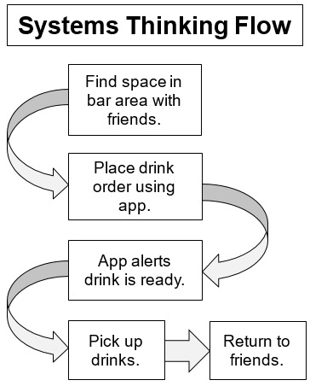

Source: Company files.

EXHIBIT 5: PROPOSED PROFIT AND LOSS

Source: Company files.

EXHIBIT 6: iBuildApP DRINKS-UP! PROTOTYPE

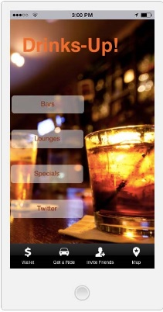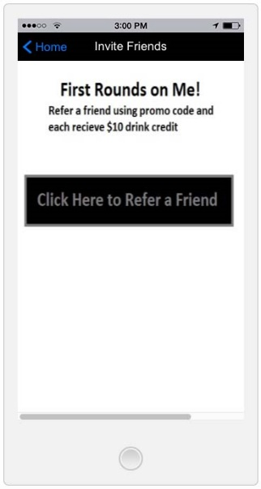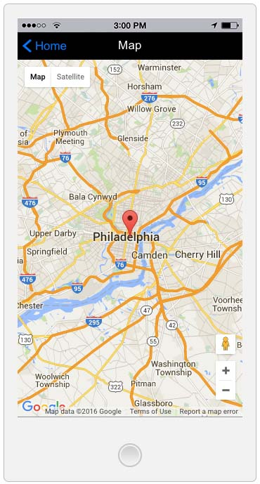

Source: Company files.

EXHIBIT 7: EXCERPTS FROM THE DRINKS-UP! TEAM’S E-MAIL CORRESPONDENCE

06/17/2016

Good afternoon Tracey,

My name is Steve Sclarow, and I received your contact information from Ellen Weber at the local university. I recently competed in the IBPC and graduated from the EMBA program at the Reynard School of Business.

My IBPC team created an app called Drinks-Up!, a new app that enhances your bar experience by providing *hassle-free* drink ordering, connecting you, the bar and your friends: <http://www.drinks-up.net/index.html>.

We would like to set up a time to speak with you about our Drinks-Up! app and learn more about Chariot Solutions. What is your availability on Monday for a brief introductory call?

06/23/2016

Notes from Chariot Solutions call with Grant and Don:

Develop an app for iOS & Android utilizing Cordova (https://cordova.apache.org/) open source coding.

They will work on a T&M basis. The fee structure is as follows:

$26k/month for one developer

The rates are as follows:

Two developers for two months minimum

Anticipated initial cost of $100–125k for the first 2–3 months

08/06/2016

Hi Paul,

Thanks for the writeup. The idea sounds interesting! We’ve some experience with online ordering and POS systems. Let me show you two quick examples of our past work”

PosCore: <http://www.poscore.co.uk/>

A complete restaurant management app for the web, tablet, and mobile devices, which had Kitchen View (along with printing options), Waiter View, and the User’s View.

We also developed the complete UX of a very similar app like Drinks-Up. You can play with the prototype here: <http://pos-planning.sahusoft.info/app>.

For the Drinks-Up app, just to give you a ballpark—Considering we will build the Kitchen View, User’s View app, and an Admin center to build the menu, manage meta data, and many other things, it may take up to 12–18 weeks, and it would cost around $20,000 to $35,000.

We can reach to a more accurate cost only after going through some rounds of discussion and deciding on the features needed. Few quick questions I can think of include

How would users login to the system? Using Facebook or using their number + SMS verification?

How would the users pay? Using credit card or any other option?

Would the Kitchen View tablet app involve docket printing?

Do we need coupons and related e-commerce features?

How are we going to handle invoices and payment receipts? Would it have discounts and tax calculations?

For the menu builder, would you add sub-menu items, combo offers, categories, etc.?

I usually recommend getting the designs or at least wireframes (proto.io is a good option) first, before getting started on building apps like this.

Let me know your thoughts.

Best, Sanket

Source: Company files.

EXHIBIT 8: SUBMISSION OF PROPOSAL EMAIL FROM Shah

July 14, 2016

Hey Team,

Pleasure chatting yesterday. Attached please find the proposal for this partnership.

After looking into what I can provide further, I think this is a perfect partnership opportunity. I mentioned my relationships to the different alcohol brands previously. In addition to this I would be able to provide access to NBA games/venues—if this works I can use that success to get us into NFL as well.

As for bars and nightlife in the Philadelphia area (assuming this is where you would like to start), I can place a few dedicated staff on this task. They would go out to all the potential bars and partner with them on DrinksUp’s behalf.

I have relationships at Rumor, 1925, Fillmore, and the D&B in Philadelphia—just to name a few.

From a business perspective, SI can assist with branding, basic marketing (flyers, brochures, etc.), and relationship management.

For this to be done correctly, I think it is vital for the first run of the app to be as close to flawless as possible, therefore for me to get involved I would want my team to develop the app as I have the most control over this process getting it done internally as opposed to a third party.

That being said, I’d be willing to structure this in a few different ways. If I am bringing this network of bars and other venues on board, I would want royalty and equity in addition to the cost of development. As you can see from the proposal, I’m willing to do different combinations of equity and royalty—that ratio is negotiable.

I believe DrinksUp has immense potential if executed properly. The two things that will kill this concept are a poorly developed app, or a lack of scalability in terms of venues. I think I can play a valuable role in the growth of DrinksUp and would love to help.

At this time, it may be best for your team to discuss the proposal and set up a call for this weekend to see if this makes sense from your end.

Let me know,

Sadeeq Shah

Source: Company files.

EXHIBIT 9: THE PROPOSAL

Shah Investors, LLC

One Penn Center

Philadelphia, PA

O: 215-555-1234

Drinks-Up! App proposal

Company: Shah Investors Apps

Prepared for: Drinks-Up! team

Prepared by: Sadeeq Shah

Date: 7/14/16

High Level Goals:

Develop interactive mobile app that allows bar customers to order drinks through their smartphones and pick up the prepaid drinks at a designated space at the bar.

Develop user-friendly static site to engage new venues for partnership.

Create partnerships with bars to utilize app (SV dedicated staff).

Assist in acquiring users for app (SV dedicated staff).

Timeline:

Week 1: Correspondence between front-end designers and Drinks-Up! team to flush out designs

Week 1–2: Create cohesive SOW document detailing all features and options in the app

Week 2–6: Backend development

Week 6–8: Deployment to stores

Week 8–10: User acquisition

Costs:

Mobile app development: $90,000

User acquisition and venue relationship:

$5,000/month + 20% royalty from profits per venue and 2% equity on reaching $10k/month revenue

Or

Mobile app development: $90,000

User acquisition and venue relationship:

$3,000/month + 10% equity

Source: Company files.

1. Temple University Fox School of Business, “Be Your Own Boss Bowl Roadmap,” accessed May 3, 2018, www.fox.temple.edu/institutes-and-centers/innovation-entrepreneurship-institute/competitions/be-your-own-boss-bowl/be-your-own-boss-bowl-roadmap/.
2. American Nightlife Association, “We Are the Voice of the Industry,” accessed March 31, 2018, www.nciaa.com/content.aspx?page_id=22&club_id=160641&module_id=29898. All currency amounts are in US dollars.
3. Yueqi Yang, “Philly’s Millennial Population Growing Fastest Among 10 Largest U.S. Cities,” *Philadelphia Magazine*, November 2, 2015, accessed March 31, 2018, www.phillymag.com/business/2015/11/02/philly-millennial-population/.
4. American Nightlife Association, “Our Industry—Facts at a Glance: U.S. Bar & Nightclub Industry,” accessed March 31, 2018, www.nciaa.com/content.aspx?page_id=22&club_id=160641&module_id=29898.
5. Mark Dent, “Philly Bar Index: Do We have More Nightlife than Other Major Cities?,” BillyPenn, May 24, 2017, accessed March 31, 2018, https://billypenn.com/2017/05/24/philly-bar-index-do-we-have-more-nightlife-than-other-major-cities/.
6. Andrew Kramer, “App Used In Some Philly Bars Aims to Expedite Drink Ordering,” 3CBSPhilly, August 5, 2016, accessed March 31, 2018, https://philadelphia.cbslocal.com/2016/08/05/app-philly-bars-expedite-drink-ordering/.
7. Catherine Clifford, “Millennials Check Their Phones 43 Times a Day. This Is What They’re Looking For. (Infographic),” Entrepreneur, June 4, 2014, accessed May 3, 2019, www.entrepreneur.com/article/234531.
8. Small Business Development Center, “Bar Business,” SBDCNet, April 4, 2012, accessed March 31, 2018, www.sbdcnet.org/small-business-research-reports/bar-business-2012.
9. Matt McCue, “E La Carte,” *Fast Company*, February 9, 2015, accessed March 31, 2018, www.fastcompany.com/3039577/e-la-carte.
10. Maggie McGrath, “Starbucks Mobile Orders Grow, But Not Enough to Lift Q1 Sales above Expectations,” *Forbes*, January 26, 2017, accessed March 31, 2018, www.forbes.com/sites/maggiemcgrath/2017/01/26/starbucks-mobile-orders-grow-but-not-enough-to-lift-q1-sales-above-expectations/#64b1709a37a1.
11. Rick Rommel, “App Tries to Tap Bar Patrons’ Thirst for Drinks,” *Milwaukee* *Journal Sentinel*, June 11, 2012, accessed March 31, 2018, http://archive.jsonline.com/business/app-tries-to-tap-bar-patrons-thirst-for-drinks-rl5n8a8-158491555.html.
12. Stephanie Yang, “BarEye App Lets You Buy and Send Drinks from Your Phone,” TechCrunch, July 25, 2013, accessed March 31, 2018, https://techcrunch.com/2013/07/25/bareye-app-lets-you-buy-and-send-drinks-from-your-phone.
13. “Overview,” Preo, accessed March 31, 2018, www.f6s.com/preo.
14. GeekyAnts website, accessed June 17, 2019, https://www.geekyants.com/.
15. Chariot Solutions website, accessed June 17, 2019, https://chariotsolutions.com/.