

9B19E010

Xoxoday.com: Customer Engagement through Social Media

Sana Ansari, Sumeet Gupta, and Manojit Chattopadhyay wrote this case solely to provide material for class discussion. The authors do not intend to illustrate either effective or ineffective handling of a managerial situation. The authors may have disguised certain names and other identifying information to protect confidentiality.

This publication may not be transmitted, photocopied, digitized, or otherwise reproduced in any form or by any means without the permission of the copyright holder. Reproduction of this material is not covered under authorization by any reproduction rights organization. To order copies or request permission to reproduce materials, contact Ivey Publishing, Ivey Business School, Western University, London, Ontario, Canada, N6G 0N1; (t) 519.661.3208; (e) cases@ivey.ca; www.iveycases.com. Our goal is to publish materials of the highest quality; submit any errata to publishcases@ivey.ca. i1v2e5y5pubs

Copyright © 2019, Ivey Business School Foundation Version: 2019-07-04

Xoxoday.com (Xoxoday), a ₹400 million[1] company, had built a good reputation among its corporate customers, as about 60 per cent of its business came from repeat clients. On April 2, 2016, the online Bengaluru-based experiential gifting start-up celebrated its fourth successful running year. Everyone on the Xoxoday team was ecstatic about the achievement—everyone except Kushal Agrawal, one of the company’s co-founders. Agrawal was worried about Xoxoday’s customer acquisition team, which was having a hard time attracting new customers to its existing experiences portfolio, making it difficult for the company to achieve its target of becoming a ₹1 billion company.

Four years earlier, Agrawal and his team had founded Xoxoday and given social and group gifting a new direction by allowing the corporate world to redefine employee rewards. Since its inception, the company had been successful in developing sophisticated technology platforms, which had helped Xoxoday delve into the gifting space. Later, after experimenting with corporate gifting, Xoxoday finally ventured into experiential gifting with the vision of enriching customers’ lives through experiences. Experience gifting involved gifting people experiences and helping them to build memories. The company secured US$150,000 in funding from Mumbai-based angel investment firm Kshatriya Ventures and US$460,000 in funding from the Mahindra Group. Thus far, the company platform and concept implementation had gone well.

However, making the company’s vision of enriching people’s lives through experiences and activities a reality was proving to be difficult. Although Xoxoday had performed extremely well in the social gifting sector, the experiential gifting sector was difficult to redefine. With social gifting, the company had converted offline ways of gifting into a technology-driven business. The Xoxoday team wondered how it could build a marketplace that would attract people seeking experiences and activities.

The customer acquisition team could not fathom why, despite being extremely active on all popular social networking sites, they were unable to attract new customers. Manoj Gupta, head of Xoxoday’s customer acquisition team, called the company’s founders for a meeting to figure out the reason behind their poor acquisition rates. The team had found that their activities on social networking sites were receiving poorer responses than expected. This made the team ponder the effectiveness of social networking sites for its brand. The meeting, however, did not reach any conclusions. Instead, it left them wondering about what changes they would need to make to their existing social media plan to attract new customers.

Social Media: A Marketing Channel

The world’s largest taxi aggregator, Uber Technologies Inc., did not own a single cab. Similarly, the world’s largest accommodation provider, Airbnb Inc., did not own any real estate. And there were many others that had adopted this new approach, referred to as a platform-based business model. India, too, had witnessed a number of start-ups following this business model. For instance, India’s largest platform for finding doctors, Practo, did not own any hospitals or clinics. This platform-based business model provided consumers and producers a digital means to connect and exchange products or services or both without owning (or by only partially owning) production units. As such, consumers and producers were able to leverage the opportunity of the network that was present in the real world. The traditional approach used for doing business was a pipeline-based model, wherein companies owned all the production units and inventory. Products and services were pushed to the customers, who stood at the other end of the pipe, for consumption. A number of traditional companies such as Nike Inc. (Nike) and Deere & Company had made the transition from pipeline-based models to platform-based models.

Almost all companies—from pipeline-based to platform-based—had a presence on social media. The term “social media”was coined as recently as 2005, although its glimpses knocked the doors back in the late 1950s[2] when Bruce and Susan Abelson created an application called Open Diary. One of the first social networking sites, Open Diary allowed diary writers to exchange ideas and collaborate. This application opened avenues for others, from discussion platforms such as Usenet (1979) to the more accessible and popular Facebook (2004) and Twitter (2005).

Blogs, virtual game worlds, collaborative communities, social networking sites, and content collaboration communities all fell under the umbrella of social media. With the advent of Web 2.0, the world witnessed a change in marketing strategies: Companies turned to social media as a marketing medium, as it easily and directly allowed them to reach out to their customers and competitors. Companies mainly focused on social networking sites (e.g., Facebook and Google+), photo-sharing sites (e.g., Instagram), micro blogs (e.g., Twitter), video-sharing sites (e.g., YouTube), communication media (e.g., WhatsApp Messenger [WhatsApp]), and personalized blogs (e.g., WordPress) for marketing their products and services.

Traditional companies such as Nike, Tata Motors Limited (Tata Motors), and Dell currently had a presence on all leading social networking sites, including Facebook, Twitter, and YouTube for marketing their products and generating brand awareness and excitement among consumers. All of these companies had their own fan pages on Facebook, handle on Twitter, and video channel on YouTube. Nike, for instance, apart from traditional marketing (e.g., billboards, television advertising, and providing sponsorships), tried to captivate customers by creating engaging and relevant content on social media. In 2016, Nike had 6.79 million followers on Twitter. Similarly, the Coca-Cola Company also actively participated on numerous social media platforms and had a network of 1,028,360 likes on Facebook, 822,244 followers on Twitter, and 22,063 followers on Instagram.[3] Indian automobile manufacturer Tata Motors also used social media for creating buzz around its cars: for instance, it launched its new Tata Tigor on Twitter with the hashtag #Tigor.[4]

Newer companies, on the other hand, used a platform-based approach and had had an established social media presence since their inception. Social media remained these start-up companies’ first choice because of its large network reach and cost-effectiveness. These companies used social media for many reasons, including establishing themselves in the market, providing immediate customer service and real-time feedback, building community, reaching out to industry pioneers, marketing products, and providing personalized offers. Some even used social media as an employee recognition platform. Having a social media presence allowed companies to form an actionable customer network. Relevant content and timely posts or tweets gave newer companies an opportunity to create future business benefits.

Even though social media was an advantageous and powerful marketing tool, companies had to be conscious of both its power and potential drawbacks. Though social media platforms allowed people to connect with a larger audience, this larger audience—which encompassed users from all over the globe—could now connect and share any unflattering story about the company or its personnel. Such unflattering or negative stories or feedback could do irreversible damage to the business. Although a quick and immediate response could minimize the damage, the communication trail could not be erased from the company’s social media pages. Setting up a presence on multiple social media platforms required minimal effort; however, gaining customers and reaping the full benefits required an investment of both time and effort. A passive Facebook page or Twitter account could not pull customers in to engage with a company’s products or services. Further, a Facebook post or a Twitter tweet broadcasted to all page or handle followers could only reach target customers that had already decided to follow these pages, rather than potential customers who had not yet heard of the company. Therefore, companies using social media as a marketing tool had to channel their resources to embrace social media effectively.

Xoxoday.com: The online gifting market

In 2012, Agrawal, along with three other budding entrepreneurs—Sumit Khandelwal, Manoj Agarwal, and Abhishek Kumar—founded Nreach Online Services Pvt. Ltd., formerly known as Giftxoxo.com and Frogo. In 2016, the start-up was renamed Xoxoday.com. It started its journey as a corporate gifting solution provider, allowing corporations to place bulk gifting orders. Xoxoday successfully procured gifts from its suppliers and fulfilled orders. The company successfully tied up with 300 leading brands, which provided gift vouchers. Gift vouchers were in heavy demand from corporations for rewarding their employees.

However, in late 2013, the founding members became dissatisfied, as they were unable to create any tangible value proposition. They expanded into the experiential gifting category and rebranded themselves as a memory-building company, with the aim to provide customers with the best gifting solutions.

Xoxoday took advantage of their existing corporate customers, who created demand for bulk gift vouchers, and tried to convert them into experience customers. Through its matching platform, Xoxoday brought together customers who wished to live an experience with suppliers who could help fulfill such an experience.

Xoxoday was in the space of discovering unique and offbeat experiences. These experiences were purchased by various people for various purposes, such as personal gifting, employee rewards, hotel concierge travel services, tourism, and celebrating special occasions.

In 2016, Xoxoday offered more than 10,000 unique experiences encompassing India, the United States, and the United Arab Emirates. It had a website (Xoxoday.com), a mobile app called Xoxoday, and a software application programming interface enterprise for travel agents and corporate gifting. Catering to both the business-to-business and business-to-consumer segments, the company looked forward to increasing its customer base and had set its target at US$15.5 million in revenue by the end of fiscal year 2017.

Using social media, Xoxoday tried to attract customers toward its offerings. The company was active on Twitter, Facebook, LinkedIn, YouTube, and WhatsApp and posted an average of three tweets per day. In April 2016, Xoxoday had 3,826 followers on Twitter[5] and 158,086 likes on its Facebook page.[6] However, its messages were not eliciting the consumer reactions Xoxoday expected, and the company was worried about the usefulness of these social media platforms for customer engagement (see Exhibit 1).

The Road Ahead

Later in the evening, while returning home, Agrawal received a call from Alok Kumar, his old school friend. Sensing anxiety in Agrawal’s voice, Kumar inquired about the matter. After listening to Agrawal’s concerns, Kumar advised his friend to use social network analysis for understanding the root cause. Kumar was not an expert in the field, but offered to help Agrawal better understand the customer acquisition issue Xoxoday was having with social media. Agrawal excitedly scheduled a meeting with Kumar for 10 a.m. the following day.

While meeting with the Xoxoday customer acquisition team, Kumar explained:

It is extremely important for the company to connect with customers with the right amount of information and content. In fact, I read in a survey by Advertising Age India that social media today plays an important role in influencing people’s purchase behaviour.[7] I think we need to check the pulse of customers on Xoxoday social media pages through social network analysis. Through this, we will try to find out information reception pattern of the customers.

The members of the team seemed satisfied with the explanation and agreed to try social network analysis for solving the issue of customer acquisition.

Kumar and and the customer acquisition team focused on Twitter, the simplest social networking site, where Xoxoday broadcasted experiences and contest alerts. Kumar retrieved tweets related to Xoxoday’s Twitter handle for the last two weeks.

Before proceeding with the analysis, Kumar briefed the team on social network analysis:

Social network analysis studies social relations among a bunch of actors. It helps in analyzing a social network and its structure. Nowadays, social network analysis helps in analysing the spread of behaviour, finding influencers of information, and in information diffusion.

A social network depicts the relationship between actors. Actors in a network are depicted by a point called a node, which can be an individual, a tweet ID, a user ID, firms, hashtag or even chimpanzees. The relationship between two nodes is represented using a line called an edge or a tie, which can be, for example, a working relationship, a business tie, friendship tie or even an animosity tie. This relationship between actors can be either unidirectional or bidirectional. Networks representing unidirectional relationship are directed networks, whereas a network representing bidirectional relationships are undirected networks. An undirected network means if I have a business tie with you then you too have a business tie with me, this infers that both the actors are equally involved in the tie formation. On the other hand, a directed network means I don’t prefer to work with another person; this doesn’t mean the other person too is not interested in working with me. Here there is a unidirectional relationship and it is asymmetrical.

Let me give an example. If A likes B, A likes C. In both the relationships A, B, and C are actors or nodes, and “likes” depict the relationship between these actors. In this case, the network formed will have three nodes as A, B, and C, and an edge forms by starting from A and directing towards B. While another edge will connect A and C. Here the graph formed will be a directed network. A network is a collection of such graphs.

The type of the node and edge is decided based on the problem we have to solve. Researchers, while studying a social network, consider any of the three things: the relationship between two actors (dyad relationship), nodes (individual level), or structure of the network (structure level).

Kumar’s words clarified the network structure and its components, but the team was still puzzled by the directionality of the ties between the nodes and how they would interpret the graph through visualization—apart from the nodes and their relationships.

Kumar further clarified:

Just as statistics have metrics such as mean, median, [and] variance[,] which help us to make sense out of data, social network analysis too has metrics for network analysis. I will start with the basic network measures, the degree centrality. The degree is the number of direct ties an actor/node has with other actors. The greater . . . the number of ties an actor has, the greater . . . his/her power in the network. In the case of the undirected network, all actors differ only in the number of ties/connections they have. However, in a directed network, actors differ on the basis of ties received (indegree centrality) and out ties (outdegree centrality).

Let me explain in terms of [a] social networking site . . . If I receive friend requests from all five of you, then I have indegree centrality of five. However, if I send friend requests to two of you[,] then I have outdegree as two. Actors are prominent in the network if they have higher indegree centrality, that is, . . . [a greater] number of ties are directed towards them. Those actors, who reach more people, are said to be more influential. Influential people display higher outdegree centrality. The second measure is closeness centrality. This centrality provides answers to the question . . . [of] why somebody is powerful. It tells about the total distance between one person and all other persons in the network[,] where larger distance defines [a] lower closeness centrality score. The last basic network measure is betweenness centrality. Betweenness centrality rests on the fact that the person is most central on the network if the actor is crucially important as an intermediator in the network. It defines the information controllability power of an actor. [I have emailed all of you the] calculation and mathematical explanation of all the three centrality approaches [(see Exhibit 2)].

Decisions Ahead

Agrawal’s team, had many decisions ahead of them, but the major one involved whether Xoxoday should continue to use its existing social media plan. If not, what changes needed to be made to acquire new customers? Other decisions involved measures for analyzing the retweet network to further enhance the social media plan.

Exhibit 1: Tweets by Xoxoday.com

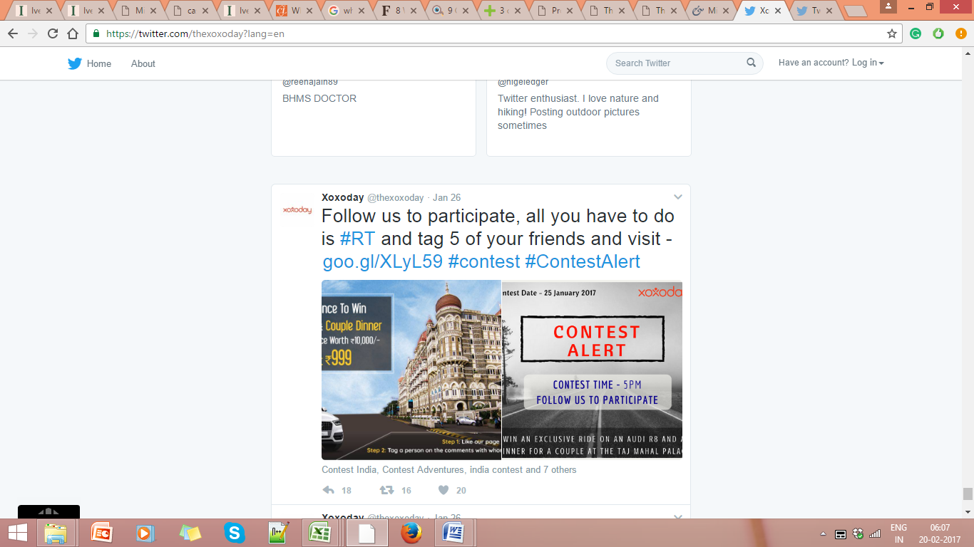

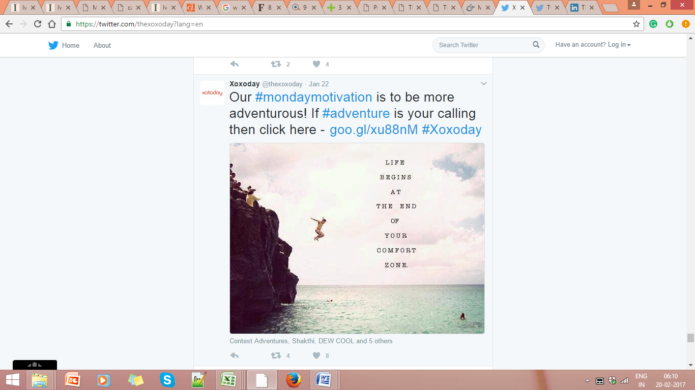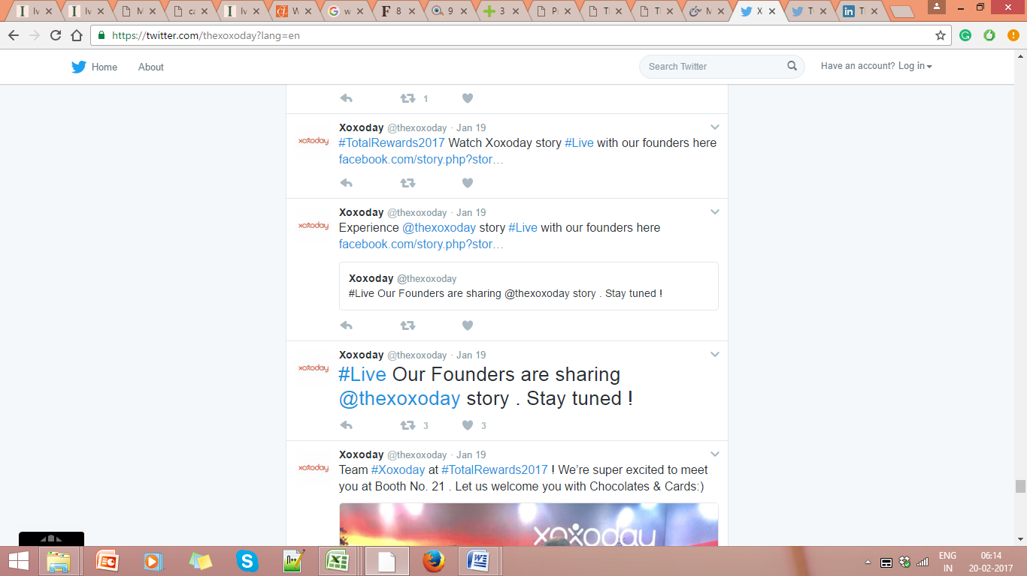

Source: Xoxoday (@thexoxoday), Twitter page, accessed January 27, 2017, <https://twitter.com/thexoxoday?lang=en>.

Exhibit 2: Centrality measures in social NETWORKS

**xyin.pdf xyout.pdf xybet.pdf xyclose.pdf**

Betweenness centrality

Outdegree

Closeness

Indegree

Definition, Application, and Mathematical Formulae of Different Centrality Measures

|  |  |  |  |  |
| --- | --- | --- | --- | --- |
| **Measure** | **Definition** | **Node-Level Calculation** | **Normalized Centralities** | **Application** |
| Degree | Number of adjacent nodes | *CD*(*i*) = )  Where  if nodes *i* and *k* are connected by a line, else 0 | Where  *N* = number of nodes in the network  = degree of node *i*  = normalized degree centrality of a network | Used when one is concerned with communication activity |
| Betweenness | Betweenness for a node is the number of shortest paths that pass through the node | Where  = betweenness of node *i*  = paths between nodes *j* and k that pass through node *i*  = all paths between nodes *j* and *k* | Where  *n* = number of nodes in the network  = betweenness of node *i*  = normalized betweenness centrality of node *i* | Used when one is concerned with who controls the information or when interested in finding out the shortest path for information flow. |
| Closeness | Length of average shortest path between a node and all other nodes present in the graph | Where  = closeness of node *i*  *d*(*i, j*) = number of lines linking nodes *i* and *j* | Where  = normalized closeness centrality of node *A*  *d*(*A, j*) = number of lines linking nodes *A* and *j*  *N* = number of nodes in a network | Used when one is concerned with efficiency and reach of the information |

Source: Prepared by the authors.

1. ₹ = INR = Indian rupee; US$1 = ₹66.2300 on April 2, 2016; all currency amounts are in ₹ unless otherwise specified.
2. Adapted from Andreas M. Kaplan and Michael Haenlein, “Users of the World, Unite! The Challenges and Opportunities of Social Media,” *Business Horizons* 53, no. 1 (2010): 59–68.
3. “Coca-Cola Journey,” The Coca-Cola Company, accessed February 16, 2017, www.coca-colacompany.com.
4. Tata Motors (@TataMotors), “#Tigor: A youthful mix of design, style, attitude meant for confident individuals who express themselves uniquely. Play for pronunciation,” Twitter tweet, February 10, 2017, https://twitter.com/TataMotors/status/830064484307853312.
5. Xoxoday (@thexoxoday), Twitter page, accessed January 27, 2017, https://twitter.com/thexoxoday?lang=en.
6. Xoxoday, Facebook page, accessed February 16, 2017, https://www.facebook.com/pg/thexoxoday/likes/.
7. Jennifer Sikora, “What the Changing Role of Social-Media Influence Means for Brands,” Ad Age, March 11, 2015, accessed February 4,2017, http://adage.com/article/digitalnext/tv-s-influence-consumer-behavior-decreases/297501/.