9B19E021

MTS: Strategies for Managing Social Media Platforms

Professor Yasser Rahrovani wrote this case solely to provide material for class discussion. The author does not intend to illustrate either effective or ineffective handling of a managerial situation. The author may have disguised certain names and other identifying information to protect confidentiality.

This publication may not be transmitted, photocopied, digitized, or otherwise reproduced in any form or by any means without the permission of the copyright holder. Reproduction of this material is not covered under authorization by any reproduction rights organization. To order copies or request permission to reproduce materials, contact Ivey Publishing, Ivey Business School, Western University, London, Ontario, Canada, N6G 0N1; (t) 519.661.3208; (e) cases@ivey.ca; www.iveycases.com. Our goal is to publish materials of the highest quality; submit any errata to publishcases@ivey.ca. i1v2e5y5pubs

Copyright © 2023, Ivey Business School Foundation Version: 2023-10-19

On a Thursday evening in Montreal, Quebec, in January 2016, Hashim Fadak was preparing a presentation for a directors meeting of the Montreal Toheed Society (MTS), a not-for-profit community-based organization of Iranian academics. Fadak had been a member of MTS since its founding, and in 2013 was entrusted as social media administrator and simultaneously as a director on the board. For the previous three years, MTS had used a digital platform to complement its community in-person activities, communicate, and enrich member experience.

In 2013, Fadak created a group within JomSocial, a social media platform, and two years later transitioned the community to the Viber Platform (owned by Rakuten Viber). Fadak, and the rest of the directors, were considering the limitations of Viber and decided that MTS should migrate its community to a new social media network, the Telegram platform. The directors requested a detailed migration and management plan for Telegram before beginning the transition. Fadak was eager to demonstrate how Telegram could better suit the community’s needs, but he had to consolidate his ideas into a presentation. The meeting with the other directors was scheduled for the following week, so Fadak began preparing the presentation immediately.

Social Media Technologies

Organizations of all types were increasingly relying on enterprise social media for digitizing interactions, both internally (to connect different departments, branches, and locations) and externally (to connect with the external community, including clients). Enterprise social media platforms were “computer-mediated tools of the Web 2.0 generation” that had been adopted for organizational purposes and that made “it possible for anyone to create, circulate, share and exchange information in a variety of formats and with multiple communities.”[1] Compared with enterprise systems (e.g., knowledge management or enterprise resource planning systems), social media technologies were a fundamentally distinct class of technologies that enabled the power of the crowd to be harnessed to co-create new uses and make them visible to other users for adoption or adaptation. Initially called Web 2.0, social media enabled content to be peer produced, shared, and modified collectively. Social media technologies ranged widely and included microblogs (e.g., Twitter), blogs (e.g., Tumblr), wikis (e.g., Wikipedia), social networks (e.g., Facebook and LinkedIn), messaging services (WeChat, Viber, Telegram, WhatsApp), and photo and video sharing networks (e.g., Snapchat, TikTok).

Social media use has proliferated significantly among organizations and individuals since 2010. In 2019, half of the top 10 most visited websites were social (e.g., Facebook, Twitter, and Instagram[2]), with users spending an average of two hours and 23 minutes on these platforms each day—a significant increase from only 90 minutes in 2012.[3] However, the time spent differed significantly depending on the platform, with an average of 58 minutes spent on Facebook, 35 minutes spent on Snapchat, and only three minutes spent on Twitter.[4] There was a relatively large variance in the average time spent per day across countries. Japan had the lowest daily rate, at 36 minutes per day,[5] whereas the Philippines, at over four hours, and Brazil, Columbia, Nigeria, and Argentina, at three to four hours, ranked highest in terms of average time spent daily on social media.[6]

In the corporate world, organization used a variety of enterprise social media technologies, such as Ning, IBM Lotus Connections, Slack, and Microsoft Teams. For example, in October 2019, Slack, a workgroup productivity application, reached the record of 12 million daily active users,[7] as corporate users found it a useful substitute for sending emails with many organizational recipients. Among the top *Fortune* 100 firms, 28 companies used Slack.[8] In early 2020, the Coronavirus (COVID-19) pandemic also helped Slack reach record user rates as work-from-home demand surged.[9]

The pace of change in the social media landscape could move at high speeds, in both positive and negative directions. For example, TikTok became the most downloaded mobile application (app) in the United States in October 2018,[10] reaching seventh position among the top 10 most downloaded apps in the 2010s.[11] In contrast, Tumblr was no longer ranked among the top 10 most visited sites in the United States and was sold for only US$3 million in 2019, compared to its previous purchase by Yahoo of over US$1.1 billion.[12] The COVID-19 pandemic, which increased social media use for both for individuals and corporations,[13] generated widespread discussion among managers and researchers about social media’s benefits (e.g., virus pandemic awareness, facilitating e-socialization during quarantine) and challenges (e.g., lack of platform control, viral misinformation, social media addiction, employee work–life balance).[14]

MONTREAL TOHEED SOCIETY

During the previous decade, the number of Iranian students who had chosen Canada for graduate studies had dramatically increased. According to Statistics Canada, in 2013–14, Iran became the second-highest-ranked country of origin for Canada’s international Ph.D. students, at 15.1 per cent, after China, at 16.4 per cent, and ahead of the United States, at 9.4 per cent (see Exhibit 1).[15] Montreal was no exception, with hundreds of Iranian Ph.D. students enrolled in a variety of programs at McGill University, Concordia University, Université de Montréal, École de technologie supérieure, and others.

While the number of Iranian graduate students in Montreal was increasing, the resources required for supporting them was lagging behind. In 2012, there were only two centres that could address the needs of Muslim Iranian students. These centres had been founded decades earlier, with a top-down structure that was falling short in addressing contemporary social (e.g., the need for socialization and community support) and informational needs (e.g., information about housing or jobs) of international graduate students. Serving newcomers was out of the scope of these centres. Newly arriving individuals or families from Iran required a variety of informational and social support to be able to survive beyond their academic life. After studying at the university, they needed to socialize in a Persian-speaking community, to have fun outside university, to talk about shared concerns such as housing, and to celebrate cultural events such as Persian New Year. Many of these students were married, and often their spouses required information and support to find a job or gain admission to study in Montreal.

With Montreal’s population of Iranian students and their families, emergencies and other serious situations inevitably began to emerge among this group—such as problems at school with advisers, losing financial aid, serious health issues, and mental health issues. These issues and emergencies made nurturing a coherent, well-connected community a crucial necessity. For example, in 2011, a few days before the start of the semester, a 24-year-old student from the Iranian community suffered a stroke after a roller coaster ride with his classmates at Montreal’s La Ronde. While the student was unconscious in the hospital’s intensive care unit, he incurred various administrative challenges. He reached the maximum international student health insurance coverage, but he still had to pay rent, complete his enrolment and tuition requirements, and find a way to bring a family member to Montreal to help with his care. Serious situations such as this incident led to the founding of a community organization intended to focus on both the informational and social needs of this population.

In February of 2012, MTS was founded by 10 Ph.D. students studying at various universities within Montreal. MTS was registered at the provincial level as a not-for-profit, democratic organization consisting of Iranian university students or graduates who resided in Montreal. The society’s vision was to create a unified “family” of Muslim Iranian scholars who would support each other spiritually, emotionally, and socially (cohesion values), while integrated in the larger Canadian society (inclusivity values). MTS had about 140 official members who signed the constitution and had voting rights in annual general assemblies. Most members were Ph.D. students, along with a few faculty members and a smaller number of undergraduate and master’s students. As a largely student-based organization, MTS did not own any physical property. It relied on active student members to book university rooms for events. According to its annual reports, MTS was self-funded, with all special events funded by ticket sales or internal fundraising by members.[16]

Every winter, official members in the general assembly elected five directors, two substitutes, and an inspector. The board of directors was responsible for identifying members’ needs, planning a portfolio of projects to address the needs, implementing the projects, and obtaining feedback. These programs were aimed at creating a unified community for Iranian academics who were immigrants with no family or connections in Canada.

MTS as a Community Organization

From an organizational perspective, MTS was classified as a community-based organization. Community-based organizations were “collectively established, owned, and controlled by the members of a local community” based on shared interests or attributes to generate social or ecological benefits.[17] They addressed various local or global issues related to a particular cause or purpose, such as maintaining a minority culture or language, locating affordable housing, monitoring water quality, or improving social health, well-being, and overall functioning. Community-based organizations could be formed geographically, culturally, spiritually, or digitally. Social media facilitated the creation of communities, which consisted of “aggregates of people who share common activities and/or beliefs and who are bound together principally by relations of affect, loyalty, common values, and/or personal concern (i.e., interest in the personalities and life events of one another).”[18] For example, the Mozilla Corporation was “a wholly owned taxable subsidiary that serves the non-profit, public benefit goals of its parent” organization by relying on the Mozilla community.[19] The organization developed various technology-based products including the Firefox web browser, Thunderbird email client, Firefox OS mobile operating system, and Bugzilla bug tracking system.[20]

Control was a considerable challenge for managers in communities and community-based organizations.[21] Communities of all types— whether predominantly based in territorial, spatial, or digital spaces—were not in full control of organizations because they relied on the voluntary participation of users without the reward or penalty structure in traditional organizations. This had led to a diversity of organizational structures to organize and control communities. For example, some communities were formally structured with bylaws and boards of directors, whereas others followed a more informal grassroots structure. As a community-based organization, MTS also saw control as a key challenge. The organization depended on volunteers who had various autonomous freedoms. For example, they could adopt a social media, create new uses of social media, or decide to discontinue using a social media platform.

MTS Activities and Events

To attain cohesion and inclusivity goals, MTS developed its community through a variety of projects, activities, and events to improve skill sets and to share job opportunities among its members. For example, the group implemented a series of panel discussions, called “Beyond Ph.D.,” which aimed to prepare graduate students for the job market. Other workshops included “Academic versus Industry Engineering Jobs,” “Tale of an Iranian Entrepreneur,” “Post-doc Opportunities in Canada,” and “Résumé Writing,” which were presented in the Persian language by Iranian speakers.

MTS developed several projects, events, and platforms to provide services to newcomers, which directly contributed to inclusivity values. A team of volunteers developed the 80-page electronic guidebook for newcomers to Montreal called *Hello Montreal*, which was written in Persian and uploaded to the MTS website. The document contained must-know information about settlement for newcomers, including information pertaining to study permits and how to acquire them, apartment rentals, the educational system in Quebec (for parents with children), apartment furnishings, low-priced grocery stores, options for opening bank accounts, and how to obtain health insurance.

MTS also organized social events to develop a bond among MTS members, which contributed to cohesion goals.[22] These projects included weekly sports programs, outdoor barbecues, Persian movie nights followed by discussions, group jogging runs, apple picking, and watching soccer matches. Other events included academic discussions, challenging talks and panel discussions on philosophy of religion, focused reading groups, and photography contests. Various professional events, such as assistance with annual tax filing, were also among the many activities that MTS provided.

fostering a digital community

MTS decided to integrate a digital community into the organization by adopting social media for two main reasons. First, adoption of a social network would expand member interactions beyond occasional, sporadic communication in face-to-face events to a more stable and continuous digital connection with more members, which would directly contribute to realizing MTS’s vision of a “family” community. Member interaction via social media could also automate the support provided among community members, help determine who needed assistance, and connect them with appropriate services. Second, digitalizing member interactions would improve the accuracy of the board’s oversight of the community’s needs and evolution. The board constantly monitored interactions, collected feedback to identify member social and informational needs, and developed projects to address those needs. Capturing member interactions by social media could improve the board’s effectiveness in both project development and implementation. As a result, MTS moved toward digitizing the MTS community through a variety of initiatives.

JomSocial

By the end of 2013, MTS had agreed to adopt JomSocial, an open-source social media platform, to launch a digital community. JomSocial allowed users to set up their own profiles, share text or multimedia content, comment on other users’ posts, and follow updates from other users (see Exhibit 2). It shared several social networking features, such as adding and following friends, sharing multimedia status updates, adding comments, and uploading videos. JomSocial was an open-source solution, which allowed MTS developers to access the system’s source code for debugging, customization, or adding new features by adopting optional extensions. Fadak was appointed platform administrator by his fellow directors. Therefore, he was responsible for technical maintenance, management, and distribution of organization-wide communications. The core rationale for adopting JomSocial was its privacy aspect. It provided a digital backyard to complement a member’s daily life in Montreal, and all accompanying user data was fully owned by MTS.

In contrast, a platform like Facebook retained all data ownership. Any activity on the MTS Facebook page (e.g., asking or answering a question, liking a post, or sharing a post about a friend in need) could be seen by any friend of an MTS member, which discouraged certain member activity. MTS even felt obliged to assure users that they should feel comfortable discussing any topic, as long as the discussion respected MTS’s norms and values. And although Facebook was a free and simple mobile-based app with several superior technological features, MTS found its openness unappealing to digitally create a local community.

JomSocial was seeded among MTS members by circulating an announcement email through the internal MTS email list. The initial adopters were limited to highly engaged MTS members. After repeated advertisements on the MTS newsletter, other MTS members started joining, including some who signed in as anonymous users. Because many users had joined anonymously, Fadak implemented a policy requiring users to provide their real identities. The policy’s intention was for users within JomSocial to feel more comfortable on the network because they would know who was seeing their posts and discussions. Mutual trust was a key prerequisite for engaging in social interactions.

Over a two-year period—when smart phone use was not yet ubiquitous among members—users created 22 subgroups for other users to join within MTS’s JomSocial community. For example, Good Deals was a user group created for sharing bargains encountered while shopping. Settlement and moving was created for finding help to move or finding a potential roommate with similar values. Open Mic was a user group offering detailed question-and-answer (Q&A) discussions on spiritual topics. However, despite the popularity of these subgroups, the number of total active users remained less than 30 —well below a critical mass for community use. Considering that the initial goal of the digital community was as a source of information and socialization for all 140 members, Fadak deemed JomSocial a failure. The platform’s technical limitations and lack of integration with mobile platforms was also a key part of the failure.

Fadak wondered if social reasons were limiting JomSocial’s adoption and growth, so he collected feedback from MTS members on their experience with JomSocial. The board members, along with their closest friends, appreciated the socialization opportunity, but Fadak recognized that this would only resonate within their close-knit group. Another cohort of MTS members who did not have as much time to socialize characterized the platform as a poor source of information, compared to their original expectations and the real-life community events.

Viber

In 2015, Fadak recognized that JomSocial had not met the critical mass for hosting a digital community for MTS, so he successfully pitched to the other directors the option of adopting Viber as a replacement platform. Viber, an app for iOS and Android, was chosen mainly because it was the leading platform in Iran; therefore, most MTS members already communicated with their families through this technology. Viber offered instant messaging among members, and supported text and voice messages over a shared timeline visible to all users in the group. In contrast to JomSocial, Viber did not allow multiple subgroups to be created within one environment. Therefore, all users were in one group and all messages were posted on the same timeline, which was visible to all group users, without any sorting. Users could post comments, pictures, and voice messages. Fadak believed that Viber could be useful for centralizing information, although users were not able to delete or edit posts. The single large group in Viber was invisible to outsiders, unless they were added by an existing user of the group. Viber allowed a maximum of 200 users in the group.

Upon inception, the group was informally announced by manually adding friends of the board of directors and then explaining how the group operated (i.e., sharing news among MTS members). The group’s governing policies, imposed by Fadak, were initially shaped by simple terms and conditions such as being respectful of MTS’s values and norms and avoiding controversial topics such as political debates. Fadak simply thought it would be best to mirror the governing policies to those of MTS in real life. In addition to sharing community-relevant news, users started using the group for socialization and for other unplanned services. For example, some users shared rides from downtown to weekly event venues, others shared pictures of belongings to sell for charity, and one user shared a sign-up sheet to a mass prayer for a terminally ill infant in the community. All these posts were distributed on the singular timeline.

These new uses were consistent with the MTS vision of creating a digital environment for members to socialize and help each other. Many users eventually used the Viber group for Q&A sessions among MTS friends about daily life issues (e.g., finding a Persian-speaking pediatrician, applying for governmental scholarships, resolving insurance problems, managing tensions with a Ph.D. adviser, renewing study permits, or selecting the best Internet package). Despite some occasional tensions (e.g., contentious religious or political topics), Fadak was able to manage the group based on the initial simple governing policies.

With improving diversity of Q&A sessions, MTS members began adding friends from outside of MTS (e.g., newcomers) who could ask questions. The addition of new users on Viber enriched and extended Q&A sessions for both MTS users and non-MTS users.

MTS governing policies allowed the addition of new non-MTS users. However, Fadak constantly updated these policies to manage emerging tensions that inevitably resulted from greater user diversity and higher usage rates. Non-MTS users from the Persian community in Montreal did not necessarily share the same values and principles as MTS users. For example, non-MTS users contributed more content that contradicted MTS values. They also posted a greater number of advertisements, which reduced the usefulness of the information for all users—but especially so for MTS users. These tensions led Fadak to tighten policies to ensure that Viber could be effective for all users. For example, after a few months, he only allowed MTS users to post advertisements on Viber. Alternatively, to make Viber more useful for non-MTS users, there was also a ban on intensive religious discussion, despite objection from some MTS users. These changes in governing policies helped reduce the frequency and magnitude of tensions (see Exhibits 3 and 4). Fadak considered this tension, but felt it was necessary to prioritize the platform’s balance between non-MTS users and MTS users.

The general opinion of Viber was characterized well by one of the MTS directors, who described the service as “a very friendly environment among people who mostly knew one another closely and tried their best to help each other as much as they could.” Most contributors who offered help and information on Viber were MTS users. Approximately 60 per cent of the group consisted of MTS users, whereas the remaining users were not MTS members. When the group reached Viber’s maximum of 200 users, Fadak created a waitlist. Overall, Viber users were pleased to see that the system was helping users support each another, while also assisting strangers.

For all its successes, however, Viber was far from an ideal social media platform for MTS for several reasons. First, some MTS members, who had not initially joined, were on a waitlist of approximately 50 individuals. Second, Viber did not provide message editing options to users. Third, the small size of the group left some poorly answered, or not answered at all. For example, some users experienced issues such as conflicts with Ph.D. advisers, rejection of a parent’s visa request for an expecting mother in a Ph.D. program, or extreme delays in getting a response from Immigration Canada. However, not many people in a group of 200 users would necessarily have experience with such specific issues to provide useful advice. Even if some did, the uniqueness of these issues made their answers unreliable.

MIGRATION TO A NEW PLATFORM

With Viber’s success causing a growing waitlist, the earlier sentiment of expanding the community had once again transpired and rose to the directors’ foreground, forcing pressure on Fadak to consider alternatives. For example, some members and directors advocated the following opinion:

Why shouldn’t we serve non-MTS users in the Persian community living in Montreal? Many of their questions are likely already being answered. We already have 50 people on the waitlist. My helpful answers can be seen by them if we move to a new platform that can host more users. Not to mention, there are questions that go unanswered! Shouldn’t we offer the chance for other users to not only learn but answer those questions?

Through Fadak’s initiative and approval by the board of directors, Telegram was selected as MTS’s new social media platform. Not only was it expected to offer a flexible group size, it was also technically superior to Viber. For analysis and comparison of the migration plan, Fadak created a table that represented the common uses (see Exhibit 3) and the governing policies of JomSocial and Viber (see Exhibit 4).

Telegram

Telegram was a social media network developed in Russia with greater capabilities than Viber (see Exhibit 5). It provided the option of creating a supergroup with an unlimited number of users. If the administrator chose to make it an open group, Telegram provided the additional feature of sharing a public link. New potential users could use the public link to explore group posts and type of content (i.e., most visible technology) before making a decision to join the group. This optional feature made the addition of new users easy and automated.

Telegram provided better privacy by allowing anonymity of phone numbers, which was not the case with Viber, where group users could see the phone numbers of other fellow users. Telegram was also superior in usability, with features such as the ability to edit a post in the group or delete a message from all devices after posting, which was also not the case with Viber. This was an important feature because it provided a greater perception of safety for users posting content in a large group. Telegram’s timeline search, in both Persian and English, was significantly more accurate. In comparison, Viber’s timeline search was only accurate in English. Telegram could reduce redundancy by helping users search for keywords, rather than having to ask the same question in the other language.[23]

Telegram also allowed the group administrator to post a poll on the timeline. This feature, and various others, could be useful for the MTS board of directors for surveying the community. Telegram made it possible to create a voting “bot” (an automated task program with specific instructions) that could be far more effective than sharing a survey link online. It also maintained a better log and backup of the system.[24]

Telegram offered a “post-pinning” feature that improved the efficiency of the timeline. For example, in the past, whenever the terms and conditions were updated, the administrator would post a notice several times per week to ensure that most users had a chance to see it. However, Telegram allowed the administrator to simply “pin” the post on the timeline so that all users could see it.

Finally, Telegram provided a variety of bot features such as automatically detecting and neutralizing spam or hacking attempts. With many people in wider-Iranian community migrating naturally from Viber to Telegram, the transition would be made easy for MTS members, who were likely to have already installed the Telegram app for communicating with their family members.[25]

Telegram Design Considerations

From managing JomSocial and Viber, Fadak understood that the technical policies of the platforms could influence some issues, even when unintended, such as volume and quality of information, capacity and comfort to socialize, user interaction, and variation in posted content. Accordingly, Fadak sought feedback from members during the several weeks before the migration date and received the following responses (among others):

The Viber group is great! most questions are usually answered with decent quality, and there aren’t many people in the group I don’t know. I am worried if we transition to Telegram our group will become chaotic.! (Mahdi Rezaei**,** MTS co-founder and director; past JomSocial and current Viber user)

I love Viber environment! Why not open the platform for even more people? More users will improve the quality of answers we give one another. It feels wrong to not offer help to people who have similar circumstances to us. Likewise, I don’t imagine many more people will join our group – maybe 100 or so? We are focused on a subset of the Persian population. I cannot conceive our group growing into the thousands as others claim. I mean, there is only 50 people on the waiting list now – lets add them and go to Telegram! (Ali Ghadir, MTS member; current Viber user)

Our Viber group has been great so far, yet my husband is in the waitlist, and I must consistently relay questions and answers for him. It’s quite the inconvenience. Contrasting our time on JomSocial, the socialization on Viber isn’t as nearly as close-knit – but at least more people can benefit from Viber! (Fatima Heidar,MTS member; past JomSocial and current Viber User)

How to manage MTS’s new platform?

The MTS board of directors accepted Fadak’s suggestion to migrate to Telegram. However, given the past failure of JomSocial and relative success of Viber, the board requested a detailed migration plan. For a successful migration to a new platform, Fadak had to determine what should be the platform policies (i.e., group openness to non-MTS users, visibility to outsiders, joining policy), the optimal balance of freedom versus control among MTS versus non-MTS users, and the types of content allowed on the platform (e.g., socialization on the timeline, advertising for MTS users versus non-MTS users, cultural religious calendar reminders)?

Fadak had to develop a governance plan that included policies for the platform’s input, process, and outputs, which would guarantee Telegram’s success in contributing to MTS’s cohesion and inclusivity values.

Exhibit 1: Top 10 source countries for international university students, 2013–14

|  |  |  |  |  |  |  |
| --- | --- | --- | --- | --- | --- | --- |
| **Rank** | **Bachelor’s Level** | | **Master’s Level** | | **Doctoral Level** | |
|  | *Country* | % | *Country* | % | *Country* | % |
| 1 | China | 40.0 | China | 25.5 | China | 16.4 |
| 2 | France | 6.9 | India | 13.1 | Iran | 15.1 |
| 3 | United States | 5.6 | France | 9.5 | United States | 9.4 |
| 4 | Saudi Arabia | 4.3 | United Sates | 5.9 | France | 8.1 |
| 5 | Nigeria | 3.6 | Saudi Arabia | 5.8 | India | 5.4 |
| 6 | India | 3.4 | Iran | 4.7 | Saudi Arabia | 2.9 |
| 7 | Republic of Korea | 3.4 | Bangladesh | 2.4 | Egypt | 2.2 |
| 8 | Pakistan | 1.9 | Pakistan | 2.3 | Germany | 2.1 |
| 9 | Hong Kong | 1.7 | Nigeria | 2.0 | Mexico | 1.9 |
| 10 | Malaysia | 1.2 | Tunisia | 1.4 | Bangladesh | 1.6 |

Source: Created by the author based on “International Students in Canadian Universities, 2004–2005 to 2013–2014,” Statistics Canada, October 20, 2016, accessed July 4, 2019, www.statcan.gc.ca/pub/81-599-x/81-599-x2016011-eng.htm.

Exhibit 2: JomSocial Demo snapshot

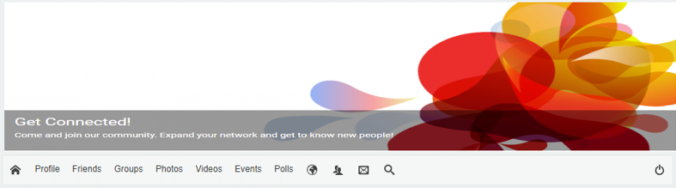

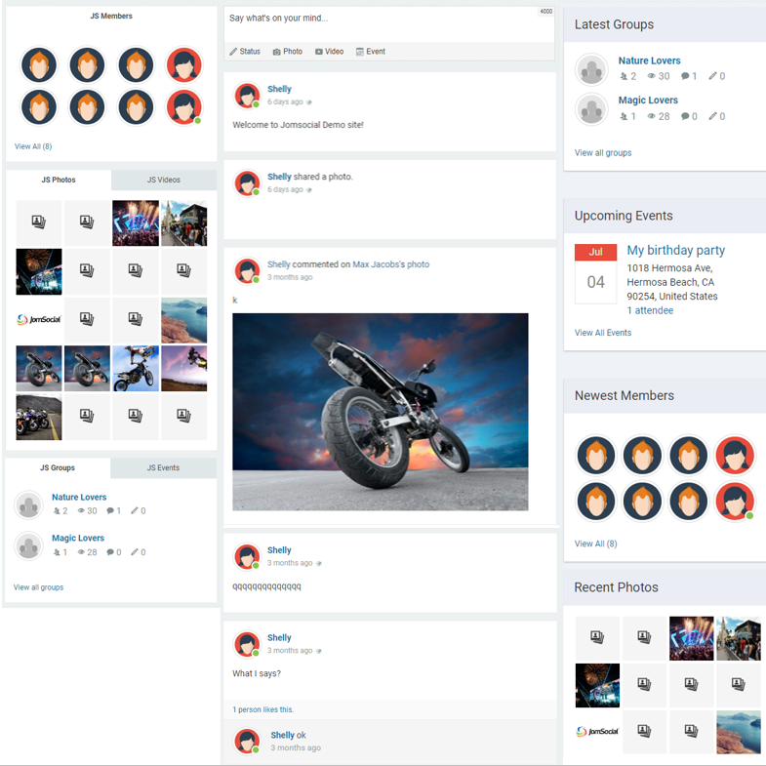



Source: Adapted by the authors from “JomSocial Demo Site,” JomSocial.com, accessed May 5, 2018, http://demo.jomsocial.com/#socialize.

Exhibit 3: Evolution of social media uses across social media platforms

|  |  |  |  |
| --- | --- | --- | --- |
| **Common Uses** | **JomSocial** | **Earlier  Viber Use** | **Later**  **Viber Use** |
| * Discussing different topics * Sharing news about MTS users * Posting reminders for community events and religious reminders * Engaging in Q&A sessions with friends (e.g., with regard to spouse insurance, family member’s visa rejection) * Socialization among users * Sharing discounts with MTS users * Fundraising for MTS members in need * Finding rides from downtown to event venues * Posting advertisements only for MTS users * Sharing discounts with all members * New Q&A sessions for all users (e.g., with regard to immigration, university admission, claiming traffic tickets) |  |  |  |

Note: MTS = Montreal Toheed Society; Q&A = question and answer.

Source: Prepared by the case writer.

Exhibit 4: Evolution of governing policies across social media platforms

|  |  |  |  |
| --- | --- | --- | --- |
| **Governing Policies** | **JomSocial** | **Earlier  Viber Use** | **Later**  **Viber Use** |
| * Confirming users’ identities (real names or pictures) * Allowing Q&A sessions for MTS users * Requiring content to be in line with MTS values * Allowing Viber users to add their friends to the Viber group * Banning ads except from active MTS users * Allowing ads from any MTS user * Allowing Q&A sessions for MTS and non-MTS users * Banning Q&A sessions not about Montreal * Allowing advertisements by all (MTS and non-MTS users) * Limiting the number of ads (MTS and non-MTS users) * Setting policies for ad format (e.g., length and number of pictures) * Banning long religious discussions among MTS |  |  |  |

Note: MTS = Montreal Toheed Society; Q&A = question and answer.

Source: Prepared by the author.

Exhibit 5: screen shot of Telegram User Page

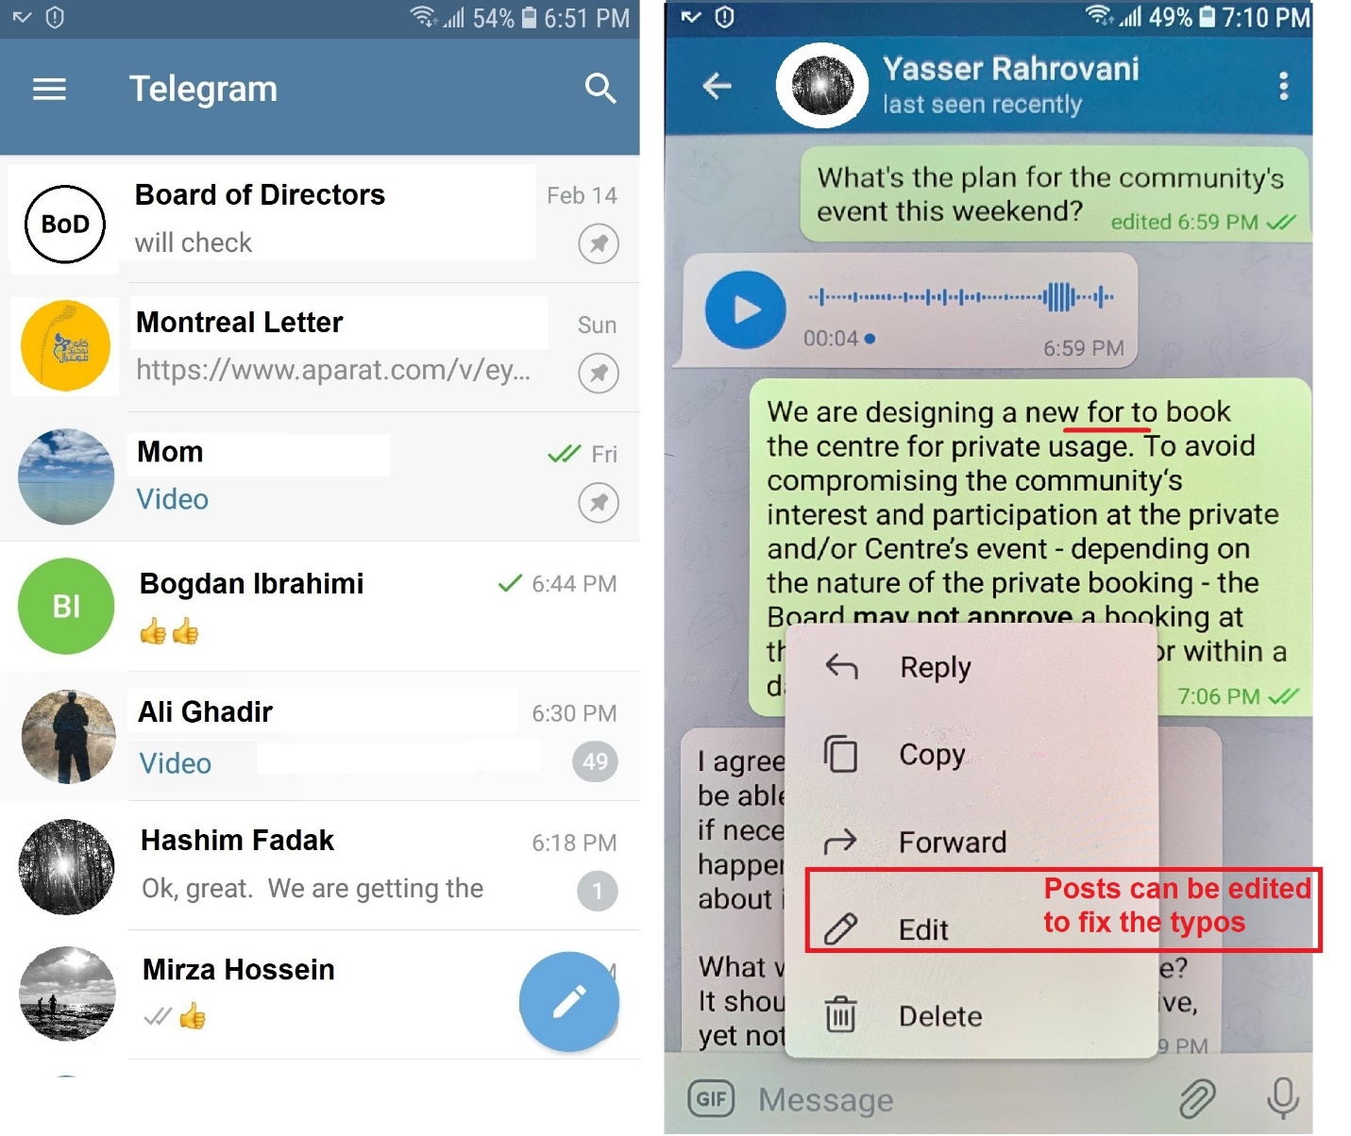

Source: Prepared by the author with information from Telegram (website), accessed June 8, 2020, www.telegram.org.

ENDNOTE

1. Paul M. Leonardi and Emmanuelle Vaast, “Social Media and Their Affordances for Organizing: A Review and Agenda for Research,” *Academy of Management Annals* 11, no. 1 (2017): 2.
2. Special Reports, “Digital in 2019: Global Internet Use Accelerates,” We Are Social, January 31, 2019, https://wearesocial.com/uk/blog/2019/01/digital-in-2019-global-internet-use-accelerates.
3. Andrew Hutchinson, “How Much Time Do People Spend on Social Media in 2019?,” Social Media Today, August 9, 2019, accessed May 5, 2020, www.socialmediatoday.com/news/how-much-time-do-people-spend-on-social-media-in-2019-infographic/560270.
4. Hutchinson, “How Much Time.”
5. Special Reports, “Digital in 2019.”
6. Hutchinson, “How Much Time.”
7. Shanhong Liu, “Slack’s Number of Users from February 2014 to October 2019, by Paid Status,” Statista, March 17, 2020, accessed May 5, 2020, www.statista.com/statistics/652779/worldwide-slack-users-total-vs-paid.
8. Tom Warren, “Slack Shows It’s Worried about Microsoft Teams with a Full-Page Newspaper Ad,” The Verge, November 2, 2016, accessed May 5, 2020, www.theverge.com/2016/11/2/13497766/slack-microsoft-teams-new-york-times-ad.
9. Warren, “Slack Shows It’s Worried.”
10. ByteDance Inc., “Tik Tok, a Global Music Video Platform and Social Network, Launches in Indonesia,” PR Newswire, September 13, 2017, accessed January 5, 2019, https://en.pmasia.com/releases/apac/Tik_Tok_a_Global_Music_Video_Platform_and_Social_Networ k_Launches_in_Indonesia-187963.shtml.
11. Alison DeNisco Rayome, “10 Most-Downloaded Apps of the 2010s: Facebook Dominates the Decade,” CNET, December 16, 2019, accessed May 5, 2010, www.cnet.com/news/10-most-downloaded-apps-of-the-decade-facebook-dominated-2010-2019.
12. Michael J. de la Merced, Nick Bilton, and Nicole Perlroth, “Yahoo to Buy Tumblr for $1.1 Billion,” *New York Times*, May 19, 2013, accessed May 5, 2020, www.nytimes.com/2013/05/20/technology/yahoo-to-buy-tumblr-for-1-1-billion.html; Rachel Siegel, “Tumblr Once Sold for $1.1 Billion. The Owner of WordPress Just Bought the Site for a Fraction of That,” *Washington Post*, August 13, 2019, accessed May 5, 2020, www.washingtonpost.com/technology/2019/08/13/tumblr-once-sold-billion-owner-wordpress-just-bought-site-fraction-that.
13. J. Clement, “Share of Social Media Users in the United States,” Statista, April 2, 2020, accessed May 2, 2020, www.statista.com/statistics/1106343/social-usage-increase-due-to-coronavirus-home-usa.
14. Logan Godfrey, “Social Media’s Role in the Coronavirus Pandemic,” Business 2 Community, March 27, 2020, accessed May 2, 2020, www.business2community.com/social-media/social-medias-role-in-the-coronavirus-pandemic-02296280; S. Harris Ali and Fuyuki Kurasawa, “#COVID19: Social Media Both a Blessing and a Curse During Coronavirus Pandemic,” The Conversation, March 22, 2020, accessed May 5, 2020, https://theconversation.com/covid19-social-media-both-a-blessing-and-a-curse-during-coronavirus-pandemic-133596.
15. “International Students in Canadian Universities, 2004–2005 to 2013–2014,” Statistics Canada, October 20, 2016, accessed July 4, 2019, www.statcan.gc.ca/pub/81-599-x/81-599-x2016011-eng.htm.
16. “Annual Reports,” Montreal Toheed Society, accessed July 4, 2019, http://toheed-mtl.ca/index.php/en/enmnuaboutus/annual-reports.
17. Christina Hertel, Sophie Bacq, and Frank-Martin Belz, “It Takes a Village to Sustain a Village: A Social Identity Perspective on Successful Community-Based Enterprise Creation,” *Academy of Management Discoveries* 5, no. 4 (2019).
18. Steven Brint, “Gemeinschaft Revisited: A Critique and Reconstruction of the Community Concept,” *Sociological Theory* 19, no. 1 (2001): 1–23.
19. “About the Mozilla Corporation,” The Mozilla Foundation, accessed May 5, 2020, www.mozilla.org/en-US/foundation/moco.
20. “About the Mozilla Corporation,” The Mozilla Foundation.
21. Siobhan O’Mahony and Karim R. Lakhani, “Organizations in the Shadow of Communities” (working paper, Research in the Sociology of Organizations, “Communities and Organizations,” Harvard Business School, Boston, 2011), accessed June 8, 2020, https://www.hbs.edu/faculty/Publication%20Files/11-131.pdf.
22. The term “MTS member” referred to an official member of the Montreal Toheed Society, the term “MTS user” referred to a social media user who was a member of the Montreal Toheed Society, and the term “non-MTS user” referred to a social media user who was not a member of the Montreal Toheed Society and therefore not part of its digital space community.
23. Yasser Rahrovani, “Platform Drifting: When Work Digitalization Hijacks Its Spirit,” The Journal of Strategic Information Systems, in press, corrected proof, June 20, 2020, https://doi.org/10.1016/j.jsis.2020.101615.
24. Wikipedia, “Telegram (software)”, accessed July 23, 2020, https://en.wikipedia.org/wiki/Telegram_(software).
25. Alireza Jozi, “Messaging Apps Most Used in The Middle East,” TechRasa, May 13, 2016, accessed June 12, 2020, http://techrasa.com/2016/05/13/messaging-apps-used-middle-east.