 

9B19M011

flytenow, Inc.: regulatory challenges in the sharing economy

David Wesley and Professor Susan Montgomery wrote this case solely to provide material for class discussion. The authors do not intend to illustrate either effective or ineffective handling of a managerial situation. The authors may have disguised certain names and other identifying information to protect confidentiality.

This publication may not be transmitted, photocopied, digitized, or otherwise reproduced in any form or by any means without the permission of the copyright holder. Reproduction of this material is not covered under authorization by any reproduction rights organization. To order copies or request permission to reproduce materials, contact Ivey Publishing, Ivey Business School, Western University, London, Ontario, Canada, N6G 0N1; (t) 519.661.3208; (e) cases@ivey.ca; www.iveycases.com. Our goal is to publish materials of the highest quality; submit any errata to publishcases@ivey.ca. i1v2e5y5pubs

Copyright © 2019, Northeastern University, D’Amore-McKim School of Business Version: 2019-02-15

Matt Voska and Alan Guichard, co-founders of Flytenow, Inc. (Flytenow), were flying high after completing three months at Y Combinator, a prestigious start-up accelerator. Demo Day, an opportunity to pitch a business to leading investors in Silicon Valley, California, was just around the corner, and the flight-sharing company Flytenow was the talk of the town.

Anybody who was anybody in Silicon Valley had heard of Voska and Guichard. The two had already passed the preliminary stages of Y Combinator, beating out thousands of other start-ups. Now they were attracting some of the same investors who had helped to start Airbnb, Inc. (Airbnb) and other “sharing economy” companies. These investors understood the fundamental aspects of Flytenow, but also recognized that flight sharing was something new and untested. Most of all, they were excited about the opportunity to get in early on a platform that had the potential to revolutionize air travel, just as Uber had revolutionized taxi services. In fact, some were calling Flytenow the “Uber of the skies.”

As the co-founders worked on their presentation with Aakash Patel, who had joined the company as chief technology officer, a letter arrived from the Federal Aviation Administration (FAA), the regulatory body that oversaw aviation in the United States. The letter stated that Flytenow “is designed to attract a broad segment of the public interested in transportation by air. . . . Because pilots using [the] website . . . are engaged in common carriage, the FAA concluded that they require [commercial operating] certificates.” In short, the letter prohibited private pilots from offering flights on the site, thereby undermining the entire business plan.

Patel was livid. “I’ve done all this work for nothing,” he complained as he stomped off and locked himself in a room. Voska just stared at Guichard, who was sitting in a rickety plastic chair reading the letter over and over. Voska finally had enough. “What are we going to do?” he repeated as he paced back and forth across the room. “I need some time to think,” Guichard replied. “We don’t have time,” Voska countered. “What about Demo Day?”

Over the past three months, Voska and Guichard had come to know some of the biggest names in Silicon Valley. After receiving the FAA’s letter, the two decided to ask some of these people for advice. “Listen, every start-up faces regulatory issues,” said one. “Don’t worry about it.” But another commented, “This raises a huge question in your business plan,” adding, “You probably should not pitch the business until you get this issue resolved.” “We haven’t taken on aviation,” said a third investor. “It’s not a big deal!” These mixed replies left them even more confused. Voska turned to Guichard and asked, “Should we pitch the business or not?”

Background

Flytenow

In December 2013, Voska, a 20-year-old computer engineering sophomore, and Guichard, a law student, met through “IDEA,” Northeastern University’s venture accelerator. Both shared a passion for flying and were licensed pilots. They saw companies such as Uber and Lyft and wondered whether they could create a similar service for private pilots like themselves. The premise was simple, explained Guichard, “Thousands of private pilots fly every day with empty seats in their planes. Whether it be a common destination, lunch at an airport restaurant or another day trip, Flytenow connects enthusiasts with pilots.”[1]

In the United States, there were more than 500,000 private pilots flying a total of nearly 25 million hours per year.[2] Voska and Guichard hoped to tap into what they saw as a vast “excess capacity,” with empty seats on most of those flights.

The idea was born from their own experiences as pilots. Guichard spent approximately US$11,000[3] to earn his pilot’s licence in 2009, but having a pilot’s licence was not the end of the costs. It only shifted the expense from training to ownership and rental. At the time, the going rate for renting a small aircraft was $140 per hour.

Owning a plane was even more expensive. A small four-seat Cessna 172 sold for approximately $300,000 new.[4] Aircraft owners also had to contend with maintenance, fuel, insurance, and hangar fees. If a pilot flew 100 hours per year, the flight costs would be $4,000 for fuel at $5 per gallon,[5] $200 for engine oil, $1,700 for engine maintenance, and $50 for landing fees. Insurance could add as much as $10,000 for a newer aircraft, while hangar fees amounted to an additional $12,000. On average, total operating fees for new and older small aircraft were between $12,000 and $30,000 per year, not including financing.[6] “So it gets really expensive, real fast,” Guichard explained. “But the way pilots have been solving this since the dawn of aviation is to share the expenses. And the way they do that is that these regional airports have a bulletin board and you can put things on there.”

Small airports utilized corkboards that were hung on the wall of a hangar, the waiting room, or the cafeteria. Pilots wrote the information about their flight plans and available seats on file cards, Post-it Notes, or notepaper and posted these along with their contact information on the corkboard. The only way for a traveller to learn about flights and available seats was to go to the regional airport and look at the notices on the corkboard.

At the same time, there was pent-up demand for direct flights to secondary destinations. Most airline passengers relied on a hub-and-spoke system that forced them through airports that were out of the way of their destinations, adding to the travel time and the cost of a typical flight. Consumers also loathed long security lines and potential interrogations by Transportation Security Administration (TSA) agents. Overall, consumer satisfaction with air travel was among the lowest of any industry, in many cases falling below hated cable and satellite television services (see Exhibit 1).

Having experienced first-hand both the challenges of being private pilots and general dissatisfaction with commercial aviation, Voska and Guichard decided to create an electronic version of the regional airport bulletin board. The Flytenow website would connect travellers and pilots, who could then share the flight costs within the parameters of FAA regulations. This basically allowed pilots and passengers to equally share certain costs but prohibited private pilots from asking passengers to pay more than a pro rata share or from earning a profit from taking passengers on flights. They believed the website addressed the issue of “holding out,” which placed a communication restriction on pilots. The “holding out” rule meant that pilots could not hold out their services to the public unless they had an operating certificate (see Exhibits 2 and 3).

Instead, the pilots saved on operating costs by filling empty seats, while travellers gained a better selection of direct regional flights to thousands of small airports scattered across the country and usually saved money compared with commercial flights. Moreover, private pilots logged 25 million hours of flight time per year in the United States, compared with only 5 million hours of commercial flight. Guichard and Voska believed that if even a fraction of those private pilots could connect with travellers, the market potential could rival ride-sharing services. “It’s imperative to focus resources on building the supply side of your business,” Guichard explained. “If the demand side of your market is proven, it will likely outstrip supply—and quickly. Efficiently matching your supply with demand can also be a significant challenge. One way to do this is to provide real-time availability of supply. For Flytenow, that means displaying pilot-posted flights to enthusiasts.”

Taking Flight

Voska and Guichard pitched their idea to a local accelerator and quickly secured $45,000 in start-up funding. They immediately headed out to several New England regional airports, each time stocked with boxes of pizza for the pilots. They used the feedback from pilots to build a site that best suited the needs of pilots without running afoul of “holding out” regulations.

In January 2014, Flytenow had its inaugural flight, a round-trip flight from Hanscom Field near Boston to Martha’s Vineyard with the pilot and passengers dividing the cost three ways and paying $100 each. A commercial charter offering the same route charged $1,200. One of Voska and Guichard’s principal goals was to simplify the process of connecting pilots and passengers by creating a site that was easy to navigate and provided a comprehensive repository of available flights. All Flytenow had done was move the transaction away from a paper note on a bulletin board to an online platform (see Exhibit 4). The business plan was simple. “Although we decided early on to just make it a flat connection fee of $30,” Guichard said, “our plan was to perhaps change that to [being] percentage based” (see Exhibit 5).

Once the venture was off the ground, Voska and Guichard applied to join Y Combinator, the most prestigious Silicon Valley-based new venture accelerator. Its three-month funding and mentorship program had already helped to bring forth Airbnb, Reddit, and Dropbox. Y Combinator’s success created a very competitive environment, with an acceptance rate of only 80 new ventures per 80,000 applications. Guichard recalled that when Flytenow was accepted in the summer of 2014, “It was huge for us.”

We started out in Northern California with flights from Palo Alto going to Lake Tahoe, all up and down the San Francisco Bay area, from the Bay to Los Angeles. So, it made a lot of sense there. It works really well for local and regional travel.

The most intriguing thing about the sharing economy is the ability to transform the way we live and interact with each other. Building a community is what it’s all about. When we started Flytenow, we principally thought about it as a means for pilots to defray the costs of flying so they could fly more often. What we found in addition to this was that pilots love sharing their knowledge and experience, and above all, the joy of flying in a small plane. On the flip side, the response from enthusiasts was extraordinary, as most had never considered flying in a small plane, let alone sitting in the right seat of a cockpit.

The Sharing Economy

Flight Sharing

Flight sharing traced its roots back to the earliest days of aviation and adopted the simple practices of that time as a way to defray some of the high fuel and maintenance costs that came with owning a private aircraft. Prior to the Internet, pilots and perspective passengers posted notes on public bulletin boards, typically in small airports, noting flight dates and destinations. If one was lucky, the times and locations would match up, whereupon passengers and pilots happily split the fuel costs. This arrangement was permitted under the FAA’s “Expense Sharing Rule,” which stated, “A private pilot may not pay less than the pro rata share of the operating expenses of a flight with passengers, provided the expenses involve only fuel, oil, airport expenditures, or rental fees.”[7]

The benefits of flight sharing were especially helpful to student pilots who needed to log a certain number of hours to keep or upgrade their pilot’s licences. Racking up those hours could prove prohibitively costly for pilots on tight budgets.

In 2012, several companies were inspired by ride-sharing services such as Uber to launch Internet-mediated flight services. Surf Air, for instance, provided a subscription service that the company dubbed the “Netflix” of the air. For a fixed monthly fee of $1,000 (later increased to $1,650), subscribers could take unlimited flights between select locations in California. In 2015, Surf Air founder Wade Eyerly left the company to create Beacon, a similar service offering flights between Boston and New York. Both services were considered common carriers, and both owned and operated their own small aircraft.

Visionary Airlines offered flight adventures in the San Francisco Bay area that would provide flight hours toward a pilot’s licence. However, the high cost of these commercial small airplane services made them unattractive to average consumers, and the company folded shortly after its launch.

BlackJet was another start-up described as the Uber for private jets. For an annual membership fee of several thousand dollars, subscribers could access a database of private jets, their destinations, and the number of available seats. A cross-country flight might cost an additional $3,000, but was a fraction of the cost of renting a jet.

Legal Issues

During the early idea development, as a law student and pilot, Guichard was doubly aware of the regulatory environment and the role of the FAA. He also recognized the crucial difference between operating within the FAA’s “Expense Sharing Rule” for private pilots and operating in a manner that made his start-up a “common carrier.”

Guichard wrote to the FAA describing the flight-sharing model he and Voska were creating, referencing prior favourable FAA determinations as precedent. He received a response indicating the FAA’s acceptance of his characterization of the model as within the FAA’s “Expense Sharing Rule.” The duo treated the response as enough of an indicator or “guidance from the FAA” to go forward with the Hanscom Field trial.

Shortly after Flytenow began offering flights across the West Coast of the United States, the company learned that several pilots had received letters from their Flight Standards District Office (FSDO),[8] declaring that by using Flytenow, they were violating the “holding out” rule and should refrain from posting flights on the site. The FAA argued that because pilots were communicating their flights on Flytenow, they were holding out and thus unlawfully acting as common carriers. Voska and Guichard were puzzled. Not only had the FSDOs and the FAA not contacted them about this issue, their recent attempts to contact the FAA had been ignored.

Suddenly the number of flights posted on Flytenow began to drop. As one pilot member noted, the FAA enforcement officials had “let me know in no uncertain terms that they consider [the Flytenow website] [to be] holding out for illegal charter. They will be going after these operations.” Unless the founders received some guidance from the FAA to reassure pilots, Guichard and Voska’s entire business plan would be in jeopardy. Guichard drafted a formal letter to the FAA demanding guidance.

As the Y Combinator program began to wind down at the end of the summer of 2014, Flytenow began to prepare its final pitch to some of the most important Silicon Valley investors. Voska, Guichard, and other key employees settled into their Mountain View apartment to prepare their presentation. Then, three days before the event, a letter arrived from the FAA stating that pilots were prohibited from using flight-sharing services such as Flytenow.

The FAA did not declare the platform illegal, only that pilots had to have a commercial operating certificate. Guichard explained:

In aviation, there are two parallel structures that dictate your privileges: (1) type of pilot licence (Private, Commercial, Airline Transport Pilot [ATP]) and (2) type of operations. Here, the FAA required an Operating Certificate, which is a business licence allowing one to make money from flying. So, even a Commercial or ATP licensed pilot would still not be allowed to communicate their flights on Flytenow.

These pilots would be considered “common carriers,” similar to commercial airlines, trains, and buses.[9] Common carriers were commercial enterprises such as Delta Airlines, Inc. that met strict operational and safety guidelines. In short, the FAA action meant pilots were prohibited from doing what they had lawfully done for decades—sharing expenses with their passengers—because the pilots had used the Internet to communicate. This meant Flytenow could operate only if, similar to travel websites Expedia, Travelocity, and Orbitz, it offered seats only on commercial airline flights. It also meant that the private pilots Flytenow had been supporting would need to stop using the Internet and go back to posting physical notices on bulletin boards at their local airport if they wanted to connect with travellers. The ruling was equivalent to requiring Uber to offer rides only with licensed, commercial taxi services and restricting Airbnb to booking reservations for hotels.

One experienced Silicon Valley venture capitalist wondered why the FAA letter was even an issue. Uber and Lyft also faced legal challenges, but simply ignored them. Flytenow should just follow their lead, he argued. “They [Uber and Lyft] just proceed on course . . . and fight the battle on the local level.” In large part, they operated illegally at first and then reached a certain scale, and then eventually the government had to come around and make their services legal.

Guichard was aware of the argument. Two years earlier, he had hailed an Uber to get home from Boston’s Logan Airport. “I literally had to give my Uber driver a hug when she dropped me off at the airport, otherwise she could have been ticketed and fined. And nowadays it is completely allowed.” In fact, if Flytenow were to modify the platform to make it more like Uber, it could make FAA enforcement action more difficult. Instead of having pilots post their destination and offer to share costs, travellers could post their destinations and ask pilots to take them. Voska and Guichard had been careful to ensure that the site was compliant with “holding out,” but if travellers were dictating the destinations, holding out would no longer apply. “We built this trying to be compliant,” Guichard said. He explained:

However, if pilots are not stating where they are going, but instead non-pilots are saying they want to go from Miami to the Florida Keys, and asking can someone take me? Then the holding out issue just erases. Pilots aren’t posting where they’re flying. Instead, someone else is posting that “I want to go from A to B” and that pilot is reaching out and saying, “Hey, I’m going there, let’s meet up.” First, it eliminates holding out, and second, if the FAA were to challenge it, they would have to take enforcement action against one of the pilots. They couldn’t just issue a letter and make it go away.

By forcing the FAA to look at each case individually to determine if pilots were violating the rule, the agency would not be able to rule against the platform. “It would make it much more difficult for the FAA to take action against us,” Guichard noted.

Alternatively, Flytenow could mount a legal challenge to the FAA ruling. However, the company’s attorney was not optimistic. “There’s no way you can take this to court,” he replied, explaining:

No one has ever appealed an FAA letter to the D.C. Circuit Court of Appeals. You think you’re going to court and that you’re going to have an equal footing? That is very much not the case when you’re dealing with regulatory bodies because what ends up happening is the agency’s interpretation of their own regulations cannot be challenged by the court. I mean, there’s varying kinds of levels of deference by the court. Sometimes they’ll review it completely, but most of the time they’ll apply this level of deference that states, we’ll look at your case, but we’re not going to challenge the FAA’s interpretation of this regulation.

Flytenow’s attorney was adamant that any legal remedy was hopeless, noting the degree of deference a court must give to agency determinations. “I am not filing this,” he declared. He did not suggest other lawyers or organizations that might be willing to take the case.

On the eve of Demo Day, Voska and Guichard were still unsure of what to do. The timing of the FAA letter meant Guichard and Voska did not have time to respond or engage in discussions with the FAA, but they did know one thing—if they went ahead with the pitch, they were sure to secure at least $500,000 in new funding.

**Exhibit 1: Worst-RANKED Companies in the united states for Consumer Satisfaction**

|  |  |  |
| --- | --- | --- |
| Rank | Company | Satisfaction Score |
| 1 | **Spirit Airlines** | (54) |
| 1 | Time Warner Cable (ISP) | (54) |
| 2 | Time Warner Cable (TV) | (56) |
| 3 | Comcast (ISP) | (57) |
| 4 | **Frontier Airlines** | (58) |
| 5 | Charter Communications (TV) | (60) |
| 5 | Comcast (TV) | (60) |
| 5 | **United Airlines** | (60) |
| 6 | Charter Communications (ISP) | (61) |
| 7 | Cox Communications (TV) | (63) |
| 7 | Motel 6 | (63) |
| 8 | Cox Communications (ISP) | (64) |
| 9 | Aetna | (65) |
| 9 | **Allegiant Air** | (65) |
| 9 | AT&T (U-verse) (ISP) | (65) |
| 9 | CenturyLink (ISP) | (65) |
| 9 | Time Warner Cable (Fixed Line Telephone) | (65) |
| 10 | WellPoint | (66) |

Note: The average American Customer Satisfaction Index score is 75; ISP = Internet service provider.

Source: University of Michigan, cited in: Christopher Elliott, “Customer Satisfaction with Airlines Is Actually at a 20-Year High, Survey Finds,” *Fortune*, April 20, 2015, accessed July 31, 2017, http://fortune.com/2015/04/20/airlines-hotels-best-worst/.

**Exhibit 2: Code of U.S. Federal Regulations**

**§61.113: Private pilot privileges and limitations: Pilot in command**

(a) Except as provided in paragraphs (b) through (h) of this section, no person who holds a private pilot certificate may act as pilot in command of an aircraft that is carrying passengers or property for compensation or hire; nor may that person, for compensation or hire, act as pilot in command of an aircraft.

(b) A private pilot may, for compensation or hire, act as pilot in command of an aircraft in connection with any business or employment if:

(1) The flight is only incidental to that business or employment; and

(2) The aircraft does not carry passengers or property for compensation or hire.

(c) A private pilot may not pay less than the pro rata share of the operating expenses of a flight with passengers, provided the expenses involve only fuel, oil, airport expenditures, or rental fees.

(d) A private pilot may act as pilot in command of a charitable, nonprofit, or community event flight described in §91.146, if the sponsor and pilot comply with the requirements of §91.146.

(e) A private pilot may be reimbursed for aircraft operating expenses that are directly related to search and location operations, provided the expenses involve only fuel, oil, airport expenditures, or rental fees, and the operation is sanctioned and under the direction and control of:

(1) A local, State, or Federal agency; or

(2) An organization that conducts search and location operations.

(f) A private pilot who is an aircraft salesman and who has at least 200 hours of logged flight time may demonstrate an aircraft in flight to a prospective buyer.

(g) A private pilot who meets the requirements of §61.69 may act as a pilot in command of an aircraft towing a glider or unpowered ultralight vehicle.

(h) A private pilot may act as pilot in command for the purpose of conducting a production flight test in a light-sport aircraft intended for certification in the light-sport category under §21.190 of this chapter, provided that—

(1) The aircraft is a powered parachute or a weight-shift-control aircraft;

(2) The person has at least 100 hours of pilot-in-command time in the category and class of aircraft flown; and

(3) The person is familiar with the processes and procedures applicable to the conduct of production flight testing, to include operations conducted under a special flight permit and any associated operating limitations.

(i) A private pilot may act as pilot in command of an aircraft without holding a medical certificate issued under part 67 of this chapter provided the pilot holds a valid U.S. driver’s license, meets the requirements of §61.23(c)(3), and complies with this section and all of the following conditions and limitations:

(1) The aircraft is authorized to carry not more than 6 occupants, has a maximum takeoff weight of not more than 6,000 pounds, and is operated with no more than five passengers on board; and

(2) The flight, including each portion of the flight, is not carried out—

(i) At an altitude that is more than 18,000 feet above mean sea level;

(ii) Outside the United States unless authorized by the country in which the flight is conducted; or

(iii) At an indicated airspeed exceeding 250 knots; and

(3) The pilot has available in his or her logbook—

(i) The completed medical examination checklist required under §68.7 of this chapter; and

(ii) The certificate of course completion required under §61.23(c)(3).

[Doc. No. 25910, 62 FR 16298, Apr. 4, 1997, as amended by Amdt. 61-110, 69 FR 44869, July 27, 2004; Amdt. 61-115, 72 FR 6910, Feb. 13, 2007; Amdt. 61-125, 75 FR 5220, Feb. 1, 2010; Docket FAA-2016-9157, Amdt. 61-140, 82 FR 3165, Jan. 11, 2017]

Source: “Electronic Code of Federal Regulations,” e-CFR, accessed August 15, 2018, www.ecfr.gov/cgi-bin/text-idx?pitd=20170501&node=se14.1.61_1113&rgn=div8.

**Exhibit 3: Federal Aviation Administration’s Advisory on “Holding Out”**

GUIDELINES:

A carrier becomes a common carrier when it “holds itself out” to the public, or to a segment of the public, as willing to furnish transportation within the limits of its facilities to any person who wants it.

Absence of tariffs or rate schedules, transportation only pursuant to separately negotiated contracts, or occasional refusals to transport, are not conclusive proof that the carrier is not a common carrier. There are four elements in defining a common carrier; (1)

a holding out of a willingness to (2) transport persons or property (3) from place to place (4) for compensation.

This “holding out” which makes a person a common carrier can be done in many ways and it does not matter how it is done.

1. Signs and advertising are the most direct means of “holding out” but are not the only ones.
2. A “holding out” may be accomplished through the actions of agents, agencies, or salesmen who may, themselves, procure passenger traffic from the general public and collect them into groups to be carried by the operator. It is particularly important to determine if such agents or salesmen are in the business of selling transportation to the traveling public not only through the “group” approach but also by individual ticketing on known common carriers.
3. Physically holding out without advertising where a reputation to serve all is gained is sufficient to constitute an offer to carry all customers. There are many means by which physical holding out may take place. For example, the expression of willingness to all customers with whom contact is made that the operator can and will perform the requested service is sufficient. The fact that the holding out generates little success is of no consequence. The nature and character of the operation are the important issue.
4. Carriage for hire which does not involve “holding out” is private carriage. Private carriers for hire are sometimes called “contract carriers,” but the term is borrowed from the Interstate Commerce Act and legally inaccurate when used in connection with the Federal Aviation Act. Private carriage for hire is carriage for one or several selected customers, generally on a long-term basis. The number of contracts must not be too great, otherwise it implies a willingness to make a contract with anybody. A carrier operating pursuant to 18 to 24 contracts has been held to be a common carrier because it held itself out to serve the public generally to the extent of its facilities. Private carriage has been found in cases where three contracts have been the sole basis of the operator’s business. Special adaptation of the transportation service to the individual needs of shippers is a factor tending to establish private carriage but is not necessarily conclusive.
5. A carrier holding itself out as generally willing to carry only certain kinds of traffic is, nevertheless, a common carrier. For instance, a carrier authorized or willing only to carry planeloads of passengers, cargo, or mail on a charter basis is a common carrier, if it so holds itself out. This is, in fact, the basic business of supplemental air carriers.
6. A carrier flying charters for only one organization may be a common carrier if membership in the organization and participation in the flights are, in effect, open to a significant segment of the public. Similarly, a carrier which flies planeload charters for a common carrier, carrying the latter’s traffic, engages in common carriage itself.

**Exhibit 3 (continued)**

1. Occasionally, offers of free transportation have been made to the general public by hotels, casinos, etc. In such cases, nominal charges have been made which, according to the operators, bear the expense of gifts and gratuities. However, the operators maintain that the transportation is free. The courts have held that such operations are common carriage based on the fact that the passengers are drawn from the general public and the nominal charge constituted compensation.
2. Persons admittedly operating as common carriers in a certain field (for instance, in intrastate commerce) sometimes claim that transportation for hire which they perform in other fields (for instance, interstate or foreign commerce) is private carriage. To sustain such a claim, the carrier must show that the private carriage is clearly distinguishable from its common carriage business and outside the scope of its holding out. The claimed private carriage must be viewed in relation to and against the background of the entire carrying activity. Historically, Civil Aeronautics Board decisions have concluded that only in rare instances could carriage engaged in by a common carrier be legitimately classified as private.
3. In summary, persons intending to conduct only private operations in support of other business should look cautiously at any proposal for revenue-generating flights which most likely would require certification as an air carrier.

Source: U.S. Department of Transportation, Federal Aviation Administration, *Advisory Circular*, “Private Carriage Versus Common Carriage of Persons or Property,” AC No: 12042A CARRIAGE OF PERSONS OR PROPERTY, Initiated by: AFS-820, April 24, 1986, accessed August 15, 2018, www.faa.gov/documentLibrary/media/Advisory_Circular/AC%20120-12A.pdf.

**Exhibit 4: Flytenow landing page**

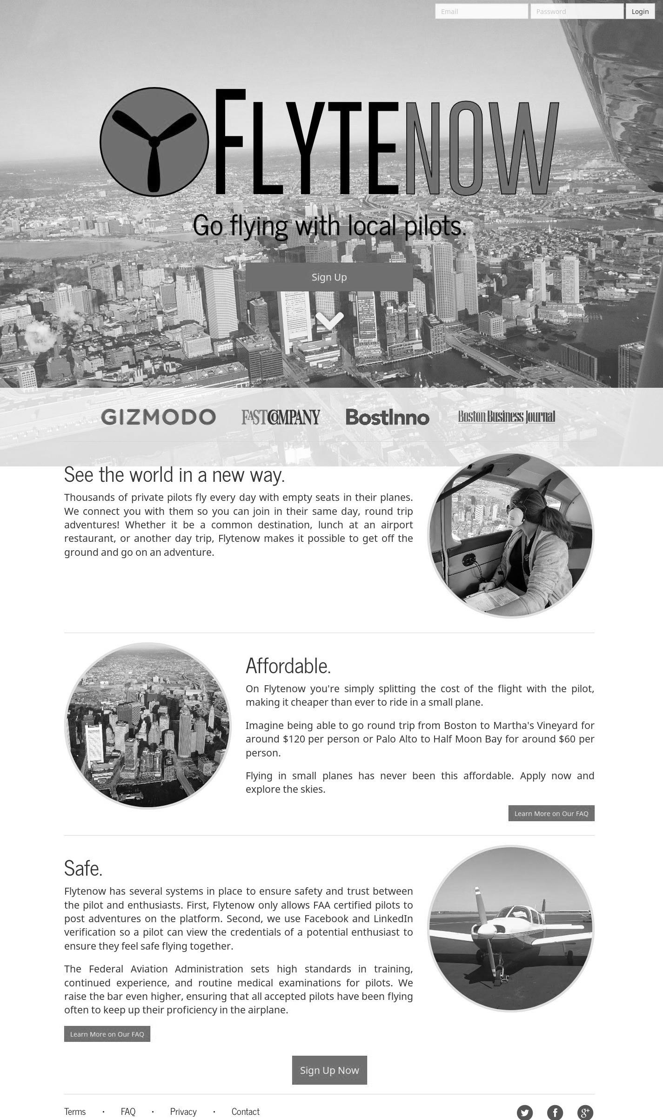

Source: Company files.

**Exhibit 5: Business Plan (Key Financial Data, US$)**

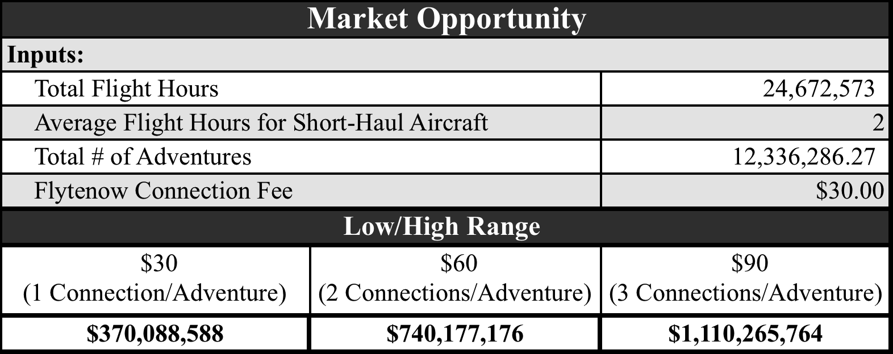

|  |  |  |  |
| --- | --- | --- | --- |
| **Channel: Direct to Consumer** |  |  |  |
|  | **Year 1** | **Year 2** | **Year 3** |
| **Total # of Adventures—Market Potential** | **12,336,286.27** | **12,339,987.16** | **12,343,689.15** |
| **Market Penetration (%)** | 0.01% | 0.05% | 0.25% |
| **# Adventures Sold in a Year** | 1,234 | 6,170 | 30,859 |
| **Average Sale Price of Adventure** | $30.00 | $30.00 | $30.00 |
|  |  |  |  |
| **Total Service Revenue** | **$37,020** | **$185,100** | **$925,777** |

Source: Company documents.

1. Alan Guichard, “The Sharing Economy from a Sky-High Perspective,” *Wall Street Journal*, May 8, 2014, accessed July 31, 2017, https://blogs.wsj.com/accelerators/2014/05/08/alan-guichard-the-sharing-economy[from-a-sky-high-perspective/](https://blogs.wsj.com/accelerators/2014/05/08/alan-guichard-the-sharing-economy-from-a-sky-high-perspective/).
2. According to Flytenow, “In 2013 there was a total of 24,673,000 GA [general aviation] flight hours. The category of short-haul aircraft includes commuter aircraft, rotorcraft, and . . . GA airplanes. A short-haul flight is commonly categorized as taking on average two hours to complete.”
3. All dollar amounts are in U.S. dollars.
4. Robert Goyer, 2012, “Cessna172: Still Relevant,” *Flying Magazine*, accessed January 25, 2018, www.flyingmag.com/aircraft/pistons/cessna-172-still-relevant.
5. 1 gallon = 3.785 litres
6. Jeremy Dingman, “The Real Cost of Owning an Airplane,” Honeywell Aerospace, February 10, 2016, accessed January 25, 2018, https://aerospace.honeywell.com/en/blogs/2016/february/the-real-cost-of-owning-an-airplane.
7. Office of the Federal Register, The Federal Register, *The Code of Federal Regulations*, Title 14 – Aeronautics and Space, § 61.113: “Private Pilot Privileges and Limitations: Pilots in Command,” (c).
8. An FSDO was a field office of the FAA. There was at least one FSDO per U.S. state, apart from some smaller New England states that fell under the jurisdiction of the Boston FSDO.
9. “As early as 1832, Justice Joseph Story defined common carriage thusly: For common carriage, service must be offered, on demand, to the public at large or to a group of people generally, and the carrier ‘must hold himself out as ready to engage in the transportation of goods for hire, as a business, not as a casual occupation.’” Joseph Story, *Commentaries on the Law of Bailments*, 1st ed. (Boston, MA: Little, Brown and Company, 1832), § 495.