

9B19M014

Zashita Ltd.: identifying Opportunity in Safety

Blaine Morry wrote this case under the supervision of Professor Dominic Lim to provide material for class discussion. The authors do not intend to illustrate either effective or ineffective handling of a managerial situation. The authors may have disguised certain names and other identifying information to protect confidentiality.

This publication may not be transmitted, photocopied, digitized, or otherwise reproduced in any form or by any means without the permission of the copyright holder. Reproduction of this material is not covered under authorization by any reproduction rights organization. To order copies or request permission to reproduce materials, contact Ivey Publishing, Ivey Business School, Western University, London, Ontario, Canada, N6G 0N1; (t) 519.661.3208; (e) cases@ivey.ca; www.iveycases.com. Our goal is to publish materials of the highest quality; submit any errata to publishcases@ivey.ca. i1v2e5y5pubs

Copyright © 2019, Ivey Business School Foundation Version: 2019-03-01

It was May 2018 in Irkutsk, Russia. Artyom Kuznetsov got out of his Lada Niva and prepared for another exciting day at work. As the founder and owner of Zashita Ltd. (Zashita), Kuznetsov reflected on how far the company had come in the five years since its inception as a security systems installation firm in 2013. The company had experienced rapid and steady sales growth over the past five years, and Kuznetsov wondered how much longer this momentum would last. Although Zashita[1] had well-established installation divisions for electrical, fire-prevention, and security systems, Kuznetsov was now considering expanding Zashita’s offerings to include smart home technology installation, taking advantage of an underutilized market of high-net-worth clients. Kuznetsov knew that expanding his offerings would require a great deal of effort, resources, and organizational restructuring, but the potential benefits could define the company as a premium service firm. Kuznetsov saw this as a potentially opportune time to take advantage of the strong reputation Zashita had developed in its short history and to seize first-mover advantage in smart home technology installation. As Kuznetsov sat down at his desk with his morning tea, his mind once again wandered. He thought about whether expanding into smart homes would be the correct decision for the company going forward. He wanted to continue Zashita’s rapid growth and secure prosperous employment for his employees, whom he had grown close to over the past five years. Zashita had a company retreat planned for June, and Kuznetsov was planning to reveal the company’s strategic direction to his co-workers at that time.

**THE RUSSIAN SMALL BUSINESS LANDSCAPE**

The small business landscape in Russia was quite different from that seen in the developed world. In economically developed countries such as the United States, small businesses accounted for about 50 per cent of gross domestic product (GDP) and employed between 50 and 70 per cent of the private workforce. By contrast, in Russia, small business development was still quite low, as small businesses provided jobs for only 17 per cent of the private working population and accounted for a mere 13–17 per cent of national GDP.[2]

Following the 1991 collapse of the Soviet Union, Russia transitioned from a centralized communist economy to a privatized economy based on capitalism. In efforts to stabilize the economy during this transition, drastic macroeconomic policy changes were implemented. Bank lending rates skyrocketed, peaking in 1995 at 450 per cent.[3] In 1996, to balance the budget, President Boris Yeltsin enacted a “loans-for-shares” program, in which stakes in valuable public natural resource companies were sold to private banks at extremely cheap prices in exchange for cheap loans. This later resulted in a very top-heavy distribution of national private wealth and the creation of Russian oligarchs in a time that Russian citizens called *prikhvatizatsiya*, or “grabification.”[4]

Over time, bank rates steadily decreased, but they were still much higher than in developed countries, thus creating a large entry barrier for many prospective entrepreneurs who wished to launch their businesses. In addition to unfavourable interest rates—which hit a low of about 8 per cent in 2011 (versus about 3.3 per cent in the United States)—loan amounts were small, requiring owners to save large quantities of money to kick-start their businesses. In 2009, business owners in Russia were provided, on average, loans of between RUB5,000[5] and RUB10,000 per employee to start their business (with the average in Irkutsk being less than RUB5,000).

These financial difficulties resulted in high entry barriers for small business owners, especially in rural regions. In Irkutsk, there were between 7.6 and 10 small enterprises conducting business per 1,000 people in 2010, versus the Russian national average of 11.35 and the U.S. national average of 74.2. General confidence in the success of start-ups was quite low in Russia, with the rate of perceived opportunities on the decline and the fear of failure rate on the upswing; only a small number of new entrepreneurs were entering the market.[6]

**KUZNETSOV'S BACKGROUND AND EXPERTISE**

Kuznetsov began his career as a city planning specialist with the municipal government economic committee after completing his degree in management at Baikal State University of Economics and Law in Irkutsk. He was responsible for keeping track of large- and small-scale developments occurring within the city. In addition to helping new prospective developers navigate the legal requirements and codes for creating new businesses, Kuznetsov also reported these developments directly to the mayor of Irkutsk. He considered this a critical period of development for his later entrepreneurial aspirations. His job with the municipal government allowed him to forge strong relationships with key decision-makers involved in small business approvals, while also allowing him to learn about the various regulations and licences required of business owners. Kuznetsov also learned about the little-known small business assistance programs offered by the city to help entrepreneurs who intended to start new businesses in Irkutsk.

In 2008, after five years with the municipal government, Kuznetsov was offered a job as deputy director of Bareer, an electrical services firm that specialized in engineering design and installation for security systems such as burglar and fire alarms, closed-circuit television, access control, and other alarm systems. The company won most bids for large-scale government contracts due to having a sufficient economy of scale to handle the work—unlike most competitors—and, as a result, was the market leader for large electrical contracting. Due to its size, Bareer focused most of its efforts on large contracts and thus did not do much work with private companies that had fewer than 500 employees. During his time at Bareer, Kuznetsov developed the industry and operational knowledge needed to succeed in the security systems contracting business. He also developed his leadership skills, which ultimately led to his promotion to chief executive officer (CEO) of the company for a short period of time.

**AN OPPORTUNITY AND THE BIRTH OF ZASHITA LTD.**

In 2013, Kuznetsov was having dinner with Serge Furtichev, a former co-worker from the city government, and an electrical engineer. Furtichev told him about a large influx of requests from small businesses for skilled security system installers in the area and said that many installers were turning away work because of a lack of available resources. Due to a very high crime rate (the crime index of Irkutsk was close to 70, compared with Russia’s average of 44), business owners considered security systems essential. Businesses could also benefit from a significant discount in insurance premiums if they had security systems installed. Kuznetsov had been saving his money over the past 10 years and was considering opening his own company. He saw this as an opportunity to move into an area he had become well acquainted with over the past five years.

Kuznetsov resigned from Bareer and applied to the Irkutsk small business assistance program, which provided him an interest-free loan of RUB200, 000 to match his investment of RUB200, 000 for starting his new business, “Zashita, Ltd.” In addition, Kuznetsov took advantage of a five-year tax-break period offered by the municipal government, known as the “Small Business Tax Vacation.” Kuznetsov partnered with Furtichev—who, as his technical director, would head the design engineering department—and another friend, Nikolai Petrov, who was an experienced foreman and would lead the engineering and installation department. Kuznetsov hired two security specialists, Mikhail Popov and Ivan Sokolov, whom he knew to be excellent security specialists and installers from his time at Bareer. The design engineering department would determine the client’s needs and specifications, then program these into a control system that would be installed on purchased hardware. The engineering and installation department would create a bill of materials for all needed electrical components, create drawings for the installation, and then install the design engineering department’s control system, resulting in an end-to-end turnkey security system installation.

Kuznetsov’s time of entry was opportune. Bank loan rates were among the lowest in the history of the Russian Federation (9 per cent), and following the financial collapse in 2008, the ability to bid on contracts with state-owned companies became available to many more companies. (Prior to this, most contracts had been handed to a few select firms.) Kuznetsov’s connections within the public and private sectors from his time with the government and Bareer had set him up well to pursue client relationships in the vulnerable initial stages of the company. Additionally, Zashita was well positioned to target small companies. Small companies were too small to get contracting work done by Bareer, and due to the unfavourable small-market perception, Zashita had few competitors. Additionally, because Kuznetsov was known as the former CEO of Bareer, the small business market soon viewed Zashita as “Bareer for the little guy,” and personal care for its clients was reflected in the company’s mission statement (see Exhibit 1). Zashita also focused its marketing efforts on the company’s friendly, inclusive, and approachable nature, placing colourful ads in various magazines and newspapers throughout the city (see Exhibit 2).

**OPERATING ZASHITA**

The first couple of months were spent pursuing contracts by calling businesses throughout the city. Kuznetsov was quickly booked solid and had to hire two additional employees to perform installations. Despite the initial steady sales volume, high upfront costs of obtaining equipment, acquiring licences, and training new staff (which consumed almost the entire RUB400, 000 initial investment) delayed profitability.

Initial installations for security systems would take about two weeks to complete. On average, a system installation would cost Zashita RUB30, 000 in equipment, travel, and employee wage costs for a RUB50, 000 contract. Zashita mostly sustained itself through repeat business from customers for maintenance service calls and technical support contracts, which were a very high margin, reliable source of sustained income.

Maintenance contracts would only cost the hourly wage of the employees and small consumables. On average, employees were paid RUB40, 000 per month. Service calls brought in about RUB5, 000 per day. Volume varied, but typically each installed system would require about three days of maintenance per year.

Technical support contracts were signed in 12-month increments for RUB10, 000. The contract would allow customers to call Zashita to troubleshoot software questions. Customers usually purchased these contracts for peace of mind and often never utilized the service, whereas others needed more assistance. On average, these contracts would each result in RUB8, 000 of profit per year.

The business was extremely seasonal. Installations were all done in the summer, as the intense cold of the Siberian winter could interfere with the ability to perform installations safely and profitably. During the winter, Zashita would shut down its installation business and rely solely on maintenance calls and technical support for revenue. On average, the installation business would function effectively for six months of the year.

**SCALING THE BUSINESS**

Zashita grew rapidly: in 2013, Zashita earned RUB2, 000,000 in sales, and by the end of 2016, this had grown to RUB48, 000,000 in sales per annum (see Exhibit 3). Kuznetsov had done an effective job of managing the company’s period of rapid growth, quickly pivoting to respond to customer volume and need.

When the business opened in 2013, it had focused mostly on installing security and fire-prevention systems as it built a customer base. By 2014, the engineering department had to grow to handle maintenance service calls. With these new demonstrated capabilities, Zashita began pursuing commercial clients more heavily, and this sector made up the bulk of its RUB15, 000,000 revenue in that year.

In 2015, Zashita launched a new subdivision: electrical installation. This division took care of general electrical work, which synergized well with the more specialized security and fire-prevention work the company already had expertise in. This allowed the company to pursue larger contracts, which helped in ballooning sales to RUB29, 000,000.

Zashita had a breakthrough in 2016, when it partnered with a local real estate construction firm to develop security systems and perform electrical work for homes in new residential subdivision that the firm had been contracted to build. This relationship proved fruitful and helped Zashita grow even more considerably—with RUB48, 000,000 in sales—while securing a positive reputation in the construction space (see Exhibit 4).

Zashita’s business had been growing considerably, and Kuznetsov was proud of the success of his business up to this point. He was most proud of the positive culture he had created at the firm. Zashita had grown from five to 25 employees over the five years it had been in business, and he had grown close to his employees and co-workers, who held him in high regard. He had earned the nickname “caring father” and took great care of his employees. On one occasion, an employee’s close family member died, and Kuznetsov allowed him to take six months of paid leave, with an invitation to take as long as needed before coming back to work—where his job would be guaranteed. In turn, Zashita’s employees performed some of the best electrical work in Irkutsk and rarely went past project deadlines.

**CUSTOMERS**

Although most small- and medium-sized engineering and electrical contracting firms specialized in either business-to-business (B2B) or business to-consumer (B2C) sales, Zashita had carved out a presence in both areas. By 2018, 60 per cent of Zashita’s sales were B2B, while the remaining 40 per cent were B2C. Most of Zashita’s early work had been in the commercial and industrial sectors, with the majority of the company’s clients coming from Kuznetsov’s personal connections through his time with the government and Bareer. After Zashita began performing general electrical work and partnering with local construction firms, the company obtained more B2C clients, with the electrical division exploding in growth (see Exhibit 4).

B2B jobs tended to be longer and more complicated, and they incurred extra costs for materials and specialized work that, in turn, required occasional training for employees and specialized personnel. By contrast, B2C contracts were quite short, relatively simple, and required little cost investment for consumable materials.

Although B2B contracts were longer and more complicated, they also tended to be more profitable in the long term. Industrial clients were far less price sensitive than residential customers and far likelier to purchase technical support agreements and keep up with regularly scheduled systems maintenance.

B2C clients were a good source of quick, low-risk money, and the installations in isolation were more profitable due to the lower investments required and shorter project timelines. However, residential customers were less likely to purchase support agreements and keep up with regular maintenance service calls.

**CHALLENGES FOR THE FUTURE**

Kuznetsov was concerned about the future of Zashita. Although the firm had been growing at a steady rate, new challenges would be facing the firm in the future. At the end of 2018, the term for the small business tax vacation would end, and Kuznetsov would be responsible for paying full business taxes of 20 per cent in 2019.[7] The Russian economy had been suffering, which had affected the purchasing power of potential clients. This economic depression was expected to continue. Current global politics were tense with the new Trump administration in the United States. Many trade partners had concerns about possible future sanctions against Russia,[8] which could, in turn, affect foreign direct investment in the country and potentially lead to new tariffs.

Most importantly, however, Kuznetsov was concerned about the seasonality of his business. Installations were a summer job, and although maintenance work was done during the winter, he believed that Zashita would need to pursue new avenues of revenue generation to have a steady supply of work in the winter.

**POSSIBLE OPTIONS**

Kuznetsov had given this problem a lot of thought. Although Zashita had been prospering since its inception, Kuznetsov had been investing in the business by hiring new employees, purchasing more advanced equipment and training, and expanding his marketing presence. Additionally, while the company had prospered, Kuznetsov had been distributing the wealth to everyone in the company; thus, he was invested in their success and prosperity as well as his own. He came up with four possible solutions, all of which had their own pros and cons.

**Continue to Focus on the Core Business**

Zashita had been on a pretty good trajectory up to this point. It had carved out market share in both the commercial and residential sectors, and many clients were a source of reliable repeat business. Kuznetsov considered expanding the marketing budget and spending more hours bidding for contracts to secure continued growth in the existing core business in Irkutsk.

There were 10 to 15 competitors in Irkutsk. Some of these businesses were larger than Zashita, and others were smaller. Up to this point, Kuznetsov had had no issues securing enough work to attain utilization of about 90 per cent most months during the summer, and he wondered if he would have to rely on stealing market share in the future to continue growth—or if the market growth would be sufficient.

Kuznetsov also considered opening a new office in another city, offering the same great business Zashita was already known for. This would require a lot of upfront effort; Irkutsk was in a very remote location in Siberia, and the nearest city of interest would be Krasnoyarsk, which was over 1,000 kilometres away.[9] This distance would necessitate opening a new office, hiring new employees, and either managing the office remotely or hiring a new manager to oversee operations. Luckily, rent was very cheap, at RUB30, 000 per month for 100 square metres, and electricity was similarly cheap, due to Russia’s wealth of natural resources, costing only RUB0.6 per kilowatt hour. There would be major challenges in trying to hire qualified personnel, however, and Kuznetsov was concerned about having to operate a remote office such a long distance away.

**Expand into Smart Home Technology Installation**

Kuznetsov realized that his business was one of technology and innovation, and he often educated himself on new, up-and-coming technologies that could disrupt his business—or give him a competitive edge.

Since 2016, Kuznetsov had been strongly considering expanding Zashita’s offerings to include smart home installation. While attending a conference that discussed “the Internet of things,” he came up with the idea of bringing interconnectedness to the homes of high-net-worth individuals. A smart home installation would enable homeowners to control every electrical device in the home—such as heat, air conditioning, door locks, window blinds, lights, televisions, and even Internet settings—from a central control hub, such as an iPad tablet.[10]

The technology itself had been available for years, but commercial installation of smart home interfaces was a recent development—and an expensive one. The upfront costs to enable Zashita to install smart home interfaces would be high. Specialized tools would cost RUB100, 000, and Kuznetsov would need to hire 10 new employees to create a new smart home–focused division. Because the technology was so specialized, Kuznetsov would have to hire specialists, who would cost between RUB70, 000 and RUB80, 000 per month (versus the average of RUB40, 000–RUB50, 000 per month with his existing staff). Additional training would also be required, costing RUB50, 000 per employee. After these hurdles were passed, the material and travel costs per project would be about RUB180, 000. Kuznetsov would almost certainly require a loan to get into smart home installation, though, luckily, interest rates were very favourable at the moment, and he expected he could get the necessary cash at 9–12 per cent if he secured a loan using his business as collateral. Selling equity was not an option and was a very uncommon practice in Russia.

Although the costs involved with smart home installation were high, so was the sale price. Kuznetsov expected that he could charge at least RUB400, 000–RUB500, 000 per smart home installation, and every installation would almost certainly secure technical support contracts at RUB10, 000 per year because the systems were so complex. Smart home installation would also be a business that could function year-round, as installation would not require working outside.

Kuznetsov expected smart home installation to be a low-volume business. Only high-net-worth individuals would be able to afford a smart home installation, and it was a residential job. Being conservative, Kuznetsov expected smart home sales volume to account for only 10 per cent of his core business—though every installation would prove extremely lucrative.

**Sell the Business**

Another alternative was to sell the business entirely. Zashita had shown tremendous growth, and several large companies (including his former employer, Bareer) had approached him with attractive offers to buy the business. It would not be enough money for him to retire, but it would certainly be enough for him to comfortably open another business, if he liked, or simply continue managing Zashita as CEO—just without majority shares in the company.

**Open a New Business**

Kuznetsov had also considered opening an entirely new business. He had been working in electrical services for 10 years now and felt it might be time to give something new a try.

He had considered a few ideas for passion projects in the past, including starting a motorsports winter rally league, opening a climbing wall, and creating a soccer summer school for young children aged three to 10.

He did not expect any of these options to be particularly profitable in the short term, though the investment required would likely be well within his own personal budget. He felt that these businesses would also ensure steady business during the winter months and buffer his earnings during the long six-month low period at Zashita.

**SHAPING THE FUTURE**

Kuznetsov finished his tea and looked out the window. He had considered all the available options and knew that they all carried their own respective benefits and risks. With all of the information available to him, he knew he had many options to consider for the future vision of Zashita. What would ensure the future profitability of the company while preserving job security for himself and his co-workers? What would be the best strategy for the company going forward?

**EXHIBIT 1: Zashita's Mission statement**



Source: Company files.

**EXHIBIT 2: Zashita Ad**



Source: Company files.

**EXHIBIT 3: Zashita Revenue growth—total sales, 2013–2016**

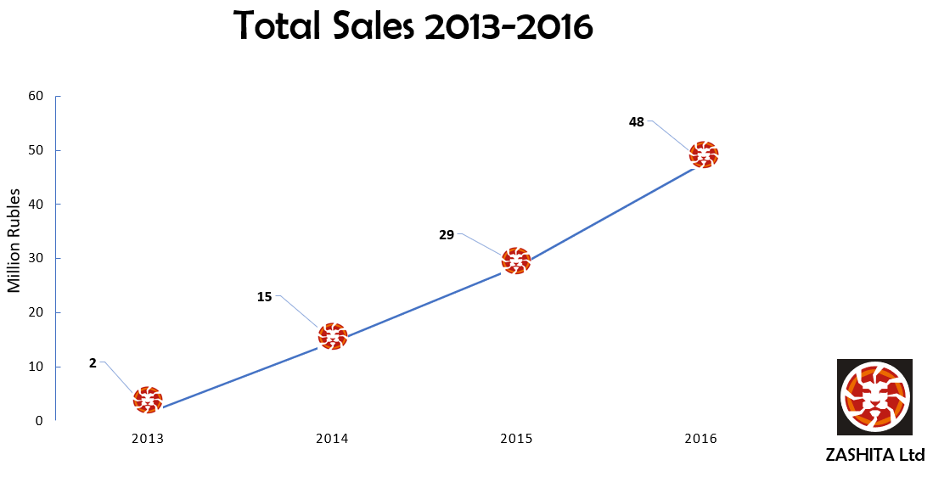

Source: Company files.

**EXHIBIT 4: Zashita, Sales Composition**

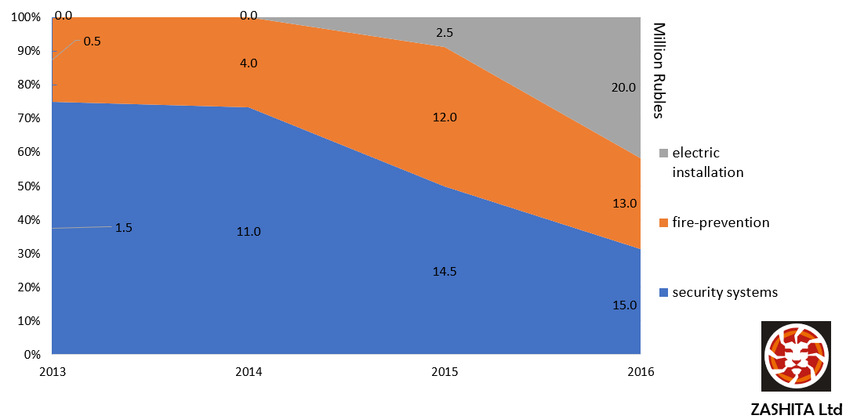

Source: Company files.

1. *Zashita* in Russian translates to “protection” in English.
2. T.F. Kreidenko and M.N. Mironova, “Modern Small Business in Russia,” *Regional Research of Russia* 2 no. 4 (2012): 358–363.
3. “Russia Bank Lending Rate,” Trading Economics, accessed November 9, 2018, https://tradingeconomics.com/russia/bank-lending-rate.
4. Linette Lopez, “How Russia's Billionaire Oligarchs Got so Very Rich,” Business Insider, March 24, 2013, accessed November 9, 2018, www.businessinsider.com/what-is-a-russian-oligarch-2013-3; Alessandra Stanley, “Russian Banking Scandal Poses Threat to Future of Privatization,” *New York Times*, January 28, 1996, accessed November 7, 2018, www.nytimes.com/1996/01/28/world/russian-banking-scandal-poses-threat-to-future-of-privatization.html.
5. RUB = Russian ruble; all currency amounts are in RUB unless otherwise specified; US$1 = RUB 62.87 on May 1, 2018.
6. “Entrepreneurial Behaviour and Attitudes,” Global Entrepreneurship Monitor, 2016, accessed November 7, 2018, www.gemconsortium.org/country-profile/104.
7. “Russia Corporate Tax Rate,” Trading Economics, 2018, accessed November 9, 2018, https://tradingeconomics.com/Russi a/corporate-tax-rate.
8. Natasha Turak, “Here’s Where Trump Has Been Tough on Russia — and Where He’s Backed Down,” CNBC, July 16, 2018, accessed November 8, 2018, www.cnbc.com/2018/07/16/heres-where-trump-has-been-tough-on-russia--and-where-hes-backed-do.html.
9. “Krasnoyarsk Map – Russia,” Mapcarta, accessed October 16, 2018, https://mapcarta.com/Krasnoyarsk.
10. Margaret Rouse, Sharon Shea, and Vendela Rendriksson, “Smart Home or Building (Home Automation or Domotics),” TechTarget, July 2018, accessed November 9, 2018, https://internetofthingsagenda.techtarget.com/definition/smart-home-or-building.