

9B19M024

ATIKAMEKSHENG FIRST NATION: MAPS, MAPLE SYRUP, AND MINING

Ron Mulholland wrote this case solely to provide material for class discussion. The author does not intend to illustrate either effective or ineffective handling of a managerial situation. The author may have disguised certain names and other identifying information to protect confidentiality.

This publication may not be transmitted, photocopied, digitized, or otherwise reproduced in any form or by any means without the permission of the copyright holder. Reproduction of this material is not covered under authorization by any reproduction rights organization. To order copies or request permission to reproduce materials, contact Ivey Publishing, Ivey Business School, Western University, London, Ontario, Canada, N6G 0N1; (t) 519.661.3208; (e) cases@ivey.ca; www.iveycases.com. Our goal is to publish materials of the highest quality; submit any errata to publishcases@ivey.ca.

Copyright © 2019, Ivey Business School Foundation Version: 2019-04-18

In 2018, Chief Steve Miller sat in his office. He was reviewing the mining files with mining liaison Robert Paishegwon, as they discussed the economic development of their community. Three years prior, they had signed an agreement with KGHM International Ltd. (KGHM), the Polish mining company; the agreement included a small yearly payment while exploration was in progress. However, base metal prices had slowed and the mine was now “under review”—a euphemism for a pause in development in anticipation of higher future metal prices.

Although there had been sporadic communication with the two other major mining companies, Sudbury Integrated Nickel Operations (Glencore) and Vale Canada Limited (Vale), the community did not have agreements with either of them. This was frustrating because the community’s traditional territory virtually encompassed the whole Sudbury mining camp, including the long-closed Long Lake Gold Mine. It seemed unfair that the community was receiving no compensation for activities taking place on their traditional territory.

The community was a party to several ongoing court proceedings in an attempt to redress claim disputes, but these were not anticipated to be resolved in the short term. In the meantime, the highway entrance to the community had been repaved for easier and safer access, retail businesses were prospering, and plans for a business park were coming along, with potential businesses interested in leasing space once the park was completed.

As Miller and Paishegwon examined a map of the area and the community’s traditional territory, the chief’s mind drifted to thoughts of long-ago leaders and what they would say. As he refocused his attention on the matter at hand, Miller wondered where best to direct his energy to maximize community development opportunities.

The Community

Atikameksheng Anishnawbek (Atikameksheng) was a First Nations community located in northeastern Ontario, 19 kilometres southwest of Sudbury on Regional Road 55. The reserve had an area of 19,750 hectares, approximately 7 per cent of the size of Manitoulin Island. Formerly known as Whitefish Lake 6, Indian Reserve, the land was situated along the Vermillion River, adjacent to Naughton, Ontario. The reserve extended east to Long Lake and southwest to Lake Panache (see Exhibit 1). The reserve was first described by the Robinson-Huron Treaty of 1850, but the reserve border in 2017 was smaller, less extensive, and not in agreement with what was described in the treaty.

The First Nation was governed by a chief (in 2017, the chief was Miller) and six councillors. The population in 2016 was approximately 1,200, of which nearly 400 lived on the reserve.[1] The community’s unemployment rate was approximately 15 per cent, higher than the less-than-10-per-cent rate in the rest of the region, but better than the 30-per-cent rate of Sagamok Anishnawbek First Nation, the next reserve to the west. Economic development and increased employment were obvious goals of the council.

Historic Context

Ancestors of the First Nations people had lived in the area for over 1,000 years. They practised hunting, fishing, and gathering at different times of the year. A study of southern archaeology sites indicated “a seasonal round where populations amalgamated and split depending on the resources available at specific locales.”[2] Similarly, northern neighbours would move to the coast or prolific lakeside or riverside community camps for a summer of hunting and fishing. In the fall, they would split up and return to traditional hunting and trapping grounds for the winter.[3]

In the words of the Atikameksheng community,

Our people have lived in this territory that we know as Atikameksheng Anishnawbek for many thousands of years. We thrived on a traditional lifestyle of hunting, fishing and gathering. We were deeply connected to the natural world. We did not live in large communities; rather two or three families would stay and travel together within a family territory. We went where the food supply was. We were not organized into any kind of structure like we have today but everyone played a role and contributed to the life of the families that lived together. We had our language, our cultural practices and our way of life, which was passed down from one generation to the next.

We settled on the shores of Lake Panache for some time, and some of the families built wigwams and maintained gardens there. Lake Panache, a big lake with a lot of fish, provided some stability and allowed families to stay in one place for a longer period of time.[4]

Research suggested that before contact with European explorers, the Ojibwe lived along the north shore of Lake Huron, where they would gather in summers at the mouth of a river or rapids to take advantage of plentiful fish and other food. Summer living could include as many as 300 people in one central location. Trade networks in pottery, copper, and shells extended across the north shore, where the ancestors of Atikameksheng[5] also travelled, enjoying extensive trade in the region and beyond (see Exhibit 2).[6]

The French explorers came into this environment. Likely the first in the area was Étienne Brûlé, an interpreter in Champlain’s entourage. In 1610, Champlain arranged for Brûlé to live with the Algonquians[7]to learn their language and customs. According to historians, the explorations of Brûlé and Grenolle, another interpreter, took them as far as Sault Ste. Marie around 1615.[8] They journeyed by canoe across the North Channel of Lake Huron, paddling past areas well known to Ojibwe ancestors of the Atikameksheng community.

Champlain was intent on exploring the new country on behalf of France to develop trade and a relationship with the Indigenous Peoples. Trading routes were established using Indigenous knowledge of the lakes and rivers, and the fur trade began to grow. The Hudson’s Bay Company (HBC), established in 1670, set up trading posts and forts in competition with the French traders, who were based in Montreal. The North West Company, an English competitor to the HBC, was established in the late 1700s. The company built a trading post on La Cloche Island, near the mouth of the Whitefish River.[9] In 1808, the trading post was relocated to the mouth of the creek running out of La Cloche Lake, south of Massey, Ontario.[10] Ancestors of the Atikameksheng likely went to the post to trade. In 1821, the HBC and North West Company merged[11] and were operated as an HBC post from 1821–1891.[12]

Having established a relationship with the British through trade at the HBC post, men from the Atikameksheng community fought alongside the British in the War of 1812.[13] The First Nations troops were led by Chief Shawenakishick[14] in battles in southern Ontario and the United States. Shawenakishick was later a signatory to the Robinson-Huron Treaty on behalf of the ancestors of Atikameksheng.

Treaty

The First Nations people had been engaged in trade first with the French and later with the British traders for 100 years, when the British Crown announced the Royal Proclamation of 1763. The proclamation followed an agreed end to a lengthy period of conflict between the French and the British over North American territories. With the end of conflict, settlers arrived and some lands were fraudulently purchased from the First Nations. To avoid these abuses, the proclamation reserved for the First Nations all of their land that had not been ceded or purchased, and made it illegal for anyone but the Crown to purchase land from the First Nations. But the growing country needed settlement lands for the immigrants arriving from south of the border and from Europe. Therefore, the government arranged a number of informal treaties in which the First Nations surrendered land in return for payment and the right to access the land for continued traditional uses.[15]

In 1836, government representatives travelled to Manitoulin Island to sign a treaty with the First Nations, who laid claim to the islands. The plan was to move First Nations people from Upper Canada to the islands, leaving much of Upper Canada available for settlement. But the proposed land was not abundant with the resources the First Nations needed for their traditional lifestyles, and it was removed from other settlements with the need for a water voyage to get there. Therefore, not many of the First Nations took up the proposed treaty.[16]

In 1849, William Robinson was appointed to negotiate treaty agreements with the Ojibway of Lake Superior and northern Lake Huron. Robinson was a fur trader, mining company director, and the brother of one of the most powerful political figures in Canada—the Chief Justice of Canada West. After some pre-negotiations and travels in the region, the Robinson-Huron Treaty was concluded in 1850 and signed on September 9 of that year.[17] The land assigned to the Atikameksheng was described as follows:

Shawenakishick and his Band, a tract of land now occupied by them, and contained between two rivers, called Whitefish River, and Wanabitaseke, seven miles inland.

Because of its location inland from Lake Huron, the Atikameksheng reserve was one of three reserves not surveyed (the other two being Wahnapitae and Gull Bay), despite the government’s explicit instructions to its Crown lands department to complete all treaty surveys within a short time. The First Nations chiefs and headmen, who were aware that miners and timber merchants were staking land and otherwise marking boundaries, wanted their reserves marked so they could keep unwanted explorers, claimers, and visitors out and sustain their own access to timber and other resources. The Spanish River Reserve (later known as Sagamok First Nation) was located 75 kilometres west of the Atikameksheng reserve on the North Channel of Lake Huron. The reserve was surveyed in the fall of 1852, but the surrounding reserves were not done.

The survey work that was done—or not done—had problems because of some or all of the following factors:

Boundaries partially or not at all surveyed; the conflict between distance dimensions understood by the Ojibwe people, the treaty commissioners and the surveyors (leagues vs. miles); the site negotiation of new boundaries; survey deficiencies; and rear boundaries not adhering to a specified depth from water frontages. Overall, the surveys were often incomplete, inadequate and inappropriate.[18]

The survey procedures were described as lacking detail and being misleading:

Location and identification descriptions for the reserves, as provided by the Chief for each signatory Band, were recorded in the treaty documents. However, the descriptions lacked specific detail . . . . Primarily, the descriptions provided an indication of the *general* location relative to the known lakes and rivers. The reserve boundaries were tentative, subject to specific details to be provided at each site . . . acknowledged that reality, and the necessity of having the surveyor accompanied by someone to translate each Band’s wishes for the locations of their boundaries.

Overall, it is apparent that Dennis and/or Keating [the surveyors] even with the understanding of the “leagues instead of miles” problem, through “negotiations” often surveyed larger tracts than described in the treaties in order to make the boundaries enclose improvements that would otherwise be excluded by a strictly “miles” interpretation. However, those tracts were still smaller than intended and expected by the Chiefs and Bands. Such actions were contrary to the intentions and instructions of the Crown Lands Department under which they were working.[19]

An historian illustrated how the surveyors sometimes excluded mineralized land. For example, with respect to the survey of Batachewana Bay First Nation (formerly Nebenaigoching and his Band), the historian wrote, “Keating caused the northern boundary to run south of the known iron and copper deposits, instead of ‘ten miles throughout the whole’ as prescribed by the Treaty, thus excluding these minerals from the Reserve area.”[20] Furthermore, she described how immediately following the signing of Treaty 3 in 1873, “Canada instructed its agents to exclude known mineral lands from the Reserves.” And in 1874 an Order in Council was issued stating that Reserves “should not include any lands known to the Commissioners to be mineral lands or any lands for which a mineral lands bona fide applications have been filed with either the Dominion or Ontario Governments.”[21] This would have an impact on future reserve surveys.

The Atikameksheng reserve was finally surveyed in 1884, when the Department of Indian Affairs asked the Indian Agent at Manitowaning, J. C. Phipps, to investigate the reserve of “Shawenakishick and his band.” Phipps described how the First Nations people visited La Cloche as a group in the late summer of 1880 to receive their treaty allotment and how he tried to ascertain the boundary of their reserve, described at that time as where the east branch of the Spanish River (later, the Vermillion River) met the Whitefish River.[22] Phipps expressed his frustration: “I cannot however get their description to fit with any Maps to which I have access, and the tract indicated by the [Chief and band’s] sketch would appear to be nearer twelve miles than three miles square. . . . The description of the reserves in the schedule of reservations seems to be far from correct.”[23]

Phipps instructed surveyor G. B. Abrey to survey three reserves inland from the north shore of Lake Huron, including Reserve Number 6. Historical records indicate that Abrey completed the work in 1884, but that the work was based on limited information and vague instructions provided to Abrey; it appears that he was provided only with the treaty description and the “position and statements of the Indians themselves.” Further complicating the survey were confusing and conflicting interests between the provincial government and the federal Department of Indian Affairs concerning the location and bounds of the reserve with respect to timber harvesting, development of the Canadian Pacific Railway, and an expected “influx of settlers.”[24]

Nonetheless, the survey was started in January 1884 and Abrey filed his report of the completed survey in June. In his report, Abrey described “the country comprised in the reserve [as] very rough and broken and not suited for agriculture.” He further stated that “The Indians belonging to the band did not at the time of the treaty nor since occupy between the Whitefish and Wahnapitae Rivers.”[25]

Abrey’s account has been disputed by the First Nations community. Their reserve in 2017 was a fraction of the area described in the original treaty, and their oral history indicated that their traditional land was much larger, even than that described in the treaty (see Exhibit 1):

During the eighteenth century and the first half of the nineteenth, the lands of the Whitefish Lake Ojibway included the traditional winter hunting and trapping area of each family, which extended from the lands of the Indians at Bear Island near Temagami and the west bank of Sturgeon River westward to the valleys of the Onaping and Vermillion Rivers, northward to the Height of Land, and southward to Tyson and Penage Lakes.[26]

The band previously had three village sites. The first and principal village was located on Lake Panache (sometimes called Lake Penage), but was relocated to the south end of Whitefish Lake in the late 1700s. There was another village on Vermillion Lake near where a dam existed in 2017. The second chief of the band had his residence in this village. The second chief assumed responsibility for the band in the absence or illness of the chief. A third camp was at Post Creek where the creek flowed into Lake Wanapitei. The land around this camp was granted to a different chief at the time of the treaty.[27]

Miller believed that Abrey may not have recognized all the traditional lands the community occupied because, according to Atikameksheng oral history, Abrey’s survey was carried out in late winter, during the annual sugaring season. The band would have been away from their regular village sites and in the area that did become noted as their reserve because they would have travelled there to tap the maple trees.

Abrey would have also been aware of, and possibly swayed by, earlier knowledge of mineralization in the area north of what became the reserve boundaries. Albert Salter was a surveyor commissioned by the province to survey the lands north of Lake Huron. As early as 1856, he found evidence of mineralization that ultimately led to the development of Creighton Mine in 1900.[28] Ironically, his work was commemorated in an Ontario Heritage Trust plaque located just north of the current reserve:

While surveying a meridian line north from Whitefish Lake in 1856, Albert Salter first noted the presence of mineral deposits in this remote region. In 1900, the Creighton Mine went into production at the site of Salter’s original discovery and for the next 30 years was the world’s leading nickel producer.[29]

Abrey, who also worked for the province, would have been aware of Salter’s discovery and likely had access to Salter’s field notes, plans, and maps. The development of the Canadian Pacific Railway was also a consideration that could have swayed Abrey’s survey findings. Indeed, correspondence between government officials dispute whether Abrey’s survey should have even continued, in light of provincial developments that failed to take into account potential reserve land and the pending arrival of the Sudbury-to-Sault Ste. Marie railway line, which was to be completed in 1888. Abrey was apprised of this information, with the Department of Indian Affairs acknowledging the community leaders’ concern that “the construction of the Canadian Pacific Railway . . . would probably pass through one if not all of the Reserves in question.”[30]

After the treaty

Timber

Having the reserve survey done long after the treaty was established created a number of problems, some exacerbated by poor communication between the federal government and the province of Ontario. Canada sold some timber rights on behalf of the Atikameksheng First Nation in 1886. The rights were severely undervalued at CA$316[31] and were subsequently resold for $55,000. The case went to court in 2006 and the First Nation was awarded $1 million. The government appealed the decision in 2007, and the court set aside the first judgement.[32] As of 2017, the matter was still before the courts and the chief was not expecting the case to be heard until at least 2018.

Another dispute also arose with the timber rights. This dispute was the result of timber being cut on berths that the province had granted, without knowing the bounds of the reserve. The federal government had included these lands in the Robinson-Huron Treaty, and after they were surveyed in 1884, the federal government sold the timber for the benefit of the First Nation. However, the province created its timber berths in 1872, before the survey was done. Communication between the federal and provincial governments was confusing, if communication existed at all. The province brought a claim against the men cutting the timber and against the federal government.[33]

The federal government had no evidence of its own to establish the existence of the reserve, but the court relied on testimony from members of the First Nation.[34] The court denied the province’s claim and, at the same time, severed 7,000 acres of the reserve above the east branch of the Vermillion River (known as the Whitefish Branch), indicating that the land was not traditional reserve land, but that the Hudson Bay agent “suggested that they might as well have this piece of land as it was in parts better adapted to cultivation.”[35] This did not amount to an official surrender of the land by the First Nation; a subsequent agreement settled the dispute with compensation of $14 million paid to the First Nation in 1998.[36] This money became the endowment for the Atikameksheng Trust, which supported education, culture, and health in the community.

Culture

Like all First Nations communities, Atikameksheng was also subject to, and suffered the consequences of the impositions under the *Indian Act*, introduced in 1876. The Act was a consolidation of existing colonial ordinances that attempted to assimilate First Nations people into Canada’s European-centric society.[37] Efforts to eradicate First Nations culture included, among other provisions, legislating attendance at residential schools, restricting First Nations people from leaving their reserve without permission, and prohibiting cultural practices.[38]

Minerals

In 1883, nickel-copper ore was discovered in Sudbury at what became the Murray Mine, just northwest of the city, adjacent to what became Highway 144.[39] That discovery led to the development of the Sudbury mining camp, consisting of more than 77 mines that went on to produce millions of tons of nickel and copper, thousands of tonnes of silver, and hundreds of tonnes of platinum and gold. The value of the base and precious metals had been estimated to be more than $330 billion. Some estimates put the value as high as $1 trillion.[40]

A line drawn northwest from the Atikameksheng Community to Vermillion Lake, northeast to Wanapitei Lake, south on the Wanapitei (Wanabitasebe) River, and west back to the Community demarcates what would have been Atikameksheng lands described in the Robinson-Huron Treaty. Those lands envelop most of the Sudbury mining camp (see Exhibit 3).

The Long Lake Gold Mine was developed in 1908 and operated sporadically for approximately 30 years, producing 57,000 ounces of gold and 650 ounces of silver.[41] The value of the gold in 2017 prices would be about $60 million. The mine was accessed by crossing the reserve property—access granted by the Department of Indian Affairs to the mining company as long as the there was “no damage done to the Reserve or spirituous liquors introduced thereon.” Indian Affairs did not demand or collect compensation for the First Nation (see Exhibit 4). A further complication was arsenic in the tailings from the mine: it leached into Long Lake, which was a source of fresh water and fish resources that formed the southern boundary of the Community.

In 2008, the First Nation sued the Canadian and Ontario governments, arguing that the reserve boundary established in the 1884 survey was incorrect. Their lawyer, Aaron Detler, surmised in a media interview, “I think that there was an effort to ensure that the reserve was as small as possible so that they could take advantage of the resources.”[42] The small reserve in the southwest area of what was the traditional territory was much smaller than described in the treaty and in community oral history (see Exhibit 1). Atikameksheng contended that the Sudbury mining camp had been developed on the First Nation’s traditional territory without compensation. The *Constitution Act, 1982* required companies to consult with First Nations before developing mines on traditional Indigenous land, but pre-existing mines were exempt. Vale and Glencore, having established their mines in the late 1800s to early 1900s, did not have a legal requirement to engage with the community for those pre-existing mines. The case was dismissed, and in 2017, the Community was re-assessing the evidence and oral history that described their traditional territory.

In 2014, Atikameksheng struck an advanced exploration agreement with KGHM, which was operating the redeveloped Victoria mine on Atikameksheng traditional territory. Because the mine was considered new (i.e., developed after 1982), the company had to consult and come to an agreement with the community. The agreement conferred some monetary benefit to the community as well as access to employment and contract work. As of 2017, the mine was still in development; however, because nickel and copper prices were low, the company had paused to have the “project’s technical and economic assumptions reviewed by independent specialists.”[43]

Atikameksheng did not have agreements in place with Vale or Glencore, the two local mining giants. There had been some intermittent attempts at coming to an agreement, but the progress was slow. Discussions were underway with Vale in May, 2018 and Miller was hopeful that some agreement of benefit to the community could be reached. Vale, and INCO before it, had benefitted greatly from resources in Atikameksheng traditional territory.

In another attempt to redress the wrongs inflicted on the First Nation, Atikameksheng was party to a claim filed in 2014 by 21 Robinson-Huron Treaty First Nations against Canada and Ontario for failing to act honourably and for breaching their fiduciary duty to the First Nations under the 1850 treaty. The claim sought, among other things, “compensation for past breaches.”[44]

Development Initiatives

The community had a number of economic development initiatives in mind. Timber harvesting was ongoing on an informal basis in the community. One idea was to formalize timber harvesting, investigate milling opportunities, and integrate the resources into the local building economy. The effort could be a potential source of community income from an activity they had pursued historically. This initiative would require staffing with people who had knowledge in timber management.

Another economic development possibility was an aggregate pit and quarry. Again, this would require staffing to manage the initiative while the commercial demand or supply in the area was unknown. A more traditional business idea was to develop an eco-lodge and camps to rent to tourists. A technology-based venture being considered was developing a solar energy farm using photo-voltaic panels. Atikameksheng had much land available for such a development.

The business park on land zoned for commercial and light-industrial use was planned to have 18 building lots. The first two lots were envisioned for an anchor tenant and a multi-use commercial building with office spaces for lease. The park was near completion and needed a dedicated staff person to promote and manage the development. The chief was hopeful that at least one or two of the tenants would be community members that developed successful businesses.

All of these ideas required resourcing, funds, and staff to investigate and implement the initiatives if they looked viable. The initiatives would be a good use of any funds received from court settlements, whether current or future actions, or funds received from mining company partnerships for resource development on Atikameksheng traditional lands. And, in all cases, there was the potential for skills and employment training to match the developing ventures.

Conclusion

The chief and liaison officer finished their meeting. Paishegwon went on his way, leaving Miller with his thoughts. The chief considered the issues arising from the incorrect treaty survey. The timber rights treaty suit could provide an award that would be used for community development. The reserve boundary question with compensation for extracted mining resources had potential; however, the community was reconsidering its approach to this situation. The most recent case filed in 2014 for the treaty breach also had potential for a future compensation; however, it would likely proceed slowly. Meanwhile, the chief had immediate development requirements to provide opportunities for employment and business for the community. Life was more complicated than in the past, and as he left the office for the day, Miller wondered where he might best focus efforts to facilitate community development.

Exhibit 1: Atikameksheng Anishnawbek Reserve and Traditional Territory (entire map)

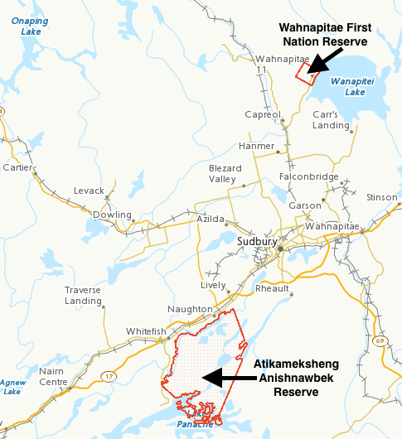

Source: “Canada Lands Survey System—CLSS Map Browser,” Natural Resources Canada, accessed May 10, 2016, http://clss.nrcan.gc.ca/map-carte-eng.php?can=06156. Used under Open Government Licence, Canada (https://open.canada.ca/en/open-government-licence-canada).

Exhibit 2: Ancient Trade Networks

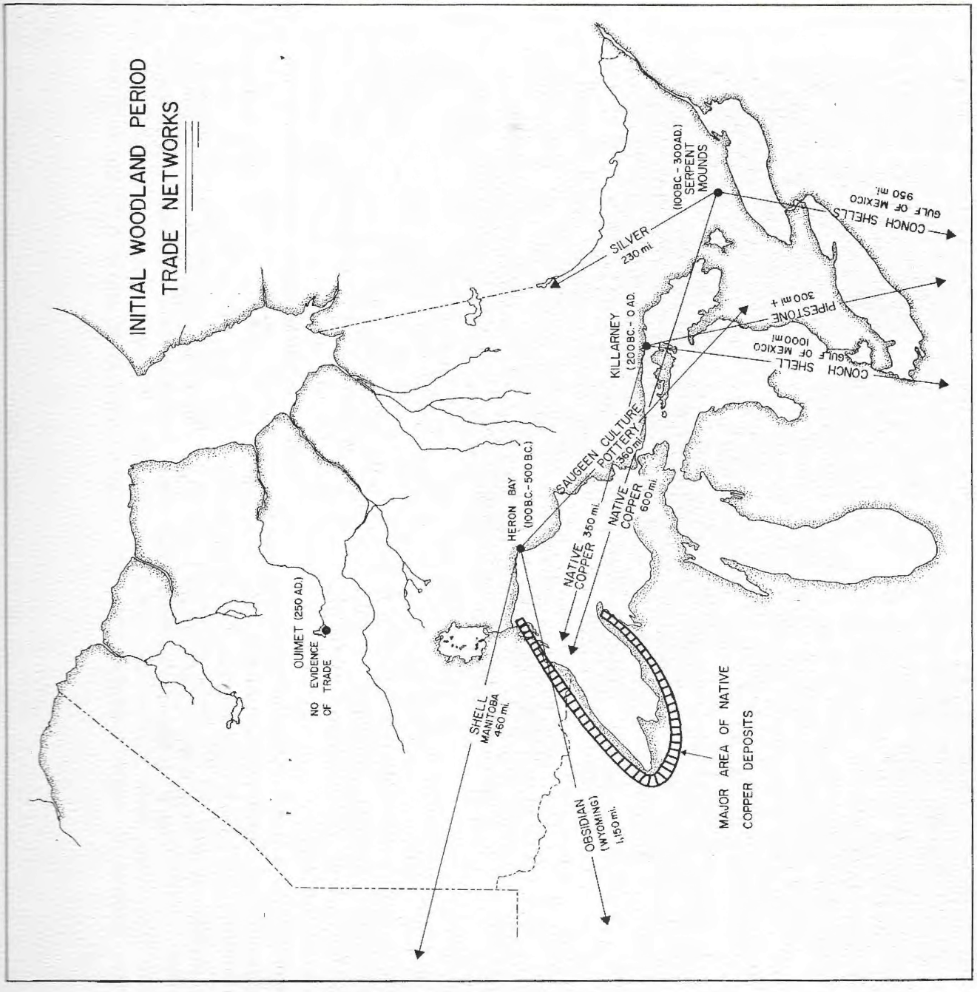

Source: James V. Wright, *Ontario Prehistory: An Eleven-Thousand-Year Archaeological Outline* (Ottawa: National Museum of Man, 1972), 49. Used with permission of the Canadian Museum of History (previously National Museum of Man).

Exhibit 3: Sudbury Mining Camp



Source: Vale Canada Limited (formerly Inco Limited). Used with permission.

Exhibit 4: Letter Granting Long Lake Gold Mine

access across Atikameksheng land

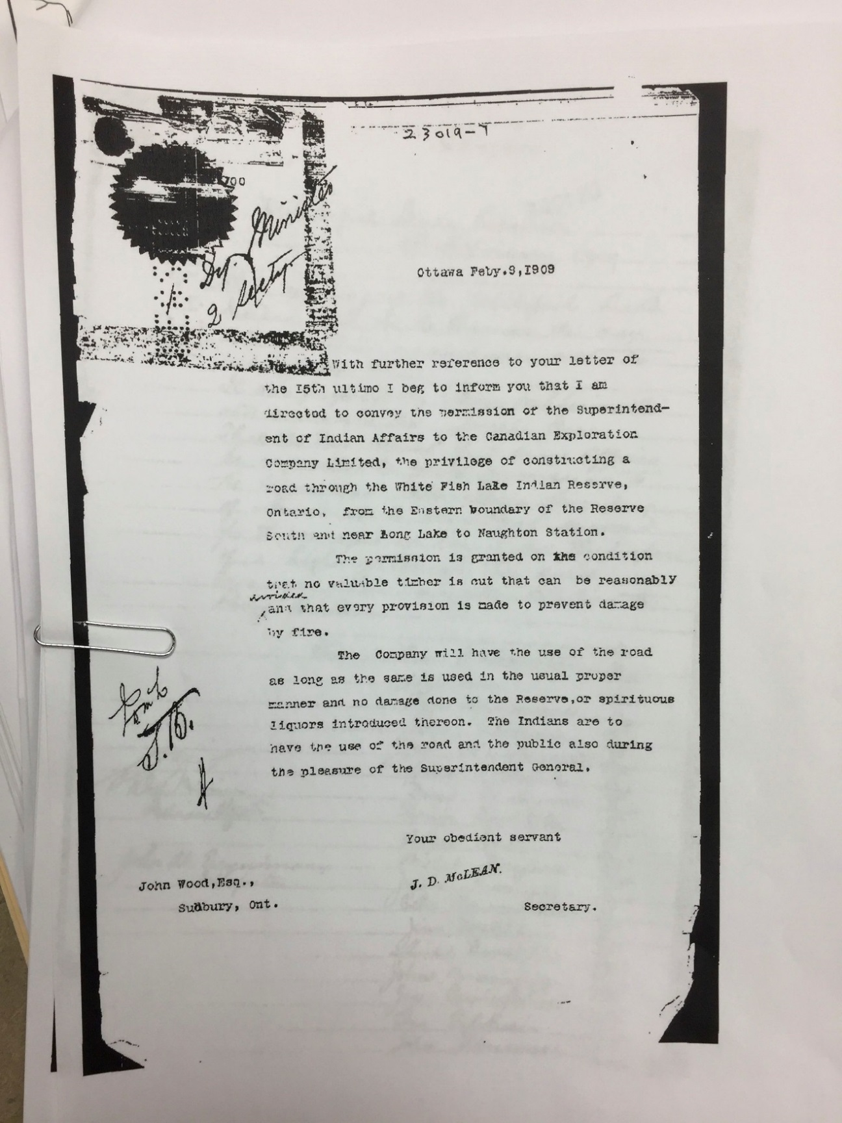

Source: Atikameksheng Anishnawbek. Used with permission.

endnotes

1. “Registered Population,” Aboriginal Affairs and Northern Development Canada, accessed September 10, 2017, http://fnp-ppn.aadnc-aandc.gc.ca/fnp/Main/Search/FNRegPopulation.aspx?BAND_NUMBER=224.
2. Shari Prowse, “Middle Woodland Fishing Methods at the Bluewater Bridge South Site” (masters thesis, University of Western Ontario, 2003).
3. David Bryan Cummins, “Attawapiskat Cree Land Tenure and Use” (doctoral dissertation, McMaster University, 1992).
4. Atikameksheng Anishnawbek, *Atikameksheng Anishnawbek Community Plan 2013*, (Halifax: Cities & Environmental Unit, Faculty of Architecture and Planning, Dalhousie University, 2013), 8.
5. “Atikameksheng Anishnawbek are descendents of the Ojibway, Algonquin and Odawa Nations,” Atikameksheng Anishnawbek, accessed December 19, 2018, www.atikamekshenganishnawbek.ca/site/community.
6. Charles A. Bishop, *The Northern Ojibwa and the Fur Trade: An Historical and Ecological Study* (Toronto: Holt, Rinehart and Winston, 1974).
7. *Algonquian* referred to a large linguistic and cultural group, which included the Algonquin nations among others. Meredith Jean Black and Zach Parrott, “Algonquin,” *Canadian Encyclopedia*, October 9, 2018, accessed November 2, 2018, www.thecanadianencyclopedia.ca/en/article/Algonquin.
8. David Hackett Fischer, *Champlain’s Dream* (New York: Simon & Schuster, 2008), 496, 499, and 507.
9. Ernest Voorhis, *Historic Forts and Trading Posts of the French Regime and of the English Fur Trading Companies* (Ottawa: Department of the Interior, 1930). La Cloche Island was later defined as two islands: Great La Cloche and Little La Cloche.
10. “Fort La Cloche,” North American Forts: Northern Ontario (East), accessed April 12, 2016, www.northamericanforts.com/ Canada/on-north.html# lacloche.
11. "History of Fort la Cloche," Willisville, accessed December 14, 2015, www.willisville.ca/History%20of%20Fort%20La% 20Cloche.htm.
12. “Post Managers at Fort La Cloche,” Willisville, accessed December 14, 2015, [www.willisville.ca/Fort%20La](http://www.willisville.ca/Fort%20La)%20Cloche%20Post%20Managers.htm.
13. Edwin Higgins and Whitefish Lake Indian Reserve No. 6, *Whitefish Lake Ojibway Memories* (Cobalt, ON: Highway Book Shop, 1982), 52.
14. Referred to as Shawinakeshick in some government documents.
15. “250th Anniversary of the Royal Proclamation of 1763,” Indigenous and Northern Affairs Canada, accessed December 16, 2015, www.aadnc-aandc.gc.ca/eng/1370355181092/1370355203645.
16. Robert J. Surtees, “The Making of the Manitoulin Treaty, 1836” in *Treaty Research Report: Manitoulin Island Treaties* (Treaty and Historical Research Centre, Indigenous and Northern Affairs Canada, 1986), accessed December 14, 2015, www.aadnc-aandc.gc.ca/DAM/DAM-INTER-HQ/STAGING/texte-text/tremtou_1100100028960_eng.pdf.
17. **Janet Elizabeth Chute,** *The Legacy of Shingwaukonse: A Century of Native Leadership* (Toronto, ON: University of Toronto Press, 1998), 140.
18. Michael Marlatt, “The Calamity of the Initial Reserve Surveys under the Robinson Treaties” in *35th Algonquian Conference*, ed. H. C. Wolfart (London, ON: University of Western Ontario, 2004).
19. Ibid.
20. Rhonda Telford, “‘The Sound of the Rustling of Gold Is under My Feet Where I Stand: We Have a Rich Country’: A History of Aboriginal Mineral Resources in Ontario” (doctoral dissertation, University of Toronto, 1996), 184.
21. Ibid., 215.
22. Leclair Historical Research, “Research Report: Report on Instructions to Abrey for Survey of Whitefish Lake Reserve” (research report prepared for Geomatics Canada, Toronto, Ontario, 2006), accessed April 15, 2016, http://clss.nrcan.gc.ca/plan-eng.php?id=FB39732+CLSR+ON. The east branch of the Spanish River later became known as the Vermillion River.
23. J.C. Phipps to the Superintendent General, Department of Indian Affairs, December 30, 1880, as reported in Leclair Historical Research, “Research Report: Report on Instructions to Abrey for Survey of Whitefish Lake Reserve” (research report prepared for Geomatics Canada, Toronto, Ontario, 2006), 5.
24. Leclair Historical Research, op. cit.,
25. G.B. Abrey, *Field Notes and Other Returns of the Survey of the White Fish Lake Indian Reserve* (Toronto: ON, June 20, 1844), 40.
26. Higgins, op. cit., 68*.*
27. Ibid., 76.
28. Royal Ontario Nickel Commission, *Report of the Royal Ontario Nickel Commission* (Toronto, ON: A.T. Willgress. 1917), 28, accessed April 15, 2016, https://archive.org/details/reportofroynickel00onta.
29. “Salter’s Meridian 1856,” Ontario Heritage Trust: Online Plaque Guide, accessed November 5, 2018, www.heritagetrust.on.ca/en/index.php/plaques/salters-meridian-1856.
30. Leclair Historical Research, op. cit., 9.
31. All dollar amounts are in Canadian dollars unless otherwise specified.
32. *Whitefish Lake Band of Indians v. Canada (Attorney General)* (2007), 87 O.R. (3d) 321, 287 D.L.R. (4th) 480 (Ont. C.A.), accessed April 15, 2016, http://canlii.ca/t/1tfq3.
33. “Ontario vs. Francis” [*Ontario (Attorney General) v. Francis et al*. (1889), Ont. H.C.], *Canadian Lumberman* 9, no. 2, February 1889, 11–12, accessed April 15, 2016, https://archive.org/details/canadianforest188990donm/page/n31?q=Canadian+lumbermen+1889.
34. Sidney L. Harring, *White Man’s Law: Native People in Nineteenth-Century Canadian Jurisprudence* (Toronto, ON: University of Toronto Press, 1998), 143–144.
35. “Ontario vs. Francis,” op. cit., 12.
36. “History,” Atikameksheng Trust, accessed April 15, 2016, www.atiktrust.ca/history-2.
37. William B. Henderson and Zach Parrott, “Indian Act,” *Canadian Encyclopedia*, October 23, 2018, accessed November 5, 2018, www.thecanadianencyclopedia.ca/en/article/indian-act.
38. Bob Joseph, “21 Things You May Not Know about the Indian Act,” CBC News, April 13, 2016, www.cbc.ca/news/indigenous/21-things-you-may-not-know-about-the-indian-act-1.3533613.
39. Science North, *Discovery Site of Sudbury Mining Camp, Sudbury,* GeoTours Northern Ontario, accessed April 18, 2016, www.sciencenorth.ca/dynamic-earth/geotours/sudbury/05_discovery_mining-camp_e.pdf.
40. “QuadraFNX Unveils Victoria’s Secrets,” *Sudbury Mining Solutions Journa*l, March 1, 2011, accessed April 18, 2016, www.sudburyminingsolutions.com/quadrafnx-unveils-victorias-secrets.html; Stan Sudol, “Ontario’s Far North Act: Aboriginal Poverty or Prosperity?” *Canadian Mining Journal*, October 31, 2011, accessed April 17, 2016, www.canadianminingjournal.com/news/ontarios-far-north-act-aboriginal-poverty-or-prosperity.
41. Ministry of Northern Development and Mines, Ontario, *Category C Environmental Assessment: Long Lake Gold Remediation, Geographic Township of Eden, Ontario* (Toronto, ON: Government of Ontario, 2017), accessed November 5, 2018, www.mndm.gov.on.ca/sites/default/files/class_ea_projects/long_lake_gold_project_document_en.pdf.
42. Bill Curry, “Native Band Sues for $550-Billion, Saying Mine Sites Belong to Them,” *Globe and Mail*, May 14, 2008, accessed November 1, 2016, www.theglobeandmail.com/news/national/native-band-sues-for-550-billion-saying-mine-sites-belong-to-them/article672485.
43. “Projects Under Development: Victoria,” KGHM Polska Miedź, accessed November 1, 2016, http://kghm.com/en/our-business/projects-under-development/Victoria.
44. “Litigation,” Robinson-Huron Treaty 1850, accessed November 5, 2018, http://rht1850.ca/litigation; Olivia Stefanovich, “Northern Ontario First Nations Take Federal and Ontario Governments to Court over $4 Annual Treaty Payments,” CBC News, September 25, 2017, accessed November 5, 2018, www.cbc.ca/news/canada/sudbury/robinson-huron-treaty-annuities-claim-court-case-1.4303287.