

9B19M036

FLASHFOOD.SHOP: SELF-SERVICE RETAILING OF FRESH MEALS IN CHINA

Yibo Lyu, Shaojie Han, Qing Liu, and Jingqin Su wrote this case solely to provide material for class discussion. The authors do not intend to illustrate either effective or ineffective handling of a managerial situation. The authors may have disguised certain names and other identifying information to protect confidentiality.

This publication may not be transmitted, photocopied, digitized, or otherwise reproduced in any form or by any means without the permission of the copyright holder. Reproduction of this material is not covered under authorization by any reproduction rights organization. To order copies or request permission to reproduce materials, contact Ivey Publishing, Ivey Business School, Western University, London, Ontario, Canada, N6G 0N1; (t) 519.661.3208; (e) cases@ivey.ca; www.iveycases.com. Our goal is to publish materials of the highest quality; submit any errata to publishcases@ivey.ca. i1v2e5y5pubs

Copyright © 2019, Ivey Business School Foundation Version: 2019-05-10

On April 1, 2017, Ye Ji founded a self-service retail platform for fresh meals called Flashfood.Shop in Dalian, Liaoning province, China. Flashfood.Shop used intelligent self-catering machines (ISM) as its physical sales terminals and an intelligent self-catering system (ISS) as its online service interface. Relying on fresh meals from catering suppliers, Flashfood.Shop provided office workers with quick and affordable 24-hour catering services. After more than a year in development, the platform was finally ready for normal operation.

By the end of June 2018, Flashfood.Shop had launched 51 ISMs, where customers could buy fresh meals from a vending machine. The company had 14 catering suppliers, 135 different types of catering products, and over 500,000 customers. The average sales volume from a single ISM had increased from 8.43 to 30.25 servings per day, which was a growth in average revenue turnover from ¥121.51[1] to ¥410.81 per day. The wastage rate of catering products had also dropped from the initial 27.97 per cent to 9.05 per cent.

However, behind the rapid development of Flashfood.Shop was a loss incurred in five consecutive quarters. After its establishment in April 2017, the company’s only income source was the sale of its catering products. At the same time, its operating costs were high due to the instability of the ISMs and ISSs, low operating efficiency, and other factors. Faced with these issues, Ji, the founder and general manager of Flashfood.Shop, was wondering how to resolve his company’s difficulties.

background

With the swift development of China’s economy and the improvement of people’s per capita income level, the population of China’s middle class reached 204 million in 2017.[2] These factors contributed to the rise of China’s catering market, which reached nearly ¥4 trillion (see Exhibit 1).[3] Alternative business models to restaurant meals achieved explosive growth in China, including fresh meals available via online food delivery, in convenience stores, and in self-service outlets. These three business models primarily targeted middle-class office workers[4] and subsequently became the main source of meals for this segment. Generally, office workers were urban people with high academic qualifications and a steady income, and engaged in intellectual work.

Online Food Delivery

Online food delivery was an Internet-based business model, where consumers could place an order online, pay through a mobile payment application (app) such as WeChat Pay or Alipay, and then wait for the fresh meal to be delivered to their doorstep. In 2011, with the establishment of domestic food-delivery companies such as Meituan, Ele.me, andBaidu Waimai, the online food delivery industry was booming in China. In the growing stage of this industry, these companies attracted more than ¥70 billion in financing. As of June2018, Meituan had successfully accumulated more than ¥40 billion in multiple-round financing, while Ele.me had raised over ¥20 billion from investors. These funds effectively promoted the development of China’s online food-delivery market (see Exhibit 2).[5] After nearly seven years of fierce competition, Baidu Waimai was taken over by Ele.me in 2017,[6] which shifted the landscape of China’s online food delivery market from a tripartite confrontation to a rivalry between Meituan and Ele.me.

The main customers of online food-delivery retailing were office workers, whose mealtimes were generally short because of high work intensity. Online food delivery allowed office workers to enjoy catering services in the office, which greatly saved time. Gradually, online food delivery also became a popular dining option for this group. According to a report by the think tank Analysis, the sales volume of online food delivery for office workers reached ¥38.13 billion, accounting for 83 per cent of the overall online food delivery market. It was clear that online food delivery had become the most popular quick meal choice for Chinese office workers.[7]

Fresh Meals in Convenience Stores

Fresh meals in convenience stores provided customers with rice, noodles, wonton, and other cooked meals, in addition to traditional convenience store products such as basic necessities, snacks, and beverages. Because of the numerous convenience stores in business districts, where office workers spent their day, fresh meals in these stores gradually became an important option for quick meals for this group. In China, the earliest companies to provide fresh meals in convenience stores were Lawson, 7-Eleven, and Family Mart. The stores provided bento boxed lunches, vegetable salads, fruits, ice cream, and other meal categories. The sales of fresh meals in convenience stores accounted for 30–40 per cent of total sales, generally accounting for 40–70 per cent of gross margins. Therefore, fresh meal retailing was the most important source of profit for these convenience stores. In recent years, some convenience stores increased the proportion of fresh meal sales in their overall sales, from an initial amount of 10 per cent, up to 30–50 per cent.[8]

A report jointly released by the China Chain-Store & Franchise Association and the Boston Consulting Group noted that in 2016, the number of convenience stores in China reached nearly 100,000, with a growth rate of 13 per cent and a market size exceeding ¥130 billion.[9]

Self-Service Machines for Fresh Meals

Despite the rapid expansion of the online food-delivery market and the increasing number of convenience stores in China, there were drawbacks to both of these options. However, self-service catering machines offering fresh meals seemed to be able to avoid the disadvantages of the other two types of retailers.

Although the online food-delivery market was still expanding, its growth rate had slowed significantly (see Exhibit 2),[10] which highlighted problems with this option. The cost of delivery was too high an expense for companies providing online fresh meal services. In some Tier 2 cities, such as Dalian, delivery could cost ¥10 per serving, while in Tier 1 cities, such as Beijing, the cost was up to ¥15 per serving for these companies, which meant that online food delivery services were not profitable for fresh meal orders below ¥30. In addition, customers often complained about long waiting times during peak hours. Customers normally waited 40 minutes for their meals, from the time the online order was placed to the time of delivery at their doorstep. During peak hours, that time could reach more than one hour, which was unacceptable for office workers who normally had only 60–90 minutes for their lunch break. There was also great demand for breakfast and midnight snacks, but these companies were rarely able to provide delivery services at these times.

The sale of fresh meals in convenience stores was also plagued with high rent and labour costs, which led to high meal prices. Convenience stores were mainly located near office workplaces in business districts, where rent costs were generally higher. For example, in 2011, the monthly rent charge at a Beijing CBD office was ¥300 per square metre; by 2014, it had reached ¥1,000 per square metre.[11] Convenience stores also required at least two workers, which had become more of an expense with increasing urban labour costs. For example, China’s average employee salary had risen five times from 2008 to 2017.[12] And although convenience stores were located near office areas, workers were still required to walk approximately 300–1,000 metres. Office workers who had become accustomed to eating meals without stepping outside their office found fresh meals from convenience stores a less appealing option.

Self-service catering machines offering fresh meals seemed to resolve the problems incurred by both online and convenience stores. The self-service fresh meals option was a new business model that made use of intelligent technologies such as mobile payment, face recognition, and Radio Frequency Identification, without requiring servers or cashiers. Compared to online food delivery, self-service fresh meals could greatly reduce delivery costs through centralized distribution, and could achieve high gross profit margins, even with unit prices of ¥30 or less. ISMs could provide 24-hour catering services, covering breakfast, lunch, dinner, afternoon tea, and midnight snacks. Customers could receive their meal within 100 seconds of making their payment, which greatly reduced waiting times. Compared to fresh meals sold in convenience stores, the self-service business model enjoyed the advantages of low rent costs (for only 1 square metre) and no labour costs, and provided office workers with shorter walking distances (usually within 100 metres) and less time wasted.

According to an Ai Media Consulting report, the market size of self-service retailing in China was ¥38.94 billion in 2017. In the next five years, China’s self-service retailing was expected to go through a high development period, and the market was expected to see a growth rate of 281.30 per cent until 2020 to exceed ¥1.8 trillion by 2022.[13] The sale of self-service fresh meals was expected to reach a market size of ¥24.1 billion in 2018, achieving a 50 per cent growth rate.[14] The online catering market had developed rapidly in recent years, but it was only able to capture a 4–6 per cent share of the overall catering market to date. Clearly, the development of the online catering market was far from its saturation point; however, the potential market space in this field was also an opportunity for self-service retail of fresh meals.[15]

founding of flashfood.shop

On April 1, 2017, Ji founded Flashfood.Shop and established the self-service catering platform to provide fresh meals through the use of both ISMs and ISS platforms, using both physical and online service interfaces. With fresh meals provided by catering suppliers, the platform offered office workers affordable and convenient 24-hour catering services.

Ji and His Team

Ji had worked as a senior engineer for IBM in the past, in information technology research and development. He had extensive experience in e-commerce, multimedia information data management, data retrieval, and data mining. In 2010, Ji left IBM and formed a team of nearly 100 people to provide research and development services in software and e-commerce. He had also worked on the development of e-commerce system projects for Haier Group, China Minsheng Bank, and other companies.

In 2014, Ji was hired by Baidu Waimai, in Dalian, where he worked for three years. The company was responsible for online and traditional food delivery promotion, distribution, operation, maintenance, and other services. During that time, Ji accumulated a wealth of experience and insight into the development of the catering industry and e-commerce technology. That experience helped him discover and learn to resolve various problems inherent in two major markets—online and convenience store fresh food retailing. His solution was self-service catering of fresh meals. As a native of Dalian, Ji had always hoped to build a Dalian-based unicorn enterprise.[16] The opportunity that self-service catering of fresh meals promised made him see his vision more clearly and ignited his fighting spirit.

At the beginning of 2017, Ji and his team began working on the development of Flashfood.Shop, a self-service retailing platform of fresh meals. His entrepreneurial team consisted mainly of three groups of people. The first group was the information technology staff working on the software system development, e-commerce, data mining, and other areas. The staff in the second group, who had come from Baidu Waimai, accumulated rich experience in the catering field. The third group consisted of Ji’s friends, whom he had invited to supplement the team and address any weaknesses. This group included Bin Zhang, who was once Neusoft’s senior business manager; Jingyi Han, who had rich experience in restaurant brand design and had created more than 10 successful catering brands; Xiaopeng Yang who had been a senior marketing manager at Lawson convenience stores; and Yuanyuan Song, who was once a senior leader of human resources in Tencent’s head office. The above three groups together formed the entrepreneurial team of Flashfood.Shop (see Exhibit 3).

The ISM and the ISS

Hardware: The ISM

Flashfood.Shop’s ISMs were physical hardware terminals for use by retail customers. They were composed of four main partition modules—refrigeration (for storing the products), heating, transmission, and display (for the purchase of fresh meals). To ensure the proper function and high quality of the ISM hardware, Flashfood.Shop collaborated with Dalian Fushibingshan Vending Machine Co., Ltd. (Fushibingshan). Founded in 2003, Fushibingshan had grown to become China’s vending machine industry leader, with total sales to date of 120,000 vending machines.

Flashfood.Shop and Fushibingshan workers focused their efforts on ensuring the proper function and stability of the hardware through iterative experiments. Fushibingshan was so convinced of Flashfood.Shop’s prospects that it offered ¥40 million in lease funding, which greatly alleviated the new business’s financial pressure. After the successful development of the ISMs, Fushibingshan trained engineering staff at Flashfood.Shop, and then authorized and assisted staff members to carry out daily operations and maintenance work, such as installation, maintenance, and repair.

Software: The ISS

Flashfood.Shop’s ISS was the key to ensure proper operation of the company’s online platform. The system featured online display, ordering, and payment processes. The software enabled Flashfood.Shop’s real-time monitoring of the quality and quantity of meals. As well, the software enabled the company to conduct data statistics and other operational duties. The software system was developed strictly by Flashfood.Shop’s team.

Flashfood.Shop’s ISS operated online via a built-in WeChat app, without the need for downloading and installation. Customers could simply search for Flashfood.Shop on their WeChat apps to access the system. Based on their current location, customers could choose the nearest machine and select their meal. After ordering and paying for the meal, they would receive a code to retrieve their meal from the chosen catering machine. Customers could also purchase fresh meals directly from the ISM by selecting their desired meal on the machine’s display, clicking the corresponding picture, and paying by scanning a code generated by the machine. The complete process could take only 20–100 seconds, depending on whether the meal required heating. The operator interface of the ISM allowed Flashfood.Shop to perform a series of operations, including machine monitoring, meal monitoring, shelf management, and operation analysis.

Suppliers and Customers of Flashfood.Shop

Essentially, Flashfood.Shop operated as a middleman platform that connected catering suppliers with customers, thereby achieving supply and demand docking (see Exhibit 4).

Catering Suppliers

Flashfood.Shop had to attract suppliers to provide catering products for its ISM and customers to purchase the products. However, the company was newly established and lacked brand recognition. Therefore, it decided to use well-known food brands and high-quality catering products to attract customers. To ensure high-quality products, the catering suppliers had to meet various standards. First, their brand had to be well known to consumers. Second, they had to have a central kitchen in Dalian, to guarantee the quality of the food. Third, the products provided by the supplier had to retain their colour and form after refrigeration or heating (if required). Fourth, the products had to pass a series of Flashfood.Shop’s quality and safety standards regarding production, transportation, and storage of the foods. Collaborating with suppliers, Flashfood.Shop was able to provide 24-hour uninterrupted catering services with meals for breakfast, lunch, dinner, afternoon tea, and midnight snacks. By the end of 2018, Flashfood.Shop was providing 135 different types of catering products, including Crispy Pork Chop Rice, Orlean Roast Chicken Leg Rice, and Black Pepper Beef Rice.

Customers

Flashfood.Shop targeted mainly office workers, so accurate placement of the ISMs near office workplaces was essential. To develop the perfect plan for site selection of the ISMs, Ji invited professionals from Lawson to join the team and provide their expertise with the convenience store location model. After considering many site selection models, Flashfood.Shop developed a standard process to evaluate potential sites based on user profiles, strategic planning, field research, and standard models.

operations of flashfood.shop

Delivery System

Flashfood.Shop’s products had to be transported from the various catering suppliers to the ISMs before customers could make a purchase. Working with third-party logistics enterprises, Flashfood.Shop developed a delivery system that used both four-wheeled vehicles and two-wheeled electric bicycles to transport the products (see Exhibit 5). Generally, the four-wheeled vehicles would deliver all catering products to ISMs at 10 o’clock every night. When a specific machine ran out of a product, the two-wheeled electric bicycle would replenish the machine.

The average delivery cost was reduced to about ¥1.5 per serving through a centralized distribution system using the two types of vehicles. With more ISMs, and with the optimization and upgrading of the delivery system, that cost could be further reduced to an average of ¥0.8 per serving.

Delivery costs remained a major concern of online food delivery businesses, with much higher rates of up to ¥10 per serving in Tier 2 cities and ¥15 per serving in Tier 1 cities. Rising rental and labour costs also resulted in high operating costs for convenience stores. However, Flashfood.Shop was able to take advantage of centralized distribution of its catering products to reduce its delivery costs.

Marketing and Promotion

With rich experience in catering promotion, the Flashfood.Shop team had built a complete marketing and promotion process in four stages: customer research, customer development, continuous optimization, and viscosity maintenance. For the first stage, conducting customer research, the marketing team prepared a questionnaire to gain basic information about potential customers within each ISM’s radius. The information collected included consumption patterns, consumption amounts, meal preferences, age distribution, and male-to-female ratio. For the second stage, to develop a customer base, the marketing team promoted its catering products using flyers and posters, and by directly inviting customers to participate in the product experience by establishing specific WeChat groups. For the third stage, continuous optimization, the team cultivated customer consumption behaviours through promotional activities. The marketing team also worked to increase the frequency of customer consumption levels and developed new customers by offering discounts for best selling items, providing incentives for inviting friends to try the service, giving one free item with the purchase of three meals, and providing coupons for free meals. For the fourth stage, viscosity maintenance, the team continuously tracked and summarized customer behaviour and dynamically adjusted its sales strategy. The marketing team made adjustments to types of catered products and to promotion strategies based on background data aggregation and analysis, and on customer feedback. The idea was to continuously enhance the customer’s experience.

Establishment of Standards for Self-Service Retail of Fresh Meals

Self-service retail standards were crucial for the operation’s security and the company’s prominence in the industry for the future. As a leading company in the self-service retail of fresh meals, Flashfood.Shop jointly formulated the industry standards in China with field experts including Wanchun Guo of the Dalian Food and Drug Administration, Fushibingshan, Dalian Acasia Food Co., Ltd. (Acasia), and Dalian Gongqingyuan Food Co., Ltd. (Gongqingyuan). The partners set standards for the complete process of food traceability, packaging, transportation, and storage. They used various established industry standards as their source, including the *Hygienic Standard of Self-service Food Retailing* and the *National Food Safety Standard of the People’s Republic of China*.

In regard to the standards for food traceability, Flashfood.Shop collaborated with well-known catering brands such as Acasia and Gongqingyuan to provide each product with a unique identifier for ease of tracking. For the food packaging standards, Flashfood.Shop set up specifications for appropriate grade and materials of paper towels, spoons, forks, and meal boxes. When setting the food transportation standards, cold chain equipment had to be provided during the transportation process so that the products could be kept at an appropriate temperature of 4 degrees Celsius or less. In reference to the food storage standards, both the supplier and the operator were required to meet appropriate fresh-keeping conditions. For example, catering suppliers had to guarantee that the products could be quickly cooled to below 10 degrees Celsius within 30 minutes after cooking, to eliminate bacteria and lock in nutrient moisture. Catering operators like Flashfood.Shop also had to guarantee that the products were always kept at 0–4 degrees Celsius before purchase. For each product, the catering operator was required to monitor the temperature and storage period in real time through the system’s back end. If a product’s temperature or storage period exceeded the pre-set value, an alarm would be immediately triggered.

flashfood.shop’s Dilemma

Flashfood.Shop successfully built a self-service retail platform to connect catering suppliers of fresh meals with the targeted office worker consumers, using ISM sales terminals and an ISS online service interface. It also kept the platform running while constructing a delivery system, a marketing and promotion system, and a set of standards for self-service retailing of fresh meals. By the end of June 2018, Flashfood.Shop had installed 51 ISMs in Zhongshan District, Xigang District, Shahekou District, and Ganjingzi District in Dalian City, with 14 catering suppliers and 135 different catered products. The number of customers exceeded the 500,000 mark. Meanwhile, the average sales volume of a single ISM increased from 8.43 servings per day to 30.25 servings per day, with an average financial turnover increase from ¥121.51 to ¥410.81 per day. Also, the rate of wastage of catering products dropped from the initial 27.97 per cent to 9.05 per cent.

Ji was very happy to see such rapid development of Flashfood.Shop in just over one year. However, behind the rapid development, Flashfood.Shop was facing a loss in five consecutive quarters (see Exhibit 6). Although it was normal for start-ups to incur losses in their early stages, Ji worried about his business. Flashfood.Shop’s only current source of income was the sale of its catering products, which was not enough to support the operation. Current delivery costs were ¥1.5 per serving, far from the optimal level of ¥0.8 per serving. Moreover, operating costs were too high because of the instability of the ISMs and the ISS, and because of low operating efficiency. Faced with this situation, Ji was wondering how to resolve the problem of ongoing losses in consecutive quarters.

**EXHIBIT 1: MARKET SIZE and growth rate of china’s catering market,   
2008–2017 (in ¥)**

Source: Created by the authors with information from Yang Yuran, “Meituan Review: China's Catering Market Will Reach a Record High of 5.1 Trillion to 5.5 Trillion by 2020,” Cyzone, (in Chinese), December 26, 2017, accessed November 20, 2018, www.cyzone.cn/a/20171226/320811.html.

**EXHIBIT 2: MARKET SIZE and growth rate of china’s online food delivery market, 2011–2017 (in ¥)**

Source: Created by the authors with information from “A Report on China’s Online Food Delivery Market From 2017 to 2018,” Iimedia, (in Chinese), January 17, 2018, accessed November 21, 2018, www.iimedia.cn/60449.html.

**EXHIBIT 3: Organizational structure of flashfood.shop**

|  |  |  |  |
| --- | --- | --- | --- |
| **General Manager** | **Department** | **Number of Employees** | **Function** |
| Ye Ji | Marketing Department | 8 | Site Selection |
| Marketing and Promotion |
| Marketing Maintenance |
| Operations Department | 6 | Delivery Services |
| After-Sales Services |
| Data Summary |
| R & D Department | 15 | System Development |
| System Maintenance |
| Data Analysis |
| Brand Department | 5 | Brand Design |
| Brand Promotion |
| Brand Maintenance |
| Engineering Department | 3 | Machine Instalment |
| Machine Testing |
| Machine Maintenance |
| HR Department | 3 | Personnel Recruitment |
| Performance Evaluation |
| Salary Distribution |

Note: R & D = research and development; HR = human resources.

Source: Created by authors using data from Ji.

**EXHIBIT 4: Comparison of food delivery by four-wheeled vehicles and   
two-wheeled electric bicycles**

|  |  |  |  |  |  |  |  |
| --- | --- | --- | --- | --- | --- | --- | --- |
| **Delivery Method** | **Delivery Quantity** | **Suitable Delivery**  **Distance** | **Quantity of Machines Covered** | **Efficiency** | **Safety Degree** | **Cost** | **Convenience**  **Degree** |
| Four-Wheeled Vehicles | More | Longer | More | Higher | Higher | Higher | Lower |
| Two-Wheeled Electric Bicycles | Less | Shorter | Less | Lower | Lower | Lower | Higher |

Source: Created by authors with information from company documents.

**EXHIBIT 5: operation diagram of flashfood.shop’s self-service retail platform for fresh meals**

Customers

Customers

Catering Suppliers

Promotion

Sell

Guidance

Products

Brand

Placing the Order

Delivery



Maintenance Personnel

Central Kitchen of Catering Suppliers

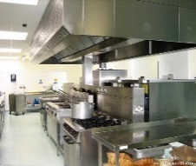

Sales Staff



Machine Maintenance

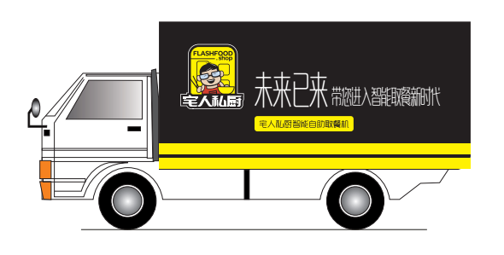

Four-Wheeled Vehicles and Two-Wheeled Electric Bicycles

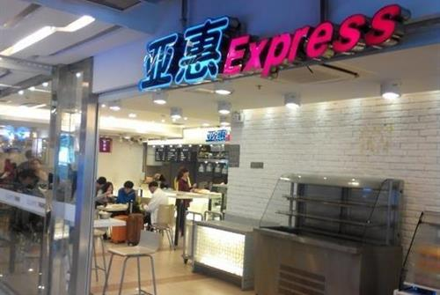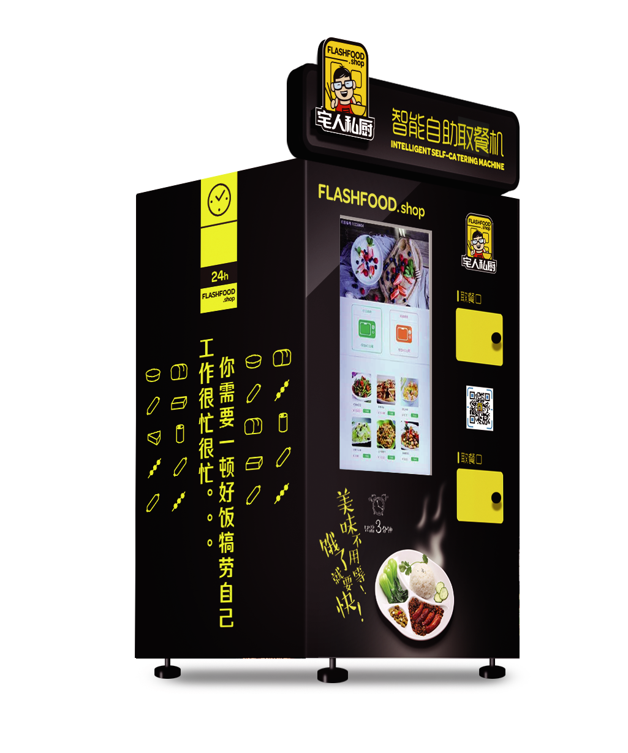

Customers



Intelligent Self-Catering Machine



Source: Created by authors with information from company documents.

**EXHIBIT 6: QUARTERLY FINAnCIAL STATEMENTS OF Flashfood.Shop (¥)**

|  |  |  |  |  |  |
| --- | --- | --- | --- | --- | --- |
| **Item** | **2017** | | | **2018** | |
| 4–6 | 7–9 | 10–12 | 1–3 | 4–6 |
| Revenue | 63,884 | 297,009 | 356,450 | 792,031 | 1,485,080 |
| Cost of Catering Products | 32,313 | 154,440 | 174,646 | 390,178 | 754,154 |
| Delivery Cost | 23,842 | 77,548 | 74,876 | 138,584 | 212,653 |
| Machinery Depreciation Expense | 625 | 625 | 625 | 625 | 625 |
| Rent Expense | 4,452 | 20,692 | 38,660 | 87,170 | 153,965 |
| Wastage | 19,261 | 74,150 | 71,589 | 118,695 | 138,684 |
| Marketing and Management Expense | 98,350 | 68,465 | 69,848 | 95,059 | 255,692 |
| Electric Expense | 2,138 | 8,910 | 10,695 | 23,795 | 54,598 |
| Profit | –117,097 | –107,821 | –84,489 | –62,075 | –85,291 |

Source: Created by authors with information from company documents.

1. ¥ = CNY = Chinese yuan; US$1 = ¥6.94 on April 1, 2017; all currency amounts are in ¥ unless otherwise specified.
2. “China Has Over 200 Million Middle-class People,” Sohu, January 2, 2018, accessed November 22, 2018, www.sohu.com/a/216960889_466885.
3. Yang Yuran, “China's Catering Market Will Reach a Record High of 5.1 Trillion to 5.5 Trillion by 2020,” Cyzone, *Chuangyebang*, November 26, 2017, accessed November 20, 2018, www.cyzone.cn/article/170357.html.
4. “Investigation and Analysis on the Demand for Online Shopping of Fresh Agricultural Products—Taking White-Collar Workers in Ningbo as an Example,” (in Chinese), CNKI, December 15, 2016, accessed November 21, 2018, www.cnki.com.cn/Article/CJFDTotal-JYGU201611016.htm.
5. “A Report on China’s Online Food Delivery Market from 2017 to 2018,” Iimedia, (in Chinese), January 17, 2018, accessed November 21, 2018, www.iimedia.cn/60449.html.
6. “Ele.me’s Acquisition of Baidu Waimai Change the Competition Landscape with Meituan,” Ebrun, (in Chinese), www.ebrun.com, August 27, 2017, accessed November 23, 2018, www.ebrun.com/20170827/244077.shtml.
7. “The Problem of Meals for 100 Million White-Collar Workers: In Addition to Online Food Delivery and Fresh Meals in Convenience Stores, There Are Intelligent Self-Catering Machines,” Sohu, (in Chinese), October 28, 2017, accessed November 21, 2018, www.sohu.com/a/200834046_363549.
8. “Self-Service Convenience Stores Are Ahead of the Industry—Will Fresh Meals Fall Behind?” Winshang, (in Chinese), October 16, 2017, accessed November 22, 2018, news.winshang.com/html/062/7645.html.
9. “The Problem of Meals for 100 Million White-Collar Workers: In Addition to Online Food Delivery and Fresh Meals in Convenience Stores, There Are Intelligent Self-Catering Machines,” op. cit.
10. Iimedia, op. cit.
11. “The Rent in Beijing CBD Is Soaring, Companies Are Fleeing,” NetEase, (in Chinese), September 10, 2014, accessed November 21, 2018, news.163.com/14/0910/16/A5PTQC0600014SEH.html.
12. “The Key to Success in Self-Service Retailing: Interpretation on Advantages and Disadvantages of the Three Formats of Self-Service Retailing,” Sohu, (in Chinese), October 23, 2017, accessed November 21, 2018, www.sohu.com/a/19960019 8_99964714/.
13. Guo Zhifu, “Zhi Yang of FUNBOX: How to Win the Fight of Self-service Retailing in the Future,” Iyiou, January 15, 2018, accessed November 21, 2018, www.iyiou.com/p/64546.
14. “Deputy Secretary-General of China Vending Association: The Intelligent Catering (Self-catering) Market Will Reach at Least ¥24.138 billion in the Next Few Years,” 36kr, June 17, 2017, accessed November 22, 2018, www.36kr.com/newsflashes/64100.
15. “The Problem of Meals for 100 Million White-collar Workers: In Addition to Online Food Delivery and Fresh Meals in Convenience Stores, There are Intelligent Self-catering Machines,” op. cit.
16. The term “unicorn” company refers to a start-up business valued at over US$1 billion, which is considered rare or even nonexistent (like the mythical unicorn).