

9B19M037

NALEDO foodS and beverages inc.: in search of investment capital

Bonita Russell and Paul Russell wrote this case solely to provide material for class discussion. The authors do not intend to illustrate either effective or ineffective handling of a managerial situation. The authors may have disguised certain names and other identifying information to protect confidentiality.

This publication may not be transmitted, photocopied, digitized, or otherwise reproduced in any form or by any means without the permission of the copyright holder. Reproduction of this material is not covered under authorization by any reproduction rights organization. To order copies or request permission to reproduce materials, contact Ivey Publishing, Ivey Business School, Western University, London, Ontario, Canada, N6G 0N1; (t) 519.661.3208; (e) cases@ivey.ca; www.iveycases.com. Our goal is to publish materials of the highest quality; submit any errata to publishcases@ivey.ca. i1v2e5y5pubs

Copyright © 2019, Ivey Business School Foundation Version: 2019-05-10

In early 2018, Nareena Switlo, the chief operating officer of Naledo[1] Foods and Beverages Inc. (Naledo), was returning from a trip to the Canadian company’s production facility in Belize. As tiring as the trip had been, the energy and commitment of the young people who worked in the plant were enough for Nareena to forget her exhaustion and put her mind to the problem of how to increase production given the enterprise’s limited financial resources. As she put it to her business partner, “[It is] so frustrating: we need new machinery to up our production, but simply because of cash flow and a limited line of credit we are stuck with our current machinery. Even with over CA$250,000[2] in sales in 2017, lending agencies were still not willing take a chance on a small start-up.”

It started with a handshake

In 2014, Umeeda Switlo, Naledo’s chief executive officer, was a volunteer with the Canadian non-profit development organization CUSO International, working with the government of Belize on entrepreneurial opportunities for young people. As part of her work in Belize, Umeeda attended the First Indian Diaspora Conference,[3] where she met with several local farmers who grew, in addition to other agricultural products, wild turmeric—a staple ingredient in curry. As a result of that meeting, a business was born.

After months of experimenting with different formulations, Umeeda and her test team came up with a recipe for the first wildcrafted,[4] whole-root turmeric paste—Truly Turmeric. From the outset, the intent of the business was not to be just another export–import operation but rather one that would have a positive impact on the growers, their families, and the communities where the turmeric was grown. Healthy, sustainable, and empowered communities was Naledo’s mission.

The Health and Wellness Industry

A focus on health and wellness had become an important consumer trend by 2016. Healthful food, regular exercise, and personal health monitoring had become lifestyle choices and, in the process, given rise to a host of new businesses. The global market for health and wellness products and services totalled US$686 billion[5] in 2016 and was expected to reach US$815 billion by 2021.[6] Growth in the Canadian market was somewhat slower, driven primarily by both an aging population and rising incomes among younger Canadians. Demand for organic packaged foods and beverages was particularly strong due to growing support for socially and environmentally responsible sourcing.[7] By 2013, some 31 per cent of Canadians were willing to pay a premium for health-promoting products. Among Canadian consumers, health awareness was coupled with a preference for Canadian-made products and products made by companies with high ethical standards.[8]

Mainstream supermarkets carried many health and wellness products, but an increasing number of specialty retail outlets, such as bakeries, chocolatiers, and tea shops, also carried such products. The specialty retailers often had a greater selection, better product knowledge, and the ability to provide personalized service.[9] Online retailers also soldhealth and wellness products; Amazon.ca’s online Health & Personal Care store, for example, offered thousands of products commonly carried by retail drug stores.[10]

By 2017, healthy living was becoming a status symbol according to Euromonitor International,[11] fuelling unprecedented demand for healthier foods and dietary supplements. Backed by the endorsement of health professionals, foods with health-giving properties such as vitamins and fibre were particularly appealing to consumers.[12] One worrisome trend for supermarkets and grocery stores was the decline over the long run in the number of people who liked to cook: according to one study, only 10 per cent of American consumers liked to cook; most did not.[13]

Consumers’ increased use of social media was good for the health and wellness industry. Social media was about community, and those who adopted a healthy lifestyle tended to share their enthusiasm for this lifestyle choice with their community of family and friends using Facebook, Instagram, Snapchat, Twitter, and other social media platforms. In 2017, over 3 billion social media users worldwide posted 60 billion messages a day on Facebook Messenger and WhatsApp.[14] Savvy online health and wellness retailers used their social media platforms to engage directly with their customers by such means as blogging, posting technical information, offering ideas for promoting wellness at home or at work, suggesting resources, uploading video tutorials, hosting podcasts, offering lifestyle quizzes and checklists, and encouraging their customers to share their personal stories.[15]

Wild Turmeric

The turmeric plant was a tropical plant native to Southeast Asia but also cultivated in India, Sri Lanka, Fiji, Australia, and the Caribbean.[16] The yellow-orange rhizomes of the plant were the main ingredient in curries and mustards. Also known as Indian saffron, yellow ginger, or curcumin, turmeric could be grated and used in raw form, cooked and mixed with a liquid to form a paste, or dried and ground. In whatever form, turmeric was known for being an antioxidant and rich in iron, vitamin C, and manganese, and it had long been used as an herbal medicine for a variety of ailments.[17] The wild plant form also had three times as much curcumin—the anti-inflammatory agent found in turmeric—as the cultivated plant.

Belizean Growers

According to Nareena, “When we started [Naledo] we had a choice . . . to farm or not to farm. That is when we discovered wildcrafting and small-scale biodiverse growing.”

Wildcrafting was the practice of harvesting plant material such as mushrooms, berries, or greens from their natural habitat, wherever that might be. In the Toledo district of Belize, turmeric was often found growing wild on farms or between other agricultural crops such as cacao. Choosing not to enter into mainstream farming, Naledo partnered with over 350 Belizean growers to harvest wild turmeric. The growers were paid three times the market price for their turmeric, a practice that gave the growers additional income and Naledo a secure supply of organically grown wild turmeric. Representatives of Naledo visited the growers regularly to test the soil and ensure that no fertilizers or chemicals were being applied. More importantly, Naledo representatives used these visits to talk to the growers about their goals for the future. Naledo was the first company in Belize to harvest wild turmeric for commercial use.

The response from the growers was positive. Giovanni Foster, a Naledo grower, stated, “Growing with Naledo, I am happy to be a part of it, it makes me feel that there is a purpose for what I am doing that benefits the greater society, not only my little community.” Another grower, Hector Rodrigez, said, “When I heard about Naledo I had been out of work for two months. I had some yellow ginger on my land and was able to pass the inspection process and sell my yellow ginger. From that payment I paid bills and bought a pig. That pig had babies and now I have another income source. I am happy and now even have a job in the processing factory!”

The Belizean Production Team

In Belize in 2010, 56 per cent of the population was under the age of 24, and the labour force unemployment rate was 23 per cent.[18] When it came to processing its product, Naledo hired young people between the ages of 18 and 30 and paid them three times the minimum wage for their work. Paying a living wage to employees improved lives. In addition, Naledo provided mentorship and business training on everything from accounting to marketing in the hope that some of its employees would go on to create other businesses in the community.[19] In 2017, 10 young people worked in the plant. They had stopped by the plant looking for employment and had ended up working there.

Ms. M., with only primary school education, began with Naledo in 2014 by washing the turmeric, but she quickly learned everything about the process. Now, she managed the entire production operation and was also the primary breadwinner in her family.

Mr. L., the organization’s labelling and shipping manager, had also started out washing turmeric. With his first few paycheques from Naledo, he had bought his mother a washing machine.

As part of Naledo’s work with young people, Umeeda and Nareena visited schools to speak with students, provided space in the organization’s community garden for school groups to learn how to grow food, and offered scholarships for post-secondary education. One of Naledo’s employees had started taking evening classes at the local business school with a $500 scholarship from the company.

The Product and the Process

Truly Turmeric, the turmeric paste produced by Naledo, was packaged in either 235-gram (g) or 470 g glass bottles; came in two flavours, original or black pepper; and retailed for between $10 and $18 (see Exhibit 1). The product was launched in 2016 after two years of development. In 2016, Naledo produced 21,000 jars of product; in 2017, it produced 65,000 jars (see Exhibit 2). Sales revenue in the first year of production was $61,314and in the second year was $251,360 (see Exhibit 3).

The turmeric paste was made from five ingredients: turmeric root, cold-pressed coconut oil, fresh lime juice, sea salt, and naturally occurring citric acid. The black pepper version was seasoned with Belizean forest-grown black pepper. The intended use for the paste was as a health-boosting additive for salad dressings, smoothies, soups, sauces, stir-fries, and curries.

Production waste was composted, recycled, or reused. The food waste was composted, and the lime seeds were used by a local nursery to grow lime plants. Used coconut oil bottles found their way into small building projects, such as greenhouses and community gardens, and the cleaning products, which were biodegradable, were packaged in reusable containers.

The production process involved preparing the turmeric roots by washing and chopping, mixing the prepared roots with coconut oil and other ingredients, and cooking the mixture until it formed a paste (see Exhibit 4). In a typical week, 500 pounds of turmeric root were processed in five-gallon batches by hand. Daily production was in the range of 400–500 units, with a production limit of about 10,000 units per month (one 20-foot container of product). There were raw material variations in the colour of the turmeric roots, the pH of the lime juice, and the colour and consistency of the turmeric paste from batch to batch, in keeping with the artisanal nature of the production process. The product had a shelf life of two years. Once opened, the product needed to be refrigerated and could be kept for up to three months.

Demand was growing, making it imperative for Naledo to increase its production capabilities, particularly as large orders could take up to six weeks to fill. The need for new equipment was pressing in terms of not only meeting demand but also reducing production costs. In an eight-hour work day, the current machine was in operation for four hours. The remaining four hours were reserved for cleaning and for staff breaks. To keep up with demand, the production team worked evenings and weekends at overtime rates. Updating the equipment would reduce the labour component and dramatically improve the production cost per jar—with the current equipment, this was estimated at $3.60 per jar in staff time; with the new equipment, this was estimated at $0.45.

The cost for new equipment was estimated at US$80,000, with an additional US$20,000 for shipping and installation. With this level of investment, production could be increased from the current 400–500 units per day to 800–1,000 units per day, at a rate of 100 units per hour from fresh root to the jar.

Distribution and Promotion

The Truly Turmeric product could be purchased online through Well.ca and Vegansupply.ca. Well.ca was a Canadian online retailer of over 40,000 health, wellness, baby, and beauty products;[20] Vegan Supply Co. was a Canadian online retailer of plant-based products, with one retail outlet in Vancouver, British Columbia.[21] The product could also be purchased through a network of retailers in Canada, the Bahamas, and Belize. Truly Turmeric’s strongest presence was in Canada, where it had 457 retail outlets across eight provinces, with the exception of Prince Edward Island and Newfoundland and Labrador. There were 15 outlets in Belize and 28 in the Bahamas. Pharmacies, health food stores, organic grocers, and community grocery stores typically carried the product.

Naledo used inbound marketing tactics to engage with its customers. The company’s cash flow had limited its marketing efforts to word of mouth, a website, and several social media sites including Instagram, Facebook, YouTube, Google+, and Pinterest (see Exhibit 5). From Naledo’s website, consumers could locate a retail outlet that carried the turmeric paste; buy a copy of the Indian cookbook *Mamajee’s Kitchen*; find a recipe; and, for those who lived in the greater Vancouver area, book a demonstration. Interested consumers could also receive a monthly newsletter from Naledo’s Facebook page.

Conclusion

As Nareena waited at the baggage carousel for her luggage, she was still thinking about where to find the money needed for new production equipment. Was crowdfunding an option? Was there an equipment supplier who might be willing to donate the needed equipment? Was there a service that could be sold to boost revenues? Was there a wealthy investor who would like to finance the equipment purchase? There had to be a way to obtain new equipment, for the mission of Naledo was too important to be stalled by the need for $100,000.

Exhibit 1: Truly Turmeric Paste

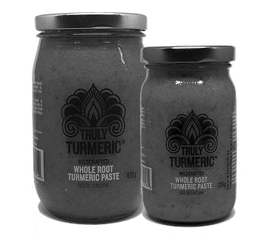

Source: Company documents.

Exhibit 2: Production in Units (JARS)

|  |  |  |  |  |  |
| --- | --- | --- | --- | --- | --- |
| **Year** | **1st Quarter** | **2nd Quarter** | **3rd Quarter** | **4th Quarter** | **Total** |
| 2014 (pre-production) |  |  |  |  | 200 |
| 2015 (pre-production) |  |  |  |  | 400 |
| 2016 | Launched in May 2016 | 1,000 | 10,000 | 10,000 | 21,000 |
| 2017 | 15,000 | 15,000 | 15,000 | 15,000 | 60,000 |

Source: Company documents.

Exhibit 3: naledo Statement of income (Loss) And Retained (Deficit)/EARNINGS (CA$) for the year ended december 31, 2017

|  |  |  |  |  |
| --- | --- | --- | --- | --- |
|  | | | **2017** | **2016** |
| **Revenue** | | | | |
|  | | **Sales** | $251,360 | $61,314 |
|  | | | | |
| **Cost of Goods Sold** | | |  |  |
|  | | Purchases/materials (see note 1) | 73,877 | 73,091 |
|  | |  |  |  |
|  | | **Gross Profit (Loss)** | 177,483 | (11,777) |
|  | | | | |
| **Expenses** | | | | |
|  | Advertising | | 8,820 | 8,878 |
|  | Amortization | | 515 | 294 |
|  | Business licence | | 247 | 870 |
|  | Interest and bank charges | | 4,702 | 2,489 |
|  | Gifts | |  | 78 |
|  | Meals and entertainment | | 1,990 | 5,384 |
|  | Professional development | |  | 410 |
|  | Professional fees | | 4,417 | 3,333 |
|  | Rent | | 6,223 | 6,990 |
|  | Supplies | | 1,784 | 3,596 |
|  | Telephone | | 812 | 2,032 |
|  | Travel | | 16,713 | 11,756 |
|  | Vehicle expenses | | 6,234 | 4,151 |
|  | **Total Expenses** | | 52,457 | 50,261 |
|  | | | | |
|  | **Net Operating Income** | | 125,026 | (62,038) |
|  | | | | |
|  | **Current Income Taxes** | | 6,680 |  |
|  | Foreign Exchange Gain | | 237 |  |
|  | | | | |
|  | | **Net Income (Loss)** | $118,109 | $(62,038) |

Note: *Naledo Canada paid Naledo Belize to produce the product on a per-unit basis. Direct labour is included in the unit price.

Source: Company documents.

Exhibit 4: truly turmeric Production Process

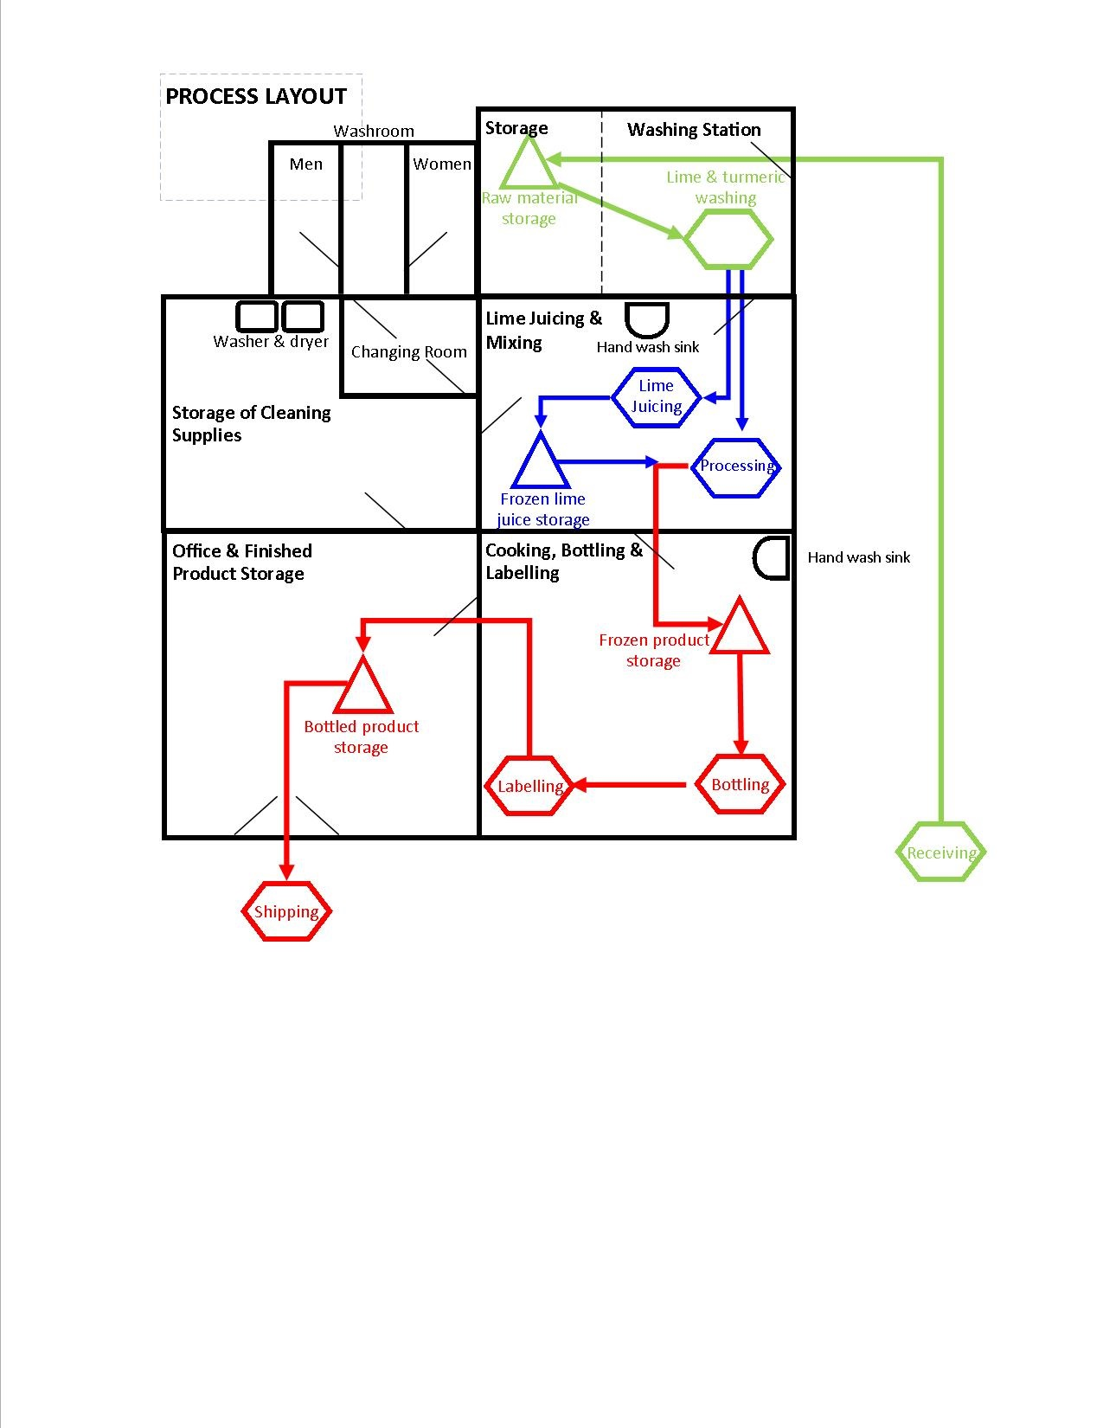

Source: Company documents.

Exhibit 5: naledo Instagram Post, April 15, 2018

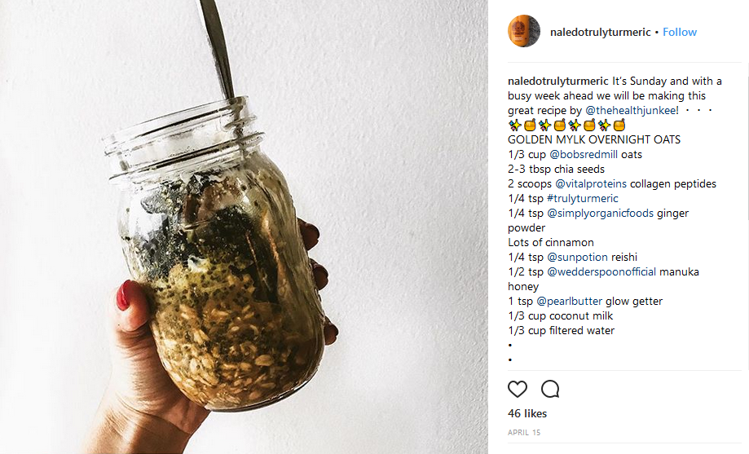

Source: Company documents.

1. The company name was derived from the first two letters of the name Nareena and the last four letters of Toledo, the district in Belize where Umeeda Switlo first discovered the wild turmeric that led to the formation of the business.
2. All dollar amounts are in Canadian dollars unless specified otherwise.
3. The first migrants from East India arrived in Belize in 1858, followed by others who came to Belize via Jamaica and Guatemala in the 1860s and 1870s. East Indians made up about 4 per cent of the population of Belize, and the only remnants of their culture were the use of turmeric in their cooking and the observance of Hosay/Muharram; “International Conference on the Indian Diaspora in Belize and the Wider Caribbean,” Global Research Forum on Diaspora and Transnationalism, accessed January 18, 2017, www.grfdt.com/EventDetails.aspx?Type=Conferences&TabId=71.
4. Wildcrafted referred to plants that were not cultivated but rather harvested in the wild.
5. US$1 = CA$1.2309 on January 31, 2018.
6. Deborah Weinswig, “Wellness Is the New Luxury: Is Healthy and Happy the Future of Retail?,” *Forbes*, June 30, 2017, accessed January 14, 2018, www.forbes.com/sites/deborahweinswig/2017/06/30/wellness-is-the-new-luxury-is-healthy-and-happy-the-future-of-retail/#4f3558bb8323.
7. Euromonitor International, *Country Report:* *Health and Wellness in Canada*, July 2018, accessed January 14, 2018, www.euromonitor.com/health-and-wellness-in-canada/report.
8. Business Development Bank of Canada, *Mapping Your Future Growth: Five Game-Changing Consumer Trends*, October 2013, accessed January 13, 2018, www.bdc.ca/Resources%20Manager/study_2013/consumer_trends_BDC_report.pdf.
9. Euromonitor International, op. cit.
10. “Health & Personal Care,” Amazon.ca, accessed January 14, 2018, www.amazon.ca/Health-Personal-Care/b/ref=sd_allcat_hpc?ie=UTF8&node=6205177011.
11. Lydia Gordon, Euromonitor Communications, “Authenticity and Wellness as a Status Symbol among the Top 10 Global Consumer Trends for 2017,” Euromonitor International, accessed March 11, 2019, https://blog.euromonitor.com/2017/11/

    wellness-status-symbol-top-consumer-trend-2017.html.
12. Ibid.
13. Eddie Yoon, “The Grocery Industry Confronts a New Problem: Only 10% of American Love Cooking,” *Harvard Business Review*, September 22, 2017, accessed January 14, 2018, <https://hbr.org/2017/09/the-grocery-industry-confronts-a-new-problem-only-10-of-americans-love-cooking>. Available from Ivey Publishing, product no. H03WSY.
14. Kit Smith, “121 Amazing Social Media Statistics and Facts,” Brandwatch, October 2, 2018, accessed January 14, 2018, www.brandwatch.com/blog/96-amazing-social-media-statistics-and-facts-for-2016/.
15. “Why Social Media Is So Sweet for Wellness Businesses,” Wellpreneur, accessed January 14, 2018, http://wellpreneuronline.com/social-media-and-wellness/.
16. New World Encyclopedia, s.v., “Turmeric,” December 2015, accessed August 28, 2017, www.newworldencyclopedia.org/entry/Turmeric.
17. Health Canada, *Natural Health Product: Turmeric – Curcuma Longa*, February 25, 2010, accessed August 28, 2017, http://webprod.hc-sc.gc.ca/nhpid-bdipsn/monoReq.do?id=216.
18. Lan Sluder, “Summary of Key Information from Belize 2010 Census,” AmbergrisCaye.com, May 5, 2011, accessed September 6, 2017, https://ambergriscaye.com/forum/ubbthreads.php/topics/407013/Summary_of_Key_Data_in_Belize_.html.
19. Three employees opened small businesses of their own; one ran a haircutting business, and two others expanded their farming operations.
20. “About Us,” Well.ca, accessed January 13, 2018, https://well.ca/about.
21. “About Us,” Vegan Supply Co., accessed January 13, 2018, https://vegansupply.ca/.