** **

9B19M041

Kutesmart: the digital transformation of APPAREL manufacturing

Professor [Ning Su](https://iveypubs.my.salesforce.com/003A000001CqbKh), Dongxiao Qiu, Jingyu Sun, and Licong Zhang wrote this case solely to provide material for class discussion. The authors do not intend to illustrate either effective or ineffective handling of a managerial situation. The authors may have disguised certain names and other identifying information to protect confidentiality.

This publication may not be transmitted, photocopied, digitized, or otherwise reproduced in any form or by any means without the permission of the copyright holder. Reproduction of this material is not covered under authorization by any reproduction rights organization. To order copies or request permission to reproduce materials, contact Ivey Publishing, Ivey Business School, Western University, London, Ontario, Canada, N6G 0N1; (t) 519.661.3208; (e) cases@ivey.ca; www.iveycases.com. Our goal is to publish materials of the highest quality; submit any errata to publishcases@ivey.ca. i1v2e5y5pubs

Copyright © 2019, Tsinghua School of Economics and Management and Ivey School of Business Foundation Version: 2019-07-04

On an April morning in 2017, the logo of the predecessor Red Collar brand, owned by Qingdao Kutesmart Co. Ltd. (Kutesmart), was being lowered from the roof and replaced by the logo for a new brand, Cotte Yolan (Cotte). This change came at an unusual time for the company. Kutesmart was mainly in the made-to-measure (MTM) mass production business of clothes and customer-to-manufacturer (C2M) solutions-based industry upgrades. After almost four years of diligent preparation for an initial public offering (IPO), the company aimed to submit its application to be listed on ChiNext—a NASDAQ-style board of the Shenzhen Stock Exchange in China.[1]

Although the company had previously wooed the market with its high growth, healthy cash flow, and zero inventory—thanks to its innovative C2M business model based on data technologies (see Exhibit 1)—in 2018, Zhang Daili, founder and chief executive officer of Kutesmart, still needed to convince potential investors that Kutesmart could not only maintain such success but also extract more value from its industry databases. In the 2018 digital era, successful corporations often differentiated themselves with their ability to offer advanced products, efficient operations, and high-quality customer services. How could Kutesmart enhance its business capabilities with the big data and Internet technology it had developed? Would digital transformation in the traditional manufacturing business entail an IPO, as Zhang expected?

APPAREL MANUFACTURING IN CHINA

For almost three decades, China had been a global hub of garment manufacturing, known for its high efficiency, low operating costs, and increasingly advanced techniques and technologies. With a 39 per cent global market share, China was the world’s largest apparel and textile exporter, dominating the global low-to-medium-end market through original equipment manufacturers (OEMs).[2] In 2018, China’s apparel manufacturers produced over 22 billion pieces of clothing; approximately 1.5 trillion dollars of clothing sold within the Chinese domestic market, and approximately 1.5 trillion were exported to foreign markets.[3]

Like many other labour-intensive manufacturing industries, China’s garment manufacturers faced challenges as China’s economic growth slowed, wages and other production costs rose, and consumer structure and preferences changed. The manufacturing of low-end apparel items, in particular, was shifting to Southeast Asian markets such as Vietnam, Bangladesh, and Cambodia, while China still possessed some competitive advantages in the manufacturing of more complex items. Chinese national statistics showed that the sector’s value-added growth slowed to 3.8 per cent in 2016—compared to the compound annual growth rate (CAGR) of 6 per cent from 2011 to 2015. In 2016, the industry produced 31.4 trillion pieces of clothing—a 1.64 per cent decrease from 2015; the production size by retail sales increased 6.8 per cent to ¥1 trillion,[4] compared to a 9.3 per cent growth rate a year earlier. Exports, whose share of revenue peaked at 86.8 per cent in 1998, were decreasing in recent years. In 2016, the value of China’s apparel exports declined 9.35 per cent to $160 billion.

With a population of 1.4 billion, China was also itself a major garment consumer market. The manufacturers were gradually divided into two camps: some continued with a mass market strategy to offer affordable clothes; another group of apparel enterprises turned to making luxury and high-end garments to serve the rising middle class in the market. The ¥500 billion menswear segment in China, in which Kutesmart operated, was a growing but smaller segment compared to womenswear. Traditionally, men’s clothing had fewer varieties, which led to less frequent purchases. However, with consumers born after the 1990s becoming a core group in China’s consumer market, the menswear segment was on the rise and was expected to achieve a CAGR of 4 per cent until 2020.[5] The appetite of younger consumers had grown beyond basic features to include stylish and individualistic outfits, and the demand for mid-range to high-end men’s clothes was increasing, according to Euromonitor International.[6] In order to win in the market, menswear manufacturers needed to upgrade their products with more individualized designs and refine their distribution channels from offline to online and offline-online hybrids.

APPAREL MANUFACTURING IN GLOBAL MARKETS

The United States and Europe were the world’s largest apparel import destinations. Together, the two markets accounted for about 63.9 per cent of the world’s total;[7] however, the two markets’ domestic manufacturing industries were waning. Garment manufacturing represented only a relatively small percentage of gross domestic product in the United States—about 0.1 per cent in 2016.[8] Employment in the industry had decreased more than 80 per cent over the last two decades.[9] The majority of the apparel companies chose to outsource and/or offshore their manufacturing to developing countries in order to save labour costs and increase capacity, leaving only high-value jobs such as research and development (R&D), design, and marketing onshore. The manufacturers that stayed in the United States were generally small factories with an average of 20 employees,[10] focusing on high-fashion, high-value, quick-turnaround, and high-margin orders.[11] Most of these factories were located in cities such as New York and Los Angeles and supported the local fashion industry.

The textile and clothing manufacturing industry played a more significant role in Europe, especially in countries such as Italy, France, and Spain. The industry, mostly consisting of small- and medium-sized enterprises, employed 1.7 million people and represented about 6 per cent of the total manufacturing jobs in Europe.[12] Companies with less than 50 employees accounted for over 90 per cent of the clothing manufacturing workforce and produced almost 60 per cent of the added value.[13] Over the last decade, the industry had undergone radical changes to maintain its competitiveness by moving towards producing high-quality clothes and high-value-added products—which inevitably led to a decline in volumes. Some companies chose to relocate production to low-cost countries. Even luxury companies, such as Kering SA and LVMH Moët Hennessy Louis Vuitton SE, manufactured products almost exclusively through contractors in developing countries.

THE TRANSFORMATION OF KUTESMART

Kutesmart, which specialized in manufacturing high-end bespoke suits and MTM men’s clothes, was an apparel group based in China’s northern province of Shandong. The company had 5,700 staff members and a portfolio of business brands: CAMEO, RED COLLAR, RCOLLAR, and RPRINCE.[14] From 2014, Red Collar’s MTM revenue maintained an annual growth rate of over 50 per cent, with 80 per cent of orders coming from overseas markets and 20 per cent from the domestic market.[15] The company enjoyed an impressive net profit margin of over 25 per cent.[16]

The company started as a garment OEM factory in 1987, before the Red Collar brand was established in 1995. While China’s ready-to-wear industry was still at its peak in the early 2000s, Zhang was aware that the traditional business model of garment manufacturers was not sustainable. Apparel OEMs often faced fierce competition due to homogenization and the long and complex value chain involving layers of agents, making it difficult for apparel manufacturers to achieve significant profit margins and to manage capacity and inventory.[17]

Zhang strongly believed that the only way out for garment makers was the mass production of made-to-order products, as it would answer directly to consumer demand and therefore minimize inventory and the cost of intermediaries. Moreover, the economy of scale gave this model high efficiency and low cost, and the tailored, differentiated nature of the product could increase profit margins.

THE TRANSFORMATION OF KUTESMART’s INFORMATION SYSTEM

The company’s information system had been at the centre of Kutesmart’s digital transformation journey. Since the company embarked on this journey in 2000, its information system had been evolving as the company’s business strategy moved forward.

Before 2007

During this period, Kutesmart’s main businesses were OEM, the production of standardized clothes on a large scale, and its custom-made business, which was in its infancy. In 2000, Kutesmart implemented its first information technology (IT) system, which was provided by Yonyou, a major business software company in China. Kutesmart implemented Yonyou’s software package for accounting and financial management, including general ledger, transaction, and inventory management tools.

As the company gradually shifted its production to tailor-made suits, it started to face higher demand in material quality and a tight production timeline. The original financial software could no longer meet the company’s needs in managing material supply chains and effectively enforcing contracts. In 2001, Kutesmart started searching for the most suitable enterprise resource planning (ERP) system supplier that could meet the company’s special demand for planning both standardized mass production and custom production.

Through trial and error, the company finally identified an IT supplier that specialized in providing ERP solutions for the apparel manufacturing industry. With the ERP system in place, Kutesmart was able to collect real-time production data and generate dynamic data profiles that would facilitate market forecasting. The system synchronized information flow in the supply chain by connecting sales and production, and the company could trace the production of each item. The company had previously received complaints from customers of tailor-made clothes for late delivery or for the lack of certain required material due to insufficient material management. The ERP system enabled Kutesmart to significantly improve material planning and timely delivery due to the efficient coordination of materials.

2007 to 2009

In 2007, Kutesmart made a major strategic decision to focus on the mass production of MTM clothes and position Cotte as a high-end men’s suits brand. Mass production and tailor-made seemed to be contradictory business models; however, technology enabled a synergistic combination of the two, thereby simultaneously satisfying customer demand for individualization and the manufacturers’ requirement for scale and cost. The core of this MTM mass production model was the ability to realize diversification and customization of products through a flexible and rapid end-to-end process—from R&D and production to sales and delivery. To achieve this goal, Kutesmart decided to redevelop its information system. This included establishing an MTM e-commerce platform, rebuilding the ERP system, upgrading the computer-aided manufacturing system, and transforming the computer and network support system as well as the office automation system.

The implementation of the MTM e-commerce platform, RCMTM, took several steps. First, Kutesmart connected its business partners, such as tailors’ shops in New York, with the company’s online system, enabling mutual data exchange through a web interface; second, Kutesmart implemented a marketing and customer relationship management system to more effectively track interactions with customers; and finally, Kutesmart integrated its systems with the upgraded ERP system and an online self-service tailoring system to meet the company’s business needs in serving both small- and medium-sized business clients and individual clients.

2009 to 2017

Since 2009, Kutesmart’s focus had been on building an information system where customers could order tailor-made products directly from manufacturers through an online platform (see Exhibit 2). To realize this vision, Kutesmart purchased more than 2,000 pieces of intelligent manufacturing equipment and gradually improved more than 40 information systems that covered every aspect of operation, including computer-aided design (CAD), advanced planning and scheduling, warehouse management, and manufacturing execution. Each system was completely interoperable, and the real-time sharing of data and information eliminated information silos. The production and supply chain management process was automated. The intelligent systems not only captured data from the customers’ side but also from Kutesmart’s workers, thereby matching workers’ skills with particular customers’ needs.[18]

Through suppliers, customers could order their individualized suits and clothes on RCMTM; the order information—including all measurement details and customer preferences—would be compiled and stored in a radio-frequency identification card and distributed among Kutesmart’s production lines. Kutesmart’s database maintained the measurement records of more than two million past customers; this database, working in integration with CAD and computer-aided process planning systems, enabled RCMTM, in theory, to generate trillions of patterns in five minutes that fit 90 per cent of the body types in the world.[19]

As a result of advanced information and production technology, the factory could make 4,000 customized suits each day and guaranteed delivery within seven working days. Capitalizing on the information and production systems, Kutesmart achieved an above-industry-average net profit rate of 20 per cent by maintaining the cost of the MTM suits just 10 per cent higher than mass produced, ready-to-wear clothes.[20] Unlike in traditional garment manufacturers’ heavy inventory model, where the factory manufactured garments before actual sales, Kutesmart’s customers had to make payment when they placed their order; such a model effectively enhanced Kutesmart’s cash flow and reduced its inventory to zero.

On the consumer-facing side, in August 2015, Kutesmart launched Magic Manufactory, a mobile application (app) for individual customers to order tailored clothes directly from the company. After a customer opened the app and selected a type of clothing, a 3-D model would appear on the screen. The app allowed the customer to select every detail of the tailor-made clothes—from texture and styles of the pockets, collars, and buttons to the initials embroidered on the clothes. When the design was completed, the customer could make an appointment for Kutesmart’s “smart tailors” to take their measurements at their homes. The positioning system could help the customer locate a tailor nearby. As 3-D measurement technology advanced, the system was soon able to capture customers’ measurement details via mobile phones.

The Human Factors of Transformation

It took Kutesmart more than 10 years to build up its current information and production systems, which continued to evolve as the company embraced new technologies and techniques. As chair, Zhang was leading the company’s transformation and innovation journey. Kutesmart was a family business, initially jointly run by Zhang and his younger brother, who were responsible for production and sales, respectively. As the property development industry had experienced a boom since the 1990s, Zhang’s younger brother decided to pursue other business opportunities in real estate. Zhang, however, pursued the garment business, as he felt a responsibility to maintain and develop the family business.

Zhang described himself as an open-minded and technology-savvy leader. He visited BMW AG in 1989 during his trip to Europe and learned how technology could enhance production efficiency and quality through automation. After visiting a factory producing customized clothes in Japan, Zhang came up with the initial idea of combining automation and customization to elevate Kutesmart’s production. Since then, Zhang had visited advanced enterprises overseas on a regular basis to learn cutting-edge technologies and management practices.

During Kutesmart’s transformation, Zhang developed a management theory that put customers’ demands at the centre. According to the theory, employees of each unit should focus on fulfilling customers’ demands.[21] To implement the customer-centric strategy, in 2014, Zhang initiated a restructuring to flatten the company’s organizational structure. Kutesmart made a bold move by eliminating multiple layers of reporting procedures within the company. The reorganization broke up more than 30 large and small departments and groups, with more than 80 per cent of middle-level managers no longer holding their previous titles.

Although the staff was still working in a department-like unit, each member was responsible for his or her own targets. These units were formed based on specific customer demands and could be dismissed once the demands were fulfilled. According to Kutesmart, the company was based on “self-organization.” Once a particular employee encountered a problem in work, the employee could initiate a so-called “strong organization” to immediately engage a team of subject experts to solve the problem. The strong organization would be dismissed when the problem was solved, and the solution would be codified into Kutesmart’s process system (see Exhibit 3).

Transformation in the Digital age

The emergence of disruptive new technologies such as advanced robotics, artificial intelligence, sensors, cloud computing, and the Internet of things had been changing the global manufacturing industry. Concepts such as Industry 4.0, which emphasized highly automated factories with machines interconnected with information and communications technologies,[22] were also profoundly shaping the future of manufacturing. After Zhang’s daughter Yunlan became president of Kutesmart, the company’s future strategy became a key question she and her team sought to answer.

Yunlan led her team to develop the concept of “Internet + Industry.” In her view, the best way for the company to grow was to form alliances with partners and customers in what she termed a customer-to-manufacturer (C2M) ecosystem—instead of focusing on individual products. Kutesmart developed this strategy into a product called source data engineering (SDE), which provided the solution of “Internet + Industry” to traditional manufacturers. This solution, including a set of IT and operations consulting services, helped companies, especially small- and medium-sized enterprises, to transform towards flexible, agile, and customized manufacturing. This solution had been implemented in more than 20 industries and 60 projects.

After adopting the SDE solution, manufacturers could become members of Kutesmart’s C2M platform (see Exhibit 4), where members shared client resources. The larger the number of modified factories with the SDE solution, the greater the ability to meet the diverse needs of consumers; meanwhile, with more orders, the factory would be able to run more effectively and maintain its profitability. Zhang envisioned that 2019 would be the turning point for Kutesmart, when the platform could reach a significant scale.

Meanwhile, a potential hurdle of this model was the capacity of Kutesmart’s IT department, which was responsible for implementing the SDE solutions for partnering companies. Currently, Kutesmart employed about 170 IT specialists who were responsible for not only SDE solution services but also other system maintenance and new system development work. Each project required Kutesmart to send IT engineers to the site to evaluate and diagnose issues. Human resources and hardware costs were the two main constraints for the IT department if it had to provide SDE solutions on a large scale.

Kutesmart’s overall vision for the company involved connecting different innovations into the company’s technology ecosystem. At the core of this ecosystem was a platform for managing and leveraging data, including those residing in different subsystems of the organization. This technology ecosystem would be supplemented by a re-engineered operational process for manufacturing customized products based on customers’ specific requirements and an improved decision-making and problem-solving process that centred on a more agile organizational culture.

The company’s president was confident about Kutesmart’s future in the age of digital disruption: “In the future, Kutesmart will become a platform company just like Alibaba [Alibaba Group Holding Limited] and JD [JD.com Inc.], the go-to place for tailor-made products.” With the company’s highly successful transformation experience, Kutesmart’s management needed to develop a set of strategies for capitalizing on its capabilities and embracing opportunities in the digital age.

The company had already ventured beyond apparel manufacturing into a new line of growth: providing educational programs, a one-stop shop, or turnkey solutions to small- and medium-sized Chinese manufacturers seeking to transform and upgrade their capabilities for the digital era. As the founder of Kutesmart’s platform, Zhang envisioned expanding the platform into an ecosystem: manufacturers across industries that received Kutesmart’s transformation consulting services would be connected to the platform, where customers could order personalized products directly from the makers. Could this strategy help Kutesmart take its business to the next level? What were the opportunities and challenges?

The Ivey Business School gratefully acknowledges the generous support of the Institute of Data Science, Tsinghua University and the support of Dr. Henry Cheng and Dr. Simon Cua through the Ivey Case Center (Asia) in the development of this case.

Exhibit 1: customer to manufacturer through data engineering

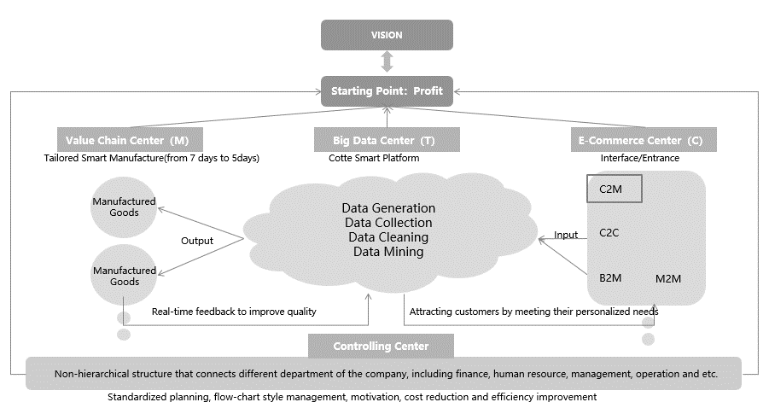

Notes: C2M = customer to manufacturer; C2C = customer to customer; B2M = business to manufacturing; M2M = manufacturing to manufacturing.

Source: Company file.

Exhibit 2: Kutesmart Data Technology plus Smart Internet of Things

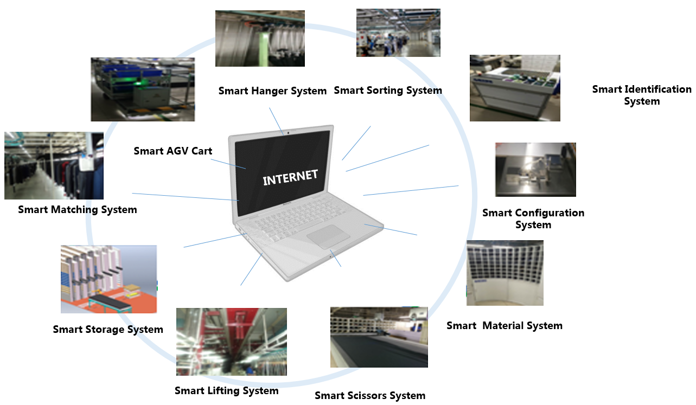

Note: AGV = automated guided vehicle.

Source: Company file.

Exhibit 3: Kutesmart Problem-solving process

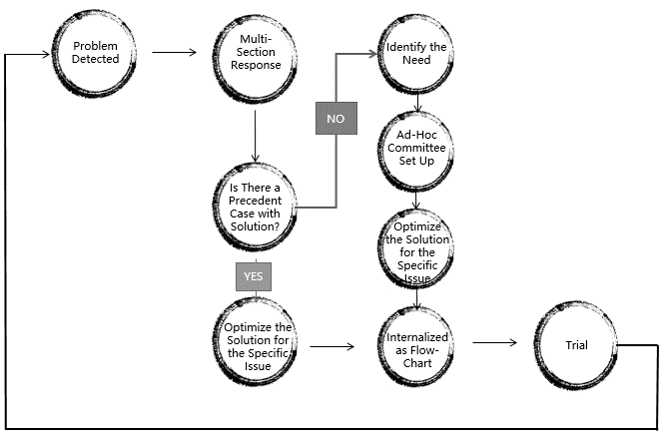

Source: Company file.

Exhibit 4: Kutesmart’s Big Data Platform

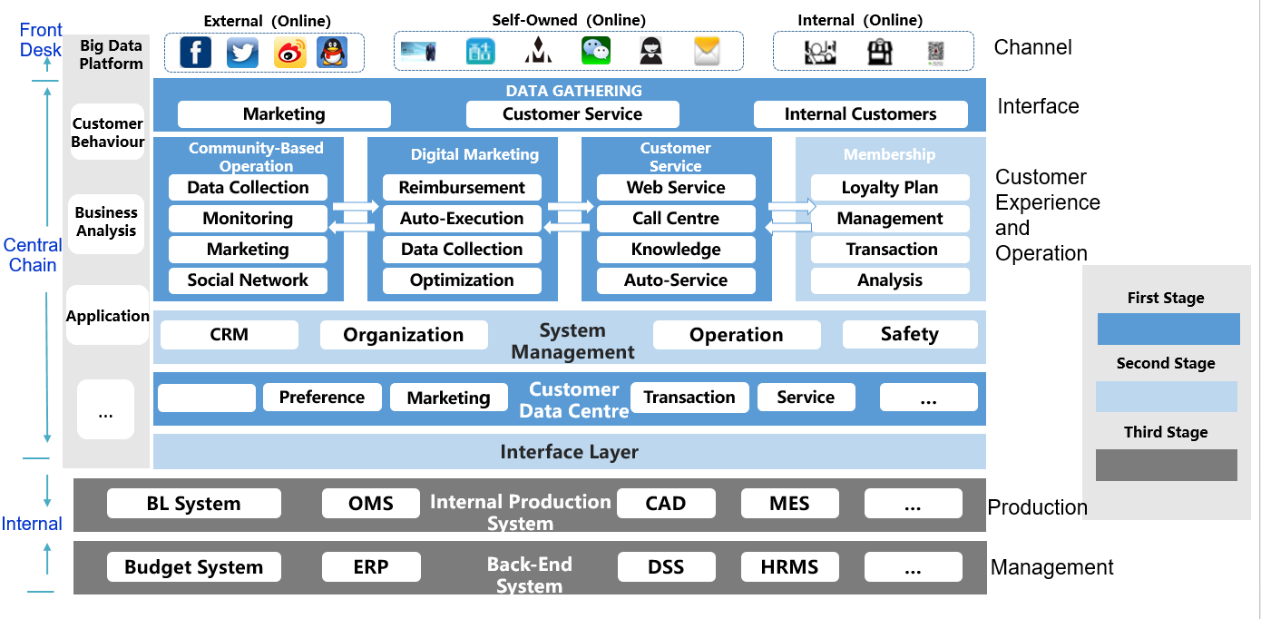

Notes: CRM = customer relationship management; BL System = body labelling system; OMS = order management system; CAD = computer-aided design; MES = manufacturing execution system; ERP = enterprise resource planning; DSS = decision support system; HRMS = human resource management system.

Source: Company file.

1. Rao Wei, Director of Fortune Capital, “Product Innovation is a Matter of Life and Death [in Chinese],” October 18, 2016, accessed May 1, 2019, <http://finance.sina.com.cn/hy/hyjz/2016-10-18/doc-ifxwvpaq1634940.shtml>.
2. Thibault, “China is About to Surpass the US as the World’s Largest Apparel Market,” Daxue Consulting, November 16 2016, accessed May 1, 2019, http://daxueconsulting.com/apparel-market-in-china/.
3. All dollar amounts are in USD unless otherwise stated; China National Textile and Apparel Council, “2018 January to December Apparel Industry Economics Operating Status Summary [In Chinese],” January 31, 2019, http://news.ctei.cn/apparel/fzrd/201901/t20190131_3837368.htm, accessed May 12, 2019.
4. ¥ = CNY = Chinese yuan renminbi; US$1 = ¥6.51 on January 1, 2016.
5. Kate Abnett, “Chinese Men Loosen Up,” The Business of Fashion, June 8, 2016, accessed May 1, 2019, https://www.businessoffashion.com/articles/global-currents/chinese-menswear-market-growth-casualwear.
6. Euromonitor International, *Menswear in Hong Kong, China*, March 2018, accessed May 1, 2019, https://www.euromonitor.com/menswear-in-hong-kong-china/report.
7. IBISWorld, *Global Apparel Manufacturing*, June 2018, accessed February 27, 2019, https://www.ibisworld.com/industry-trends/global-industry-reports/manufacturing/apparel-manufacturing.html.
8. United States Bureau of Economic Analysis, *GDP by Industry*, accessed May 1, 2019, https://bea.gov/industry/gdpbyind_data.htm.
9. Bureau of Labor Statistics, United States Department of Labor, “Spotlight on Statistics: Fashion,” June 2012, accessed May 1, 2019, https://www.bls.gov/spotlight/2012/fashion/.
10. Ibid.
11. United States Congress, Joint Economic Committee, *The Economic Impact of the Fashion Industry*, February 6, 2015, accessed May 1, 2019, https://maloney.house.gov/sites/maloney.house.gov/files/documents/The%20Economic%20Impact%20of%20the%20Fashion%20Industry%20--%20JEC%20report%20FINAL.pdf.
12. European Commission, “Textiles and Clothing in the EU,” accessed December 15, 2018, https://ec.europa.eu/growth/sectors/fashion/textiles-clothing/eu_en.
13. Ibid.
14. “Red Collar Group Profile,” *China Daily*, <http://qingdao.chinadaily.com.cn/2010-02/24/content_9497970.htm>.
15. Yan Yanhong,“Red Collar and its Secret Weapon [In Chinese],” *The Paper News*, “June 17, 2015, accessed May 1, 2019, [www.thepaper.cn/baidu.jsp?contid=1342491](http://www.thepaper.cn/baidu.jsp?contid=1342491).
16. MOFCOM, “Red Collar Group: Customized Clothing on the Assembly Line [In Chinese],” accessed February 27, 2019, http://dzsws.mofcom.gov.cn/anli15/detal_12.html.
17. Interface JMedia, “Red Collar Group Zhang Agent: Embracing Virtuality with Manufacturing to Achieve a Perfect Upgrade that Combines Internet and Industry [In Chinese],” Jieman, July 21 2016, accessed May 1, 2019, [www.jiemian.com/article/755087.html](http://www.jiemian.com/article/755087.html).
18. Liu Meiqi, “Visiting the Revolution of Manufacturing: Remaking Suits [In Chinese],” December 3, 2014, accessed May 1, 2019, [www.tmtpost.com/174226.html](http://www.tmtpost.com/174226.html).
19. Real Economy, “What Made Haier and Alibaba Come to Learn from Red Collar [In Chinese],” November 3, 2016, accessed May 1, 2019, www.sohu.com/a/118005527_494450.
20. Qiao Qian, “Flexible Production, C2M’s Real Opportunity [In Chinese],” December 8, 2016, accessed May 12, 2019, http://36kr.com/p/5058705.html.
21. Zhang Daili, *“Enterprise Management System of Original Point Theory* [in Chinese],” accessed May 1, 2019, www.kutesmart.com/web/about/view.html?pid=1.
22. Deloitte AG, *Industry 4.0: Challenges and Solutions for the Digital Transformation and Use of Exponential Technologies*,2015, accessed May 1, 2019, https://www2.deloitte.com/content/dam/Deloitte/ch/Documents/manufacturing/ch-en-manufacturing-industry-4-0-24102014.pdf.