|  |  |
| --- | --- |
|  | VLERICK LOGO |

9b19m046

KPN: HOW TO NAVIGATE THE DIGITAL TIDES

Stijn Viaene wrote this case solely to provide material for class discussion. The author does not intend to illustrate either effective or ineffective handling of a managerial situation. The author may have disguised certain names and other identifying information to protect confidentiality.

*This publication may not be transmitted, photocopied, digitized or otherwise reproduced in any form or by any means without the permission of the copyright holder. Reproduction of this material is not covered under authorization by any reproduction rights organization. To order copies or request permission to reproduce materials, contact Ivey Publishing, Ivey Business School, Western University, London, Ontario, Canada, N6G 0N1; (t) 519.661.3208; (e)* [*cases@ivey.ca*](mailto:cases@ivey.ca)*;* [*www.iveycases.com*](http://www.iveycases.com)*.*

Copyright © 2019, Vlerick Business School Version: 2019-05-31

In June 2018, Bouke Hoving, executive vice-president (EVP) of Networks and Information Technology (IT) at KPN BV (KPN), the leading telecommunications company (telco) in the Netherlands, was anticipating the arrival of a new chief executive officer (CEO) the next April and evaluating the company’s transformation. Hoving had been an initiator of a turnaround that had started at KPN in 2014, after a financially and operationally hectic year in 2013. The invasion into the market by over-the-top (OTT) digital services, had forced KPN to act swiftly, fundamentally revisiting its strategy. OTT digital services used the Internet to bypass platforms the traditional telcos had once used to control access to customers. Hoving had steered KPN to tackle this challenge with a digital transformation that aimed to make KPN the best service provider in the Netherlands. A new operating model that radically rethought customer service and operational excellence was at the heart of the transformation.

KPN was in much better shape than it had been in 2014. By working in agile ways, the company had been able to respond more quickly to market and technological developments. Nevertheless, Hoving could not help wondering if KPN had done enough. Was the company ambitious enough? Was it transforming fast enough? Was it getting enough out of its new operating model? The answers to these questions would define the next stage of KPN’s digital transformation.

BACKGROUND

KPN was founded in the 19th century as Royal Post, Telegraphy and Telephony (PTT), the Netherlands’ publicly owned, fixed-line operator. From 1994 on, the company was gradually privatized. PTT’s postal and telecommunications (telecom) services went their separate ways in 1998, and the telecom arm was renamed KPN. In 2006, the government gave up its [golden share](https://en.wikipedia.org/wiki/Golden_share) veto rights, and KPN remained the largest telco in the Netherlands. By 2017, the company had more than 13,000 employees supporting operations in the Netherlands; revenues of €5,741 million;[1] earnings before interest, taxes, depreciation, and amortization (EBITDA) of €2,187 million (see Exhibit 1); and retail and business market shares in excess of 40 per cent.

KPN pursued its purpose—which it indicated in its annual reports was, “to make life more free, fun, and easy by connecting people”—through three core activities: (1) building and maintaining network infrastructure, which accounted for its main investments and expenses; (2) delivering connectivity services to voice, data, and video end-users; and (3) serving customers through all commercial service and service delivery interactions during the customer journey. KPN offered its retail customers a broad range of communication, information, and entertainment services. These were marketed individually and in bundles across different brands for fixed and mobile Internet, TV, and telephony. KPN’s portfolio of brands for small- to medium-sized enterprises (SME) and large business customers spanned a complete range of connectivity services from fixed and mobile Internet and telephony to end-to-end solutions in infrastructure, workspace management, cloud computing, security, data networks, and data centre services.

KPN had been facing intensifying competition on different battlegrounds. OTT players such as Skype and WhatsApp had entered the voice and messaging market with innovative, convenient, and often more attractive, low-cost alternatives. The media space, an exciting new battleground and the hardest fought, was also increasingly becoming the domain of OTT services such as Netflix and YouTube. While KPN’s infrastructure business benefited from the explosion in digital data traffic, it also risked being completely disintermediated from its customers. The situation in the consumer space seemed like an uphill battle, but there were opportunities for KPN in the business market. Here, the job was to leverage the company’s customer relationships and asset capabilities to position KPN as a service and platform solution in fast-growing digital business ecosystems such as those involved in smart cities, digital health, the Internet of Things (IoT), and Industry 4.0.[2]

Technology and Internet firms were also becoming increasingly active in the field of connectivity services. For example, Google Fi and Apple eSIM services already allowed customers to switch seamlessly between mobile plans and operators, eliminating much of the pain of changing providers while travelling or relocating.[3] And even though the nascent IoT space was seen as a key growth opportunity for telcos, more and more IoT devices, such as connected cars and smart home or health devices, were being sold with embedded connectivity as a free service. Technology giants such as Amazon.com Inc. (Amazon), Microsoft Corporation (Microsoft), and International Business Machines Corporation (IBM) were increasingly competing for customers and revenues in growth areas such as cloud computing, security, last-mile networks, and IoT—and were tying customers to their own ecosystems in the process.[4]

customer satisfaction and cost cutting

KPN started its digital transformation in 2014. A weak macro-economic climate and a high level of investment in fibre, copper, and mobile infrastructure had impacted KPN’s financial results. More importantly, OTT competitors were driving KPN’s operations to their limits and weighing on its financials. The European Commission’s regulatory framework for creating a single market for electronic telecommunications services in the European Union (EU) threatened to further erode revenues. In 2013, a takeover bid by KPN’s biggest shareholder, Mexican telecom giant América Móvil, was announced in August but withdrawn in October.

KPN had enjoyed several decades of new demand generation thanks to the rapid introduction of new technologies such as integrated services digital networks (ISDN), digital subscriber lines (DSL), Internet, fibre, TV, and mobile. However, in bringing new products to the market quickly, the company had not had time to rework its legacy systems. With each new product, it added a new product silo that used separate processes and IT systems (see Exhibit 2), and this complexity was hurting KPN’s customer engagement. This was also the case for KPN’s consumer flagship, Compleet, an attractive quad-play bundle that combined TV, Internet, mobile, and fixed telephony services. Customer service agents in KPN shops and call centres were complaining that it took about 30 minutes to process each new order because of the need to enter separate orders for multiple products. More importantly, customers struggled to navigate the many product options and websites with separate log-ins and customer care applications. Due to a lack of consistency and integration, customers experienced a great deal of friction moving from one channel to another.

In October 2013, the company’s CEO, Eelco Blok, and the managing director for the Netherlands, Joost Farwerck, called upon Hoving to play a leading role in addressing the problems:

They asked me to take charge of the IT, squeeze money out, and fast. I had a nice job as Business Market Vice-President Products at the time, and central IT programs had a history of failure at KPN. So why would I take this job? There was an appetite for transformation in the company, but corporate IT was perceived as the collective enemy of the business. What I had in mind would require breaking down the power of the business units, which wouldn’t be easy. I was willing to help, but on one condition: I wanted to set things up for success, even though we were in a hurry.

Blok, Farwerck, and Hoving agreed to give themselves three years to find several hundred million euros of cost reductions, inject new energy into the company, and look for new growth potential. They organized visits to other telcos in Europe to see what their peers were doing. By the end of the year, KPN’s board of management and executive committee had signed off on an aggressive digital transformation program, Simplification and Innovation (S&I), which would drastically reduce and simplify the company’s product portfolio, fundamentally rationalize and standardize its business processes and IT systems, and introduce a radical focus on customer value creation. All other change programs inside the company were centralized to ensure that they were well aligned and focused on the primary transformational objectives.

**a** simplified operating model

KPN communicated the ambition of the transformation to all stakeholders to become the best service provider in the Netherlands, with an un-telco-like high net promoter score (NPS).[5] The pillars of the transformation strategy were (1) to strengthen customer relationships, network, and IT, (2) to simplify products, processes, and systems, and (3) to grow customer loyalty. In February 2014, KPN announced a target of at least €300 million in run-rate operating expenditure (opex) and capital expenditure (capex) savings within three years. The combined NPS for KPN brands in the Netherlands, which had been −6 in consumer, −18 in business, and −10 overall in 2013 (see Exhibit 3), was expected to turn positive by the end of 2015. The transformation roadmap would be based on quarterly results; this meant that, from the start, the transformation team would be able to prove to customers and the organization that it was on track.

Over the coming years, KPN transformed itself from a product-oriented company into a customer-centric, digital organization. The vision of the desired results was captured in a new, simplified-target operating model, a big-picture description of key relationships between customer engagements, business and operating processes, and systems that were required for KPN to fulfil its ambition (see Exhibit 4). Most notably, a virtual access layer of application programming interfaces (APIs)[6] was introduced; this would enable KPN to decouple the transformation of its back-end processes from the transformation of its front-end customer engagement. This software layer allowed KPN to tackle both transformations in parallel but at different speeds. Hoving emphasized the importance of the new operating model for the transformation:

This simple picture represented our vision to become future-proof. By agreeing to that picture top-down, the board gave us a full mandate to execute a fast, “no-compromise” transformation. It was a very bold choice. We needed to proceed quickly and did not have an all-encompassing plan for change, but we had this clear view of where we were heading. We always had great architects at KPN, but in the past, we had not listened very carefully. By giving back the mental mandate, we created totally different conversations.

s&I DIGITAL

In the past, KPN had outsourced all its digital capabilities. To become a digital telco, it had to bring these core capabilities in house, whether they were IT development, IT architecture, digital sales, or digital marketing. KPN also needed to place a premium on attracting and developing new digital talent. It hired external specialist recruiters to find the best innovative software experts in the market and identified these people as “magnets” who could convince others to join. KPN grouped the new recruits in a unit called S&I Digital. Leon Bedaux, the VP for S&I Digital, was given free rein “to set up Digital as a start-up.” Bedaux commented:

After the first couple of interviews, it was clear that the craftsmen we were after weren’t interested in working at KPN. What motivated them was flexibility, room for experimentation, freedom to make their own choices of programming languages and software development environments. They wanted to develop in open-source cloud technology. We had none of that. So we asked them what they expected, and then offered just that: an environment where they could feel at home and develop themselves.

The new unit was allowed to redesign customer engagement from scratch, beginning by identifying customer needs and expectations (customer jobs-to-be-done) and outlining stages in the omni-channel journey (see Exhibit 5). The unit needed to create a uniform digital, mobile-first customer experience across all channels and customer touchpoints that would be able to compete with OTT players. To emphasize KPN’s new customer-centricity and to attract international talent, the unit relocated from the KPN head office in The Hague to Amsterdam. This move also brought customer-facing IT and commercial people under one roof.

S&I Digital employed an agile-scrum[7] philosophy: people in the unit organized themselves into small multidisciplinary teams that delivered sub-projects in short cycles. This new method of working emphasized customer focus, journey thinking, speed, and flexibility, and it allocated final responsibility for the results to the teams. Product owners, who representing the customers, helped teams prioritize solutions for feature releases. A new development and operations (dev-ops) role facilitated communication and collaboration between teams and IT operations. The agile setup did not fit easily into KPN’s corporate environment, where control mechanisms and predictability remained important, so the unit addressed this challenge pragmatically by introducing proxies, who acted as liaisons between S&I Digital and KPN’s corporate reporting bodies.

By the end of 2016, Bedaux, who worked very closely with Hoving, was overseeing some 30 scrum teams of digital experts without any formal hierarchy. S&I Digital had its own human resources (HR) head, four development coaches, a finance manager, and a tech lead.

back-end process transformation

While Bedaux was setting up teams to reimagine the customer journey, Hoving was preparing to overhaul the back-end processes and systems. As a first step, the S&I program simplified KPN’s portfolio in 2014, reducing the number of propositions by 65 per cent in the consumer mobile segment and by 20 per cent in the business segment. This laid a solid foundation that allowed S&I to rapidly rationalize the company’s back-end processes and systems. This also played a part in establishing S&I Digital, as Hoving explained:

That first year, the digital benefits were zero. I had to rationalize €100 million out of the IT budget. It was a painful exercise. IT didn’t have the best track record, and this certainly did not make us more popular with the business. Nevertheless, I decided to make another €20 million in savings. We used this to start up S&I Digital. I didn’t explicitly ask for permission from the board, and they might not even have agreed. I simply felt that we had no choice, as we had promised our new digital talents autonomy.

By 2015, every S&I Digital developer had access to a virtual access layer of more than 300 APIs that exposed traditional KPN back-end services such as billing and customer analytics independent of channels and products. This uniform software interface between the new world of digital channels and applications and the old world of telco services and processes effectively hid back-end complexity for S&I Digital developers and gave them the freedom to create a new omni-channel experience, ONE KPN.

With this access layer in place, Hoving started a green-field transformation of the IT back-end. To simplify and standardize processes, they used an enhanced telecom operations map (eTOM) framework from TM Forum,[8] combining this comprehensive, industry-agreed business process and service blueprint with their own customer journey designs. This gave rise to a unique KPN process framework. KPN chose its implementation partners according to their expertise, track records, co-creation ability, and likelihood to accelerate KPN’s learning curves. Hoving’s team agreed with S&I Digital that the APIs would be frozen for one year, after which they could be further optimized based on the progress made in the IT back end. In contrast to the agile, continuous development model S&I Digital adopted for releasing new software features, the back-end transformation followed a more traditional, waterfall approach.

KPN instituted a three-year freeze on new product launches—until the end of 2016—while the S&I program radically simplified products, processes, and systems. Hoving admitted this was a risky decision for a traditional product-oriented telco:

Portfolio simplification risked dramatically affecting product lines and revenues. However, we spent a lot of time sharing details with the business units about the program and the commercial possibilities. For example, simplifying the portfolio could help us to gain market share because it facilitated sales. Simplifying processes would allow us to cut quad-play order handling from half an hour to minutes in our retail stores. In fact, we saw the NPS very quickly go up and we reversed the negative trend for retail market shares.

a new organization

To implement its strategy faster, KPN launched a new functional organization (see Exhibit 6) at the start of 2016. This simpler and flatter structure was the result of several months of extensive reviews and discussions. Blok explained to KPN employees that the new organization was integral to KPN’s vision for 2020 (see Exhibit 7) for the following reasons:

We need breakthroughs in NPS and cost levels now. This will not happen if we continue to optimize locally. We need a fundamental business transformation, aligning customer, organization, employee, and financial perspectives. That is why we are moving to a simpler, process-driven organization; one that uses customer requirements as the only reason for differentiation. The customer journey and our KPN process framework will be paramount, and collaboration will be essential across departments and throughout the value chains.

All departments performing similar work that used to be separated by, for example, brand or market, were grouped, and several management layers representing “unnecessary complexity” were eliminated. Three new central departments were created under the chief commercial officer (CCO), who reported directly to the CEO. These units, which operated as competence centres, were Customer Experience, Data and Analytics, and New Business. They were expected to make expertise and tools (e.g., design thinking and advanced analytics) available to all employees, to orchestrate initiatives across KPN, to promote key perspectives in all discussions, and to stimulate grassroots initiatives for new, agile ways of working. Erik Vercouteren, EVP Customer Experience, explained:

We needed to have the whole company working together on the mission to become the best service provider. My team’s job was making sure everyone thought “customer journey,” “customer jobs-to-be-done” and “customer ecosystem” first, rather than “product,” “process” or “system.” That meant introducing a common language and new tools and techniques. We were also working very hard on people and culture with a view to breaking silos end to end.

To support the rationalization of unnecessary process and functional differences, the re-structuring of the line organization was complemented by strategic and tactical governance, with decision councils that focused on end-to-end processes.

agility at scale

The job of developing a new corporate culture alongside the new organization fell to Lisette Oosterbroek, VP Organization Excellence. Formerly responsible for new ways of working within S&I, in this new KPN function, she now reported directly to the CEO.

By 2016, dozens of agile-like experiments on various scales had popped up all across KPN. There was agreement within the board of management and the executive committee that KPN could benefit from scaling up these agile grassroots initiatives. However, not all the top managers agreed on the scale and scope of this exercise. Some believed that agile teamwork only worked for software development activities or for the front-end. Others thought that agile working only flourished in relative isolation, or that it worked best for innovation separated from the core business. Yet others were more skeptical about the general fit with a corporate environment. Many wanted more certainty—a proven plan of action—before deciding. Oosterbroek had her own views on how to scale up:

I did not have a clear three-year, ten-step plan, which was difficult to sell to some of the top managers. I was not building a bridge. I believed in crossing the river by feeling the stones, and being circumspect and pragmatic every step of the way. Like other early adopters within KPN, I had a dream for KPN to become this agile fleet of sailboats, navigating the oceans together. My view was to get there one stone at a time.

To address the leadership’s concerns, Oosterbroek needed to make the agile scaling choices more tangible. She therefore decided that, for 2016, she would systematically expose its members to what was happening in four agile experiments that were already operating at some scale: S&I Digital, KPN iTV, and teams serving Nederlandse Spoorwegen (Dutch Railways) and Amsterdam Airport Schiphol. Every month, Oosterbroek allowed KPN’s leadership team to directly witness the progress that had been made. Based on these observations, they became convinced that, while different maturity levels prevented rolling out a new way of working uniformly across KPN, some KPN domains were ready to be scaled up.

For 2017, the leadership wanted a framework that unified the many agile-like variants that were in vogue at KPN. This gave rise to the KPN Kompas, a navigation guide for the organization, its leaders, and employees. This guide was conceived not in isolation, but with and by a coalition of KPN employees who wished to work differently—and already did. Intent on providing direction and freedom for future exploration, the document listed 12 guiding principles for thinking and working in agile ways (see Exhibit 8). Kompas also proposed a unifying language for talking about agile organization. Inspired by the popular agile model in use at the digital music service Spotify,[9] the guide spoke about issues such as organizing in autonomous, multidisciplinary teams or “squads,” purposeful groupings of highly dependent teams or “tribes,” and cross-team disciplinary development networks or “chapters.”

The leadership subsequently used the Kompas guide to raise agile experimentation to the next level by launching a number of 500-person agile tribes. Meanwhile, the role of digital services in the transformation was reaffirmed when all key business owners aligned on the “100% Digital KPN” ambition (see Exhibit 9).

Oosterbroek’s Organization Excellence team adopted a change approach based on participation, mobilization, and culture interventions at all levels. For example, the Kompas roadshow went around the country, board and executive committee members personally invited KPN employees to join the agile movement, and external experts were regularly invited on stage to share their experiences. All management teams received personal assistance for kick-starting local cultivation tracks. Workshops, inspiration sessions, and hackathons were organized. Management was offered leadership master classes, coaches, and internal consultants. A new leadership model was created, and Oosterbroek worked with corporate HR to revisit recruitment and performance management. Hubs, communities of practice, and co-working spaces were introduced to facilitate disciplinary, cross-disciplinary, and peer-to-peer networking across KPN. Many interventions were personal, as Oosterbroek explained: “Real change? That is what people do themselves. So we engaged and listened carefully to individuals’ needs and worries, took away roadblocks for them, and helped them capitalize on momentum.”

new growth

Throughout the transformation, data and analytics capabilities had played ever more important roles at KPN—not just for simplification, but increasingly, for generating growth and innovation. This evolution gave rise to the central Data and Analytics department. Its focus was on creating more intimate customer relationships—for example, through personalized TV ads and churn reduction and through finding new business models and revenue streams. A good example of a new revenue stream was the decision to offer use of KPN’s proprietary real-time data streaming platform to external clients. Martijn Koning, EVP Data and Analytics and New Business, explained how his competence centre worked:

The use cases came from the business; we offered the data and analytics craftsmanship. We functioned more as a chapter than as a line organization. That is, we tried to operate from inside the teams. Nevertheless, for scale, we needed data architecture and governance, so we worked with the business and IT to identify shared building blocks. We did this by mapping initiatives onto the operating model. At the same time, we invested in data literacy. For example, hundreds of people took part in data, analytics, or advanced analytics training. The entire senior management team joined a two-day workshop to debunk common myths.

In 2016, KPN officially changed its strategic focus from “strengthen, simplify and grow” to “simplify, grow and innovate.” This shift came with several initiatives to stimulate outside-in innovation, the most prominent of which were the New Business department, for internally incubating start-ups; the KPN Ventures investment fund, for externally accelerating scale-ups; and the IoT Academy, for exploring IoT-related business opportunities. KPN chose to work with key partners to speed up innovation; these were partners with whom the company could explore strategic goals and improve the supply chain. In 2017, for example, it made more than 80 deals, including pilot projects, investments by KPN Ventures, co-creation propositions, distribution partnerships, and asset-sharing deals. This joint approach to innovation enabled KPN to benefit and learn from the speed with which start-ups could innovate, while the start-ups benefited from KPN’s expertise, network, brand, and marketing capabilities.

KPN’s approach to partnerships was best illustrated by the way KPN Ventures chose investments. By 2018, KPN Ventures managed a €70 million fund that was used for investments in new digital business models and revenue streams in selected high-growth digital ecosystems adjacent to KPN’s core business (e.g., IoT, cyber security, smart life, and digital health). It executed direct minority investments in scale-ups or made indirect fund investments. The Ventures team assessed investments based on potential financial and strategic return. Herman Kienhuis, EVP and managing director of KPN Ventures, explained:

We looked at factors like management quality, market size, product competitiveness, growth plans, and risks to evaluate financial return. Strategic return was assessed based on concrete use cases showing the value of the collaboration and the asset-leveraging potential for KPN. No investment was made without a strong case for strategic return.

By 2018, KPN had established a respectable ecosystem of digital partners. Hoving was particularly proud of the partnership it established in 2017 with Tencent Holdings Limited (Tencent), China’s software giant, to launch the WeChat Go SIM card for Chinese tourists travelling in Europe:[10]

We had to compete against big European telcos, which offered further network capabilities. But we had superior software and IT capabilities. We were the only ones that could meet Tencent’s challenging time-to-market requirements. We basically plugged our APIs directly into their system and were able to launch Europe-wide in weeks, not months. Also, it gave us a unique opportunity to co-develop the customer experience with Tencent. The partnership has now been extended to tourists travelling in Australia.

GOING FORWARD

In 2016, KPN’s simplification program received TM Forum’s Business Transformation of the Year award; and in June 2018, Hoving was lauded as European CIO of the Year by CIONET.[11] Both awards recognized KPN for having made significant strides in transitioning to a low-cost, customer-centric, agile operating model (see Exhibit 10). Indeed, the company’s spending levels were structurally lower, with €570 million in cumulative run-rate savings compared to 2013. Consumer order handling times had been cut by 80 per cent, SME delivery costs had been cut by 57 per cent, and IT systems had been cut by 25 per cent. The NPS was up 18 points, and customer interaction was becoming increasingly digital (see Exhibit 3). In terms of customer satisfaction, KPN was the best telco in the Netherlands; but it was not yet the country’s best service provider.

KPN could not afford to rest on its laurels. Big tech and Internet players were entering the traditional telco and media domains fast. And while KPN’s search for new digital growth had intensified since 2016, the investment was still relatively moderate compared with the company’s focus on simplification. Hoving knew the pressure to cut costs would not let up, as management expected another €250 million in recurrent savings by 2020. Moreover, with preparations for the rollout of 5G in the Netherlands fully underway and demand for new IoT infrastructure rising, capital investments would remain high. The business market remained challenging. Due to complex market segmentation, an extensive customized product portfolio—especially for large businesses—and a very turbulent market, KPN had not fully achieved the simplification success it had anticipated and had so far enjoyed in its consumer business.

There were so many battles to be won that Hoving sometimes had trouble focusing. Oosterbroek continued to emphasize the importance of management thinking and acting even more as one. Maybe, as some had suggested, it was time for KPN to take a step back from the transformation that had emerged from a crisis in 2013, and start “doing things more by the book.” It was clear that the company’s attempt to become a super-slim telco remained a work in progress. Short-term survival seemed to have been secured. However, none of the stakeholders would settle for survival—especially not the incoming CEO. The real strategic question was: How could KPN thrive in an environment where digital dominated?

Exhibit 1: KPN financials—the Netherlands (€ Millions)

|  |  |  |  |  |  |  |  |
| --- | --- | --- | --- | --- | --- | --- | --- |
|  | **2011** | **2012** | **2013** | **2014** | **2015** | **2016** | **2017** |
|  |  |  |  |  |  |  |  |
| **Total revenues** | 8,259 | 7,532 | 6,802 | 6,455 | 6,162 | 6,052 | 5,741 |
| Consumer revenues | 3,803 | 3,559 | 3,472 | 3,323 | 3,095 | 3,143 | 3,044 |
| Business revenues | 3,069 | 2,956 | 3,201 | 2,920 | 2,482 | 2,309 | 2,183 |
| Other revenues | 1,387 | 1,017 | 129 | 212 | 585 | 600 | 515 |
| **Total operating expenses** | −4,731 | −4,397 | −4,047 | −4,005 | −3,861 | −3,650 | −3,554 |
| **EBITDA** | 3,528 | 3,135 | 2,755 | 2,450 | 2,301 | 2,402 | 2,187 |
| Depreciation and amortization | −1,753 | −1,756 | −1,679 | −1,630 | −1,597 | −1,487 | −1,413 |
| **Operating profit** | 1,775 | 1,379 | 1,076 | 820 | 704 | 915 | 774 |
|  |  |  |  |  |  |  |  |
| **Share price end-of-year (€)** | 5.61 | 2.25 | 2.34 | 2.63 | 3.51 | 2.81 | 2.91 |
| **Dividend per share (€)** | 0.850 | 0.120 | 0.000 | 0.070 | 0.114 | 0.125 | 0.127 |

Notes: Other revenues = wholesale, network operations and IT, and other (incl. eliminations); EBITDA = earnings before interest, tax, depreciation and amortization.

Source: Created by the case author based on data from KPN annual reports and fact sheets (2012–2017).

Exhibit 2: KPN OPERATIng mODEL—status at end of 2013

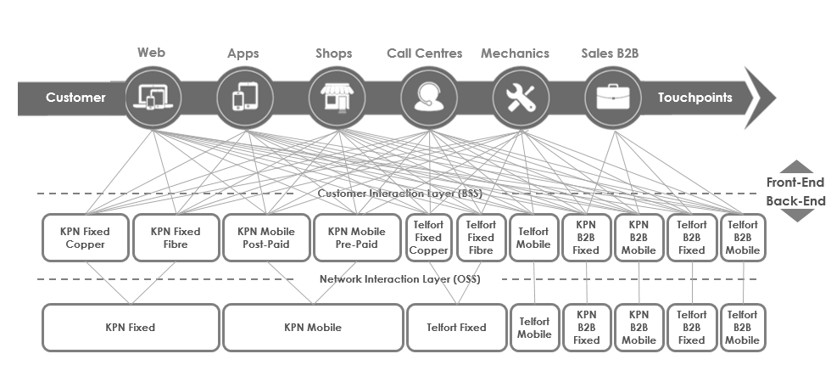

Note: B2B = business to business; BSS = business support systems; OSS = operations support systems.

Source: Company documents.

Exhibit 3: KPN, transformation Performance indicators—The Netherlands

|  |  |  |  |  |  |
| --- | --- | --- | --- | --- | --- |
|  | **2013** | **2014** | **2015** | **2016** | **2017** |
| **Customer satisfaction (NPS)** |  |  |  |  |  |
| Overall | −10 | −3 | +3 | +6 | +8 |
| Consumer | −6 | +2 | +9 | +10 | +13 |
| Business | −18 | −13 | −10 | −3 | −1 |
| Reputation (RepTrak Pulse score) | 63 | 70 | 69 | 67 | 71 |
| Run-Rate savings (€ millions) | 0 | 140 | 140 | 180 | 110 |
| **Proposition reduction versus 2013** |  |  |  |  |  |
| Consumer mobile (%) | 0 | −65 | −75 | −80 | −80 |
| Business (%) | 0 | −20 | −35 | NA | NA |
| **Process improvement versus 2013** |  |  |  |  |  |
| Consumer order handling time (%) | 0 | −40 | −80 | −80 | −80 |
| Consumer calls (%) | 0 | −15 | −30 | −45 | −50 |
| SME delivery costs (%) | 0 | NA | NA | −10 | −60 |
| SME servicing costs (%) | 0 | NA | NA | −10 | −65 |
| **Converged services** |  |  |  |  |  |
| Households in fixed-mobile bundles (%) | NA | 15 | 30 | 35 | 40 |
| Post-Paid customers in fixed-mobile bundles (%) | 10 | 20 | 35 | 45 | 50 |
| SME multi-play seats (thousands) | NA | 15 | 60 | 315 | 475 |
| **Data usage** |  |  |  |  |  |
| Total data traffic (terabytes per second) | 1.6 | 2.0 | 2.6 | 3.4 | 4.7 |
| Avg. 4G download speed mobile (megabytes per second) | 20 | 20 | 50 | 50 | 60 |
| **Own staff (#FTEs)** | 14,782 | 14,346 | 13,772 | 13,249 | 13,022 |

Notes: NA = not available; NPS = net promoter score; FTE = full-time equivalents; 4G = fourth generation of mobile technology; SME = small and medium-sized enterprises; RepTrak = methodology to measure reputation by Reputation Institute; Pulse score of 70-79 is considered “strong,” while 60- 69 is “average.”

Source: Company documents.

EXHIBIT 4: KPN, NEW TARGET OPERATING MODEL

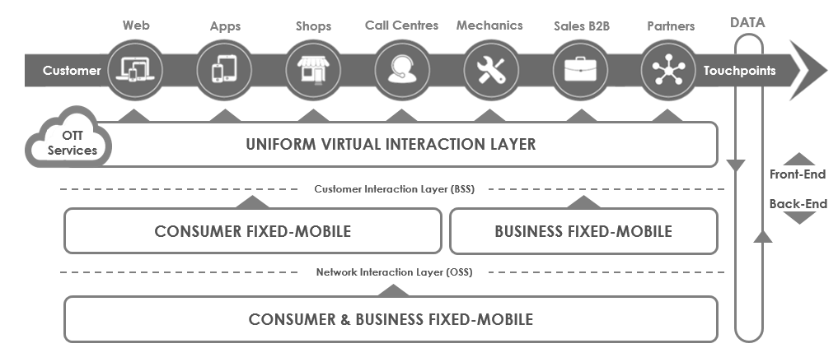

Notes: B2B = business to business; OTT = over the top; BSS = business support systems; OSS = operations support systems.

Source: Company documents.

EXHIBIT 5: KPN CUSTOMER JOBS-TO-BE-DONE AND OMNI-CHANNEL JOURNEY (ILLUSTRATIVE)

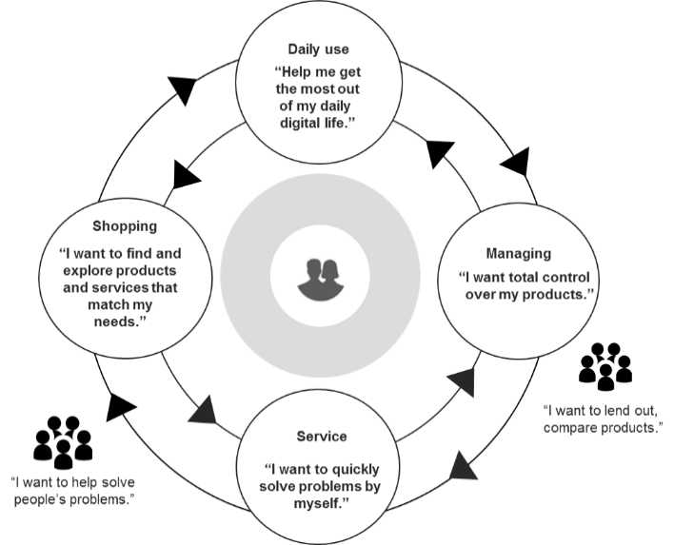

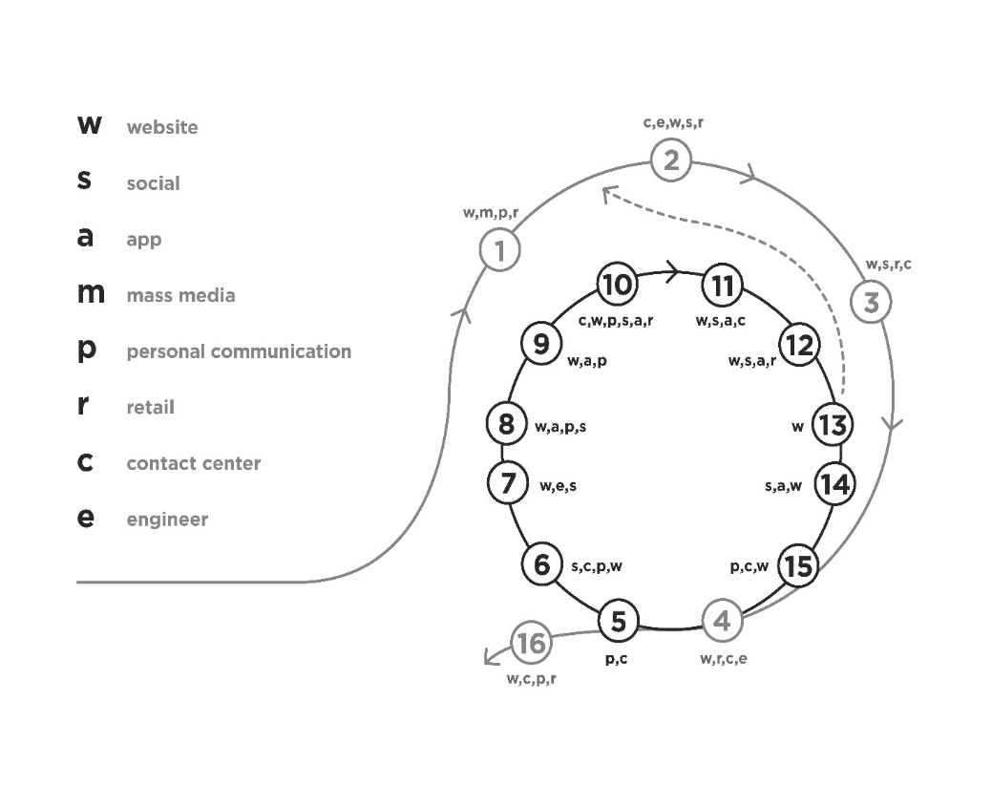

Source: Company Documents.

EXHIBIT 6: KPN ORGANIZATIONAL PIVOT (PARTIAL VIEW)

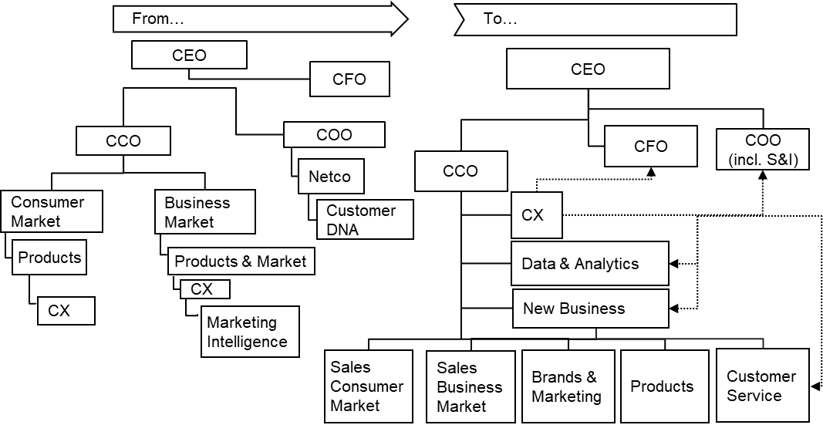

Notes: CEO = chief executive officer; CFO = chief financial officer; COO = chief operations officer; incl. S&I = simplification and innovation; CX = customer experience; DNA = master blueprint.

Source: Company documents.

Exhibit 7: KPN Vision 2020

Notes: IT = information technology; ROI = return on investment.

Source: Company documents.

Exhibit 8: KPN Kompas agile principles

1. **PURPOSE:** Our shared purpose—derived from KPN strategy and KPN experience—inspires us to navigate to our future KPN.
2. **TRANSPARENCY:** We strive for maximum transparency in everything we do and in our strategy, which is clear and understandable.
3. **WHOLE OVER PARTS:** Our approach is holistic. We believe the whole is greater than the sum of its parts.
4. **CONNECTION:** Every employee and each team is connected to a purpose underpinned by the KPN strategy.
5. **CROSS-FUNCTIONAL:** Targets are achieved by cross-functional multidisciplinary teams working in close proximity.
6. **CUSTOMER VALUE:** We make fact-based decisions focused on maximum customer value.
7. **AUTONOMY:** Teams/squads operate with the greatest autonomy and experience minimal dependency.
8. **HEARTBEAT:** We work in a harmonious rhythm to minimize coordination and dependency.
9. **LEARNING ORGANIZATION:** We experiment and learn—the basis for continuous improvement.
10. **RESPONSIBILITY:** The mandate lies with the people with the knowledge and information.
11. **MASTERY:** We facilitate in exchanging knowledge and strengthening professional skills.
12. **TRUST:** We work on the basis of trust rather than keeping tabs on each other.

Source: Company documents.

Exhibit 9: 100% digital KPN

1. Digital transformation leads to better customer experience and cost reduction.
2. “100% digital” means that all interaction with KPN can be done via digital channels. “Mobile first” means that all interaction with KPN can be done via a mobile device.
3. In a 100% Digital KPN, we will have non-digital customer interaction.
4. The most important challenge for KPN is employees’ mind-shift from “telco” to “digital.”
5. Digital transformation will guide us to become a smaller and simplified organization.
6. Agile working is not a goal in itself, but will be a vehicle to simplify the company.
7. Digital transformation has not been given enough priority, but we clearly feel a sense of urgency now.

Source: Company documents.

EXHIBIT 10: KPN OPERATING MODEL—STATUS at MID-2018

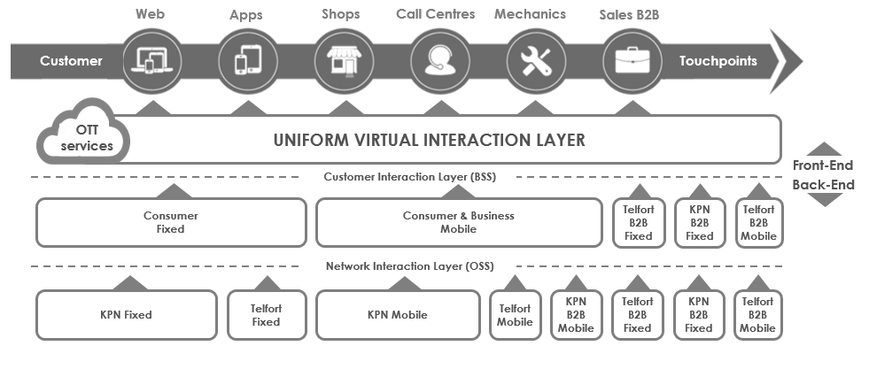

Notes: B2B = business to business; OTT = over the top; BSS = business support systems; OSS = operations support systems.

Source: Company documents.

1. € = euro; €1 = US$1.1693 as of June 1, 2018; All currency amounts are in € unless otherwise specified.
2. Industry 4.0 was a paradigm referring to the transformation of industrial manufacturing and supply chains through exploitation of the potential of new technologies.
3. Google, “FAQ What is an eSIM,” Google FI, accessed May 31 2019, https://fi.google.com/about/faq/#devices-10.; Apple Inc., “Using a Dual SIM with an eSIM,” Apple Inc., accessed May 31 2019, https://support.apple.com/en-ca/HT209044.; GSMA, “eSIM,” GSMA, accessed May 31 2019, www.gsma.com/esim/.
4. Jürgen Meffert and Niko Mohr, “Overwhelming OTT: Telco’s Growth Strategy in a Digital World,” McKinsey & Company, January 2017, accessed December 23, 2018, www.mckinsey.com/industries/telecommunications/our-insights/overwhelming-ott-telcos-growth-strategy-in-a-digital-world.
5. The net promoter score (NPS) was a metric ranging from −100 to 100 that measured the willingness of customers to recommend a company’s products or services to others. Companies used it to measure customer satisfaction with a product or service and loyalty to a brand.
6. An application programming interface (API) provided access to an information system component through a set of routines, protocols, and tools, making it easier for developers to use the component as building blocks to create software applications.
7. Scrum was a popular agile project management method used primarily for software development projects with the goal of delivering new software in short cycles called sprints. Development methods labelled “agile” subscribed to the agile manifesto’s values; see Kent Beck et al., “Manifesto for Agile Software Development,” Agile Manifesto, February 2001, accessed December 23, 2018, https://agilemanifesto.org.
8. TM Forum was a non-profit industry association for service providers and their suppliers in the telecommunications industry (e.g., network operators, software suppliers, and management consultants). As of June 2017, the forum had over 850 member companies that collectively generated US$2 trillion in revenue and served 5 billion customers across 180 countries.
9. In 2014, Henrik Kniberg, an agile/lean coach working mostly with Lego and Spotify, explained the engineering culture at Spotify in two videos on the Spotify Labs blog. See Henrik Kniberg, “Spotify Engineering Culture (Part 1),” Spotify Labs, March 27, 2014, accessed December 23, 2018, https://labs.spotify.com/2014/03/27/spotify-engineering-culture-part-1/.
10. For an illustration of the WeChat Go Europe offering, see “WeChat Go Europe,” YouTube video, 1:11, posted by “WeGoEU KPN,” July 11, 2018, accessed December 23, 2018, www.youtu.be/J2UB2sJvZ60.
11. Sarah Wray, “KPN: Business Transformation of the Year,” TMForum, May 2016, accessed April 12, 2019, https://inform.tmforum.org/features-and-analysis/2016/05/kpn-business-transformation-of-the-year/; “The 2018 European CIO of the Year Winners,” European CIO of the Year, accessed April 12, 2019, https://ecoty.eu/. CIONET was a community of senior IT people focused on IT, innovation, and digital transformation topics from all industries. As of December 2017, it had over 7,000 members across Europe and Latin America.