|  |  |
| --- | --- |
|  | ISB_Logo_BW2 |

9B19M055

SANDU PHARMACEUTICALS: FAMILY DYNAMICS AND SUCCESSION

Kajari Mukherjee and Sanjay Goel wrote this case solely to provide material for class discussion. The authors do not intend to illustrate either effective or ineffective handling of a managerial situation. The authors may have disguised certain names and other identifying information to protect confidentiality.

*This publication may not be transmitted, photocopied, digitized or otherwise reproduced in any form or by any means without the permission of the copyright holder. Reproduction of this material is not covered under authorization by any reproduction rights organization. To order copies or request permission to reproduce materials, contact Ivey Publishing, Ivey Business School, Western University, London, Ontario, Canada, N6G 0N1; (t) 519.661.3208; (e)* [*cases@ivey.ca*](mailto:cases@ivey.ca)*;* [*www.iveycases.com*](http://www.iveycases.com)*.*

Copyright © 2019, Ivey School of Business Foundation Version: 2019-06-26

Sandu Pharmaceuticals Ltd. (Sandu Pharmaceuticals) was a publicly listed company operating in the pharmaceuticals and health care sectors. Incorporated in 1985, the company traced its history back over more than a century. The third generation was at the helm of the firm in September 2016. Sandu Pharmaceuticals manufactured Ayurvedic medicines. Ayurveda was a traditional Indian system of medicine native to the Indian subcontinent and a popular form of alternative medicine. The demand for Ayurvedic medicinal products had seen an upswing not only in India but across many countries in Africa, Europe, and North and South America. Shashank Sandu, the company’s director, was in a “happy space” in his business. One day, while chatting with his friends about opportunities for setting up manufacturing bases in countries outside India, the conversation turned to the subject of grooming the next generation to run the business. This got Shashank thinking about how previous successive generations in the family had handled the challenge of absorbing family members into the business, and in particular about whether he was doing enough to prepare the next generation to take over a business that was bound to grow more rapidly in the future, given the growing concern worldwide about the cost of allopathic health care and demand for less invasive and more holistic treatments.

The Business of Ayurveda

In 1899, Shashank’s grandfather and his four brothers, all of whom were practitioners of Ayurveda (*Ayurvedacharyas*), decided to set up a business to formulate and sell Ayurvedic medicines. Their entrepreneurial venture was a direct response to the nationalistic *Swadeshi* movement,[[1]](#footnote-1) and specifically to the call by one of the first leaders of the Indian independence movement, Balgangadhar Tilak, to revive domestic products and production processes. Ayurveda was one of the world’s oldest holistic healing systems. Therapies were typically based on complex herbal compounds, minerals, and metal substances. This system of medicine had had a continual presence in the Indian subcontinent for more than 3,000 years. However, by the late 19th century, Ayurveda and other traditional systems of healing were under threat, not only from the British regime that ruled India and was skeptical about these systems, but also from modern (allopathic) medicine, even though allopathic formulations were far more expensive. Historically, practitioners of Ayurveda made their own formulations. Sandu Brothers Private Limited (Sandu Brothers) was one of the early attempts to create an industrial-scale manufacturing and distribution operation focused on Ayurvedic medicines. As demand grew, the company moved its factory to larger premises soon after its founding. The success of Sandu Brothers’ products was driven by a commitment to quality and a firm adherence to the basic tenets of Ayurveda.

Since its inception in 1899, the business had expanded greatly; it had a pan-India presence and significant exports to 22 countries. The company had close to 950 employees, out of which 30 were in management. About 100 employees were in manufacturing, 400 were in marketing and sales, 40 were in quality control and research, 50 were in warehousing and logistics, and the rest were categorized as workers. Though it stayed true to tradition in its use of ingredients, the business incorporated modern pharmaceutical practices in formulation, manufacturing, testing, and quality control. By 1998–99, the company had manufacturing units in New Mumbai and Goa, as well as a full-fledged research unit. The company was not only growing its export market, but also actively considering setting up units including wellness spas and centres outside India (see Exhibit 1 for the organization structure at the senior level.)

During the past century, allopathy had been at the top of the hierarchy of preference for medical systems in India. Since the nation’s independence in 1947, the Indian government had endeavoured to provide affordable health care using this “modern” system. However, many Indians saw Ayurveda as an effective choice for managing certain chronic diseases and recognized its potential to promote overall well-being, wellness, and health with minimal side effects. Some popular formulations were believed to improve immunity, aid in indigestion, relieve musculoskeletal conditions like joint pain, and promote healthy hair growth. However, due to a lack of active government support and involvement, this and other indigenous systems of medicines had languished for decades. It was only in 1995 that the government set up a department devoted to Indian systems of medicine under the Central Ministry of Health and Family Welfare. A separate ministry dedicated to research, development, and education in various branches of non-allopathic systems[[2]](#footnote-2) was set up in 2014. In many countries around the world, practices derived from Ayurveda were seen as being part of the family of complementary or alternative medicine and, more recently, were being integrated into general wellness applications and, in some cases, medical treatment.

The Family in Family Business

The Sandu family belonged to the close-knit Karade Brahmin community, which had been socially and politically influential in the Konkan and Goa region of Western India under various ruling dynasties before the area was colonized by the Portuguese in the 16th century. Karade Brahmins typically served as village [record](https://en.wikipedia.org/wiki/Kulkarni) keepers and accountants, financiers, tax farmers, merchants in intra-Asian trade, priests, and diplomats. As a result of the Portuguese invasions, the community had scattered to nearby regions, where its members took up administrative vocations under the ruling dynasties and established themselves as landowners and traders. The community continued to be close-knit and it emphasized learning through both traditional and modern systems of knowledge.[[3]](#footnote-3) This focus inspired the five Sandu brothers to venture out of the traditional occupation of landownership and join the growing tribe of indigenous entrepreneurs who were trying to break the stranglehold of the British in the health care sector and many other sectors of the Indian economy.

A majority of the founders’ sons had decided to join the family business. In most cases, the sons either were not given a choice in the matter or did not even consider pursuing another career. For example, Shashank’s father was admitted to the first batch of a top-notch management institution, but the family urged him to forgo that opportunity and join the family business instead (he did, however, take a part-time management course at the same institution). Based on their aptitude, the second generation members were put in charge of various aspects of the business. Some of them were trained in particular trades to make the job–person fit more appropriate. For example, Shashank’s father had a business degree, one of his two uncles was an Ayurvedic doctor, and another was a printing technologist. Some of his cousins, however, had chosen to work in areas of the business that caught their fancy. Some had only a sinecure management position (e.g., in charge of transportation). The daughters of the family got married and moved away and were not expected to make any ownership claims. Daughters-in-law were not expected to join the operations, but to preserve family peace and harmony instead.

The joint family structure had been the norm in India for centuries and continued to be quite prevalent even in modern times, particularly among business families. The Sandu family, though close-knit, had maintained separate establishments for the past few decades; Shashank’s grandmother had had the foresight to encourage the separation of the household to minimize conflicts. However, the entire family, spread across many households, jointly participated in a number of prescribed religious rituals and festivals every year. The family aimed to abide by traditional Indian middle-class values:

* Health is wealth.
* A paisa saved is a rupee[[4]](#footnote-4) gained.
* Avoid all types of wastage—food, electricity, raw materials.
* Be frugal and live simply—take a bus if possible, not the car.
* Good education and learning is a must and will last throughout your life.
* Respect elders, even though you may think they are wrong.

Growing up in a family imbued with a strong set of values still did not eradicate the problem of some family members blurring the lines between their entitlement as owners and their responsibilities as managers. The second generation had 15 male cousins (see Exhibit 2). Among them, one family member decided to buy a luxury vehicle with money drawn from the business. Another decided to fuel his gambling habit from the business cash box. Some had unrealistic aspirations that they expected the business to support. One wanted to produce a movie, which he expected the business to back, rationalizing that the company’s product placement in the movie would help in marketing. Some members decided to start their own businesses using family resources, without thinking through the consequences. For example, one member started a car repair showroom within the factory premises without requesting the necessary permissions. Everyone wanted a personal car and a driver—paid for by the business. In some sense, many family members viewed the business as an entity that existed to bankroll their whims and fancies.

The Business in Family Business

The second generation continued to view the employees of the company as an extension of the family. Most of the workers were from the same region as the family. Many were second generation employees themselves. The approach to managing employees was distinctly paternalistic. The family’s belief in paternalism was severely shaken when there was strike in the factory in the late 1980s, which led to the factory’s closure for nine months. The industrial unrest was fomented by external leaders who specialized in galvanizing employees to raise questions against real or perceived injustices. One of Shashank’s uncles was stabbed (he survived), there was sloganeering against the family owner/managers, their effigies were burned, and an atmosphere of terror and fear reigned. For the family, it was a psychologically devastating time.

Shashank, who had just finished high school at that time, was drafted into interacting with lawyers and courts, as he was not targeted by the striking employees. The industrial dispute was eventually resolved through the use of various legal strategies, but it had led to the closure of one unit and the shifting of the manufacturing base to regions with a more positive industrial climate. More importantly, more nuanced thinking about the management–employee relationship emerged as a consequence of these events. From a strong emotional bond based on paternalism, the relationship shifted to one in which commercial ties and economic value constituted important strands. The company ensured that the new plants did not have unions.

Shashank recollected that from a young age it had been drilled into him and all of his siblings that in business, a personal promise or verbal commitment was golden. Before the company went public in 1993, capital formation was primarily financed through personal loans.[[5]](#footnote-5) These loans were typically between two parties, where one’s word of honour was paramount. However, meeting the commitment to pay back the principal with hefty interest rates on the due date at periodic intervals was also a big challenge. Shashank said, “I have seen my father and uncle crushed with stress about sticking to their commitment [to pay back on time].”

The third generation insisted on changing the pattern of capital accumulation by accessing more formal channels. They had to fight their predecessors’ inherent fear of both loss of control and of disclosure requirements. There was a great deal of opposition from various family members to a public listing. Some said, “How much do you want for your business expansion?—here, let me write a cheque.” Ultimately, there was only a mandatory dilution of 25 per cent of the shares to the public. The father and uncles took a pledge from the third generation, telling them, “You are only going to the public to generate money. Don’t ever ‘play the market’ because if you start playing the market, your focus will shift from manufacturing.” See Exhibit 3 for the business value system that guided the family.

By 2015, the family business consisted of the publicly listed pharmaceutical company as well as privately held companies and trusts that controlled various types of assets and discharged different types of responsibilities.[[6]](#footnote-6) As the business grew, the family felt the need to introduce modern practices of manufacturing, quality control, and process orientation. In time, the company’s manufacturing plants adopted aseptic techniques to improve quality, with the entire process of converting raw material to products untouched by human hands.[[7]](#footnote-7)

Rules for Joining THE Family Business

The family had never done any formal succession planning. But as Shashank and his siblings and cousins were growing up, Shashank’s father and uncles, who were involved in managing the business, put in place some broad rules for working for the family business based on what they had learned from past experience. The next generation was told that joining the business should not be considered an entitlement. They were expected to earn appropriate educational degrees and work in an outside firm in a responsible position before they would be considered for a suitable role in the company. Shashank recalled:

We were told categorically and repeatedly that we should get trained in roles that the business requires. The prime requirements in any business are marketing, manufacturing and finance/legal. We were expected to gauge our aptitude before deciding on the role in which we wanted to specialize. For example, during my summer holidays in high school, I worked as an assistant clerk with one of our chartered accountants. I didn’t like it as a vocation but understood what an accountant does. Similarly, my brother worked under a well-respected chartered company secretary. My cousin went to work in a pharmaceutical company as a research scientist and today handles the manufacturing and R&D [research and development].

Shashank subsequently completed a master’s degree in business management from a reputed institute and worked for about three years in marketing at two well-known companies in the private sector. Recalling his stint at a fast-moving consumer goods multinational company, he said:

I was selling the product in Dharavi, the largest slum in Asia. It taught me to respect the customer. The demand for the company’s products was naturally limited in such a poverty-stricken area. I had to think out of the box to get the shopkeeper to place an order for even a very small amount of products. Rejections were part of life there. I really learned the art of sales there. In my second stint, I learned how to manage workers to ensure that production always kept pace with client demand.

After about three years, Shashank was invited to apply for a position in the family business. He was interviewed by an external expert and his salary was negotiated based on his last drawn salary.

While discussing how the third generation was prepared for operational responsibilities, Shashank said:

We come with three types of baggage: (a) our personality, (b) our character, and (c) the perceived value placed by all those who surround us. The last type starts even with the nickname given to you. I and my siblings had domestic help who also did some light office work during the day. So, their perceptions of us and what gets communicated among employees is also part of the baggage. Family members had their own set ideas of what we should do when we grew up. I think education and outside work experience helps a person overcome this baggage to a large extent.

Talking about the norms of the business that were informally communicated to all (see Exhibit 4), Shashank recollected some conflicts within the family:

Everyone wanted to join the business as their birthright. Everyone wanted the same salary. But can a business take this load? By the time the third generation was joining the business, the distinction between ownership and management was becoming clear. Family members who didn’t fit the requirements were either eased out or were retiring anyway.

There were family members who were not interested in contributing to the business. They were happy with the dividends they earned. Over the years, such members were bought out (see Exhibit 5 for the changing pattern of family owners and managers). Shashank explained, “Business is like a capitalist system. You need to constantly feed it with various types of expertise to be supplied by the family. There were some who didn’t want to be bothered. But those who were contributing to the requirements of the business started increasing their holdings.”

SUCCESSION IN THE TRUE SENSE

When a next generation member joined the business, they had to learn the business and make their presence felt. Shashank recollected that in his initial days as a management trainee, he spent two months in each department. While in the logistics department, he realized that the carrying and forwarding agent was getting richly remunerated because of a flawed commission formula. He had this changed. Similarly, he brought down the cost of bottling by negotiating a better deal with the bottle suppliers. He was able to do these things because people were willing to listen to him due to his position as a family member as well as his external job experience. Shashank recollected:

People in the company are very smart. They figured out that I could make good decisions, but they also separately got these decisions ratified by the big bosses (my father and uncles) as they didn’t know where the power centre was and they themselves had a different equation with the older power centres. At some point in time, from both sides, a line has to be drawn, when the older generation says clearly, “Don’t involve me,” and the employees understand that the power centre has shifted.

Recalling how he had had to fight his way in, Shashank described an incident where a very senior professional in the company misrepresented facts to his uncle after ferreting out information from him through a junior colleague. Shashank had actually initially fed partial information to the concerned professional, who then encouraged the older generation to essentially negate the proposal before it was even formally presented. In the formal meeting, Shashank supplied the full information and had his proposal accepted. This was how he ensured that this particular person stopped pitting family members against each other. Shashank joined as management trainee in 1992, was promoted as manager (planning and development) in 1993, and became general manager (marketing) in 1994 and director in 1996.

With two brothers and two cousins (one actually belonged to the fourth generation but was referred to as a cousin)[[8]](#footnote-8) handling various roles in the business,[[9]](#footnote-9) conflicts did occur from time to time. Typically, conflicts between any two family members were openly discussed, with the other two acting as arbitrators. Conflict was considered a healthy way to understand different perspectives of the business. Shashank explained that this way of resolving conflicts reflected the way things were handled in his family, saying, “Business is an extension of how the family is.”

Role for family members who retireD

Both Shashank’s father and uncles retired upon reaching the age of 60, an occasion that was marked by an appropriate farewell function. After retirement, each took some time off for religious tourism.[[10]](#footnote-10) After a few months, they started coming back to the office and spending a few hours in the afternoon in offices assigned to them. None of them was part of the organizational structure. However, their presence was welcomed, as the operational managers used them as a sounding board. Many older employees dropped by to chat with them, even about personal issues. The elders also looked after the religious traditions of the family, planning family events such as get-togethers and weddings as well as various community events not connected with the business.

current CHALLENGES OF the BUSINESS

By the second decade of the 21st century, 65 per cent of India’s population was less than 35 years of age. The challenge before the company was to present its products in such a way that it appealed to the young generation. The global phenomenon of aspiring to a healthy lifestyle was catching up in India as well. Shashank felt that opportunities to explore and expand in the Indian market were significant. To cater to modern sensibilities and lifestyle requirements, the company had come out with individual pack sizes of its products, which allowed daily doses to be carried easily in a purse or lunch box. The company was also thinking about creating certificate courses to allow practitioners to recommend correct therapies and appropriate doses.

The Next Generation

The fourth generation of the family, comprised of the children of the four cousins involved in managing the business, fell into various age groups ranging from toddler to college student. Shashank said:

With the new generation, it is a different story. They know the rules of joining, but they may not even be interested in our business. Ayurveda is not exciting enough for a generation with many more avenues of success in the digital age. This generation doesn’t see joining the family business as a sacred duty or at the very least a responsibility. We have a family friend and advisor who interacts a lot with the children to understand their mindset and interests. We have to find ways and means to get the youngsters interested in what we do. For example, we asked my college-going niece to host the program when the prime minister of Mauritius was visiting our factory in Goa to inaugurate a herbarium facility. We encouraged her and her college friends to come to Goa and go on a field trip to our state-of-the-art plant there, which is a bonus as Goa is also a lovely vacation spot. When groups like this see how well managed the plant is, our children start looking at their own property in a different light!

It was clear that Shashank had been mulling over the future of the family business, and in particular the role of the next generation as leaders (see Exhibit 6). While much of the preparatory work for the next generation was rather informal, such as plant visits, it seemed inevitable that Shashank’s attention would turn toward a more formal and planned approach for a smooth and seamless succession from the third to fourth generations. He wondered how other family businesses faced this inevitable event in their history, and whether something could be tailored to fit the context of Sandu Pharmaceuticals.

EXHIBIT 1: ORGANIzATIONal CHART (AT the BOARD Level AND ONE LEVEL Down)

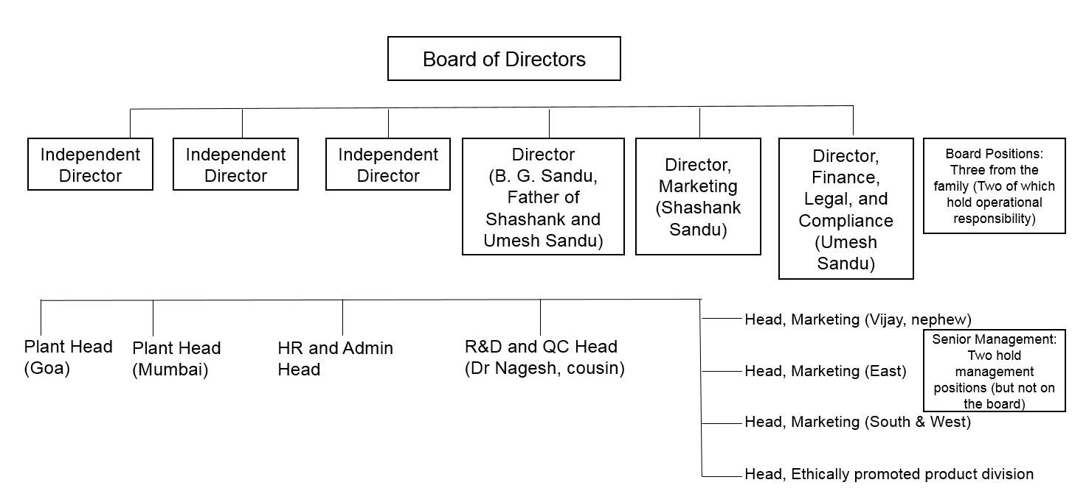

Note: HR = human resources; R&D = research and development; QC = quality control.

Source: Created by the case authors based on company documents.

EXHIBIT 2: GENOGRAM

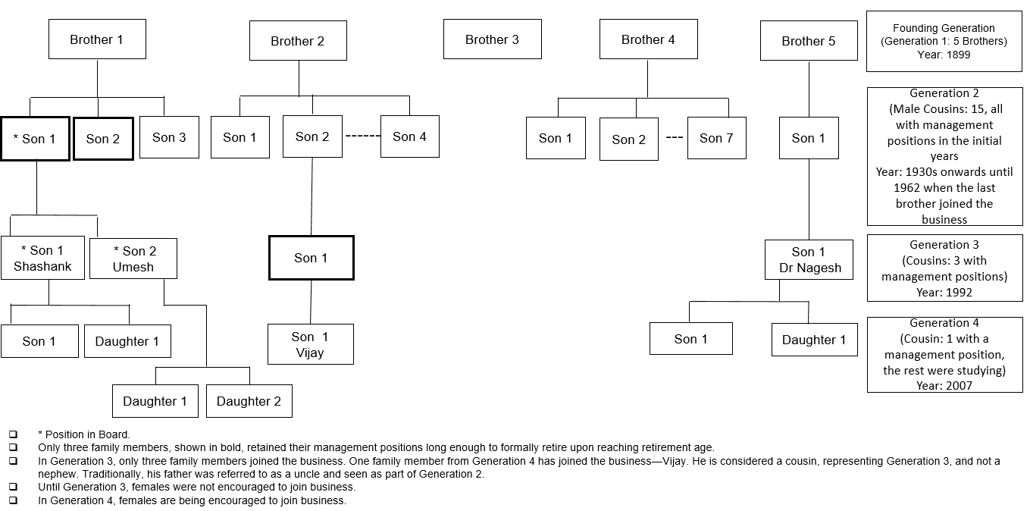

Source: Created by the case authors based on company documents.

EXHIBIT 3: BUSINESS VALUE SYSTEM PROFESSED BY THE FAMILY

* The institution comes first, then the family, and then the individual (member).
* In the company’s progress lies your progress.
* Your surname does not assure you of anything.
* We are here to propagate the science of Ayurveda.
* Promise what you can deliver.
* Profit is not, and should not, be the only criteria for success.
* By manufacturing effective but affordable medicines, we are serving society.

Source: Created by the case authors based on company documents.

EXHIBIT 4: FAMILY CODE OF CONDUCT

* Induction of family member occurs only if the business requires it, not by right.
* Family members must be professionally qualified.
* Family members must have worked outside the business for at least two years.
* Compensation will be decided by an outside panel.
* Business needs are different from family requirements and one should not be confused with the the other.
* Management is separate from ownership.

Source: Created by the case authors based on company documents.

EXHIBIT 5: CHANGING OWNERSHIP AND MANAGEMENT POSITIONS ACROSS GENERATIONS IN the family’s PORTFOLIO OF BUSINESSES

|  |  |  |
| --- | --- | --- |
| **Generation** | **Ownership Stakes** | **Management Positions** |
| First | 5 | 5 |
| Second | 22 | 15 |
| Third | 28 | 4 |
| Fourth | 4\* |  |

Note: The management position held by the lone member of the fourth generation in the table is considered to be part of the third generation by the family, and hence is indicated as such; \*only the adult children of Shashank, his brother, and his cousins had shares allotted at the time of writing the case.

Source: Created by the case authors based on company documents.

Exhibit 6: Income statement across two financial years

|  |  |  |  |
| --- | --- | --- | --- |
| Particulars | | For the year ended March 31, 2016  Amount (₹) | For the year ended March 31, 2015  Amount (₹) |
| A | CONTINUING OPERATIONS |  |  |
| 1 | Revenue from operations (gross) | 467,838,570 | 447,343,026 |
|  | Less: Excise duty | 7,303,840 | 5,127,185 |
|  | Less: Trade discount | 50,012,086 | 48,013,846 |
|  | Add: Insurance claim received | 261,650 | 1,814,304 |
|  | Revenue from operations (net) | 410,784,293 | 396,016,299 |
| 2 | Other income | 1,452,085 | 1,368,833 |
| 3 | Total revenue (1 + 2) | 412,236,378 | 397,385,132 |
| 4 | Expenses |  |  |
|  | (a) Cost of materials consumed | 84,179,586 | 67,618,878 |
|  | (b) Purchase of stock-in-trade | 134,463,267 | 138,238,168 |
|  | (c) Changes in inventories of finished goods, work-in-progress, and stock-in-trade | (5,774,572) | 14,386,275 |
|  | (d) Employee benefits expenses | 45,111,494 | 36,898,828 |
|  | (e) Finance costs | 16,434,143 | 13,702,573 |
|  | (f) Depreciation and amortization expenses | 6,930,806 | 5,745,361 |
|  | (g) Other expenses | 124,097,246 | 114,507,629 |
|  | Total expenses | 405,441,969 | 391,097,712 |
| 5 | Profit/(Loss) before exceptional and extraordinary items and tax (3 − 4) | 6,794,431 | 6,287,420 |
| 6 | Exceptional items |  |  |
| 7 | Profit/(Loss) before extraordinary items and tax (3 + 4) | 6,794,431 | 6,287,420 |
| 8 | Tax expense: |  |  |
|  | (a) Current tax expense for current year | 2,150,000 | 1,250,000 |
|  | (b) (Less): MAT credit (where applicable) |  |  |
|  | (c) Current tax expense relating to prior years |  |  |
|  | (b) Net current tax expense | 2,150,000 | 1,250,000 |
|  | (c) Deferred tax | (734,540) | 900,793 |
|  |  | 1,415,460 | 2,150,793 |
| 9 | Profit/(Loss) for the year (5 + 6 − 8) | 5,378,971 | 4,136,627 |
| 10 | Earnings per share (of 10 each): |  |  |
|  | (a) Basic |  |  |
|  | (i) Continuing operations | 0.76 | 0.58 |
|  | (ii) Total operations | 0.76 | 0.58 |
|  |  |  |  |
|  |  |  |  |

Note: ₹ = INR = Indian rupee; ₹1 = US$0.0149 on September 1, 2016; MAT = minimum alternate tax.

Source: Company files.

1. The Swadeshi (literally meaning “of my country”) movement was a key component and aim of the Indian independence struggle and developing Indian nationalism. It was an economic and political strategy aimed at improving economic conditions in India and developing a national identity by following the principles of self-sufficiency. [↑](#footnote-ref-1)
2. The name of the ministry was AYUSH, which in Sanskrit (the classical language of the Indian subcontinent) meant “life.” It was also an acronym incorporating various types of medical/wellness systems—Ayurveda, Yoga and Naturopathy, Unani, Siddha, and Homoeopathy. [↑](#footnote-ref-2)
3. In modern India, the Karade Brahmin community was one of the most educated and prosperous communities in the country, with a global footprint in a variety of professions including the arts and sports. [↑](#footnote-ref-3)
4. One rupee was equal to 100 paise. Rupee = ₹ = INR; ₹1 = US$0.0149 on September 1, 2016. [↑](#footnote-ref-4)
5. In India, certain communities traditionally served as moneylenders for business. Since medieval times, a financial instrument called a *hundi* had been used as a remittance instrument to transfer money, as a credit instrument, and as a bill of exchange in trade transactions. These had no legal standingbut continued to be popular, even though the interest rates were much higher than those available through formal channels. [↑](#footnote-ref-5)
6. To discharge various religious and community responsibilities, the Sandu family created a trust. For example, daily prayers and religious rites were performed in temples located within the factory premises and in their ancestral village. [↑](#footnote-ref-6)
7. Ayurvedic products typically were made in small batches by individual doctors who sourced the ingredients themselves. In the initial years, the production approach followed the same route, though the volume was large. The introduction of modern pharmaceutical techniques in manufacturing improved the quality, stability, and acceptability of Ayurveda products. This trend was seen across the industry and was not specific to Sandu Pharmaceuticals. [↑](#footnote-ref-7)
8. We continue to refer to him in the case as a cousin, though he is listed in the fourth generation in Exhibits 1 and 2. [↑](#footnote-ref-8)
9. Shashank’s brother, being based in Goa, also oversaw the plant there. One cousin headed the research and development department and the other cousin headed regional sales in the North. [↑](#footnote-ref-9)
10. Religious tourism comprised about 15 per cent of total domestic tourism in India. Also known as faith tourism, people travelled individually or in groups on pilgrimages or for missionary purposes. [↑](#footnote-ref-10)