

9B19M056

ontario racquet club

Martin Eidenberg wrote this case under the supervision of Julie Gosse solely to provide material for class discussion. The authors do not intend to illustrate either effective or ineffective handling of a managerial situation. The authors may have disguised certain names and other identifying information to protect confidentiality.

This publication may not be transmitted, photocopied, digitized, or otherwise reproduced in any form or by any means without the permission of the copyright holder. Reproduction of this material is not covered under authorization by any reproduction rights organization. To order copies or request permission to reproduce materials, contact Ivey Publishing, Ivey Business School, Western University, London, Ontario, Canada, N6G 0N1; (t) 519.661.3208; (e) cases@ivey.ca; www.iveycases.com. Our goal is to publish materials of the highest quality; submit any errata to publishcases@ivey.ca. i1v2e5y5pubs

Copyright © 2019, Ivey Business School Foundation Version: 2019-08-01

As Pete Mitchell, chief executive officer of the Ontario Racquet Club (ORC), glanced at the updated membership numbers on his desk in January 2014, he contemplated what could be done to boost membership. Operating in an ever-changing industry with new and increasingly fierce competition, the ORC faced significant external pressure to retain current membership and attract new long-term, active, and profitable members. Mitchell knew that any future projects to address these issues would need to be approved by the board of directors.

THE HEALTH, WELLNESS, AND SPORTS CLUB INDUSTRY[1]

The first sporting club in (pre-Confederation) Canada was the Montreal Curling Club, founded in 1807.[2] Driven by increases in disposable income, population, and time available for leisure activities, as well as a societal trend toward healthier lifestyles, health and fitness clubs became a significant and growing industry in Canada after this time, with total industry revenues exceeding CA$2.8 billion.[3] Over the past six years, industry revenues had grown by an average of 5.9 per cent per year, and the outlook was similarly positive. The Canadian economy was generally recovering from the 2008–09 recession, with real gross domestic product growth well over 2 per cent.[4]

With the adult obesity rate in Canada climbing over 50 per cent, government health campaigns and incentives (i.e., child and adult fitness tax credits) contributed toward stimulating membership sales across the industry. With health care costs skyrocketing, government and insurance providers were predicted to increasingly look toward prevention as a means to reduce costs; the subsidization of fitness and sports club memberships was a major mechanism by which to do so. This was especially true for individuals with comprehensive benefits coverages provided by their employers.

THE ONTARIO RACQUET CLUB

Since the ORC’s founding in 1975, the club had grown to become one of Canada’s largest private family sports clubs, with over 4,300 members (see Exhibit 1). Over the years, the ORC had undergone several large renovations, including investing $5.5 million in 2005 on a brand new entrance area to the club and modernized reception, office, spa, locker room, and group fitness areas (see Exhibit 2). Today, the ORC’s facilities covered 8.5 acres of land and 150,000 square feet of indoor space. The ORC’s tennis facilities included seven climate-controlled indoor hard courts and 10 additional hard courts that were outdoors in the summer and under a heated bubble during the winter. Additionally, the ORC housed six singles squash courts and one doubles squash court, as well as an extensive state-of-the-art fitness centre. An outdoor pool, full-service all-day restaurant, fully supervised play centre for children, on-site pro shop, and massage, physiotherapy, and spa facilities further enhanced the member experience.

Approximately 150 individuals were employed at the ORC. This included a roster of highly regarded and qualified tennis, fitness, and squash professionals. The ORC also had qualified staff in place for the full range of corporate activities, including finance and accounting, marketing, membership sales, and human resources, as well as specialized operations professionals in each of the ORC’s departments.[5] Mitchell himself had worked at the ORC for over 30 years, starting as the director of tennis before taking on his current management role.

MISSISSAUGA, ONTARIO

The ORC was established in Canada’s sixth-largest city by population—Mississauga, Ontario (population of 721,599).[6] It was located in the south-westernmost corner of the city, near the affluent neighbourhoods of Clarkson, Lorne Park, and Port Credit. It was also located near the border with Oakville, Ontario which itself had an affluent population of 193,832. The population in the Toronto suburbs was projected to continue to grow, with Mississauga’s population projected to reach 930,900 by 2051. Mississauga’s population was also slightly younger and significantly more ethnically and linguistically diverse than the national average. Average and median household incomes in Mississauga were also higher than the national and provincial averages (20 per cent and 10 per cent higher, respectively).

COMPETITION

With the industry continuing to experience strong growth, the ORC was faced with an increasingly competitive landscape in which to attract new active and profitable members. Mitchell identified three main groups of competitors to the ORC: other private clubs, new commercial facilities, and community-oriented clubs that were often focused on only one element of the ORC’s extensive offerings.

Private Clubs

The first major area of competition for the ORC was other private clubs with similar offerings. These clubs offered an exclusive, upscale atmosphere in a similar or higher price range. The Oakville Club was located in the heart of downtown Oakville and offered five outdoor tennis courts, four squash courts, four badminton courts, an outdoor pool, fitness centre, yachting, and an extensive clubhouse with high-class dining facilities. Further west, in Burlington, Cedar Springs Health, Racquet & Sports Club offered extensive facilities with a focus on aquatics. It had eight pools, including an outdoor–indoor waterpark. In addition, Cedar Springs offered 11 indoor tennis courts, two outdoor clay courts, 11 squash courts, six racquetball courts, four badminton courts, and a large fitness centre. Eastward from the ORC, the Boulevard Club was a noteworthy facility located on the shores of Lake Ontario on the west side of Toronto. It offered 10 outdoor clay tennis courts (eight bubbled in the winter), a state-of-the-art badminton centre, a fitness centre, an indoor and a separate outdoor pool, yachting, and extensive wellness and dining facilities, along with numerous other activities.

Fitness Chains

Commercial facilities that competed with the ORC, especially in the fitness and squash realms, were increasing in number and scale. These included nearby locations of Goodlife Fitness (Goodlife), along with brand new LA Fitness International (LA Fitness) and Life Time Inc. (Life Time) facilities. These facilities had lower membership costs than the ORC; however, they lacked the breadth of amenities and the strong social community that were the cornerstone of the ORC and other private clubs and that enabled these private clubs to retain members and obtain premium membership fees.

These commercial facilities were also part of larger corporate networks. Goodlife operated over 300 facilities in Canada. LA Fitness and Life Time were both international companies with over 700 and 135 locations across Canada and the United States, respectively. In fact, Life Time was a publicly listed company with revenues exceeding US$1 billion.[7] While these fitness chains benefited from economies of scale from their many locations, they typically lacked the community atmosphere that was a hallmark of private clubs.

Community Clubs

There were a number of tennis-specific community summer clubs that competed with the ORC for casual, summer-only tennis players. ORC members would often take up an additional membership at one of these smaller clubs for the summer. There were three notable clubs of this nature in the area: Whiteoaks Park Tennis Club had eight outdoor tennis courts located in the heart of the Lorne Park neighbourhood of Mississauga. Located in Oakville, Wallace Park Tennis Club had five outdoor courts, and in central Mississauga, Credit Valley Tennis Club boasted eight outdoor clay tennis courts.

Two facilities on the northern Oakville–Mississauga border each offered outdoor tennis in the summer, erecting a bubble for play during the winter. Joshua Creek Tennis had six courts, while the nearby Tennis School had five. Overall, these facilities provided significantly reduced costs to play tennis. However, they did not provide any of the many additional amenities available at the ORC or other private clubs.

MEMBERS

As maintaining a healthy, active lifestyle was not exclusive to any particular demographic segment, the ORC’s membership was diverse. Nevertheless, Mitchell noted that the ORC’s members could be grouped into three broad segments: young families, older families, and retirees. It was also important to note that while the ORC’s premium membership fees and prices remained competitive in the Mississauga–Oakville market, generally they did mean that the ORC’s members were primarily drawn from higher-income households.

While all members tended to use the club at various times of the day, there were a few noticeable trends: Young families tended to use the club most during the after-school period and on weekends and holidays. Retirees tended to use the club most on weekdays in the mornings and early afternoons. Older adults who were stay-at-home parents tended to use the club most during the school day. Those who were active professionally tended to use the club most in the early mornings and in the evenings on weekdays.

Young Families

Young families accounted for approximately 35 per cent of members.[8] They were often drawn to the ORC’s breadth of activities. This meant parents could attend a group fitness class or workout while their children attended a tennis or squash clinic. This could be followed by a family dinner in the restaurant. Young families were also drawn to the ORC’s play centre. Here, children were fully supervised with a variety of games and activities. Rates were charged on an hourly basis directly to a membership account. However, included in the price for each ORC family membership were two hours of free play centre child care per child per day.

Older Families

Accounting for approximately 39 per cent of the ORC’s membership, older families (consisting of older adults and any older children who continued to be active at the ORC) were the largest of the three groups.[9] They typically led busy lifestyles, so convenience was paramount for this market segment. This demographic often wanted to remain active as they aged, and the ORC allowed them to do this in a familiar social atmosphere. In general, the longer someone remained a member, the more entrenched they became in the ORC community and, therefore, the more likely they were to remain members for longer.

Retirees

Retirees—considered all members aged 56 and above[10]—accounted for about 26 per cent of the ORC’s membership. These members wanted to remain as active as possible. They were also often engaged in the various social activities at the club. Within the ORC’s membership a wide variety of clubs had formed, including a book club, a wine club, and a gardening club. Additionally, members took advantage of various social events (such as a New Year’s Eve gala and an east coast surf-and-turf dinner) that were held throughout the year.

ALTERNATIVES

Mitchell considered five strategic options for the ORC. In addition to maintaining the status quo or selling the business, he considered other alternatives that would hopefully boost membership levels. Under consideration were options to create an indoor multi-purpose sport court; build a new pool with a retractable roof, along with expanding the restaurant area; and allow children who were not ORC members to participate in programming at the club.

Status Quo

Keeping in mind the ORC’s successful history since its founding in 1975, Mitchell wanted to ensure he considered the option of maintaining the club’s status quo. He estimated that membership revenue would increase by about $100,000 in the coming year, while revenue from tennis, fitness, and squash clinics and lessons would remain at same dollar levels. All other forms of revenue were conservatively projected to increase by three per cent. With the exception of the telephone expense,[11] all expenses were expected to remain at the same dollar amounts or proportions of total revenue for the upcoming year (see Exhibits 3–5).

Sport Court Expansion

Mitchell wondered whether expanding the ORC’s range of activities would help to spur growth in membership. Upon further investigation, he discovered that converting an existing fully indoor tennis court into an all-purpose sport court was a feasible alternative. For a projected total construction cost of $750,000, the space could house a gym, with room for a full-sized basketball court; an additional space for weightlifting activities, which would be adjacent to the existing fitness area; and a storage area for all equipment that would be associated with the new space.

The sport court would allow for a variety of new programming to suit all age groups. Drop-in basketball and volleyball were the obvious uses for the space; however, Mitchell noted that the space had potential for many other additional purposes: The fitness department would be able to offer additional classes that required more space than was currently available—especially for classes that focused on children. The space could also be used to start badminton and pickleball[12] programs and clinics at the ORC. Finally, the space could be used to enhance the experience for children attending the ORC’s popular summer camp programs.

Mitchell projected that the sport court expansion would result in new revenue of $70,000 from additional members joining the club. Incrementally, an additional 300 people were expected to sign up for six-week clinics in the sport court compared to the current tennis court.[13] Of this additional lesson and clinic revenue, 60 per cent would go toward instructors in variable labour costs. Additionally, credit card processing fees would apply. Revenue from court fees would decrease by three per cent from 2013 levels. The maintenance and utilities expenses would increase by $8,000 and $12,000, respectively. The initial investment would be wholly financed through internal cash.

Finally, Mitchell wondered if there would be members who might be lost without this expansion. If so, how would they be accounted for, if at all?

Indoor–Outdoor Pool Addition

With the ORC’s outdoor pool beginning to look outdated, Mitchell also began to look at options to upgrade these facilities. One alternative stood above the others in this regard: by expanding the pool area and removing one outdoor tennis court, there would be enough space to build a brand new 25-metre pool and hot tub area, both within a modern glass enclosure. What was most impressive about these plans was that the roof of the enclosure would be retractable. This would ensure that the pool area remained heated during the lengthy Canadian winters, whereas during the summer, the roof could be opened, allowing members to enjoy the outdoor pool experience they were accustomed to. The new pool would allow for an expanded aquatics program that could be offered all year long. Aquatics programming typically focused on younger children, but the ORC was also well known for a variety of aquafit classes, which were popular among retirees.

Alongside the new pool, the expansion plans called for new and modern pool-specific locker rooms and changing areas. The restaurant would also be expanded to almost double the current indoor eating area. Additionally, the outdoor patio area would also be completely renovated and expanded to include a children’s splash pad on the wall adjacent to the pool itself.

In order to fully understand the implications of pursuing this expansion option, Mitchell made a number of conservative projections. First, he projected that this large $5.25 million[14] expansion would generate significant publicity in the community and lead to an additional $520,000 in membership revenue. Mitchell also predicted that additional lesson and clinic revenue and costs from the pool would be similar to the expected results of the sport court expansion. With the expansion of the restaurant, Mitchell projected an additional $200,000 in revenue.[15] To ensure the expansion would attract enough attention and anticipation in the surrounding community, Mitchell felt that allocating an additional $15,000 to the advertising budget was warranted. With this expansion, the maintenance and utilities expenses would increase by $22,000 and $30,000, respectively. As with the sport court, one tennis court would be lost due to this expansion; hence, three per cent of court fee revenues would be lost. With year-round pool usage, the ORC’s liability exposure would increase. The club’s insurance broker predicted an additional $5,000 premium on next year’s policy as a result. Similar to the sport court expansion option, Mitchell wondered if there could be a loss in members if the addition of the pool and expansion of the restaurant were *not* pursued. If so, how should he account for these, if at all?

Non-Member Children’s Programs

Currently, the ORC did not allow children over the age of eight who were not members to participate in any lessons, clinics, or programs at the club. This created more of a private club perception and provided incentive for families to join so that their children could utilize the facilities. However, Mitchell wondered if the dynamic industry in which the ORC operated warranted a review of this policy.

Allowing non-member children to participate in programming could be an additional profitable revenue stream.[16] Mitchell estimated that the ORC would need to spend an extra $15,000 on advertising to spread the message about this policy change.[17] This would be done primarily through advertisements in local newspapers and with informational flyers in a direct mail campaign. Mitchell predicted that this advertising campaign would yield a total of approximately 12,000 views by members of the local community.

Mitchell wondered whether implementing this policy change would have other additional benefits or drawbacks: Could this change positively benefit the ORC’s restaurant operations? Would it create overflowing programs? Would it devalue membership? How would it affect the social atmosphere at the ORC?

Sell the Business

Mitchell also wondered if it was time for the ORC to sell the business and whether the board of directors (consisting of the ORC’s founders and owners) would be open to pursuing this option. Having grown substantially since its founding, the ORC was a profitable business with further growth potential that could be attractive to potential buyers. Selling the business would require significant effort in finding a suitable buyer and determining a fair selling price that would be attractive to both the buyer and the board of directors. Mitchell knew that board members would undoubtedly want any future owner to continue to build on the ORC’s past success and enhance their vision of creating an upscale hub for an active local community.

CONCLUSION

As Mitchell sat at his desk looking onto the continual hive of activity in the ORC’s parking lot, he knew he had a lot of work to do in determining the best course of action. The board of directors expected him to present his strategic plan at a meeting scheduled for the following month.

**EXHIBIT 1: ORC LOGO**



Source: Company website: “The New ORC: Ontario Racquet Club,” ORC, accessed April 10, 2019, www.ontarioracquetclub.com/.

**EXHIBIT 2: COMPLETED 2005 RENOVATION PICTURES**

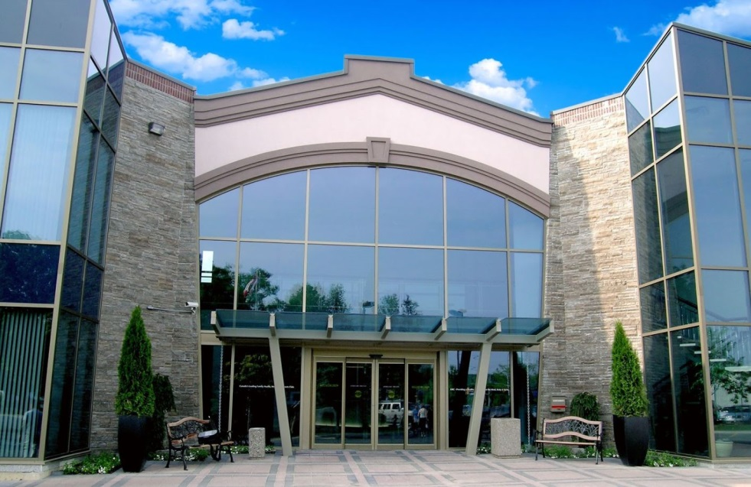

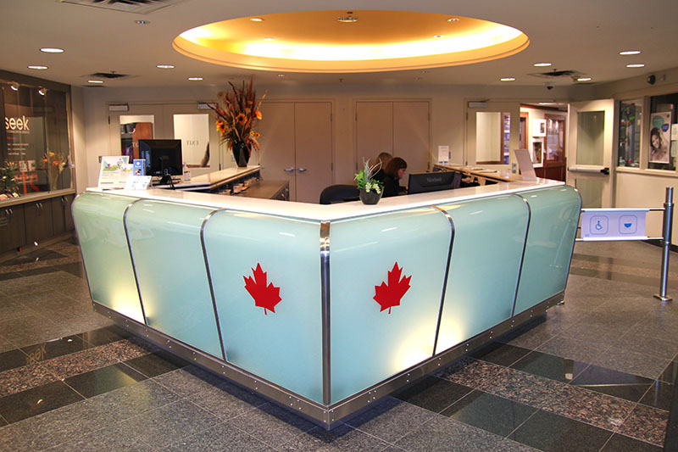

Source: Company files.

**EXHIBIT 3: INCOME STATEMENTS AND FINANCIAL RATIOS (UNAUDITED)**

**FOR THE YEARS ENDING DECEMBER 31**

|  |  |  |  |  |
| --- | --- | --- | --- | --- |
|  | **2013** | | **2012** | |
| **Revenue** |  |  |  |  |
| Memberships | $ 3,226,557 |  | $ 3,223,746 |  |
| Lessons/Clinics | 1,783,118 |  | 1,733,954 |  |
| Court Fees | 611,905 |  | 621,665 |  |
| Restaurant | 673,918 |  | 674,599 |  |
| Miscellaneous* | $ 376,880 |  | $ 456,413 |  |
| **Total Revenue** | **$ 6,672,378** | 100% | **$ 6,710,377** | 100% |
|  |  |  |  |  |
| Cost of Goods & Services Sold** | $ 1,475,602 | 22.1% | $ 1,492,529 | 22.2% |
|  |  |  |  |  |
| **Gross Profit** | **$ 5,196,776** | 77.9% | **$ 5,217,848** | 77.8% |
|  |  |  |  |  |
| **Expenses** |  |  |  |  |
| Advertising | $ 96,494 | 1.4% | $ 117,821 | 1.8% |
| Amortization & Depreciation | 415,286 | 6.2% | 411,174 | 6.1% |
| Credit Card Processing Fees | 152,109 | 2.3% | 175,855 | 2.6% |
| Insurance | 31,697 | 0.5% | 31,039 | 0.5% |
| Interest | 20,270 | 0.3% | 20,812 | 0.3% |
| Labour | 2,219,740 | 33.3% | 2,185,009 | 32.6% |
| Maintenance | 199,854 | 3.0% | 195,893 | 2.9% |
| Miscellaneous | 159,948 | 2.4% | 144,327 | 2.2% |
| Office & Supplies | 217,929 | 3.3% | 222,269 | 3.3% |
| Property Taxes | 343,054 | 5.1% | 339,658 | 5.1% |
| Rent | 340,311 | 5.1% | 325,021 | 4.8% |
| Services | 450,113 | 6.7% | 439,849 | 6.6% |
| Telephone | 14,521 | 0.2% | 15,050 | 0.2% |
| Utilities | $ 310,969 | 4.7% | $ 298,466 | 4.4% |
| **Total Expenses** | **$ 4,972,295** | 74.5% | **$ 4,922,243** | 73.4% |
|  |  |  |  |  |
| **Net Income Before Tax** | **$ 224,481** | 3.4% | **$ 295,605** | 4.4% |
|  |  |  |  |  |
| Income Tax | $ 60,609 | 0.9% | $ 79,813 | 1.2% |
|  |  |  |  |  |
| **Net Income** | **$ 163,872** | 2.5% | **$ 215,792** | 3.2% |

Notes: * This included locker rental, guest fees, special events, play centre, and other miscellaneous income; ** This was made up of variable labour costs for lessons and clinics as well as cost of goods sold for the restaurant.

Source: Company files. Financial information has been adapted for case purposes.

**EXHIBIT 4: BALANCE SHEETS (Unaudited)**

**at the years ended December 31**

|  |  |  |  |  |
| --- | --- | --- | --- | --- |
|  | **2013** |  | **2012** |  |
| **ASSETS** |  |  |  |  |
| **Current Assets** |  |  |  |  |
| Cash | $ 648,048 |  | $ 682,156 |  |
| Marketable Securities | 187,663 |  | 197,540 |  |
| Accounts Receivable | 336,823 |  | 344,820 |  |
| Income Tax Receivable | 114,025 |  | 94,235 |  |
| Inventory | 50,998 |  | 41,565 |  |
| Prepaid Expenses | $ 65,564 |  | $ 50,196 |  |
| **Total Current Assets** | $ 1,403,121 |  | $ 1,410,512 |  |
|  |  |  |  |  |
| **Fixed Assets** |  |  |  |  |
| Furniture & Fixtures | $ 823,183 |  | $ 831,498 |  |
| Computer Equipment | 157,645 |  | 171,353 |  |
| Leasehold Improvements | 2,030,848 |  | 1,952,739 |  |
| Total Fixed Assets (Cost) | $ 3,011,676 |  | $ 2,955,590 |  |
| Less: Accumulated Depreciation | $ (1,427,637) |  | $ (1,413,502) |  |
| **Total Fixed Assets (Net)** | $ 1,584,039 |  | $ 1,542,088 |  |
|  |  |  |  |  |
| **Intangible Assets** |  |  |  |  |
| Goodwill | $ 78,750 |  | $ 78,750 |  |
|  |  |  |  |  |
| **TOTAL ASSETS** | **$ 3,065,910** |  | **$ 3,031,350** |  |
|  |  |  |  |  |
| **LIABILITIES** |  |  |  |  |
| **Current Liabilities** |  |  |  |  |
| Accounts Payable | $ 341,510 |  | $ 280,915 |  |
| Property Tax Payable | 53,412 |  | 66,564 |  |
| Other Current Liabilities | 60,468 |  | 61,961 |  |
| Deferred Revenue | 995,847 |  | 1,015,387 |  |
| Current Portion of Long-Term Debt | $ 28,333 |  | $ 28,333 |  |
| **Total Current Liabilities** | $ 1,479,570 |  | $ 1,453,160 |  |
|  |  |  |  |  |
| Long-Term Debt | $ 478,413 |  | $ 491,987 |  |
|  |  |  |  |  |
| **TOTAL LIABILITIES** | $ 1,957,983 |  | $ 1,945,146 |  |
|  |  |  |  |  |
| **SHAREHOLDERS’ EQUITY** |  |  |  |  |
| Retained Earnings | $ 1,107,927 |  | $ 1,086,203 |  |
|  |  |  |  |  |
| **TOTAL LIABILITIES & EQUITY** | **$ 3,065,910** |  | **$ 3,031,350** |  |

Source: Company files. Financial information has been adapted for case purposes.

**EXHIBIT 5: FINANCIAL RATIOS**

|  |  |  |
| --- | --- | --- |
|  | **2013** | **2012** |
|  |  |  |
| **Profitability** |  |  |
| Return on Equity | 14.8% | 19.9% |
|  |  |  |
| **Liquidity** |  |  |
| Current Ratio | 0.95 : 1 | 0.97 : 1 |
| Acid Test | 0.79 : 1 | 0.84 : 1 |
|  |  |  |
| **Stability** |  |  |
| Net Worth to Total Assets | 36.1% | 35.8% |
| Interest Coverage | 12.07× | 15.20× |
|  |  |  |
| **Growth** |  |  |
| Sales | −0.6% |  |
| Net Income | −24.1% |  |
| Total Assets | 1.1% |  |
| Equity | 2.0% |  |

Source: Company files. Financial information has been adapted for case purposes.

1. The information in this section was largely obtained from an IBISWorld Canada industry report; Ediz Ozelkan, “Gym, Health & Fitness Clubs in Canada,” IBISWorld, March 2019, accessed May 25, 2018, <https://clients1.ibisworld.ca/reports/ca/industry/default.aspx?entid=1655>.
2. Peter L. Lindsay and J. Thomas West, “Canadian Sports History,” *The Canadian Encyclopedia*, September 30, 2016, accessed May 25, 2018, www.thecanadianencyclopedia.ca/en/article/sports-history.
3. All currency amounts are in CA$ unless otherwise specified.
4. Global Affairs Canada, “Annual Economic Indicators: Canada—Economic Indicators 2013–2017,” Government of Canada, last updated March 12, 2018, accessed June 20, 2018, www.international.gc.ca/economist-economiste/statistics-statistiques/data-indicators-indicateurs/Annual_Ec_Indicators.aspx?lang=eng.
5. This included the restaurant, play centre, spa, and others.
6. City of Mississauga, Population, Demographics & Housing, last updated July 2017, accessed June 6, 2018, www7.mississauga.ca/documents/business/2017/Population_Demographics_Housing.pdf.
7. CA$1 = US$0.94 in January 2014.
8. This number was the percentage of members between the ages of 27–45 and 1–12.
9. This number was the percentage of members between the ages of 46–55 and 13–26.
10. This included individuals who were not technically retired.
11. The telephone expense was expected to increase by $3,000.
12. Pickleball was a racquet sport played with a paddle, combining elements of tennis, table tennis, and badminton. The sport had increased in popularity in recent years, especially with retirees and seniors.
13. Six-week clinics were priced at an average of $200 per person.
14. Financing for the expansion would come from a bank loan with a 4 per cent interest rate.
15. The restaurant’s cost of goods sold had historically been 45 per cent of revenue.
16. On average, six-week clinics were priced at $200 per person. Of this, 60 per cent went to variable labour costs.
17. An additional $12,000 was needed to cover administrative costs associated with this change.