

9B19M063

yuser: pitching a new social networking app

Eunika Sot wrote this case under the supervision of Professors Simon C. Parker and Lawrence A. Plummer solely to provide material for class discussion. The authors do not intend to illustrate either effective or ineffective handling of a managerial situation. The authors may have disguised certain names and other identifying information to protect confidentiality.

This publication may not be transmitted, photocopied, digitized, or otherwise reproduced in any form or by any means without the permission of the copyright holder. Reproduction of this material is not covered under authorization by any reproduction rights organization. To order copies or request permission to reproduce materials, contact Ivey Publishing, Ivey Business School, Western University, London, Ontario, Canada, N6G 0N1; (t) 519.661.3208; (e) cases@ivey.ca; www.iveycases.com. Our goal is to publish materials of the highest quality; submit any errata to publishcases@ivey.ca. i1v2e5y5pubs

Copyright © 2019, Ivey Business School Foundation Version: 2019-07-05

In June 2018, Eunika Sot, the chief operations officer (COO) of Yuser Inc. (Yuser), a start-up based in London, Ontario, sat down at her desk to ponder the design for a pitch presentation aimed at investors and other stakeholders. Yuser was a new social networking app with gamified elements and a cryptocurrency payment system. On the Yuser network, companies would be able to sponsor social media influencers and pay them for attracting new customers to their products using Yuser tokens, Yuser’s new cryptocurrency. Sot knew very well that the complexity of Yuser’s core business model could potentially confuse and dissuade investors. Knowing this, she wanted to design the most effective pitch possible to spark outside interest.

AN OPPORTUNITY FOR A NEW SOCIAL MEDIA PLATFORM

Online media consumption in North America was predicted to reach parity with television by 2019.[1] The rapid increase in consumption of online media on mobile devices had contributed to this shift. Combined with social media services and apps, mobile and Internet technologies were transforming society. Three related developments were converging to create an exciting opportunity for Yuser: First, greater online connectivity had given rise to the phenomena of social media influencers and influencer marketing. Second, a host of privacy, content, and transparency problems posed serious challenges to users of traditional social networking platforms such as Facebook and YouTube. Third, the arrival of blockchain technology and cryptocurrencies had emerged as revolutionary new ways of monetizing online activities.

The Emergence of Social Media Influencers

The ascent of social media influencers was a result of this heightened degree of connectivity. Influencers were social media users with established, credible online presences. They often shared their expertise or content about specific industries online; they commanded large audiences; and they were able to persuade others through their authenticity and reach. In 2018, Huda Kattan and Zach King were noted examples of this new breed.[2]

Aware of social media influencers’ ability to persuade and command audiences, businesses and brand managers saw a role for influencers in their online advertising campaigns. Corporate marketing managers could identify influencers with audiences or followings that represented the brands’ target markets and could then establish arrangements with the influencers whereby the influencers persuaded their audiences to buy or use the companies’ products or services. Aided by influencers, companies or brands would benefit financially by selling to their core target markets and would then (in principle at least) compensate the influencers for their marketing assistance (see Exhibit 1).

Major social networks, including Facebook, did not have built-in monetization models for targeted influencer campaigns. (Facebook instead offered exposure for brands through digital display advertising—a system that utilized Facebook’s large user base but didn’t take into account influencers’ use of the platform.) Subsequently, it fell to third-party services such as influencer aggregators to monitor the outcomes of influencer-based social media campaigns published on these platforms. These third-party services acted as brokers between influencers and advertisers, and they often operated on a payment model based on cost per mille (CPM), a commonly used online marketing term that described the traffic conversion rate per 1,000 clicks. The idea was that a sponsor would pay an influencer for the amount of traffic that the influencer could bring to the sponsor’s page. However, in practice, it was hard to know who the sponsor was working with, how many followers that influencer had, or the impact of the influencer’s efforts: this created the so-called attribution problem.

Influencer marketing was a new and fast-growing trend. Between 2016 and 2017, there had been a 325 per cent increase in Google searches for the term *influencer marketing*,[3] and a related survey showed that the use of influencer marketing as a customer-acquisition method was growing faster than digital online advertising.[4] Moreover, 92 per cent of consumers in another study said that they trusted social media influencers more than traditional advertisements or celebrity endorsements.[5] By the end of 2017, influencer marketing had generated over $1 billion on Instagram alone. In sum, influencer marketing was fast becoming the word-of-mouth marketing system for the digital age: users (consumers) relied on familiar and trusted faces to communicate to them the value of given products or services.

The Decline of Facebook?

Early in 2018, Facebook and Google dominated the social networking and media space. The two companies accounted for 63 per cent of global online ad revenues.[6] While offering many social media services at no cost to users, these companies were collecting massive amounts of private data on their users and selling the data to advertising clients. Moreover, most companies continued to sell such data despite growing resistance from platform users.[7] Social media users were becoming increasingly frustrated by the lack of transparency from the social network operators. After a series of scandals in 2016 and 2017 involving data mining, election manipulation, fake news stories, and troublesome advertising, social networks in general, and Facebook in particular, were facing something of a user revolt. On April 10, 2018, Mark Zuckerberg, Facebook’s chief executive officer (CEO), testified in front of the U.S. Congress following allegations that Facebook had allowed the data of over 87 million of its users to be compromised by Cambridge Analytica Ltd.—a breach that may have contributed to foreign interference in the 2016 U.S. presidential election. This news, a major scandal for Facebook, ultimately bankrupted Cambridge Analytica.

Reacting to such concerns, Facebook introduced several changes that negatively affected social media influencers. One set of policy changes affected users with large pages—that is, those having audiences in the thousands or millions. For example, Facebook started to restrict audience reach and wanted users and influencers with large pages to boost their posts by paying to have their content distributed more widely through Facebook’s news feed.[8] Thus, Facebook was effectively forcing influencers to pay to reach the audiences they had once reached for free. In addition, in January 2018, Facebook announced that it would further reduce the overall reach of large pages and stated that “page owners were not permitted to accept ‘anything of value’ in exchange for sharing content that they did not have a hand in creating through their pages.”[9] To enforce this policy, Facebook would penalize users who did not follow the new rules by disabling their accounts. Since earning money from posting company- and brand-sponsored content was a major source of revenue for many influencers, these changes cut deeply into their bottom lines. Beyond Facebook, influencers on other platforms such as YouTube were also reporting declines in revenues.[10] Some influencers stated that their reach on Facebook had been “decimated” and that they feared Instagram would be next.[11]

Social media users and influencers thus faced four pain points: reduced audience reach, limited monetization of user-created content, privacy concerns, and shifting platform rules and policies. Because of all these factors, by the end of 2017, Facebook had lost 2.8 million U.S. users under the age of 25.[12] While such a decline seemed small for a platform of nearly 2.2 billion users worldwide, the loss was larger than forecasted. According to marketing data, younger users no longer saw Facebook as a “cool” platform but saw it more as a place where older users posted book recommendations and cooking recipes. Facebook’s new content and audience restrictions only added to this perception. In fact, the perception of many users was that Facebook was making changes to its platform that improved the company’s bottom line at the expense of the users creating and offering content on the platform.

Although influencer marketing had been growing quickly, there was not yet a clear and reliable financial benefit for content creators on social platforms—even for influencers with large followings.[13] Influencer marketing continued to grow mainly because content creators and influencers still had access to faithful niche-market audiences that were valuable to brand sponsors and businesses looking to create the right brand images online. Yet the future was highly uncertain. Because the major existing social networks did not officially sanction account monetization, deals between influencers and sponsors existed subject to the networks’ discretion. Accounts participating in sponsored campaigns were sometimes deleted without explicit reasons or explanations, and key functionality could be disabled at the sole discretion of the networks, effectively hindering influencers’ ability to deliver campaign objectives to their sponsors.

The Rise of Cryptocurrency

While the social media environment was changing, new disruptive technologies such as blockchain and cryptocurrencies started to emerge. In 2008, an unknown person (or group of people) called Satoshi Nakamoto published a white paper on bitcoin that laid the groundwork for what became known as blockchain technology.[14] Blockchain was an open ledger composed of cryptographic hashes that coded any given information into a string of data of an even size. Nakamoto applied economic principles from game theory to make blockchain a decentralized database that did not require trust (since blockchain transactions were expressions of objective truth that could not be retrospectively modified without collapsing the entire blockchain). In principle, it was more secure than any other system used for handling transactions employed to date since making any retroactive changes to blockchain’s structure was so cumbersome as to be almost impossible. Blockchain recorded transactions using decentralized digital currencies, called cryptocurrencies, which were a form of electronic cash. By 2018, bitcoin (₿) had become the most widely used cryptocurrency in the world.

By 2018, cryptocurrency and blockchain had become better established; there were thousands of public and private blockchains and hundreds of cryptocurrencies. At the beginning of 2018, one bitcoin was valued at approximately US$10,000, and the currency’s main rival, Ethereum, traded at approximately one Ethereum token or ether (ETH) to US$800. Ethereum was particularly interesting because it introduced two new concepts: smart contracts and decentralized applications (dapps), which existed on decentralized blockchains such as Ethereum. Smart contracts facilitated transactions between two parties or signatories to a contract. Smart contracts held funds and only released them when the variables specified by both parties had been met. Smart contracts were trustless, fully transparent, irreversible, and immutable—and by early 2018, they were already being utilized by many companies seeking to change the way they handled online transactions.

YUSER: A GAMIFIED SOCIAL NETWORK WITH BLOCKCHAIN-POWERED REWARDS

The Yuser social media app was the result of the company’s pivot away from its initial position as a viral media publisher. Yuser’s novel idea was to reward network users for in-app activity that contributed to the growth of the Yuser social network. Yuser envisioned the day when all people sharing content online would be rewarded for their contributions—creative, social, or otherwise.

The Yuser app comprised a few key elements that had not been applied previously to a social networking platform. First, Yuser envisioned its app as an economy with a built-in method of value exchange for online transactions for all participants. Users were encouraged to gift each other with in-app assets called gems, which in turn could be exchanged for Yuser tokens. Yuser tokens, the currency of the network, were distributed to users based on their contributions, such as sharing content or interacting with other users. People could also purchase Yuser tokens and redistribute them on the network through smart sponsorships—blockchain-powered smart contracts between parties on the Yuser network. This ensured that Yuser did not need to sell advertising space to make money; instead it collected small transaction fees from sponsors.

Second, Yuser used gamification to provide incentives for people to grow their social media accounts. Employing an achievement-based system was key to ensuring effective in-app governance and network growth. The rewards provided to users were fully functional powers that increased their status on the network. To make it easy and fun for users to create and grow their accounts, Yuser utilized role-playing gaming strategies; gamification and challenge-oriented strategies made Yuser fun for teens and young adults.

Third, Yuser incorporated pioneering privacy solutions to ensure that the data of its users was protected. Yuser had already proved that it didn’t need to obtain user data to make money by having a built-in model for in-app transactions. Users were encouraged to share their information with each other, not with Yuser, when they completed transactions on the app. Yuser’s platform therefore included elements from several types of platforms: consumer-to-consumer (C2C) or social networks, business-to-consumer (B2C) or brand-sponsored content, and business-to-business (B2B) or smart sponsorships (see Exhibit 2). Under this model, users were never asked to pay to play as Yuser fully sanctioned sponsorships between any two parties right on the platform and simply took a cut of the smart contract transactions conducted on the network itself. These transactions were happening on other social networks but usually through third-party services such as PayPal. Furthermore, Yuser devised a network-sanctioned punishment system that filtered and publicly displayed fake interactions created with bots, click-farms, or spam—disincentivizing gaming of the system by users. Additionally, users could invest their efforts into identifying good-quality, truly entertaining content with viral potential, and they could expect returns if they were successful.

In short, Yuser incorporated both role-playing methods and blockchain technology to provide incentives for users to grow their presence. This way, the network not only shared rewards with its users but also promoted its own growth.

Initial Coin Offering (ICO)

An initial coin offering or ICO was a method of crowdfunding a blockchain-based project from the community. The goal was to raise capital through the creation of a token and the sale of a portion to the public. Investors bought tokens with their own cryptocurrency. The company issuing the ICO could then either use the cryptocurrency or exchange it into fiat currency. An ICO was based on a publicly released white paper that outlined the purpose of the tokens the company created and their use within the economy.

The first ICO, or Mastercoin, occurred in 2013; then in 2014, over US$2 million was raised to jumpstart the Ethereum project. In 2017, ICO-centred projects rose rapidly due to the increased popularity of dapps. That year, start-ups collectively raised over US$5.6 billion through ICOs.[15] In December 2017, CryptoKitties—a cute, blockchain-based cat game—congested the Ethereum network so much that it hindered ICOs taking place on the network.[16] CryptoKitties could be described as the first truly viral blockchain project. Even though CryptoKitties was an online game, the kitties quickly became repositories for value, with some kitties selling for over US$100,000; on average, they cost around US$25 each.[17]

By 2018, ICOs were commonplace, with at least a few new projects starting every day. In 2018, the most notable projects that were predicted to raise millions if not billions of dollars were Telegram’s Telegram Open Network (TON), Kodak’s digital rights tracking tool KodakCoin, and Envion’s mobile mining device.[18]

HOW TO PITCH?

Yuser was a young start-up with six full-time employees (see Exhibit 3). Each member of the team took on multiple responsibilities to push the project forward, and all were working all the hours they could. Working for a start-up was exciting and full of learning opportunities but also highly demanding. Resources were stretched and, having nearly exhausted its modest seed funding, the Yuser team realized it had to obtain outside financing to extend its development runway and jumpstart its marketing strategy. Having a more diverse source of funding would also boost confidence in the project externally and could complement the upcoming ICO.

Originally, Yuser had planned to launch its ICO in April 2018. However, the Ontario Securities Commission (OSC) had just started to regulate projects planning to participate in ICOs, and this required Yuser to postpone its ICO to satisfy the new criteria (see Exhibit 4). This postponement increased the need for outside capital.

Sitting at her desk, Sot wondered how to craft a short pitch that would best convey to investors the essence, potential, and excitement she felt for Yuser’s business model. She knew there were at least three groups of potential investors: (1) those who were familiar with social media ventures but not with blockchain; (2) those who were interested primarily in cryptocurrency ICOs but not interested in social media; and (3) those with little experience in either social media or financial technologies (fintech). Sot believed that many investors would likely fall into the third category. She believed that it was essential for them to understand the importance of this project for the future of social media without becoming scared by the disruptive potential of blockchain and the negativity around ICO exit scams, which had dominated the press at the beginning of 2018.[19] What worried Sot most was the complexity of the underlying business model and all the moving parts of the Yuser venture. She knew that an effective pitch would convey key information about the business model while not overwhelming investors with confusing details. This would surely be a tricky balance to pull off, and she pondered how to structure her pitch.

EXHIBIT 1: CURRENT SOCIAL MEDIA LANDSCAPE

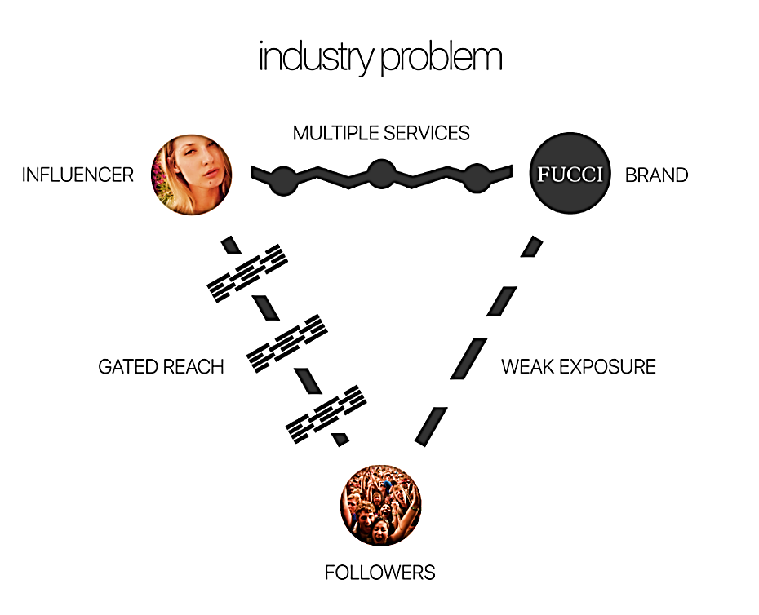

Source: Company documents.

EXHIBIT 2: YUSER BUSINESS MODEL

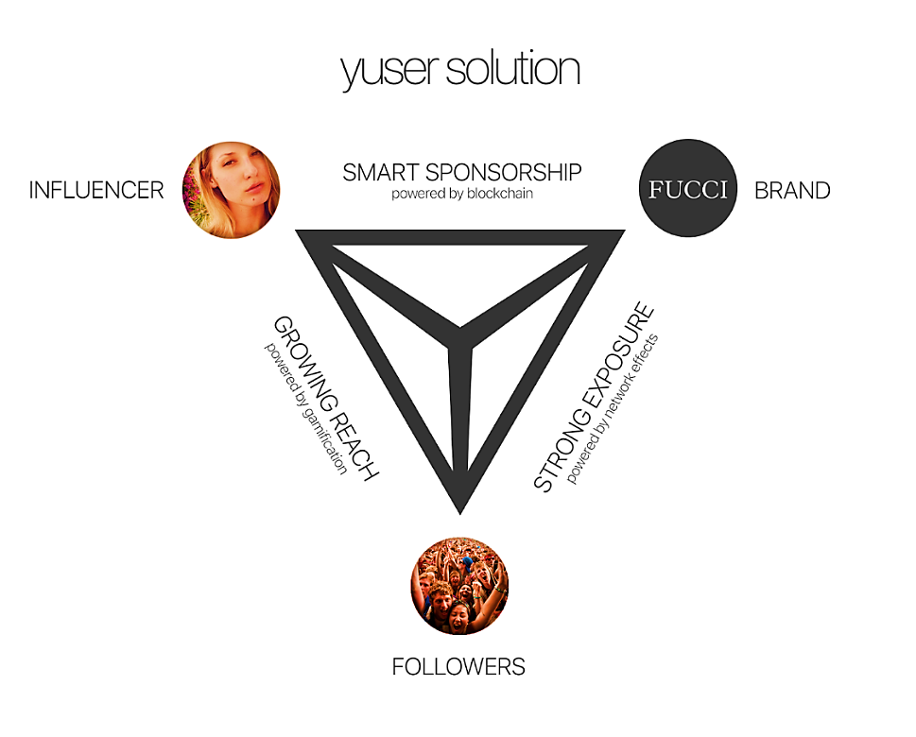

Source: Company documents.

EXHIBIT 3: YUSER TEAM

**Thomas Cermak, CEO and CTO** **[Chief Technology Officer]:** serial entrepreneur and founder of LondonFuse, PMF Ent. and Yuser (among others); has extensive background in working with creative teams, software development, UX design, and keen interest in the application of disruptive technologies to solve real-world problems.

**Mitchell Brogan, Co-Founder and CSO** **[Chief Security Officer]:** heavily invested in blockchain technologies since their inception; pioneer in exoskeleton technologies; futurist and founder of Able Bionics.*

**Eunika Sot, COO:** extensive experience in project and account management, team coordination; skilled in working with social media influencers; interested in application of economic principles in social network design.

**Mike Simpson, Director of Community Operations:** video producer and experienced designer with multitude of industry connections; responsible for managing the growth of the Yuser network by onboarding advisors, ambassadors, and influencers.

**Shane Maitland, Vice-President of Business Intelligence:** skilled in analytics and SEO [search-engine optimization]; interested in gamification, strategy, and brand image development.

**Eli Sadaka, Full Stack Developer:** recent computer science graduate with aptitude for creating cutting-edge software.

**Natalia Visla, Full Stack Developer:** uses her developing skills to create seamless UX design and fun online experiences.

*Mitch contributed to Yuser only on a part-time basis as he was heavily involved in other projects focused on exoskeleton technology.

Source: Company documents.

EXHIBIT 4: Yuser—TENTATIVE TIMELINE

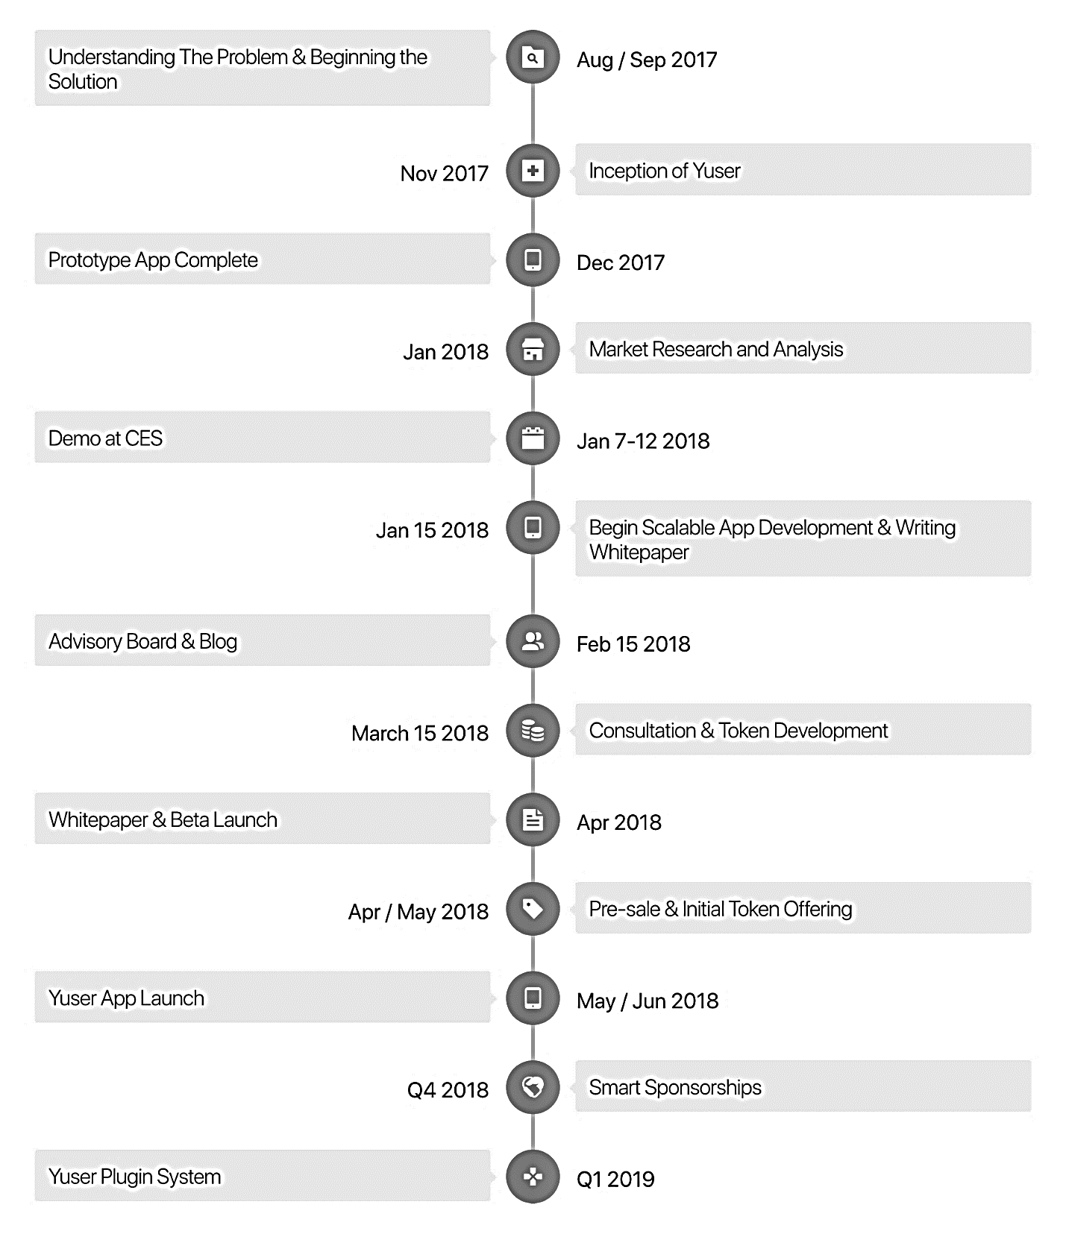

Note: This timeline was accurate for Yuser as of March 2018. After that point, Yuser filed for compliance with the Ontario Securities Commission, and all actions in relation to the Yuser ICO had to be postponed.

Source: Company documents.

1. Rani Molla, “People Consumed More Media than Ever Last Year—But Growth Is Slowing,” Recode, May 30, 2017, accessed March 18, 2018, www.recode.net/2017/5/30/15712660/media-consumption-zenith-mobile-internet-tv.
2. “Top Social Media Influencers of 2018,” CBS News, accessed March 23, 2018, www.cbsnews.com/pictures/social-media-influencers-influential-2018/4/.
3. “The Remarkable Rise of Influencer Marketing [Infographic],” Influencer Marketing Hub, accessed March 18, 2018, https://influencermarketinghub.com/the-rise-of-influencer-marketing/.
4. Quora Contributor, “Influencer Marketing Is Growing Faster than Digital Ads,” *Forbes*, May 2, 2017, accessed March 27, 2019, www.forbes.com/sites/quora/2017/05/02/influencer-marketing-is-growing-faster-than-digital-ads/.
5. Deborah Weinswig, “Influencers Are the New Brands,” *Forbes*, October 5, 2016, accessed March 18, 2018, www.forbes.com/sites/deborahweinswig/2016/10/05/influencers-are-the-new-brands/#50234da17919.
6. eMarketer, accessed March 18, 2018, https://na2.totalaccess.emarketer.com/Login.aspx?ReturnUrl=%2freports%2fviewer.

   aspx%3fr%3d2002174&r=2002174.
7. Jenna Wortham, “The Facebook Resisters,” *New York Times*, December 13, 2011, accessed March 18, 2018, www.nytimes.com/2011/12/14/technology/shunning-facebook-and-living-to-tell-about-it.html.
8. Andrew Hutchinson, “Facebook Announces Coming News Feed Change Which Will Reduce the Reach of Page Posts,” Social Media Today, January 11, 2018, accessed March 18, 2018, www.socialmediatoday.com/news/facebook-announces-coming-news-feed-changes-which-will-reduce-the-reach-of/514662/.
9. Max Willens, “Facebook’s New Branded-Content Guidelines Will Force Some Publishers to Abandon a Business Model,” Digiday UK, February 12, 2018, accessed March 18, 2018, https://digiday.com/media/facebooks-new-branded-content-guidelines-will-force-publishers-abandon-business-model/.
10. Julia Alexander, “YouTube’s Lesser-Known Creators Worry for the Future after Major Monetization Changes (Update),” Polygon, January 17, 2018, accessed March 18, 2018, www.polygon.com/2018/1/17/16900474/youtube-monetization-small-creators-adsense.
11. Nathan McAlone, “A Creator with 4.7 Million Facebook Followers Says Her Reach Has Been ‘Decimated’ on the Platform, and She Fears Instagram is Next,” Business Insider, January 31, 2018, accessed March 18, 2018, www.businessinsider.com/jessica-nigri-facebook-instagram-reach-decimated-2018-1.
12. Kurt Wagner and Rani Molla, “Facebook Lost Around 2.8 Million U.S. Users under 25 Last Year. 2018 Won’t Be Much Better,” Recode, February 12, 2018, accessed March 16, 2018, www.recode.net/2018/2/12/16998750/facebooks-teen-users-decline-instagram-snap-emarketer.
13. S.E. Smith, “Creative Work Is Work—And It Should Be Compensated,” *This Ain’t Livin’* (blog), February 25, 2017, accessed March 18, 2018, meloukhia.net/2017/02/creative_work_is_work_and_it_should_be_compensated/.
14. Satoshi Nakamoto, “Bitcoin: A Peer-to-Peer Electronic Cash System,” White Paper, October 31, 2008, accessed March 18, 2018, https://bitcoin.org/bitcoin.pdf.
15. Oscar Williams-Grut, “Only 48% of ICOs Were Successful Last Year—But Startups Still Managed to Raise $5.6 Billion,” Business Insider, January 31, 2018, accessed March 18, 2018, http://uk.businessinsider.com/how-much-raised-icos-2017-tokendata-2017-2018-1.
16. Stan Higgins, “ICO Delayed by Ethereum’s CryptoKitties Congestion,” Coindesk, December 5, 2017, accessed March 18, 2018, www.coindesk.com/ethereums-cryptokitties-blockchain-deluge-sparks-ico-delay/.
17. Evelyn Cheng, “Meet CryptoKitties, the $100,000 Digital Beanie Babies Epitomizing the Cryptocurrency Mania,” CNBC, December 6, 2017, accessed March 18, 2018, www.cnbc.com/2017/12/06/meet-cryptokitties-the-new-digital-beanie-babies-selling-for-100k.html.
18. “The 5 Best ICOs in 2018 Which Might Make You a Millionaire,” Bitcoinist: Press Release, February 22, 2018, accessed March 18, 2018, http://bitcoinist.com/5-best-icos-2018-might-make-millionaire/.
19. Alexandre, Ana, “New Study Says 80 Percent of ICOs Conducted in 2017 Were Scams,” Cointelegraph, July 13, 2018, accessed April 8, 2019, https://cointelegraph.com/news/new-study-says-80-percent-of-icos-conducted-in-2017-were-scams.