

9B19M075

FOTILE: THE BUSINESS STRATEGY OF A TOP KITCHEN APPLIANCE BRAND ROOTED IN CHINA

Dr. Di Deng and Dr. Liang (Lucas) Wang wrote this case solely to provide material for class discussion. The authors do not intend to illustrate either effective or ineffective handling of a managerial situation. The authors may have disguised certain names and other identifying information to protect confidentiality.

This publication may not be transmitted, photocopied, digitized, or otherwise reproduced in any form or by any means without the permission of the copyright holder. Reproduction of this material is not covered under authorization by any reproduction rights organization. To order copies or request permission to reproduce materials, contact Ivey Publishing, Ivey Business School, Western University, London, Ontario, Canada, N6G 0N1; (t) 519.661.3208; (e) cases@ivey.ca; www.iveycases.com. Our goal is to publish materials of the highest quality; submit any errata to publishcases@ivey.ca. i1v2e5y5pubs

Copyright © 2019, Ivey Business School Foundation Version: 2019-11-12

In January 2018, it was the start of the celebration season for the Chinese Spring Festival and this year’s festival was particularly memorable for Fotile Kitchenware Co. Ltd. (Fotile). Fotile’s sales for 2017 had been announced at over ¥10 billion.[1] Fotile had become the first kitchen appliance manufacturer in China to reach this significant milestone, despite its relatively short operational history. For years, Fotile had also been considered China’s most prominent brand in the kitchenware industry, beating several internationally-reputed brands. Since the company’s founding by Zhongqun Mao, he had set a differentiation strategy for this new venture to compete in the kitchen appliance industry. He had also made numerous tough decisions along the way to ensure that this strategy was persistently followed through. However, could Mao’s strategy continue to sustain Fotile’s growth for the future?

COMPANY BACKGROUND

Mao was a second-generation entrepreneur in his family. His father, Lixiang Mao, had founded a business in China’s Zhejiang province in the 1980s. Despite a humble start as a small, family-owned venture, the company eventually became Feixiang Group, a large manufacturer and exporter of electronic ignition torches. However, since 1992, Feixiang’s business had been plummeting due to intensified competition with numerous new entrants. Therefore, Mao was called home in 1994 to help revive the withering family business, having completed a master’s degree in power electronics from Shanghai Jiao Tong University, a respected Chinese university.

Two years later, in 1996, Mao founded Fotile. With the vision of blazing a new business trail, instead of fulfilling the expectation of inheriting the family business, Mao established the new company in his hometown. Mao drew up three policies for the new venture. First, Fotile had to be fully autonomous. Second, no employee could transfer from the existing family business and no family relatives could hold an executive position. Third, Mao would be responsible for all strategic decisions.

Fotile’s business from the start was the development, manufacturing, and marketing of range hoods (also known as an extractor hood, ventilation hood, or fume extractor) for Chinese consumers. Mao’s father had initially rejected the idea of manufacturing range hoods because he did not believe that Fotile, being a new venture, could rise above the 250 companies already present in the market. He suggested manufacturing microwave ovens instead, a kitchenware segment that was still in its infancy and was poised to increase in demand along with the growing wealth of Chinese families. However, Mao disagreed, opting instead for the range hood business. He believed that the market of range hoods still had a huge potential for growth. With the boom of the real estate industry and continuous urbanization, more families would demand range hoods. Yet, the supply fell far behind, causing a supply-demand discrepancy of three million units annually, and this discrepancy afforded room for Fotile to survive and thrive.

Fotile was clearly a late entrant to the industry, but its growth was exponential. Merely three years into operation, Fotile became a major brand with the second-largest market share in the Chinese kitchen appliance industry. In 2017, Fotile led the kitchen appliance industry in China with the largest annual revenues (see Exhibit 1). With more than 19,000 employees,[2] Fotile controlled more than 40 per cent of the high-end range hood market.[3]

The company’s success earned Fotile recognition and many awards. In 2011, Fotile received the National Quality Award from the China Quality Association, the highest national honour awarded to organizations with excellent quality management. This marked the first time that the award was given to a kitchen appliance producer. Fotile was also ranked the most respected brand in the kitchen appliances industry from 2009 to 2016 consecutively by CBNweekly’s Chinese Company Brand Survey. From 2011 to 2018, Fotile won 21 Red Dot Design Awards and 27 iF Design Awards in Germany.

GLOBAL RANGE HOOD MARKET

The range hood was patented by Theodore R.N. Gerdes in New York City in 1926.[4] To extract cooking fumes to the outdoors, Gerdes had built an electric fan inside a hood. This design had then sparked the development of a thin shallow hood with a fan embedded in its centre, covered by a flat ventilation grille.

In the 1940s, European manufacturers made one significant refinement to the design by installing a cuboid chimney on top of the flat hood. This design, which resembled a reverse T shape, became known as the European style. The added chimney not only served to channel fumes outside but also elevated the delicacy of the range hood appearance to another level.

In the early 1990s, Japanese manufacturers were among the first in the world to produce the deep type of range hoods. This new design featured a deep hood downward to the stove, which created a fume collection space above the stove, further preventing fumes from escaping and reducing the noise level of the fan while in operation.

In the global range hood market, the top selling model varied considerably across different nations. In 2017, China's top selling range hood online was Fotile’s Cloud Rubik, a European design with a wind volume of 15 cubic metres per minute and a price of about US$420. Amazon’s top selling range hood in the US market was a shallow hood from Broan, with a wind volume of 4.5 cubic metres per minute and a price of US$70.[5] In the Japanese market, the deep model range hood was still among the mainstream products.

A noticeable feature of the global range hood market was that the leading brands in major national markets were usually local. For example, in the United States, the most popular brands included NuTone, Broan, GE Appliance, and Whirlpool; whereas Fujioh claimed control of over 60 per cent of the domestic range hood market in Japan.[6]

RANGE HOOD MARKET IN CHINA

In July 1984, the state-owned Shanghai Xenon Lamp Factory made the first range hood in mainland China, modelled after a Taiwan-made prototype. Only three years later, the number of hood producers jumped to 52, mostly located in Shanghai, Zhejiang, and Guangdong. These early hoods were of the shallow type.

Shallow hoods worked well in western kitchens, but they were far from satisfactory to Chinese customers. Western cooking was mostly boiled, stewed, or lightly fried, with minimal amounts of fumes generated in the process. Smoked and grilled foods were prepared mainly outdoors. However, except for the occasional boiling and stewing, Chinese cooking included daily dishes made by sautéing (*jian*), stir frying (*chao*), and deep frying (*zha*), which produced enormous amounts of greasy fumes and odours within seconds. Shallow hoods could only extract a small fraction of the cooking fumes, leaving most fumes and odours inside. Moreover, thin hoods had no device to collect and store the filtered oil drips, which became frequent and widespread after a short time.

Functional deficiency of thin hoods was compounded by the unique layout of Chinese kitchens. Standard apartments in urban cities in China were, on average, much smaller than their western counterparts, with less efficient indoor ventilation. Cooking fumes that could not be extracted through range hoods tended to linger inside and cloaked the walls, floors, and furniture with oil residue.

In 1993, several producers in Zhejiang started making deep range hoods, which were clearly influenced by Japanese models of that period. Deep hoods from these producers partially addressed the limitations of shallow types by capturing and extracting a relatively greater amount of fumes. However, they shared other issues such as oil drips, cleaning challenges, and a primitive appearance.

Up to the early 1990s, the Chinese range hood market was replete with more than 250 local brands. Nearly all producers sought to appeal to customers with a low price. To gain an upper hand in price competition, most manufacturers cut costs across various value chain stages. They committed minimal resources and managerial attention to research and development (R&D), developing products largely by replicating models from foreign brands—in some cases, with only minor modifications. Production costs were slashed considerably and product categories were limited to achieve economy of scale. Without independent R&D and quality production, range hoods from these producers were highly homogenous in design and poor in performance, with inconsistent craftsmanship, extraction effectiveness, and noise level. The market was highly fragmented, and no brand was widely recognizable to customers.

The shift from shallow to deep hoods marked a clear improvement in functionality, but this feature alone was not sufficient for the increasingly wealthy Chinese families. Being perhaps the most conspicuous electric appliance in the kitchen, range hoods played a major role as an integral home decoration component. Upscale customers assigned more weight to the appearance and style of range hoods in their purchasing decisions.

In 2001, Fotile introduced the first European model to the Chinese market. Unlike the traditional thin or deep hoods in China that used a combination of iron and plastics, European models were typically made of stainless steel. Their silver colour and smooth metal texture gave stainless steel hoods a look of elegance and class that appealed to customers. Spearheaded by Siemens and Electrolux, European home appliance companies forayed into the Chinese range hood market with their European-style models in 2005. The delicate craftsmanship, fashionable look, and aesthetic versatility made the range hoods particularly appealing to Chinese customers. These European brands, which were targeted at high-end consumers, featured a much higher price than local brands. With more Chinese producers launching their own European-styled hoods, the Chinese range hood market entered a new era. As European and deep models became the two mainstream categories, thin hoods regressed to a minor choice for consumers.

The range hood industry saw the addition of a new hood type around 2009. Commonly known as angled or side draft hood, this new design resembled a right triangular prism with a cuboid chimney on the top. A side draft hood was attached to the wall next to the stove and extracted fumes from the side, while deep or European-style hoods normally hung right above the stove. Side draft hoods swiftly picked up market share, replacing deep models.

In 2017, the range hood was the largest category of kitchen appliances in China. Approximately 24 million range hoods were sold in the Chinese market for a total revenue of US$6.4 billion[7] (see Exhibit 2). The Chinese range hood market accounted for around 60 per cent of the global market. In terms of structure, the market saw a migration from previous years toward the high-end segment, with products priced above US$670 contributing 21 per cent of the total retail volume in this market, compared to only 12.4 per cent in 2015.[8]

After enjoying double-digit annual growth for nearly 30 years, the Chinese range hood market was projected for a slower growth rate of 7.9 per cent in 2018. Comparatively, common Chinese household products such as refrigerators, washing machines, and television sets started to experience zero growth, or even negative growth rates, starting in 2014.[9]

FOTILE’S BUSINESS STRATEGY

Since its founding, Fotile had followed a unique business strategy with a position in the high-end segment. Unlike other Chinese brands that had strived to gain price competitiveness by slashing costs, Fotile sharpened its edge by adding more value for customers. This strategy seemed counterintuitive at the time. Even Mao’s father was baffled by Mao’s strategy, but he insisted that it was the best path forward:

By the time Fotile entered the business of range hoods, foreign and pricy brands dominated the high-end segment, whereas local Chinese brands were cooped in the low-end segment. I hence had an ambitious dream: we will make Fotile the first high-end brand of electronic appliance in China and prove to the world that the Chinese can make excellent range hoods as well.

Product Development

To offer distinctive and appealing features in its range hoods, Fotile resorted to the dual strategy of technological innovation and industrial design—an approach that had proven successful since the company’s first product. Yongding Zhu, the director of Fotile’s product development department, reflected on the company’s approach:

We were the pioneer in China that had driven product development with innovative industrial design. Design is critical to high-end products like ours. As Chinese households were getting wealthier, their demands for well-designed home appliances were poised to grow. Only recently had the government started to push for the innovation on both technology development and industrial design in manufacturing industries. We embraced these two forces some 20 years ago.

Deep Hoods: A Model and Q Model

In 1996, Fotile released its first range hood design: the A Model. At that time, deep hood designs, like the A Model, were on the verge of becoming the mainstream choice in the market. Two innovations made the A Model stand out from competing brands. First, it featured a curved and smooth fume collection hood that allowed oil to fall to the edge of the electric motor, where it could be easily swept away. Second, the fume collection hood could be effortlessly detached from the motor, allowing the customer to clean it without risk of electric shock.

Sales of the A Model range hood were surprisingly strong in its debut year. Consistent with its high-end position, the A Model was priced at US$120 per unit, which was 20 per cent above the most expensive competing brand. Given the anonymity of the Fotile brand, no one had expected its success, yet more than 30,000 units were sold at the end of the year. Clearly, the valued features of the A Model provided a strong justification for its premium price.

Inspired by the success in the first year, Fotile took swift action to upgrade the A Model into the Q Model the next year by reducing the size of the hood while increasing the power of the extraction fan. Sales of the Q Model steadily grew over the next few years, reaching an annual sales high of over 400,000 units.

European Models

Sensing the rising demands for design and appearance, Fotile pioneered the introduction of European-style hoods to the Chinese market in 2001. Fotile’s designers noticed that the motor of the original European range hoods was too small for the narrow chimney to provide sufficient extraction power, and Chinese kitchens could not accommodate the typical 70-centimetre-high chimney. By redesigning the internal structure of the chimney, Fotile was able to reduce the chimney’s height and create enough space to fit a larger motor.

Another significant innovation of Fotile’s European model was a cone-shaped grille with an oil container attached on the bottom. Compared with the flat grille in the original European models, Fotile’s cone grille extended to the overall surface of the net, thereby strengthening extraction and filtration, while reducing the grille’s degree of clogging by the filtrated oil. By channelling the oil to the container, which could be easily emptied and cleaned, the cone grille also prevented oil from dripping onto the stove or into the wok. The cone grille and oil container design became an industry standard feature.

All of the innovative modifications done by Fotile eased the difficult trade-off between appearance and function that Chinese customers faced. The additional R&D commitments and the use of expensive stainless steel pushed up the price of Fotile’s European models to about US$400- much higher than the average hood price of US$120. Fotile anticipated that only a few hundred units of these high-end models would be sold in the first year; however, over 10,000 units were sold. Without a competing producer of such European models at that time, Fotile had a monopoly in that market segment for more than two years.

In 2013, Fotile launched an upgraded line of European-style range hoods called the Cloud Rubik. The unique innovation in these range hoods was a thin wing-like plate—appropriately named “butterfly wing”—that hung right below the suction outlet, instead of the filtering grille-container set. This plate enlarged the zone of negative pressure above the stove and directed rising fumes to its edges, where the suction power of the fan was strongest, so that all fumes could be extracted before spreading. This feature offered Fotile’s Cloud Rubik the opportunity to claim “no escaped fumes in any direction,” setting it apart from all other European-style range hoods in the market. A long and narrow oil container was attached to the back edge of the hood, which was barely visible, but served to hold any oil drips from the inner hood and plate.

Side Draft Hoods: Wind Rubik

Fotile’s deep and European hood design resulted mainly from incremental modifications to the models that had existed in the market. However, the side draft hood design was purely authentic. In 2001, Fotile introduced a side draft hood that was the first of its kind in the Chinese market. In 2009, Fotile launched an updated side draft hood product line—the Wind Rubik—and sold over 40,000 units, technically opening a new market segment.

The development of the side draft hood design was sparked by two problems that both deep models and European designs shared in respect to the Chinese customer: size and location. Both deep and European models were still too large for the typical kitchen of most Chinese apartments. They were more suitable for spacious and expensive homes. The hoods also hung above the stove, which led to frequent incidents of head injuries during cooking. Side hoods, however, were attached to the wall next to the stove and took up little space, thus reducing the likelihood of customers suffering head injuries. The shorter distance from the source of fumes also made side hoods more effective.

2013: A Year of Innovations

The success of side draft hoods made Fotile engineers realize that the distance between the range hood and the source of fumes was an important factor that had been ignored in the past. Design upgrades began to reflect the optimal height for the suction outlet of different hood designs. In 2013, Fotile enhanced its Wind Rubik hoods by adjusting the distance between the suction outlet and the stove to maximize the extraction effect. In the five-year period following its launch, the upgraded Wind Rubik design became the top seller in the Chinese market. In 2013, Fotile also modified the butterfly plate of the Cloud Rubik so that the plate could automatically ascend or descend according to the fumes sensed, thus ensuring that extraction occurred at the proper height.

Another design innovation that substantially improved extraction was the powerful Auto Turbo System. These hoods had a sensor installed in the chimney that constantly monitored the degree of resistance from the back-drifting air and automatically adjusted the power level of the fan to achieve optimal exhaustion. The Auto Turbo System solved an ongoing issue that Chinese customers experienced during popular cooking times in high-rise apartments, when the common chimney became congested and fumes drifted inside.

All innovations combined enabled Fotile’s range hoods to extract over 97 per cent more fumes, helping to keep kitchens clean and grease-free, while the indoor air remained fresh. Fotile’s range hoods also helped improve the layout and interior design of apartments in China. As Mao explained, “Chinese families once had to keep the kitchen closed to cage fumes but, with Fotile’s range hood, they could now open and integrate it with dining or even living places. Open kitchens had long been a dream for Chinese families; we made it come true.”

Research and Development

Fotile’s consistent success in product development would not have been possible without continuous commitment to independent research and development (R&D). As Zhu stressed, “Since its founding, Fotile’s R&D department has strived for impeccable product quality rather than sale volumes. We held fast to the belief that perseverance produces success.”

Mao instilled this spirit of perseverance in the R&D team that developed the A Model design, which lasted eight months in the market, compared to the typical three-month development cycle of the range hood industry. The extended development cycle was accomplished through Mao’s strict requirements for both product functionality and industrial design. Fotile’s R&D team was the first in the industry to include engineers and industrial designers, unlike other companies at that time that relied exclusively on engineers for product development, who would emphasize functionality but ignore appearance.

In 2003, Fotile implemented a new system called Integrated Product Development to boost R&D effectiveness. This systematic process drove R&D through organizational mechanisms, rather than isolated individual or team efforts. It began with a quality-function-demand management tool that sensed customer demand and translated it into technology and design specifications for the various components of the range hood.

Fotile had always prioritized investment in R&D, with more than five per cent of total revenues, compared to the more common three per cent investment by leading international appliance producers.[10] In 2004, it set up an award for the most significant innovation of the year. In 2009, Fotile invested approximately US$4 million to establish electric and gas appliance laboratories. The company’s research teams included over 600 kitchenware experts across China, Germany, and Japan.[11]

Fotile’s investment, commitment, and effective R&D strategies resulted in over 2,200 patents (including 350 company inventions) by December 2018, making Fotile a dominant force for innovation in the industry.[12] Mao had no intention of losing that dominance:

There was no such thing as the best in Fotile’s philosophy. Every “best” was another starting point for the next round of improvement. Although we had been the leading innovator in the industry, we would continue our commitments to R&D and harness innovation to drive our company.

Branding of Fotile

The Fotile brand name was derived from the sound of two Chinese words: *Fang* and *Tai*. The first word *Fang* was associated with the term *Fang Bian*, which literally meant “convenience.” The second word, *Tai*, was a short form for “housewife.” Therefore, the term *Fang Tai* projected the image of “bringing convenience to housewives.”

In 1997, Fotile created a very successful television commercial featuring a famous cooking show personality known as Fang Tai (also known as Ms. Fang). The commercial, with the same name for both the product brand and the brand ambassador, became popular across China with the slogan “cooking with Fang Tai and eliminating fumes with Fang Tai.” The sudden increase in brand recognition, coupled with the company’s reputation, resulted in a strong boost in sales of Fotile products to US$30 million by the end of 1998. This sales total was an increase over the previous year’s sales by almost 200 per cent.

Another branding strategy Fotile employed was opening over 40 high-profile exhibition halls in the central district of the largest cities in China (see Exhibit 3). The online-to-offline strategy allowed customers to experience Fotile’s home appliances, interact with sales representatives, and take part in related programs (e.g. cooking workshops offered by Michelin star chefs).

Fotile maintained its brand promotion strategies to ensure that the company remained associated with quality, social status, and elegant taste. Fotile continued to achieve successful brand promotion, despite most Chinese manufacturers struggling or failing to establish a recognizable brand.

Distribution and Marketing

Most range hood makers in China had relied on external distribution venues such as department stores as a way of reducing costs and retaining flexibility, although thereby relinquishing much of the control. Fotile chose to build its own retail and distribution channels, while attempting to balance control with flexibility. Liming Sun, Fotile’s vice president of marketing and branding, explained:

Fotile invested to build its own distribution and retailing systems to ensure thorough execution of its marketing strategies. Meanwhile, we also allocated much more autonomy to those branch stores than other foreign competitors. The store managers were given a set of basic prices with a variation scope; within the scope they could discretionarily tailor prices to market demands.

In 2000, Fotile started selling its range hoods through major branded retailing chains such as Gome and Suning. Specializing in home electric appliances and consumer electronics, these retailing chains had widespread coverage and a loyal customer base across China.

Rather than using a passive approach, Fotile’s sales force used outreach promotions such as direct marketing to local residences, and large order sales to organizational buyers, including home decoration companies and real estate developers. In 2017, about 30–40 per cent of store sales were generated from general retail and 60–70 per cent resulted from outreach initiatives. With the rise of online shopping, Fotile also established an online presence, where customers could conveniently browse different range hood models, place orders, and request services.

By 2018, Fotile had established a distribution network composed of more than 119 branches and 2,000 stores all over the country (see Exhibit 4). Offline distribution channels contributed the largest share of sales at about 70 per cent, although e-commerce was growing quickly at about 25 per cent. Orders from real estate projects and overseas markets contributed the rest.

Fotile offered a five-year warranty and a free, one-time, deep-cleaning and maintenance service within two years after the sale of its products. In 2010, Fotile launched a service hotline to provide efficient customer service around the clock, regarding matters such as consultations, complaints, troubleshooting, delivery, and installation. By 2016, Fotile operated 73 customer service centres and 1,500 local service branches across China, with a team of more than 3,600 service engineers. These centres were often awarded high praise and satisfaction results in surveys and customer feedback.

FACING CHALLENGES TO BUSINESS STRATEGY

Over the years, Mao and his executive team faced tough business strategy decisions to ensure that Fotile remained consistent in its vision. This included having to turn down various promising opportunities for business growth, including going public, mergers, original equipment manufacturing (OEM), and price wars.

Going Public

By 2017, most of China’s kitchen appliance market leaders had chosen to list some or all of their business on the stock market. Numerous external investors had approached Mao to do the same with Fotile, but he turned down all requests:

Going public would mean an instant inflow of capital but also inevitably imposed short-term financial objectives. Shareholders tended to push for quick returns for investments, while caring less about sustaining our brand. I don’t object to IPOs [initial public offerings] per se. The key is to figure out the pros and cons from our own perspective.

Mergers and Acquisitions

In 2000, Cixi, the city where Fotile was located, was home to approximately 2,000 manufacturers of various home appliances and more than 6,000 suppliers of parts and components. Most of these businesses were small, without a recognizable brand. Seeing Fotile’s rise in the market, the municipal government urged Mao to acquire local manufacturers and suppliers to create a regional conglomerate, with substantial capital subsidies and preferential policies offered to the company. Mao, however, turned down the offer to pursue his company’s original vision.

Original Equipment Manufacturing

In the home appliance industry, original OEMs were seen as a convenient means for firms with strong design capabilities and brands to outsource production from external providers. However, Fotile, remained committed to making all of its products in-house, even after becoming one of the most respected brands in the industry. Fotile also refused offers from foreign range hood producers to become their local OEM subcontractor.

No Compromise to Price Competition

Low-price competition by other local brands had always been a serious threat to Fotile’s strategy and performance. The most striking incident was the 1999 price war in the home appliance industry, when 30 major producers of range hoods announced major price cuts as high as 50 per cent.[13] Regardless, Fotile’s Q-Model continued to be priced at ¥700, although sales failed to rise for the first time in Fotile’s history, during that five-month period.

Pressure to follow the price-cutting trend came from all levels of management and marketing, including from Mao’s father. However, Mao’s decision to fight the price war by launching an even more expensive new model surprised all observers. In 2000, Fotile released the T Model deep hood priced at ¥800, offering better extraction and a lower noise level. Fotile sales soon regained market share.[14] The next year, Fotile released a European model at the even higher price of ¥3,000, which was successful in meeting its market objectives.[15]

After prices in the industry were back to normal, Fotile confirmed to its sales and marketing teams the company’s philosophy to engage in a war of value, rather than price. A series of training sessions were put in place to help sales teams acquire the capabilities of promoting products with a higher price than that of the most expensive competitors. Sun explained:

We repeatedly reminded our sales managers about the trade-off between catching sale volumes and maintaining brand status. It is unrealistic to meet the demands of every customer. High-end position is our focus.

Response to a Market Entry by Siemens

In 2005, Siemens diversified into the high-end range hood segment through an OEM arrangement with a local partner after it established a stronghold in the white goods industry (e.g., freezer and refrigerator). It quickly became the greatest challenge to Fotile. With its superior design and craftsmanship; strong brand; and exotic profile, Siemens quickly gained a 6.1 per cent market share.[16] Its sales exceeded Fotile in some major cities, including Shanghai, Guangzhou, and Hangzhou. Inspired by its early success, Siemens’s management set an ambitious goal to dethrone Fotile in the Chinese range hood market within the next three years.

The aggressive expansion of Siemens sounded a warning alarm to Mao. To respond, Fotile first undertook a thorough comparative analysis, which revealed that Siemens’s strongest advantage stemmed from its brand, design, stainless steel processing technology, and overall craftsmanship. Mao realized that it was unlikely to match Siemens’s brand over the short term, but his company could take the next two years to upgrade its production equipment, technologies, designs, materials, and products to better meet China’s specific demands. Fotile also strengthened its ties with branded retail chains and, together with its own retailing stores, staged aggressive promotion campaigns in various cities across China. Siemens, in contrast, continued to rely on its own branded stores across several major cities. In the end, Fotile’s strategic decisions and competitive actions proved successful, and Siemens soon saw its market share drop.

WHAT’S NEXT?

At the company’s 2018 Chinese New Year celebration, Mao announced a new mission statement for the company: “For the Happiness of Hundreds of Millions of Families.” The new mission statement was more ambitious in scope, compared to the previous statement: “Making the Feelings of Home Better.” To realize the new mission, Mao understood that he needed to closely examine the business strategy that had driven Fotile all the way to the top of the range hood industry in China. Whether this strategy could keep the company’s growth momentum consistent was unknown, particularly with more competitors threatening to launch their own high-end brands, as the market segment was starting to become saturated.

Dr. Di Deng is an Assistant Professor at Jinan University, and Dr. Liang (Lucas) Wang is an Assistant Professor at the University of Nottingham Ningbo China.

The authors would like to thank Qiaoying Hu for her able assistance in the writing of this case.

Exhibit 1: Sales revenue of FOTILE and other Range hood brands, 2010–2017

(in US$100 million)

|  |  |  |  |  |  |  |  |  |
| --- | --- | --- | --- | --- | --- | --- | --- | --- |
| **Company** | **2010** | **2011** | **2012** | **2013** | **2014** | **2015** | **2016** | **2017** |
| Fotile | 3.42 | 3.95 | 3.90 | 5.85 | 7.60 | 9.58 | 11.70 | 17.55 |
| Robam Appliances | 1.80 | 2.24 | 2.87 | 3.88 | 5.25 | 6.64 | 8.55 | 10.23 |
| Vanward | 3.35 | 3.85 | 4.45 | 5.40 | 5.82 | 6.13 | 7.25 | 9.55 |
| Macro | 4.14 | 2.96 | 2.89 | 3.38 | 5.70 | 6.04 | 6.34 | 12.08 |
| Vatti | 2.39 | 2.98 | 3.64 | 5.42 | 6.18 | 5.44 | 6.43 | 9.55 |

Source: Fotile company files; Hangzhou Robam Appliances Co., Ltd., *Periodic Reports,* www.robam.com/about/investment.html, accessed July 8, 2019; Shi Jiu, *Macro at the Crossroads: Facing Double Challenges,* www.caijing.com.cn/20190111/4554450.shtml, January 11, 2019, accessed July 8, 2019; Guangdong Vanward Group Co., Ltd., *Periodic Reports,* www.vanward.com/knEYSmNPg.html, November 15, 2017, accessed July 8, 2019; Vatti Co., Ltd., *Periodic Reports*, www.vatti.com.cn/about/report/cid/105/years/, accessed July 8, 2019..

Exhibit 2: Retail market size and annual growth rate of kitchen appliance products in China (2017)

|  |  |  |
| --- | --- | --- |
| **Products** | **Sales Revenue (US$100 Million)** | **Annual Growth Rate (%)** |
| Drinking water equipment | 40.4 | 0.30 |
| Desktop ovens | 30.3 | 6.70 |
| Bath heaters | 19.7 | –11.60 |
| Built-in appliances | 65.7 | 38.10 |
| Dishwashers | 43.3 | 119.00 |
| Sterilizers | 66.7 | 8.80 |
| Desktop microwave ovens | 74.0 | 9.90 |
| Gas stoves | 263.6 | 11.50 |
| Water purification equipment | 328.9 | 18.30 |
| Electric-water-storage water heaters | 302.4 | 6.40 |
| Gas water heaters | 344.3 | 13.90 |
| Range hoods | 432.9 | 12.80 |

Source: China Market Monitor Co, Ltd., *2017 Summary and 2018 Outlook of Kitchen Appliances Market*, January 19, 2018.

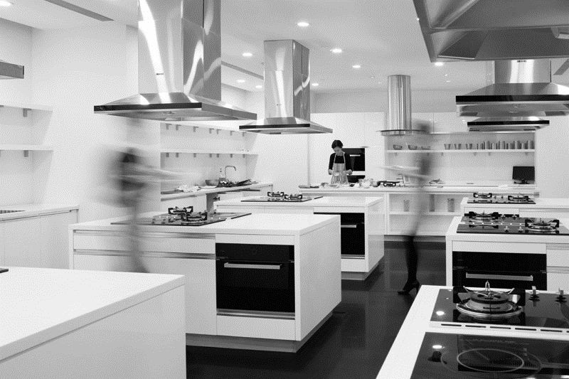Exhibit 3: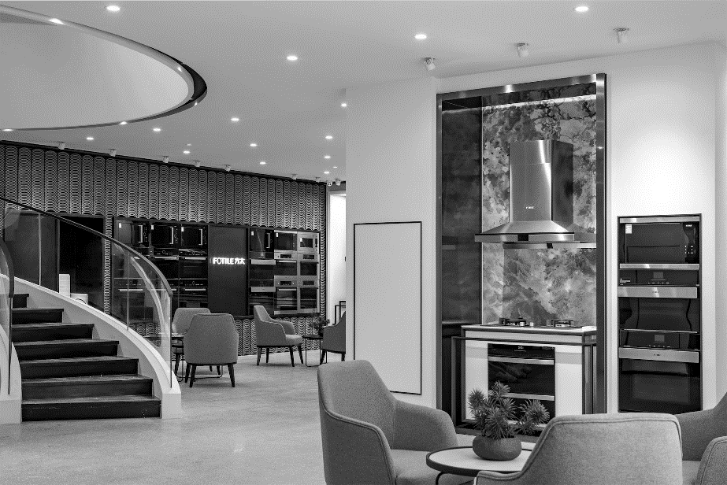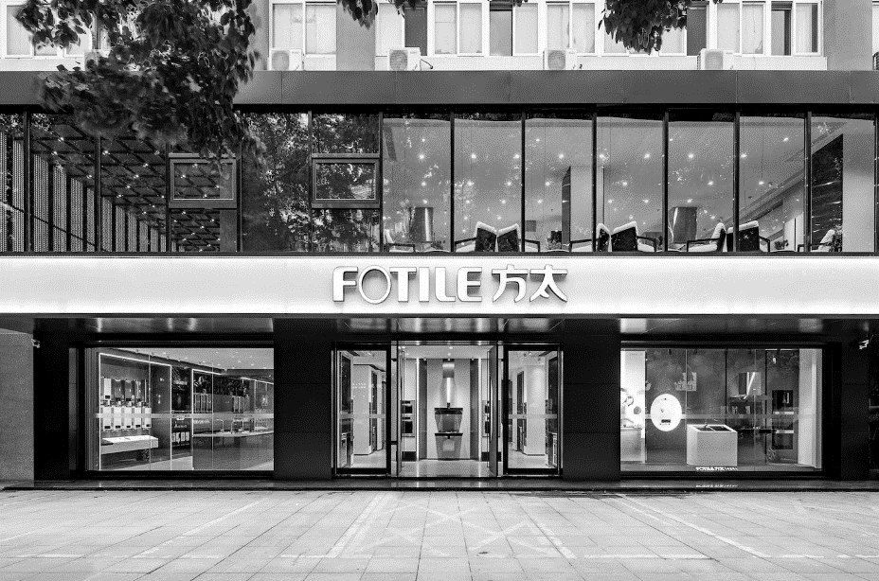 Fotile Kitchenware Co. Ltd. Exhibition Hall

Source: Company files.

Exhibit 4: Fotile Kitchenware Co. Ltd. distribution channels and sale components in 2017

Fotile’s Distribution Channels

17.5 (US$100 million)

Online Store

4.4

Offline Retailing

12.0

Real Estate Project

0.7

Overseas Sales

0.4

External Retailing Chains

21%–22%

Traditional

Department Stores

15%–18%

Own Stores

60%

Store Patrons

18%–24%

Outreach Promotions

36%–42%

Note: Non-percentage figures in this exhibit are expressed in US$100 million.

Source: Company files.

1. Kui Xue, “A Summary of China’s Kitchen Appliance Market in 2017 [in Chinese],” Sohu, January 9, 2018, accessed April 2, 2019, https://m.sohu.com/n/527610927/?wscrid=95360_2; ¥ = RMB = Chinese yuan renminbi; US$1 = ¥6.31 on February 26, 2018; all currency amounts are in ¥ unless otherwise specified.
2. “About Fotile [in Chinese],” Fotile, accessed April 2, 2019, www.fotile.com/brand/about.html.
3. Xiaoyong, “How Could Fotile Achieve the 100 Billion Objective after Reaching the 10 Billion Milestone [in Chinese],” Dingkeji, January 22, 2018, accessed April 2, 2019, www.dingkeji.com/post/79246.html.
4. “History of Range Hoods,” Old World Stoneworks, September 22, 2016, accessed April 2, 2019, https://oldworldstoneworks.com/history-range-hoods/.
5. Amazon.com, Inc. “Broan-NuTone 413004 Range Hood, 30-Inch, Stainless Steel: Appliances,” accessed July 29, 2019, www.amazon.com/Broan-413004-Non-Ducted-Under-Cabinet-Stainless/dp/B0002YTM0I.
6. “Japanese Range Hood Brand Fujio Entered Chinese Market [in Chinese],” PChouse, March 8, 2018, accessed April 2, 2019, https://news.pchouse.com.cn/214/2145035.html.
7. China Market Monitor, *2017 Summary and 2018 Outlook of Kitchen Appliances Market,* China Market Monitor Co, Ltd., January 19, 2018, p. 5.
8. Ibid., 13.
9. Ibid., 25.
10. “Fotile’s Sale Revenue Exceeded 10 Billion, Creating a New Record in the Industry,” CCTV, January 5, 2018, accessed April 2, 2019, http://1118.cctv.com/2018/01/05/ARTI390PgxRwL9quU3EVUoqN180105.shtml.
11. “About Fotile [in Chinese],” op. cit.
12. Ibid.
13. Ping Li, “Quality Fotile,” *China Civil Entrepreneur* (2009): 94–97.
14. Netease Financial, “Fotile’s Philosophy: Do Nothing, Yet Noting Is Left Undone [in Chinese],” 163.com, September 19, 2010, accessed April 2, 2019, http://money.163.com/10/0919/09/6GUF9QL800253G87.html.
15. Zhong Qi, “Witnessing the Development of China’s Range Hood Industry in the Past Three Decades: Interview with Senglan Shi, Vice Chairman of the China National Hardware Association [in Chinese],” China National Hardware Association, July 10, 2014, accessed April 2, 2019, www.chinahardware.org.cn/xhhk/xhhk/201407/t20140710_43737.html.
16. Jianfeng Li, “An Observation on the Strategies of the Major Range Hood Brands in 2007 [in Chinese],” Sina, September 17, 2007, accessed April 2, 2019, http://tech.sina.com.cn/e/2007-09-17/07551743045.shtml.