

9B19M078

jump gymnastics: jumping into the future

Selena Shannon Pritchard and Megan Wambolt wrote this case under the supervision of Professor W. Glenn Rowe solely to provide material for class discussion. The authors do not intend to illustrate either effective or ineffective handling of a managerial situation. The authors may have disguised certain names and other identifying information to protect confidentiality.

This publication may not be transmitted, photocopied, digitized, or otherwise reproduced in any form or by any means without the permission of the copyright holder. Reproduction of this material is not covered under authorization by any reproduction rights organization. To order copies or request permission to reproduce materials, contact Ivey Publishing, Ivey Business School, Western University, London, Ontario, Canada, N6G 0N1; (t) 519.661.3208; (e) cases@ivey.ca; www.iveycases.com. Our goal is to publish materials of the highest quality; submit any errata to publishcases@ivey.ca. i1v2e5y5pubs

Copyright © 2019, Ivey Business School Foundation Version: 2019-08-01

In February 2018, Jennifer Hood, owner of Jump Gymnastics Inc. (Jump), was sitting in her office preparing for her upcoming strategic planning cycle. Jump was a privately owned children’s recreational sport business that delivered gymnastics programs designed to prepare children for lifelong sport participation and healthy living. Having just celebrated Jump’s 10-year anniversary, Hood reflected on how her passion for helping children reach their full physical potential had resulted in a growing company. Jump operated two locations in Vancouver, British Columbia, and had expanded into hosting birthday parties and other special events. An expert in her field, Hood had also started to engage in outside consulting work and had become a sought-after speaker in the Vancouver athletics community. As Hood reflected on the opportunities for growth, she considered which options would provide for Jump’s best financial security.

Since its inception, Jump had been delivering weekly programs that fostered physical literacy in children between the ages of six months and eight years old through non-competitive developmental gymnastics. Physical literacy was a critical part of the Canadian Long-Term Athlete Development model but was relatively unknown to the general public. Physical literacy was defined as “the motivation, confidence, physical competence, knowledge, and understanding to value and take responsibility for engagement in physical activities for life.”[1] Research had shown that children who developed skills in physical literacy went on to live healthy, active lives as adults. Hood had been able to use the foundational elements of physical literacy to differentiate Jump’s core curriculum and attract a loyal following from parents and children alike. Hood’s expertise in physical literacy made Jump about much more than gymnastics classes. “This wasn’t about training gymnasts,” said Hood. “This was about using developmental gymnastics—the sport that offers the best opportunities to develop foundational movement skills—as a starting point to help our children be active for life.”

As Hood reflected on the business, she considered what laid ahead. Given her passion for physical literacy, she wondered whether she should consider other opportunities to grow the impact of her curriculum. However, as she had grown the business purely through organic financing, she was wary of embarking on a growth plan that could risk the business she had built. Hood saw opportunities in adding new Jump locations, expanding her consulting and public speaking practice on the topic of physical literacy, or perhaps even leveraging her expertise of physical literacy into a coaching certification program. While each of these options looked viable, Hood needed to consider not only the best use of her time and energy but also the option that would provide the most financial security.

The Children’s Recreational Sport Industry

Jump operated in the children’s recreational sport industry. Children in Vancouver had many options for recreational athletic programs. Jump competed with other gymnastics facilities; however, the company also competed with alternative individual sports programs, as well as multi-sport programs (see Exhibit 1). In addition, the company faced competition from lower-priced offerings subsidized by governments, such as community centre programs and after-school programs offered by local elementary schools.

Recreational sports were a part of everyday life for many children across Canada. Children’s sports represented a CA$5.7 billion[2] industry in Canada alone and was growing quickly. One report from the United States had shown that the industry had grown more than 55 per cent between 2010 and 2017.[3] Recreational sports offered young children an opportunity to develop their abilities and test out their likes and dislikes.

Based on her more than 20 years of working in sports, Hood noted that recreational sport activities were often conducted by local and usually long-established organizations, run by former athletes. However, when assessing Jump’s competitors, Hood had noticed that some private organizations were offering premium programs at low prices that were difficult to compete with; she wondered how profitably some of these organizations operated.

Developing programs that children enjoyed and found fun was critical in this industry. Organizations relied on children returning every year. A key reason for children dropping out of sports was a lack of fun. According to one poll, 70 per cent of children dropped out of sports by the age of 13 and did not return.[4] Furthermore, it had been reported that early involvement in sports was leading to children experiencing burnout at a younger age than ever before.[5]

Helping all Children Achieve Their Physical Potential

Physical literacy was the underlying practice at Jump; however, Hood knew that it was not overtly understood. Physical literacy had been defined more than two decades ago and was part of the Canadian Long-Term Athlete Development model (see Exhibits 2 and 3).

The more physically literate people were, the more likely they were to be physically active. Those who were physically literate were confident in their abilities and were motivated to continue physical activities throughout their lives. This knowledge, confidence, and motivation came from learning fundamental movement skills. Similar to math, reading, and writing, physical literacy needed to be taught, and practice was required to become skilled at it. Jump’s weekly programs provided a breadth of activities and movements so that children began building fundamental movement skills while gaining confidence (see Exhibit 4).

Hood had heard again and again from parents how their child’s confidence had grown over the years of attending programs at Jump This confidence was what was needed for a child to go on to live a healthy, active adulthood. At speaking events, Hood had seen people’s surprised expressions when she explained the difference between being physically active and having physical literacy. This distinction had helped parents connect their early childhood experiences in athletics with their current view of themselves as athletes or non-athletes. Knowing this, Hood still wondered whether the parents she spoke with and worked with understood the importance of intentionally developing physical literacy in their children versus just being physically active. She often felt like she was one small voice advocating for physical literacy.

Jump’s History of Growth

In 2008, Jump opened its first location in Yaletown, a neighbourhood in downtown Vancouver. It was currently running at capacity, offering 80 sessions a week, with more than 500 students per term and earning revenues of $210–$300 each session. While the location operated at capacity, it had a history of only break-even profitability. In 2014, Jump opened its second location through a partnership with another local business, Kids Physio Group. An extension of the Jump brand, the second location was a boutique gym large enough to house a fully equipped and brightly coloured gym, a parents’ lounge that overlooked the gym, a party and camp kitchen and craft space, and two fully equipped physiotherapy treatment rooms. The additional capacity had enabled Jump to run the location slightly above break-even profitability; however, in 2018, programs at the second facility were running at only two-thirds capacity.

To date, Jump’s marketing efforts had focused on raising awareness of the brand through standard walk-by signs and print advertising in family-focused, local magazines. Over the past few years, Hood had seen more programs using the term physical literacy. Hood wanted greater awareness, acceptance, and support of physical literacy; therefore, she appreciated that other programs had started to embrace the concept. However, she noted that the term was often being used in ways that could cause confusion and lead people to assume physical literacy was the same as being physically active. Additionally, Hood was unsure how much she could grow the business if more direct competition began to surface in the Vancouver marketplace, especially given that many programs offered classes at a lower price point than Jump’s standard rate.

THE Power of Referrals

Hood understood and shared the importance of parent referrals—as she stated, “Parents move in groups.” Therefore, Hood had put a lot of effort into creating strong relationships between Jump’s coaches and Jump’s customers—the parents who made the decision to enrol their children in Jump programs. She knew that these referrals were essential to the sustainability of Jump, especially because children grew out of the programs at age eight.

Jump had maintained basic analytics on the sources of new customers. These data showed that Jump attracted new clients based on existing customers’ referrals and achieved strong conversions from trials (including when children attended birthday parties in the space). In addition to referrals, Jump received some new customers through Google searches for gymnastics and gymnastic birthday parties; however, the company had not heavily invested in digital marketing.

THE Importance of Coaching

Hood recognized that developing a strong coaching staff was the best way to not only spread physical literacy but also ensure that the business would continue to succeed. When hiring coaches, Hood sought people who were personable, cared about children, enjoyed teaching, and understood the importance of Jump’s mission. Coaches with a variety of backgrounds, such as a history in athletics or experience in teaching, had proven to be successful at Jump.

Hood was passionate about providing the best possible training to coaches and investing significant time in lesson development. She had created five training modules for new coaches to learn the Jump mission, the physical literacy methodology, and basic class management skills. Modules were covered through at-home videos and group training sessions led by each location’s facility manager.

Before leading their own Jump class, all coaches in training shadowed a senior coach, which provided hands-on training on skills, the facility, and class management. Coaches in training were paid for their job-shadowing hours. From start to finish, Jump’s training, in and out of class, could last 12 weeks. While this training was much longer than at many other recreational sport programs, Hood believed it was critical that coaches were well-trained and confident in both the skills needed to develop physical literacy and the Jump approach to developing physical literacy.

Additionally, Jump maintained coach-to-child ratios that were lower than the industry average, all in an effort to ensure the best possible experience for both the children and the coaches (see Exhibit 5). Based on her experience in the industry, Hood had found that eight kids per coach was common practice, whereas many of Jump’s unassisted programs were four to six kids per coach. Hood liked to refer to the gym space as a “lab,” where coaches could help parents and children learn and explore how their bodies moved. Educating parents on their child’s current stage of development and what to expect as their child continued to develop represented a big part of the coach’s role in the parent-assisted classes, especially for children between the ages of six months to three years old. It was common for parents to stop by Hood’s office to express their enjoyment of their child’s class and coach. Comments consistently included both parent and child becoming more confident as the program progressed.

Consulting Opportunities

Word had spread on Hood’s expertise in developing children’s physical literacy, which had led to opportunities to consult and speak at events (see Exhibit 6). Hood enjoyed these opportunities and found them to be personally fulfilling. Additionally, Hood recognized that consulting and speaking fees were a great way to bring in additional revenue to Jump, particularly when its facilities were operating at capacity.

In Vancouver, Hood had been a sought-after speaker to various parenting groups. Hood’s hour-long presentations to groups at schools, daycare centres, and other venues were informal talks on what physical literacy was and the importance of developing physical literacy in children from a very young age.

Gymnastics Canada had recently hired Hood to create a new levels program that would complement its existing Canada-wide program. The program would focus on developing skills in children younger than six years of age and preparing children in the fundamental movement skills that comprised larger skills in gymnastics and other sports. The existing Gymnastics Canada program, which was used by gymnastics facilities across Canada, had existed for decades. Therefore, Hood was excited to add to this curriculum, and she hoped that it indicated a positive trend for the recognition of physical literacy.

Beyond Canada, a group in Egypt had hired Hood to consult on a new physical literacy space in its community and to work with the group on the class programs, the equipment, and the space layout.

On occasion, Hood had pulled in some of her coaches to help with research or design work. Fortunately, some coaches on the team had always been keen to stretch their knowledge and abilities by working on a consulting project. That said, Hood had wondered whether they actually had the skills to do this research and design work to the high quality she committed to each project; if they lacked such skills, she wondered what time investment would be needed to develop those skills and manage those individuals to help her in this work.

Hood believed that there was sufficient demand in the market for this type of consulting and public speaking work; however, she was unsure how to profitably price her offerings and how to organize the company to take advantage of these opportunities.

Physical Literacy Certification

Hood recognized that while physical literacy was not yet mainstream, awareness of it was slowly growing within Canada, which could present an opportunity to offer a physical literacy certification program. Because of her knowledge and application of physical literacy, she was uniquely positioned as an expert. Hood believed that training coaches of various disciplines in physical literacy could increase the role of physical literacy in more programs and, in doing so, help more children with the fundamental movement skills they needed in life.

The first type of certification option that Hood had considered was to train and certify coaches and other instructors in physical literacy. Coaches could use this certification as an additional differentiator when applying for coaching positions, and organizations could use this certification to enhance the quality of their programs.

Currently, there was no certification group or governing body on physical literacy. Therefore, if Hood pursued this option, she would need to weigh the benefits of broader awareness and acceptance of physical literacy against the impact these benefits could have on her company’s differentiation. She would also need to exert significant focus on marketing to drive the certification across Canada.

The second option that Hood had considered was to develop a coaches-in-training certification program at the two Jump locations. This program would train teenagers on the fundamentals of physical literacy and basic coaching skills. This option excited Hood because of the opportunity to develop young people, connect with organizations, and create a pipeline of coaches for Jump. Hood also believed that this option would be easier to implement than a training program for adults, and that it would help her to better understand the viability of a coach training program.

Hood estimated that she could have two intake periods for the teenage trainees—one in the fall and one in the spring. A group of 12 trainees would attend training over two weekends, with the expectation that every trainee complete 50 hours of on-the-floor shadowing, over the next three to four months.

The coaches-in-training program would then provide the participants with a certificate of completion, which would make them eligible for coaching positions within Jump or prepare them for moving on to coaching within other sports organizations. Training programs for youth, such as babysitting courses and sport-specific training programs, were offered at a range of prices, which made it difficult for Hood to have confidence in a price point. The program would be a great opportunity for teenagers to gain training and part-time work; therefore, she believed that parents of teenagers would be willing to pay for this type of experience. Hood, therefore, estimated that $300–$500 represented a potential price range for the program.

Beyond generating revenue, this program would also save wages by having trainees work for free while completing their 50 hours of on-the-floor training. If all 12 trainees completed their 50 hours of on-the-floor training within a single term, the savings could represent $9,000 per quarter in coaching and support staff salaries.

Developing the program would require an upfront investment in time, which Hood estimated to be approximately 150 hours. An additional 130 hours of coaching hours would be needed for the actual training per year. Hood estimated this payroll expense at roughly $10,000. Starting with this coaches-in-training program was certainly less daunting for Hood than setting up an adult certification program, and it would provide the platform to build a reputation for coaching and certification programming.

Adding New Locations

Adding new locations was a tempting option for Hood because of the success she had experienced in her first two locations. However, she knew that for the long-term success of the company, if she were to add an additional location, it would need to operate profitably. Hood estimated that each new location would generate revenue of $400,000–$500,000 per year. She had considered markets outside of the Vancouver core, which could offer considerable savings in rent (see Exhibit 7). In addition, economies of scale would be achieved by spreading an annual $321,000 of shared costs (e.g., shared staff salaries and legal and accounting expenses) across more than two locations.

Hood’s greatest concern about adding new locations was the toll it would put on both herself and her leadership team. Currently, Jump’s four-person management team wore many hats, playing important roles in managing the facilities and developing the team of coaches. At each location, one facility manager oversaw the coaching team, the third-party vendors who cleaned the facility, and other duties specifically related to the facilities. Facility managers also directly delivered 20 coaching hours each week. In addition, a marketing and administration manager contributed one day per week at the front desk at each facility, oversaw both full-time and part-time front desk employees, and performed all marketing work (e.g., print ads, website, on-site signage, and promotions). A year earlier, Hood had also hired a coach to both work full-time at the North Vancouver facility and manage social media. Finally, Hood herself directly managed the leadership team, performed payroll duties, managed rent, and coordinated major suppliers (see Exhibit 8).

The majority of the leadership team had worked in sports in various forms and excelled in coaching. While Hood felt that the coaching skills on her team were strong, Hood had seen challenges with other aspects of the team’s roles, especially in the areas of project and people management skills, which had not been a core focus of the company. Instead, Hood provided much of the guidance on day-to-day management activities. As she considered an expansion, these challenges were concerning. Would the managers be willing—and capable—of taking on new opportunities, or would Hood need to continue to lead the managers in their daily responsibilities?

Financials

Maintaining a cash flow–positive company had always been top-of-mind for Hood. She had started with a shoestring budget, which had been a challenge in one of the most expensive markets in Canada. In addition, Hood’s commitment to the low-class ratios had presented an ongoing financial challenge to the company, as it constrained the ability to grow revenues at each location (see Exhibits 7 and 9).

Staff costs were Jump’s highest expense. Historically, Jump had paid its coaching staff on the lower end of the market rate. However, Hood recognized that the extensive training and development Jump’s coaches received built them into capable leaders, which many saw as a benefit that would set them up for their future careers. On the other hand, Hood was concerned about the cost of turnover, especially given the investment in training made in each coach.

Rent was the second-largest expense at each Jump facility; however, Hood had worked diligently to negotiate preferential leases and could not see how to achieve further cost savings. Hood’s only consideration was to open any future Jump locations in lower-cost regions outside of the Vancouver core.

While Hood had grown the business organically, she had benefited from small business loans and a fund from the Women’s Enterprise Development Centre. She expected that if she were to grow the business, she would again need access to a reasonable amount of capital through one of these loan sources.

What Next?

As Hood prepared to step onto the gym floor to greet the next group of students arriving at the gym, she wondered exactly where she should take the company she had built. She was proud of her current operations, which reflected her values, and she truly believed that Jump had made an impact on children’s lives. However, she was concerned about the profitability of the company and how to take it forward. Hood ultimately needed to consider which path offered the best opportunity for her to spread her passion for physical literacy while allowing her to continue building a financially sustainable business.

**Exhibit 1: A COMPARISON OF PROGRAMS OFFERED BY JUMP GYMNASTICS INC.**

**AND ITS COMPETITORS in vancouver (in CA$)**

|  |  |  |  |  |
| --- | --- | --- | --- | --- |
| Organization | Focus  (Sport, Age Range) | Competing Program | Program Pricing | Other Information |
| Jump Gymnastics Inc. | Physical literacy programs in a gymnastics facility; 8 years of age and under | Weekly programs; average of 80 classes per term, per facility; 2 facilities | $200–$310  (based on age) | North Vancouver facility shares space with Kids Physio Group |
| Flicka Gymnastics Club | Recreational and competitive gymnastics programs; all ages | Weekly recreational gymnastics; children under 8 years of age; average of 94 classes per term | $99.17–$377 |  |
| Britannia Gymnastics | Recreational and team-based demonstration performance gymnastics; 15 years of age and under | Weekly recreational gymnastics; children under 8 years of age; average of 10 classes per term | $81–$94 per term  (based on age, 9 sessions per term versus market standard of 11–13) | Part of the City of Vancouver recreational programming |
| Vancouver Athletic Football Club | Soccer; all school ages | House league; weekly | $175–$275 per term (based on age) | Long-Term Player Development model (soccer and overall athletic performance) |
| Sportball | Specialized programs and multi-sport programs; 12 years old and under | Multi-sport for children under 8 years of age; weekly; 52 classes per term (average) | $68–$162  (based on age and length of term [4–9 sessions]) | Multi-sport programs in open gym space, using various equipment |
| City of Vancouver Swimming | Recreational activities across a range of sports; all ages (adult and children) | Swimming lessons for children under 8 years of age; 395 classes; same period as other programs  Note: a number of swimming programs run for shorter terms. More swim terms for every 1 term of other programs. | $37–$85  (based on age and length of term; 50% discount available to members) |  |
| Kids in Motion: Creative Arts Studio | Dance; 3–12 years of age | Weekly dance lessons for children under 8 years of age; 48 classes per term (average) | $105–$230  (based on age and length of term) |  |
| TumbleTown Movement Education Centre | Physical literacy programs in a gymnastics facility; 8 years of age and under | Weekly programs; 102 classes per term (average) | $188.50–$341.25  (based on age) | Sister business of Aquaventures Swim Centre |

Source: Flicka Gymnastics Club (website), retrieved March 28, 2019, www.flickagymclub.com; Britannia Gymnastics (website), retrieved March 28, 2019, www.britanniagymnastics.com; Vancouver Athletic Football Club (website), retrieved March 28, 2019, http://vafc.ca/; Sportball Vancouver (website), retrieved March 28, 2019, www.sportball.ca/vancouver/; City of Vancouver Swimming (website), retrieved March 28, 2019, https://ca.apm.activecommunities.com/vancouver/Activity_Search?Page=2; Kids in Motion Creative Arts Studio (website), retrieved March 28, 2019, www.kidsinmotiondance.com; TumbleTown Movement Education Centre (website), retrieved March 28, 2019, http://tumbletown.ca/.

**Exhibit 2: Canada’s LONG-TERM Athlete Development Model**

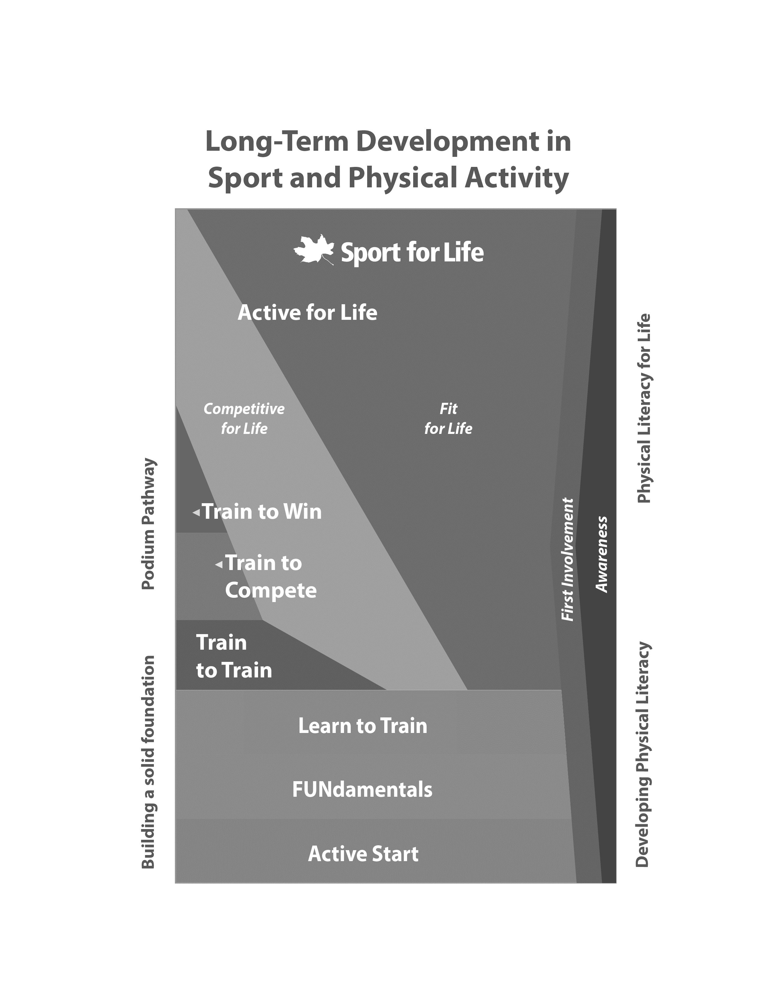

Source: Sport for Life, “Sport for Life Rectangle,” accessed April 15, 2019, http://sportforlife.ca/wp-content/uploads/2017/04/Sport-for-Life-Rectangle-EN_2015_web.jpg. Used with permission.

**Exhibit 3: The Elements of Physical Literacy**

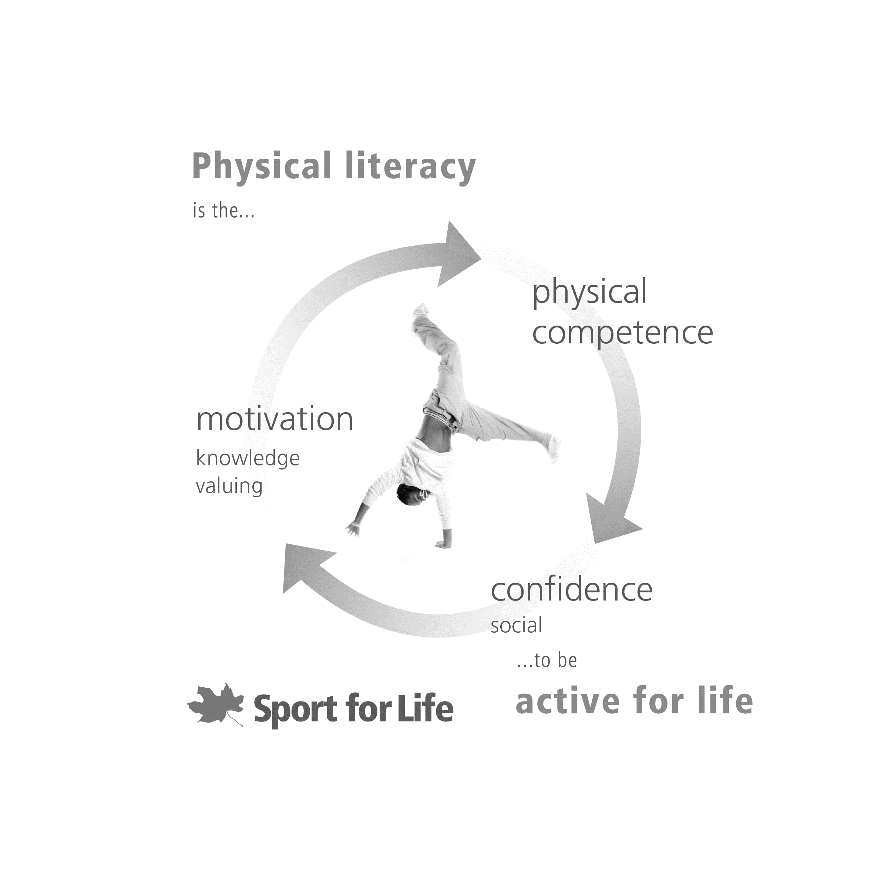

Source: Sport for Life, “The Elements of Physical Literacy,” accessed April 15, 2019, <http://sportforlife.ca/physical-literacy/>. Used with permission.

**Exhibit 4: Jump class Registration for one term, North Vancouver Location (in CA$)**

|  |  |  |  |
| --- | --- | --- | --- |
| **Program** | **Price** | **No. of Classes**  **Offered per Week**  **(Single Facility)** | **No. of Total Registrants** |
| Baby Jump | $200 | 3 | 15 of 33 |
| Jump 1 | $220 | 10 | 72 of 98 |
| Jump 2 | $240 | 14 | 86 of 120 |
| Jump 3 | $270 | 21 | 65 of 85 |
| Jump 4 | $290 | 11 | 41 of 66 |
| Jump 5 & 6 | $310 | 8 | 41 of 49 |
| Jump 7 & 8 | $310 | 5 | 16 of 29 |

Note: Data in the table represent the programs for one term. Jump offers three terms per location each year.

Source: Company files.

**EXHIBIT 5: coach-to-child Ratios at Jump programs**

|  |  |  |  |  |
| --- | --- | --- | --- | --- |
| **Class** | **Regular**  **Alone** | **Regular**  **Shared** | **MAX\***  **Alone** | **MAX\***  **Shared** |
| Baby Jump | 11:1 | – | 12:1 | – |
| Jump One | 11:1 | 7:1 | 12:1 | 8:1 |
| Jump Two | 10:1 | 6:1 | 11:1 | 7:1 |
| Jump Three | 4:1 | 4:1 | 5:1 | 5:1 |
| Junior Jump | 6:1 | 6:1 | 7:1 | 7:1 |
| Senior Jump | 6:1 | 6:1 | 7:1 | 7:1 |
| Birthdays | 12:2 | – | 12:2 | – |
| Camps | 6:1 | – | 7:1 | – |
| Date Night | 12:2 | – | 13:2 ** | – |

Note: According to typical industry ratios, for children younger than five years of age, the coach-to-child ratio was 5:1; for children older than five years of age, the coach-to-child ratio was 8:1; alone = only one class in the gym; shared = more than one class (of any type) in the gym at the same time; * includes room for make-up sessions; ** allowed only in special circumstances.

Source: Company files.

**EXHIBIT** **6: jennifer hood’s Consulting and Speaking Fees in 2017 (in CA$)**

|  |  |  |  |  |
| --- | --- | --- | --- | --- |
|  | **Hourly Rate** | **Average Hours per Engagement** | **Length of Engagement**  **(in Weeks)** | **Number of Engagements per Year** |
| Typical Consulting Engagement | $50 | 96 | 24 | 3 |
| Typical Speaking Engagement | $100 | 2 | – | 10 |

Source: Company files.

**Exhibit 7: New Location Revenue and Costs (in CA$)**

|  |  |  |  |  |  |  |
| --- | --- | --- | --- | --- | --- | --- |
|  | **Estimated Revenue** | **Estimated Annual Rent** | **Estimated Build-Out Cost** | **Estimated Equipment and Fixtures** | **New Salary Expenses per Year** | **General Expenses per Year** |
| In Metro Vancouver | $400,000–$500,000 | $90,000–$150,0000 | $80,000–$100,000 | $50,000 | $145,000–$180,000 | $90,000–$100,000 |

Source: Company files.

**Exhibit 8:** **Jump’s Organizational Chart**



Source: Company files.

**Exhibit 9: Jump gymnastics inc.’s Abbreviated Income Statement, 2016–2018 (in CA$)**

|  |  |  |  |
| --- | --- | --- | --- |
|  | **2018** | **2017** | **2016** |
| Income | $959,570 | $905,389 | $813,186 |
| Fixed Expenses | 29% | 25% | 28% |
| Variable Expenses | 72% | 71% | ~72% |
| Net Income | 2% | 4% | -0.003% |

Source: Company files.

1. “Choosing Physical Activity for Life,” International Physical Literacy Association, accessed March 28, 2019, www.physical-literacy.org.uk/about/.
2. All amounts are in Canadian dollars.
3. Sean Gregory, “How Kids’ Sports Became a $15 Billion Industry,” *Time*, August 24, 2017, accessed March 2, 2019, http://time.com/4913687/how-kids-sports-became-15-billion-industry/.
4. “National Standards for Youth Sports,”National Alliance for Youth Sports*,* accessed March 2, 2019,www.nays.org/resources/nays-documents/national-standards-for-youth-sports/.
5. J. J. Adams, “Fear, Greed, Broken Dreams: How Early Sports Specialization Is Eroding Youth Sports,” *Vancouver Sun*, April 1, 2018, accessed March 2, 2019, <https://vancouversun.com/news/local-news/fear-greed-broken-dreams-how-early-sports-specialization-is-eroding-youth-sports>.