

9B19M091

The Red Hen Controversy[1]

Benjamin Bigio wrote this case under the supervision of Professor Jana Seijts solely to provide material for class discussion. The authors do not intend to illustrate either effective or ineffective handling of a managerial situation. The authors may have disguised certain names and other identifying information to protect confidentiality.

This publication may not be transmitted, photocopied, digitized, or otherwise reproduced in any form or by any means without the permission of the copyright holder. Reproduction of this material is not covered under authorization by any reproduction rights organization. To order copies or request permission to reproduce materials, contact Ivey Publishing, Ivey Business School, Western University, London, Ontario, Canada, N6G 0N1; (t) 519.661.3208; (e) cases@ivey.ca; www.iveycases.com. Our goal is to publish materials of the highest quality; submit any errata to publishcases@ivey.ca. i1v2e5y5pubs

Copyright © 2019, Ivey Business School Foundation Version: 2019-08-20

June 22, 2018, had been a beautiful sunny day in the small rural city of Lexington, Virginia. Stephanie Wilkinson, co-owner of the Red Hen, a small farm-to-table restaurant in Lexington, had just poured herself a glass of red wine and was getting ready for a relaxing Friday evening at home when the phone rang. It was the chef at the Red Hen. Apparently, the White House press secretary, Sarah Huckabee Sanders, had just walked into the restaurant and joined a table of eight booked under her husband’s name. The chef explained that many of the Red Hen staff were uncomfortable because several of them were part of the LGBT2Q+[2] community and knew that Sanders had defended President Trump’s statements about banning transgender people from the military. Further, some of the staff were similarly concerned about Sanders’s support of President Trump’s policies on immigration. The staff at the Red Hen did not know what to do, and there was no ethics or code-of-conduct policy to follow.

Wilkinson found it unlikely that President Trump’s press secretary was at her 26-seat restaurant in rural Virginia, but at the same time, Wilkinson trusted that her staff was able to identify Sanders, who had recently been all over the news amid a flurry of media statements that supported highly contentious issues and policies instituted by the Trump administration. Before the chef could even say goodbye, Wilkinson had grabbed her keys and jumped into her car. The Red Hen was only a 10-minute drive away; with so many thoughts racing through her head, Wilkinson barely had any time to think about what she was going to do.

How could she de-escalate the rising tension with her employees? Should she consider ejecting Sanders from the restaurant? If so, on what grounds? What stakeholders should she consider when making any decision on the matter, and what factors were important to them? What would the consequences be of whatever decision she made? She knew that she would likely face the media with questions on what happened and why. What message should Wilkinson convey? And how, if at all, should she communicate with the media? Wilkinson believed that the Red Hen restaurant had managed to stay in business for over 10 years by keeping politics off the menu.[3] Now she needed to make some important decisions.

STEPHANIE WILKINSON

Wilkinson was an avid traveller, self-confessed gourmet, philanthropist, proud mother, and entrepreneur at heart. After completing her Ph.D. in European and American religious history from the University of Virginia in the 1990s, in 2000, Wilkinson co-founded *Brain, Child: The Magazine for Thinking Mothers*. She continued to publish and edit literature for 13 years, helping to shape the “award-winning literary magazine dedicated to motherhood.”[4]

Wilkinson had always dreamed of starting and owning a farm-to-table restaurant that supported the local community, and, in 2008, she officially opened the Red Hen. In 2013, Wilkinson helped launch the volunteer-based organization Main Street Lexington to preserve, sustain, enhance, and promote the city of Lexington, serving as the executive director for the non-profit.[5] Later, in 2017, Wilkinson co-founded House Mountain Yarn Co. with several friends out of a collective love of knitting and a desire to help the community recognize the benefits of knitting and crocheting.[6]

SARAH HUCKABEE SANDERS

Born in Arkansas in 1982, Sanders was raised in a strong Republican family and, even as a little girl, was always politically motivated. Sanders’s father described her childhood:

I always say that when most kids are seven or eight years old out jumping rope, Sarah [Sanders] was sitting at the kitchen table listening to political commentators analyze poll results. She was also doggone tough and fearless due to having grown up with two brothers.[7]

Sanders was a founding partner of Second Street Strategies, a general consulting services provider for Republican campaigns, where she also worked on national political campaigns.[8] After managing her father’s unsuccessful presidential campaign, in 2016, Sanders joined Donald Trump’s presidential campaign and, shortly after Trump was elected, Sanders was named to the position of deputy and then official White House press secretary. Since joining the Trump administration, Sanders had adamantly defended Trump’s immigration policies,[9] actively criticized the media for spreading “fake news,”[10] and staunchly supported Trump’s statements regarding his business and personal dealings.

Moreover, Sanders was an avid user of Twitter and did not shy away from speaking her mind, even when using the official press secretary Twitter account. On September 6, 2018, Sanders used the official account to tweet that the author of an essay published in the *New York Times* criticizing Trump was a “gutless loser” and that those in the newspaper’s opinion department were “deceitful.”[11] There was considerable debate surrounding Sanders’s use of the White House Twitter account and the blurred lines between her personal opinions and the White House’s official statements. She was further criticized by the former director of the United States Office of Government Ethics, Walter Shaub, for having violated ethics laws by using public office for private gain.[12] Specifically, Shaub argued that when Sanders reacted to the Red Hen situation on Twitter as a government official—and not as a private citizen, using her own resources and her own time—Sanders was directly violating US law.[13]

THE CITY OF LEXINGTON, VIRGINIA

The city of Lexington, located approximately 300 kilometres from Washington, DC, had a population of only 7,136.[14] The entire city covered an area of only six square kilometres. As of 2017 US census estimates, the city was 85 per cent White and 10 per cent African American.[15] The median and mean annual household incomes were US$37,309 and US$54,075, respectively.[16] Twenty-one per cent of the general population and 18 per cent of those under the age of 18 lived below the poverty level.[17]

Lexington was home to the Virginia Military Institute and Washington and Lee University. Aside from higher education, tourism made up a significant amount of the city’s economic activities, attracting American Civil War history buffs from across the eastern United States. The city also owned the first and only community-owned, non-profit drive-in theatre in the United States. Lexington was conveniently located at the intersection of historic US Routes 11 and 60, with excellent connections to more modern highways.

Despite its small population, Lexington had become a politically charged city. In 2016, the city had voted against Trump—in a county that had voted overwhelmingly in favour of his presidency. The community was equally divided over issues such as the Confederate flag, a long-standing community subject that had faced intense debate and scrutiny in recent years.[18] A local resident described how it was not unusual to see “people driving around with bumper stickers that say boycott Lexington.”[19]

THE RED HEN

Co-founded in 2008 by Wilkinson and a friend, the Red Hen was marketed as a “farm-to-table fine dining restaurant offering inspired Shenandoah cuisine.”[20] Located in rural Virginia, the Red Hen was Lexington’s first farm-to-table restaurant, and it had sourced food from arguably the region’s most talented farmers. Wilkinson believed that the small restaurant would bring the community together under a roof that gave back to the community by encouraging and supporting local, sustainable farming, and that it would also support local tourism.

Since its inception in 2008, the Red Hen had strong local support from the community, and it quickly became a favourite spot for locals. The small restaurant seated 26 people and had a total of six employees, including one chef. Wilkinson made sure to employ a staff team that represented the cultural mosaic of Lexington, and she openly embraced diversity. Reservations were often made weeks in advance, especially during the busy summer tourist season, given the restaurant’s limited hours of operation—5 p.m. to 9 p.m., Tuesday–Saturday.

The intimate dinner environment allowed patrons to see the open kitchen and the chef working away as they ate. A customer’s review on Yelp read:

Unbelievable is one of the words that comes to mind when I think of the Red Hen, as well as delicious, modern and exclusive. This small restaurant is the hidden gem of Lexington with only 10 tables, and a new menu each day, so you know what you’re getting is fresh! On Saturday, once we arrived to the Red Hen, we were seated quickly at a small table by the open kitchen. It was exciting to be able to see all the action happening in the kitchen while seated at our table. We are already planning a new visit to Lexington, for the sole purpose of going to the Red Hen, and will make sure to make a reservation with more time in advance![21]

Another review on Yelp read, “We really enjoyed our dinner at the Red Hen. This is a gem in Lexington for sure! Warm and cozy atmosphere reminiscent of a small family owned restaurant you would find in a small town in the South of France. Farm-to-table experience without any pretentiousness.”[22]

Between January 2014 and June 2018, the Red Hen consistently had a 5.0 Yelp review score—an insurmountable feat for even the best restaurants in the country (see Exhibit 1).[23] Wilkinson was a proud co-founder of the restaurant and believed that strong Yelp scores were important for her business, as tourists typically relied on Yelp to choose restaurants in the community.

THE DECISION

Wilkinson arrived at the Red Hen shortly after 8 p.m. on June 22, 2018, and discovered that there had been no mistake. Sanders, her husband, four middle-aged men and women, and an older couple were impossible to miss as they sat at a table in the middle of the tiny restaurant with a cheese plate in front of them. The group had already ordered from the reluctant wait staff, and the kitchen was preparing the group’s entrees.

Wilkinson was relieved, in a sense, that the group had already been served by her staff. She believed that it could have been confrontational if the staff had outright refused to serve Sanders. At the same time, there was no moral or ethical code of conduct that Wilkinson employed at the Red Hen, nor had she trained her staff on what to do in such a situation. While her staff did not refuse to serve Sanders on her arrival, it was important, as Wilkinson described, to recognize that “Sanders was a public official, not just a customer with whom she disagreed, many of whom were included in her regular clientele.”[24]

Wilkinson believed that Sanders worked in the service of an “inhumane and unethical” administration, as Sanders vehemently defended and supported President Trump’s controversial policies on, among other issues, immigration and transgender rights.[25] At the same time, Wilkinson admitted, “I’m not a huge fan of confrontation. I have a business, and I want the business to thrive. This feels like the moment in our democracy when people have to make uncomfortable actions and decisions to uphold their morals.”[26]

Wilkinson quickly huddled with her staff, who were clearly tense. “Tell me what you want me to do. I can ask her to leave,” said Wilkinson. The staff replied, “Yes.”[27]

Wilkinson walked up to Sanders’s chair and said, “I’m the owner. I’d like you to come out to the patio with me for a word.” As they stepped outside, away from the restaurant crowded with other patrons, Wilkinson was nervous but took a big breath and delivered the message to Sanders: “I was babbling a little, but I got my point across in a polite and direct fashion. I explained that the restaurant had certain standards that I feel it had to uphold, such as honesty, and compassion, and cooperation. I’d like to ask you [Sanders] to leave.”[28]

Sanders’s response was immediate and anticlimactic for what Wilkinson had braced herself for: “That’s fine. I’ll go,” said Sanders.[29] Sanders went back to the table, picked up her things, and walked out. “The others at her table had been welcome to stay,” Wilkinson said, “but they didn’t, so the servers cleared away the cheese plates and glasses. The group offered to pay. I said, ‘No, it’s on the house.’”[30]

Wilkinson was surprised by how everything had taken place with dignity and respect. “There was politeness. There was civility. There were no issues,” said Wilkinson. She was relieved that the situation had been resolved amicably and that she could now go back home. Or so she thought.

THE IMMEDIATE AFTERMATH

While Wilkinson was confident that she had made the right decision in asking Sanders to leave, she had not anticipated the wave of public emotion that would ensue. Within minutes of asking Sanders to leave, Red Hen waiter Jaike Foley-Schultz posted on Facebook, “I just served Sarah Huckabee Sanders for a total of 2 minutes before my owner asked her to leave.”[31] Within seconds of the posting, a whirlwind of celebratory and outraged comments flooded in from Foley-Schultz’s Facebook wall, the Red Hen’s social media accounts, and then the restaurant’s Yelp review page:

Five stars: Thank you for refusing to serve a person who lies to the American people for a living.

One star: They made some snide remark about a “spit soufflé” for the Florida Nazi.[32]

Despite the Red Hen’s exemplary 5.0 Yelp review score since 2014, with the incoming firestorm of comments by people who believably had not even eaten at the restaurant, the Red Hen’s Yelp review score now averaged 1.5 stars.[33] The Red Hen had nearly 15,000 reviews on Yelp, despite a population in Lexington of only 7,000. Within 24 hours, the influx of so many posts had triggered an “Unusual Activity Alert” (see Exhibit 2) and subsequent “Active Cleanup Alert” by Yelp: “Yelp temporarily disabled the posting of content to this page because the business recently made waves in the news, which often means people come to this page to post their views on the news.”[34] During this alert, Yelp employees worked to identify and remove what they believed were fraudulent reviews.[35]

The following morning, an unaffiliated restaurant in Washington called “Red Hen” was egged, and the “Olde Red Hen” in Collingwood, Ontario, and another unaffiliated “Red Hen” in New Jersey were inundated with angry comments and bad reviews on Facebook.[36] Restaurants with any variation of “Red Hen” in its name were quick to point out that they were unaffiliated with the Lexington-based restaurant, as they also saw plunging Yelp review scores.

To make matters worse, by the following afternoon, there was rumour of a major protest to be held outside the Red Hen. Reporters and photographers loitered outside the restaurant, and passersby were yelling “Boo, Red Hen!” and “Yay, Trump!” from their car windows.[37] On the other hand, a local Lexington resident brought flowers and a hand-lettered sign that read, “Democracy requires principled government. Thank you Red Hen!”[38] Meanwhile, the Red Hen’s phone line was ringing off the hook with what were believed to be fake reservations from Trump supporters.

Given the public outcry and escalating backlash against the Red Hen, Wilkinson had no choice but to cancel all reservations for Saturday evening. Chris Roessler, a would-be customer unaware of the Sanders situation, stood outside the restaurant, looking at his mobile phone in confusion, as he had just received an email telling him that his reservation had been cancelled. The email from the Red Hen said, “We would like to avoid exposing our patrons to any potential unpleasantness from outside entities.”[39]

Public debate continued to escalate over the next several days, with protesters actively marching outside the Red Hen. Wilkinson had no choice but to cancel reservations for the next several days. The *Washington Post*’s editorial board wrote, “While Trump’s behavior in office might be terrible, officials who work for him should be allowed to eat dinner in peace. Those who are insisting that we are in a special moment justifying incivility should think for a moment how many Americans might find their own special moment.”[40]

As Wilkinson’s Red Hen brand was taking a beating, she wondered if and when the situation would blow over. She had worked tirelessly over the past 10 years to establish a good reputation for her restaurant, and, in a matter of 24 hours, it was being destroyed.

THE WHITE HOUSE RESPONSE

The day after the incident, Sanders used her official press secretary Twitter account to post about her experience at the Red Hen:

Last night I was told by the owner of [the] Red Hen in Lexington, Virginia to leave because I worked for @POTUS [the president of the United States] and I politely left. Her actions say far more about her than about me. I always do my best to treat people, including those I disagree with, respectfully and will continue to do so.[41]

On Monday, June 25, 2018, Sanders delivered an opening address in the White House briefing room. She spoke about the controversy at the Red Hen, the numerous aftershocks that came in its wake—including harassment directed toward the restaurant and others with the same name—and political confrontation. Sanders said, “We are allowed to disagree but we should be able to do so freely and without fear of harm. Healthy debate on ideas and political philosophy is important. But the calls for harassment and the push for any Trump supporter to avoid the public is unacceptable.”[42]

President Trump supported the White House press secretary and subsequently tweeted, “The Red Hen Restaurant should focus more on cleaning its filthy canopies, doors and windows (badly needs a paint job) rather than refusing to serve a fine person like Sarah Huckabee Sanders. I always had a rule, if a restaurant is dirty on the outside, it is dirty on the inside!”[43]

While Sanders had been criticized by former White House ethics chiefs over the weekend for having used the government’s official Twitter account for personal gain and specifically naming the restaurant and its location, the damage to Wilkinson’s Red Hen brand had already been done. Wilkinson felt that things could not get any worse for business.

REFLECTION

Within three days of asking Sanders to leave the restaurant, Wilkinson’s personal voicemail was full, her business line was not accepting calls, and a believed hacker had redirected the Red Hen’s website to a Japanese-language automotive blog. On Tuesday, June 26, 2018, demonstrators and protesters had gathered outside the Red Hen entrance with signs and flags displaying homophobic messages and Trump’s presidential campaign slogan, “Make America Great Again.”[44] Others carried signs saying, “Hey Red Hen Go Cluck Yourself.”[45] One protester was even arrested after throwing what was believed to be chicken feces at the side of the Red Hen while yelling, “Make America Great Again!”[46] It was clear that the Red Hen’s brand had been tarnished, and demonstrations seemingly had no end in sight (see Exhibit 3). Wilkinson was forced to temporarily close the restaurant, and there was a worry that her business may not recover.

To make matters worse, things were becoming increasingly personal for Wilkinson. Her home address and personal phone number had been circulating on social media. Known as “doxxing,” this leaking of personal information online was a “common internet practice used to punish or shame someone and was a particularly common practice among the alt-right.”[47] One blog post read, “Go after her children . . . and husband . . . just like the leftist do to Trump employees.”[48] These threats were also being sent to Wilkinson’s extended family, friends, and even former employees of the Red Hen.

Spillover from Wilkinson’s decision to ask Sanders to leave also began affecting Wilkinson’s other charitable interests. Fearing that Wilkinson’s role as executive director of Main Street Lexington—a local non-profit that she founded to revitalize the city—was hindering the organization, Wilkinson had no choice but to resign from her position. “Considering the events of the past weekend, Wilkinson felt it best that for the continued success of Main Street Lexington, she should step aside,” said Elizabeth Outland Branner, the non-profit’s president.[49]

As Wilkinson looked back at her decision—made only days ago—to ask Sanders to leave the Red Hen restaurant, she wondered whether she had made the right decision. It seemed that her passion to bring the community together with a farm-to-table restaurant was now doing the exact opposite and further ripping the nation apart. Had Wilkinson discriminated against Sanders? Should she have invested in a more formalized ethics or code-of-conduct policy that would have helped her make the decision? Was she wrong to apply her own personal morals to her business to ask a customer to leave? How could she now move forward and redeem her business? The media was also at Wilkinson’s doorstep with questions on what had happened and why. What message should Wilkinson convey, and how, if at all, should she communicate with the media? What advice would you give to Wilkinson in regard to strategic communication? The damage had already been done to the Red Hen brand, but, as an entrepreneur at heart, Wilkinson wondered what the greater learnings were from this experience.

Exhibit 1: YELP REVIEWS OF THE RED HEN, 2014–2018 (5-point scale)

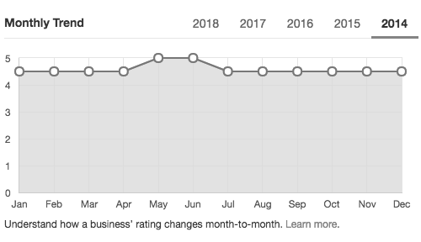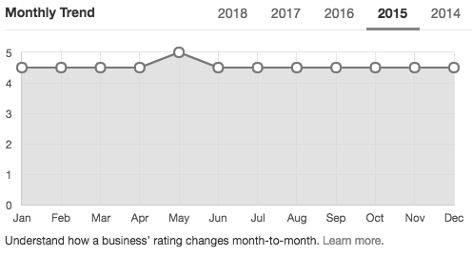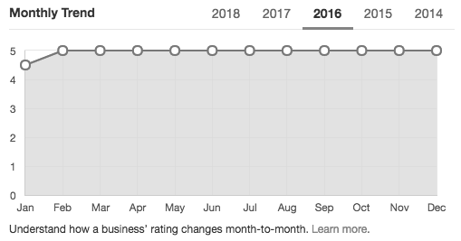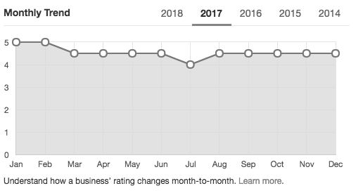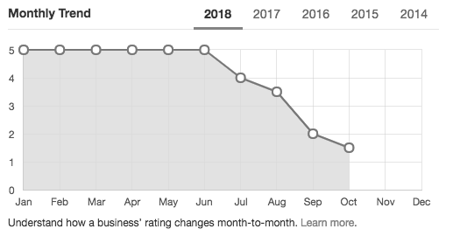

Source: “The Red Hen,” Yelp, 2018, accessed October 14, 2018, www.yelp.com/biz/the-red-hen-lexington-3?sort_by=date_desc. Used with permission.

Exhibit 2: YELP’S UNUSUAL ACTIVITY ALERTY

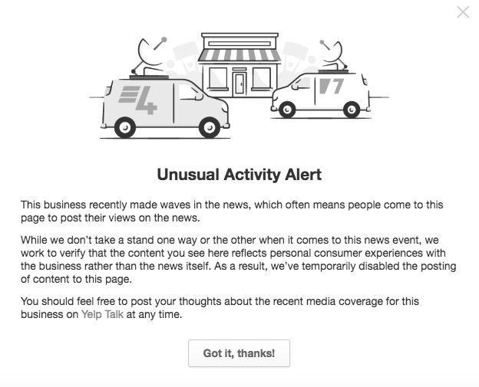

Source: “The Red Hen,” Yelp, 2018, accessed October 19, 2018, www.yelp.com/biz/the-red-hen-lexington-3?sort_by=date_desc. Used with permission.

Exhibit 3: PROTESTS AT THE RED HEN



Source: Powdered Wig Society, accessed July 30, 2019, https://powderedwigsociety.com/wp-content/uploads/2018/07/cluck.jpg. Used with permission.

ENDNOTES

1. This case has been written on the basis of published sources only. Consequently, the interpretation and perspectives presented in this case are not necessarily those of Stephanie Wilkinson, the Red Hen, or its employees.
2. Lesbian, gay, bisexual, transgender, two-spirit, queer, plus allies.
3. Avi Selk and Sarah Murray, “The Owner of the Red Hen Explains Why She Asked Sarah Huckabee Sanders to Leave,” *Washington Post*, June 25, 2018, accessed October 14, 2018, www.washingtonpost.com/news/local/wp/2018/06/23/why-a-small-town-restaurant-owner-asked-sarah-huckabee-sanders-to-leave-and-would-do-it-again/?noredirect=on&utm_term=.ea

   3c1da4bb01.
4. “About Brain, Child,” *Brain, Child Magazine* (website), accessed October 14, 2018, https://brainchildmag.com/about/.
5. “What We Do,” Main Street Lexington, accessed October 14, 2018, www.mainstreetlexington.org/who-we-are.html.
6. “About Us,” House Mountain Yarn Co., accessed October 14, 2018, www.housemountainyarnco.com/about-us/.
7. Kaitlyn Schallhorn, “Who Is Sarah Huckabee Sanders? How Her Family Prepped Her for the White House Briefing Room,” Fox News, May 12, 2017, accessed October 14, 2018, www.foxnews.com/politics/who-is-sarah-huckabee-sanders-how-her-family-prepped-her-for-the-white-house-briefing-room.
8. “About Us,” Second Street Strategies, accessed October 14, 2018, https://web.archive.org/web/20160913043747/http://ww

   w.secondstreetstrategies.com/about.
9. Tucker Higgins, “White House on Separating Migrant Children from Parents: ‘It’s Very Biblical to Enforce the Law,’” CNBC News,June 14, 2018, accessed October 14, 2018, www.cnbc.com/2018/06/14/white-house-on-separating-migrant-children-from-parents-its-very-biblical-to-enforce-the-law.html.
10. Aaron Blake, “Sarah Huckabee Sanders Lambastes Fake News—And Then Promotes a Journalist Accused of Deceptive Videos,” *Washington Post*, June 27, 2017, accessed October 14, 2018, www.washingtonpost.com/news/the-fix/wp/2017/06/27/sarah-huckabee-sanders-lambastes-fake-news-while-promoting-journalist-known-for-deceptive-videos/.
11. Paige Williams, “Sarah Huckabee Sanders, Trump’s Battering Ram,” *New Yorker*,September 24, 2018, accessed October 14, 2018, www.newyorker.com/magazine/2018/09/24/sarah-huckabee-sanders-trumps-battering-ram.
12. Morgan Gstalter, “Ex-White House Ethics Chief: Sarah Sanders Tweet Violates Ethics Laws,” *The Hill*, June 23, 2018, accessed October 19, 2018, https://thehill.com/homenews/administration/393816-ex-white-house-ethics-chief-sarah-sanders

    -tweet-on-restaurant-that.
13. “Use of Public Office for Private Gain,” title 5, §2635.703, *Code of Federal Regulations*, January 1, 2012, accessed November 21, 2018, www.gpo.gov/fdsys/granule/CFR-2012-title5-vol3/CFR-2012-title5-vol3-sec2635-702.
14. United States Census Bureau, “Annual Estimates of the Resident Population: April 1, 2010 to July 1, 2017,” American FactFinder, accessed July 29, 2019, https://factfinder.census.gov/bkmk/table/1.0/en/ACS/17_5YR/S1901/0100000US|05000

    00US51678.
15. United States Census Bureau, “Annual Estimates of the Resident Population: April 1, 2010 to July 1, 2018,” American FactFinder, 2019, accessed July 29, 2019, https://factfinder.census.gov/bkmk/table/1.0/en/PEP/2018/PEPANNRES/0100000

    US|0500000US51678.
16. United States Census Bureau, “Selected Economic Characteristics: 2013-2017 American Community Survey 5-Year Estimates,” American FactFinder, 2019, accessed July 29, 2019, https://factfinder.census.gov/bkmk/table/1.0/en/ACS/17_5Y

    R/DP03/0100000US|0500000US51678.
17. Ibid.
18. Ned Oliver, “Lexington Has Battled over Confederate Flag Issue for Years,” *Richmond Times-Dispatch*,June 25, 2015, accessed October 14, 2018, www.richmond.com/news/virginia/lexington-has-battled-over-confederate-flag-issue-for-years/article_7b6d1140-c791-56bb-bb1e-9c89b8a4ded4.html.
19. Ibid.
20. The Red Hen (website), accessed October 14, 2018, https://redhenlex.com/.
21. Patricia H., February 24, 2018, comment on Yelp, “The Red Hen,” accessed October 19, 2018, www.yelp.com/biz/the-red-hen-lexington-3.
22. James L., March 15, 2018, comment on Yelp, “The Red Hen,” accessed October 19, 2018, www.yelp.com/biz/the-red-hen-lexington-3.
23. “The Red Hen,” Yelp, 2018, accessed October 14, 2018, www.yelp.com/biz/the-red-hen-lexington-3?sort_by=date_desc.
24. Selk and Murray, op. cit.
25. Ibid.
26. Ibid.
27. Ibid.
28. Ibid.
29. Ibid.
30. Ibid.
31. Ibid.
32. Ibid.
33. Louise Matsakis, “The Red Hen and the Weaponization of Yelp,” *Wired Magazine*, June 26, 2018, accessed October 14, 2018,www.wired.com/story/red-hen-trump-and-weaponization-of-yelp/.
34. “The Red Hen,” Yelp,October 14, 2018, accessed October 14, 2018, www.yelp.com/biz/the-red-hen-lexington-3?sort_by=date_desc.
35. Matsakis, op. cit.
36. The Red Hen (@RedHenDC), “Good morning! @PressSec went to the unaffiliated @RedHenLex last night, not to our DC-based restaurant,” Twitter, June 23, 2018, 7:25 a.m., accessed October 14, 2018, https://twitter.com/RedHenDC/status/1010529

    207036891136; Jeff Lagerquist, “Ontario Eatery Targeted Online by Sarah Sanders Supporters,” CTV News, June 25, 2018, accessed October 14, 2018,www.ctvnews.ca/canada/ontario-eatery-targeted-online-by-sarah-sanders-supporters-1.3987505; Associated Press, “People Angry over Sanders Slam the Wrong Red Hen,” CTV News, June 24, 2018, accessed October 14, 2018, www.ctvnews.ca/world/people-angry-over-sanders-slam-the-wrong-red-hen-1.3987078.
37. Selk and Murray, op. cit.
38. Ibid.
39. Ibid.
40. Fred Hiatt and Molly Roberts, “Let the Trump Team Eat in Peace,” *Washington Post*,June 24, 2018, accessed October 14, 2018, www.washingtonpost.com/opinions/let-the-trump-team-eat-in-peace/2018/06/24/46882e16-779a-11e8-80be-6d32e18

    2a3bc_story.html?utm_term=.36c1bfdf4ba1.
41. Sarah Sanders (@PressSec), “Last night I was told by the owner of Red Hen in Lexington, VA to leave because I work for @POTUS and I politely left,” Twitter, June 23, 2018, 7:53 a.m., accessed October 14, 2018, https://twitter.com/PressSec/sta

    tus/1010536237457924096.
42. Ben Klayman, “White House Press Secretary Responds to Controversy over Restaurant Ouster,” Reuters, June 25, 2018, accessed October 19, 2018, www.reuters.com/article/us-usa-trump-sanders/white-house-press-secretary-responds-to-controversy-over-restaurant-ouster-idUSKBN1JL32O.
43. Selk and Murray, op. cit.
44. Rachel Langlitz, “Trump Supporters Gather outside the Red Hen to Protest Restaurant,” abc13 News, June 26, 2018, accessed October 14, 2018, http://wset.com/news/local/trump-supporters-gather-outside-the-red-hen-to-protest-restaurant.
45. Ibid.
46. Lia Eustachewich, “Red Hen Owner Steps Down from Business Group over Sarah Sanders Flap,” *New York Post*, June 27, 2018, accessed October 14, 2018, https://nypost.com/2018/06/27/red-hen-owner-steps-down-from-business-group-over-sarah-sanders-flap/.
47. Whitney Filloon, “Red Hen Restaurant Owner Doxxed after Kicking Out White House Press Secretary,” Eater, June 25, 2018, accessed October 19, 2018, www.eater.com/2018/6/25/17502078/red-hen-doxxing-sarah-huckabee-sanders.
48. Inconvenient Truth, June 23, 2018, comment on Jonathan Turley, “No Breakfast for You: Red Hen Kicks Out Sarah Sanders and Her Family [Updated],” *Jonathan Turley* (blog), June 23, 2018, accessed October 14, 2018, https://jonathanturley.org/2018/06/23/no-breakfast-for-you-red-hen-kicks-out-sarah-sanders-and-her-family/comment-page-3/.
49. Eustachewich, op. cit.