|  |  |
| --- | --- |
|  |  |

**9B19M096**

PROFICO: THE WAY FORWARD

Narine Bolghourjian wrote this case under the supervision of Dr. Marina Apaydin solely to provide material for class discussion. The authors do not intend to illustrate either effective or ineffective handling of a managerial situation. The authors may have disguised certain names and other identifying information to protect confidentiality.

This publication may not be transmitted, photocopied, digitized, or otherwise reproduced in any form or by any means without the permission of the copyright holder. Reproduction of this material is not covered under authorization by any reproduction rights organization. To order copies or request permission to reproduce materials, contact Ivey Publishing, Ivey Business School, Western University, London, Ontario, Canada, N6G 0N1; (t) 519.661.3208; (e) cases@ivey.ca; www.iveycases.com.

Copyright © 2019, Ivey Business School Foundation Version: 2019-08-28

On Saturday, June 3, 2017, Henry Hajj, the general manager of Profico Trading and Contracting Company WLL (Profico),[1] an aluminum and glazing contracting company in Beirut, Lebanon, was attending his son’s graduation. Alex Hajj, Henry’s eldest son, was graduating from the American University of Beirut, but Henry’s mind had drifted from the occasion to Profico’s prospects for success with a US$70,000[2] investment opportunity to acquire a second-hand production line for processing glazing panels.

Profico, established in 1988, assembled and installed aluminum and glazing doors and windows and aluminum composite panels for local construction projects in Lebanon. Profico’s revenues had increased over the years, reaching close to $1 million less than five years earlier. However, over the most recent four years, revenues had decreased as a result of the regional political turmoil that was affecting Lebanon’s construction industry. The company’s revenues were now well below $500,000. As a result of the downturn, Profico’s employees had begun to leave, choosing bigger competitors for safer future prospects.

Alex was about to receive his bachelor’s degree in civil and environmental engineering, but he was already actively involved in the family business. Both he and his father had deliberated when presented with the opportunity to invest in the new production line; it was an opportunity to test their prospects in manufacturing. They knew that to reverse the company’s trend of decreasing revenues in the prevailing political and economic conditions, they needed to manage the company’s resources and strategically decide in which direction to take the company.

As he waited for his son to walk on stage and receive his diploma, Henry’s mind rolled through the challenge. Was the investment in a production line worthwhile, and if so, how they might finance it? And what could they do to improve on the people and resource management front to retain key employees and clients?

OVERVIEW OF LEBANON[3]

The Lebanese Republic was a mountainous country of 10,452 square kilometres. Located on the eastern shore of the Mediterranean Sea, Lebanon was bordered by Syria on the north and east, and by Israel on the south.

Politics

After its independence from the French mandate in 1943, Lebanon went through three prosperous decades up until 1975 when a civil war broke in the country, greatly damaging the economic infrastructure. The war lasted until the early 1990s when the Taef Agreement was signed to proportionally distribute political and ruling power among the 18 officially recognized sects forming the country.[4] The political situation was then relatively stable internally, despite the presence of Syrian troops across the country and Israel’s occupation of the south. However, Lebanon entered into another period of unrest in 2005 with the assassination of former Lebanese prime minister Rafic Hariri and the subsequent multiple assassinations of several other political figures, followed by the 33-day war with the neighbouring state of Israel in July 2016, which greatly damaged the country’s infrastructure.[5]

In addition to the internal political turmoil and the war in 2006, Lebanon was greatly affected by the Syrian conflict, which started in 2011 and intensified in 2014 with the intervention of several large countries and coalitions. Compounding these challenges, Lebanon suffered a two-year spell, from 2014 to 2016, without a president. Even after the election of Michel Aoun as president in October 2016, and despite the formation of a new government cabinet in December 2016 headed by the son of the late prime minister Rafic Hariri, the political situation in Lebanon continued in turmoil due to the ongoing Syrian conflict and its impact over the entire region.

Demographics

In 2017, Lebanon had a population of about 6.2 million with a growth rate of 1 per cent. (No official census had been carried out in Lebanon since 1932.) The population included 95 per cent Arabs, 4 per cent Armenians, and 1 per cent other ethnic groups. They spoke mainly four languages: Arabic (the country’s official language), French, English, and Armenian. In addition, there were tourists and refugees, and the inflow of the latter had been considerable since the onset of the Syrian crisis.

About 45 per cent of the population was between the ages of 25 and 54. The majority of the people lived on or near the Mediterranean coast on the western side of the country, most living in the capital, Beirut, and its suburbs. The eastern side of the country behind the mountain ranges was mostly populated by an agricultural population residing in the Beqaa (or Bekaa) Valley.

The majority of the population, about 94 per cent, were literate. Education expenditures represented approximately 2.6 per cent of the country’s gross domestic product (GDP).

Economics

In 2017, Lebanon had a free-market economy with no governmental restrictions on foreign investment. The economy was mostly service-oriented with tourism and banking forming the main sectors; real estate also represented a major sector contributing to GDP, especially after the 2006 war and the subsequent reconstruction. However, the economy suffered from several issues, including outdated legislation, high taxes and tariffs, weak intellectual property rights, and corruption, among other problems. The country also had a huge debt burden, which had mainly accumulated as a result of the spending on reforms following the civil war of 1975–1990. The debt put the country’s debt-to-GDP ratio at the third highest in the world.

The country’s GDP in 2017 was low, at about $50 billion, distributed into the services, industry, and agriculture sectors at 73.3 per cent, 21 per cent, and 5.7 per cent respectively. Moreover, due to the spillover of Syrian refugees, the GDP growth rate, previously averaged at 8 per cent, began decreasing in 2011 to 1–2 per cent and remained in that range in 2017. This situation was further worsened by the government’s need to direct the majority of its spending to service the country’s debt, pay the salaries of government workers, and sustain the electricity sector, which left limited spending capacity on infrastructure improvements such as electricity, water, and transportation.[6]

Lebanon’s credit score was rated in 2016 as highly speculative by Moody’s, Fitch, and S&P, with Moody’s giving a negative rating, while the other two gave a stable rating.[7]

THE ALUMINUM INDUSTRY

Aluminum was a strong, lightweight, easily worked and formed, and corrosion-resistant material, which could be repeatedly recycled, thus ensuring environmental sustainability. In addition, aluminum was highly suited to the increasingly mobile and technologically sophisticated world. Primary aluminum was extracted by electrolysis from aluminum oxide, also known as alumina, which was a white powder obtained by purifying aluminum ore, also known as bauxite.

Worldwide

During the final decades of the 20th century, aluminum production trends shifted considerably. In 1972, almost 60 per cent of primary aluminum production had been in the United States (32 per cent), the Soviet Union (16 per cent), and Japan (9 per cent). But four decades later, in 2010, the production of primary aluminum was mainly in China (39 per cent), Russia (9 per cent), Canada (7 per cent), and the Middle East (6 per cent). The shift was mainly caused by the cost of energy in different parts of the world.[8]

Aluminum was used in several industries, including transportation, engineering, building and construction, and packaging. Despite the increasing importance of aluminum in the transportation industry, aluminum continued to be highly valued in the building and construction industry where it had been mainly used with glazing for roofing, facades, curtain walls, and windows and doors, with an average life span of 50 years or more. Moreover, with the emphasis on sustainable measures, aluminum products had become increasingly mainstream in the building and construction industry.[9]

In 2015, the global door and window market was estimated at $82 billion and was projected to reach $137 billion in 2024 with a compound annual growth rate (CAGR) of 5.6 per cent over eight years.[10] In comparison, the global aluminum door and window market in 2016 was expected to grow to $72.1 billion in 2021 with a CAGR of 5.1 per cent over five years, mainly as a result of the expected growth of the residential and commercial construction industry.[11]

Lebanon

The Construction Industry[12]

The aluminum and glazing sector in Lebanon had always been an important contributor to the building and construction (real estate) industry, which in turn had always been a major contributor (approximately 15 per cent) to the country’s GDP.

Between 2010 and 2016, activity in the real estate market in Lebanon slowed due to the region’s uncertain political and economic situation, leading to decreasing domestic and foreign demand for real estate. During this time, the volume of real estate transactions dropped from 82,984 to 64,248, despite the overall value of these transactions remaining fairly stable, from $8.8 billion in 2011 to $8.4 billion in 2016. Issued construction permits indicated that supply had also dropped, from 16,645 thousand square metres of permitted construction in 2011 to 12,200 thousand square metres in 2016.

This slow activity in the construction industry had its impact on all sectors of the industry, including the aluminum and glazing sector. It was foreseen that, in the short term, the real estate market would continue to be slow, waiting for a positive shock to be instigated by political stability and economic recovery.

Value Chain and Major Players[13]

The aluminum and glazing value chain comprised raw glazing producers, importers and suppliers of accessories, aluminum extrusion companies, and glass manufacturers and processors, in addition to contractors, who were assemblers and installers with engineering input needed for the very large (mega) projects. These different players imported raw materials, extracted aluminum profiles, manufactured and cut to size glass panels of different specifications, and assembled doors, windows, and other building parts for installation on construction projects (see Exhibit 1).

The major extrusion companies operated either in Lebanon or in the surrounding region. According to Profico, although Lebanese companies provided better quality products, they also had slightly higher prices. SIDEM (Société pour l’industrie des Métaux SAL[14]) was the major aluminum extractor in the country.

Accessories were mainly supplied from Europe or China, and none of the glass manufacturers that produced raw glass were located in Lebanon. However, glass manufacturers in Lebanon could cut glazing panels to size and make these panels into tempered[15] or double-glazed panels.[16] They supplied aluminum and glazing contractors with the glazing panels to be used in assembling the windows, doors, and façade or roof elements that the contractors installed on construction projects. Tempo Glass SAL was one of the major players for glass manufacturing; they supplied processed glass panels to the majority of the contracting companies. Very few of the aluminum and glazing contractors processed glazing panels for tempering or double glazing in-house.

The aluminum and glazing contracting segment in Lebanon was worth about $100 million in 2017. The industry was dominated by a few major players, including Glassline Industries Company (20 per cent market share), AluSteel SAL (20 per cent market share), and Alumco LLC (15 per cent market share), which controlled the majority of mega projects in the country and the region on a design-build basis. In addition to the three dominating players in the segment, Algeco Ltc. (Aluminum Glazing Engineering & Contracting Company Sarl), Bifem Paralu Industries, Profitech Aluminium Hmeidani, and Profico also had a share of the market by being more involved in medium-sized projects.

Barriers to Entry

Because of the payment terms applied in construction projects, contractors entering the aluminum and glazing contracting industry required a high upfront capital investment and intricate control of cash flow, especially when targeting mega construction projects. To be awarded projects, contractors were required to exhibit financial health by providing bank guarantees ensuring their financial position. The contractors were usually paid with a long lead time, often reaching or exceeding 60 days from the date of completing the works or a part of the works.

Returns, however, were high, with profits reaching a margin of 25 per cent for mega projects that required extensive material procurement and engineering. In some instances, margins could be even higher, depending on where the materials were sourced. Products were sometimes difficult to differentiate as having been produced by the original manufacturer, so some contractors sourced products from alternative manufacturers at lower prices, which highly magnified the contractors’ profit margins.

Entering the aluminum extraction or glass manufacturing segments was also capital-intensive. Capital was required upfront to purchase the necessary equipment for the processes involved, and investments were needed to acquire employees with the right professional talents and skills to carry out the process. This segment of the industry, however, was less challenging in terms of cash flow management because aluminum extraction and glass manufacturing were more of a trading and supply activity with a much shorter lead time for payment as of the date of delivery.

PROFICO

History and Developments to Date

Profico was established in 1988 by Henry Hajj, an electrical engineer who then had just a few years of working experience, and John Khoury, a technician with vast experience in the aluminum industry. The two partnered and established a small contracting company operating in Choueifat in the southern suburbs of the Lebanese capital, Beirut. They pursued and were awarded contracting jobs to supply aluminum doors and windows for small residential projects.

In 1997, after nine years of successful operations, one of the company’s major clients went bankrupt, which prompted Khoury to step out of the company, leaving Henry in a difficult situation. However, Henry refused to give up; he slowly restored momentum, leading the company to its golden decade between 2004 and 2014. During that time, the company developed its production abilities, increased its size to approximately 50 employees, earned higher revenues, reaching the threshold of $1 million, and expanded its operations to carry out aluminum and glazing contracting projects in Lebanon, the Democratic Republic of the Congo, and Qatar. A majority of Profico’s jobs in Lebanon during this period were for educational institutions and residential projects as part of the reconstruction of the southern suburbs of Beirut, which had been destroyed in the war of July 2006 (see Exhibit 2).

Intensification of the Syrian crisis, beginning in 2011, and its impact on the Lebanese real estate industry, beginning in 2014, caused a significant downturn in the Lebanese construction industry. Profico and many other companies operating in Lebanon experienced a significant decrease in the number of projects awarded between 2013 and 2017. This situation greatly reduced revenues, which were also impacted by late payments and, in certain situations, by payment defaults during the same four-year period. Moreover, a considerable number of Profico’s employees left the company for larger competitor companies, afraid that if they stayed, they would lose their jobs, as awarded projects reduced in number and construction value.

Corporate Organization, Operations, and Personnel

At the beginning of 2017, the company of 15 employees was managed by key personnel who took care of the administrative and technical aspects of the business. Henry was the general manager and had been the main decision-maker for all business matters since taking sole ownership of the company. Alex was his father’s administrative assistant and associate, entrusted with updating the company’s administrative practices.

The company’s operations were split into administrative and technical operations (see Exhibit 3). However, the company lacked a clear and well-devised career path and compensation plan for its employees.

In administration, accounting and financial reporting were done by an accountant under the direct supervision of Alex, as was the case in most Lebanese family businesses that were run and micromanaged by the family general manager.

In technical operations, the company had teams inside the factory doing assembling (i.e., manufacturing) and outside the factory doing installation on construction sites (see Exhibit 4). The manufacturing team inside the factory consisted of six employees who carried out the different assembling activities as assigned by the technical manager. That team reported directly to the technical manager, who was also responsible for quality control inside the factory. The technical manager reported directly to the general manager.

The installation team was structured differently. Installation and execution jobs were carried out by two construction teams, each headed by a construction manager. Both construction managers reported to the technical manager, who was responsible for quality control on construction sites. The construction managers were also responsible for following up with clients and handling sales activities for repeat clients—a few important ones of which were lost in 2014 with the drop in new projects and the loss of some key company personnel.

As of 2017, Henry and Alex took care of all sales and business development. They were, as a result, heavily burdened with the increasing workload, so they hired a new sales representative who would directly report to Alex.

Cost Structure and Financial Position

Profico priced its projects on a cost-plus basis. Its revenues were broken down as 65 per cent for cost of goods sold, 12 per cent for labour costs, 13 per cent for overheads and other expenses, and, finally, 10 per cent as a fixed margin for profits. Revenues were distributed among glazing (37 per cent), aluminum windows and doors (33 per cent), and aluminum composite panels (30 per cent).

Revenues had been ever-decreasing over the previous four years, dropping from $730,000 in 2012 to $380,000 in 2016; thus, profit had also been decreasing by the year despite a constant 10 per cent margin (see Exhibit 5). Moreover, the company had a debt-to-equity ratio of 1:3, which needed to be considered in any future investment decisions.

the 2017 SITUATION AND FUTURE PROSPECTS

Henry and Alex needed to decide by June 30, 2017, whether they would purchase the second-hand production line for double glazing panels in their factory. The production line would allow the company to backward integrate in the value chain by entering the manufacturing side.

The offer was financially attractive because it involved a second-hand but high-capacity production line at less than one-quarter of the market price: $70,000 instead of an average of $300,000 for a new production line of a lower capacity. This production line would also provide Profico with the possibility of supplying double glazed panels to its contracting competitors who did not own such a production line. That option could lead to incremental sales of approximately 40–50 per cent of current sales, thereby minimizing risk and diversifying the sources of income, while, if managed properly, also improving the company’s overall cash flow and accounts payables status.

However, Henry and Alex were cautious, uncertain how to move forward with this option and how much to rely on manufacturing as opposed to Profico’s core business of contracting. Also, given the company’s prevailing financial situation, Henry and Alex needed to decide how to finance such an investment, while enduring slow movements in the construction industry and in the country in general. They were unsure about the company’s prospects for generating sufficient cash flow and profits to finance growth in the near future and how to best manage Profico’s internal affairs to retain key personnel and key clients in the absence of a constant stream of new projects.

Exhibit 1: ALUMINUM AND GLAZING SECTOR VALUE CHAIN IN LEBANON

Note: Société pour l’industrie des Métaux SAL was French for Society for the Metal Industry SAL; SAL = Société anonyme libanaise, which translated as “Lebanese anonymous company” and was the French term for a joint stock company.

Source: Prepared by the case authors based on company information.

Exhibit 2: SAMPLE PROJECTS (ALUMINUM and GLAZING WORKS) BY PROFICO

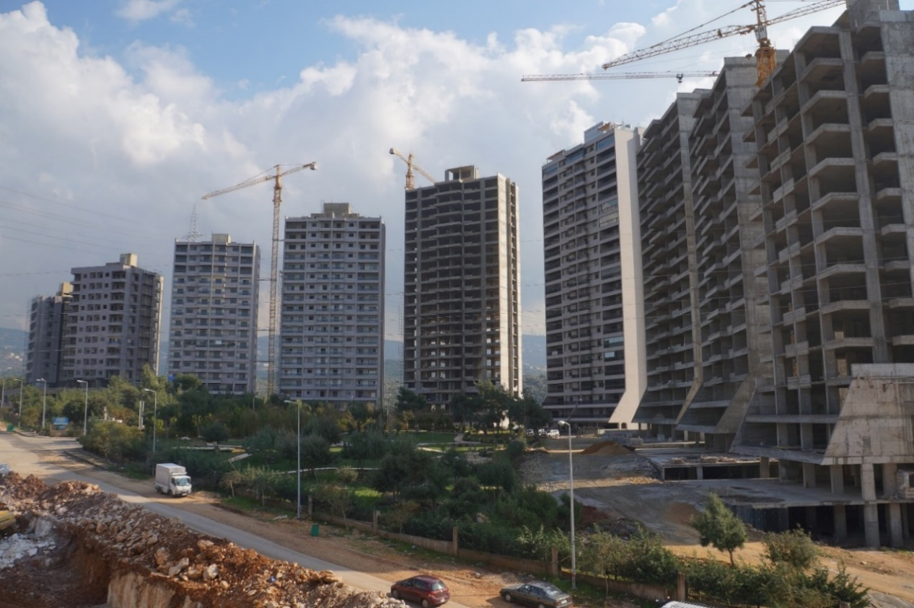

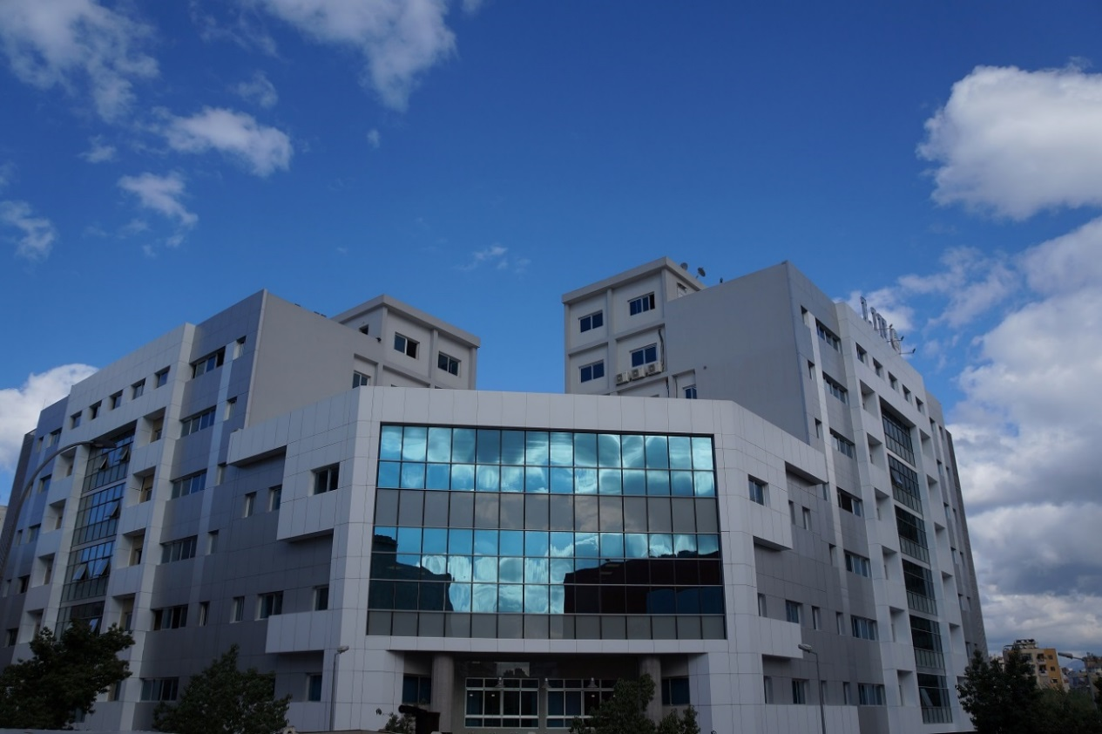

Source: Company files.

Exhibit 3: PROFICO ORGANIZATION CHART

Note: Eng. = engineer

Source: Company files.

Exhibit 4: PROFICO’s MANUFACTURING AND INSTALLATION PROCESS

Source: Company files.

Exhibit 5: PROFICO REVENUES, 2012–2016 (IN US$ thousands)

Note: Data have been disguised to protect confidentiality.

Source: Company files.

1. WLL = with limited liability. Unlike a limited liability company (LLC), a WLL company could also be a sole proprietorship or partnership.
2. All currency amounts are in US$.
3. “Middle East: Lebanon,” CIA World Factbook, accessed November 11, 2017, www.cia.gov/library/publications/the-world-factbook/geos/print_le.html; “About Lebanon,” United Nations Development Programme, Lebanon, accessed November 11, 2017, www.lb.undp.org.
4. The Taef (or Taif) Agreement, formally known as the National Accord Document or National Reconciliation Accord, was named after Ta’if, Saudi Arabia, where the accord was negotiated. *The National Accord Document—The Taef Agreement*, 1989, accessed January 16, 2019, www.presidency.gov.lb/Arabic/LebaneseSystem/Documents/TaefAgreementEn.pdf.
5. “2006: Lebanon War,” BBC News, May 6, 2008, accessed January 16, 2019, http://news.bbc.co.uk/2/hi/middle_east/7381389.stm.
6. “Middle East: Lebanon,” CIA World Factbook, accessed November 11, 2017, www.cia.gov/library/publications/the-world-factbook/geos/print_le.html.
7. “Rating: Lebanon Credit Rating,” Country Economy, accessed November 19, 2017, https://countryeconomy.com/ratings/lebanon.
8. Aluminum Association, *Aluminum Industry Vision: Sustainable Solutions* (Washington, DC, November 2001), accessed November 19, 2017, www.energy.gov/sites/prod/files/2013/11/f4/alum_vision.pdf.
9. Ibid.
10. Dhananjay Punekar, “Global Window and Door Market Size to Surpass USD 137 Billion by 2024: Asia Pacific to Lead the Regional Landscape,” Glass on Web, February 7, 2017, accessed November 11, 2017, www.glassonweb.com/news/global-window-and-door-market-size-surpass-usd-137-billion-2024-asia-pacific-lead-regional.
11. “Research and Markets, Growth Opportunities in the Global Aluminum Door and Window Market 2016-2021: Trends, Forecast, and Opportunity Analysis,” Research and Markets, December 2016, accessed January 17, 2018, www.researchandmarkets.com/reports/4032194/growth-opportunities-in-the-global-aluminum-door.
12. Fransabank, *Lebanon’s Real Estate Sector: Current Status and Future Trend*, ed. Imad Shehab (Beirut: Fransabank, March 2017), accessed January 16, 2019, www.fransabank.com/English/MediaCenter/PressReleases/Documents/Lebanon%20

    Real%20Estate%20Sector%20Study%20March%202017.pdf.
13. This section is based on the case author’s experience within the construction industry and information provided by the company.
14. Société pour l’industrie des Métaux SAL was French for Society for the Metal Industry SAL; SAL = Société anonyme libanaise, which translated as “Lebanese anonymous company” and was the French term for a joint stock company.
15. Tempered glass was glass that had been processed for safety using thermal and chemical treatments to increase its strength and cause it to crumble into small granular pieces rather than shards when broken.
16. Double-glazed panels were glazing panels that had been pressed together for acoustic and temperature insulation.