|  |  |
| --- | --- |
|  | **UC-hashayne-black** |

**9B19M100**

SPRUCELAND PROPERTIES: SOCIAL ENTERPRISE THROUGH REAL ESTATE DEVELOPMENT

Pernille Goodbrand and Thomas Holloway wrote this case solely to provide material for class discussion. The authors do not intend to illustrate either effective or ineffective handling of a managerial situation. The authors may have disguised certain names and other identifying information to protect confidentiality.

*This publication may not be transmitted, photocopied, digitized or otherwise reproduced in any form or by any means without the permission of the copyright holder. Reproduction of this material is not covered under authorization by any reproduction rights organization. To order copies or request permission to reproduce materials, contact Ivey Publishing, Ivey Business School, Western University, London, Ontario, Canada, N6G 0N1; (t) 519.661.3208; (e)* [*cases@ivey.ca*](mailto:cases@ivey.ca)*;* [*www.iveycases.com*](http://www.iveycases.com)*.*

Copyright © 2019, Ivey Business School Foundation Version: 2019-10-16

It was February 2016 and the board of SpruceLand Properties Inc. (SpruceLand)[1] faced a difficult decision. Since SpruceLand’s inception in 1969 in the northern Alberta town of Slave Lake, the company had a two-fold purpose: to earn a financial return and to engage in socially beneficial projects. SpruceLand was a community development company owned by individual members of the community. It had started through the sale of shares at CA$1[2] per share plus small investments from oil and gas companies entering the northern Alberta region as Alberta’s energy sector was starting to take off.

A critical need for infrastructure and real estate development in the region, combined with the opportunities associated with the increasing presence of oil and gas companies, meant that SpruceLand had grown steadily from the 1970s through to 2009. The expansion was impressive, but the company had not been structured to grow as large as it had become. Shares would occasionally trade hands privately, mostly between existing shareholders; by 2016, shares were trading at about $22 per share.[3] This price was approximately half the net value per share of SpruceLand’s properties themselves, minus debt. The oil- and gas-fuelled Alberta economy had started to collapse in 2014,[4] and now the board needed to make a difficult decision: Should it continue to operate as a profitable company with shares that were undervalued, restructure, or dissolve?

NORTHERN ALBERTA REGION

The northern Alberta region (the North) comprised 60 per cent of Alberta’s land area (see Exhibit 1), but in 2011, it was home to less than 11 per cent of Alberta’s population. The region was sparsely populated with a population density of just 0.97 persons per square kilometre, compared with 5.7 persons per square kilometrefor the rest of Alberta.[5] With vast, remote lands, and awe-inspiring nature, the North was often considered a “last frontier” that held immense opportunity for those who could stand the challenging weather and relative solitude.

The 2011 National Household Survey revealed that the North had a relatively young population compared with the rest of Alberta, and a 5.6 per cent unemployment rate with approximately 15 per cent of the population working in “mining, quarrying, and oil and gas extraction.” The survey also showed educational attainment levels largely similar to the rest of Alberta with two notable exceptions: the region had a higher proportion of both people with apprentice and trade credentials and people who lacked educational credentials. The region also had huge disparities with respect to where these two distinct groups were located: those people with the highest educational attainment levels tended to reside close to oil extraction activities.[6]

The region’s economic activity had steadily increased since the 1960s due to the discovery and subsequent extraction of oil and gas, most notably in the Alberta oil sands. In 2011, workers in the Wood Buffalo region (Fort McMurray and area) earned nearly 90 per cent more than the median income in Alberta, while other areas in the region generally fell below the median income for the province. [7]

The region was home to a relatively large Indigenous population, comprising 18.4 per cent of the region’s total population, compared with comprising 7.4 per cent of the overall population of Alberta. Almost 40 per cent of the population in the town of Slave Lake was Indigenous. The region was home to 28 First Nations and eight Metis settlements; however, more than half of the Indigenous population lived off reserves or settlements.[8] The former chief of the Sawridge First Nation, Walter Twinn, was one of the founding members of SpruceLand and had strongly advocated for more economic opportunities in the area.

ECONOMIC DEVELOPMENT OF NORTHERN ALBERTA

Although the energy industry[9] had contributed to the growth and development of the North, the northern and southern parts of Alberta had historically experienced and continued to experience similarity in terms of people’s standard of living, opportunities for training and education, and wages. The cost of living, however, was much higher in the North. In 2015, the North was still, as a 1981 report suggested, a resource of wealth for the South, especially Calgary, where most head offices for the energy industry and supporting services were located.[10]

The business of resource extraction had faced considerable booms and busts, which had an immense impact on the North. Obtaining steady economic growth had been an ongoing concern. In addition to economic growth, considerations for the future included social, educational, and cultural wealth. Commercial success did not guarantee social success, and vice versa. Steady growth needed to be “sustainable social and economic development in the region in order to realize economic prosperity and a healthy society.”[11] It had always been essential to find a way to ensure maximum positive social impact for residents of the area.

When SpruceLand was first founded, government reports described the North as “underdeveloped” (compared with the rest of Alberta), and the Alberta government had committed to community development efforts.[12] The government recognized that the North had many strengths in terms of resources and opportunities, but inherent in these strengths were also potential weaknesses: high costs, the need for infrastructure, and a small market. Transportation was listed as both a strength and a weakness. The government, being the primary landowner in the North, recommended interventions in terms of four development tools: (1) technical support, (2) research and development, (3) infrastructure, and (4) financial incentives. The report, however, also came with the caveat that people needed to express “real needs in a coordinative fashion while at the same time not making endless demands on the public purse.”[13]

BACKGROUND of SPRUCELAND properties Inc.

The town of Slave Lake was located in north-central Alberta, roughly 260 kilometres north of Alberta’s provincial capital, Edmonton. When SpruceLand was founded, its former president and chief executive officer (CEO), Preston Manning, recalled Slave Lake as being in “rough shape.” The town did not have paved streets, had virtually no rental accommodation or commercial space, and the population was in decline. Prior to Manning’s involvement, and with the encouragement of a local civil servant, Neil Gilliat, five Slave Lake community members and local entrepreneurs—William Thomas, Melvin Zachary, Gordon Cook, Joseph Mouallem, and Walter Twinn—had incorporated Slave Lake Developments Ltd., a “community development company,” with a two-fold purpose. They established that the company was to “earn profits for shareholders through the development of the physical resources of the Lesser Slave Lake region of Alberta,” and it was “to overcome the problems of social and economic underdevelopment in the region through the exercise of private enterprise and initiative,” with the goal of attracting further investment and opportunities to engage in profitable business partnerships.[14]

Shortly after incorporation, the founders approached Manning and his father, Ernest Manning, to ask for their assistance in developing the initial projects. The founders argued that Slave Lake had potential to become an oil field service town, but a lot of work was needed to make that happen. The founders did not want to stand idly while the government awarded contracts to outsiders or while large companies moved in. Instead, the founders wanted the community to actively participate and create opportunities for development. The Mannings agreed to be involved.

Manning believed that the key to achieving SpruceLand’s dual purpose was to obtain critical infrastructure and housing for Slave Lake and more economic opportunities for area residents. As a staunch conservative, he argued that the solution was to gain access to the “tools of wealth creation” and, specifically, access to markets. With the aim of providing shareholder opportunities to as many community members as possible, Manning suggested reincorporating the company as a public, unlisted company, which would enable both a larger number of local shareholders and the possibility of pursuing joint ventures with incoming oil companies, thereby ultimately creating wealth for stakeholders in a way that government transfers never could. In 1970, Manning became SpruceLand’s inaugural president and CEO.

A SOCIAL ENTERPRISE

SpruceLand was a rare example of an unlisted public corporation. It was “public” because the corporation was registered (with the Alberta Securities Commission) as a reporting issuer. This registration required the regular public dissemination of the company’s annual and interim financial reports, management discussion and analysis, and several other reports.[15] Early on, the company requested relief from some regulatory costs and received an exemption to file semi-annually instead of quarterly. The company was “unlisted” because the shares did not trade on a stock exchange such as the Toronto Stock Exchange (TSX) or the TSX Venture Exchange. An exchange listing required additional disclosures and costs, and requirements related to governance, size, and liquidity. SpruceLand succeeded in attracting more than 300 community-based shareholders, which required it to choose a public structure.[16]

SpruceLand championed a “community focus,” which meant seeking local solutions to local problems rather than turning to external governments and companies. It was not a non-profit; instead, as an early example of “a social enterprise,” SpruceLand focused on both social objectives and modest returns. Manning argued that the best way to involve the community was to give people direct access to participate in the venture. Accordingly, 65,000 shares were sold at $1 per share, and no shareholder was permitted to own more than 10 per cent of all shares available. It took 18 months to sell all the shares because few community members had been exposed to investment opportunities, so many assumed it was a scam. Manning and his successors, therefore, placed a great emphasis on establishing rapport and trust with the local communities.

The advantage of a social enterprise went beyond giving people access to investment opportunities. The investors were not speculators, and the local focus of the company made it possible to invest in their own community. Other investors had overlooked the region because capital was difficult to access for projects; returns were not as high as most developers would want. In other words, investors required a higher rate of return before investing illiquid assets in projects located in uncertain locations.

In 1970, the available housing in the town of Slave Lake was largely either temporary or substandard. The Alberta government had labelled housing as a critical need for the region.[17] Slave Lake needed housing for both its current population and to attract new skilled workers to the oil fields. To meet this need, SpruceLand’s first venture in Slave Lake was a 90-unit apartment and townhouse rental complex, called Woodland Place. The mandate of the organization matched the project: to provide much-needed housing and to generate returns.

The project cost $1 million and was funded partially with shareholder dollars combined with joint venture partners from the oil and gas industry: Imperial Oil Limited, Exxon Mobil Corporation, and Rainbow Pipe Line Company Limited. This initial capital enabled SpruceLand to take out a mortgage with the Canada Mortgage and Housing Corporation. Woodland Place brought the much-needed workforce housing to the town, and the project was an instant success. Within three years, SpruceLand bought out its joint venture partners.

GEOGRAPHICal EXPANSION AND REAL ESTATE PORTFOLIO GROWTH

In the years that followed, SpruceLand turned a relatively small initial investment into a multimillion-dollar real estate portfolio—but not without difficulty. Despite the success of Woodland Place, Manning still needed to approach 35 mortgage companies in an attempt to secure a mortgage for SpruceLand’s first commercial project in 1972: a 20,000 square foot office building called Slave Lake Place. The mortgage lender, which was also the area’s premier insurance company, agreed to lend the funds only after Manning secured the Government of Alberta as the primary tenant. The Government would lease the space for offices and services rather than build its own facility, thereby providing SpruceLand with market access that was otherwise out of reach. Three other projects followed: an office building, an apartment building, and a townhouse development, all completed in the 1980s. SpruceLand started paying common share dividends in 1987.

Manning resigned in 1987 to pursue a career in politics, and Doug Victoor took over the reins of SpruceLand as president and CEO. Even through difficult economic times in the 1980s, where prime rates were at more than 20 per cent, Manning had paved the way for success with good initial investments, collaborations with solid industry partners, and a low debt to equity ratio. He had created a proven track record for SpruceLand, which allowed Victoor to sell additional shares, obtain financing for new projects, and grow joint venture partnerships, many of which were ongoing.

With the help of trusted joint venture partners, such as general contractors, engineers, and regulatory authorities, Victoor skilfully and rapidly expanded SpruceLand with more residential and commercial/retail offerings within the Slave Lake region and beyond to other towns in the area. He also expanded outside the region entirely. SpruceLand bought apartment buildings in the towns of Athabasca, St. Paul, and Lac La Biche; several industrial properties in Nisku and Edmonton; and a mobile home park in Leduc. SpruceLand also invested in commercial space, which it leased to retailers moving into the northern market. This expansion necessitated the name change from Slave Lake Developments Ltd. to SpruceLand Properties Inc.; Victoor realized that gaining shareholders’ trust in these new communities meant that the name of the company needed to reflect the broader regional focus. Victoor faced some backlash from shareholders who wanted the community development company to stay focused on the community of Slave Lake, but he argued that the economic reality of working with increasingly bigger lenders necessitated diversification. The dividends during this time showed that Spruceland was successful.

When Victoor’s health started to decline in 2005, Steve Cribb was brought in as a consultant, and in 2006, he became president and CEO. Cribb took over a growing company and capitalized on lower interest rates by refinancing properties, selling older properties, and buying newer ones. Where Victoor had first faced some resistance in expanding outside of Slave Lake and the region, the economic case for expansion now resonated with shareholders, and Cribb was able to continue in this direction.

Cribb led SpruceLand through a period of intense growth by constantly evaluating the company’s diversification. He described the company’s growth as a natural evolution helped along by the improvement of processes and investments. The regulatory system had also changed since SpruceLand’s inception and required an increasing degree of sophistication in business dealings. Shareholders were receiving annual dividends, but if they wanted to sell their shares, they needed to do so privately and were unable to achieve a price that reflected the value of the underlying assets. In 2015, SpruceLand had $120 million in assets (see Exhibit 2), which was likely too small for a public listing and too big for the original community-ownership model. In the meantime,

while the Board was considering current and developing market conditions and other related factors, in September 2014 the Corporation received an unsolicited expression of interest from a western-based publicly traded entity (the “Initial Offeror”) regarding the sale of all or substantially all of the Corporation’s assets. The Board determined that such an opportunity could be in the best interests of the Corporation and its Shareholders and, consequently, that it should consider the option.[18]

In the first quarter of 2015, oil prices had fallen from more than US$100 a barrel to less than US$50 (see Exhibit 3); however, SpruceLand was conservatively positioned. The board knew that the extremely good conditions that SpruceLand had enjoyed for many years would not continue forever, so it had been pursuing a strategic position that involved building up a significant (for the size of SpruceLand) cash reserve (see Exhibit 2). The cash reserve gave SpruceLand flexibility and protection in the event of a market event, such as oil prices plummeting, and an opportunity to take advantage of good buys when others needed to sell. The board was confident that SpruceLand was very well positioned.

WINDING UP?

The company was in good shape, but the gap between asset value and market value was a problem, especially as more of the original investors were starting to focus on estate planning. Why were investors trading the shares at such a low price relative to the property values?[19] Meanwhile, each year, the company issued shares at the low valuation as part of a dividend reinvestment program (DRIP) (see Exhibit 4).[20]

Cribb and the board disliked that long-time shareholders who wanted to sell their holdings had to accept less than full value for their shares. Victoor, who was still on the board, described a market that was favourable for action: interest rates were dropping, capitalization rates were down, and appraisals were up. Financially, winding up the company by selling the properties seemed to be a straightforward way to realize the full value per share, provided the company could pull it off. However, emotionally, it was more complicated.

SpruceLand had succeeded by keeping shareholders largely local, with 75 per cent of roughly 300 shareholders located in the Slave Lake region. Over the company’s almost 50 years in the Slave Lake community, it had made a positive impact throughout the region: $11 million had been distributed to shareholders as dividends, and economic activity had been created through employee payrolls and company purchases made in the community. SpruceLand had enabled locals to participate in a venture and to be a part of the development of the region. Victoor recalled a deeply invested working board and employees who could buy shares and feel like they were working for themselves. The company had progressed from a single project to having a $120-million diversified real estate portfolio, and in doing so, the company had enriched people’s lives both financially and socially.

With the Alberta economy reeling from the freefall of oil prices, the clock was ticking. Cribb and the board knew they needed to act to get surface value for shareholders. Should they dismantle Slave Lake’s innovative social enterprise success story, use the company’s conservative positioning to take advantage of a market opportunity, or restructure completely? What should the board do?

The research for this case was made possible through the generous support of the Westman Centre for Real Estate, Haskayne School of Business, University of Calgary.

**EXHIBIT 1: MAP OF NORTHERN ALBERTA**

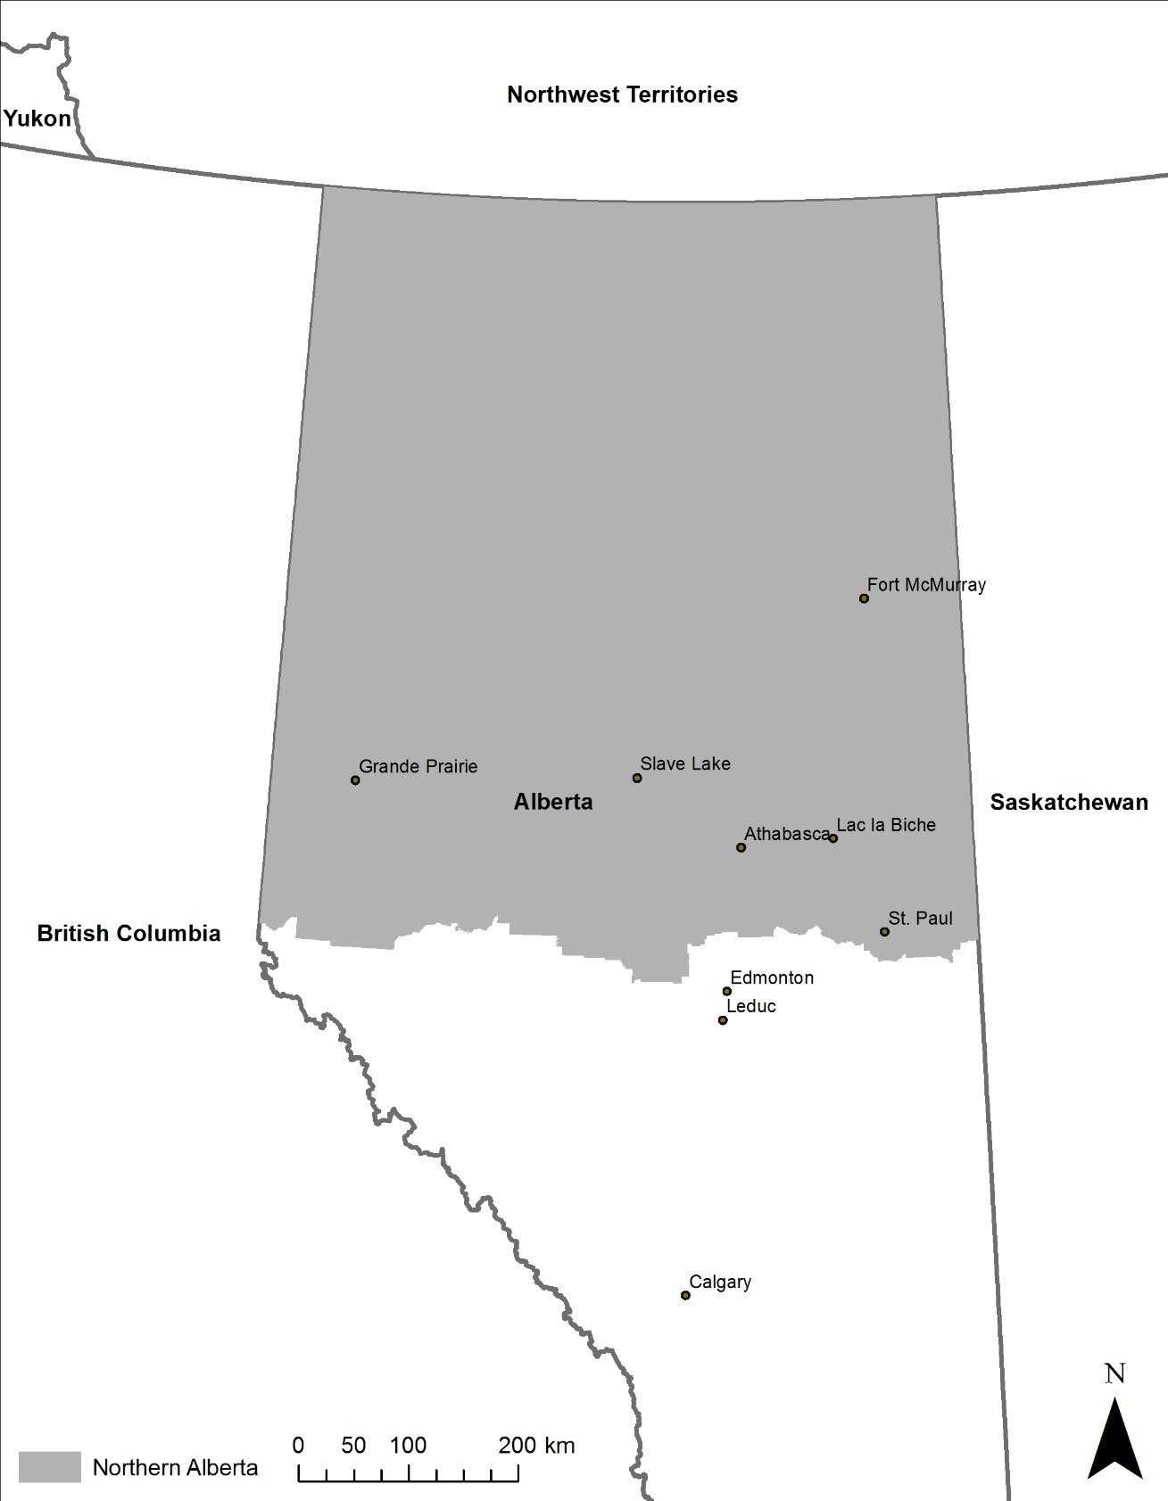

Note: km = kilometres.

Source: Created by the authors with assistance from Dr. Kwangyul Choi, University of Calgary.

Exhibit 2: Spruceland properties inc.

consolidated financial statements, 2014–2015 (in CA$)

Consolidated Statements of Financial Position

|  |  |  |
| --- | --- | --- |
| **as at June 30th** | **2015** | **2014** |
|  |  |  |
| **ASSETS** |  |  |
| Investment properties | **$102,697,500** | $95,988,979 |
| Property and equipment | **281,434** | 305,277 |
| Investments in and advances to equity accounted joint ventures | **2,811,399** | 4,161,169 |
| Mortgages receivable | **554,416** | 1,279,984 |
| Accounts receivable | **128,449** | 382,543 |
| Prepaids and other assets | **41,250** | 160,699 |
| Deposit on real estate | **–** | 500,000 |
| Term deposit | **175,091** | 165,112 |
| Cash and cash equivalents | **17,149,623** | 10,499,951 |
| **Assets** | **$123,839,162** | $113,443,714 |
|  |  |  |
| **LIABILITIES** |  |  |
| Debt on properties | **$46,260,126** | $43,663,102 |
| Deferred revenue and tenants’ deposits | **669,976** | 854,074 |
| Deferred income taxes | **10,654,160** | 9,928,603 |
| Income taxes payable | **1,842,934** | 32,827 |
| Accounts payable and accrued liabilities | **604,274** | 849,241 |
|  | **60,031,470** | 55,327,847 |
|  |  |  |
| Contingencies |  |  |
|  |  |  |
| **SHAREHOLDERS’ EQUITY** | **63,807,692** | 58,115,867 |
| **Liabilities and shareholders’ equity** | **$123,839,162** | $113,443,714 |

Exhibit 2 (continued)

Consolidated Statements of Earnings and Comprehensive Income

|  |  |  |
| --- | --- | --- |
| **for the year ended June 30** | **2015** | **2014** |
|  |  |  |
| **REVENUE** |  |  |
| Revenue from investment properties | **$9,497,597** | $9,327,784 |
| Property management income | **247,089** | 195,470 |
| Interest and other | **242,265** | 183,798 |
|  | **9,986,951** | **9,707,052** |
|  |  |  |
| **EXPENSES** |  |  |
| Property operating | **$2,808,001** | $3,051,210 |
| Interest and bank charges | **2,380,322** | 2,048,167 |
| Corporate | **1,001,920** | 1,053,761 |
| Depreciation of property and equipment | **23,843** | 24,285 |
|  | **6,214,086** | 6,177,423 |
| **Earnings before other gains and income taxes** | **3,772,865** | 3,529,629 |
|  |  |  |
| Net earnings in equity accounted joint ventures | **384,740** | 532,426 |
| Gain on disposal of interest in joint ventures | **916,953** | — |
| Fair value gain on investment properties | **3,911,020** | 1,744,751 |
| Gain (loss) on disposal of investment properties and property and equipment | **4,169** | (694) |
|  | **5,216,882** | 2,276,483 |
| **Earnings before income taxes** | **8,989,747** | 5,806,112 |
|  |  |  |
| Income taxes | **2,057,217** | 334,342 |
| Deferred income taxes expense | **725,557** | 1,032,504 |
|  | **2,782,774** | 1,366,846 |
| **Net earnings and comprehensive income** | **$6,206,973** | $4,439,266 |
|  |  |  |
| **Earnings per share – basic** | **$4.48** | $3.28 |
| **Earnings per share – diluted** | **$4.45** | $3.24 |

Exhibit 2 (continued)

Consolidated Statements of Shareholders’ Equity

|  |  |  |  |
| --- | --- | --- | --- |
| **as at June 30, 2014** | **Share Capital\*** | **Retained Earnings** | **Total** |
| Shareholders’ equity June 30, 2013 | $3,171,085 | $50,808,848 | $53,979,933 |
|  |  |  |  |
| Changes during the year: |  |  |  |
| Net earnings and comprehensive income | — | 4,439,266 | 4,439,266 |
| Dividends | — | (805,865) | (805,865) |
| Issuance of common shares – dividend reinvestment plan | 292,544 | — | 292,544 |
| Issuance of common shares – stock option plan | 209,989 | — | 209,989 |
| Shareholders’ equity June 30, 2014 | $3,673,618 | $54,442,249 | $58,115,867 |
|  |  |  |  |
|  |  |  |  |
| **as at June 30, 2015** | **Share Capital** | **Retained Earnings** | **Total** |
| **Shareholders’ equity June 30, 2014** | **$3,673,618** | **$54,442,249** | **$58,115,867** |
|  |  |  |  |
| Changes during the year: |  |  |  |
| Net earnings and comprehensive income | — | **6,206,973** | **6,206,973** |
| Dividends | — | **(892,934)** | **(892,934)** |
| Issuance of common shares – dividend reinvestment plan | **337,811** | — | **337,811** |
| Issuance of common shares – stock option plan | **39,975** | — | **39,975** |
| **Shareholders’ equity June 30, 2015** | **$4,051,404** | **$59,756,288** | **$63,807,692** |

* Share Capital consists of authorized, as well as issued and outstanding no-par-value common shares.

Exhibit 2 (continued)

Consolidated Statements of Cash Flows

|  |  |  |
| --- | --- | --- |
| **for the year ended June 30** | **2015** | **2014** |
|  |  |  |
| **OPERATING ACTIVITIES** |  |  |
| Net earnings for the year | $6,206,973 | $4,439,266 |
| Add (deduct) items not affecting cash and cash equivalent |  |  |
| Recognition of rent on a straight-line basis | (59,587) | (47,153) |
| Non-cash lease incentives on investment properties | — | (85,229) |
| Depreciation of property and equipment | 23,843 | 24,285 |
| Amortization of prepaid financing fees | 38,046 | 40,410 |
| Amortization of lease incentives | 13,559 | 15,829 |
| Net earnings in equity accounted joint ventures | (384,740) | (532,426) |
| Gain on disposal of interest in joint venture | (916,953) | — |
| Fair value gain on investment properties | (3,911,020) | (1,744,751) |
| (Gain) loss on disposal of investment properties and property and equipment | (4,169) | 694 |
| Deferred income taxes | 725,557 | 1,032,504 |
|  | 1,731,509 | 3,143,429 |
| Changes in non-cash working capital |  |  |
| Income taxes payable | 1,810,107 | 277,747 |
| Accounts receivable | 254,094 | 488,555 |
| Prepaid expenses | 119,449 | (6,001) |
| Deferred revenue and tenants’ deposits | (184,098) | 237,039 |
| Accounts payable and accrued liabilities | (244,967) | 168,649 |
| **Cash provided by operating activities** | **3,486,094** | **4,309,418** |
|  |  |  |
| **FINANCING ACTIVITIES** |  |  |
| Dividends paid | (555,123) | (513,321) |
| Proceeds from debt on properties | 8,862,000 | 5,709,500 |
| Financing cost on new debt | (28,040) | (55,259) |
| Repayment of debt on properties | (6,295,447) | (1,746,857) |
| Stock options exercised | 39,975 | 209,989 |
| **Cash provided by financing activities** | **2,023,365** | **3,604,052** |
|  |  |  |
| **INVESTING ACTIVITIES** |  |  |
| Acquisition of investment properties | (7,486,645) | (7,826,973) |
| Additions to investment properties | (373,546) | (713,202) |
| Additions to investment property under development | (2,870,818) | — |
| Proceeds from sale of investment properties | 8,004,170 | — |
| Proceeds from sale of joint venture interest and repayment of advances | 2,391,463 | — |
| Purchase of property and equipment | — | (16,942) |
| Repayment from joint arrangements | 260,000 | 251,000 |
| Repayment of mortgages receivable | 725,568 | 42,608 |
| Advances of mortgages receivable | — | (700,000) |
| Net interest in term deposit | (9,979) | (15,010) |
| Increase in deposits on real estate | — | (500,000) |
| Decrease in deposits on real estate | 500,000 | 100,000 |
| **Cash provided by (used in) investing activities** | **1,140,213** | **(9,378,519)** |
|  |  |  |
| **Net increase (decrease) in cash and cash equivalents** | **6,649,672** | **(1,465,049)** |
| Cash and cash equivalents, beginning of year | 10,499,951 | 11,965,000 |
| **Cash and cash equivalents, end of year** | **$17,149,623** | **$10,499,951** |

Source: Company files.

EXHIBIT 3: WTI CRUDE OIL PRICES, 2000–2016 (in US$ per barrel)

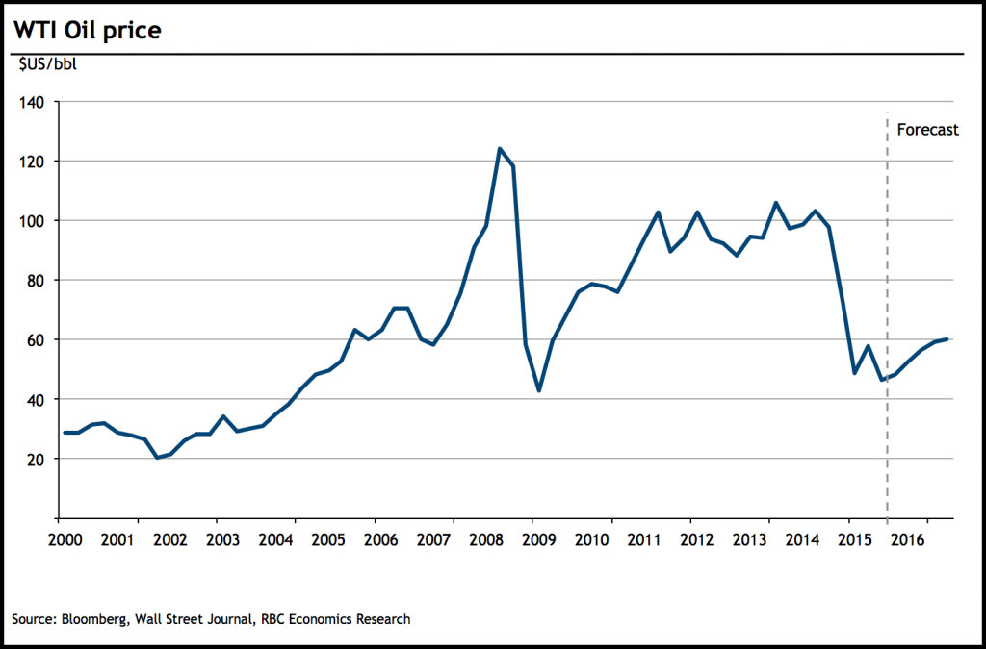

Note: WTI = West Texas Intermediate; bbl = barrel.

Source: Used with permission of original creator, Dawn Desjardins, Bloomberg, Wall Street Journal, RBC Economic Research.

EXHIBIT 4: SPRUCELAND SHARE VALUES AND DIVIDENDS, 2009–2016 (IN CA$)

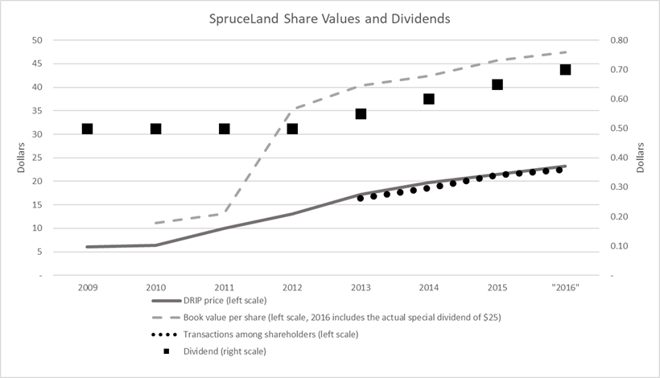

Source: Created by the authors. The dividend value and dividend reinvestment program (DRIP) price are from annual reports (SpruceLand Properties Inc., *Annual Report to Shareholders*, 2014, 2015, and 2016, accessed May 14, 2019, www.sedar.com); book value per share was calculated from the same documents by using shareholders’ equity (i.e., book value) and dividing it by the number of shares. The price of transactions among shareholders is from the Quantum fairness opinion (SpruceLand Properties Inc., *Notice of Annual General and Special Meeting of the Shareholders of SpruceLand* *Properties Inc. and* *Management Information Circular for the Meeting to Be Held on March 10, 2016*, February 11, 2016, 28, accessed May 14, 2019, www.sedar.com).

1. SpruceLand was formerly named Slave Lake Developments Ltd.
2. All currency amounts are in Canadian dollars unless otherwise noted.
3. The shares split three for one in 2010; the relative equivalent value of the original share purchase price was $0.33 per share.
4. John Gibson, “Alberta Recession One of the Most Severe Ever, TD Economics Report Finds,” CBC, July 18, 2016, accessed October 16, 2019, <https://www.cbc.ca/news/canada/calgary/td-economics-report-alberta-recession-gdp-forecast-1.3684056>.
5. Northern Alberta Development Council, *NADC Area Profile: An Economic Description of the Region*, May 2016, 9, accessed August 9, 2018, www.nadc.ca/media/1189/area-profile-an-economic-description-of-the-region.pdf.
6. Ibid, 2.
7. Ibid, 2.
8. Ibid, 13.
9. The energy industry included oil and gas, mining, minerals, and other “carbon capture and storage.” Ibid, 20.
10. Co-West Associates, *Socio-Economic Overview of Northern Alberta*, prepared for the Northern Alberta Development Council, April 1981.
11. Northern Alberta Development Council*, NADC Area Profile*, op. cit., 3.
12. Co-West Associates, op. cit.
13. Northern Alberta Development Council, *Economic Development of Northern Alberta*, 1977, prefix.
14. Slave Lake Developments, *Prospectus: Slave Lake Development Ltd*., 1971.
15. Reports from January 1, 1997 forward can be found on Sedar, the online filing database for all Canadian public corporations, at www.sedar.com. Examples of these reports can be found at SpruceLand Properties Inc., “President’s Message,” in *2014 Annual Report to Shareholders*, October 2, 2014, 3–5; and SpruceLand Properties Inc., “President’s Message,” in *2015 Annual Report to Shareholders*, October 1, 2015, 4–6.
16. To remain a private corporation, the entity must have had no more than 50 shareholders. When a corporation had more than 50 shareholders, the regulator’s view was that the greater transparency required of public companies was required to protect small investors. Marc Mercier, Bryan Woodman, and Richard Ngo, “Establishing a Business in Canada (Federal),” Thomson Reuters Practical Law, accessed October 3, 2019, https://ca.practicallaw.thomsonreuters.com/9-564-0499.
17. Northern Alberta Development Council, *Economic Development of Northern Alberta*, op. cit., 15.
18. SpruceLand Properties Inc., *Notice of Annual General and Special Meeting of the Shareholders of SpruceLand Properties Inc. and Management Information Circular* *for the Meeting to Be Held on March 10, 2016*, February 11, 2016, 28, accessed May 14, 2019, www.sedar.com.
19. Such a gap between a low share price and high property values was not in itself uncommon. For an in-depth discussion of price to net asset value (NAV) ratios for publicly traded real estate investment trusts, see William M. Gentry, Charles M. Jones, and Christopher J. Mayer, “Do Stock Prices Really Reflect Fundamental Values? The Case of REITs,” NBER Working Paper Series no. 10850 (Cambridge, MA: National Bureau of Economic Research, October 2004), accessed January 16, 2019, www.nber.org/papers/w10850.pdf.
20. The DRIP provided SpruceLand’s shareholders with “the option to reinvest dividends into common shares of the company.” SpruceLand Properties Inc., *Annual Report to Shareholders*, 2015,October 5, 2015, 45, accessed August 14, 2018, www.sedar.com. For more detail on the DRIP program and fair value assessment, see others of SpruceLand’s financial reports filed on Sedar, www.sedar.com.