|  |  |
| --- | --- |
|  |  |

9B19M113

DELHI METRO AIRPORT Express LINE: making it viable

Sunil Ashra, Narain Gupta, Shiv S. Tripathi, and Sharat Sharma wrote this case solely to provide material for class discussion. The authors do not intend to illustrate either effective or ineffective handling of a managerial situation. The authors may have disguised certain names and other identifying information to protect confidentiality.

This publication may not be transmitted, photocopied, digitized, or otherwise reproduced in any form or by any means without the permission of the copyright holder. Reproduction of this material is not covered under authorization by any reproduction rights organization. To order copies or request permission to reproduce materials, contact Ivey Publishing, Ivey Business School, Western University, London, Ontario, Canada, N6G 0N1; (t) 519.661.3208; (e) cases@ivey.ca; www.iveycases.com. Our goal is to publish materials of the highest quality; submit any errata to publishcases@ivey.ca. i1v2e5y5pubs

Copyright © 2019, Management Development Institute Gurgaon and Ivey School of Business Foundation Version: 2019-09-18

Introduction

On June 30, 2014, Sharat Sharma, the director of operations of the Delhi Metro Rail Corporation (DMRC), was sitting in his Barakhamba Road office, contemplating the meeting that had just concluded. He had invited all key personnel of the DMRC to discuss the strategy to make its recent takeover of the Delhi Airport Metro (DAM) viable. Since its inception in 2008, DAM had operated on a public–private partnership model, yet it was continuously operating at a loss. The DAM ran from the Indira Gandhi International Airport (IGI) to the New Delhi railway station, which was 17 kilometres away. There were many challenges before Sharma, including a low occupancy rate of the DAM, unsustainable revenues, and an inability to meet operating expenses. Because any new metro line also had significant capital expenditure, it was going to be difficult for Sharma to come up with the necessary changes to make the venture viable—unless a reduction in operating expenses supported them. How the company should rationalize the fare, increase non-fare revenue, and attract more people to the DAM were some immediate questions that he and his team had to address to revive the company that they had taken over.

The Indian Economy

Despite a slowdown in world economies after the 2008 crisis, India had kept the pace of economic growth alive and was projected to overtake both the United Kingdom and France in 2018 to become the fifth-largest economy in the world, with a nominal gross domestic product of US$2.9 trillion. In a period when several developed countries were witnessing slowdowns in growth, the Indian economy recorded high rates of growth among the emerging economies, second only to China.[1]

The National Capital Region (NCR) of Delhi found itself uniquely positioned as the world’s second most populous urban agglomeration.[2] Beginning with mid-1991, the government made some radical changes in its policies related to foreign trade, foreign direct investment, exchange rate, industry, and fiscal discipline.[3] Migrants preferred to reside in the affordable suburbs. As per the 2011 Census of India, Delhi had the highest population density out of all Indian states and Union Territories, with 11,297 people per square kilometre (km2), compared to the national average of 382 people per km2.[4] The task of providing an efficient mode of transportation in such a densely populated city made the DMRC a lifeline in the NCR.

the DELHI AIRPORT METRO LINE

Between 2000 and 2010, international traffic quadrupled at IGI in Delhi while the number of domestic passengers, many of whom flew in and out of Delhi on single-day trips, increased by seven times.[5] Before February 2011, commuter services to the airport were limited to expensive taxis and unreliable public buses, leaving most passengers frustrated and dissatisfied.

The XIX Commonwealth Games were to be held in New Delhi in October 2010. This event was expected to attract many athletes, officials, journalists, support staff, and spectators. The anticipated increase in air traffic created the need for a rapid transit system to connect the Delhi airport to various parts of the city. The Airports Authority of India (AAI) awarded the contract to expand the Delhi International Airport Limited (DIAL) in order to accommodate the projected traffic and bring its services in line with international standards.

The airport was about 17 km southwest of the New Delhi railway station, near Connaught Place—one of the city’s busy business districts. Because airport traffic faced congestion, the AAI desired a dedicated rail connection to the airport. In November 2004, the AAI commissioned the DMRC and RITES Limited to prepare a detailed project report.[6]

A new terminal of the airport—Terminal 3—was to be constructed and connected to the city centre by a new, state-of-the-art mass rapid transit system similar to those in Singapore and Hong Kong. The AAI sanctioned the project in April 2007.

The DMRC was commissioned to complete tasks with long lead times, including land acquisition and the civil construction of tunnels, viaducts, and stations. It was funded through viability gap funding provided by the federal government and by grants from the Delhi Development Authority and DIAL. The DMRC also commissioned two electrical substations to supply electrical power to the DAM.

The DAM was financed through a public–private partnership using a hybrid build-operate-transfer model. The private concessionaire was responsible for providing tracks, signals, power distribution systems, and rolling stock and for operating the line for 30 years.[7]

Reliance Infrastructure Limited established Delhi Airport Metro Express Private Limited (DAM) as a special purpose vehicle, in which it held a 95 per cent stake. The remaining 5 per cent of the equity was owned by the Spanish company Construcciones y Auxiliar de Ferrocarriles SA (CAF). CAF also supplied the rolling stock for the DAM. The concessionaire possibly expected high returns from the project and therefore quoted negative viability gap funding. In August 2008, a concession agreement between the DMRC and the concessionaire was signed.[8] The line started functioning in February 2011.[9]

Colloquially dubbed the Orange Line, the DAM operated between Dwarka metro station, via the IGI, and the New Delhi Railway (NDRU) station in the city centre. Both ends connected it to the DMRC network’s Blue Line (East–West Corridor) and Yellow Line (North–South Corridor).

Delhi Metro Rail Corporation

The DMRC was registered on May 3, 1995, under the Companies Act 1956, with equal equity participation of the government of the National Capital Territory of Delhi and the federal government to implement the dream of constructing and operating a world-class rail-based mass rapid transit system. The DMRC introduced comfortable, air-conditioned, and eco-friendly services in India for the first time. It completely revolutionized the mass transportation scenario in the NCR and set a standard for all future metros in the country. It became a benchmark for the execution of a huge and technically complex infrastructure project within a given budget and timeline by a government agency. The DMRC also ran five other regular metro services (the Red, Yellow, Blue, Violet, and Green lines) in Delhi and the NCR.

Takeover of the Delhi Aiport Metro by the Delhi Metro Rail Corporation

On July 1, 2013, control of the DAM was handed over to the DMRC from the private sector concessionaire, who had found it difficult to operate profitably.[10]

At the time of the takeover, it was found that the Delhi Metro Airport Express Line (DMAEL) was not able to generate even 25 per cent of the traffic estimated. DMAEL losses amounted to about ₹40–₹50 million[11] each month, and the project had become financially unviable. On June 27, 2013, the concessionaire served notice to the DMRC that it intended to cease operations on the DAM effective July 1 of that year. After detailed deliberations, the DMRC claimed that this violated the concession agreement, which subsequently led to arbitration proceedings.[12]

The DMRC decided that it would be in the public interest to take over the DAM operations.[13] At the time of the takeover, capacity utilization (passenger kilometres as a percentage of capacity kilometres) was well below initial expectations (see Exhibit 1), and the ratio of operational expenditure to operational revenue (operating ratio) was about 2.7.[14] The initial attempts made by DMRC to revive the DMAEL did not have the desired results (see Exhibit 2).

The Issues

The DMRC recognized that they needed to consider a two-pronged approach to improving the operating ratio—namely increasing revenue while reducing costs. Revenue was generated from two sources: fare-box revenue (from passenger kilometres) and non-fare-box revenue (mainly from property business leasing and advertisements on trains and stations). Both depended on footfall traffic.

Fare-Box Revenue Optimization Strategies

When the DMRC took over the DAM, they had many questions to answer and problems to solve. At times, Sharma thought that there were too many permutations and combinations available to try. The first issue was to increase train occupancy. One option was to see whether the train timings could be changed to suit commuters who could be feeders to these trains. For example, passengers arriving in the morning at the New Delhi Railway Station could become feeders to DMAEL trains going to the airport. Were there any other consumer groups who could become feeders to these trains in order to increase the occupancy?

A second issue was to alter the fare (reduce or increase) to make it viable. The minimum fare was ₹30 and the maximum was ₹180 (see Exhibit 3). Should the DMRC make the DMAEL more affordable, or should they convert it into a premium service? How frequently could fares be reduced or increased? What should the targeted earnings be to make it sustainable? Should the company aim for profits?

The third issue concerned whether anything could be done about the frequency and speed of the trains. What was the ideal number of trips to make the DMAEL viable or even profitable? There were six stations on the Delhi Airport metro line (see Exhibit 4), and the weekly traffic pattern suggested that some stations were underutilized (see Exhibit 5). Another issue was ideal train timing. Other metro services typically had a recess from midnight until 6:00 a.m. Should the DMAEL follow suit, or—keeping international flights in mind—should it operate at all hours of the night? If yes, what would the ridership be, and which consumer groups would prefer to ride during the night? Were there any international passengers? Should there be differential pricing for foreigners?

Fourth, could a terminal station of the DMAEL be used as a hub where other metro lines converged and fed into the DMAEL? What about the anticipated growth of DIAL? Terminals 1 and 3 of the airport were currently operating; however, there were plans to start a new Terminal 2 (due to a serious rise in passenger traffic at IGI). Should they consider the option of connecting Terminals 1, 2, and 3 and running shuttles between these terminals in addition to the regular DMAEL line?

The fifth and most important area to examine was people’s willingness to travel by the DMAEL. Sharma was considering having some market research done to find out customer pain areas in order to ascertain why they did not travel by airport metro—even though the other metros were overcrowded.

Non-fare-Box Revenue Optimization Strategies

In the concessionaire’s business plan, non-fare-box revenue was estimated to contribute 74 per cent of total revenue by 2014, but this could not be realized due to low traffic.[15]

At the time of the DMRC’s takeover, non-fare-box revenue was only ₹7.3 million each month. Sharma was thinking of developing the DMAEL space like a shopping complex or the duty-free section of the airport. The challenges of such an ambitious plan included selecting tenants to occupy the retail space for shops and developing a business value proposition for them, including the tenant mix, space and crowd management, and the revenue-sharing model they would implement with the tenants. For example, the crowds at airport shopping or duty-free areas were typically easy going, as most people there had clear ideas about when they needed to catch their flights. On the other hand, a typical DMAEL metro passenger would be in a hurry to catch their train. A customer may become relaxed upon reaching the airport terminal, as the customer would then be able to browse items that were available. In addition, such a space for the DMAEL would start competing with the airport’s own shopping area, which was presumably better designed, with open spaces and a comfortable shopping experience. Therefore, making such a development viable was a challenge.

Another aspect of non-fare-box revenue optimization was the usage of free space for advertising. The DMRC needed to decide what kinds of advertisements could be shown in the proposed shopping space, which products or services shown by such advertisements could be made available to consumers at DMAEL terminal stations, and what the advertising mix should be.

Cost Optimization

The DMAEL had three major operational costs—namely, labour, maintenance, and energy. In each of these three areas, there was scope for reduction or optimization. Sharma had to decide which types of jobs could be outsourced, keeping security in mind. Personnel were deployed in the areas of supervisors and managers, ticketing and security services, driving, maintenance, and housekeeping. DMAEL also had to find ways to reduce electricity consumption both during travel as well as at the stations.

The way ahead

Sharma had a major task before him, yet he was confident that he and his team of experienced professionals, drawing on their experiences from DMRC operations, would be able to optimize the DMAEL system to convert it into a successful model of public transportation with a far-reaching impact. “Let’s buckle up and do it,” he said.

Sunil Ashra, Professor (Economics), MDI Gurgaon, India.

Narain Gupta, Associate Professor (Operations Management), MDI Gurgaon. India.

Shiv S Tripathi, Assistant Professor (Strategic Management), MDI Gurgaon, India.

Sharat Sharma, Former Director (Operations), DMRC, New Delhi, India.

The authors of this case would like to acknowledge Mangu Singh, the Managing Director of Delhi Metro Rail Corporation, and thank him for his full cooperation and support. The authors would also like to thank Sankalp Devendra, Senior Deputy General Manager of Delhi Metro Rail Corporation, who was instrumental in extracting and preparing the data required for the case study.

Exhibit 1: DELHI Airport Metro—Basic Data on Traffic and Earnings

|  |  |  |  |  |  |  |
| --- | --- | --- | --- | --- | --- | --- |
| **Year/Month** | **Revenue (₹)** | **Realized Passenger Kilometres** | **Ridership** | **Trips per Month (N)** | **Seats**  **(N × 849)** | **Passenger Kilometres Capacity**  **(N × 849 x 22.69** |
| 2013/07 | 25,821,199 | 3,994,761 | 312,132 | 4,526 | 3,842,574 | 87,188,004 |
| 2013/08 | 28,235,440 | 4,327,893 | 336,541 | 5,291 | 4,492,059 | 101,924,819 |
| 2013/09 | 26,000,747 | 4,217,913 | 327,219 | 5,112 | 4,340,088 | 98,476,597 |
| 2013/10 | 26,865,338 | 4,378,780 | 336,342 | 5,292 | 4,492,908 | 101,944,083 |
| 2013/11 | 27,524,771 | 4,323,540 | 317,675 | 4,982 | 4,229,718 | 95,972,301 |
| 2013/12 | 28,315,607 | 4,511,934 | 352,482 | 4,945 | 4,198,305 | 95,259,540 |
| 2014/01 | 27,913,312 | 4,581,345 | 362,207 | 4,972 | 4,221,228 | 95,779,663 |
| 2014/02 | 29,231,202 | 4,638,412 | 362,898 | 4,486 | 3,808,614 | 86,417,452 |
| 2014/03 | 31,975,923 | 4,979,987 | 386,497 | 4,875 | 4,138,875 | 93,911,074 |
| 2014/04 | 29,186,054 | 4,446,329 | 357,101 | 4,766 | 4,046,334 | 91,811,318 |
| 2014/05 | 32,492,399 | 4,851,016 | 392,886 | 4,966 | 4,216,134 | 95,664,080 |
| 2014/06 | 32,383,275 | 5,048,974 | 394,290 | 4,817 | 4,089,633 | 92,793,773 |

Note: 849 was the car capacity (seating and standing), 22.69 kilometres was the length of the trip, and there were six cars in each train.

Source: Provided by the Delhi Metro Rail Corporation.

Exhibit 2: DELHI Airport Metro—Earnings, Traffic, and Fares (Based on Daily averages, calculated monthly)

|  |  |  |  |  |  |
| --- | --- | --- | --- | --- | --- |
| **Summary Statistics** | **Earnings** | **Passenger Kilometres** | **Ridership** | **ARPPKM** | **ARPR** |
| **July 2013 – June 2014** | | | | | |
| Cumulative Growth (%) | 29.60 | 30.60 | 30.50 | −0.06 | −0.70 |
| Compound Monthly Rate of Growth CMRG (%) | 2.18 | 2.25 | 2.25 | −0.08 | −0.06 |

Note: ARPPKM = average per-passenger kilometre; ARPR = average revenue per rider.

Source: Created by the authors using data provided by the Delhi Metro Rail Corporation.

Exhibit 3: Delhi Airport Metro Line—Fares for one-way Tickets

|  |  |  |
| --- | --- | --- |
| **Period** | **Maximum** | **Minimum** |
| July 2013 – June 2014 | ₹180 | ₹30 |

Source: “Fares on Airport Express Line to Be Reduced From 24th July 2014,” Delhi Metro Rail Corporation, accessed May 25, 2019, www.delhimetrorail.com/whatnew_details.aspx?id=eQ9ONLZmFAwlld.

Exhibit 4: Map and Distance between DELHI Airport Metro Stations

|  |  |  |  |  |  |  |
| --- | --- | --- | --- | --- | --- | --- |
| **Station Name** | **Dwarka** | **Airport Terminal 3** | **Delhi Aerocity** | **Dhaula Kuan** | **Shivaji Stadium** | **New Delhi** |
| **Station Code** | DSTO | APOT | DACY | DKV | SJSU | NDRU |
| **Distance (Kilometres)** | 0.00 | 3.11 | 6.56 | 13.53 | 20.35 | 22.32 |

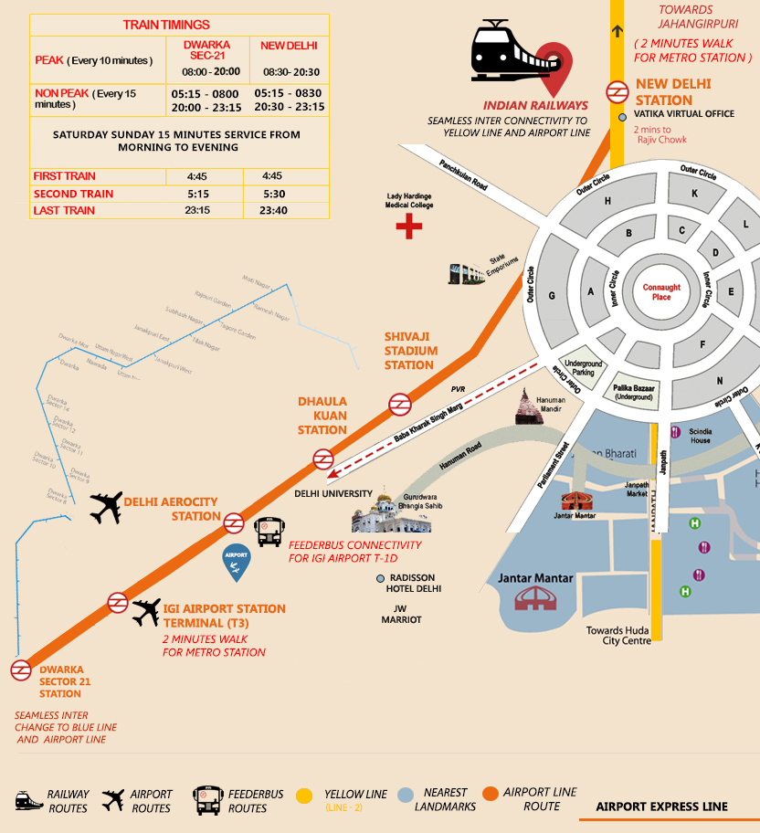

Source: Provided by the Delhi Metro Rail Corporation.

Exhibit 5: Entry/Exit of Riders through particular stations (week 3 of June 2014)

|  |  |  |  |  |  |  |  |
| --- | --- | --- | --- | --- | --- | --- | --- |
| **Entry/Exit** | **NDRU** | **SJSU** | **DKV** | **DACY** | **APOT** | **DSTO** | **Total Weekly Ridership** |
| NDRU | 486 | 88 | 2,775 | 5,703 | 10,826 | 3,097 | 22,975 |
| SJSU | 65 | 62 | 370 | 932 | 1,725 | 3,313 | 6,467 |
| DKV | 2,413 | 448 | 43 | 142 | 821 | 1,013 | 4,880 |
| DACY | 5,822 | 1,204 | 140 | 95 | 222 | 1,101 | 8,584 |
| APOT | 8,664 | 1,361 | 638 | 138 | 269 | 10,901 | 21,971 |
| DSTO | 3,310 | 3,868 | 859 | 870 | 11,786 | 1,287 | 21,980 |

Note: NDRU = New Delhi; SJSU = Shivaji Stadium; DKV = Dhaula Kuan; DACY = Delhi Aerocity; APOT = Airport Terminal 3; DSTO = Dwarka.

Source: Based on data provided by the Delhi Metro Rail Corporation.

1. “The World’s Top 10 Largest Economies,” Focus Economics, accessed November 8, 2018, www.focus-economics.com/blog/the-largest-economies-in-the-world.
2. United Nations Department of Economic and Social Affairs, Population Division, *World Urbanization Prospects: The 2014 Revision, Highlights* (New York: United Nations, 2014), accessed July 16, 2019, https://esa.un.org/unpd/wup/Publications/Files/WUP2014-Highlights.pdf.
3. Hemant Pratap Singh, “New Economic Policy of 1991: Objectives, Features, and Impacts,” Jagran Josh, June 10, 2019, accessed July 16, 2019, www.jagranjosh.com/general-knowledge/new-economic-policy-of-1991-objectives-features-and-impacts-1448348633-1.
4. “Density of India,” Census 2011, accessed September 13, 2018, www.census2011.co.in/density.php.
5. “Total Traffic Handled at Delhi Airport (1992–1993 to 2009–2010),” Indiastat, accessed January 15, 2016, www.indiastat.com/table/transport/30/totaltrafficatairportofindia19892016/452959/52734/data.aspx.
6. Rail India Technical and Economic Service was a government owned and managed engineering consultancy company. It was later renamed as RITES Limited.
7. O.P. Agarwal and Jose A. Gomez-Ibanez, *Case-Study on Delhi Airport Metro Express* (n.p.: World Bank Group, n.d.), accessed June 21, 2016, www.ppiaf.org/sites/ppiaf.org/files/publication/Delhi-Airport-Metro-Express-Case-Study.pdf.
8. “Delhi Awards Airport Rail Link PPP Contract,” *Railway Gazette*, January 23, 2008, accessed July 16, 2019, www.railwaygazette.com/news/infrastructure/single-view/view/delhi-awards-airport-rail-contract.html; “Delhi Metro Takes Over Airport Express Line,” *Railway Gazette*, July 1, 2013, accessed June 6, 2019, www.railwaygazette.com/news/single-view/view/delhi-metro-takes-over-airport-express-line.html.
9. “Delhi Airport Express Rail Link Opens,” *Railway Gazette*, February 24, 2011, accessed June 6, 2019, www.railwaygazette.com/news/single-view/view/delhi-airport-express-rail-link-opens.html.
10. “Reliance Pulls Out of Airport Metro as Controversy Continues with Planning,” *Daily Mail*, June 28, 2013, accessed July 16, 2019, www.dailymail.co.uk/indiahome/indianews /article-2351211/Reliance-pulls-Airport-Metro-controversy-continues-planning.html.
11. ₹ = INR = Indian rupee; all currency amounts are in ₹ unless otherwise specified; US$1 = ₹59.53 on July 1, 2013.
12. Kumar V. Pratap, “Delhi Airport Metro Fiasco: What Can Be Done to Redeem the Project?,” *Economic & Political Weekly* 48, no. 49 (December 7, 2013), accessed July 16, 2019, www.epw.in/journal/2013/49/commentary/delhi-airport-metro-fiasco.html; “DMRC Proposes Linking Airport Metro with Rapid Transit Lines,” *The Indian Express*, March 20, 2014, accessed July 16, 2019, [http://indianexpress.com/article/cities/delhi/dmrc-proposes-linking-airport-metro-with-rapid-transit-lines/](http://indianexpress.com/article/cities/delhi/dmrc-proposes-linking-airport-metro-with-rapid-transit-lines/\); “DMRC Says Losses Slashed on Airport Line,” *The Indian Express*, January 15, 2014, accessed July 16, 2019, <http://indianexpress.com/article/cities/delhi/dmrc-says-losses-slashed-on-airport-line/#sthash.WrJfxNbW.dpuf>.
13. Delhi Metro Rail Corporation Ltd., *Annual Report 2014–2015*, accessed April 29, 2016, www.delhimetrorail.com/OtherDocuments/DELHI1-92english.pdf.
14. Sweta Dutta, “Airport Express Line Has Turned the Corner, Believe Officials,” *The Indian Express*, November 1, 2015, accessed June 6, 2019, <http://indianexpress.com/article/cities/delhi/airport-express-line-has-turned-the-corner-believe-officials/>.
15. Pratap, op. cit.