

9B19M122

TELENOR GROUP: DEVELOPING A NEW BUSINESS MODEL

Frank Elter, Marcus Moller Larsen, and Torben Pedersen wrote this case solely to provide material for class discussion. The authors do not intend to illustrate either effective or ineffective handling of a managerial situation. The authors may have disguised certain names and other identifying information to protect confidentiality.

This publication may not be transmitted, photocopied, digitized, or otherwise reproduced in any form or by any means without the permission of the copyright holder. Reproduction of this material is not covered under authorization by any reproduction rights organization. To order copies or request permission to reproduce materials, contact Ivey Publishing, Ivey Business School, Western University, London, Ontario, Canada, N6G 0N1; (t) 519.661.3208; (e) cases@ivey.ca; www.iveycases.com. Our goal is to publish materials of the highest quality; submit any errata to publishcases@ivey.ca. i1v2e5y5pubs

Copyright © 2019, Ivey Business School Foundation Version: 2019-10-04

In January 2019, Sigve Brekke, the chief executive officer (CEO) of the giant Norwegian telecommunications company Telenor Group (Telenor), was preparing his keynote address for the forthcoming Telenor town hall meeting. “We’re facing a massive transition,” he thought, “and we do not have much time.”[1] Brekke’s ambition was to save Telenor from merely providing connectivity and voice services by changing the company into a full-fledged digital service provider that shifted the distribution of connectivity from physical to digital channels. Yet he knew that this change was going to be full of painstaking uncertainty. Telenor was sorely aware that actors such as Google LLC (Google), Facebook Inc. (Facebook), Apple Inc. (Apple), and Microsoft Corporation (Microsoft) had started offering communications services and thus had entered the turf of telecommunications companies (telcos). How could Telenor deal with the competitive threat posed by new actors who competed with a set of capabilities not possessed by telcos?

TELENOR Group

Telenor Group—a Norwegian company that provided voice, Internet connectivity, and media services in the Nordic countries, as well as voice and Internet connectivity services in central and eastern Europe and Asia—was established in 1855 as Telegrafverket, a state-operated monopoly providing telegraph services. As a result of the deregulation of the Norwegian telecommunications sector, the company became a public organization in 1994. Telenor’s telecommunications operations were divided into segments that operated in the Nordic countries, central and eastern Europe, and Asia. In the Nordic countries (i.e., Norway, Denmark, and Sweden), Telenor was one of the leading providers of mobile and fixed services and had a strong position in the broadband market. With over 211 million mobile subscribers in 12 country markets, more than 38,000 employees, and the prestigious status of one of the world’s 500 largest companies by market value, Telenor was by all means a proud and successful company. With NOK110 billion[2] in revenue in 2018, it was one of the world’s 20 largest mobile operators.[3]

In 2016, the bulk of Telenor’s revenue came from providing connectivity, with voice, messaging, and data constituting the sources. However, the telecommunications industry was in 2019 undergoing radical changes that both stirred and undermined traditional business models. The growth rate of worldwide telecommunications services spending was down to 2.2 per cent in 2016 and was expected to further decrease to 0.9 per cent in 2020, with the largest drop in the mature markets.[4] With slower growth rates and fierce price competition, most telcos in mature markets had started to experience dropping margins.

THE disrupted telecommunications INDUSTRY

In 2015, Brekke was appointed CEO of Telenor to replace Jon Fredrik Baksaas. Baksaas, who had once been voted one of the world’s 100 best performing CEOs by the *Harvard Business Review*, had decided to retire as CEO after 13 years at the top. Before transitioning to CEO, Brekke had been head of Telenor’s operations in Asia, where he had succeeded in establishing the company as a leading telecommunications operator with more than 100 million subscribers contributing more than 40 per cent of Telenor’s total enterprise value. “In Sigve Brekke,” explained former CEO Baksaas, “the Board of Directors has found the perfect candidate to continue Telenor’s growth and value creation. We have worked closely for many years, and his knowledge of the business, customer focus, and hands-on management style will ensure a great future for the company.”[5]

While Telenor was generally in a healthy state as Brekke assumed responsibilities as CEO—results were positive, and the organization was lean—the disruptive nature of the industry had taught him not to rest on his laurels. “In the year 2020,” the newly appointed CEO reasoned, “80 per cent of the earth’s population will own a smartphone. Telenor has no intention of giving all the opportunities to Google and Facebook. We also want to have a position in this area.”[6]

Accordingly, Brekke, who had been in the company since 1999 and had therefore experienced many of the ups and downs of running a telco, had learned that, to succeed in the industry, firms needed not only to be able to adapt to changing environments but also to take an active lead in the change. Over the last few decades, the industry had evolved in ways that had forced traditional firms to radically reassess and reinvent their business models (see Exhibit 1). In the 1990s and early 2000s, Telenor had adhered to the common model among telcos by vertically integrating operations to offer voice and messaging over fixed lines and mobile networks. The intention here was largely to generate revenue by charging for the length of the voice calls and the number of messages. Therefore, with the launch of the second-generation (2G) cellular technology network in the 1990s, Telenor made good revenues on voice and messaging. In the early 2000s, with the introduction of the third-generation (3G) network, the key value proposition was expanded to cover data usage, and telcos charged per megabyte downloaded as customers began using their phones for email or surfing the Internet. But even then, voice and messaging still functioned as the core services. When the fourth-generation (4G) network was launched in 2010, the business model altered toward data. Voice and messaging were increasingly bundled into fixed subscription fees for large data use allowances and consequently appeared as free add-ons to the data subscriptions.

In approximately 2016, with a mature 4G market and an awaited fifth-generation (5G) network, the industry was starting to evolve—even disrupt—in ways that were unpreceded. A number of new suppliers of digital services—including both the tech giants such as Google, Facebook, Apple, and Microsoft, and an army of small start-ups—were disrupting industries by providing new services on top of the connectivity and business models supporting them. It was expected that digital services would grow to almost 25 per cent of revenue in the telecommunications industry in 2020, while the revenue generated by mobile and fixed connectivity would be stagnating on a global scale (but decreasing in mature markets) (see Exhibit 2). In addition, those companies providing the digital services would likely obtain the direct relationships with the ultimate customers, as they provided the platforms and applications demanded by customers. Traditional telcos, however, ran the risk of being pushed down the value chain as mere providers, where the focus would be on minimizing costs. While telcos were previously protected by the fact that the hardware was dedicated to a specific use, the hardware was now becoming more standardized, and so the dedication was all done in the software. This implied that companies no longer needed to control the hardware to dedicate it to uses such as voice, SMS (short message service), and Internet. Moreover, as the physical SIM card was projected to be embedded in the phones over the next few years, the strong position in physical distribution would diminish as an advantage. If telcos did not build the capacity to serve customers through attractive digital channels, the provisioning of mobile services could be overtaken by the actors controlling the operating systems on the phones (with Google and Apple as the most prominent players).

Faced with these challenges, traditional telecommunications operators found themselves in an increasingly marginalized position. Brekke explained:

We’ve built a business where we’ve controlled the whole value chain of the products we’ve offered, such as SMS, MMS [multimedia messaging service] and voice. . . . We’re now facing a brand new world where other companies offer the end products and services. We need completely different technological solutions, we can’t own the whole infrastructure ourselves any longer, and we need to collaborate and form new partnerships. This means that the entire way of operating will be done on a more integrated network system where we do something ourselves and have minority positions, joint ventures, and pure partnerships.[7]

As the industry was shifting from a well-ordered sector made up of broadly vertically integrated telcos toward a dynamic, competitive landscape fluidly populated by a number of new entrants—making it increasingly difficult to create an unambiguous value proposition—Brekke feared that Telenor would be pushed into a position as a wholesaler of mobile broadband to other companies that could take over the direct relationship with customers. Brekke knew that being reduced to such a utility-provider position would be a pure cost game with very low margins. As Telenor had a history as a retail mobile operator that served consumers directly, Brekke considered the option of selling only mobile connectivity highly undesirable.

DIGITAL TRANSFORMATION

In light of the recent turn of the industry, Telenor’s 2016 strategy could be summarized as making the shift from acting as a telecommunications company to becoming a digital service provider. In particular, Telenor would continue focusing on its telecommunications business but would increasingly emphasize current and new digital verticals to retain a focus on growth and value creation. Officially, Telenor stated its strategic ambition as follows:

To deliver on the ambitions of growth and value creation, we will take the position as our customers’ favourite partner in digital life. We will be delivering a broad range of relevant, personalized, and engaging digital services. These include connectivity and communications services, select Internet services within, for example, storage and communication, and select stand-alone digital verticals.[8]

To initiate the process of becoming a digital service provider, Telenor had started to develop a number of services accessed through applications (apps) in areas such as online storage, banking, and gaming, as well as music that would be used to attract and retain new and prospective customers (see Exhibit 3). For example, an app called Capture was developed so that photos taken on customers’ mobile phones could be automatically saved in the cloud. In several markets, there was no data charge associated with this automatic picture uploading, and the pictures would be automatically available on all of the customer’s devices.

Another app, Appear.in, was the result of Telenor’s incubator environment. The purpose of the app was to provide one-click video conferences in a browser without the need for customers to log in or use additional software. By 2016, a team of 18 people were working full-time with Appear.in, with the long-term ambition of creating “easy video meetings for your business.”[9] In 2009, Telenor had also partnered with Tameer Microfinance Bank Ltd. to develop a service for branchless banking in Pakistan, called Easypaisa. Since then, the app had received significant international recognition and reported more than 5 million unique users of the service every month. In 2015, Telenor launched a lifestyle app in Bangladesh called WowBox, which upsold internal product offers and provided users with engaging local content from established partners, such as daily trending news, sport results, built-in games, free music, lifestyle articles, and much more. According to the head of the app, Holger Hussmann, “WowBox has established a unicast channel between Telenor and the individual customer. As the current backend implementation is being extended with stronger analytics features, the content will become even more personalized and the offers more targeted.”[10] The business potential was therefore obvious, as Hausmann argued: “it will also allow targeted advertisement within the app, which will result in improved revenue.”[11]

Besides organically developing digital services that would attract and retain customers, the company had also initiated a new process of targeted acquisitions to strengthen its competence pool. For example, in February 2016, Telenor made a NOK3.1 billion acquisition of Tapad Inc. (Tapad), a New York–based marketing and technology company. Commenting upon the acquisition, Brekke stated that Tapad was “world class in targeting marketing and [would] help in making Telenor’s operations highly customer and cost oriented.”[12] Tapad, whose CEO, Are Traasdahl, was also Norwegian, would therefore assist Telenor in generating new sources of revenue. As Brekke explained, “We shall take up the competition with others dealing with such solutions and services. We operate in large markets where there are no payment solutions. Google is largely based on markets with Wi-Fi, but must, in many areas, collaborate with the telcos. We bought Tapad because we need competencies in advanced business models.”[13]

Brekke knew that a digital service provider could mean a lot of different things (see Exhibit 4). On the lower end of the continuum, a digital service provider could represent an actor characterized as “bit pipe” that provided high-quality networks but without specific digital service delivery. In this respect, firms would operate within the digital service arena but without any direct contact with the end-users. In contrast, firms could also embrace the role of digital enabler, wherein they would act as third-party service suppliers to operators closer to the end-users. Moreover, firms could characterize themselves as digital telecommunications companies, in which capacity they would own digital services and engage widely in third-party partnerships. Finally, firms could strive toward becoming over-the-top digital players (such as Google and Amazon), focusing on delivering digital services directly to a network-agnostic customer base.

GOING FORWARD

Finding one identity in the ever-disrupted telecommunications industry was surely not a straightforward endeavour. As the traditional connectivity business still generated most of the revenue, the more palpable strategy would be to exploit existing sources of income to generate the necessary liquidity for the future business model. However, several uncertainties loomed: How fast should a telecommunications company switch from the old to the new business model? How much funding should be redirected from the old to the new business? And, more generally speaking, what was the future business model? Should the customers be at the centre of attention, or would a business-to-business or business-to-business-to-consumer model be more feasible? For example, Telenor had started to explore collaborations with municipalities in Norway as a way to offer focused, niche-oriented solutions instead of serving the broad group of end-customers it was currently serving. As such, would it be possible to manage two conflicting business models under the same roof?

Notwithstanding the sheer complexity of adding another business model to a company, a big challenge also related to getting the existing employees on board an uncertain journey toward becoming a digital service provider. Internal political battles had unfolded in regard to Telenor’s organizational development: some employee groups (referred to as “Bellheads”) were advocating the old network technology that had served them well, whereas other groups (referred to as “Netheads”) were fighting for a new model embracing digital technologies. How could Telenor foster a culture that encouraged innovation and knowledge sharing in an organization that had previously optimized activities separately in each country?

Brekke doubted that Telenor’s only path was to become a digital service provider. He also knew, however, that the task before him would be challenging. “The core company must be digitalized,” he acknowledged. “Telenor needs to establish digital verticals and must be fuelled with competencies in analytics and the systematic use of big data.”[14] Above all, he recognized that a key hurdle would be to convince all employees to embrace the basic fact that the future would encapsulate radical changes to the current business model. While the current organization was dominated by the “telco mentality,” wherein digital services were primarily developed as an add-on reward for existing customers who paid for connectivity, Brekke sought a change toward a “digital service provider mentality,” wherein digital services were the main source of revenue, and connectivity was regarded as a simple utility. “A lot of our employees need retraining,” Brekke explained. “We need new expertise in computer technology, product development, IT [information technology], and network strategy. Some of our employees will not stay with the company, but overall we will be a growth industry.”[15]

To avoid being cornered into becoming a marginal provider of simple utilities—or, worse, of sharing the fate of the likes of the Eastman Kodak Company and Nokia Corporation—Brekke had to develop a strong and convincing strategy to steer Telenor in the right direction. The question, of course, was how.

**EXHIBIT 1: BUSINESS MODEL EVOLUTION**

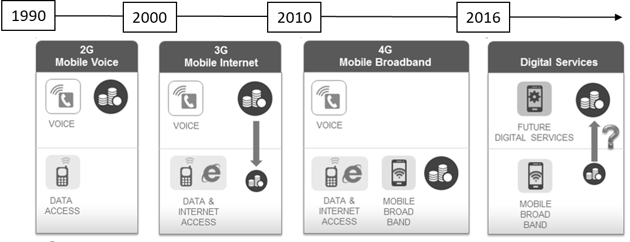

Source: Created by the case author.

EXHIBIT 2: WORLDWIDE MARKET FOR TELECOMMUNICATIONS SERVICES, 1990–2020 (ESTIMATES)

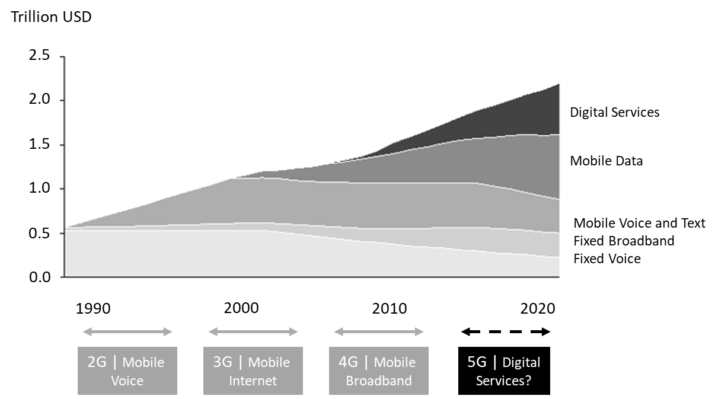

Source: Internal company documents.

EXHIBIT 3: OVERVIEW OF TELENOR’S DIGITAL SERVICES



Note: VoIP = voice over Internet protocol; BD = Bangladesh; PK = Pakistan; IoT = Internet of things; M2M: machine to machine.

Source: Created by the case author.

EXHIBIT 4: POSITIONING OF BUSINESS MODEL ARCHETYPES

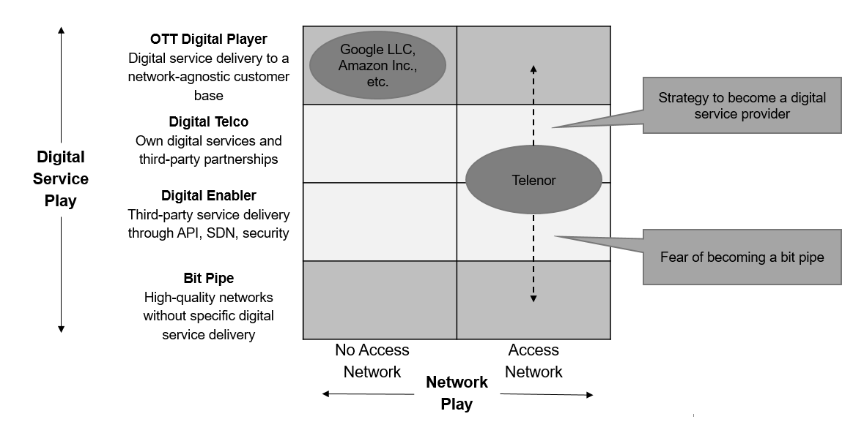

Note: OTT = over the top; telco = telecommunications company; API = application programming interface; SDN = software-defined networking.

Source: Created by the case author.

1. Jorun Sofie F. Aartun and Marte Ramuz Eriksen, “Vi har ikke mye tid [We Don’t Have Much Time],” *Dagens Næringsliv*, April 25, 2016, accessed December 5, 2018, [www.dn.no/nyheter/naringsliv/2016/04/25/1815/Telekom/-vi-har-ikke-mye-tid?v=39178](http://www.dn.no/nyheter/naringsliv/2016/04/25/1815/Telekom/-vi-har-ikke-mye-tid?v=39178).
2. NOK = Norwegian krone; US$1 = NOK8.6142 on January 1, 2019.
3. “The World’s Largest Public Companies,” *Forbes*, accessed May 22, 2019, www.forbes.com/global2000/list/#industry: Telecommunications%20services.
4. “Forecast Growth Worldwide Telecom Services Spending from 2019 to 2023,” Statista, accessed December 5, 2018, www.statista.com/statistics/323006/worldwide-telecom-services-spending-growth-forecast/.
5. “Sigve Brekke New Telenor Group CEO,” Telenor Group, May 12, 2015, accessed December 5, 2018, [www.telenor.com/media/press-releases/2015/sigve-brekke-new-telenor-group-ceo/](http://www.telenor.com/media/press-releases/2015/sigve-brekke-new-telenor-group-ceo/).
6. Tormod Haugstad, “Vi skal bli et verdensledende digitalt fyrtårn [We will become a world-leading digital lighthouse],” Digi.no, February 3, 2016, accessed December 5, 2018, [www.digi.no/artikler/vi-skal-bli-et-verdensledende-digitalt-fyrtarn/320528](http://www.digi.no/artikler/vi-skal-bli-et-verdensledende-digitalt-fyrtarn/320528).
7. Aartun and Eriksen, op. cit.
8. “Our Strategy,” Telenor Group, accessed December 5, 2018, [www.telenor.com/about-us/our-strategy/](http://www.telenor.com/about-us/our-strategy/).
9. “Our Team,” Appear.in, accessed May 22, 2019, https://appear.in/information/team/.
10. “WowBox Reaches 1.5 Million Users,” Telenor Group, October 2015, accessed December 5, 2018, www.telenor.com/media/articles/2015/wowbox-reaches-1-5-million-users/.
11. Ibid.
12. Richard Valmot, “Alt går ikke på skinner for Telenor i Asia [Everything is not going well for Telenor in Asia],” Digi.no, February 25, 2016, accessed December 5, 2018, [www.digi.no/artikler/alt-gar-ikke-pa-skinner-for-telenor-i-asia-men-verdensdelen-er-full-av-muligheter-mener-brekke/320575](http://www.digi.no/artikler/alt-gar-ikke-pa-skinner-for-telenor-i-asia-men-verdensdelen-er-full-av-muligheter-mener-brekke/320575).
13. Haugstad, op. cit.
14. Ibid.
15. Aartun and Eriksen, op. cit.