|  |  |
| --- | --- |
| **Ivey Publishing logo** | Bond University logo |

9B19N001

OptionS TRADING STRATEGIES

Kyle Fernandez wrote this note under the direction of Professor Colette Southam and Gregory Pill solely to provide material for class discussion. The authors do not intend to illustrate either effective or ineffective handling of a managerial situation. The authors may have disguised certain names and other identifying information to protect confidentiality.

This publication may not be transmitted, photocopied, digitized, or otherwise reproduced in any form or by any means without the permission of the copyright holder. Reproduction of this material is not covered under authorization by any reproduction rights organization. To order copies or request permission to reproduce materials, contact Ivey Publishing, Ivey Business School, Western University, London, Ontario, Canada, N6G 0N1; (t) 519.661.3208; (e) cases@ivey.ca; www.iveypublishing.ca. Our goal is to publish materials of the highest quality; submit any errata to publishcases@ivey.ca. i1v2e5y5pubs

Copyright © 2019, Ivey Business School Foundation Version: 2022-09-28

Options trading is a highly appealing investment alternative that can enable investors to profit from both share price movements and non-volatile market environments. This note provides a guide to options trading for entry-level traders and represents a logical next stage to the note *An Introduction to the Pricing of Options*.[1] The note reviews characteristics of options and the factors affecting their valuation, and outlines several trading mechanisms that new options traders might use as they seek their most effective strategies. These mechanisms include long call, short put, bull call spread, short call, long put, bear put spread, short straddle, short strangle, long butterfly, long straddle, and long strangle.

**A BRIEF INTRODUCTION**

Options are financial products that derive their value from an underlying asset. They are leveraged financial instruments that allow traders to make a higher return on a smaller outlay than they might make by investing directly in the underlying asset. Options give traders increased exposure to changes in the value of the underlying asset; that is, traders can profit and lose more with an option than with the underlying asset itself.

Options are bought and sold. A buyer is said to *take* an option, and is thus referred to as a taker. A seller is said to *write* the option, and is thus referred to as the writer.

There are two types of options: call options (calls) and put options (puts). Calls give the holder the right, but not the obligation, to *buy* the underlying asset at a predetermined price (the strike price) before or at the expiration date of the option. Puts, on the other hand, give the holder the right, but not the obligation, to *sell* the underlying asset at a predetermined price before or at the expiration date. Both calls and puts share the same uniform characteristics: premiums, maturity, strike price, an underlying asset, and option style.

**OPTION CHARACTERISTICS**

**Premium**

A premium is the amount a buyer pays to receive the option; that amount changes on a daily basis. When a trader buys an option (takes a long position), the trader pays the premium. When a seller writes an option (takes a short position), the seller receives the premium. The premium compensates the option seller for taking on the risks associated with writing the option.

The premium for an option is the sum of the option’s intrinsic and time values. The intrinsic value is the difference between the strike price and the current market price of the underlying asset. The time value represents the amount a buyer is willing to pay for the possibility that the market will move before the option expires. As the amount of time available decreases, the opportunity to become profitable declines; this decline in value is referred to as time decay. Time value is influenced by several factors: market volatility, time to expiry, future dividends, and interest rates.

**Maturity**

Maturity is the time remaining between the date the option is purchased and the date the option expires. The majority of options bought and sold have a maturity of a month. However, the Australian Securities Exchange (ASX) and the Chicago Board Options Exchange (CBOE) list both options that expire in a month and those that expire in a week, providing traders with a choice of maturity. When deciding on a trading strategy, traders need to consider when and over how much time (the time period) their predicted event or movement will occur. As the needed amount of time increases (the maturity gets longer), the associated premium increases because the option writer takes on a greater risk.

**Strike Price**

Strike price is the predetermined price a buyer will pay if exercising the option to purchase the underlying asset. The strike price is locked in with the options contract. For instance, on August 19, 2016, Commonwealth Bank of Australia (CBA) stock was trading at A$73.12.[2] Assume a trader believed the share price was going to rise, so took a long position in a call option—that is, took an option to purchase the underlying asset—with a strike price of $73.00. The trader would have the right to buy CBA shares at $73.00, regardless of the market price, up to the option’s expiry date.

**Underlying Asset**

Each option derives its value from an underlying asset. Options on both the ASX and the CBOE derive their value from either equities or indexes. The CBA example discussed above under “Strike Price” would be classified as an equity option because the option value is derived from an individual company’s stock. In contrast, the value of an index option is derived from the underlying index (e.g., S&P500). Options less frequently use commodities as the underlying asset; commodities traders prefer trading with other derivative instruments such as futures and forwards.

**Option Style**

There are two option styles available on the ASX: American and European. An American style option allows the option holder to exercise the option at any time, up to and including the expiry date; European style options, in contrast, can only be exercised at maturity. Index options are all European style, while equity options can be either style, based on trader preferences. CBOE equity options are all American style.

American and European style options are the most frequently used styles; however, there are numerous other styles. The styles vary mainly in terms of the rights to exercise the options; for example, a Canary option allows the option holder to exercise the option at quarterly dates but not before a set period of time has elapsed. Another, a Bermudan option, gives the holder the right to exercise the option a set number of times prior to maturity.

**Contract Size**

All single stock options traded on the ASX have an initial standardized contract size of 100 underlying shares. On rare occasions, the contract size may be adjusted to compensate for corporate actions on the underlying asset, such as issuing new shares.[3] In general, a standardized contract size means a trader who has purchased a call option on CBA stock would have the right, but not the obligation, to purchase 100 CBA shares at the predetermined price any time up to the option’s maturity.

Index options (e.g., XJO) are usually standardized at an index multiplier of $10 per index point movement.

Equity options traded on CBOE also have a standard contract size of 100 shares; however, their index options have varying amounts for the index multiplier, dependent on the underlying index.

**Factors Influencing Option Price and Value**

There are several factors that affect the value and price of an option. When investing directly in an equity, the trader’s only concern is price movement: did the share increase or decrease in price? The value of an option, however, depends on several factors: volatility, intrinsic value, movement of the underlying asset price, expiry date, interest rate changes, and dividends.

**Volatility**

Volatility captures the variation in price expected in the underlying equity, or in the case of index options, the variation in the underlying index. The variation is measured by the standard deviation of returns; that is, how much the price or index deviates from the mean. When an underlying equity asset is highly volatile, the share price fluctuates widely, increasing the chances that the anticipated price of the shares will be reached. The premium paid for the option is, thus, greater. When the implied volatility is low, the price for the underlying equity is predicted to be reasonably constant, and the premium paid for the option will be less. As implied volatility increases, the value of both calls and puts increases, and as implied volatility decreases, option values decrease accordingly.

The ASX and CBOE each have real-time volatility indices (see Exhibits 1 and 2). The ASX has the A-VIX, which reflects expectations about volatility in Australia’s equity index, the S&P/ASX 200 VIX. The CBOE tracks the Volatility Index (VIX), which is based on the S&P 500 Index. Both the A-VIX and the VIX provide insight to expectations of market volatility and the sentiment of futures traders. The A-VIX has a strong negative correlation (inverse relationship) with the underlying S&P/ASX 200 index (see Exhibit 3), and is therefore a useful tool for assessing the market trend and anticipated changes in volatility.

**Intrinsic Value**

The intrinsic value of an option is largely dependent on the strike price set in the option.

If, on August 19, 2016, when the market price of CBA was $73.50, a trader took a long call position on CBA stock with a strike price of $65.00, the intrinsic value of the option would have been $8.50 (the difference between the market and strike prices). When a share price on the market is greater than the strike price in a call option (as in this example), the option is said to be “in the money” (ITM). Option buyers pay a high premium for this valuable option.

If, on the same day, another trader took a long call position in CBA stock with a strike price of $73.50, the current market price and the strike price would be the same. This call option would be considered to be “at the money” (ATM). ATM options have no intrinsic value, but because the market price is almost certainly going to change over time, ATM options have the greatest time value. A premium for an ATM option is usually less than the premium for an ITM option.

In the final scenario, if yet another a trader on the same day took a long call position in CBA stock with a strike price of $75.00, the current market price would be less than the strike price. When the strike price is higher than the market price, the call option is said to be “out of the money” (OTM). OTM options have no intrinsic value and have a smaller chance of success than ITM or ATM options. OTM options require the most price movement in the underlying asset to be ITM. The premium on an OTM option is significantly less than the premiums for ITM and ATM options. Therefore, the advantage to buying an OTM option is the potential, even if small, for a significant return on a very low premium.

**Movement of the Underlying Asset Price**

The price movements of the underlying asset play a key role in determining the value of an option. If the price of the underlying asset is increasing, the value of a call option (the opportunity to buy the underlying asset at a fixed lower price) increases and the value of a put option (the opportunity to sell the underlying asset at a below market price) decreases. When the price of an underlying asset is decreasing, the opposite is true: the value of call options decreases, and the value of put options increases.

**Expiry Date**

The more time there is before an option expires, the greater the chance the option will end ITM. Time decay (decline in the opportunity to become profitable) has the greatest negative impact on the value of an option. Typically, an option loses one-third of its time value in the first half of its life, and the remaining two-thirds of time value in its second half. An OTM option approaching expiry will suffer the greatest drop in value.

**Interest Rate Changes**

Interest rate changes have a small, but measurable, impact on option prices. When interest rates increase, call premiums increase and put premiums decrease. This occurs because call buyers have the right to purchase the underlying asset at any time up to expiry; until they decide to exercise their option (or not), call buyers can invest their funds at higher yielding, risk-free rates. Call buyers, in this case, are earning income while holding the option. Put prices decrease because put buyers have the right to sell the underlying asset any time up to maturity. They are holding the underlying asset, so do not have the ability to invest their funds at higher risk-free rates. Traders, in this case, have the benefit of purchasing put options at a lower premium.

**Dividends**

Option prices are affected by anticipated dividends to be paid on the underlying asset within the option’s term (i.e., before expiry). The general consensus is that when a dividend is paid out on a stock, the share price will drop in proportion to the dividend paid. Therefore, if a dividend of an underlying asset increases during the term of the option, the value of the underlying asset will likely decrease before the option expires. This affects the option’s premium: call premiums decrease and put premiums increase.

(When assessing the impact of dividends, it is important to remember that a share’s ex-dividend date—the date when a declared dividend belongs to the holder of the stock—is usually earlier than the date the dividend payment will be made.)

**Option Value Sensitivity Measures**

*Delta* is a sensitivity measure comparing the change in an option’s price to the change in the price of the underlying asset. We can estimate the likely change in an option’s price by multiplying the underlying asset price change by the option’s delta. Delta also infers the intrinsic value of an option and constantly changes with price movements in the underlying asset.

All call options have a delta range of zero to one. A delta below 0.5 implies the option is OTM; a delta of exactly 0.5 implies the option is ATM; and a delta above 0.5 implies the option is ITM.

All put options have a delta range of zero to negative one. A delta above −0.5 (approaching zero) implies the option is OTM; a delta of exactly −0.5 implies the option is ATM; and a delta below −0.5 (approaching negative one) implies the option is ITM.

*Vega* is also a sensitivity measure. It measures the impact of changes in the underlying asset’s volatility on the option’s price. The vega of an option represents the amount that an option’s contract changes in relation to a 1 per cent change in the underlying asset’s volatility.

Besides delta and vega, there are other “Greeks” measuring option sensitivities. For example, *theta* measures the change in an option’s price as the number of days until expiration decreases; theta is usually measured by one day. *Rho* measures an option’s change in premium if interest rates move by a specified percentage. *Gamma* measures the option’s delta change if the underlying asset moves by a specified percentage. (Further information on options Greeks is available on ASX’s website.[4])

**Options at Expiration**

When an option expires—which for monthly single stock contracts listed on the ASX is every Thursday before the last Friday of the month and on the CBOE is the third Friday of the month—the option holder faces three alternatives: exercise the option, sell the option, or roll the option into another option if the held option is ATM or ITM. If the held option is OTM at expiration, the option expires worthless. Tree diagrams demonstrate the call and put option holder’s choices at expiration (see Exhibits 4 and 5).

**Market Participants**

Options market participants include hedgers, speculators, arbitrageurs, and market makers. *Hedgers* use options to reduce the risks associated with market uncertainty. *Speculators* use options to leverage into a position to capture gains based on the direction they believe a market is going. *Arbitrageurs* exploit imperfections and inefficiencies in the market, often at very high speeds, to make money. *Market makers* trade volatility (vega) as opposed to market movements (delta).

Traders normally fall into the categories of hedgers or speculators. Brokers and dealers represent investors and place orders on their behalf for execution on the exchange (central market).

There are four types of trades that an options market participant can make:

* Buy a call.
* Sell a call.
* Buy a put.
* Sell a put.

Option holders, called buyers or takers, can choose whether or not to exercise the option. These participants could be hedging their current shareholdings from price risk, or they could be investing in these leveraged derivatives to get greater exposure to the predicted price movement in their underlying asset. Losses for option holders are limited to the premium paid for the option (if the option expires OTM); however, option holders have the potential to earn unlimited profits if the option expires ITM.

Option providers, called sellers or writers, provide option holders with the right to exercise the option. That means that option providers are obligated to buy or sell the underlying asset if the holder decides to exercise the option. Thus, option providers limit their profit to the premium received for providing the option; however, they have potentially unlimited losses if the option expires ITM (with the market price higher than the strike price). For this reason, option sellers are required to lodge a margin to ensure they can meet their obligations if an undesirable outcome occurs.

Exhibits 6, 7, 8, and 9 provide profit and payoff diagrams of the four options trades. The four trade types, when combined in different ways, create different strategies for trading options.

**ANALYSES**

An options trader needs to be able to make a market prediction and set an investment goal before selecting a trading strategy.

**Market Prediction: What do you think will occur in the future?**

An options trader must first predict what will happen to an underlying asset over a given period. Most traders will use some type of analysis, whether it be fundamental or technical, to determine what they believe will happen to an underlying asset, whether a stock or an index. The analysis should consider when and over what period of time the underlying asset is expected to move. For example, a trader’s prediction may be linked to a type of planned market announcement, such as company results, or to a piece of economic news, such as a change to the reserve bank cash rate.

Once the investment period and expected price movement are calculated, traders need to add their own (or their investors’) risk profiles to the decision to decide what strike price and maturity to use within an options strategy. It is fair to say that the more a trader risks, the more a strategy will return.

**Investment Goal: What are you trying to accomplish using options?**

Knowing what is wanted from an investment will reduce the number of option strategies to those appropriate for reaching the desired goal. An investor may want to protect the value of held shares in the event the market goes down, or an investor may want to earn extra income from held stocks while markets are flat.

To illustrate these goals, assume the market analysis indicates stock XYZ will rise 2 per cent in the next four months (the prediction) and the investor wants to earn extra income (the goal). A trader could sell a 102 per cent strike call option with a maturity of four months, meaning the option holder can purchase the investor’s shares at 102 per cent of their value at any point during or at the end of the four months. The prediction is that the investor will not have to sell the shares (because the market and strike price are the same), and the investor earns the premium paid by the option buyer. However, if the analysis is slightly out—say, for example, the investor’s stock goes up 2.5 per cent—the option holder will exercise the option to purchase the shares and the investor will need to deliver them, meaning the investor will have sold the stock at a loss. If the trader was writing a call option to gain income on a stock position, this would not be the desired result.

To reduce the risk of the option being exercised (also called “assigned”) and keep the underlying stock, the trader may want to consider writing a call option with a shorter maturity date (three months) or a higher strike price (103 per cent), or possibly both. In either case, the option premium would be less.

**Tools for Analysis**

Traders now have multiple tools they can use to analyze option strategies and choose which are the best to use under certain conditions. An example of one of these tools is the ASX/TradeFloor options trading simulator,[5] which was developed to help first-time options traders understand how options work. Within this application, traders can review stocks they are interested in, build different option strategies based on their views of where an underlying asset may trade in the future, and manage their portfolios. The application allows traders to investigate the payoffs and risk profiles of using different strategies while also allowing the trader to see how a particular risk profile of a given strategy changes when using different strike prices and maturities.

Fundamental Analysis

Fundamental analysis involves evaluating the intrinsic value of a company. It involves the use of balance sheets, financial reports, cash flow statements, public announcements, earnings reports, and all publicly available information to establish an opinion about the direction and outlook of the company. There are numerous methods for determining a fair share value; that value can then be compared to the current market price, which in turn signals the direction of price movement.

Earnings per Share

Earnings per share (EPS) provides information about the earnings attributable to each outstanding share.[6] This ratio is easily calculated by dividing a company’s net profit after tax by its total number of shares outstanding. Traders prefer an EPS to be growing at a consistent rate, which suggests a bullish outlook, while a decreasing ratio implies a bearish outlook.

Price to Earnings Ratio

The price to earnings (P/E) ratio provides information about a company’s growth prospects and indicates whether the company’s shares are currently over, under, or fairly priced.[7] The ratio is calculated by dividing the share’s current market price by its EPS. In isolation, the P/E ratio is meaningless; for meaningful information, a company’s P/E ratio needs to be compared to that of a similar company.

The P/E growth (PEG) ratio further aids in determining whether an equity is under- or overpriced. The PEG ratio is calculated by dividing the P/E ratio by the expected rate of growth in EPS. A PEG ratio close to 2 suggests that the stock is overpriced, and a PEG ratio of 1 suggests the stock may be fair value.

Dividends

When analyzing a company, the trader must determine whether the company pays a regular dividend on the equity. A dividend that is maintained or increased from the previous year signals to the market that the company is in good financial health. A dividend that is reduced signals that the company does not have sufficient profits each year to pay its shareholders.

To calculate a dividend per share ratio, divide the sum set aside for dividends by the number of shares outstanding.

Dividend yield is a good method for comparing dividends paid out from companies in similar industries. To calculate dividend yield, divide the dividend payout per share by the current share price. Companies with growing dividend yields suggest a bullish outlook, and companies with decreasing yields suggest a bearish outlook.

Return on Equity

Return on equity (ROE) provides information about how well a company is using shareholders’ funds.[8] This ratio is calculated by dividing the company’s after-tax profit by the shareholders’ equity. A high ROE suggests that management is making good use of shareholders’ funds, while a low ROE suggests the contrary.

Earnings Reports

It is essential to know when companies are due to release any earnings reports or announcements. These releases can have a profound effect on share price. If a company were to report mass losses for a quarter, the information could initiate a massive sell-off in the market, which would cause a large drop in share price. Alternatively, the company could publish profits higher than expected, which would cause an increased demand for the company’s shares and, hence, a rise in share price.

Technical Analysis

Technical analysis consists of studying past market data, specifically the price and volume, to predict future price direction. There are a vast number of technical indicators that traders use to forecast price movements. In this note, we will focus on the use of trend lines, Bollinger bands, moving average convergence divergence, and relative strength indicators to evaluate a company.

*Trend Lines*

Trend lines are highly suggestive of the direction a stock price will move. Support and resistance lines are established for the desired period of time: the support line illustrates the lowest price traders believe the share will fall to, and the resistance line indicates the highest share price traders believe the share will earn. Technical analysts believe that a share will trade between the two lines and that the price is unlikely to fall below a support line or rise above the resistance line. Analysts believe that if a resistance or support line is broken, once it is broken, the share price will continue in the direction of the breakout, requiring a new resistance or support line to be established (see Exhibit 10).

There are numerous patterns that technical analysts seek with trend lines (see Exhibits 11 and 12 for uptrend and downtrend, respectively). An ascending triangle occurs when an up-trending support line approaches a flat resistance line. This suggests the share may well make a sharp move upward for an explosive breakout*.* A descending triangle, where the down-trending resistance line approaches a flat support line, signals the opposite—a large price drop (see Exhibit 13 for a descending trend line).

*Bollinger Bands*

Bollinger bands are used to establish a share’s short-term prices. The indicator is created by plotting the average predetermined number of prices. Two trading bands are then added, representing the standard deviation of the share price, one band above (the highest price) and the other below (the lowest price) the centre line. Simply adding and subtracting one standard deviation from the moving average creates the outer bands. Under normal market conditions, the price of a security will trade within the bands. The bands will expand as the share price becomes more volatile and contract as volatility decreases.

Bollinger bands help establish common trends. Periods of high volatility (expansion) tend to follow periods of low volatility (contraction). When the price of a share crosses the upper Bollinger band, analysts believe the share is overbought and the price is due for a correction with a drop (a pullback). When the price crosses the lower band, analysts believe the security is oversold and a price correction back up to its true value (rally back) is imminent (see Exhibit 14)*.*

*Moving Average Convergence Divergence*

Moving average convergence divergence (MACD) is a momentum indicator that analysts use to establish a buy or sell signal. MACD illustrates the relationship between two moving price averages. The MACD is the result of subtracting the 26-day exponential moving average (EMA) from the 12-day EMA. A 9-day EMA of the MACD, termed a signal line, is then plotted on top of the MACD. When the MACD falls below the signal line, it is a bearish signal. When the MACD rises above the signal line, it is a bullish signal (see Exhibit 15).

*Relative Strength Indicator*

A relative strength indicator (RSI) is also a momentum indicator; it compares the magnitude of recent gains and losses over a specified time period to gauge the speed and change of a share’s price movements. RSI is used to identify overbought and oversold conditions. If RSI values cross above 70, it is believed that the security is overbought and due for a pullback in price. If the RSI values cross below 30, the share is believed to be oversold, and a price increase is due (see Exhibit 16).

**Option Strategies**[9]

There are many option strategies available for varying market conditions. We will analyze a select few strategies for bullish, bearish, neutral, and event-driven situations.

It is important to understand the risks involved with trading options. Buying an option with the expectation that the value of the underlying asset will increase limits the buyer’s potential loss to the premium paid for the option. Providing or writing an option, however, exposes the trader to the potential of unlimited losses; for that reason, the provider must have a margin account containing collateral.

To analyze the selected strategies, we will focus on the construction, margin requirement, market outlook, and profit and loss of the strategies. For the purpose of explanation, a hypothetical strike prices has been added for the following strategies.

**Bullish View**

Bullish strategies do better in a rising market. They usually involve buying call options and selling put options to benefit from increasing asset prices.

Long Call (see Exhibit 6)

When a trader expects the price of the underlying stock to rise, the bought call can provide leveraged exposure to the price increase. Buying a call also locks in a maximum purchase price for the life of the option.

*Construction*: Buy one call at strike price A.

*Margin requirement*: No

*Market outlook*: Bullish view on stock; share price will rise above A; volatility increasing.

*Profit*: Unlimited profit potential if share price continues to rise (see Exhibit 6).

*Loss*: Limited to premium paid.

*Break-even*: Share price = strike price + premium paid.

*Intuition*: Share price will rise above A; the call option’s value will increase accordingly for a profit.

Other points of consideration:

* Effect of time decay works against the buyer of the call. If the expected rise in share price does not take place soon after entering the position, time decay will erode the value of the option.
* The trader will usually have a choice of strike prices and must balance the cost of the option against the rise in share price required for the strategy to be successful. The OTM option will be the cheapest but will also require the largest rise in share price. Many traders regard the ATM option as offering the best balance of risk and reward.
* A longer-term option allows more time for the share price to rise and will be more expensive than a shorter-term option. The trader needs to decide when and over what period of time the share price is expected to move.
* If the rise in share price takes place as expected, the option buyer must decide whether to close out at a profit or maintain the position in the hope of a further increase in price. The longer the option position is left open, the greater the effect of time decay.
* If the share price does not rise as expected, it is often advisable to exercise the option (“close out the position”) and recover some time value on the investment.
* If the option is ITM when it expires, the trader must choose whether to sell the option or exercise it. The choice will be determined by whether the trader wants to own the underlying shares.

Bull Call Spread

If the trader is not bullish enough to buy a call outright but expects the share price to rise moderately, the bull spread is a lower-cost way to gain exposure to such a market movement. The strategy consists of the simultaneous *purchase* of a call option (“long leg of the spread”) and *sale* of a call option with a higher strike price (“short leg of the spread”), but with the same expiration date.

*Construction*: Buy one call at strike price A, and sell a call at strike price B.

*Margin requirement*: No

*Market outlook*: Bullish; market price to rise; volatility steady to rising.

*Profit*: Limited to the difference between A and B (spread) less the premium paid for the spread.

*Loss*: Limited to the premium paid for the spread.

*Break-even*: Share price = lower strike price + cost of spread.

*Intuition*: Bought call A will be ATM (hence costly); therefore, sell an OTM call with higher strike price B to receive a premium that reduces the overall cost of the strategy.

Other points of consideration:

* The bull spread has limited risk and limited reward. It is a cheaper strategy than simply buying a call option. As a result, the profit potential is reduced.
* The trader must be satisfied that the cost of the spread is worth the potential reward. Commission costs on entering and exiting will be greater for this strategy than when buying a call outright.
* Time decay will vary depending upon where the share price is. If the market is around the lower strike price, the option will cost money; however, if the stock is trading around the higher strike price, the option will make money.
* If the stock unexpectedly rises sharply, it may be advisable to exit the strategy once the upper strike price is reached. Although time value is helpful around the strike price of the short call, unwinding the strategy early removes the risk that the short call will be exercised. If the stock price falls suddenly, the spread may be unwound before the long call loses too much time value.
* Consider the bull spread when expecting a limited rise in the price of the stock.
* Do not enter the call options separately (“leg in” to the strategy). Enter the trade as a spread and unwind it as a spread.

**Bearish View**

Bearish strategies work best in falling markets. Bearish strategies generally rely on buying put options to lock in selling prices as asset prices decrease.

Long Put (see Exhibit 8)

When the trader expects the price of the underlying stock to fall, the bought put provides leveraged exposure to the price fall. Buying a put option is one of the few ways traders can speculate on a falling share price. Put options may also be used to protect an investor’s holding in the underlying stock.

*Construction*: Buy one put at strike price A.

*Margin requirement*: No

*Market outlook*: Bearish; market price to fall below A; volatility rising.

*Profit*: Limited to strike price less premium paid for the option (see Exhibit 8).

*Loss*: Limited to premium paid for the option.

*Break-even*: Share price = strike price − premium paid.

*Intuition*: Share price will drop below strike price A; the put option’s value will increase accordingly for a profit.

Other points of consideration:

* Time decay works against the buyer of the put. If the expected share price fall does not take place soon after entering the position, time decay will start to erode the value of the option.
* When setting the strike price, the trader must balance the cost of the option against the fall in share price required for the strategy to be successful. The OTM option will be the cheapest but will also require the largest fall in share price.
* If the trader is buying a put to protect a shareholding, the cost of the option must be weighed against the required protection. The ITM option locks in the highest sale price for the underlying shares but is also the most expensive option.
* If the fall in share price takes place as expected, the put option taker must decide whether to close out at a profit or maintain the position in the hope of a further increase in price. The longer the option position is left open, the greater the effect of time decay.
* If the share price does not fall as expected, it is often advisable to close out the position to recover some time value.
* At expiry, the holder of an ITM put option will usually close out, rather than exercise, the position (unless the holder owns the underlying shares). If the put has been bought to protect a shareholding, the trader must decide whether to continue holding the stock, in which case the put would be sold, or sell the shares, in which case the option would be exercised.

Short Call (see Exhibit 9)

When the trader expects the price of the underlying stock to go down, the sold call can provide leveraged exposure to the price reduction. Selling a call does not limit the trader’s potential loss, so it carries a greater risk profile than purchasing a put.

*Construction*: Sell one call at strike price A.

*Margin requirement*: Yes

*Market outlook*: Bearish; share price will go below strike price A; volatility neutral to reducing.

*Profit*: Maximum profit is premium received for providing the option (see Exhibit 9).

*Loss*: Maximum loss is unlimited.

*Break-even*: Share price = strike price − premium received.

*Intuition*: The option will expire worthless; the premium received for providing the option will be pocketed.

Other points of consideration:

* Time decay works for the seller of the call. If the expected share price reduction does not take place soon after entering the position, time decay will start to erode the value of the option to the seller’s advantage.
* The trader will usually have a choice of strike prices and must balance the premium received on the option against the reduction in share price required for the strategy to be successful. The OTM option will obtain the lowest premium but also carries the lowest chance of loss. Many traders regard the ATM option as offering the highest risk and reward.
* A longer-term option allows more time for a reduction in the share price to take place. It will generate a higher premium, but it carries a greater risk of the market moving against the trader.
* The trader needs to identify the time period over which the share price movement is expected to take place. If the share price reduction takes place as expected, the call option taker will normally not exercise the option. However, if the stock price is ATM or ITM and the taker exercises the option, the writer must deliver the stock.
* If the share price does not reduce as expected, it is often advisable to close out the position to remove the risk of assignment if not already holding the underlying shares. This is called a “naked” position since you hold an option on shares you do not own and would have to acquire these shares if the option were exercised. Assignment risk brings the uncertainty associated with the pricing and timing of acquiring the shares before you can sell them.

Bear Put Spread

The bear spread can be considered when the trader expects a moderate fall in the market but is not prepared to take a put position outright. The strategy consists of the purchase of a put option (“long leg”) and the sale of a put option with a lower strike price (“short leg”).

*Construction*: Sell one put at strike price A, and buy one put at strike price B.

*Margin requirement*: No

*Market outlook*: Bearish; market price to expire below strike price A; volatility steady to increasing.

*Profit*: Maximum profit is limited to the difference between A and B (the spread) less the premium paid.

*Loss*: Maximum loss is limited to the premium paid for the spread.

*Break-even*: Share price = upper strike − cost of spread.

*Intuition*: Purchased put B will be ATM—hence, fairly costly. Therefore, sell an OTM put with a lower strike price A to receive a premium, which decreases the total net cash outlay. Once the share price drops below strike price A, the profit is capped. (A short position creates a loss; however, this is counterbalanced by the purchased put being deep ITM.)

Other points of consideration:

* The bear spread has limited risk and limited reward. It costs less to place than an outright purchase of a put option. As a result, the potential for profit is also reduced.
* The trader must be satisfied that the cost of the spread is justified by the potential reward. Commission costs on entering and exiting can significantly reduce profitability.
* Time decay will vary depending upon where the share price is. If the market is around the lower strike price, the impact of time decay will be positive and you will make money due to the strategy; if the stock is trading around the higher strike, it will cost money to hold the strategy.
* If the stock unexpectedly falls sharply, it may be advisable to exit the strategy once the lower strike price is reached. Time decay will benefit the spread around the lower strike price; however, the trader will usually be more concerned with avoiding exercise on the short leg.
* If the stock price rises suddenly, the spread may be unwound before the taken put loses too much time value.
* Use the bear spread when you are expecting a limited fall in the underlying stock.
* Do not leg in to this strategy; rather, trade both options at the same time.

**Neutral View**

Neutral strategies work best in stagnant markets. They often involve balancing the purchase and sale of both call and put options to take advantage of any changes in underlying asset prices.

Short Put (see Exhibit 7)

The written put can provide the trader with extra income in flat to rising markets. It can also be used as a way to buy stock cheaply. This strategy is generally used when the trader expects the share price to remain steady or increase slightly over the life of the option.

*Construction*: Sell one put at strike price A.

*Margin requirement*: Yes

*Market outlook*: Bullish view on stock; share price will expire above A; volatility falling.

*Profit*: Limited to premium received (see Exhibit 7).

*Loss*: Maximum loss equals strike price A less premium received.

*Break-even*: Share price = strike price − premium received.

*Intuition*: The option will expire worthless; the premium received for providing the option will be pocketed.

Other points of consideration:

* Many traders write put options as a way of buying stock cheaply. If the share price falls and the option is exercised, the purchase price is effectively the strike price of the option less the premium received, which is less than the price of the stock at the time of writing the option. If the share price at expiry is above the strike price, the option will expire worthless. The trader does not get to buy the stock but has benefited from the receipt of the premium.
* Time decay works in favour of the put writer. If the stock price stays steady, the ATM option will deliver the most profit to the put writer because this is the option with the most time value.
* The put writer must be wary of exercising the option too early. Generally, a put option is more likely than a call option to be exercised early.
* This strategy can result in heavy losses if the share price falls significantly. Puts should only be written if the seller has the financial capacity to buy the underlying shares should the option be exercised.
* Monitor the position closely. An ITM option will need to be closed to avoid exercise.

Short Straddle

When option premiums are overpriced and the trader believes the underlying shares will stay within a narrow price range, the short straddle may be considered. This strategy has a higher potential profit than the short strangle; however, it offers less protection since the share price remains within a tighter price range in order to profit. The strategy consists of the sale of a call option and a put option with the same strike price.

*Construction*: Sell one call at A, and sell one put at A.

*Margin requirement*: Yes

*Market outlook*: Neutral; share price will expire around A; volatility reducing.

*Profit*: Maximum profit limited to combined premium received for providing options.

*Loss*: Maximum loss is unlimited on the upside and limited on the downside to the strike price less the premiums received.

*Break-even*: Share price = strike price +/− premium received.

*Intuition*: The break-even point for the sold call A is the strike price plus the premium received. For the sold put A, the break-even point is the strike price less the premium received. These distinctive break-even points create a spread in which the trader expects the underlying asset to remain, hence causing the option to expire worthless, and the premiums received to be pocketed.

Other points of consideration:

* The straddle yields higher potential profit than the strangle because of the higher premiums received for writing ATM options. However, the strategy provides less protection against an unexpected increase in volatility in the underlying shares because the share price does not have to move as much before the strategy incurs a loss for the writer.
* The short straddle benefits from time decay. It is often best to construct this combination using options with near-month expiries to gain the most from time decay.
* There is high risk of early exercise on one of the written options making up the straddle because both the call and the put have the same exercise price. Unless the stock price closes at the strike level set in the options, one of the options will be ITM and more than likely be exercised.
* The options trader may choose to limit potential losses by purchasing protection. Taking a call and a put, both of which are further OTM than the written options, places a ceiling on losses. While the cost of taking these options reduces potential profit, it may be worthwhile for the conservative trader.
* If the share price stays within a narrow band as expected, the position may be maintained until near expiry in order to gain the maximum benefits from time decay.
* If the share price makes an unexpected move, the trader should consider closing out the option that would be in danger of being exercised. Another alternative is to vary the break-even points of the strategy by rolling one of the legs up or down (by increasing or decreasing the strike prices in one of the options), thereby creating a strangle.
* Because the potential is for unlimited losses, be sure that the premium received is worth the risk taken.
* Do not choose distant expiry months.

Short Strangle

When option premiums are overpriced and the trader believes the underlying shares will stay within a narrow price range, the short strangle may be considered. This strategy has a lower potential profit than the short straddle; however, it offers greater protection because the share price must move further to cause a loss. The strategy consists of the sale of a call option with a higher strike price and a put option with a lower strike price.

*Construction*: Sell one call at B, and sell one put at A.

*Margin requirement*: Yes

*Market outlook*: The option will expire between strike prices A and B; volatility falling.

*Profit*: Maximum profit is limited to the combined premiums received for providing options.

*Loss*: Maximum loss is unlimited on the upside and limited on the downside to the strike price less the premiums received.

*Break-even*: Share price = higher strike + premium received; Share price = lower strike − premium received.

*Intuition*: The intuition for the short straddle also applies here. The difference is that with the short strangle, both options have distinctive strike prices. This extends the spread (bounds) within which the trader expects the share price to remain. This strategy would be beneficial for an underlying asset with higher implied volatility, while the short straddle is better in a less volatile environment.

Other points of consideration:

* The strangle yields lower potential profit than the straddle because the premiums are lower for writing OTM options. However, the strategy provides better protection against an unexpected increase in volatility in the underlying shares because the share price has to move further before the strategy incurs a loss for the writer.
* As with the short straddle, the short strangle benefits from time decay. It is often best to construct this combination using options with near-month expiries to gain the most from time decay.
* Because the strangle is constructed using OTM options, there is a lower risk of early exercise than for the straddle. However, a dramatic change in the share price can bring one of the options ITM, thereby introducing the risk of exercise.
* The option trader may choose to limit potential losses by purchasing protection. Taking a call and a put, both of which are further OTM than the written options, places a ceiling on losses. While the cost of taking these options reduces potential profit, it may be worthwhile for the conservative trader. By taking protection, the short strangle is transformed into another strategy known as a “long condor.”
* If the share price stays within a narrow band as expected, the position may be maintained until near expiry in order to gain the maximum benefits from time decay.
* If the share price makes an unexpected move, the trader should consider closing out the option that would be in danger of being exercised. Another alternative is to vary the break-even points of the strategy by rolling one of the legs up or down, thereby maintaining the strangle. The trader should always be aware that although the short strangle is a more defensive strategy than the short straddle, a sudden and extreme change in volatility can be very damaging.
* Because of the potential for unlimited losses, be sure that the premium received is worth the risk taken.
* A trader should use the short strangle over the short straddle if there are any doubts about the market’s neutrality.
* Do not choose expiry months that are too distant.

Long Butterfly

The long butterfly can be used to generate extra income when the trader believes the market is stagnating but does not want to be exposed to an unexpected rise or fall. The strategy consists of buying one ITM and one OTM call and writing two ATM calls.

*Construction*: Buy one call at A, sell one call and one put at B, and buy one put at C.[10]

*Margin requirement*: No

*Market outlook*: Neutral; market price will expire around B; volatility reducing.

*Profit*: Maximum profit will occur at strike price B.

*Break-even*: Share price = lowest strike price (A) + the cost of strategy; Share price = central strike price (B) − the cost of strategy.

*Loss*: The maximum loss is limited to the premiums paid for the strategy.

Other points of consideration:

* The maximum profit from the long butterfly will be earned if the market finishes at the middle strike price when the options expire. In this case, only the lower strike price call will finish ITM. Accordingly, the trader will profit on the difference between the middle and lower strike prices, less the cost of the spread. Most of this profit will develop in the last month, as time decay accelerates. The most the trader can lose is the cost of the spread, which will occur if the market finishes out past either “wing” of the long butterfly.
* The presence of short options in the strategy means that an increase in the market price above the central strike price introduces the risk of exercise.
* The long butterfly can be difficult to place in all but the most liquid stocks. The ATM options that are required on both sides are often thinly traded (exchanged in low volumes with limited interested traders), making the strategy difficult and sometimes costly to set up and trade out. In these circumstances, the reward may not justify the effort of entering the position.
* If the share price remains steady, the position may be left until close to expiry since the profit develops almost entirely in the last month.
* If the share price moves sharply up, the trader may consider liquidating the position in order to avoid exercise. If the share price moves sharply down, the trader may close out in order to salvage some time value from the taken options in the strategy.
* Be sure the rewards are sufficient to justify establishing the strategy in the first place.
* Do not use this strategy on thinly traded stocks.
* Enter the position with at least a month until expiry.

**Event Driven (Price Break Out)**

Long Straddle

When the trader expects a sharp movement in the share price but is unsure of the direction the movement will take, the long straddle may be appropriate. The strategy consists of buying a call option and a put option with the same strike price.

*Construction*: Buy one call at A, and buy one put at A.

*Margin requirement*: No

*Market outlook*: Volatile; unsure of the direction of stock—however, a large price movement is imminent.

*Profit*: Maximum profit is unlimited on the upside; on the downside, the maximum profit is limited to the strike price less premiums received.

*Loss*: Maximum loss is limited to the premium paid for the options.

*Break-even*: Share price = strike price +/− premium paid.

*Intuition*: The break-even point for the bought call A is the strike price plus the premium received. The break-even for the bought put A is the strike price less the premium received. These distinctive break-even points create a spread in which the trader does not expect the underlying asset to remain, hence causing the option value to increase.

Other points of consideration:

* The bought straddle consists of two long positions. As a result, time decay works strongly against the strategy. The longer the straddle is left in place, the greater the loss due to time decay. The position must, therefore, be closely monitored and may need to be closed out well before expiry.
* The trader must balance the cost of the strategy against the time needed to give it the best chance of success. Distant expiry months will provide the strategy with more time; however, longer-dated options will be more expensive than those with shorter dates.
* The taker of a straddle expects volatility in the market to increase. Only rarely will this strategy be held to expiry. If the trader’s market view proves correct, the straddle should be unwound to crystallize the profits. The position can be liquidated on both sides simultaneously or, if the OTM option has little value, it could be left open in the event the market were to reverse.
* If volatility does not increase as expected, the strategy should be unwound well ahead of expiry, before time decay damages the position.
* Choose options over shares if the market is expected to remain or become volatile.
* Select an expiry month that gives the strategy time to work.
* Monitor the position closely and be prepared to unwind it well before expiry.

Long Strangle

When implied volatility is relatively low but the trader expects the stock price to make an explosive move, buying a strangle may be appropriate. The strangle is cheaper than the straddle; however, a larger move in the share price is required for the strangle to be profitable. The strategy consists of buying a call option with a higher strike price and a put option with a lower strike price.

*Construction*: Buy one call at B, and buy one put at A.

*Margin requirement*: No

*Market outlook*: Volatile; unsure of the direction of stock—however, a large price movement is imminent.

*Profit*: Maximum profit is unlimited on the upside and limited on the downside to the strike price less premiums received.

*Loss*: Maximum loss is limited to the premium paid for the options.

*Break-even*: Share price = higher strike + premium; Share price = lower strike − premium.

*Intuition*: The intuition for the long straddle also applies to the long strangle. The difference is that both options have distinctive strike prices, which broadens the spread (bounds) that the trader expects the share price to exceed. This strategy would be beneficial for an underlying asset with higher implied volatility, while long straddle is more beneficial in a less volatile environment.

Other points of consideration:

* As with the long straddle, the long strangle is exposed to time decay. Since both options are OTM, they consist entirely of time value. As expiry approaches, time decay accelerates. For this reason, the strangle is generally unwound well before expiry.
* Because the strangle is constructed using OTM options, it costs less than the straddle. The disadvantage is that the share price must move further for the strategy to be profitable. The trader must be expecting a significant move for the long strangle to be considered. If the expected increase in volatility or change in share price is not achieved, both options will expire worthless.
* The strangle should not be held too close to expiry. If the expected move in the share price has taken place, the position can usually be unwound at a profit well before expiry. If the stock’s direction becomes clear, it may be appropriate to close out the option that is losing its value and continue to hold the profitable option.
* If the expected increase in volatility does not take place, it may be advisable to close the position out before time decay starts to damage the strategy.
* Choose options over shares when the share price is expected to move strongly in either direction.
* Always be aware of the effects of time decay and do not hold the position too close to expiry.
* Choose expiry months that allow enough time for the underlying shares to move.

**ALTERNATIVES TO TRADING OPTIONS**

There are a number of alternative products that can be used by traders to obtain a leveraged investment profile similar to that of options. These products include warrants, futures, and contracts for difference (CFDs).

In order to compare the appropriateness of using an option instead of an alternative product, the trader needs to consider the following questions:

* What is the delta exposure of the product, and does this change?
* Can I write (short) the product?
* Is margin charged, and if so, to whom?
* Is the product traded on exchange or over the counter (OTC)?
* Who issues the product?
* How is the market price determined?

**Warrants**

Warrants are very similar to options in that they have rights but not obligations to purchase or sell an underlying product at a given date. Warrants can also have varying degrees of delta, just like options. However, warrants are issued by companies either on exchange or OTC as opposed to exchange-traded options (ETOs), which are listed by the exchange. Traders cannot write warrants like they can options. Warrants normally have longer expiries than options. The issuer (or appointed market maker) of the warrant product is the only one allowed to write, meaning the issuer dictates the price. Options allow all participants to buy and sell, creating a more efficient market. Because warrants can only be purchased, they do not require a margin to be lodged. ETOs also do not require a margin to be lodged if purchasing, but they do require a margin if selling.

**Futures**

Futures are highly leveraged products that give users the ability to hedge or speculate on price movements of an underlying product. The primary difference between options and futures is that an options contract contains the right to buy or sell the underlying asset; equity futures, on the other hand, are traditionally cash settled at expiry. Futures are a delta one product, whereas options have a delta range of between minus one and one. Margins are required to be lodged against futures positions for both the long and short holder of the contract, and this can change daily. For options, only the seller is required to post a margin. Both futures and options are listed on exchanges, and the market users set the prices. However, in Australia, retail access to trade futures is limited to available brokers as compared to traders’ access to options.

**CFDs**

A CFD is a varied futures style product that gives the holder delta one exposure to the underlying asset. The contract normally settles a cash amount between the buyer and seller daily, based on the change to the value of the underlying asset over the day. This is separate from a daily change in margin.

CFDs are traditionally highly leveraged and require margins to be posted. CFDs are traditionally traded on an OTC market where the market price is ultimately determined by the CFD provider. This can, on occasion, lead to variations in price from the true underlying market price. The cost for trading CFDs is normally less than for options and futures listed on a traditional exchange. A trader should be mindful, though, that CFDs are not suitable for a buy-and-hold strategy due to the daily interest changes being applied to the trader’s account based on the notional exposure. It is also important to note that the risks associated with CFDs are higher due to the less stringent regulatory framework in which CFD product providers operate.

Considering the above, options provide traders with greater flexibility than competing products. Options not only allow traders the ability to trade underlying movement (delta) but also volatility (vega). What this equates to is a marketplace where the buyer and seller can both benefit from a trade. In addition, the strategies discussed earlier in the note can only be achieved using different combinations of options, and this ultimately enables traders to achieve a better risk–return profile and a closer match to their goals for investment.

**EVALUATION**

Before implementing any strategy, traders must determine what they think the market is going to do over a given period of time. Once the prediction is established, traders can implement a corresponding strategy based on the market outlook for the respective equity (or index) to exploit the expected condition. Understanding how the respective market index is calculated and making use of the tools outlined above greatly increase the likelihood of a positive outcome.

In Australia, the companies listed on S&P/ASX 200 are ranked based on market capitalization. The top 20 listed companies will affect the movement of the S&P/ASX 200 index more than the other companies. As previously noted, the A-VIX is inversely correlated to the S&P/ASX 200. The A-VIX exhibits mean reversion (i.e., oscillates around a long-term average); hence, a trader can try to predict where the market is heading and further anticipate the general direction of the top 20 equities that will cause the most likely trend.

When implementing investment strategies, traders must choose the strike price, spread size, and maturity month for the options. Strike prices are set according to the desired outcome; their intrinsic value is a key determinant in the premium paid. On a spread trade (where several calls and puts are employed), the respective option strike price creates the boundaries in which a trader expects the underlying asset to remain (or exceed). The majority of options are traded in the short term with outlooks of a month or two, primarily because there is more certainty over the short term about an anticipated underlying trend.

There are numerous online calculators that check the risk and potential profitability of an option’s position. The calculators make use of a simple Monte Carlo simulator that allows the trader to enter the current underlying asset market price, the target price, days remaining to expiry, and the annual volatility percentage (from the respective volatility index). The results provide traders with information about the probability of the underlying asset being above or below the target price.

Prior to implementing any strategy, traders need to outline and understand the associated costs, risks, potential profit, potential losses, and potential impact of time decay on the strategy. The long call, long put, bull call spread, bear put spread, long straddle, and long strangle are low-cost strategies that require no margin, are easy to implement, and provide the desired leveraged exposure to the underlying asset. The short call, short put, short strangle, long butterfly, and short straddle all require margin accounts because the risk involved with these strategies is higher.

**CONCLUSION**

Options trading strategies can result in great returns and can achieve a much better tailored risk profile than alternative products. An entry-level trader can use strategies that do not include margins, are low cost, and are relatively easy to implement. In order to be successful and achieve the best outcome, traders must do the required pre-investment analysis and understand the factors that affect the value of the options.

**EXHIBIT 1: INDEX PRICES FOR S&P/ASX 200 VIX (01/02/2008–01/09/2017)**

Source: Created by the authors.

**EXHIBIT 2: INDEX PRICES FOR THE CHICAGO BOARD OPTIONS EXCHANGE VIX (01/02/2008–01/09/2017)**

Source: Created by the authors.

**EXHIBIT 3: INDEX PRICES FOR THE S&P/ASX 200 INDEX VERSUS A-VIX**

A-VIX

Source: Created by the authors.

**EXHIBIT 4: TREE DIAGRAM OUTLINING CALL OPTION HOLDER’S ALTERNATIVES AT EXPIRATION**

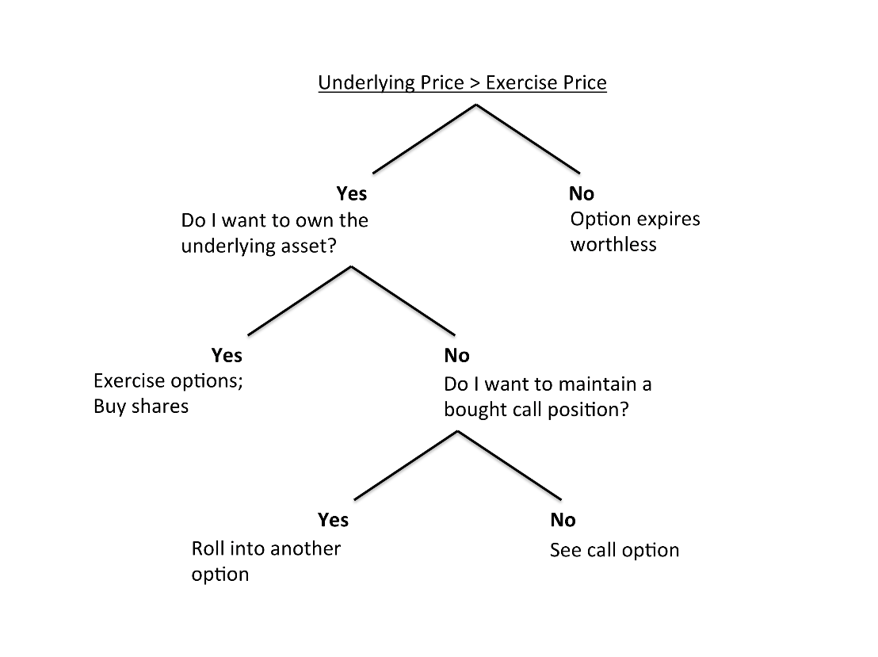

Source: Created by the authors.

**EXHIBIT 5: TREE DIAGRAM OUTLINING PUT OPTION HOLDER’S ALTERNATIVES AT EXPIRATION**

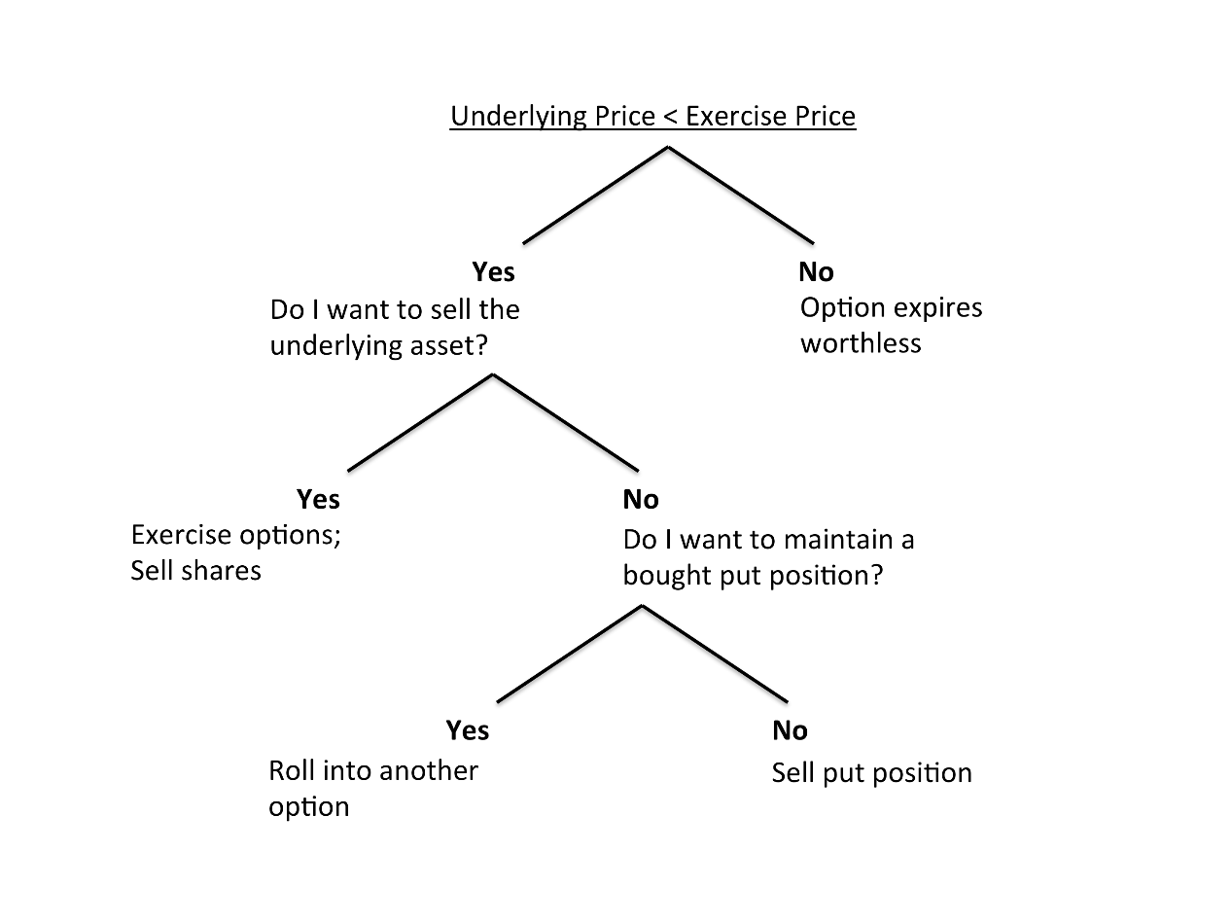

Source: Created by the authors.

**EXHIBIT 6: PROFIT DIAGRAM OF A LONG CALL**

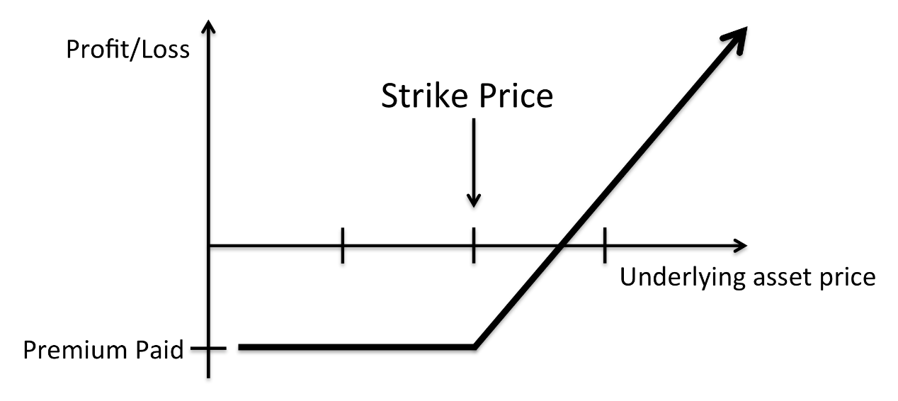

Source: Created by the authors.

**EXHIBIT 7: PROFIT DIAGRAM OF A SHORT PUT**

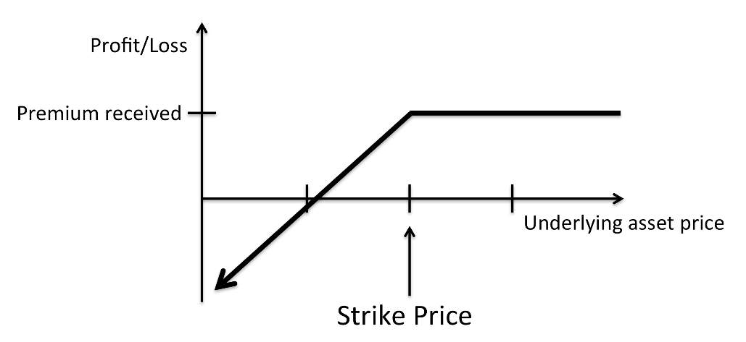

Source: Created by the authors.

**EXHIBIT 8: PROFIT DIAGRAM OF A LONG PUT**

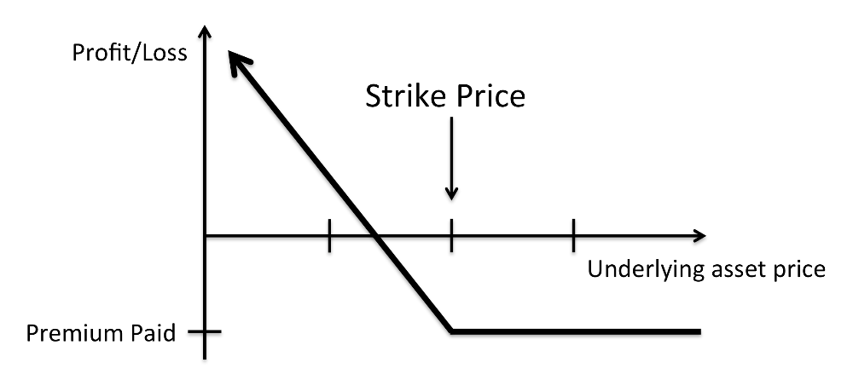

Source: Created by the authors.

**EXHIBIT 9: PROFIT DIAGRAM OF A SHORT CALL**

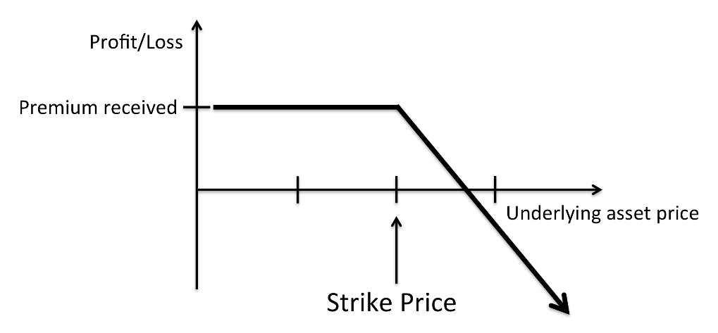

Source: Created by the authors.

EXHIBIT 10: SUPPORT AND RESISTANCE TREND LINES

Support Line

Source: “Support and Resistance Trend Lines,” Bloomberg Terminal, accessed September 1, 2017.

**EXHIBIT 11: UPTREND**

Source: “Uptrend,” Bloomberg Terminal, accessed September 1, 2017.

**EXHIBIT 12: DOWNTREND**

Source: “Downtrend,” Bloomberg Terminal, accessed September 1, 2017.

**EXHIBIT 13: DESCENDING TRIANGLE**

Downtrend

Support Line

Breakout

Breakout

Source: “Descending Triangle,” Bloomberg Terminal, accessed September 1, 2017.

**EXHIBIT 14: USE OF BOLLINGER BANDS**

Source: “Use of Bollinger Bands,” Bloomberg Terminal, accessed September 1, 2017.

**EXHIBIT 15: USE OF MACD**

Source: “Use of MACD,” Bloomberg Terminal, accessed September 1, 2017.

**EXHIBIT 16: USE OF RELATIVE STRENGTH INDICATOR**

Source: “Use of the Relative Strength Indicator,” Bloomberg Terminal, accessed September 1, 2017.

1. Walid Busaba, Zeigham Khokher, and Jaclyn Grimshaw, *An Introduction to the Pricing of Options* (London, ON: Ivey Publishing, 2005). Available from Ivey Publishing, product no. 9B05N014.
2. A$ = AUD = Australian dollar; all currencies are in A$ unless otherwise stated.
3. Australian Securities Exchange, *Explanatory Note for ASX Option Adjustments*, accessed September 2, 2017, www.asx.com.au/documents/products/Explanatory_Note_for_Option_Adjustments_and_Terminations_10_July_2013_cash_adjusttments.pdf.
4. “Prices and Research: Option ‘Greeks,’” ASX, accessed September 27, 2017, www.asx.com.au/prices/options-greeks.htm.
5. “2017 ASX + TradeFloor Options Trading Game,” accessed September 27, 2017, www.optionsgame.com.au.
6. “Earnings per Share—EPS,” Investopedia, accessed July 5, 2016, www.investopedia.com/terms/e/eps.asp.
7. “P/E Ratio: Using the P/E Ratio,” Investopedia, accessed August 2, 2016, www.investopedia.com/university/peratio/peratio2.asp.
8. “Return on Average Equity—ROAE,” Investopedia, accessed August 5, 2016, www.investopedia.com/terms/r/roae.asp.
9. For a comprehensive overview of option strategies, refer to the Australian Securities Exchange, Option Strategies: 26 Proven Option Strategies (Sydney, AU: ASX, 2011), accessed July 20, 2016, www.asx.com.au/documents/resources/UnderstandingStrategies.pdf.
10. This is only one way to construct a butterfly spread; there are several other options.