

9B19N014

lONDON MINING Plc: the offer from blackrock world mining trust

Ken Mark wrote this case under the supervision of Professor Walid Busaba solely to provide material for class discussion. The authors do not intend to illustrate either effective or ineffective handling of a managerial situation. The authors may have disguised certain names and other identifying information to protect confidentiality.

This publication may not be transmitted, photocopied, digitized, or otherwise reproduced in any form or by any means without the permission of the copyright holder. Reproduction of this material is not covered under authorization by any reproduction rights organization. To order copies or request permission to reproduce materials, contact Ivey Publishing, Ivey Business School, Western University, London, Ontario, Canada, N6G 0N1; (t) 519.661.3208; (e) cases@ivey.ca; www.iveycases.com. Our goal is to publish materials of the highest quality; submit any errata to publishcases@ivey.ca. i1v2e5y5pubs

Copyright © 2019, Ivey Business School Foundation Version: 2019-07-19

Graeme Hossie, chief executive officer of London Mining Plc (London Mining), an iron ore mining firm based in the United Kingdom, was focused on his company’s producing asset, the Marampa mine (Marampa) in Sierra Leone. It was March 29, 2012, and London Mining had been producing iron ore at Marampa since December 2011. Phase 1 of the project—moving from zero to five million tons per annum (Mtpa)[1]—was fully funded, and the ramp-up was proceeding smoothly. Now that the mine’s start-up had been “de-risked,” Hossie was starting to think about the funding of the second part of Phase 1, which would ramp up production to 9 Mtpa. (See Exhibit 1 for an overview of London Mining’s operations.)

Funding the next part of Phase 1 would require approximately US$600 million[2] in total, approximately $250 million of which could be raised by issuing senior debt. The remaining $350 million could be raised with convertible debt. An alternative was a financing option that Hossie was considering from BlackRock World Mining Trust (BlackRock). BlackRock was offering an investment of approximately $110 million in exchange for a 2 per cent royalty on top-line ore sales. Given that the Marampa project was gaining momentum as ore production was steadily rising, Hossie believed he could turn his focus to financing Marampa’s expansion.

The Market for Iron Ore

In response to demand from emerging economies such as China, iron ore prices rose from the $20 per ton range in the early 2000s to a peak of $197.12 per ton in March 2008. During the Great Financial Crisis of 2008, iron ore prices dropped to as low as $59.78 per ton in April 2009, then recovered to achieve a high of $187.18 per ton in February 2011. In March 2012, iron ore was selling for $144 per ton.[3] The iron ore market was currently dominated by the big iron ore producers such as Rio Tinto, which also accounted for 60–65 per cent of the required future growth in capacity. London Mining was aiming to be a small producer—defined as having production of less than 10 Mtpa. In contrast, the larger mining companies produced more than 100 Mtpa. Steel production continued to grow in 2011, albeit at a slower rate than in 2010. The World Steel Association estimated crude steel production to be 1,490 Mtpa—up by 4 per cent from the previous year, compared with a 16 per cent increase in 2010. CRU Group (CRU), a data firm focused on the global mining markets, estimated global iron ore consumption would increase by 380 Mtpa over the period from 2015 to 2021, which was equivalent to an expected compound annual growth rate of 3.6 per cent over the period 2011–2021, following predicted steel-production growth of 680 Mtpa between 2011 and 2021.The net effect was that global seaborne trade was expected to expand by 4 per cent in 2012 and to maintain a consistent growth rate over the medium term of 6–9 per cent per year. (See Exhibit 2 for the estimated market size for iron ore and Exhibit 3 for total iron ore consumption by region.)

CRU’s forecasted growth in global iron ore production of 75 Mtpa in 2012 was equivalent to 4.1 per cent growth year-on-year. This growth was forecast to come mostly from Brazil and Australia but also from West Africa. India was forecast to show a 26 Mtpa decrease. Developing regions continued to drive the bulk of this growth, with strong expectations for expansion in the Middle East, South America, and the Commonwealth of Independent States. The majority of new steel production, however, would come from Asia. Signiﬁcant amounts of new capacity came on stream in China, where crude steel production capacity was expected to increase by 60 Mtpa in 2012.

London Mining expected greater increases beyond 2015 from several of the large diversiﬁed mining companies. These increases would potentially have a material impact on the global market balance.

CRU expected global exports of iron ore to reach almost 1.5 billion tons in 2015. Looking to the longer term, CRU remained bullish about Chinese ore consumption to 2015, as Chinese ore imports were still expected to advance signiﬁcantly and at a faster pace than in 2010–11. CRU forecast that by 2015 Chinese imports would increase by 324 Mtpa to almost 1 billion tons, nearly 50 per cent higher than in 2011. Growth in Chinese imports was expected to be augmented by higher imports across much of the rest of Asia and the Middle East. Notwithstanding the likely weakness in European and Japanese demand going forward, global seaborne trade in iron ore was expected to advance by approximately 350 Mtpa by 2015.

Sierra Leone

London Mining was attracted to Sierra Leone because of the opportunity to develop a project that was based on a proven deposit and had iron ore concentrate already on site. Hossie estimated that the Sierra Leone deposit had 132 million tons of ore at a 34 per cent iron grade, which was sufficient for a profitable project.

Hossie recalled:

Marampa is particularly attractive because of its good location and the nature and quality of its ore. It is located only 40 km [kilometres] from tidewater, allowing simple and low cost logistics. What is more, the nature of the types of ore present—now clearly identiﬁed after 90,000 metres of drilling—allows us to develop it very ﬂexibly in a series of increments toward its ultimate planned yearly capacity of greater than 16 Mtpa. As a result, we can produce signiﬁcant cash ﬂows early and defer other capital expenditure to later stages of development, signiﬁcantly funded from early cash ﬂow. An additional differentiating factor is that the mine produces high-speciﬁcation product, which commands a premium price over more standard products. This high-grade ore is preferred by steel mills that are encountering falling grades from other suppliers.

Our primary focus for 2011 was on ﬁnancing, developing and implementing an expanded operation at Marampa following conﬁrmation of over 1 billion tons of JORC[4] resource, of which 81 per cent now falls in the Indicated category. The increased resource formed the basis of a preliminary feasibility study (PFS) in April, which outlined the development plan for a greater than 16 Mtpa operation. This plan set out a staged development, starting with reprocessing of tailings from previous operations then moving to mining and processing of weathered ore, and then the un-weathered primary ore for a large-scale, long-term mining operation. Test work continued through the year, and key ﬁndings were incorporated and engineered into the initial plant design.

London Mining Plc

London Mining aimed to develop mines to supply the global steel industry and to become a top-10 global producer of iron ore. Its goal was to select assets with near-term production or expansion potential, with viable logistics and long-term sustainable margins.

Its assets had a defined logistics plan, meaning that railroad tracks or a road could be built to send ore to shipping ports. London Mining’s current iron ore projects were located no further than 110 kilometres from deep water suitable for the loading of ocean-going vessels. These projects either had been previously producing or had signiﬁcant resource identiﬁcation and feasibility work carried out, and they were able to produce a high-speciﬁcation product that was readily saleable on the seaborne iron ore market. The current projects were low-cost for the type of product they produced and had the potential to be brought quickly to production, with cash ﬂow often able to fund further expansion.

Building production rapidly to generate cash ﬂow to fund and drive further expansion was the firm’s preferred development strategy that was then taking place in London Mining’s Sierra Leone and Colombia operations. Hossie stated:

Twenty months on from ordering our long-lead items for the Marampa mine and logistics system in Sierra Leone, we produced our ﬁrst ore in December 2011. The Marampa plant and logistics system was working as designed and began regular shipments of premium speciﬁcation iron ore sinter feed concentrate from January 2012 as we ramp up to initial installed capacity of 1.5 Mtpa.

As a result, our Phase 1 plan, which originally targeted 1.5 Mtpa from tailings, has now been expanded to a planned 5 Mtpa from a blend of tailings and highly weathered ore. Marampa began production of high-speciﬁcation iron ore in December 2011 and shipments of Marampa concentrate to both Europe and China began in January 2012.

We see strong feasibility work as the basis for attracting investment to larger capital projects and expansion phases. We ﬁnance our projects on a case-by-case basis in the most appropriate way for each asset. This makes sense because each asset has a distinct ﬁnancing solution and opportunities to optimize value for our shareholders. At Marampa for example, the presence of tailings from former operations and presence of soft, highly weathered ore means that production can be developed quickly for relatively low initial capital expenditure, with fast capital payback, and then expanded in stages using early cash ﬂow. Marampa also beneﬁts from its ability to produce a premium product, enabling us to secure offtake-related ﬁnancing with pricing related to the spot benchmark.

This approach at Marampa meant that London Mining would be able to plan on the basis of later expansions being funded from a combination of cash ﬂow, offtake arrangements,[5] and debt. It had commenced construction for its second plant to complete the Phase 1 expansion to 5 Mtpa. London Mining expected to deliver 1.5 Mtpa of iron ore production from Marampa in 2012 and, through construction of its second plant, grow to 4.2 Mtpa in 2013 and to 5 Mtpa in 2014. London Mining had mine operating costs of $77 per ton, and these costs were anticipated to fall to less than $50 per ton at 5 Mtpa, and higher. The company was aiming to have a bankable feasibility study for the Marampa expansion to 9 Mtpa completed by Q3 2012. Beyond that, there was the potential to accelerate its Phase 2 expansion at Marampa to more than 17 Mtpa if a strategic investor provided ﬁnancing on suitable value-accretive terms. Hossie described the funds raised for Marampa and for London Mining’s other projects:

Through 2011, we arranged a variety of ﬁnancings to support our development activities and the implementation of a larger project at Marampa than originally planned. These included a convertible bond placement of $110.0 million, a corporate debt facility of $90.7 million with Standard Chartered Bank, initial offtake prepayment facility with Glencore of up to $27.0 million, and a 1 per cent royalty arrangement on Isua for $30.0 million with Anglo Paciﬁc. In the post period we have secured net proceeds $18.4 million of lease ﬁnancing through Oldendorff for the “Pride of Marampa” Floating Offshore Transhipment Platform (FOTP) along with gross proceeds of $90.7 million through an issue of new common shares, and have signed a prepayment agreement linked to offtake of $45.0 million from Vitol. We are conﬁdent of continuing to fund growth in our projects through various methods of ﬁnance as may be appropriate for each project. This will be based on identifying clear value-creation potential through expansion or implementation and demonstrating the expertise to carry it out. For larger capital projects such as Greenland, we are pursuing strategic partner funding.

As of March 26, 2012, a total of 271,892 wet metric tons[6] had been produced from the Marampa plant in accordance with London Mining’s ramp-up plans. The integration of a new equipment in Q3 2012 would increase production further to 150,000 tons per month and addition of a gravity circuit would enable a further increase in the capacity to more than 200,000 tons per month. A second identical plant was targeted for 2012 for commissioning in Q1 2013, resulting in combined installed capacity of 5 Mtpa. (See Exhibit 4 for an overview of the Marampa mine.) Hossie explained:

We expect production to be 1.5 Mtpa in 2012, 4.2 Mtpa in 2013, and 5 Mtpa in 2014. The preproduction capital expenditure was $168 million. Capital expenditure for the installation of the second plant and processing optimization (including retroﬁtting of milling and gravity circuits in the ﬁrst plant) is expected to be $92 million. With further expenditure to increase plant efﬁciency and to upgrade and improve logistics of $40 [million]–50 million, the total capital expenditure for the ﬁrst 5 Mtpa of production is estimated to be $310 million, equivalent to installed capital intensity of $62 per annual ton of capacity, which is very low compared to industry norms.

(See Exhibit 5 for London Mining’s stock price performance, Exhibit 6 for its income statement, Exhibit 7 for balance sheets, and Exhibit 8 for its cash flow statement.)

Reviewing the offer from BlackRock

In late March 2012, BlackRock approached London Mining with a unique offer. It would pay $110 million in exchange for 2 per cent of all future iron ore sales from the Marampa mine. The royalty would be payable quarterly in arrears and calculated on the amount receivable at the relevant point of sale. It was non-recourse financing, and no payments would be made if the mine was not in production.

“We’re currently implementing a fully funded expansion to 5 Mtpa,” said Hossie. “We could use additional funds to expand Marampa to 9 Mtpa. We could also look for alternative sources of debt or equity.” Hossie estimated that the expansion from 5 Mtpa to 9 Mtpa would cost $600 million over two years. With a bankable feasibility study, London Mining could try to raise funds for the expansion in the next few months (see Exhibit 9).

Hossie noted that the price of iron ore had fluctuated significantly in the last few years. He wondered what impact any future changes in the price of iron ore would have on revenues from the mine and the royalty payments to BlackRock. (The iron ore forecast price assumptions can be found in Exhibit 10, and a forecast of the related annual royalty payments to BlackRock World Mining Trust can be found in Exhibit 11.)

London Mining’s finance group had calculated its weighted average cost of capital to be approximately 12.75 per cent. Hossie wondered how to value payouts tied to the top line instead of the bottom line, and wanted to conduct a sensitivity analysis to see the impact of a different cost of capital on the BlackRock deal. In addition, he considered the volatile nature of industry demand, and the fact that the mine was in Sierra Leone.

Hossie estimated that London Mining would not be able to raise the entire $600 million in debt. Instead, he envisioned funding the expansion with about $250 million in senior debt, at an expected cost of 10.6 per cent per annum, and the rest coming internally from free cash flow or from more expensive external sources. Hossie was thinking of raising the entire $350 million balance with convertible debt (tenure of 10 years, and convertible within five years at 40 per cent over the current stock price). On March 29, 2012, London Mining’s shares were trading at £2.74[7] or US$4.37 and Hossie saw that analyst reports had target prices that were significantly higher, some even twice the current price. London Mining had a current equity market value of £374.88 million.

Hossie reasoned, “If we were to accept the offer from BlackRock World Mining Trust, then we could seek a lower amount of convertible debt.” He then wondered, “Should we take BlackRock’s offer?”

Exhibit 1: London Mining Plc—Group Overview

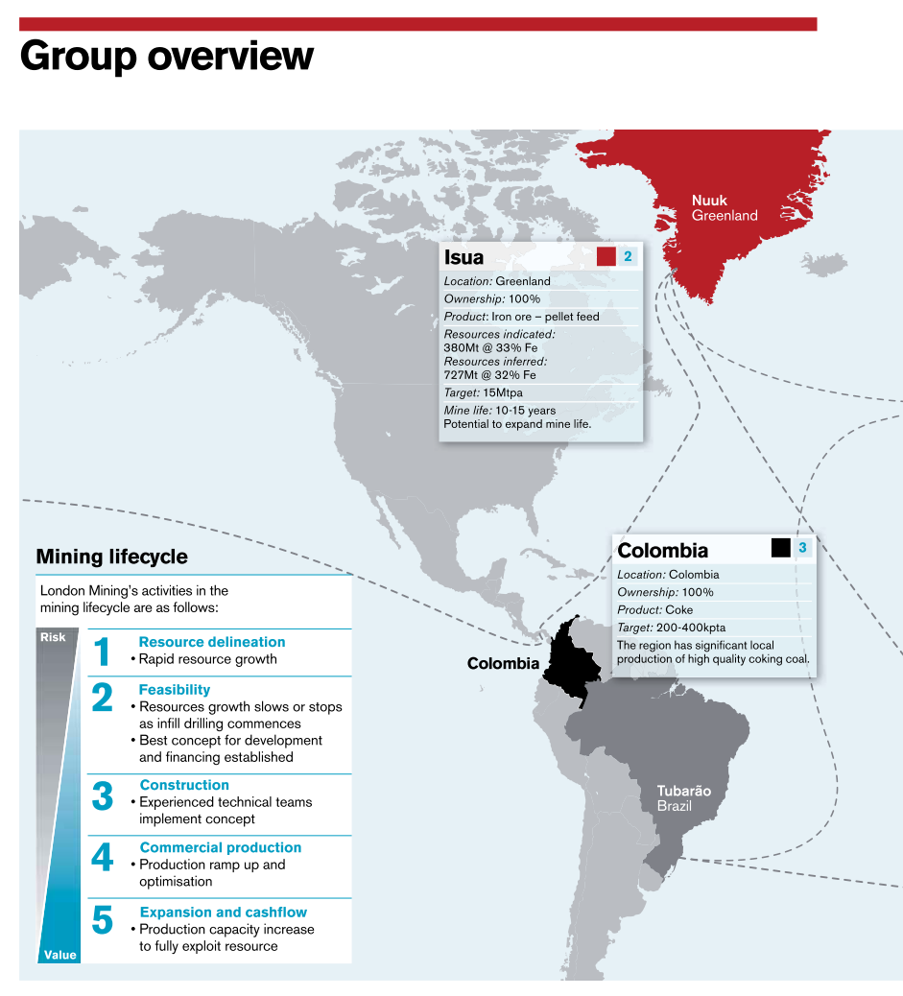

Note: Mt = million tons; Fe = iron; Mtpa = million tons per annum; kpta = thousand tons per annum.

Source: Company documents.

Exhibit 1: London Mining Plc — Group Overview (Continued)

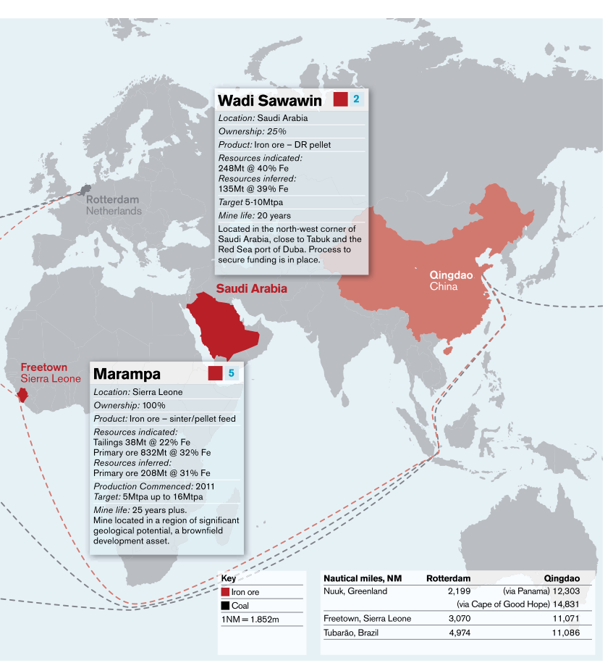

Note: DR = direct-reduction grade; Mt = million tons; Fe = iron; Mtpa = metric tons per annum; NM = nanometre.

Source: Company documents.

Exhibit 2: London Mining Plc

Seaborne Iron Ore ImportS—Estimated Global Market, 2011–2021 (in millions of tons)

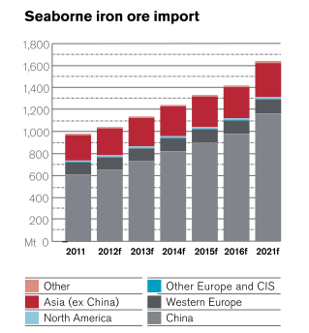

Note: CIS = Commonwealth of Independent States; ex = excluding.

Source: Company documents.

Exhibit 3: London Mining Plc

Total Iron Ore Consumption By Region, 2011–2021 (in millions of tons)

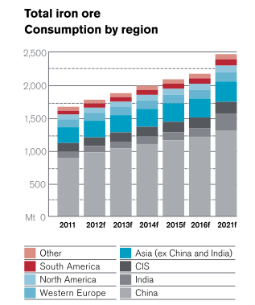

Note: CIS = Commonwealth of Independent States; ex = excluding.

Source: Company documents.

Exhibit 4: London Mining Plc Operational Review—Marampa, Sierra Leone

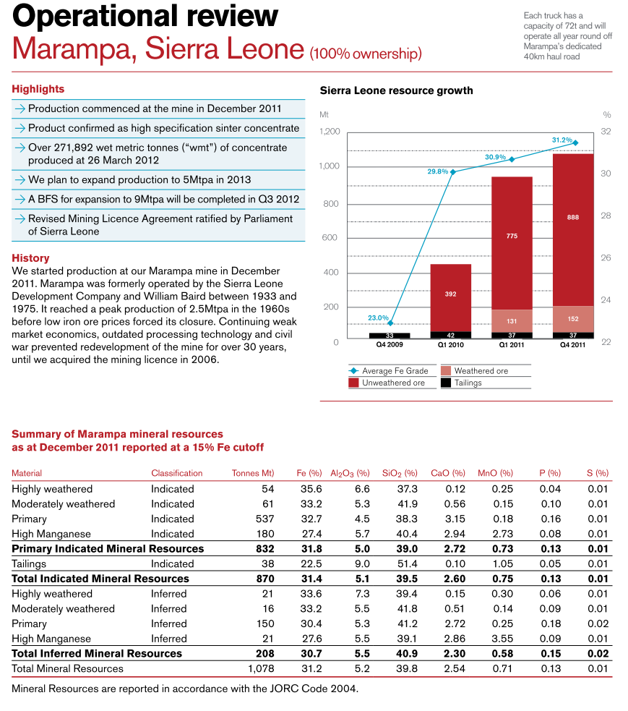

Note: t = tons; km = kilometres; Mtpa = million tons per annum; BFS = bankable feasibility study; Fe = iron; Mt = million tons; A1203 = aluminum oxide; Si02 = silicon dioxide; CaO = calcium oxide; MnO = manganese oxide; P = phosphorous; S = sulphur; The JORC Code was a professional code of practice that set minimum standards for the public reporting of minerals exploration results, mineral resources, and ore reserves.

Source: Company documents.

Exhibit 5: London Mining Plc Stock Performance from November 2009 to December 2011

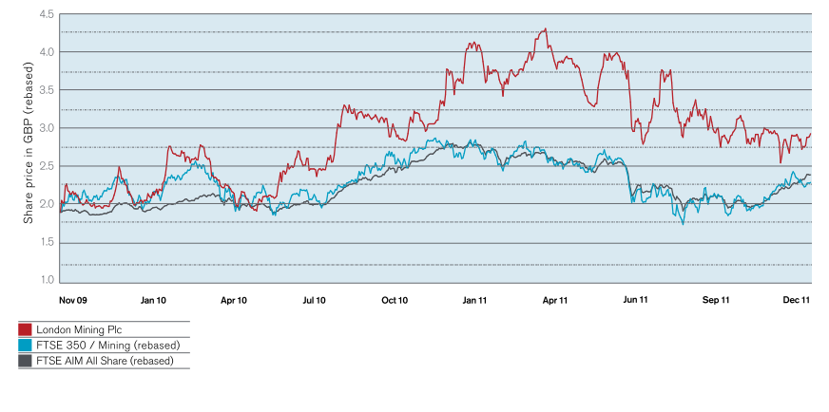

Note: GBP = British pound sterling; FTSE = Financial Times Stock Exchange.

Source: Company documents.

Exhibit 6: London Mining Plc Income Statement, 2010–2011

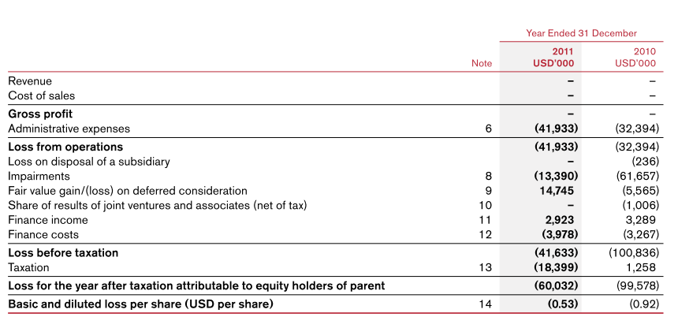

Source: Company documents.

Exhibit 7: London Mining Plc Balance Sheet, 2010–2011

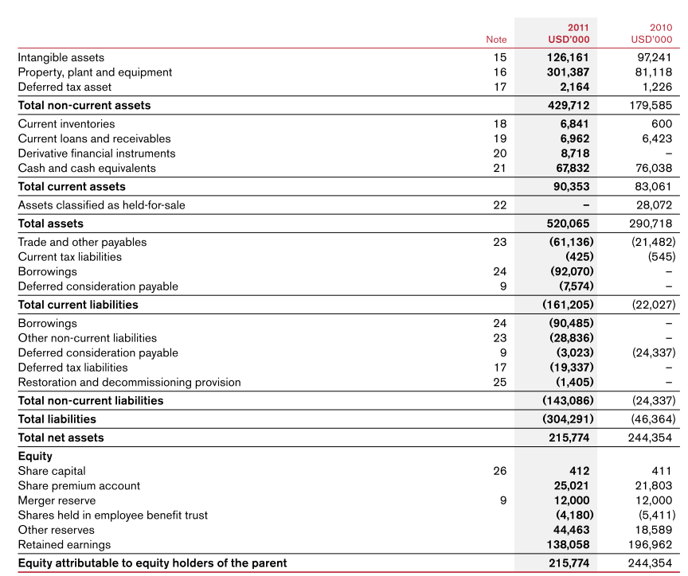

Source: Company documents.

Exhibit 8: London Mining Plc Cash Flow Statement, 2010–2011

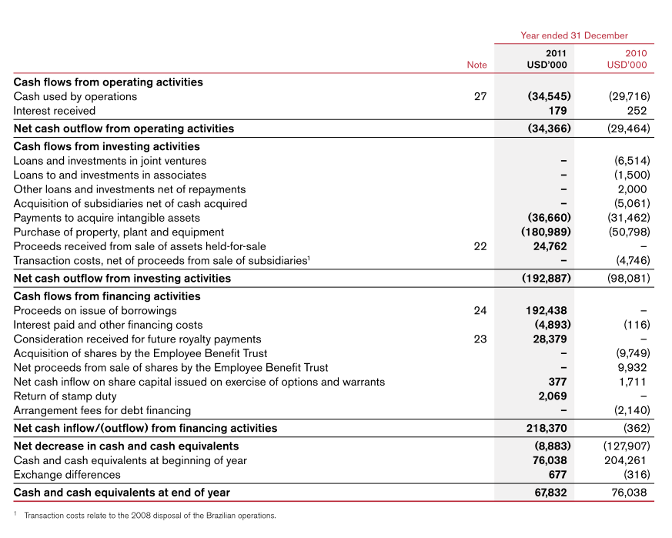

Source: Company documents.

EXHIBIT 9: estimated capital expenditures for London Mining’s various projects, early 2012

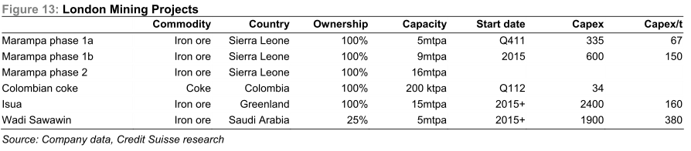

Note: Capex = capital expenditures; Capex/t = capital expenditures per ton; mtpa = million tons per annum; kpta = thousand tons per annum.

Source: London Mining company documents.

Exhibit 10: Forecast Spot CFR Iron Price and Marampa realized FOB Price, 2012–­2037

|  |  |  |  |  |  |  |  |  |  |  |  |  |  |
| --- | --- | --- | --- | --- | --- | --- | --- | --- | --- | --- | --- | --- | --- |
| **US/Ton** | **2012** | **2013** | **2014** | **2015** | **2016** | **2017** | **2018** | **2019** | **2020** | **2021** | **2022** | **2023** | **2024** |
| Iron ore spot CFR China 62% Fe | 140 | 135 | 120 | 105 | 105 | 100 | 100 | 90 | 97 | 97 | 97 | 97 | 97 |
| Marampa realized FOB price | 110 | 105 | 105 | 85 | 80 | 80 | 80 | 65 | 70 | 70 | 70 | 70 | 70 |
| Changes to forecast, in % | 0% | 0% | 0% | 0% | 0% | 0% | 0% | 0% | 0% | 0% | 0% | 0% | 0% |
|  |  |  |  |  |  |  |  |  |  |  |  |  |  |
|  | **2025** | **2026** | **2027** | **2028** | **2029** | **2030** | **2031** | **2032** | **2033** | **2034** | **2035** | **2036** | **2037** |
| Iron ore spot CFR China 62% Fe | 97 | 97 | 97 | 97 | 97 | 97 | 97 | 97 | 97 | 97 | 97 | 97 | 97 |
| Marampa realized FOB price | 70 | 70 | 70 | 70 | 70 | 70 | 70 | 70 | 70 | 70 | 70 | 70 | 70 |
| Changes to forecast, in % | 0% | 0% | 0% | 0% | 0% | 0% | 0% | 0% | 0% | 0% | 0% | 0% | 0% |

Note: CFR = cost and freight; FOB price = freight-on-board price; Fe = iron.

Source: Company documents.

Exhibit 11: Expected Payments to BlackRock World Mining Trust, 2012–2037

|  |  |  |  |  |  |  |  |  |  |  |  |  |  |
| --- | --- | --- | --- | --- | --- | --- | --- | --- | --- | --- | --- | --- | --- |
|  | **2012** | **2013** | **2014** | **2015** | **2016** | **2017** | **2018** | **2019** | **2020** | **2021** | **2022** | **2023** | **2024** |
| Phase 1 to 5 Mtpa | 2.0 | 10.2 | 10.2 | 9.0 | 9.0 | 8.5 | 8.5 | 8.0 | 8.0 | 8.0 | 9.0 |  |  |
| Phase 1 to 9 Mtpa (incremental) |  |  | 0.5 | 2.0 | 3.5 | 5.5 | 5.5 | 5.5 | 5.5 | 5.5 | 1.0 |  |  |
| Phase 2 - 17 Mtpa |  |  |  |  |  |  | 3.0 | 5.0 | 6.0 | 7.0 | 18.0 | 28.5 | 29.0 |
| **Total** | **2.0** | **10.2** | **10.7** | **110** | **12.5** | **14.0** | **17.0** | **18.5** | **19.5** | **20.5** | **28.0** | **28.5** | **29.0** |
|  |  |  |  |  |  |  |  |  |  |  |  |  |  |
|  | **2025** | **2026** | **2027** | **2028** | **2029** | **2030** | **2031** | **2032** | **2033** | **2034** | **2035** | **2036** | **2037** |
|  |  |  |  |  |  |  |  |  |  |  |  |  |  |
|  |  |  |  |  |  |  |  |  |  |  |  |  |  |
|  | 29.5 | 30.0 | 30.5 | 32.0 | 33.0 | 34.0 | 35.0 | 36.0 | 37.0 | 37.0 | 38.0 | 39.0 | 40.0 |
|  | **29.5** | **30.0** | **30.5** | **32.0** | **33.0** | **34.0** | **35.0** | **36.0** | **37.0** | **37.0** | **38.0** | **39.0** | **40.0** |

Note: Mtpa = million tons per annum.

Source: Company documents.

1. All weights are in metric tons.
2. All funds in US dollars unless otherwise noted.
3. “Iron Ore Monthly Price–US Dollars per Dry Metric Ton,” Index Mundi, accessed September 1, 2018, www.indexmundi.com/commodities/?commodity=iron-ore&months=120.
4. The Australasian Code for Reporting of Exploration Results, Mineral Resources and Ore Reserves (“the JORC Code”) was a professional code of practice that set minimum standards for the public reporting of minerals exploration results, mineral resources and ore reserves. JORC, “What Is the JORC Code?,” accessed September 1, 2018, www.jorc.org/.
5. An offtake agreement set the terms for the purchase of a mining company’s future production at a stated price, usually linked to a benchmark price. “Offtake Agreement,” Investopedia, accessed September 1, 2018, www.investopedia.com/terms/o/offtake-agreement.asp.
6. A wet metric ton was a ton of ore material that included water and other solids. After separating fluids from the material, the miner was left with a dry metric ton.
7. £ = GBP = British pound sterling. On March 29, 2012, £1 = US$1.5958. “Historical Rates for the GBP/USD currency conversion on 29 March 2012 (29/03/2012),” Pound Sterling Live, accessed September 1, 2018, www.poundsterlinglive.com/best-exchange-rates/british-pound-to-us-dollar-exchange-rate-on-2012-03-29.