

9B21A003

Linc Pen and Plastics Limited: Creating a Brand from a New Product

Atanu Adhikari, and Seema Lall wrote this case solely to provide material for class discussion. The authors do not intend to illustrate either effective or ineffective handling of a managerial situation. The authors may have disguised certain names and other identifying information to protect confidentiality.

This publication may not be transmitted, photocopied, digitized, or otherwise reproduced in any form or by any means without the permission of the copyright holder. Reproduction of this material is not covered under authorization by any reproduction rights organization. To order copies or request permission to reproduce materials, contact Ivey Publishing, Ivey Business School, Western University, London, Ontario, Canada, N6G 0N1; (t) 519.661.3208; (e) cases@ivey.ca; www.iveycases.com. Our goal is to publish materials of the highest quality; submit any errata to publishcases@ivey.ca. i1v2e5y5pubs

Copyright © 2021, Ivey Business School Foundation Version: 2021-02-16

On an autumn afternoon in October 2019, Deepak Jalan, the managing director of Linc Pen and Plastics Limited (LPPL), sat in his office in Kolkata, West Bengal, India, studying the company’s September 2019 half-yearly results (see Exhibit 1). He was encouraged by LLPL’s financials.

LLPL’s writing instruments business offered value products to its customers through its Linc brand. In 2018, LPPL had developed a new ballpoint pen, the Pentonic, with an objective to capture those customers who were willing to pay a premium for low-involvement lifestyle products. The Pentonic was a tall, cylindrical, black ball pen with a smooth, light writing experience that differentiated it from competitors as well as from Linc’s other ball pens. LPPL priced the Pentonic ball pen at ₹10,[1]while its other ball pens were priced at about ₹5. Consumers liked the Pentonic ball pens, and its sales rose right from the launch. LPPL crossed the ₹1-billion mark in revenue for the first time in its history during the first quarter of fiscal year (FY) 2019–2020. Within a year, Pentonic became the company’s second-largest product in terms of volume and its most extensive product in terms of value.

LPPL promoted this new product with full emphasis on the brand name Pentonic, which earned it an independent identity in the market, with a very subtle Linc endorsement. Jalan, at the last board meeting, had proposed building the Pentonic brand separately from the Linc brand. He had proposed making Pentonic a brand for the mass-premium market while keeping Lincas a brand for the mass market. The board had suggested that Jalan form a detailed plan outlining how LPPL could develop the new Pentonic product as a complete brand to target the mass-premium market. The Board had also asked Jalan to explain how LPPL could balance the marketing mix and positioning strategy for the specific target customers of the two brands—Linc and Pentonic—while keeping two distinct brand images in consumers’ minds. LPPL expected Pentonic brands to contribute 50 percent to domestic revenues by FY 2021.

While the proposal seemed sophisticated, Jalan knew that it was a risky undertaking that would trigger significant internal planning and a great deal of brand management with external stakeholders, namely channel partners, creative agencies, and customers. However, given the company’s vulnerability to highly competitive forces and external factors such as the price of raw materials and the uncertainty of export markets, developing an independent new brand for LPPL was essential, albeit easier said than done. Developing the Pentonic as a separate brand would require different investments, since LPPL would not be able to leverage Linc’s ads for the new brand. At the same time, if LPPL wanted to defend its position as a value writing instrument manufacturer, it would have to take this risk. Otherwise, it might miss the opportunity to establish its presence in the slightly premium segment, which was the future consumer trend in India. As Jalan leaned back in his chair, he made up his mind to chalk out a detailed plan for a dual-market strategy for LPPL.

Linc brand

The Linc brand was established in 1976 by Jalan’s father, Surajmal Jalan. Deepak joined his father’s business in 1980. By 2019, the over-40-year-old business based in Kolkata was known for its quality writing instruments. The Linc brand manufactured and sold ball pens, gel pens, and good-quality pencils at affordable prices, targeting the value segment. Linc had built a name over the years in both Indian and international markets, and had a presence in about 50 countries. Linc was a brand for the mass market. Its ball pens were priced at ₹5, and LPPL believed they were of better quality than their competitors’ pens in terms of the smoothness of writing and the quality of the grip. In the past, LPPL’s ability to gain and successfully maintain its market value within the writing segment had come mainly from four critical success areas: (1) its innovative capability and contemporary technology, which had helped LPPL manufacture a quality product at a lower cost;(2) its broad geographical reach, which it had established by strategically controlling its distribution channels across India; (3) its unconventional promotional strategy, including both below the line (BTL) and above the line (ATL) communication; and (4) its ability to keep its price low even though its product quality was superior to that of its competitors. LPPL had carefully maintained close relationships with its channel partners, constantly aligning its product development to fit market demand according to market feedback from its distributors and its sales force.

Creation of the Pentonic ball pen

As LPPL planned to develop a new product for its mass-premium market, the obvious choice was to think beyond the realm of the Linc brand and create a new ball pen brand; this led to the birth of the Pentonic brand in mid-2018 (see Exhibit 2). One of the top product design agencies from Korea was engaged to design the pen, and Linc’s creative agency was asked to suggest a name for it. The agency came up with the name Pentatonic, of which Jalan explained “had something to do with music and was too long for a brand name. Therefore, we opted for Pentonic, suggestive of ‘Tonic in the Pen.’” The Pentonic was presented as an independent brand, and the name Pentonic was visible and highlighted in the product, while the brand name Linc was written in a very small font. LPPL management felt that the Pentonic name was modern and exciting. During the launch of Pentonic, Jalan said,

In a time when the world is moving towards digitization and students are typing more than writing, Pentonic gives a reason to write, for its effortless smooth writing feature and innovative hybrid technology. Through Pentonic, we believe the future lies in the present, and as a writing instrument, it will be an architect to script the varied ideas of future Indian milieu.

LPPL managers said the ₹10 and above segments had contributed 30 percent to total volumes and 40 percent to the overall value in the first quarter of FY 2020.[2] Pentonic was targeted to become LLPL’s top revenue earner by maintaining the top line as well as the bottom line. Jalan explained:

When we wanted to launch Pentonic ball pen, we wanted to keep it at a ₹10 price point. However, when we compared the Pentonic ball pen with competitors’ and Linc’s other products, input-wise and feature-wise, it looked similar to a ₹5 pen. When we looked from the manufacturer’s viewpoint, it looked like a ₹5 pen to us. But when we looked at the Pentonic pen independently from the consumer’s viewpoint, it looked like a ₹10 pen. So, we thought we would launch it at the ₹10 price point; but if we launched it under the Linc brand, we might have faced resistance. That’s why we decided to launch the sub-brand Pentonic and highlight it far more than Linc and put the brand Linc in very small font.

The Pentonic Philosophy

LPPL felt that the Pentonic ball pen was an advanced writing instrument. It was based on a hybrid technology and ink solution that gave a feather-light writing experience that differentiated it from products available from competitors at the same price point. Speaking about the newness of the Pentonic pen, Jalan said,

Compared to other existing products of Linc or of competitors, Pentonic offers better writing comfort with the Pentonic refill system (i.e., the combination of tip and ink). The flow of the ink and the tip smoothness level is much better: The inside engineering of the tip is modified to add smoothness. The quality of ink is also much superior.

The Pentonic ball pen was meant for generation-Z and generation-Alpha consumers, and it focused on meeting their advanced needs and demands. The Pentonic ball pen was initially positioned with the tagline “Pentonic—Write the future.” Jalan felt that combining the idea of meeting the future with a certain boldness, which was inspiring and challenging, might attract the Pentonic’s target generations like “the rising of a phoenix with the boldness of black.” Pentonic ball pens were given a black matte finish and a sleek design and were targeted at students, office goers, homes, and offices—that was, to anyone who desired a mid-premium writing experience. Expressing his views on Pentonic pens, Jalan remarked, “The newly launched Pentonic ball pen has been instrumental to a large extent in beating the blues of the steep increase in polymer prices owing to the surge in crude oil prices.”

Product Innovation

The Pentonic was a result of LPPL’s undying quest for innovation. Over the last four decades, LPPL had developed considerable understanding about consumers’ needs and preferences. LPPL had also done formal consumer studies. Knowledge gathered from these studies and from channel partners’ inputs were incorporated in the design of the body, ball, and ink so that the products could cater to the distinct requirements of its users. The industry norm was for pens at the ₹10 price point to have metalized parts in the pen, a metal clip, film on the body, and individual packaging. For the sake of trade, these many inputs were expected and therefore essential to have. Jalan said,

We took a bold step on our part to pursue this product at ₹10 against all resistance even though the Pentonic pen had none of these inputs. We defied all industry norms, and it clicked. Initially, no one believed in us—neither trade nor our people nor the industry. This step was different from the industry beliefs, and our industry friends wrote it off at ₹10, but we still pursued it. There was some conviction that Pentonic could be a trendsetter in the industry.

Along with designing the Pentonic ball pen, LPPL’s design team and product development team had also readied two other products, but these had not yet been taken into production. LPPL felt that if the Pentonic ball pen was successful in the market, it might explore the possibility of launching the other two products as extensions in the gel and retractable category, under the Pentonic brand.

Pentonic Gel

The Pentonic Gel was a gel version of the Pentonic pen that offered the smooth writing of a gel pen in red, blue, and black ink. This range of desk pens was characterized by a ball diameter of 0.6 millimetres (mm), waterproof ink, and a matte finish design in a tall black body (seeExhibit3A). LPPL thought of pricing it at ₹10. Jalan explained the use of gel pens in schools as follows:

Schools made it mandatory for its students to use pencils up to class IV. The writing instrument for class V to VIII students should be a gel pen since the gel pen has water-based ink, which ensures better control over writing. Earlier, schools would emphasize fountain pens, but over the years, gel pens have replaced fountain pens. On the other hand, ball pens have oil-based ink, which gives beginners less control over writing. Gel pens, as such, are primarily for students.

Pentonic B-RT

The Pentonic B-RT was another product variant designed by the same design agency from Korea. It had a premium black matte finish body, a 0.7-mm diameter ball, and a grip that was better and smoother than that of any retractable ball pen in the market (see Exhibit 3B). The Pentonic B-RT had an advanced retraction mechanism and fast-flowing ink. This retractable pen was available in red, blue, and black ink. Jalan considered emphasizing the uniqueness of its design in the tagline for this pen when it was launched. The Pentonic B-RT was priced at ₹20 and primarily targeted at corporations and office workers. Jalan said,

The Pentonic B-RT would be a classy extension to the other range of Pentonic products. In an era when the world is leaning towards digitalization, the Pentonic B-RT will give us a lot of reason to write, thanks to its sleek corporate look, curvilinear body, smooth grip, fluidic finish, as well as superior ink technology. It is expected to carry forward our brand ethos, differentiating itself with innovation and delivering a writing experience that no other Indian pen has been able to offer so far.

LPPL had an experienced and dynamic product development team that believed the Pentonic ball pen might pave the way to launch the other two prototypes that had been designed: Pentonic gel pens and Pentonic retractable pens. Jalan felt that if Pentonic was built as an independent brand, LPPL could not stop at pens only. He had asked the product development team to come up with ideas for long-term extensions to both the product line and the brand line in order to leverage the independent brand. Jalan thought, “Consumers form a strong association between the brand and the category. Also, if you are selling multiple products under one brand, consumers form associations accordingly with a multi-product brand.”

Packaging of Pentonic ball pen

Typically, ₹10 pens were individually packaged, either in paper or plastic pouches. LPPL felt that there was a lot of wastage because customers would throw away the packaging and keep the pens. While individual packaging was the industry norm at this price point, Pentonic pens were put in dispensers that could be refilled instead of being individually packaged (see Exhibit4). They also came in boxes of10 pens and wholesale packs of 100 pens. Packaging the pens this way allowed LPPL to avoid a great deal of waste and to increase the savings on individual packages, transforming Pentonic into a profitable brand. While this packaging became a reason for resistance from distributors, who wanted separate packages to compete with the competitors’ products, LPPL’s management insisted on the innovative packaging and promised to change to individual packs if the dispenser packaging did not work. LPPL insisted that retailers keep the dispensers at the front of the store to catch customers’ attention.

Pricing Issues

Price played a significant role in establishing the brand within a competitive market. A price point too far off from that of the competition would delay the brand’s acceptance. Over the years, Linc pens had been sold at a low price point, between ₹5 and ₹10. LPPL had not been able to change the brand’s prices over the last 15 years despite a steep rise in the cost of raw materials. The next price point was ₹20. There were no pens in the market priced between ₹11 and ₹19 due to the inconvenience caused by returning change to customers. Jalan shared his views regarding pricing Pentonic ball pens at ₹10: “We won’t be cheap, but won’t be expensive either. It would be slightly more expensive than other brands. We are focusing on Pentonic being mid-premium for the masses.”

Distribution

Pentonic products were available at brick-and-mortar stores in all states across the country. Distribution was facilitated through clearing and forwarding agents in every state. The products went either from these agents to distributors and then finally to retailers, or through these agents from wholesalers to retailers. Jalan said, “When we sell to a distributor, then we know who he is selling to; but if we are selling to wholesalers, we don’t know what is happening. Our salespeople only visit retailers and wholesalers.”

Pens were distributed through traditional fast-moving consumer goods (FMCG) channels such as stationery shops, general FMCG outlets, and modern trade stores as well as through online sales. LPPL’s own stores, Just Linc and Office Linc, sold Pentonic ball pens, as did online aggregators’ platforms such as Amazon, Flipkart, StatMo, Offimart, and School Kart.

Advertising and Promotion

The Pentonic range of ball pens was stylish, with an appropriate tagline, “Driven by design.” The top competing brand sold 100 million pens a year, or 1.8 million pens a month, but Pentonic had overtaken these sales figures to become the top-selling brand.

Pentonic’s carefully chosen communication medium hinted at the perception of the brand’s high quality and positioning as a lifestyle brand—elements that were always taken into consideration when promotional materials such as t-shirts, coffee mugs, and caps were procured. Even though print did not cater to the core target group of students, who seldom read newspapers, this medium was chosen for Pentonic’s advertising communications (see Exhibit 5), as this helped Pentonic by increasing brand awareness among trade participants and ultimately widened the brand’s distribution. At the same time, print media also helped increase awareness among the secondary target group of office workers, and expanded the customer base. Electronic media and outdoor hoardings were also used to expand the customer base. Jalan reflected, “If you want to make your brand big, you must advertise on mass media. Hence, we planned a TV commercial and also used various other touchpoints like airport branding and air travel magazines to advertise the brand.”

In 2018, Pentonic mainly targeted students, coming up with an exam campaign that reflected the roller-coaster ride of emotions experienced by examinees during the crucial exam period. Pentonic’s connection with students through this exam advertisement series revolved around its initial tagline, “Write the future,”[3] and encouraged students to use Pentonic pens.[4]Jalan stated,

Pentonic has to be one of the best offerings from the stable of Linc. With its effortless, smooth writing and unique ink flow system, Pentonic helps the students to write their exams with command and confidence. The new ad campaign is dedicated to the exam warriors who have put in their hard work to achieve success in academics, like the spirited soldier of a nation in the battlefield.

Pentonic had a social media presence on platforms such as Facebook, Twitter, Instagram, LinkedIn, and YouTube. Its Television commercial, produced by the creative agency Brand Bazooka, was live on multiple digital platforms including YouTube and Facebook. It had achieved over 12,000 hits on YouTube and over 64,000 views on Facebook as of March 2019.

Building a brand image

As in any industry, even the writing instruments industry, when a new product was developed and a competitor’s product was the best seller, it was common practice to imitate the successful product of the competitor. The designer was asked to develop a new product but was told that it must not be an exact replica of the competitor’s best-selling product; by default, the new product became a look-alike product because of the given benchmark—the competitor’s product. While most companies resorted to this practice, LPPL seldom did. Jalan reflected on these imitation products, noting that it was difficult for them to create their own identity: “In the last few years, we were developing products, and we ensured that aesthetically pens were not look-a-like and were nowhere near to any products in the market. We have observed that [imitations] will never be successful. You have to be different than the competition.”

The aesthetics of Pentonic were much better than those of any of LPPL’s existing products. A top designer, much sought after in the industry, was hired at ten times the normal fee. According to the general practice and trend in the industry, competitors would start working around the product once it was accepted and retailers’ confidence was gained, and in due course, competitors would cannibalize Pentonic. While this was indeed happening—it was not difficult for competitors to bring a similar product to the market—there was no point in being concerned. Sharing his strategy, Jalan said, “We shall be more aggressive in such a scenario by capturing the market and occupying the shelf space across the channels at a rapid pace. If we keep space or leave any window open, then competitors will invade.” He added, “In my 30 year career, I have seen no me-too [copycat] product becoming successful. I have seen competition copying others, copying us, but no instance of success has been witnessed.”

Sales Force and Retailing

Despite initial resistance, the Pentonic launch was successful. Once the product was accepted by customers, Linc won the retailers’ confidence and Pentonic gained depth and reach. Retailers’ motivation came from the acceptance of products; next, if consumers liked the product, they would buy it again, which would motivate the retailers to stock more. Jalan mentioned that “salespeople must have conviction. The challenge is to convince our sales team to like the product, love the product, so we tend to incentivize them. Incentives play a key role at that level and have a big role to play in retail sales.”

LPPL had 350 salespeople all over India. Point-of-sale (POS) marketing was most important because the retailer had a lot of influence in selling or promoting the product. The retailers were incentivized to place Pentonic products at a vantage point where customers could look at and eventually purchase them. Typically, if customers liked the product’s appearance, they would pick up a pen to try it. (It was a general practice of customers to ask for the products that were displayed at retail counters and to try them.)If the writing was excellent and the price was affordable, then customers would buy it. Retailers pushed the products that gave better margins or a high turnover. They needed confidence to stock products.

Consumer Behaviour

For consumers, price was the primary factor in selecting a pen, followed by ink colour and then brand. Students were comparatively more loyal to the brand than older adults, but both looked for another brand if they could not get the pen of their choice. The fourth factor was the look of the pen. For students, appearance often played a primary role in their choice of pens. An undergraduate student remarked, “The new Pentonic ball pen looks smart and writes too smooth! One can feel the smoothness in the palm. The barrel design is unique. It’s not like other pens in the market.”

When purchasing a new pen, consumers who were not brand-sensitive would tell the retailer their price range and would ask to be shown a pen within that price range. A service employee who forgot his pen went to a nearby store and asked for a pen for about₹10. The storekeeper handed over a Pentonic ball pen. The service employee shared, “I wrote on the writing pad the shopkeeper gave me to test the pen, and I simply loved it. It feels like a feather! I would not mind paying a little more for a pen that will give me such smooth writing with a comfortable grip. I did not expect such smooth writing from a ₹10 pen.”

Consumers generally asked for pens at a particular price point, and sometimes they asked for particular pens, i.e., a particular brand or category. The probability of this was 50:50. Brand-loyal customers who enquired for a particular brand would repeatedly buy it, hence retailers had to stock all brands. Students who asked for particular pens were high in numbers during the exam period, which was a serious occasion. During other events, they would go for any brand of pen at any price point, but during examinations, students stuck to the tried and tested. Although loyalty remained higher with premium brands like Parker, Waterman, and Sheaffer, if other pens were displayed at the retail counter, customers would ask for these and try them out. Jalan remarked, “Once you have crossed that stage and created a pull for your product, even though the retailer might earn less, he will still stock and sell because customers will ask for your product. Thus, we gained the retailers’ confidence.”

Present Situation

Jalan’s call for a dual-market strategy required Pentonic to be established as a brand. Within a year and a half, Pentonic had become the largest selling pen in its price segment independent of the Linc brand. The objective was to develop Pentonic’s brand positioning as a mass-premium brand for the mass market. “Premium brand for the mass market! Doesn’t it sound like an oxymoron?” Jalan wondered. He realized the strategy might backfire if the Pentonic brand gravitated to Linc’s image after some time. Consumers would be confused and might think that Pentonic was a high-priced version of Linc. LPPL needed to create a distinct brand equity for Pentonic as a superior quality mass-premium product.

How could it develop a completely independent new brand from this new product? Jalan wondered whether the Pentonic ball pen should be the only source of Pentonic’s brand equity or if LPPL should develop a holistic Pentonic product portfolio. If so, how should it do so? Should LPPL extend the Pentonic brand to other product categories? If so, which categories? What would be the positioning strategy for the Pentonic brand? Now that Pentonic was an established independent brand, could LPPL sell Pentonic pens at its exclusive brand outlets Just Linc and Office Linc?

Jalan knew that the brand image of Pentonic had to be distinct from that of Linc. He was aware that Linc and Pentonic had similar target markets, and Pentonic would undoubtedly take away some of Linc’s market share. This had already created a debate at one meeting of board members and senior managers the previous week. Having defended a premium pricing model for premium segment customers, Jalan had proposed building a mass-premium image for LPPL through the Pentonic brand. Some managers wondered about the fate of the Linc pens that were priced at ₹10 and above. In fact, they said that Pentonic was cannibalizing a share of the Linc brand. Wouldn’t these markets be disassembled entirely? Jalan reasoned: “Ideally, we wish for a target of 20 percent market share even though it’s a fragmented industry. If we can create a power brand from power products like Pentonic, then that will help achieve the target. Brands like Pentonic, being a lifestyle brand and mass premium in nature, can help us reach that target.”

Pentonic, as a new brand, had no history, and it earned a reasonable and adequate margin. Jalan did not mind that Pentonic had taken some of Linc’s existing market share. Cannibalization of LPPL’s brands was happening, and Pentonic was also taking a percentage of competing brands at ₹10. There was no doubt that the Pentonic ball pen was a huge success, as it was the most sought-after pen at its price point. There must be a strategy to help the Pentonic brand attract consumers who had a slightly different preference for writing instruments—those who would not mind paying a little more for an excellent writing experience and contemporary looks. This would reduce the cost of reaching out to this consumer segment, as they were already familiar with the Pentonic brand.[5]

There were many challenges to face, including resistance from trade and consumers. People at both levels wanted established brands. Shelf space at the retail level was a necessity but also a challenge because Pentonic had been a mass-premium brand in its market space. Jalan thought the challenges could be dealt with gradually if he did things right and if the product had some perceived uniqueness. It would be essential to have an offering that provided consumers with value according to their actual requirement. Then he would need to keep an eye on the performance of the offering and plan the next move accordingly.

Exhibit 1: Linc Pen and plastics Ltd—Half-yearly Financials (as of September)

|  | **2019** | **2018** | **2017** |
| --- | --- | --- | --- |
| **INCOME** | | | |
| Net Sales Turnover | 202.28 | 174.69 | 146.16 |
| Other Income | 0.07 | 0.80 | 0.64 |
| **Total Income** | **202.35** | **175.49** | **146.79** |
| **EXPENSES** | | | |
| Stock Adjustments | (3.53) | (6.60) | (4.00) |
| Raw Material Consumed | 73.12 | 64.11 | 43.17 |
| Employee Expenses | 16.29 | 14.13 | 11.89 |
| Other Expenses | 96.53 | 90.58 | 85.23 |
| **TOTAL EXPENSES** | **182.41** | **162.22** | **136.29** |
| Operating Profit | 19.87 | 12.47 | 9.87 |
| **EBITDA** | **19.94** | **13.27** | **10.51** |
| Depreciation | 6.25 | 5.01 | 4.55 |
| **EBIT** | **13.68** | **8.26** | **5.96** |
| Interest | 2.94 | 3.00 | 2.06 |
| **EBT** | **10.75** | **5.26** | **3.90** |
| Taxes | 0.80 | 1.90 | 1.75 |
| **Profit and Loss for the Year** | **9.95** | **3.36** | **2.16** |

Notes: EBIT = earnings before interest and taxes; EBITDA = earnings before interest, taxes, depreciation, and amortization; EBT = earnings before taxes.

Source: Company documents.

Exhibit 2: Pentonic Ball pen

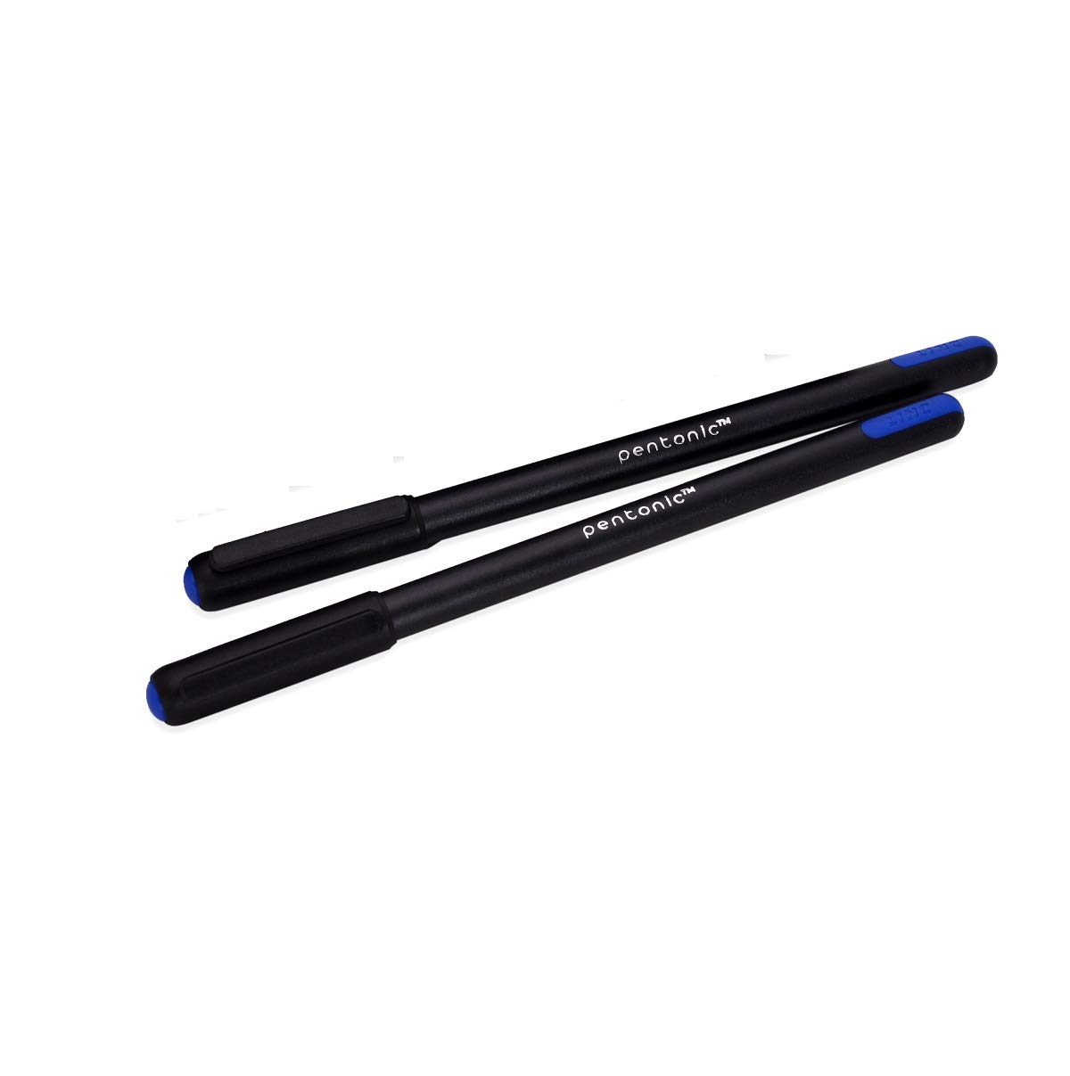

Source: Company documents.

Exhibit 3A: Design of Pentonic Gel Pen

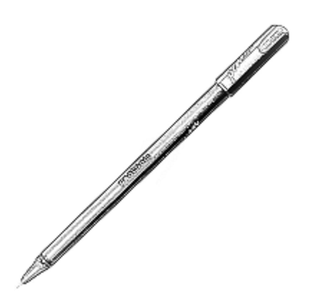

Source: Company documents.

Exhibit 3B: Design of Pentonic V-RT Pen

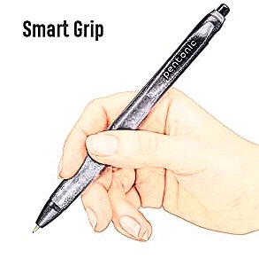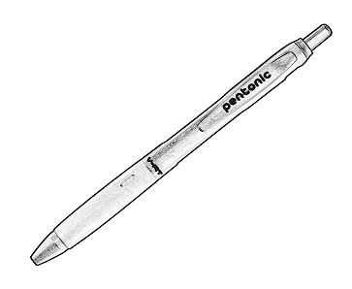

**Pentonic pen grip Pentonic V-RT design**

Source: Company documents.

Exhibit 4: Pentonic Pen Dispensers

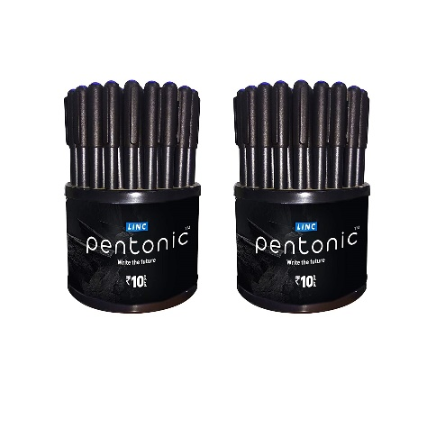

Source: Company documents.

Exhibit 5: Print Ad forPentonic Ball Pen

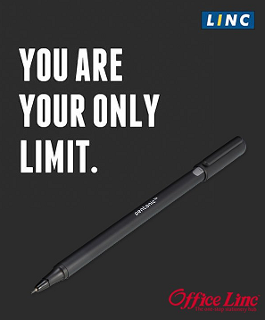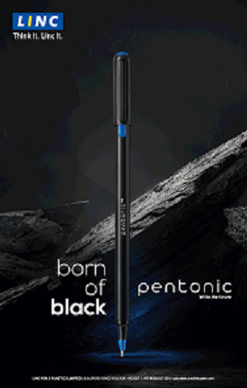

Print Ad 1 Print Ad 2

Source: Company documents.

1. ₹ = INR = Indian rupee; ₹1 = US$0.01400 as of October 2019; all currency amounts in ₹ unless specified otherwise.
2. Equity Bulls, “Stock Report, Linc Pen & Plastics Ltd’s Turnover Crosses Rs. 100 Crores in Q1 FY20,” July 11, 2019, accessed September 5, 2020, www.equitybulls.com/admin/news2006/news_det.asp?id=253274.
3. “Exam Warriors—LincPentonic, ”YouTube video, 0:30, posted by “Linc Pens,” March 2, 2019, https://youtu.be/XrgzNJvkcgs.
4. Ibid.
5. Baker Marketing Editorial Team, “Extending Your Brand’s Reach with a Product Extension,” Baker Marketing, August 3, 2015, accessed September 5, 2020, https://bakermarketingservices.com/2015/08/extending-your-brands-reach-with-a-product-extension/.