

9B21A010

tentree: planting for the future

Jack Stevenson wrote this case under the supervision of Julie Gosse solely to provide material for class discussion. The authors do not intend to illustrate either effective or ineffective handling of a managerial situation. The authors may have disguised certain names and other identifying information to protect confidentiality.

This publication may not be transmitted, photocopied, digitized, or otherwise reproduced in any form or by any means without the permission of the copyright holder. Reproduction of this material is not covered under authorization by any reproduction rights organization. To order copies or request permission to reproduce materials, contact Ivey Publishing, Ivey Business School, Western University, London, Ontario, Canada, N6G 0N1; (t) 519.661.3208; (e) [cases@ivey.ca](mailto:cases@ivey.ca); [www.iveypublishing.ca](http://www.iveycases.com). Our goal is to publish materials of the highest quality; submit any errata to publishcases@ivey.ca. i1v2e5y5pubs

Copyright © 2021, Ivey Business School Foundation Version: 2022-02-22

It was late December 2019, and as Shawn McIntyre sat with his sashimi lunch at his desk at the Vancouver headquarters of Ten Tree International Inc. (tentree), he knew he had some important decisions to make regarding tentree’s marketing plan. McIntyre had worked as the digital marketing manager at tentree for three years and had loved every minute of it. He was proud of being a tentree employee because, as an eco-friendly clothing retailer, the business focused on making a positive impact on the environment. For every item a customer purchased, tentree planted ten trees in areas that needed reforestation.

McIntyre had just come from a meeting with his chief executive officer (CEO), Derrick Emsley, during which they had discussed the results from this fiscal year end. Both men were happy with the overall outcomes and excited about the future. This past year had been momentous for their brand. After just over seven years of operations, tentree had achieved $32 million dollars[1] in annual revenues and had reached a major milestone of 30 million trees planted. tentree had also launched its most successful promotional campaign to date, which had celebrated Earth Week in 2019. With such an impressive year wrapping up, McIntyre was now looking forward and trying to determine tentree’s next steps. He had a revenue goal of $43 million dollars for 2020 and he wanted to generate a healthy profit margin. He took a bite of his lunch and considered the information he had in front of him.

VANCOUVER

Vancouver was the third-largest city in Canada and the largest city in British Columbia, with a population of 631,486 in an area of 114 square kilometres.[2] An international tourist destination, Vancouver was known for its natural beauty and outdoor activities. It was considered to be among the world’s best cities in terms of quality of life, and it attracted those who loved the outdoors.[3] Home to a number of iconic neighbourhoods, Vancouver was one of the most diverse cities in Canada (see Exhibit 1).[4] Vancouver was also known for its dedication to the environment. It was currently the 10th cleanest city in the world,[5] and it aimed to be known as the greenest city by 2020.[6]

TENTREE’S HISTORY

tentree was founded in 2012 by Kalen Emsley and David Luba. Emsley, inspired by his job as a tree planter, was visiting Luba in Hawaii when the pair came up with the idea for a clothing brand that gave back to the environment. The duo then brought in Derrick Emsley, a graduate of Ivey Business School, which McIntyre had also attended, to act as CEO, and tentree was born. Initially operating out of Kalen Emsley’s basement in Regina, Saskatchewan, tentree quickly outgrew this space. After four years of operations—during which it planted over 1 million trees, appeared on the reality venture capital TV show *Dragons’ Den*, and created over 160,000 hours of employment in developing countries—tentree decided to move its home office to Vancouver, British Columbia.[7]

Planting trees was not enough for tentree. The company founders wanted to make a larger environmental impact, and the best way to do this was to focus on their supply chain. They decided that their supply chain should be based on the same principles as the company itself: transparency, sustainability, and respect. To ensure these values were upheld, the company shifted its production to incorporate more sustainable fabrics and environmentally progressive clothing. As the majority of its suppliers were located overseas (70 per cent in China, and the rest distributed across Vietnam, India, and Central America), tentree was unable to monitor its production facilities regularly. To ensure that the company’s suppliers shared its values, tentree created a strict supplier code of conduct (see Exhibit 2). This collection of strict supplier standards was a key driver that enabled tentree to be certified as a B Corporation (B Corp) in 2016.[8] In order to become certified B Corps, brands had to score at least 80 points on the B Corp scale. tentree scored 124, demonstrating the brand’s commitment to the environment.[9]

EARTH WEEK 2019

Earth Week was a week-long international campaign focused on environmental sustainability. Every year, Earth Week was celebrated by individuals, organizations, and educational institutions alike. The centrepiece of the week was Earth Day, on which people around the world raised awareness about the effects of humans on the planet and encouraged others to take action to reduce our impacts.[10] Earth Week events included community park clean-ups, tree planting, and forums on how businesses could become greener.[11]

For Earth Week in 2019, tentree was looking for a way to create a tangible positive impact while simultaneously increasing its brand awareness. After a series of debates and brainstorming sessions, tentree’s marketing team decided to create a campaign highlighting “the world’s most sustainable post” on Instagram. Partnering with the non-profit Eden Reforestation Projects, tentree promised to plant a tree for every 10 likes the post received.[12] The initial goal for the campaign was 5 million likes, which would translate to 500,000 trees planted.[13] With 2.3 million followers, an employee count of 50 people,[14] and an average of 80,000–100,000 likes per post, this was an ambitious goal.[15]

The marketing team decided that the post would need to be easy to understand, catch the attention of the viewer, clearly indicate what the viewer needed to do, and be easy to share with friends.[16] These four criteria were the basis on which tentree judged dozens of photos (see Exhibit 3) before deciding on the final images that would be the focus of its campaign (see Exhibit 4). In order to maximize awareness of the post, tentree also partnered with social media influencers and press agencies so that consumers would be aware of the campaign from day one. This strategy was extremely successful, as throughout Earth Week, tentree’s brand awareness reached new heights. The campaign quickly surpassed the initial goal of 5 million likes, within days of posting, and it was even featured on the stories of celebrities such as Stephen Laurel “tWitch” Boss (Ellen DeGeneres’s DJ) and actress Rosario Dawson.[17]

By the end of the week, tentree had gained an additional 400,000 followers on Instagram and increased its website traffic by over 200 per cent.[18] Its post even became the fifth-most-liked photo on Instagram, with a total of 15.6 million likes.[19] tentree was thrilled that its post had gone viral, but this increased awareness had not translated to a similar increase in sales. Other than an increase of around $20,000 over regular sales levels, the campaign had had no lasting impacts. With tentree’s average conversion rate for online advertisements sitting at 2.0 per cent in Canada and 1.5 per cent in the United States, this comparatively small sales bump was disappointing. Five months later, McIntyre was wondering how the company could take this increased brand awareness and translate it into sales.

REVENUE STREAMS

tentree currently had two main revenue streams: sales from e-commerce and sales from brick-and-mortar stores. Since its advent, e-commerce had been increasing in both size and popularity. Since 2001, online retail sales had grown by 300 per cent, increasing 11.4 per cent in 2018 alone.[20] More and more businesses were transitioning to e-commerce, and it was more cost-effective to operate websites than to operate physical storefronts.[21] Transitioning to e-commerce was also beneficial for stores because it allowed them to track and understand their customers using digital analytics and to more quickly and easily expand into new geographical areas.[22] However, as more companies entered the e-commerce space, consumers were beginning to have higher expectations in terms of the service and quality of goods they could expect from e-commerce companies. In fact, the average length consumers were willing to wait for online purchases had dropped from 5.5 days to 4.5 days.[23] Throughout 2019, tentree had generated $17 million through online sales, with $8.5 million coming from Canada and $7.0 million coming from the United States. Over the last several years, tentree’s website sales had increased overall by 40–60 per cent.

The success of e-commerce did not represent the death of all brick-and mortar-stores—those businesses that sold their goods and services primarily through physical locations.[24] Overall, 61 per cent of consumers still shopped mainly in stores rather than online. Doing so allowed them to obtain goods instantly and to access employee expertise, and it gave them the option to physically interact with items to test their durability and fit.[25] With overall brick-and-mortar sales amounting to over $3 trillion dollars in 2019 and growing at 1.4 per cent per year,[26] this method of distribution did not appear to be leaving any time soon.

tentree’s wholesale accounts generated $15 million in sales, which represented about a 10 per cent growth from the year before. With $10 million in sales in Canada and $5 million in the United States, both markets were a large source of revenue. Major retailers in Canada included Boathouse, Below the Belt, and Mountain Equipment Co-op (MEC); Buckle Inc., LIDZ, and Zappos were tentree’s main retailers in the United States.

Many businesses, tentree included, favoured a blended model that focused on both e-commerce and in-person sales. When consumers shopped, few looked exclusively online or in person before making decisions about what to buy: 87 per cent of shoppers started their retail experiences online, taking advantage of price comparisons and narrowing their options. They then visited physical retail stores later to determine the quality of products and avoid shipping fees and lengthy waits for deliveries.[27]

PRODUCTION INFORMATION

tentree sold a wide array of both men’s and women’s clothing. Given its recent success and a sales breakdown that was fairly equal across all categories, tentree was not currently planning to launch any new products in the near future and was not interested in expanding into categories beyond those it had already established. The company’s average cost of goods sold (COGS) across all products was 30 per cent of its retail selling price (RSP) (see Exhibit 5). To ensure that the prices on its website matched those charged by brick-and-mortar retailers, tentree sold its products at 50 per cent of its RSP to wholesalers, who then marked the items up 100 per cent.

tentree had to include not only the costs of production but also tree-planting costs when determining its net profit from each sale. Depending on the location and type of tree planted, this cost could vary—from $0.10 for a tree planted in Canada to $3.00 for a tree planted in remote areas of Peru. On average, though, the cost to plant ten trees was $2.00. Because the current US administration had recently increased tariffs on goods manufactured in China, it had become more expensive to export products to tentree’s US consumer base. McIntyre was concerned that this administration might increase tariffs even further, decreasing the company’s profitability levels.

COMPETITION

tentree’s largest competition in North America was United by Blue (Blue), another clothing retailer looking to give back to the environment. Whereas tentree planted ten trees for each item sold, Blue removed one pound (0.45 kilograms) of trash from oceans and waterways.[28] Based in Philadelphia, Blue partnered with both US and Canadian distributors, selling its products in stores that tentree was also listed in, such as MEC.[29] Like many retail clothing lines, Blue had no self-branded physical locations, but sold its products on its website, which meant that consumers who did not live near a store could purchase Blue products online. This put Blue and tentree in direct competition for the attention of consumers who were looking to use their disposable income to make an environmental impact.

Another noteworthy competitor of tentree was Roots Canada (Roots), a Canadian company with an iconic brand that was easily recognized based on its beaver-shaped logo. A considerable portion of Roots’ branding was built around its Canadian heritage, and the company had generated a strong reputation as a producer of high-quality, fashionable products.[30] Although Roots did not have a similar commitment to giving back to its community or a transparent supply chain, its products were strong competitors. One of Roots’ staples was its loungewear; as this category was popular among tentree’s target market, this made Roots a credible threat to tentree’s long-term success. Additionally, Roots had more financial and marketing resources than tentree. With total sales of $329 million,[31] it was able to spend much more on marketing than tentree.

A final significant competitor was the large skate and surf brand Quiksilver. Founded in Australia in 1969,[32] Quiksilver had grown its business internationally and become one of the most recognizable skate brands in North America. Although this brand did not have any formalized community contribution programs, it shared a similar aesthetic with tentree, and its products were often sold in the same stores, but at lower average price points.[33] This brand also had the advantage of being older and much larger than tentree, with yearly revenues over $1 billion.[34]

CONSUMERS

The ways that consumers interacted with retail businesses were affected by many trends, including ethical and values-based shopping, which had never been more prominent in North America than they were now. Consumers wanted to feel good about the brands they were buying rather than just searching blindly for the lowest prices.[35] Consumers also wanted to interact with brands—and not just their products—when they were browsing. This desire had led to the popularity of pop-up partnerships within large retailers.[36] This trend was popular with brands that focused on corporate responsibility, as it allowed the brand representatives to explain the purchasing benefits that went beyond the quality of these products. Different consumer age groups also displayed different preferences: for example, 67 per cent of millennials and 56 per cent of generation X consumers claimed a preference for online shopping,[37] whereas 41 per cent of baby boomers and 72 per cent of seniors still preferred to shop in person.[38]

tentree described its target demographic as “Earthmovers.” These people typically lived in urban areas but still cared about the environment and considered themselves to be eco-progressive. They enjoyed participating in engaging outdoor adventures that were not extreme, and they were willing to invest in brands that supported the environment they loved. Within this overarching group, tentree targeted those who were 18–35 years old, with annual incomes from $70,000 to $100,000. Seventy per cent of tentree’s consumers were female, which was noteworthy, since men, on average, spent 30 per cent more online than their female counterparts.[39]

Within the Earthmover demographic, tentree split its market between Canadian, US, and international consumers. Canadian consumers were its largest group and were major contributors to the company’s current success. Canadians had become environmentally conscious in recent years, with a large inclination towards sustainability. Roughly 33 per cent of Canadians indicated that they were willing to pay a premium for sustainably or ethically produced products, especially in relation to the fashion industry.[40] This inclination for sustainability had led to both a high repeat purchase rate and an average order value (AOV)[41] of $125 at tentree. However, Canadians were more price sensitive than tentree’s other demographics. They focused more on the prices of the products they were buying than on the particular brands.[42]

Compared to Canadians, US consumers were less concerned about their environmental impact; over half of US citizens believed that climate change was not an issue currently harming people.[43] However, with a population 10 times the size of Canada, the United States represented huge potential for tentree. With similar sales growth rates in the United States and Canada, increased penetration throughout the United States could lead to a large influx in sales for tentree. In addition to different attitudes about environmentalism, Canadian and US shoppers also had very different shopping habits. US shoppers were more comfortable shopping online than their Canadian counterparts, and they purchased more online in terms of dollars spent.[44] Additionally, they placed a high value on innovation and were more likely to shop with companies they saw actively promoting new products or ideas.[45] With an AOV of $80 and a lower repeat purchase rate, tentree still clearly had room for improvement within the US market.

The international market—specifically Europe, whose population of 741 million was enticing—represented another area with huge growth potential for tentree. A large difference between European and North American shoppers was North American consumers’ increased willingness to purchase online. Due to their higher population density, European consumers enjoyed easier access to storefront locations and did not rely as heavily on the distribution networks that made e-commerce so successful in North America.[46] It would also be more logistically complex for tentree to ship to Europe, and this would lead to longer delivery times than in North America. However, Europeans shared Canadians’ sentiments about the environment, with citizens of most European nations viewing climate change as a major threat.[47] Since the company had limited experience operating in the European market, McIntyre thought expanding into the United Kingdom, a country with 66.5 million potential consumers,[48] should be the first step in testing the market. He did not have an AOV on hand, but he expected it to be similar to that in the United States. If tentree did decide to expand into the United Kingdom, it would need to decide how to distribute its products there.

DISTRIBUTION ALTERNATIVES

The different distribution options McIntyre was considering could be separated into two overarching categories: direct sales and channel sales. Direct selling was the process of selling directly to the end-consumer, avoiding the markups and complications of wholesale partners.[49] Many companies implemented this strategy exclusively due to the high margins and the level of control it gave them over their sales process. Not partnering with other organizations meant that companies using the direct sales method received all of the profit associated with a single sale and were able to decide where to sell their goods and for how much. It was also much easier for them to receive feedback from customers about future iterations of their product due to their direct relationships with end-consumers. tentree currently pursued this strategy with its online shop, which received approximately 20,000 visitors a day and cost roughly $100,000 in platform fees each year to run.

One of the major problems associated with direct selling was the high cost and difficulty of expanding into new markets.[50] Without external partners, these businesses relied entirely on their internal marketing and sales teams to drive revenue growth. Maintaining these teams was expensive and required additional overhead for activities such as payroll and administration. If they were looking to expand into new markets, these businesses also had to essentially start from scratch: they had to build brand awareness among consumers in a new region and convince these consumers to choose their brand over familiar brands. There were also many costs associated with direct selling that were not present with channel sales. For example, orders that were placed on tentree’s website were subject to fees that did not apply to orders in the wholesale stream. On average, 2 per cent of each online order went towards processing fees: $3 from each order went towards pick-and-pack fees, and an additional charge was levied for shipping, depending on the origin of the order.[51]

McIntyre wondered if, moving forward, tentree should double down on e-commerce and focus on selling online. The large portion of its sales being generated through e-commerce indicated that consumers were clearly comfortable with shopping online. tentree could run its website as usual, or it could invest in improving it. The main website improvement tentree was considering was the introduction of a virtual fitting room. As long as consumers had access to a camera on the device they were shopping with, a virtual fitting room would allow them to try on tentree’s products and see how they looked. To add this functionality, tentree would partner with a third-party developer, which would charge it $450 per month or $4,500 per year.[52] As virtual fitting rooms were a relatively new development, there was still little research in terms of their discernible impacts. McIntyre had learned at Ivey that physical retail stores had a 25 per cent foot traffic-to-fitting room conversion rate, and that 67 per cent of those customers made purchases.[53] He wondered if the same would be true with a digital fitting room and how many purchases would be needed for it to be worthwhile.

The other direct selling option tentree was considering was opening its own brick-and-mortar store in downtown Vancouver. Currently, tentree did not operate any physical stores directly. Opening physical stores could be a strong way to increase awareness of the brand and to provide more opportunities for consumers to interact with the brand. Before tentree committed to opening stores in multiple cities, it would need to ensure that customers would react positively. McIntyre believed the location that made the most sense was downtown Vancouver, where many tentree enthusiasts lived; this was also close enough to the company’s head offices that it could be monitored regularly. He projected that the first year of operations would cost about $30,000, not including COGS or tree planting. After each year, these costs would decrease slightly as the company learned how to manage the store properly. Having never run a brick-and-mortar location before, McIntyre was unsure how much profit the store would generate during its first few years in operation. He knew that, on average, a single store of a tentree retail partner generated $3,000–$50,000 in sales of tentree products, depending on the size of the account. He believed this would make a useful starting point for his projections.

The other overarching distribution category tentree pursued was a channel sales strategy—a process whereby the company sold its products to consumers through third-party partners.[54] One of the benefits of pursuing this strategy was that partnering with well-known brands allowed the company to reach out to new customers with whom it would never have interacted before. It was also easier to scale a business and enter new geographic regions by partnering with several key wholesale partners.[55] Currently, tentree pursued this strategy by selling through brick-and-mortar wholesale retail partners. Having found success through physical wholesalers, McIntyre was interested in partnering with digital wholesalers and having tentree’s products listed on their sites.

The first partner he was considering was DoneGood (DG), a US-based B Corp online marketplace that listed products only from companies that were dedicated to making a positive impact on the world.[56] McIntyre believed that DG would be willing to list tentree’s products due to tentree’s mandate to plant 10 trees per item sold. Being listed on DG would be a great way to increase brand awareness in the United States, where tentree still had room to grow. As well, DG was known for only listing brands it supported, and this would add legitimacy to tentree’s brand in the eyes of consumers who had not yet interacted with tentree. By virtue of the nature of DG’s business model, the consumers who shopped at DG were looking to use their purchasing power to make a difference and would be naturally attracted to tentree’s mission.

Another digital marketplace tentree was considering was Vancouver-based ARC Apparel (ARC). Like DG, ARC only listed brands that focused on sustainability, ethical manufacturing, or giving back.[57] Considering that tentree fulfilled all three of these requirements, McIntyre was confident he could have tentree listed on the site. ARC would provide tentree with a similar level of legitimacy as DG—but with Canadian consumers who were unfamiliar with the brand. Unlike selling to a physical wholesale partner, who then owned the inventory sold to them, listing tentree products on the DG or ARC sites would mean that tentree still owned the products and would be charged on a per-sale basis. McIntyre anticipated that the costs of selling through a digital marketplace would include 12 per cent of the RSP, going towards a marketplace fee; 3 per cent, going to a payment processor; as well as pick-and-pack fees and shipping costs, which would come to around the same totals as with website sales. Based on the sizes of DG and ARC, McIntyre expected that if tentree were listed on their sites, it would be exposed to an additional 100,000 and 1,000,000 potential consumers, respectively.

The final online marketplace being considered was Amazon.com Inc. (Amazon), an international digital marketplace that prided itself on selling everything from A to Z. With more than 200 million unique visitors to the Amazon website,[58] being listed here would massively increase tentree’s reach and could potentially allow the company to expand into markets it had not yet explored. Amazon’s listing policies were not as strict as those of the other marketplaces McIntyre was considering. This made him worry that tentree might become lost in a sea of competitors. In order to list its products and have Amazon manage delivery logistics, tentree would be charged $55 per month as a flat fee, with an additional 17 per cent of each sale going towards referral fees and $5.35 per order to shipping fees.[59] tentree would still be responsible for the initial packing of orders. If tentree was able to effectively attract its target market to Amazon, this could mean a huge increase in sales.

**PROMOTION ALTERNATIVES**

Regardless of what distribution channel McIntyre chose, he still needed to come up with a promotion plan to accompany it. In order to maintain brand awareness, tentree needed to advertise on social media. The costs to advertise on each site differed. This meant that promoted posts would have different impacts, depending on the site chosen and whether the company pursued a cost-per-click (CPC) or a cost-per-impression pricing strategy (see Exhibit 6). McIntyre needed to determine how much of the $5,000,000 advertising budget would be allocated to standard social media advertising compared to the other options he was currently considering.

One of these alternatives was to create a viral follow-up social media campaign. Not wanting consumers to forget tentree, McIntyre felt that another campaign would be a great way to keep the business front of mind. As the 2019 Instagram campaign had been so successful, he wondered if maybe it was time to branch out to other forms of social media. How would the users of sites such as Twitter and TikTok respond to a brand focused on giving back to the environment (see Exhibit 7)? He knew that he could not recycle the 2019 campaign, but he still had no ideas about what the new campaign would be about or what medium tentree should use.

A second promotional method being considered was partnering with influencers to have them promote tentree. As tentree had seen with the 2019 Earth Day campaign, its previous relationships with influencers had been quite positive. However, that campaign had focused on nature, photography, and outdoor space influencers[60]—which had helped provide tentree with legitimacy as a brand that supported the environment—but partnerships with more prominent influencers with wider reaches could translate into a tangible increase in sales. Depending on the site, prices for influencers varied; McIntyre was weighing the options of partnering with several smaller-scale influencers against partnering with one influencer with a great many followers (see Exhibit 8). During this past Earth Week, several celebrities had shared tentree’s post to their stories. McIntyre wondered if tentree could potentially commission a celebrity. Either way, he knew that many consumers trusted real people’s experiences more than they trusted regular advertisements. On average, the site conversion rate for an influencer was 3.13 per cent[61]—noticeably higher than tentree’s typical conversion rates.[62] The question still remained: Who would tentree’s target market respond best to, and what platform made the most sense?

McIntyre was also considering launching a new program called Climate+ to catch the attention of potential consumers. Climate+ introduced the idea of carbon offsetting at an individual level. In carbon offsetting, a process typically performed by large companies, organizations participated in activities that reduced the amount of carbon in the air by an amount that was equivalent to the amount of carbon they produced. Climate+ would run on the same underlying logic, but would focus on daily activities that the average person performed and the number of trees required to offset those activities (see Exhibit 9). For these packages, tentree planned to plant trees in Canada and charge $0.50 per tree—but it was uncertain whether this would be enough for the campaign to be profitable. McIntyre believed the program would both inform consumers about the process of carbon offsetting and create an even stronger eco-friendly brand image for tentree.

CONCLUSION

Although tentree had seen huge levels of success this year, McIntyre knew that now was not the time to get complacent. tentree had much more room to grow, and he was determined to prove that his plan would be the way to get it there. Finishing the last bite of his sashimi, he refocused on the information in front of him and prepared to make his decision.

EXHIBIT 1: VANCOUVER POPULATION BY AGE

Source: Government of Canada, “Census Profile, 2016 Census: Age Groups—100% Data, Both Sexes,” Statistics Canada, April 21, 2020, accessed May 10, 2020, www12.statcan.gc.ca/census-recensement/2016/dp-pd/prof/details/page_Figures.cfm?Lang=E&Tab=1&Geo1=CSD&Code1=5915022&Geo2=PR&Code2=01&SearchText=5915022&SearchType=Begins&SearchPR=01&B1=All&TABID=3&type=0.

EXHIBIT 2: TENTREE’S SUPPLIER CODE OF CONDUCT

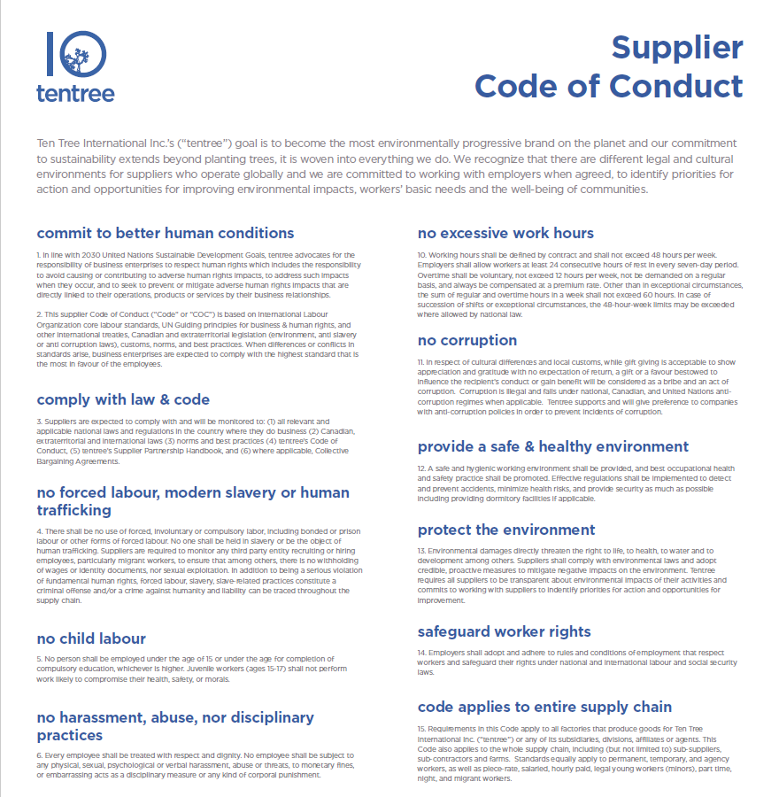

Source: Tentree, “Supplier Code of Conduct,” Shopify, accessed May 10, 2020, https://cdn.shopify.com/s/files/1/2404/6643/t/439/assets/Code_of_Conduct_2020.pdf?v=16608280940142435475.

EXHIBIT 3: PHOTOS Not cHOSEN for tentree’s EARTH WEEK 2019 campaign

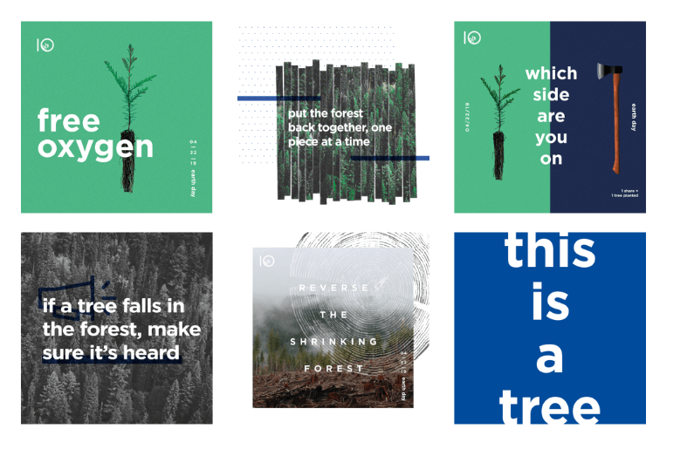

Source: Ash Read, “How tentree Took Over Instagram: Behind a Record-Breaking Social Media Campaign,” *Buffer* (blog), June 26, 2019, accessed May 25, 2020, https://buffer.com/resources/tentree-earth-day-social-media-campaign.

EXHIBIT 4: EARTH WEEK 2019 PHOTOS

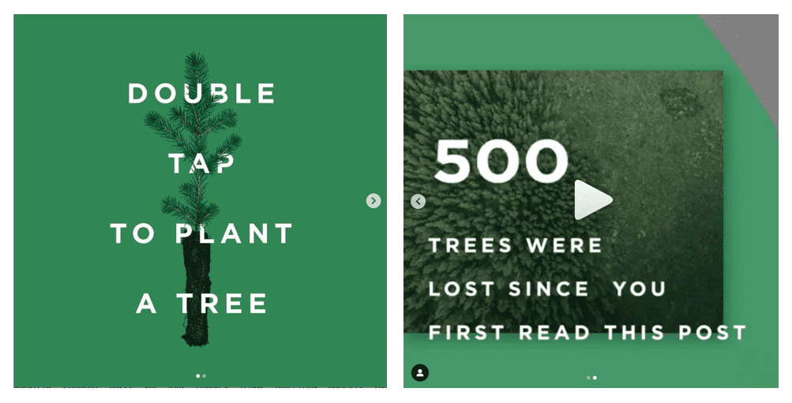

Source: @tentree “The World’s Most Sustainable Post - 5m likes - 500k trees - 20m likes - 1m trees - 50m likes - 100m likes - Join our mission to make the most sustainable post on the planet. Thank you to the millions of people who have lifted their fingers to start a movement to plant more trees. Together, we will be planting 500,000 trees in Indonesia as a result of you liking this post. But we're not stopping here. As the number of likes on this post grows, we will unlock a new level of sustainability and plant even more trees around the world!” Instagram photo, April 22, 2019, accessed May 20,2020 https://www.instagram.com/p/Bwjpxgph9DE/?hl=en.

EXHIBIT 5: tentree—AVERAGE SELLING PRICE BY CATEGORY

| **Category** | **Average Selling Price** |
| --- | --- |
| T-Shirts | $42.00 |
| Long Sleeves/ Button-Ups | $60.00 |
| Sweaters | $68.00 |
| Hoodies | $77.00 |
| Outerwear | $149.00 |
| Dresses | $69.00 |
| Shorts | $58.00 |
| Pants | $80.00 |

Source: Company documents.

EXHIBIT 6: COST TO ADVERTISE ON SOCIAL MEDIA

| **Social Media Platform** | **Average Advertising Cost (CPC)** | **Average Advertising Cost (CPM)** |
| --- | --- | --- |
| Facebook | $0.97/click | $7.19/1,000 impressions |
| Instagram | $3.56/click | $7.91/1,000 impressions |
| YouTube | $3.21/click | $9.68/1,000 impressions |
| LinkedIn | $5.26/click | $6.59/1,000 impressions |
| Twitter | $0.38/click | $6.46/1,000 impressions |
| TikTok | N/A | $10.00/1,000 impressions |

Notes: CPC = cost per click; CPM = cost per thousand impressions

Source: Compiled by the case author based on data from WebFX, “Social Media Advertising Costs by Platform,” WebFX, accessed June 2, 2020, www.webfx.com/how-much-does-social-media-advertising-cost.html#average-advertising-cpc; Influencer Marketing Hub, “How Much Do TikTok Ads Cost?,” Influencer Marketing Hub,accessed June 2, 2020, https://influencermarketinghub.com/how-much-do-tiktok-ads-cost/.

EXHIBIT 7: UNIQUE USERS ACROSS SOCIAL MEDIA platforms

| **Social Media Platform** | **Unique Users (CAN)** | **Unique Users (US)** | **Unique Users (UK)** |
| --- | --- | --- | --- |
| Facebook | 23.80 million | 190.0 million | 37.0 million |
| Instagram | 13.00 million | 120.0 million | 25.4 million |
| YouTube | 17.60 million | 167.4 million | 53.3 million |
| LinkedIn | 17.00 million | 169.0 million | 28.0 million |
| Twitter | 8.15 million | 64.2 million | 17.8 million |
| TikTok | 3.40 million | 41.0 million | 3.7 million |

Source: Compiled by the case author based on data from “Social Media & User-Generated Content: Leading Countries Based on Number of Twitter Users,” Statista, accessed May 25, 2020, www.statista.com/statistics/242606/number-of-active-twitter-users-in-selected-countries/; “Social Media & User-Generated Content: Leading Countries based on Instagram Audience Size,” Statista, accessed May 25, 2020, www.statista.com/statistics/578364/countries-with-most-instagram-users/; “Social Media Users in United Kingdom: May 2020,” NapoleonCat, accessed May 25, 2020, https://napoleoncat.com/stats/social-media-users-in-united_kingdom/2020/05; Felix Richter, “Where TikTok Has Been Downloaded the Most,” Statista, June 30, 2020, accessed May 25, 2020, www.statista.com/chart/16939/tiktok-app-downloads/; David Brown, “TikTok Was a Big Deal in 2019, But Just 9% of Canadians Are Using It,” The Message, February 13, 2020, accessed May 25, 2020, https://the-message.ca/2020/02/13/tiktok-was-a-big-deal-in-2019-but-just-9-of-canadians-are-using-it/; Natasha Lomas, “Leaked TikTok Ad Deck Suggests It Has 17M+ MAUs in Europe,” TechCrunch, January 31, 2019, accessed May 25, 2020, https://techcrunch.com/2019/01/31/leaked-tiktok-ad-deck-suggests-it-has-17m-maus-in-europe/; “Social Media & User-Generated Content: Leading Countries Based on Facebook Audience Size,” Statista, accessed May 25, 2020, www.statista.com/statistics/268136/top-15-countries-based-on-number-of-facebook-users/; “Number of Facebook Users in Canada from 2017 to 2023,” Statista, accessed May 25, 2020, www.statista.com/statistics/282364/number-of-facebook-users-in-canada/; Algonquin College, “YouTube Stats,” Algonquin College, accessed May 25, 2020, www.algonquincollege.com/ac-social-media/youtube-stats/; Geoffrey Migiro, “Which Countries Watch the most YouTube?,” World Atlas, accessed May 25, 2020, www.worldatlas.com/articles/which-countries-watch-the-most-youtube.html; “YouTube Users in the United Kingdom (UK) in January 2018, by Household Income,” Statista,accessed May 25, 2020, www.statista.com/statistics/611140/youtube-users-in-the-united-kingdom-uk-by-household-income/#:~:text=YouTube%20is%20the%20most%20active,a%20rate%20of%2078%20percent; “About Us,” LinkedIn, accessed May 25, 2020, https://news.linkedin.com/about-us#1.

EXHIBIT 8: COST TO PARTNER WITH AN INFLUENCER

| **Social Media Platform** | **Average Cost** |
| --- | --- |
| Facebook | $25/1,000 Followers |
| Instagram | $10/1,000 Followers |
| YouTube | $20/1,000 Subscribers |
| LinkedIn | N/A |
| Twitter | $2/1,000 Followers |
| TikTok | $10/1,000 Followers |

Source: Compiled by the case author based on data from WebFX, “Influencer Marketing Pricing: How Much Does It Cost?,” WebFX, accessed May 27, 2020, www.webfx.com/influencer-marketing-pricing.html; Amanda Perelli, “How Much TikTok Stars Should Earn from a Brand Deal, According to a Talent Manager Who Says They Often ‘Can Get A Lot More Money’ Than They Think,” Business Insider, March 9, 2020, accessed May 27, 2020, www.businessinsider.com/how-much-money-tiktok-influencer-1-million-followers-can-make-2020-3.

EXHIBIT 9: Tentree CLIMATE+ ACTIVITY BREAKDOWN

| **Activity** | **Number of Trees to Offset** |
| --- | --- |
| A Lifetime of Smartphone Use | 9 |
| Binge Watching Television | 12 |
| Driving to Work for A Year | 25 |
| Food Delivery | 11 |
| International Flight | 15 |
| Long Shower | 27 |
| Road Trip | 10 |
| Shipping A Package | 10 |
| Surfing the Net | 28 |

Source: Company files.

1. Excluding corporate accounts and warehouse sales. All currency amounts are in Canadian dollars.
2. “About Vancouver: Geography,”City of Vancouver,accessed May 15, 2020, https://vancouver.ca/news-calendar/geo.aspx.
3. Oishimaya Sen Nag, “The 10 Biggest Cities in British Columbia,” World Atlas, January 30, 2019, accessed May 15, 2020, www.worldatlas.com/articles/the-10-biggest-cities-in-british-columbia.html.
4. “About Vancouver,” World Forum Foundation accessed, May 10, 2020, https://worldforumfoundation.org/2021-about-vancouver/.
5. “Living in Vancouver, British Columbia,” Living in Canada, accessed May 10, 2020, www.livingin-canada.com/living-in-vancouver.html.
6. “The Story of tentree,” *The Environmentor* (blog), tentree, accessed May 11, 2020, www.tentree.com/blogs/posts/the-story-of-tentree.
7. “The Story of tentree,” op. cit.
8. B Corps were businesses that met “the highest standards of verified social and environmental support, public transparency, and legal accountability to balance profit and purpose.”; Fairware, “Certified B Corporations | Leading B Corps Share the Benefits,” July 25, 2019, accessed February 2, 2021, https://fairware.com/certified-b-corporations-leading-b-corps-share-the-benefits/.
9. “The Story of tentree,” op. cit.
10. “Earth Hour, Earth Day,” Niagara Falls Canada, accessed May 25, 2020, https://niagarafalls.ca/living/environment/earth-events.aspx.
11. “Adm_now,” “Earth Week Events,” NOW, April 14, 2011, accessed June 1, 2020, https://nowtoronto.com/news/earth-week-events/.
12. “The Story of tentree,” op. cit.
13. Ash Read, “How tentree Took Over Instagram: Behind a Record-Breaking Social Media Campaign,” *Buffer* (blog), June 26, 2019, accessed May 25, 2020, https://buffer.com/resources/tentree-earth-day-social-media-campaign.
14. 20 of these employees were dedicated to Marketing.
15. Read, op. cit.
16. Ibid.
17. Ibid.
18. Ibid.
19. @tentree “The World’s Most Sustainable Post - 5m likes - 500k trees - 20m likes - 1m trees - 50m likes - 100m likes - Join our mission to make the most sustainable post on the planet. Thank you to the millions of people who have lifted their fingers to start a movement to plant more trees. Together, we will be planting 500,000 trees in Indonesia as a result of you liking this post. But we're not stopping here. As the number of likes on this post grows, we will unlock a new level of sustainability and plant even more trees around the world!” Instagram photo, April 22, 2019, accessed May 20,2020 https://www.instagram.com/p/Bwjpxgph9DE/?hl=en.
20. Jia Wertz, “5 Trends That Will Redefine Retail in 2019,” *Forbes*, November 28, 2018, accessed May 28, 2020, www.forbes.com/sites/jiawertz/2018/11/28/5-trends-that-will-redefine-retail-in-2019/#e40489665260.
21. Carly Botelho, “The Pros and Cons of Online Retailers vs. Brick-and-Mortar Stores,” Business 2 Community, April 22, 2014, accessed June 1, 2020, www.business2community.com/strategy/pros-cons-online-retailers-vs-brick-mortar-stores-0848992.
22. Business Development Bank of Canada, “4 Reasons Why You Need to Get Onboard with E-Commerce,” accessed May 24, 2020, www.bdc.ca/en/articles-tools/marketing-sales-export/sales/pages/e-commerce-benefits-small-businesses.aspx.
23. Wertz, op. cit.
24. Chris Joseph, “Definition of a Brick and Mortar Retailer,” Chron, accessed May 22, 2020, https://smallbusiness.chron.com/definition-brick-mortar-retailer-13628.html.
25. Botelho, op. cit.; Susan Ward, “Brick and Mortar Stores vs Online Retail Sites,” The Balance Small Business, June 25, 2019, accessed May 25, 2020, www.thebalancesmb.com/compare-brick-and-mortar-stores-vs-online-retail-sites-4571050.
26. “Canadian Retail Sales Growth Lowest in a Decade: Expert,” Retail Insider, February 27, 2020, accessed May 30, 2020, www.retail-insider.com/retail-insider/2020/2/canadian-retail-sales-growth-lowest-in-a-decade-expert.
27. Ben Shabat, “Brick and Mortar Stores vs Online Retail,” Become, September 2, 2019, accessed June 3, 2020, www.become.co/blog/brick-and-mortar-vs-ecommerce-retail/.
28. “Our Story,” united by blue, accessed June 5, 2020, https://unitedbyblue.com/pages/our-story.
29. “United by Blue Clothing,” MEC, accessed June 5, 2020, www.mec.ca/en/brand/united-by-blue/products/clothing/c/981.
30. “Our Story,” Roots, accessed May 28, 2020, www.roots.com/ca/en/about-us.html?fdid=test&psortb1=category-pos_AboutUs.
31. Roots Canada, “Roots Reports Fiscal 2018 Fourth Quarter and Year-End Results,” news release, Roots, April 3, 2019, accessed May 28, 2020, https://investors.roots.com/news-and-events/press-releases/press-release-details/2019/Roots-Reports-Fiscal-2018-Fourth-Quarter-and-Year-End-Results/.
32. “Welcome to Quiksilver!,” Quiksilver, accessed June 8, 2020, www.quiksilver.com.au/about-us.
33. “Sweatshirts & Hoodies,” Quiksilver, accessed June 8, 2020, www.quiksilver.com/en-ca/mens-sweatshirts-hoodies/.
34. United States Securities and Exchange Commission, “Quiksilver, Inc.” *United States Securities and Exchange Commission*, accessed April 14, 2021, https://www.sec.gov/Archives/edgar/data/805305/000162828016010383/zqk_20151031x10-k.htm.
35. Colleen Egan, “5 Retail Trends You Should Know About in 2019,” Square, December 28, 2018, accessed May 18, 2020, https://squareup.com/ca/en/townsquare/retail-trends-2019.
36. Brands featured in large stores with multiple clothing lines sometimes created pop-up ‘“kiosks,”’ where consumers could try on clothing while also interacting with brand representatives who answered consumer their questions.
37. “Canadian Retail Sales Growth Lowest in a Decade,” op. cit.
38. Shabat, op. cit.
39. Ibid.
40. PricewaterhouseCoopers LLP, *Return on Experience Is a Metric Businesses Can’t Ignore: 2019 Consumer Insights Survey*, PWC, 2019, accessed May 29, 2020, www.retailcouncil.org/wp-content/uploads/2019/06/pwc-canada-2019-canadian-consumer-insights-p567530.pdf.
41. An AOV represented the average total value of goods the end-consumer purchased, on average, in a single transaction.
42. “American & Canadian Consumers: Not as Similar as You Think,” *Buxton* (blog), accessed June 5, 2020, www.buxtonco.com/blog/american-canadian-consumers-not-as-similar-as-you-think.
43. Jacob Poushter, “Americans, Canadians Differ in Concern about Climate Change,” Pew Research Center, March 9, 2016, accessed June 5, 2020, www.pewresearch.org/fact-tank/2016/03/09/americans-canadians-differ-in-concern-about-climate-change/.
44. “American & Canadian Consumers,” op. cit.
45. Christopher Lombardo, “Canadian vs American Shoppers,” Strategy, June 26, 2019, accessed June 5, 2020, https://strategyonline.ca/2019/06/26/canadian-vs-american-shoppers/.
46. Kamal Karmakar, “Why North Americans and Europeans Differ in Their Shopping Preferences,” iVendRetail, accessed June 7, 2020, https://ivend.com/why-north-americans-and-europeans-differ-in-their-shopping-preferences/.
47. Moira Fagan and Christine Huang, “A Look at How People around the World View Climate Change,” Pew Research Center, April 18, 2019, accessed June 5, 2020, www.pewresearch.org/fact-tank/2019/04/18/a-look-at-how-people-around-the-world-view-climate-change/.
48. Office for National Statistics, “Overview of the UK Population: August 2019,” Office for National Statistics, accessed June 5, 2020, www.ons.gov.uk/peoplepopulationandcommunity/populationandmigration/populationestimates/articles/overviewoftheukpopulation/august2019.
49. Mindy Lilyquist, “What is Direct Selling?,” The Balance Small Business, July 20, 2020, accessed May 29, 2020, www.thebalancesmb.com/what-is-direct-selling-1794391.
50. Ibid.
51. Average shipping costs per order were $10−$15 in Canada, $5–$6 in the Unites States, and $15–$20 for international orders.
52. “Set Up Your Virtual Mirror,” Virtooal, accessed June 3, 2020, https://try.virtooal.com/en/pricing.
53. Alert Tech Staff, “5 Most Important Retail Industry Benchmarks for Fitting Rooms,” Alert Tech, March 9, 2016, accessed May 26, 2020, https://alerttech.net/retail-industry-benchmarks-for-fitting-rooms/.
54. “What is Channel Sales and how is it Different than Direct Sales?,” *Lighter Capital* (blog), accessed May 25, 2020, www.lightercapital.com/blog/what-is-channel-sales/.
55. Martin Kirov, “Channel Sales vs Direct Sales: The Sales Rep’s Guide with Pros and Cons,” *Sales Hacker* (blog), accessed June 2, 2020, www.saleshacker.com/channel-sales-direct-sales-strategy/.
56. “About Us,” DoneGood, accessed May 23, 2020, https://donegood.co/pages/about-us.
57. ARC, “Who We Are: What We Do,” ARC Apparel, accessed May 23, 2020, www.arcapparel.ca/service/about/.
58. Jillian Hufford, “Amazon Statistics: Need to Know Numbers about Amazon [Infographic],” *N Channel* (blog), February 12, 2020, accessed June 6, 2020, www.nchannel.com/blog/amazon-statistics/.
59. Amazon.com Inc., “Pricing: Let’s Talk Numbers,” Amazon, accessed June 2, 2020, https://sell.amazon.com/pricing.html?ref_=sdus_soa_pricing_2_n.
60. Read, op. cit.
61. Site conversion rate refers to the number of users who will visit the company's website but does not guarantee a purchase.
62. Steven Chen and Megan Knisely, *2016 Influencer Marketing Benchmarks*, Grapevine Village, 2016, accessed June 5, 2020, https://cdn2.hubspot.net/hubfs/418657/Brand-Collateral/Reports/Influencer_Marketing_2016_Benchmarks.pdf.