

9B21A019

Invento Robotics: Launching humanoid robots

M. Harshvardhan and Professor Bipul Kumar wrote this case solely to provide material for class discussion. The authors do not intend to illustrate either effective or ineffective handling of a managerial situation. The authors may have disguised certain names and other identifying information to protect confidentiality.

This publication may not be transmitted, photocopied, digitized, or otherwise reproduced in any form or by any means without the permission of the copyright holder. Reproduction of this material is not covered under authorization by any reproduction rights organization. To order copies or request permission to reproduce materials, contact Ivey Publishing, Ivey Business School, Western University, London, Ontario, Canada, N6G 0N1; (t) 519.661.3208; (e) cases@ivey.ca; www.iveycases.com. Our goal is to publish materials of the highest quality; submit any errata to publishcases@ivey.ca. i1v2e5y5pubs

Copyright © 2021, Ivey Business School Foundation Version: 2021-06-16

It was a pleasant cold morning in October 2017, and Balaji Viswanathan, founder of Invento Robotics (Invento), was eagerly waiting for his team members to join him in the corporate board room. An event manager for the Global Entrepreneurship Summit (GES), an international entrepreneurship event organized by the US and Indian governments,[1] had approached Invento with a mandate to build a unique humanoid robot that would locomote around the stage to greet India’s prime minister, Narendra Modi, and Ivanka Trump, senior adviser to the US president, Donald Trump, when the two would appear together at the summit in Hyderabad. Viswanathan was not interested in participating in the summit because of the money; the event was poised to be a platform to showcase what humanoid robots could do. The event would attract the attention of the international media and could propel Invento onto the international stage. Viswanathan was aware that the event might offer the perfect platform to expose Invento to many potential customers. It was thus imperative to design a complete marketing strategy—target customers, product highlights, distribution, and advertising—before heading to the GES.

With just one year of research and development (R&D) thus far invested in the creation of its humanoid robot, it would be difficult for Invento to finish casting, casing, and finalizing all product functions in only three weeks’ time, which was when the robot was expected to be ready for the summit’s opening ceremony. It was likely that potential customers and industry stalwarts would bombard Viswanathan with questions about the robot’s features and price as well as information about how they could purchase a robot, once unveiled to public eyes at GES. With so much on his plate, Viswanathan was disconcerted about the complex marketing strategy decisions he had to make in the next few days.

Invento Robotics

Viswanathan, Invento’s chief executive officer (CEO) and founder, completed a master of science at the University of Maryland, Baltimore County in 2007 and a master of business administration at Babson College in 2014. After spending three years at his first job with Microsoft Corporation, he returned to India, where he started a set of entrepreneurial ventures⎯NalandaU,[2] Agni Innovation Labs,[3] Zingfin,[4] and Limitless[5]⎯some of which were in India, some in the United States. Viswanathan had a great deal of followers on the popular social media platform Quora, where he regularly wrote answers to questions on topics such as history, economics, politics, and society. As of 2017, he was one of the most followed persons on that platform. He enjoyed an extensive reach on other social media platforms, as well.

Viswanathan started Invento in Bangalore in 2016 with the aim to make robots relevant in the households of India. Invento designed and manufactured two product lines, named Mitra and Mitri, humanoid robots in male and female versions (see Exhibits 1 and 2). Humanoid robots were robots with features resembling a human being. The company wished to enable robotics and artificial intelligence (AI) solutions to reach the public in a way that would be similar to what personal computers had done for the computing industry. Invento’s mission was to productize key inventions from the labs by combining research with business sense. The vision was to bring about a robotics revolution similar to those brought about by the iPhone in 2007 and personal computers in 1981. Invento built robotic stacks that sustained and provided a platform for delivering proprietary and third-party AI solutions (see Exhibit 3). See Exhibit 5 for Invento’s balance sheet for the years ending 2017 and 2018.

Robots made by Invento were equipped with four unique features. First, they had a location-based awareness with a precision tolerance of a centimetre that enabled them to navigate through indoor spaces. The robots could be directed by voice to reach a particular location, which was specifically useful for retail settings. Second, gesture-based immersive voice conversations allowed the robots to understand non-audible cues in the conversation. Robots could also understand verbal exchanges ranging from a one-line command to a natural conversation. Third, voice stacking with triggerless exchange allowed for a user’s face to serve as a trigger instead of having to use trigger words (such as “Hey Alexa!”). Invento had developed proprietary natural language processing techniques that were utilized for this feature. Fourth, Invento’s distinct computer-vision stack combined with a computer-vision application programming interface (API) and TensorFlow models enabled the robots to detect emotions, objects, and faces.[6] These features were distinctively present in Invento’s products and put Mitra and Mitri a step above the competition.

Most of Invento’s clients recognized the high quality of the company’s products. In interactions with Invento’s senior leaders, various companies had shown interest in humanoid robots and in deploying them. These positive testimonials were deemed of great importance and generated positive sentiments about the company’s future.

Market for Humanoid Robots

The market size of humanoid robots, also known as humanoids, was valued at US$450 million[7] in 2016. The use of humanoids was an increasing trend globally, with an expected compound annual growth rate (CAGR) of 35 per cent from 2017 to 2024.[8] The industrial robot industry had grown at a cumulative annual growth rate of 9.5 per cent between 2013 and 2017. As of 2017, China was the biggest market, closely followed by Japan and Germany. However, new markets such as Mexico, India, and Australia had displayed faster growth rates (see Exhibit 5).[9]

According to an industry profile on global robots published by MarketLine,[10] all strategic forces (buyer power, supplier power, degree of rivalry, threat of substitutes, and threat of new entrants) were equally high and played a relatively important role in the industry. Robots were internationally marketed products, and a player’s performance was decidedly based on the alignment of all strategic market forces. Buyers in the industry were mainly large organizations and multinational conglomerates that possessed the wherewithal to handle such large-ticket purchases. Suppliers were fragmented and globally dispersed. Extensive specialization in production resulted in high switching costs. Entry to market was restricted due to the intellectual property rights held by existing players. However, new players were quickly emerging and were applying their knowledge to new developments and proprietary technology.

Major international players included Japan-based SoftBank Robotics and China-based Amy Robotics and Sanbot Robotics (Sanbot) from China. Backed by the multinational conglomerate holding company SoftBank Corp., SoftBank Robotics was the world’s leading humanoid robot manufacturer, with three major offerings⎯a customer service robot, a teaching assistant robot, and an autonomous vacuum sweeper. The company had a wide global presence, with offices in Tokyo, Shanghai, San Francisco, Boston, and Paris.[11]

Amy Robotics, a Chinese humanoid manufacturer founded in June 2015, had research offices across the globe. It had development centres and offices in the United States, Germany, Japan, and the United Kingdom. Amy Robotics’ robot was supported by its state-of-the-art AI extensions in addition to well-developed hardware.[12] Sanbot was also a Chinese robotics firm[13] and had four major humanoid offerings, differentiated by size: Sanbot Nano, Sanbot Elf, Sanbot Mini Elf, and Sanbot Max.[14] Sanbot offered an API service that enabled developers to build their own apps for Sanbot robots. Pepper⎯a robot built by Aldebaran, a French robotics company later acquired by SoftBank Robotics⎯was possibly most similar to Invento’s offerings.[15] Invento’s robots performed better than Pepper on several parameters, including autonomous navigation, inbuilt support for facial recognition, and contextual conversations. Importantly, Pepper was not available outside Japan and had multiple restrictions on its use and publicity.[16] Apart from international competitions, Invento’s robots faced competition from Indian manufacturers such as Sirena Technologies.

Viswanathan commented,

The key competitive advantage we are going for is being very focused on enterprise applications⎯including integration into their [the enterprise’s] systems, security, privacy, and deployments. The robot is only as useful as it is integrated into an enterprise’s systems. Our Chinese or Japanese competitors often lack this understanding of large software teams and enterprises.

For example, a humanoid in a hospital would require contextual integration and updating—hardware to hardware, hardware to software, and software to software. The humanoid should know where to pick up and drop off medical instruments and medicines in operation theatres and pharmacies while updating the information system with inventory, wait times, and other elements. Even when a humanoid was great at navigation, facial recognition, and conversations, integrating it with an enterprise’s information technology (IT) system added multifold value.[17]

Indian Market

The humanoid robot market in India was expected to follow the global trend, although specific numbers varied, with unreliable estimates. Nevertheless, in terms of installation, India’s industrial robot market was the 11th largest in the world, as reported by the International Federation of Robotics.[18] Further, in 2017 alone, the country increased its robot production from $111.23 million to $124.27 million (i.e., by 11.7 per cent). The cumulative annual growth rate between 2013 and 2017 was 9.3 per cent, which was less than the global CAGR of 9.5 per cent (see Exhibit 4). The general sentiment, however, was that India’s market would soon increase significantly.[19] The industry was expected to grow further, as the country was expected to follow a steep economic growth trajectory.[20] The country’s gross domestic product was expected to grow by 7 per cent[21], and companies intended to increase capacity and automate menial jobs,[22] an initiative that would result in higher sales of robots and robotic equipment.

TARGET CUSTOMERS

Invento positioned its humanoids for six major industries and sectors: retail, finance, health care, government, hospitality, and education. Humanoids were becoming increasingly attractive for use in retail for their emotional engagement proposition. The robots could create an empathetic link with shoppers, providing them a better shopping experience. Typical usage for robots in retail included offering greetings, processing payments, providing information, and sales support services, including surveying the shoppers. The finance industry used robots for personalized targeted positioning of financial products, among other things; the expected use cases included employing the robots as receptionists, for on-demand report generation, and as recommendation engines. The health care industry used humanoids as health assistants for self-diagnosis and preliminary nursing. In the government sector, robots could be used to create additional methods to deliver services in multiple languages. In the hospitality industry, humanoids could be employed for the direct delivery of information and personalized services to customers (see Exhibit 3). They could also be used by educational institutions as a teaching-aid tool. In the service sector, humanoid robots were considered a latent need, and there were few manufacturers of service-sector robots. The finance and hospitality sectors were expected to drive a major share of revenues in the forthcoming year.

Invento targeted Fortune 1000 companies that were looking for such humanoid robots. Its primary customers mainly belonged to two industries: (1) banking, finance, and insurance (BFI); and (2) IT. Some prominent names in Invento’s portfolio included Barclays PLC, HDFC Bank Limited, Accenture PLC, Infosys Limited, and HCL Technologies. BFI customers looked for humanoids for customer engagement and product selling. IT customers, on the other hand, used robots to offer different solutions to their customers. Viswanathan explained, “In the next five years, we believe almost every major enterprise in the world would use robots⎯in a way akin to PC [personal computer] entry into [the] enterprise world in the 1980s. The applications would range from customer engagement to sales, visitor management, security and employee engagement.”

Beyond industry requirements, Invento categorized its customers into two groups: vanity and sanity. The customers who made up the vanity segment were typically high-end users who took pride in owning a robot, appraising it as a luxury good. Serving this segment resulted in higher margins but lower sales volumes. On the other hand, sanity customers had a complex and long buying process. The perceived value for sanity customers revolved around the novelty of robots. With this segment, the margins were lower, but the sales volumes were much higher.

Invento’s closest competitor, SoftBank Robotics, targeted its robot Pepper to players in the hospitality, retail, banking, and automotive industries.[23] In the past, SoftBank Robotics had engaged customers such as HSBC Bank in Manhattan, New York,[24] and Courtyard by Marriott. HSBC Bank used Pepper for providing information to customers about financial products; directing customers to the appropriate staff; and even posing for selfies, telling jokes, and dancing for the audience. Courtyard by Marriott had observed an 11-point increase in customer satisfaction by using Pepper.[25]

Product

Invento had built a vendor supply chain to outsource many of the standardized components required in the assembly of robots. The final product was manufactured at Invento’s Bengaluru plant. As the product specifications evolved rapidly, it was a challenge for Invento to find appropriate vendors to whom it could outsource the relevant parts. As Viswanathan maintained, the production of the robots would remain in India in the foreseeable future.

The male version of the humanoid robot, Mitra, was five feet tall and weighed 50 kilograms. It could easily be disassembled, carried, and reassembled as per the requirements. It had a unique suspension system that enabled it to walk on surfaces as rough as earthen roads. The robot was equipped with a battery that had a working capacity of more than 12 hours on a single charge. It was also equipped with a screen, speaker connectivity, and Bluetooth support to allow it to carry out its daily operations (see Exhibit 1). Considering its size, Mitra’s movement needed to be calibrated and controlled to safeguard it from toppling.

Viswanathan stated, “Autonomous navigation in an uncontrolled environment is the toughest problem to solve. Designing robots for [an] indoor environment eliminates the possibility of having a line-flow arrangement, atypical of theoretical modelling.” It was apparent that training the user base for interaction with robots in environments such as retail settings was a tough task, given that such places attracted people unfamiliar with humanoids.

Mitri, the female version of the humanoid robot, was a new addition to Invento’s product portfolio. The Mitri line of robots was designed to be a human-resource robot, with its usage aligned to jobs like operating a reception desk. She was equipped with “soft skills” such as etiquette, which made this robot unique. Invento claimed Mitri to be India’s first female robot receptionist. She constantly blinked her blue LED (light-emitting diode) eyes and looked around to register people in her database. She could register the emotions of the people around her and was programmed to frequently cheer up employees who were feeling low. Interaction with Mitri typically started at the reception area of a workplace, where the interactor communicated to Mitri their details, such as their name, age, workplace, and the purpose for their meeting. Based on the registered data and data saved during any previous interactions, Mitri would recognize the person with her wide eyes.

Her head was spherical and had an antenna fitted to it. The body was cased in a plastic frame that was reminiscent of C-3PO from *Star Wars*. Like Mitra, the body could be disassembled and packed easily. Mitri was also equipped with the ability to communicate in multiple languages⎯including Indic languages⎯that were coded as needed. Both Mitri and Mitra came with a one-year warranty and a service-level agreement of 24-hour, level-1 support. This could be topped up with an annual maintenance contract. Although the two robot lines were used for different purposes, they had some overlapping characteristics. Viswanathan sometimes wondered whether sales of Mitri robots could cannibalize sales of Mitra robots. Were the products different enough to be targeted to different segments?

Mitra and Mitri robots were discernibly branded. On a casual look, Mitra’s name, written in a satiny font, was visible on the robot’s right arm and bottom wheels. The front of Mitra was loaded with a touch screen⎯used for taking instructions that were beyond audio- or visual-based input mechanisms⎯whose screen saver, usually set to be the client company’s logo, could be changed. Mitri was available in bright colours such as yellow, pink, and violet. Mitri’s lower body was characteristically unique: it appeared as if the humanoid was wearing a frock or a robe (see Exhibit 2).

Price

Equally challenging for Invento was what price it should charge for the Mitra robot. There was a perfect Goldilocks zone for pricing: set the price too high, and the product would remain unsold; set the price too low, and there was risk of leaving a surplus on the table. Further, the pricing had to take care of recovering the costs. Apart from production costs, the R&D costs were quite high for a specialized product like a robot. According to Invento’s internal research, other players in the market priced their product in a range of $12,550−$16,730.[26]

It was difficult to gauge exact figures for production, as most of it was done in-house, and Invento did not have any pre-determined cost accounting system in place. Viswanathan estimated that Invento spent around $34,863 per month as fixed costs. About four-fifths of these were salaries paid to staff and personnel. The R&D and design departments were deemed important from a product perspective and were expected to remain as such in the near future.[27] Viswanathan recalled contemplating the pricing the previous year: “It was confusing. Should we just add a flat margin to all over and above the cost? Should we estimate the ‘true value’⎯as MBA [master of business administration] grads put it⎯and charge for that? Could we somehow peg the price to our competitors? In any case, we can’t push our gross margins to below 75 per cent.”

Sumit Roy, Invento’s chief revenue officer, explained that either Mitra or Mitri would ideally be suited to replace a receptionist at, for example, a health care facility. The median salary of a receptionist in India was $2,621 per year. In addition to this, an average receptionist earned about $209 as a bonus and another $140 as commission every year.[28] The humanoid robot could also be used for selling credit cards in a mall. In that case, the number of credit card leads generated for the bank could be estimated. The objective, for a start-up like Invento, was not to maximize cost savings but to increase revenue generation through customer engagement, an area where the company performed well. While making such calculations, one could assume the average life of Mitri to be around five years.

Distribution

Most of Invento’s sales had thus far been through direct sales. Invento’s salespeople, who were first trained on sales and product features, contacted potential buyers and negotiated the purchase. Having a completely isolated sales department enabled the salespeople to close deals rather swiftly. The typical cost to company for a new salesperson at Invento was about $19,520. Of this, 70 per cent was fixed, and the remaining cost was variable.

The company lacked direct distribution partners. Most of its sales were driven through its own sales professionals. The company struggled to find distribution partners; small and medium-sized enterprises often lacked the resources and the right sales force to sell a complex product such as the Mitra and Mitri robots. Further, executive sales representatives were difficult to train for non-traditional products. Invento was considering the idea of having an external sales agency driving the sales, as the sales numbers were not yet certain. Even though the company had never entered any contract for independent sales representatives, it was common knowledge that independent sales representatives could present new opportunities as a channel partner. They were apparently also less expensive than a regular sales force (until they closed deals). Most of them had no fixed charge and worked on commission.[29] According to Invento’s estimates, independent sales representatives would command a commission of somewhere between 30 and 40 per cent of the order value. Important benefits of employing independent sales representatives were their vast knowledge of the territory in which they operated and their ability to work remotely.

Advertising

For Invento, public relations, interaction with the press, and social media played an important role in how it communicated to the public and disseminated critical information about the firm and its robots. Viswanathan himself was very active on social media platforms such as Quora and Facebook. He had a huge following on Quora that enabled communication on a large scale.

Invento also participated in more than 20 international trade shows, including CES and the World AI Show, which often led to international client leads. CES was the annual trade show organized by the Consumer Technology Association, a standards and trade organization representing more than 2,200 consumer technology companies in the United States. The annual event, inaugurated in 1967, was currently held in Las Vegas, Nevada, every January.[30] CES 2017 saw an attendance of 184,279 people from around the world, which substantiated its popularity.[31] The World AI Show hosted international AI experts, data scientists, start-ups, think tanks, technology leaders, government bodies, and investors together in a single event aiming for the promotion and exchange of developments in the field of AI.[32]

Invento had a one-person public relations department that coordinated different activities. Viswanathan’s personal online presence was very strong and attracted significant attention for Invento and its robots as a result. When communicating with industry participants and businesses, Invento highlighted the benefits of using humanoid robots and took such opportunities to promote its flagship products. It presented major statistics and data about the changing industry to prospective customers. Invento continued to emphasize to its prospective and current customers that robots were going to be present in all industries soon. It constantly reminded them that not utilizing humanoid robots could put their firms in a disadvantageous position, competitively. Invento spent around $1,394 on direct advertising but more than $27,886 on indirect advertising (trade show participation, travel, etc.). In addition to the CEO, the head of marketing, and a sales executive, there were four full-time personnel on Invento’s sales team.

The Way Forward

In the short term, participating in the GES would be an enriching experience for Invento. However, Viswanathan still had challenges to face. As a start-up, Invento was almost always bootstrapping itself out of its issues⎯but would this method be sufficient in the long run? The foundations of a company were important, and Viswanathan had to ensure that Invento had strong foundations. Invento had to work on the final outline of the marketing strategy comprising product, price, channels of distribution, and promotion. Viswanathan and his team members were aware that this task would not be limited to three weeks. The bigger question concerned whether they could put a concrete marketing strategy in place that would boost their confidence when they inevitably met curious minds at the summit.

**Exhibit 1: Mitra Robot**

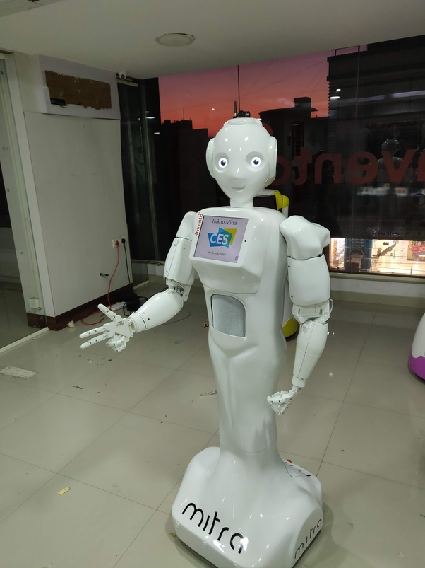

Source: Company files.

**Exhibit 2: MItri robot employed at smartworks**

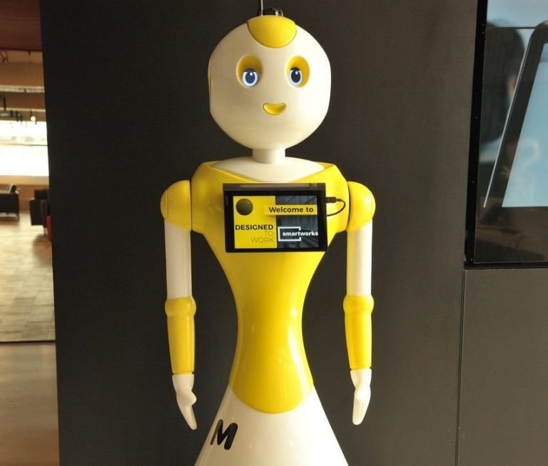

Source: Company files.

Exhibit 3: Smart Kiosk Management Using Mitri robots

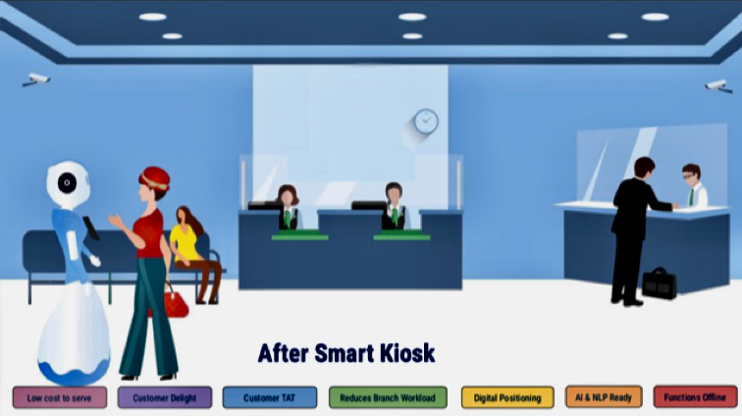

Note: TAT = turnaround time; AI = artificial intelligence; NLP = natural language processing. Text in boxes, from left to right: “Low cost to serve,” “Customer Delight,” “Customer TAT,” “Reduced Branch Workload,” “Digital Processing,” “AI & NLP Ready,” and “Functions Offline.”

Source: Company files.

Exhibit 4: INVENTO ROBOTICS Balance Sheet (US$)

| **Particulars** | As on March 31, 2018 | As on March 31, 2017 |
| --- | --- | --- |
| **EQUITY AND LIABILITIES** |  |  |
| **Shareholders’ Fund** |  |  |
| (a) Share capital | 12,130.51 | 12,130.51 |
| (b) Reserves and surplus | −40,440.74 | −17,254.71 |
| (c) Money received against shares warrants | 0.00 | 0.00 |
| **Share application money pending allotment** | 0.00 | 0.00 |
| **Non-current liabilities** |  |  |
| (a) Long-term borrowings | 13,386.87 | 0.00 |
| (b) Deferred tax liabilities (net) | 1,044.88 | 141.40 |
| (c) Other long-term liabilities | 0.00 | 0.00 |
| (d) Long-term provisions | 0.00 | 0.00 |
| **Current liabilities** |  |  |
| (a) Short-term borrowings | 27,590.23 | 23,963.89 |
| (b) Trade payables | 5,646.79 | 0.00 |
| (c) Other current liabilities | 106,891.40 | 0.00 |
| (d) Short-term provisions | 0.00 | 0.00 |
| Total | 126,249.93 | 18,981.08 |
| **ASSETS** |  |  |
| **Non-current assets** |  |  |
| (a) Fixed assets |  |  |
| 1. Tangible assets | 71,113.09 | 12,391.37 |
| 1. Intangible assets | 0.00 | 0.00 |
| 1. Capital work-in-progress | 0.00 | 0.00 |
| 1. Intangible assets under development | 0.00 | 0.00 |
| (b) Non-current investments | 0.00 | 0.00 |
| (c) Deferred tax assets (net) | 0.00 | 0.00 |
| (d) Long-term loans and advances | 0.00 | 0.00 |
| (e) Other non-current assets | 0.00 | 0.00 |
| **Current assets** |  |  |
| (a) Current investment | 0.00 | 0.00 |
| (b) Inventories | 19,161.42 | 4,257.72 |
| (c) Trade receivables | 14,289.57 | 0.00 |
| (d) Cash and cash equivalents | 1,520.68 | 2,296.74 |
| (e) Short-term loans and advances |  |  |
| (f) Other current assets | 20,165.17 | 0.00 |
| Total | 126,249.93 | 18,981.08 |

Note: The original balance sheet was in Indian rupees (₹); the authors have converted this to US dollars using the exchange rate US$1 = ₹71.72. The financial year is considered from April 1 to March 31.

Source: Invento Makerspaces Private Limited, “Annual Returns and Balance Sheet eForms,” Ministry of Corporate Affairs Database, Government of India, accessed September 21, 2020, www.mca.gov.in/mcafoportal/viewPublicDocumentsFilter.do.

Exhibit 5: SaleS of Special Purpose Industrial Robots (US$ millions)

|  |  |  |  |  |  |
| --- | --- | --- | --- | --- | --- |
| **Country** | **2013** | **2014** | **2015** | **2016** | **2017** |
| Australia | 47.24 | 62.11 | 69.61 | 77.04 | 81.38 |
| Brazil | 48.72 | 62.37 | 83.69 | 57.81 | 61.37 |
| Canada | 298.80 | 315.34 | 359.55 | 364.06 | 416.32 |
| China | 24,393.74 | 26,211.73 | 28,499.19 | 30,339.20 | 34,049.56 |
| France | 599.78 | 570.43 | 627.39 | 685.11 | 773.15 |
| Germany | 3,968.04 | 4,056.63 | 3,905.54 | 4,160.22 | 4,886.85 |
| India | 87.17 | 99.37 | 104.84 | 111.23 | 124.27 |
| Indonesia | 6.86 | 7.80 | 7.43 | 7.51 | 8.17 |
| Italy | 710.65 | 805.98 | 912.72 | 888.80 | 1,030.87 |
| Japan | 3,485.15 | 4,260.36 | 4,824.01 | 4,784.96 | 6,042.55 |
| Mexico | 49.03 | 49.45 | 60.74 | 66.72 | 73.22 |
| Russia | 39.77 | 53.33 | 48.55 | 50.58 | 57.64 |
| Saudi Arabia | 7.17 | 10.45 | 8.72 | 8.43 | 9.23 |
| South Korea | 1,681.23 | 1,459.89 | 1,799.07 | 2,110.68 | 3,696.30 |
| Spain | 100.87 | 111.20 | 107.07 | 123.04 | 126.85 |
| Turkey | 16.83 | 19.35 | 20.99 | 26.73 | 36.86 |
| United Kingdom | 138.96 | 271.30 | 251.17 | 265.84 | 297.53 |
| United States | 2,418.90 | 2,470.20 | 2,508.60 | 2,589.10 | 2,930.70 |

Note: Sales are calculated at the manufacturer’s selling price, adjusted to current market prices in US dollars using the following exchange rates: CNY/USD = 7.04, INR/USD = 71.72, IDR/USD = 13,939.75, JPY/USD = 110.69, KRW/USD = 1,213.74, AUD/USD = 1.52, RUB/USD = 65.25, BRL/USD = 4.39, MXN/USD = 19.04, SAR/USD = 3.75, CAD/USD = 1.33, EUR/USD = 0.92, TRY/USD = 6.15, and GBP/USD = 0.77.

Source: Authors’ estimates; Special Purpose Industrial Robots, “Country-Wise Production of Special Purpose Industrial Robots,” Euromonitor International, accessed February 2, 2020.

1. GES was an annual event organized by the American federal government in collaboration with foreign governments. GES 2017 was held in Hyderabad, India, where the Indian prime minister and Ivanka Trump, senior adviser to the US president, were the chief guests.
2. NalandaU was started in 2010 as a massive open online course platform, with courses available for free from top universities including the Massachusetts Institute of Technology, Stanford University, Yale University, and the Indian Institutes of Technology.
3. Agni Innovation Labs was started in 2011 as a portal focused on small and medium-sized enterprises that helped discover new start-ups and ideas with investors, early adopters, and the media.
4. Founded in 2012, Zingfin was a Tennessee-based start-up that integrated social media into investors’ dashboards, helping investors make better decisions about their portfolios.
5. Limitless was a California-based productivity software company that used a mixture of statistics, imagery, and website blocking to help people remain productive.
6. “Guest Interaction with Mitra Robot from Invento,” YouTube video, 0:33, posted by “Invento Robotics,” May 4, 2018, accessed July 6, 2020, https://youtu.be/wPOlqa45eII.
7. All dollar amounts are in US dollars; conversion of Indian rupees to US dollars based on an exchange rate of US$1 = ₹71.72; ₹ = INR = Indian rupees.
8. Preeti Wadhwani and Prasenjit Saha, “Humanoid Robot Market Forecast,” Global Market Insights, November 2017, accessed September 21, 2020, https://www.gminsights.com/industry-analysis/humanoid-robot-market.
9. Special Purpose Industrial Robots, “Country-Wise Production of Special Purpose Industrial Robots,” Euromonitor International, accessed February 2, 2020.
10. MarketLine, *Global Robots*, *MarketLine Industry Profile,* September 2012, accessed February 25, 2020, https://advantage.marketline.com/Analysis/ViewasPDF/global-robots-2653.
11. “Our Vision,” Softbank Robotics, accessed September 21, 2020, https://softbankrobotics.com/corp/vision/.
12. Amy Robotics, “About Amy,” Amy Robotics, accessed September 21, 2020, www.amyrobotics.com/indexcompanyprofileen.
13. “About Us – Brand Story,” Sanbot, accessed September 21, 2020, http://en.sanbot.com/about/brand-story.
14. “Sanbot,” Sanbot, accessed September 21, 2020, http://en.sanbot.com.
15. “Pepper,” Softbank Robotics, accessed September 21, 2020, https://www.softbankrobotics.com/emea/en/pepper.
16. Balaji Viswanathan, “What Is the Difference between Pepper Robot of SoftBank and Mitra Robot?,” Invento Robotics, June 6, 2018, accessed September 21, 2020, https://mitrarobot.com/what-is-the-difference-between-pepper-robot-of-softbank-and-mitra-robot/.
17. “Why Is Integration among Systems So Important? How Does This Affect the Value That a Robot Can Bring to an Industry?,” Vecna Robotics, accessed November 26, 2020, https://www.vecnarobotics.com/why-is-integration-among-systems-so-important-how-does-this-affect-the-value-that-a-robot-can-bring-to-an-industry/.
18. “India’s Robot Wonder,” International Federation of Robotics, October 24, 2019, accessed July 6, 2020, https://ifr.org/ifr-press-releases/news/indias-robot-wonder.
19. Ibid.
20. International Federation of Robotics, *Executive Summary World Robotics 2018 Industrial Robots*, 2018, accessed September 21, 2020, https://ifr.org/downloads/press2018/Executive_Summary_WR_2018_Industrial_Robots.pdf.
21. “India Fastest Growing Economy! GDP Expands at 7.7% in Q4, 6.7% in Full Year,” Business Today India, accessed June 11, 2021, https://www.businesstoday.in/current/economy-politics/india-fastest-growing-economy-gdp-expands-at-7-7-percent-q4-6-7-percent-in-2017-18/story/278184.html.
22. McKinsey Global Institute, “A Future That Works: Automation, Employment and Productivity”, McKinsey&Company, accessed June 11, 2021, https://www.mckinsey.com/~/media/mckinsey/featured%20insights/Digital%20Disruption/Harnessing%20automation%20for

    %20a%20future%20that%20works/A-future-that-works-Executive-summary-MGI-January-2017.ashx.
23. “Pepper,” op. cit.
24. “Pepper the Robot Coming to HSBC’s Main NYC Branch,” PYMNTS.com, June 27, 2018, accessed December 21, 2020, https://www.pymnts.com/news/artificial-intelligence/2018/pepper-robot-hsbcs-nyc/.
25. “Customers Embrace SoftBank’s Robot, Pepper,” PYMNTS.com, July 30, 2018, accessed December 21, 2020, https://www.pymnts.com/news/artificial-intelligence/2018/pepper-robot-softbank-robotics-technology-innovation/.
26. These were Invento’s internal estimates.
27. Ninety per cent of non-salary fixed expenses were currently for R&D, with Invento producing only one humanoid. However, this was expected to decrease to 50 per cent in the long term, with around six units produced for the same fixed expenses.
28. “Average Receptionist Salary in India,” Payscale, accessed February 10, 2020, <https://www.payscale.com/research/IN/Job=Receptionist/Salary>.
29. “How to Work with Independent Sales Reps,” Inc.com, accessed September 21, 2020, https://www.inc.com/guides/2010/09/how-to-work-with-independent-sales-reps.html.
30. Randy Alfred, “June 21, 1967: First CES Dazzles New York,” Wired, June 25, 2018, accessed September 21, 2020, https://www.wired.com/2010/06/0625first-consumer-electronics-show-new-york/.
31. Consumer Technology Association, *CES 2017* *Attendance Audit Summary*, accessed September 21, 2020, https://cdn.ces.tech/ces/media/pdfs/ces-audit_1.pdf.
32. World AI Show (website), accessed September 21, 2020, https://www.worldaishow.com.