 

9B21A023

SALONSCALE: START-UP CUSTOMER RELATIONSHIP STRATEGIES FOR NICHE MARKET GROWTH

Professors Simon C. Parker and Peter Moroz wrote this case solely to provide material for class discussion. The authors do not intend to illustrate either effective or ineffective handling of a managerial situation. The authors may have disguised certain names and other identifying information to protect confidentiality.

This publication may not be transmitted, photocopied, digitized, or otherwise reproduced in any form or by any means without the permission of the copyright holder. Reproduction of this material is not covered under authorization by any reproduction rights organization. To order copies or request permission to reproduce materials, contact Ivey Publishing, Ivey Business School, Western University, London, Ontario, Canada, N6G 0N1; (t) 519.661.3208; (e) cases@ivey.ca; www.iveycases.com. Our goal is to publish materials of the highest quality; submit any errata to publishcases@ivey.ca. i1v2e5y5pubs

Copyright © 2021, Ivey Business School Foundation Version: 2021-06-25

Alicia Soulier was the owner of Capelli Salon Studio (Capelli), a hair salon based in Saskatoon, Saskatchewan, Canada. Noticing that she was losing money on hair colourings, Soulier conducted some research to discover the reason for it and found that the standard industry practice of uniform pricing was the culprit. Further investigation revealed to Soulier a potentially valuable opportunity: an app that calibrated colour-mix costs and separated them from labour costs to price the service more accurately. This opportunity had the potential to save her salon and others like it thousands of dollars per month. Soulier launched her application (app) SalonScale (SalS) in June 2018, but after a promising start she quickly realized that her intensive salesmanship efforts were not building her customer base fast enough. At the same time, the app was diverting her attention from the Capelli studio, threatening her core business. Soulier wondered whether her current strategy was scalable, or even sustainable. As she geared up for the start of 2019, Soulier knew she had to make some hard decisions about her customer acquisition strategy⎯and she had to make them soon.

THE HAIR AND Aesthetics SALON Market

In Canada, the hair and aesthetics salon market comprised nearly 35,000 hair, nail, and beauty service providers, with estimates of $406.7 million dollars[1] in sales in 2017.[2] In the United States, over 800,000 salons generated over US$60 billion dollars a year in revenue.[3] Statistics from the United Kingdom[4] showed that 60 per cent of practitioners were between the ages of 16 and 34. Salons typically employed 5−10 workers; 83 per cent of people working in the hair care market were women without a degree. Due to the stable demand for these services, salons typically had five-year survival rates, slightly higher than other comparable service businesses. The profitability for salon owners ranged from 4−8 per cent, which was also slightly above the average of other typical service businesses. Hair colourings were an important aspect of the salon sector, with colour clients being habitual customers who received services three to six times a year. This highlighted the importance of customer relationships in the industry as well as a well-established culture of loyalty among patrons.[5] The beauty salon business model was thus well established, easily replicated, and in constant demand.

Most workers in the sector were self-employed, leasing chair space from salon owners.[6] This made it more difficult for business-to-business firms selling beauty and styling products to reach their customers. Most privately owned salons operated on slim margins; the average annual salary for employees in the industry was US$26,271 (roughly CA$35,000).[7] Traditional hair-styling product sales, which typically carried higher margins, were slowly being squeezed by larger retailers, leading to declining revenues from retail sales at the same time that new stylings and colouring innovations were growing in importance.[8] In short, salon owners were experiencing a sharp financial squeeze, making cost savings a top priority.

In response, some salons had adapted by embracing new technology, in the form of customer relationship management (CRM) software, online self-booking, and other automated receptionist services. There was also a growing trend of advertising salon services on social media sites such as Facebook, Instagram, and YouTube.[9] Online support communities also began to spring up, where beauty bloggers and salon owners could offer support and share advice, self-help guidance, and business tips. Social media influencers had emerged in the sector as well; they recommended new trends to their followers, and advocated for the salons that could cater for them.

RECOGNIZING THE opportunity

Hairstylists commonly used scales to measure hair colours (dyes) before mixing them according to prescribed formulae. It was standard practice to charge clients blanket fees despite substantial variations in the materials and labour costs required for different colours. It was during a conversation with a financially minded client in October 2017 that Soulier realized uniform pricing was inflating the costs of some of her mixes above the price she was charging clients. She saw the need for a technological solution that automatically calculated the cost of the dyes used in hairstylists’ scales⎯to which the labour cost could be added to obtain a total cost specific to the colour being made.

Soulier spent several weeks calibrating the costs of dye combinations used in her salon. She then paid a third-party developer to build an app to calculate and display costs via a user-friendly interface that could be connected to Bluetooth-enabled scales. By November 2017, Soulier had an app that could be easily paired with any Bluetooth-enabled scale. Excitedly, she put the app to work at her salon, Capelli. The first tests realized a cost savings of $3,100 in just under a month, leading her to wonder if a market existed for other salon owners, too. She immediately trademarked the name SalonScale (SalS) and started thinking about how to leverage her 10 years of business experience and networks in the salon industry. She believed that her people skills and passion for helping others in the industry to succeed would quickly help her spread the word and build a social movement that would improve the sustainability of salon operators everywhere.

PREPARING TO LAUNCH

In January 2018, Soulier joined the Co.Labs technology incubator in Saskatoon to upgrade her entrepreneurial skills and networks. There, Soulier learned the importance of lean analysis techniques and the need to test and experiment when it came to building the best business model possible. Upon arrival, she was challenged to acquire 100 signatures of people who would commit to buying her product. Obtaining these signatures confirmed to her not only that her product had value, but also that speaking to potential customers could improve the functionality of her software product. This was an important lesson because she often made decisions based on gut instinct without much concern for the numbers. Co.Labs also provided advice to Soulier and help in acquiring resources, which led to an Industrial Research Assistance Program grant from the National Research Council of Canada that focused on helping digital companies to scale by providing resources for hiring employees. This allowed Soulier to hire two software developers to turn the fledgling app into a market-ready product.

Soulier’s venture development efforts were putting ever greater strain on her core salon business. To help relieve the strain, she hired a long-term friend, Kim Baduik. Having previously helped out in a managerial role at Capelli, Baduik was trusted to manage the day-to-day operations of SalS. Soulier continued to refine the product by leveraging her networks to beta test the app in three local salons. In March 2018, SalS received its first round of investment, amounting to $150,000 from friends, family, and a few local angels connected with the incubator. Not knowing if this would be enough, Soulier started working on raising another round of angel financing for $250,000. At the same time, Soulier sought advice and tips from industry experts, consultants, and influencers about the industry, her product, and marketing. She also began providing local demos for salons, an experience that taught her that salon owners were unwilling to make large upfront payments for her technology, despite the cost savings it would generate later. This prompted Soulier to offer a straight subscription model costing $29 per month, per technician, or $99 per month for an entire salon. She also decided to give the scale away for free with any trial of the software. She explained, “The power of having our logo on a $15 scale that we gave away for free during a demo was actually significant to getting the customer interested in the product.”

SalS launched in Saskatoon on June 8, 2018. Soulier invited investors, local media, salon owners, business leaders, and tech start-ups from her Co.Labs cohort to the launch party. The event was a success, and local salons began to sign up for the app. SalS netted another $15,000 in a Co.Labs pitch event on June 20, and received the rest of the original investment notes (another $250,000, for a full $400,000 first round) at the end of July, 2018. This was a lifeline, since SalS was burning capital quickly owing to Soulier’s travel, demo days, and other events, and had only 23 days of funds left in its bank account.

In the meantime, three stylists from Capelli had quit. Soulier’s repeated and lengthy absences to promote SalS had prompted a feeling of neglect among her stylists. Soulier could not afford to lose money at the salon, so she worried about achieving the right balance between attention to her salon and attention to the app. She also became aware for the first time of competitors for SalS. Vish Ltd. (Vish), operating out of Toronto, and SureTint Technologies (SureTint), operating out of Chicago, were also selling a hair colour dye-measuring system (see Exhibit 1). Unlike SalS, both Vish and SureTint were selling not only software but also a physical system that integrated the dye calibration process with a point-of-sale system to provide a seamless checkout. Soulier also learned that their systems took days to install and came with a large up-front installation fee, as well as more expensive monthly subscription fees. Further, it appeared that Vish had been around for almost three years but still had only a few hundred customers. Thus, Vish and SureTint had not been moving quickly within their respective markets and had little to no penetration outside of North America.

CUSTOMER ACQUISITION CHALLENGES

Despite demonstrated cost savings of $4,200 per month at Capelli and $1,900 at a nearby salon called Luxe Beauty, owners of other salons remained reluctant to sign up to SalS. Soulier learned, unexpectedly, that despite the financial pressure salons were under, appealing to salon owners’ emotions was more effective than appealing to their bottom line. Specifically, Soulier’s story, charisma, and relatability as a salon owner whom other owners saw as “one of us” proved to be a strong draw at demo days and trade shows. Her brand and vision of creating a social sustainability movement, in which her product played a significant role, also appealed to salon owners⎯they felt they could trust her. Soulier’s strategy was to book her own event spaces, inviting local stylists and salon owners to glitzy demos of the app. While pre-sign-ups tended to be high, only a few potential clients usually showed up; yet, of those who did, 90 per cent would sign up for a subscription. Soulier found that one-to-one contact was necessary to engage and excite potential customers, familiarize them with the product, and follow up and convert interest into a subscription. Holding the client’s hand through the set-up process was an emotional salve for clients unfamiliar with technologies. Building a trust-based and authentic relationship appeared to play an inordinate role in sales. Thus, she was convinced that SalS customers did not want to purchase the app through a website, by phone, or via a professional salesperson who were not directly involved. Her one-to-one relationship model was also an integral part of her co-creation strategy to evolve the app based on customer feedback, and made the app more appealing to clients. Soulier often took customer questions back to her team in the form of: “Can we do this? Can we do that?” It was satisfying for Soulier to inform her customers that she and her team could include their ideas. Unfortunately, a personalized sales strategy based on building and leveraging customer relationships was time-consuming and did not lend itself well to scaling.

By September 2018, SalS had 59 customers with annual recurring yearly revenue (ARR) of $64,314. SalS also had another 175 sign-ups on a free trial⎯if they converted to paid subscriptions, this would yield an additional ARR of $173,323. This was all a long way from the $1 million ARR Soulier was aiming for. It was also insufficient for her to hire new employees.

As the demo days were failing to generate traction, Soulier contacted a social influencer with half a million followers, Josie Vileym, and gave her a free scale. Vileym unboxed the scale online in an Instagram post and shared the event with her followers, live. Over the course of a few hours, a staggering 220 new clients signed up. Unfortunately, however, this rate of client sign-ups was not sustained, and many of these sign-ups failed to convert to full subscriptions. At the same time, Soulier noticed that although demo day participants were small in number, they generated more new sales leads if they posted SalS on their Instagram pages. These revelations forced Soulier and Baduik to rethink SalS’s business model.

DEVELOPING A STRATEGY FOR SCALING UP SALONSCALE

Despite her vision of creating a supportive ecosystem for salon owners, Soulier was failing to connect with salon owners at a quick enough rate. Why were the demo days failing to fill the funnel, while the social media side could fill it quickly but not activate and retain clients? The value proposition for the app was strong, but it seemingly needed Soulier and her authenticity to get customers to commit to it⎯and this did not scale. Soulier needed to develop a more effective strategy for filling up her sales funnel (see Exhibit 2), while continuing to convert leads into subscriptions at near her current rate. Soulier identified some options.

The first option was to continue with her one-to-one customer relationship strategy, but to enlist support either from commission-led sales reps (e.g., reps from companies that sold the colour dyes) or from “evangelists”[10] among her existing customers. These would be individuals who could raise awareness of the product to drive sales through word of mouth. Reps would likely be expensive, though; and Soulier was unsure whether they would be interested in building the relationships and making the emotional connections clients needed. But reps might have a better sense of which geographical areas to target, and they could relieve the time pressure on Soulier herself. Some form of partnership between SalS and other salon industry supply companies might also be possible, but Soulier was unsure what that might that look like.

A second option was to make greater use of social media influencers (SMIs). Most of Soulier’s SMI contacts had come from trade shows, which were mostly held in large North American cities. These events were good for raising awareness and meeting people, but they were also costly, time consuming, and relatively ineffective in terms of customer acquisition. While SMI promotion was sporadic and hard to control, it did generate numerous leads, even if these did not all convert into subscriptions. Compared to the 90 per cent conversion rate of the one-to-one model, conversions from the SMI unboxing event were closer to 20 per cent, with 5−10 per cent dropping out even after paying for a month or two of subscription to the app. SMIs were also unpredictable in terms of conveying Soulier’s brand and vision. What would be the outcome if Soulier sent out free boxed scales, hoping to get a favourable online review or plug from these SMIs? Also, to whom and where might she send the scales? Canadian SMIs had smaller audiences and so reached fewer target customers than US SMIs, but US social media channels, although encompassing more followers and having greater impact, were hard to access. Soulier wondered whether she should instead adopt a paid media strategy where SalS products could be professionally pitched.[11] While this might generate more traffic, it could be expensive; she might also lose control over both the messaging of her brand and, more importantly, her (and SalS’s) authenticity.

A third option was for Soulier to develop her social media presence and build out her own online social networks. She was getting to know many beauty-focused business consultants, experts, and influencers; could she mobilize or leverage them in some way? Perhaps she could host her own webinars and demo days, generate more content, and leverage other SMIs to help build her vision of a sustainable community. This might enable her to project her authenticity and brand vision, though it would likely take some time to attract the followers and influential online nodes she would need. Soulier believed that a solution to her problem existed⎯she just did not yet know what it was. She felt trapped in a vicious circle: if she could only scale up her venture she would be able to pay for the marketing expertise that might be necessary for scale to become achievable.

CRUNCH TIME

Troublingly, by December 2018 Soulier noticed that a slow trickle of monthly subscriptions had begun to fall out the bottom of the funnel⎯and it was not clear why. Soulier could see opportunities not only for better marketing but also to enhance the website to process sales, attract and analyze trial sign-ups, and convert sign-ups into hard sales. But there was only one of her, and she felt that, for now, she could only employ a limited number of staff. The app also required capital to implement, and investors would be looking for steady sales growth before they would be willing to invest another tranche of funds into the venture. Soulier felt the pressure mounting, and knew she had to act fast.

EXHIBIT 1: The competition (2019)

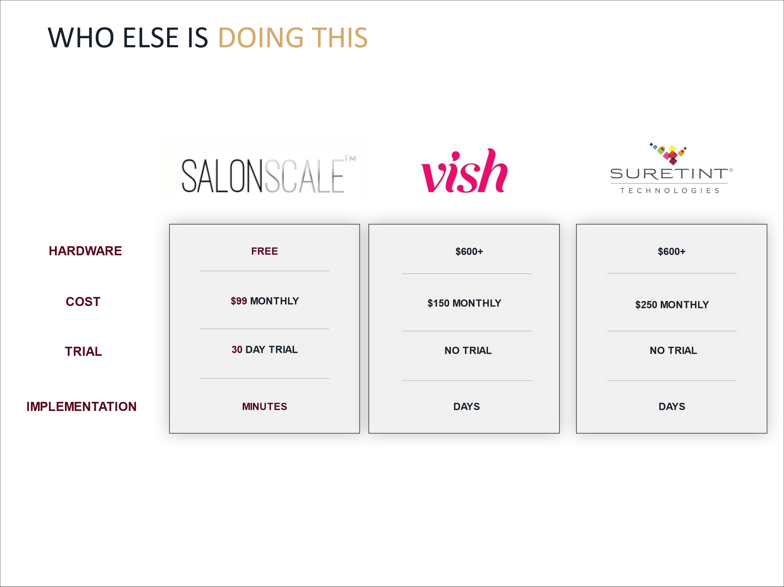

Source: Company files.

EXHIBIT 2: THE CUSTOMER RELATIONSHIP FUNNEL

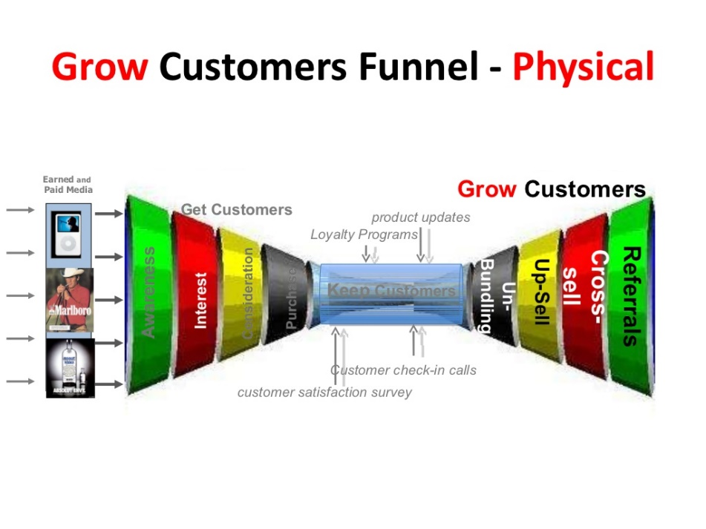

Source: Steve Blank, “Customer Relationships Web/Mobile Products Get/Keep/Grow,” SlideShare, June 27, 2012, accessed October 10, 2020, https://www.slideshare.net/sblank/nsf-online-lecture-5-customer-relationships/36-Customer_RelationshipsWebMobile_Products_GetKeepGrow_2012.

1. All dollar amounts are in Canadian dollars unless specified otherwise.
2. IndustryARC, *Canada Professional Hair Care Market - Forecast (2021 - 2026)*, 2019, accessed June 1, 2021, https://www.industryarc.com/Report/7396/canada-professional-hair-care-market-report.html#:~:text=The%20Canada%20professional%20hair%20care,1.4%25%20during%202018%2D2023.
3. Statista, “Market size of beauty salons (hair, skin, nails) in the United States from 2017 to 2020,” accessed June 25, 2021, https://www.statista.com/statistics/296193/revenue-hair-and-nail-salons-in-the-us/, accessed June 1, 2021.
4. NHBF Limited, *2019 Industry Statistics for Hairdressing, Barbering & Beauty*, March 23, 2017, accessed June 1, 2021, https://www.nhbf.co.uk/documents/hair-and-beauty-industry-statistics/.
5. “10 Hair Salon Industry Stats that Will Blow Your Mind,” Salt Society, 2019, accessed June 1, 2021, https://saltsocietyeducation.com/blogs/news/hair-salon-industry-statistics.
6. Ibid. [“10 Hair Salon Industry Stats that Will Blow Your Mind,” Salt Society, 2019, accessed June 1, 2021, https://saltsocietyeducation.com/blogs/news/hair-salon-industry-statistics.]
7. “Beauty Salons,” DATA USA, accessed June 1, 2021, https://datausa.io/profile/naics/beauty-salons.
8. “10 Hair Salon Industry Stats that Will Blow Your Mind,” op. cit.
9. Ibid. [“10 Hair Salon Industry Stats that Will Blow Your Mind,” op. cit.]
10. “Evangelism marketing”; Guy Kawasaki, “The Art of Evangelism,” May 2015, Harvard Business Review, accessed June 25, 2021, https://hbr.org/2015/05/the-art-of-evangelism.
11. For example, through a media influencer company such as Virtual Nation. See *Viral Nation: The COVID-19 Pandemic and the Entrepreneurial Venture Sale Decision* (London, ON: Ivey Publishing, 2020). Available from Ivey Publishing, product no. 9B20A088.