

9B21B004

NCEM: improving accounting processes for a canadian charity

Brian Lane wrote this case solely to provide material for class discussion. The author does not intend to illustrate either effective or ineffective handling of a managerial situation. The author may have disguised certain names and other identifying information to protect confidentiality.

This publication may not be transmitted, photocopied, digitized, or otherwise reproduced in any form or by any means without the permission of the copyright holder. Reproduction of this material is not covered under authorization by any reproduction rights organization. To order copies or request permission to reproduce materials, contact Ivey Publishing, Ivey Business School, Western University, London, Ontario, Canada, N6G 0N1; (t) 519.661.3208; (e) cases@ivey.ca; www.iveycases.com. Our goal is to publish materials of the highest quality; submit any errata to publishcases@ivey.ca. i1v2e5y5pubs

Copyright © 2021, Ivey Business School Foundation Version: 2021-03-04

The end of the 2019 calendar year was looming for Walter Selke, general director of Northern Canada Evangelical Mission (NCEM). With 20 separate ministries across the country and problems in NCEM’s accounting, Selke knew that significant changes in the accounting process were required, and that these should be implemented quickly. Each ministry had a separate set of books in NCEM’s accounting system, which led to redundant, time-wasting entries. Data entry problems made the T3010 charitable activities report required by Canada Revenue Agency (CRA) difficult to complete. There were problems with tracking the provincial sales tax (PST) and goods and services tax (GST) that needed to be paid. And NCEM’s board of directors wanted increased timeliness in the delivery of financial statements.

Faced with these challenges, Selke knew that he would have to develop new procedures for bookkeepers, ministry leaders, and the executive team. Key issues included choosing between a hard or soft close, changing the organization’s year-end date, educating staff about accounting reports, and implementing all of these changes. NCEM’s year-end was only five months away, so Selke did not have much time.

History of the Mission

NCEM was an interdenominational ministry organization in Prince Albert, Saskatchewan, Canada. The organization’s goal was reflected in its vision and mandate statements: “By faith to establish strong indigenous multiplying churches . . . to fulfill the Great Commission of Jesus Christ among and in partnership with the Aboriginal Peoples of Canada” (see Exhibit 1).[1]

Established in June 1946 in Meadow Lake, Saskatchewan,[2] NCEM either ran or partnered with Bible camps, churches, fellowships, and youth programs across the country, focusing on indigenous communities. The organization’s executive team, office workers, and operations staff were all missionaries first, developing their own salary support through reliance on churches, businesses, and individuals.[3] NCEM was growing steadily. By 2019, its operations included almost 20 separate ministries across Canada, with donations of approximately CA$4.6 million[4] in 2018/19.

With plans in place to add a significant number of new, younger missionaries in the near future, changes to the accounting system were needed as soon as possible to ensure that the system worked efficiently and provided timely, useful information to the board, the executive team, donors, and CRA.

Accounting Processes at NCEM

In the early 2000s, NCEM had separate bookkeepers at many of its ministry locations and numerous accounting programs with varied charts of accounts. Accounting processes had developed over time without standardization, and some were not based on sound accounting rationale. Changes were initiated in 2006 to standardize accounting systems between the ministries. Since then, successive financial managers had worked toward transferring all of the ministries to Intuit’s QuickBooks software,[5] with a common chart of accounts that was to be used by all of the ministries, with no exceptions. By 2006, these efforts had resulted in significant progress but further work remained to be done.

As of 2006, all of the ministries had made the switch to QuickBooks; however, each ministry was still represented as a separate company file with a separate set of books within the accounting system. And although each ministry was represented by a separate entity, the ministries transacted with one another. Thus, the transfer of funds between ministries created accounts receivable and accounts payable within each set of books that would ultimately be eliminated upon consolidation.

NCEM managed the consolidation by using its headquarters’ books as a parent organization and making transfers to and from each ministry. The consolidated QuickBooks file was commonly referred to as “the Inc.,” which was an abbreviated version of “the incorporated file.” In the end, manual adjustments were required when consolidating to remove the inter-organization transactions. It would have been helpful to have the accounting software automatically manage these transfer entries, but too many of the entries required manual oversight to ensure that they were made correctly. Additionally, because of problems in the accounting process, NCEM was not able to use its accounting software to automate the preparation of the annual T3010 report to report charitable activities to CRA. This slowed the preparation of the mandatory report.

Most of NCEM’s operations were tax-exempt, with exceptions that included the print shop and bookstores. Those operated as profit centres that paid income tax.

Manual adjustments were made when donations income was received by head office and recorded in a custom software program designed in-house called “Acts 6.”[6] Income designated for one of the ministries had to be transferred out of the headquarters’ books and into, for example, a Bible camp’s books, so that the income would not be recorded twice. Even though the headquarters’ books and the Bible camp’s books were housed at head office, the accounting records for each of the ministries were actually separate files. Each ministry, such as the print shop, aviation services,[7] Big River Bible Camp,[8] Pine Ridge Bible Camp,[9] and others, had its own separate file in the accounting software. There was inadequate coordination between the files, even though transactions often spanned multiple ministries. Each year, the annual consolidation was a significant source of stress for NCEM, with the required volume of intercompany journal entries placing a heavy load on the bookkeepers and the chief financial officer (CFO).

NCEM had been using the Acts 6 accounting software since approximately 2005, and the program appeared to be capable of meeting the organization’s needs. Donation receipts were processed in Acts 6 and booked as income in QuickBooks. Selke and the CFO had no plans to change either program, but they hoped to change the way that QuickBooks was used.

Responsibility for the organization’s accounting structure rested on the headquarters’ finance team and six ministry leaders who maintained the books for their own divisions, as outlined in the company’s organizational chart (see Exhibit 2). Selke did not see any value in moving slowly and making all sorts of small changes along the way. He thought that this would cause people more pain as time went by since they would have to adjust their work multiple times. He thought that, instead, they should change as much as possible, all at once, since NCEM was going to try to consolidate all of the ministries in the current year.

Hard Close versus Soft Close

NCEM’s finance team needed to choose between using a hard and soft close at the end of each accounting period. Despite changes that had been ongoing since 2006, the long-term goal of bringing all of the ministries together in a software-driven automated consolidation process remained unmet. The finance department’s primary challenge then was to address the board’s requests for increased timeliness in delivering both the monthly and the annual statements.

Full consolidation occurred at the end of each fiscal year, but even at month-end, the bookkeepers and ministry leaders had to make numerous manual journal entries. These were in addition to the regular month-end entries and accruals. As a result, the finance team was not able to execute a complete close of the period every month. There were always receipts and payments that occurred shortly after month-end. If they closed the period, ran reports, and then reopened the period and changed the numbers, confusion could be magnified.

Changing the Year-End Date

A separate challenge came from the CFO’s desire to change NCEM’s financial statement year-end from April to December. Based on experience and a recommendation from the auditor, it made sense for NCEM’s financial year-end to coincide with the date when all of the ministry files would be brought together into the consolidated file. Donation receipts were tallied based on a calendar year-end, and the T3010 report followed a calendar year-end as well. Changing the financial statement year-end now would fit with the goal of making as many changes as possible within a short time frame.

A change in year-end would require a number of stub year entries and accounting adjustments, which could require significant time on the part of the CFO, so adequate time and resources would need to be available. Additionally, NCEM would have to write a letter to CRA seeking approval to change the year-end and outlining the reasons for the requested change. Once the transition from the current fiscal year was finished, the CFO hoped that in the future, the time drain of reconciling disparate year-ends would no longer exist.

Training, Knowledge Gaps, and Human Resources

Selke hoped that NCEM could enable built-in functionality within QuickBooks to automate the preparation of the organization’s annual T3010 as part of its financial statements (see Exhibit 3). While the accounting software was designed to generate much of this report automatically, manual intervention was often required because of problems with the coding of T3010 entries. At first glance, it would have seemed that this was a technology issue and that perhaps the accounting software could be modified so that automatic preparation of the T3010 report might be possible. Unfortunately, it was more likely that some entries for T3010 transactions and tax liabilities were not accurate because users were regularly adding accounts to the general ledger without understanding how these affected tax reporting. Fixing these issues would require that NCEM make numerous changes in the way entries were made and coded, which would start with training. Using the system’s built-in functionality to handle inter-divisional tax entries would have been more efficient, but NCEM’s accounting problems made this impossible.

NCEM staff were missionaries first and office employees second, so some headquarters staff took extended absences through the year to engage in missionary work. Absences of four to six weeks were common with their missionary work taking staff to various communities, some of which were geographically distant from the head office in Prince Albert. Maintaining continuity in the accounting department was difficult when these key people were out in the field, although NCEM’s airplanes did occasionally help to bring people back to the office as quickly as possible. Office staff shared a story of a retired missionary travelling in an NCEM aircraft: he enjoyed looking out the window and seeing, every eight minutes or so, the approximate location of one of his overnight bush camps. Much of his early mission work had involved travel by dogsled.

Some key people within NCEM’s head office did not have much experience with financial reporting, particularly with the difference between cash-based and accrual-based accounting. Increasing general knowledge of the balance sheet also needed to be addressed. Primary training for most staff had been in missions, but now that they worked both as missionaries and administrators, accounting had become an important part of their roles. Closing these knowledge gaps would be important for the mission to continue to grow and to accurately report to its stakeholders.

One option for dealing with this problem was to cross-train head office staff so that if a bookkeeper left on mission duties, other administrative staff could help to fill the gap. This was how NCEM had dealt with the issue for many years, but keeping everyone up to an appropriate level of knowledge was challenging because missionaries had often moved on to different responsibilities outside of the head office. Selke had another alternative in mind, which was to hire a recent business school graduate to begin work in a full-time, paid administrative position. Doing this would require a shift in thinking because NCEM had never had a paid employee. The benefit, however, was that NCEM would have a full-time employee in the administrative and bookkeeping position every day. A major negative was that the plan was a departure from the way that NCEM had always run the organization’s administrative structure.

Adding to the list of issues, one of the two head office bookkeepers had recently given one month’s notice of retirement. If the CFO was not able to fill the position quickly, NCEM could be in an administrative crisis: how could a single bookkeeper possibly keep up with the work? As it was, the CFO and two bookkeepers were stretched thin; it seemed unlikely that the CFO and one bookkeeper could continue to manage the accounting function. With only a few months remaining until year-end, a new hire and the accounting changes would have to happen quickly if the organization’s books were to continue to support the mission.

Conclusion

NCEM’s executive team and the board wanted to see changes made quickly, believing that the changes had been necessary for a long time. The desired accounting changes seemed daunting: a large organization with 20 subsidiaries reporting in 20 separate sets of books would need to bring together all these records in one company file, and within a tight timeframe of approximately five months.

In early August, Selke stated,

I believe that these changes are important and that they need to happen as soon as possible. With the growth that we expect in NCEM’s mission team in the next few years, we have to be willing to put money and resources into updating our accounting processes and addressing our accounting issues. The board has made it very clear that improving the timeliness of month-end reports is important if this organization is going to continue to grow and thrive.

NCEM had existed since 1946, and in some respects, the organization was still operating as it had back in the early years. Donations income was climbing, the organization was becoming bigger and more complicated, missionaries were based in communities across the country, and the bookkeeping and accounting functions needed to support these realities. NCEM’s auditor cautioned that with 20 separate entities to consolidate, it probably would not be possible to address these challenges quickly. Selke’s desire, however, was to make as many changes as possible within a short time span to minimize the effect on people and their jobs. The auditor was concerned about the integrity of the accounting process and the load placed on the finance department.

Thinking forward over the next few months, Selke pondered different plans of action. How could he be sure that the path NCEM was taking would be correct? Change was necessary; however, change could not come about at the expense of compromising NCEM’s vital relationships with donors, missionaries, and the First Peoples communities in which NCEM operated. To top it all off, the near-crisis short staffing situation in finance was causing Selke a great deal of stress. He believed that it would take much prayer and planning to resolve these issues and wondered how to manage the change.

Exhibit 1: Northern Canada Evangelical mission Website

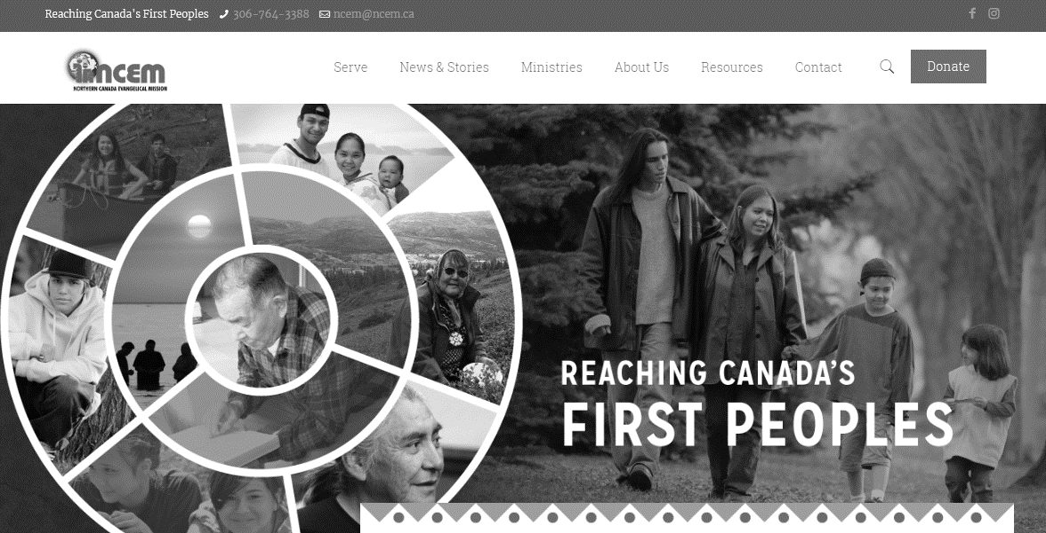

Source: “Reaching Canada’s First Peoples,” Northern Canada Evangelical Mission, accessed October 28, 2019, www.ncem.ca.

Exhibit 2: Northern Canada Evangelical Mission Organizational Chart

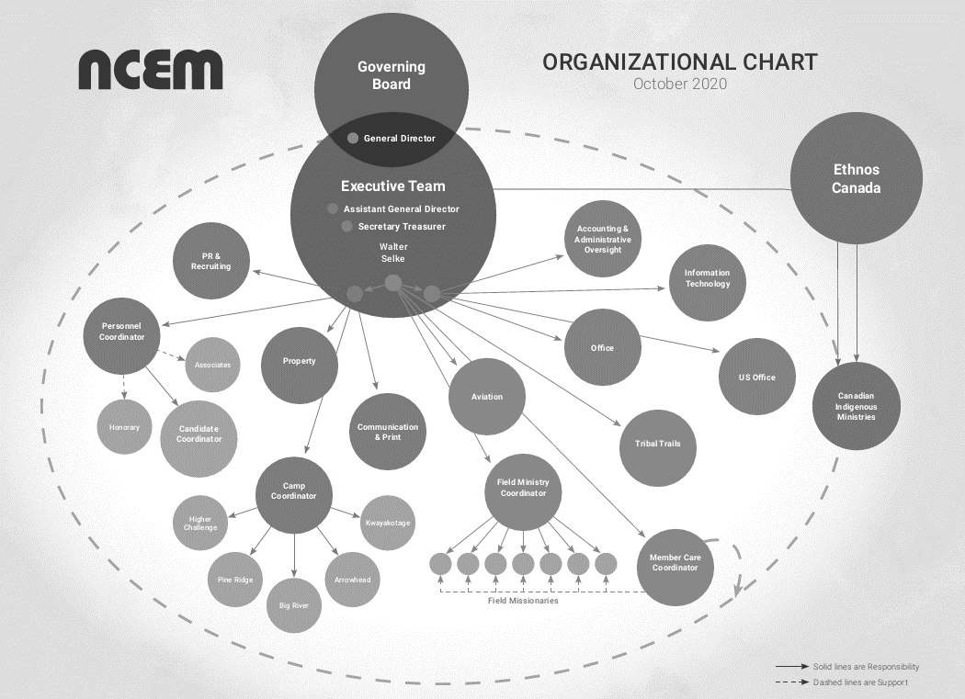

Source: Company documents.

Exhibit 3: Northern Canada Evangelical Mission balance sheet and income statement (2018 and 2019) with corresponding T3010 line items

| **Description** | **Year Ended March 31st**  **(in CA$)** | | **T3010 Line** |
| --- | --- | --- | --- |
| **2019** | **2018** |
| **Assets** |  |  |  |
| Cash, bank accounts, and short-term investments | 2,093,653 | 1,424,316 | 4100 |
| Amounts receivable from non-arm's length persons |  | 129,039 | 4110 |
| Amounts receivable from all others | 86,889 | 95,773 | 4120 |
| Investments in non-arm's length persons |  |  | 4130 |
| Long-term investments | 586,574 | 585,310 | 4140 |
| Inventories | 202,027 | 211,787 | 4150 |
| Land and buildings in Canada | 3,496,731 | 3,459,049 | 4155 |
| Other capital assets in Canada | 1,304,892 | 1,278,938 | 4160 |
| Capital assets outside Canada |  |  | 4165 |
| Accumulated amortization of capital assets | (2,251,059) | (2,176,381) | 4166 |
| Other assets | 134,982 | 35,037 | 4170 |
| 10-year gifts |  |  | 4180 |
| Total assets (add lines 4100 to 4170) | 5,654,689 | 5,042,868 | 4200 |
| Amounts not used in charitable activities |  |  | 4250 |
|  |  |  |  |
| **Liabilities** |  |  |  |
| Accounts payable and accrued liabilities | 171,653 | 117,528 | 4300 |
| Deferred revenue | 253,598 | 185,540 | 4310 |
| Amounts owing to non-arm's length persons |  |  | 4320 |
| Other liabilities |  |  | 4330 |
| Total liabilities | 425,251 | 303,068 | 4350 |
|  |  |  |  |
| **Net Assets** |  |  |  |
| Internally restricted | 209,277 | 193,022 |  |
| Net investment in capital assets | 2,550,564 | 2,561,606 |  |
| Unrestricted | 2,469,597 | 1,985,172 |  |
| Total net assets | 5,229,438 | 4,739,800 |  |
| **Total Liabilities and Net Assets** | **5,654,689** | **5,042,868** |  |

Exhibit 3: Continued

| **Description** | **Year Ended March 31st**  **(in CA$)** | | **T3010 Line** |
| --- | --- | --- | --- |
| **2019** | **2018** |
| **Revenue** |  |  |  |
| Line number 4350 |  |  |  |
| Eligible amount of gifts for which the charity issued tax receipts | 3,412,146 | 2,327,542 | 4500 |
| Eligible amount of tax-receipted tuition fees |  |  | 5610 |
| Amount of 10-year gifts received |  |  | 4505 |
| Amount received from other registered charities | 688,470 | 703,791 | 4510 |
| Other gifts received for which a tax receipt was not issued | 33,938 | 77,331 | 4530 |
| Revenue received from federal government |  |  | 4540 |
| Revenue received from provincial/territorial governments |  |  | 4550 |
| Revenue received from municipal/regional governments |  |  | 4560 |
| Tax-receipted revenue from all sources outside of Canada | 23,079 | 15,012 | 4571 |
| Non-tax-receipted revenue from all sources outside Canada | 23,650 | 469,250 | 4575 |
| Interest and investment income received or earned | 18,941 | 13,238 | 4580 |
| Gross proceeds from disposition of assets | 2,838 | 76,136 | 4590 |
| Net proceeds from disposition of assets | 2,838 | 76,136 | 4600 |
| Gross income received from rental of land and/or buildings | 139,700 | 86,312 | 4610 |
| Non-tax-receipted memberships, dues, and association fees | 92,923 | 93,892 | 4620 |
| Non-tax-receipted revenue from fundraising |  | - | 4630 |
| Revenue from sale of goods and services (except to government) | 84,322 | 77,643 | 4640 |
| Other revenue not already included in the amounts above | 40,359 | 63,019 | 4650 |
| **Total Revenue**  — (lines 4500, 4510–4560, 4575, 4580, and 4600–4650) | **4,537,287** | **3,988,154** | 4700 |

Exhibit 3: Continued

| **Description** | **Year Ended March 31st**  **(in CA$)** | | **T3010 Line** |
| --- | --- | --- | --- |
| **2019** | **2018** |
| **Expenditures** |  |  |  |
| Advertising and promotion | 121,450 | 90,660 | 4800 |
| Travel and vehicle expenses | 210,028 | 331,031 | 4810 |
| Interest and bank charges | 19,108 | 8,698 | 4820 |
| Licences, memberships, and dues | 45,706 | 58,151 | 4830 |
| Office supplies and expenses | 71,657 | 66,632 | 4840 |
| Occupancy costs | 296,936 | 265,510 | 4850 |
| Professional and consulting fees | 23,308 | 23,773 | 4860 |
| Education and training for staff and volunteers | 64,010 | 100,120 | 4870 |
| Total expenditure on all compensation | 2,060,110 | 2,068,838 | 4880 |
| Fair market value of donated goods used in charitable activities | |  | 4890 |
| Purchased supplies and assets | 67,382 | 167,545 | 4891 |
| Amortization of capitalized assets | 119,247 | 121,190 | 4900 |
| Research grants and scholarships as part of charitable activities | |  | 4910 |
| Expenditures not included in the amounts above  —TV production | 928,288 | 641,716 | 4920 |
| Expenditures before gifts to qualified donees  — (lines 4800–4920) | 4,027,230 | 3,943,864 | 4950 |
| Of the amounts at lines 4950 and 5031: |  |  |  |
| (a) Total expenditures on charitable activities | 3,491,561 | 3,470,260 | 5000 |
| (b) Total expenditures on management and administration | 530,570 | 472,375 | 5010 |
| (c) Total expenditures on fundraising | 5,099 | 1,229 | 5020 |
| (d) Total expenditures on political activities |  |  | 5030 |
| (e) Total other expenditures included in line 4950 |  |  | 5040 |
| Total amount of gifts made to all qualified donees | 20,419 | 25,065 | 5050 |
| **Total Expenditures** (add lines 4950 and 5050) | **4,047,649** | **3,968,929** | 5100 |
| **Excess of Revenues over Expenses** | **489,638** | **19,225** | 4020 |
|  |  |  |  |
| Was an accrual or cash basis used? Accrual. |  |  |  |

Source: Northern Canada Evangelical Mission Inc., “T3010 Registered Charity Information Return: Schedule 6 for the period April 1, 2018 to March 31, 2019,” May 8, 2019, https://apps.cra-arc.gc.ca/ebci/hacc/srch/pub/t3010/v23/t3010Schdl6_ dsplyovrvw; and Northern Canada Evangelical Mission Inc., “T3010 Registered Charity Information Return: Schedule 6 for the period April 1, 2017 to March 31, 2018, May 8, 2019,” https://apps.cra-arc.gc.ca/ebci/hacc/srch/pub/t3010/v23/ t3010Schdl6_dsplyovrvw.

1. Walter Selke, “Welcome to Our Site,” NCEM, accessed January 4, 2021, https://ncem.ca.
2. “Our History,” NCEM, accessed November 25, 2020, http://ncem.ca/about-us/our-history.
3. A missionary was a person whose primary role was to proclaim their religious beliefs in specific geographical areas or among specific people groups. NCEM’s religious values were based in Christianity.
4. All dollar amounts are in Canadian dollars (CA$) unless otherwise specified.
5. “More Automation to Save Time and Boost Productivity,” Intuit QuickBooks, accessed August 2, 2019, https://quickbooks.intuit.com/ca/desktop/pro.
6. “Acts 6” is a Bible reference to the book of Acts, chapter 6. In this reference, Jesus’ disciples choose seven from their group to be responsible for the care of some widows who were being overlooked in the daily distribution of food. At NCEM, money received through Acts 6 goes to the daily needs of the organization’s missionaries, hence the name.
7. “Aviation,” NCEM, accessed January 27, 2021, https://ncem.ca/ministries/aviation/.
8. “Big River Bible Camp,” BRBC, accessed January 27, 2021, www.bigriverbiblecamp.ca/.
9. “Pine Ridge Bible Camp,” PRBC, accessed January 27, 2021, www.pineridgebiblecamp.ca/.