

9B21C010

Social Justice at the Stratford Festival (A)

Professor Gerard Seijts and Vania Sakelaris wrote this case solely to provide material for class discussion. The authors do not intend to illustrate either effective or ineffective handling of a managerial situation. The authors may have disguised certain names and other identifying information to protect confidentiality.

This publication may not be transmitted, photocopied, digitized, or otherwise reproduced in any form or by any means without the permission of the copyright holder. Reproduction of this material is not covered under authorization by any reproduction rights organization. To order copies or request permission to reproduce materials, contact Ivey Publishing, Ivey Business School, Western University, London, Ontario, Canada, N6G 0N1; (t) 519.661.3208; (e) cases@ivey.ca; www.iveycases.com. Our goal is to publish materials of the highest quality; submit any errata to publishcases@ivey.ca. i1v2e5y5pubs

Copyright © 2021, Ivey Business School Foundation Version: 2021-03-25

In March 2020, due to the outbreak of the COVID-19 pandemic, it became clear that life would not go on as usual for Canada’s Stratford Festival (Festival) and its many stakeholders. Many changes were implemented to help the Festival continue to function. Additionally, social justice issues had come to the forefront, and action had to be taken. In June 2020, questions remained as to whether the Festival’s actions were enough to mitigate the financial damage caused by the pandemic and whether the executive team had made the correct choices regarding how to address social justice issues.

Public-Health Crisis

The outbreak of the COVID-19 pandemic in early 2020 upended the work of the Festival. Everything about that work depended on people gathering. Audiences, artists, artisans, and administrators would literally gather shoulder to shoulder to create and to enjoy the productions on the Festival’s stages located in Stratford, Ontario, Canada.

The 2020 season was set to be one of the Festival’s most ambitious, with more than 700 performances of 15 productions presented on four different stages. Productions ranged from an all-new staging of the musical *Chicago* to William Shakespeare’s *Hamlet*, with a black woman, Amaka Umeh, playing the title role. *The Rez Sisters*, by renowned Canadian Indigenous writer Tomson Highway, was also planned to be performed, as well as Shakespeare’s *Richard III*, starring Colm Feore, which was to officially open the brand new CA$72-million[1] Tom Patterson Theatre.

But on March 20, in an effort to stem the transmission of the pandemic and under the direction of government officials, the Festival halted work on its 2020 productions and ultimately postponed the entire season, which was to have run from April through to November 2020.

As a result of the postponement, the Festival’s financial outlook was bleak. Before the pandemic, the anticipated budget for the year was $76 million. By mid-March, $15 million had already been spent on season preparations, paid for in large part by revenue from advance ticket sales, which at that point also amounted to $15 million. With those sales suspended, the Festival was forced to issue temporary layoff notices and reduce its staff complement from more than 500 people to just 70.

The impact of the postponement extended far beyond the Festival’s four theatres, its production centre, its staff members, and its audience of 500,000 patrons. As a catalyst for economic activity in the Southwestern Ontario region, the Festival normally drove $135 million in tourism spending, generated 2,300 jobs in the community, and yielded $55 million in taxes for all three levels of government.

To achieve some measure of financial stability, the Festival’s leaders—executive director Anita Gaffney and artistic director Antoni Cimolino, reporting to a volunteer board of governors and supported by a senior management team—took a series of drastic steps.

They drew $6 million from the Festival’s debt facility, suspended all projects that were not mission-critical, renegotiated with suppliers, appealed to government for a one-time investment, and mounted an accompanying lobbying campaign. They also drew on the Festival’s endowment fund, instituted a 50 per cent salary reduction for the artistic director and executive director, successfully applied for the Canadian Emergency Wage Subsidy program to enable the Festival to rehire 300 staff members, and launched the Recovery 2020 fundraising campaign.

From Theatre to Broadcaster

In 2014, the Festival set out to film the entire Shakespeare canon over a 10-year period. To date, 15 productions had been filmed, with the catalogue ranging from such popular titles as *Romeo and Juliet* to such lesser-known plays as *Pericles*. With this asset in hand, the Festival decided to mount a free online film festival during the current performance hiatus.

The film festival started on April 23, Shakespeare’s birthday, with a production of *King Lear*, starring Colm Feore. Each Thursday night, a viewing party was conducted around the film screening on YouTube. On the following Saturday morning, the Festival broadcasted a live virtual “Meet the Festival” session with artists featured in that week’s film. A series of interviews related to the films rounded out the digital content that was generated and promoted each week.

To date, that content had attracted more than one million views around the world, meeting the Festival’s goal of staying connected to its stakeholders while showcasing the work of its artists. With digital media activities thus accelerated by the need for physical distancing, the management team was developing a plan to monetize this content through a subscription service, online donations, advertising, and merchandise. As well, the Festival hoped to make the content available through existing aggregators such as iTunes and Amazon Prime.

From Theatre to Social Justice Champion

The killing of US hip-hop artist George Floyd on May 25, 2020 in Minneapolis, Minnesota, United States, shook the world. A police officer, Derek Chauvin, who is white, kept his knee on Floyd’s neck for eight minutes and 46 seconds. Chauvin did not remove his knee even after Floyd lost consciousness. Floyd was unarmed and handcuffed. The incident was yet another example of police brutality and racist violence. Watching the protests unfolding across North America, the Festival’s executive and management team recognized the pain their black colleagues were experiencing and set their sights on doing something meaningful to champion anti-racism. On Monday, June 1, 2020, as social media channels were inundated with messages of support for the anti-racist movement, the Festival posted an official statement from the artistic director and executive director (see Exhibit 1).

The executive team thought deeply about what the Festival could do to advance the discussion on anti-racism, address the organization’s failings, and create a better culture. Noting how this period of physical distancing had underscored the strength of the Festival’s social media platform and its digital connection to its numerous stakeholders, the team reached out to the Black Caucus and to the Indigenous Circle—two informal groups of Festival artists and administrators. The executive team offered each group the opportunity to take over the Festival’s social media channels for a 48-hour period and to conduct a town-hall session on the Festival’s YouTube channel.

The question remained, however, whether turning over the social media channel to the two groups was a prudent strategy, given the difficulty of predicting the outcomes of activities that start out with good intentions.

The Ivey Business School and the Ian O. Ihnatowycz Institute for Leadership gratefully acknowledge the generous support of Bill and Kathleen Troost in the development of this case.

Exhibit 1: Stratford Festival’s Anti-Racism Statement

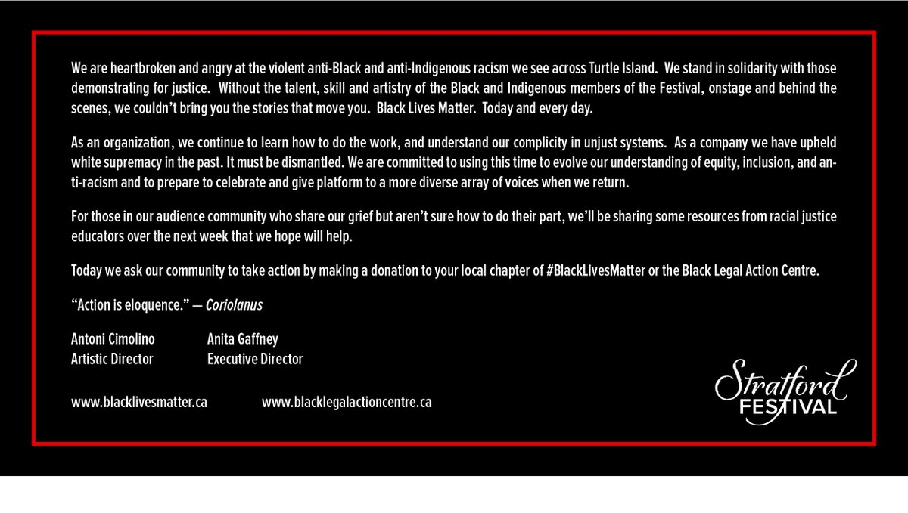Source: Company documents.

1. All currency amounts are in CA$ unless otherwise specified.