

9B21C016

ST jOSEPH’S HEALTH CARE: Leveraging collaboration and innovation to define strategic directions

Vania Sakelaris wrote this case under the supervision of Martha L. Maznevski and Alison Konrad solely to provide material for class discussion. The authors do not intend to illustrate either effective or ineffective handling of a managerial situation. The authors may have disguised certain names and other identifying information to protect confidentiality.

This publication may not be transmitted, photocopied, digitized, or otherwise reproduced in any form or by any means without the permission of the copyright holder. Reproduction of this material is not covered under authorization by any reproduction rights organization. To order copies or request permission to reproduce materials, contact Ivey Publishing, Ivey Business School, Western University, London, Ontario, Canada, N6G 0N1; (t) 519.661.3208; (e) cases@ivey.ca; www.iveycases.com. Our goal is to publish materials of the highest quality; submit any errata to publishcases@ivey.ca. i1v2e5y5pubs

Copyright © 2021, Ivey Business School Foundation Version: 2021-05-17

In early 2018, Dr. Gillian Kernaghan was working on her organization’s next strategic plan. Kernaghan was the chief executive officer of St. Joseph’s Health Care (St. Joseph’s) in London, Ontario, Canada. With only six weeks before the March 31, 2018 deadline, Kernaghan acknowledged the increasing risk of possible delays in completing the strategic plan. She had not anticipated the resistance that she encountered from her management team in response to the draft copy presented to them. Kernaghan had led an innovative and collaborative strategic planning process. Finalizing the strategic themes and goals generated from that process would be a challenge. Although Kernaghan had established a good working relationship with her senior team, she had not expected that the perspectives on the strategic plan ownership and the wording in the plan would generate such resistance. The organization’s board members felt that control and accountability for implementing the strategic plan had been delegated to them, regardless of ownership.

Kernaghan had developed trust in her leadership team and she believed in the importance of empowering her senior team. However, she did not agree that the strategic plan’s goals should be made shorter and tighter. As an authentic leader, she took issue with simplifying or condensing the plan’s goals, which had been crafted to reflect input received from all stakeholders engaged in the process. It was imperative to honour the voices of over 2,000 people that had contributed to the comprehensive and collaborative strategic planning process. Kernaghan was proud of the innovative approach to engaging stakeholders that she had introduced to St. Joseph’s. She was also proud of the non-traditional process she had developed to collect and integrate stakeholders’ input. Her main goal was to effectively capture the essence of their input and ensure that the suggested wording resonated with them.

Their input demonstrated the integrity of the process that had been used to prepare the strategic plan. However, Kernaghan worried that she could lose her senior management team’s trust and support if she ignored their suggestions to sharpen and dilute the plan’s goals. As a values-based and authentic leader, Kernaghan also knew that she faced reputational risk. She had to honour the commitments made in recent months, during the engagement process of the numerous stakeholders, and deliver a strategic plan by March 31, 2018. But she also had to find a way to mitigate the resistance from the senior management team without compromising that relationship. She was proud of the working relationship she had forged with her team to date. How could she retain the support of her management team and also honour the commitments made to the stakeholders involved in the comprehensive strategic planning project?

INDUSTRY BACKGROUND

St. Joseph’s was one of 145 hospital corporations in Ontario, which included 262 hospital sites.[1] Ontario hospitals provided 24-hour care to patients including acute care, chronic care, and emergency, surgical, specialty, and rehabilitation services. Hospitals worked in collaboration with other parts of the health care system to provide coordinated care to the patients served. Each Ontario hospital was governed by a board of directors who had overarching accountability for the allocation of public funds received by that hospital, and for the quality and efficacy of care provided by the hospital. Funding was provided by Ontario’s Ministry of Health and Long-Term Care through 14 regional local health integration networks (LHINs).[2]

LHINs were established in 2007 to fund, plan, deliver, and integrate local health care. The 14 networks oversaw nearly CA$30 billion[3] in annual operating funding from the Ministry of Health and Long-Term Care to provincial health service providers. They were designed to improve the health of Ontarians by providing increased access to health care services planned, coordinated, and delivered locally. They were also intended to work with their respective local communities to identify health care priorities for their regions. LHINs collaboratively and efficiently addressed health care needs by providing accessible high-quality health services. The mandate of LHINs included a focus on effective and sustainable health care programs that were designed to meet the diverse, growing, and changing health care needs of Ontarians.

As provincial crown agencies, LHINs were accountable to the Ontario Ministry of Health and Long-Term Care. In turn, LHINs held the health service providers in their respective regions accountable through Service Accountability Agreements (SAAs) that were prepared in accordance with the *Local Health System Integration Act* of 2006. SAAs were negotiated annually and outlined approved budgets and funding targets, together with financial and performance reporting obligations. St. Joseph’s was accountable to the South West LHIN. Kernaghan and her team were challenged with addressing the increased demands for health care within an environment of fiscal constraints. With health care costs increasing across the country, St Joseph’s and all other health service providers were accountable for ensuring efficient and effective use of taxpayer dollars.

Ontario hospitals were committed to ensuring that patients received high quality and safe health care. They incorporated a variety of quality improvement initiatives into their practices as part of their contribution to the Ontario health care system. Committees on the board of directors oversaw key quality and performance measures to help ensure that legislated requirements and standards were met. These requirements included complying with the regulations outlined in the *Public Hospitals Act* and the *Mental Health Act*.[4] Such committees also closely monitored changing health care trends so that existing programs could be adapted and new effective programs and services could be added to meet emerging needs. A major challenge that health care providers including St. Joe’s faced was how to meet the growing needs of an increasingly aging population with complex health care needs, which reflected costly acute care services.

HEALTH CARE ISSUES AND TRENDS

Over the previous decade, the share of health expenditure spent on Canadians aged 65 and older had risen slightly, from 44.3 per cent to 46.0 per cent, while the percentage of seniors in the population had grown, from 13.1 per cent to 16.1 per cent, and was expected to continue rising. By 2020, the global segment of the population aged 65 and older was forecast to increase by 8 per cent worldwide, resulting in over 604 million people over the age of 65. The prevalence of dementia was also expected to double every 20 years.[5]

Such shifts in demographics required the St. Joseph’s team of health care professionals to be responsive and agile to the changing needs of patient populations, despite limited budgets and staff. Strong, resilient, and collaborative interdisciplinary teams were a critical success factor that Kernaghan had built and relied upon. Her leadership team was also responsible for delivering operational efficiencies to help ensure efficient, scalable, and sustainable high-quality care for patients.

In their quest for continual quality improvement, hospitals such as St. Joseph’s collected and measured data regarding the patient experience. Patients and caregivers were invited to participate in hospital planning and decision-making initiatives. This included participation on committees, input through questionnaires, and feedback provided through town hall meetings hosted by the organization, often during periods of proposed changes. Accreditation reviews helped to assess compliance with national standards for hospitals through organizations such as Accreditation Canada. Strategic planning was an activity used by organizations to set priorities, and to help identify areas of focus with respect to goal setting, resource allocation, and performance measurement to help ensure that strategic objectives and related outcomes were being achieved. Strategic plans typically spanned time frames of three to five years. The level of involvement in the process by patients, family, and staff could vary by organization. When opportunities for input were greatly limited, the engagement level was considered only a token gesture.

Ontario hospitals aimed to be closely aligned with provincial priorities. This was a key consideration for the strategic planning process. The Ministry of Health and Long-Term Care was committed to improving access to health care services and providing better information to help patients make informed decisions regarding their care. The ministry was focused on helping to enhance coordination and integration of health care services, as well as supporting and protecting the health of Ontarians. These priorities were outlined in the ministry’s action plan for health care, entitled *Patients First: Action Plan for Health Care*.[6]The plan was designed to help deliver on the government’s commitment to improve health care outcomes and patient experience. However, it had been launched during a period of fiscal constraints, when the provincial government was committed to reducing its deficit. Therefore, the availability of new funding to support new program development was limited. The commitment shifted to demonstrating more value for taxpayer dollars, forcing innovation and efficiency measures to be adopted in organizations such as St. Joseph’s.

ORGANIZATIONAL BACKGROUND

St. Joseph’s was one of 20 Catholic health care providers in Ontario. The academic acute care hospital served London and the surrounding region in Southwestern Ontario at five main sites. As a key health care provider, it was publicly funded to enhance access to quality care in its region.[7] St. Joseph’s had been providing care since 1869. It was dedicated to helping its patients live to their fullest by helping to minimize the effects of disease, injury, and disability (see Exhibit 1). In addition to community-based services, the organization provided a range of services that included acute and ambulatory care, complex and veteran care, rehabilitation services, specialized geriatrics, specialized mental health care, long-term care, and research to help inform and advance its patient care practices.

St. Joseph’s provided health care with over 1,000 hospital beds for more than 900,000 ambulatory visits each year. It employed an interdisciplinary team of over 4,000 staff members, 1,288 physicians, and more than 900 volunteers[8] (see Exhibit 2). St. Joseph’s had an operating budget of over $450 million. Its research funding of more than $120 million, in collaboration with a partner hospital, supported over 2,000 active research projects. The hospital provided clinical education to over 2,000 students each year. St. Joseph’s also supported fundraising efforts through its foundation to meet the growing and changing needs of the organization.[9] The foundation allocated millions of dollars of grant funding to support care, education, and research across the organization to make a difference in the lives of patients.[10] St. Joseph’s actively engaged patients, families, physicians, staff members, volunteers, donors, and community partners whose efforts helped provide the best care possible to those served.

The Ontario Hospital Association used an assessment tool, named the NRC Picker Employee Experience Survey, to assess employee engagement in hospitals. Employee engagement was viewed as a prerequisite for high performance and had a strong correlation with quality of care and services provided to patients. The assessment tool measured factors that influenced the levels of employee engagement including work environment, management, and organizational culture. St. Joseph’s overall physician and employee engagement scores had reflected a steady increase during Kernaghan’s tenure over the last five years (see Exhibit 3).

LEADERSHIP BACKGROUND

In 2010, Kernaghan was appointed president and chief executive officer of St. Joseph’s. She assumed this role after having served as vice-president for various hospitals in the London area. In her capacity as vice-president, she had led various successful restructuring efforts that were a catalyst for sustainable change in those hospitals within the local health care system. Before assuming this role, Kernaghan had served for many years as a family physician after graduating from Western University in 1984.[11] She also raised three boys while running her practice in collaboration with her spouse of over 39 years.

Kernaghan believed in the importance of spending personal leisure time with her family and took part in various leisure activities such as skiing, kayaking, biking, hiking, and scuba diving. She understood and emphasized the benefits of unwinding in the great outdoors and maintaining work−life balance through recreational activities. She believed that holding a successful executive career should not mean having to sacrifice time spent with family or being a mother and a working spouse. As a values-based leader, Kernaghan took her allotted vacation time to enjoy with her family members and set aside appropriate time to attend to family commitments. In her experience, she had found that other workers in similar positions of executive leadership did not seem to place the same level of importance on family.

Kernaghan had a passion for integrated care, performance excellence, and leadership. She shared her knowledge through several public speaking engagements. She also provided leadership development courses across the country, with a focus on crucial conversations and accountability. She viewed her efforts as an important foundation in relationships and leadership. She believed in the value of being a role model for the concept of “servant leadership,” which maintained that the leader should be a servant first. Kernaghan saw leadership as a privilege that allowed her to develop and excel based on her strengths. She received various awards for her noteworthy leadership accomplishments, including the Canadian Society of Physician Leaders Excellence in Medical Leadership Award and the YMCA Women of Excellence Award in Health, Science & Technology. As an active volunteer, Kernaghan had served as a member of many national, regional, and provincial boards and committees. She always set aside time in her schedule to support such commitments.

Kernaghan’s leadership style and passion for exemplary care influenced the organization’s vision: “To earn complete confidence in the care we provide.” She believed in the critical imperative to “walk the talk” and be a role model for integrity and authentic leadership. She was a strong advocate for people being true to themselves, finding their own voice, and ensuring that their voice was heard. Kernaghan reinforced to her team the importance of congruent words and actions, with clear intent for all actions taken. She promoted the importance of being reflective, particularly in advance of stepping into challenging work or scenarios. She often reminded her team members that leadership could be demonstrated from any position and stressed a “we” rather than “me” approach. She saw leadership as a journey of building capability with time and experience.

Kernaghan felt privileged to work in an organization that had values aligned with her own. She believed that these values enabled her and her team members to work together to serve others. She strove to ensure that St. Joseph’s values were demonstrated through her actions and decisions. She ensured that the organization’s recruitment efforts included an assessment of values for potential candidates to help identify a suitable fit within the organization. She made it imperative for her team members to respect and publicly support the values and ethics of the organization. Those values were woven into the orientation process and performance evaluations of staff members, reinforcing the importance of integrating the values into their work. Individual and collective performance was measured in relation to the organization’s values. As validated by accreditation surveyors, St. Joseph’s demonstrated evidence of being true to its values. Team members were frequently reminded of the importance to being true to one’s values and were advised to lean on the organization’s values to inform their actions and decisions when faced with issues.

Kernaghan believed that leaders should be able to live with uncertainty, set the direction for the future, and have the courage to advance the necessary actions for a desired future state. These qualities were critical to the organization’s success.[12] It was imperative, she felt, to use principles as a guide for implementation of change strategies, in alignment with the organization’s long-term vision. She acknowledged the key role that teams played in this process, and how important it was to draw upon the team’s strengths to mobilize change. Leaders had to demonstrate effective listening, she believed, to integrate all input collected into strategic actions. However, she understood the importance of resisting the urge to act too quickly to find solutions. She favoured an approach that considered the longer-term view for change.

STRATEGIC PLANNING

Significant decisions had to be made regarding the future of the organization. To help inform the decision-making process, Kernaghan proposed that the organization take a non-traditional approach to strategic planning. The organization’s governance team supported the innovative co-operative approach and opted for an active role in the development of the new strategic plan. The governance team trusted the proposed process and the wisdom that was expected to emerge from the collective knowledge and voices. Information would be collected through an analysis of the external environment, current issues, and new trends. Preconceived notions would be set aside in favour of trusting that the resulting inputs received would provide options for the future strategic direction of St. Joseph’s.

In collaboration with the St. Joseph’ board of directors, Kernaghan engaged the services of a consulting firm for assistance in the process. The consultants would help develop a broad consultation effort that included engaging and collecting input from many different stakeholders, including patients, caregivers, front-line staff workers, leaders, board members, physicians, industry partners, and researchers. Social media would be used to invite feedback on priorities that the organization should consider. It also included low-technology approaches. For example, sticky notes on easels and boards at the front doors of all five St. Joseph’s sites would record people’s ideas regarding the role that St. Joseph’s should play in the future in support of building a more integrated health care system.

The planning process incorporated input collected from over 2,000 people and organized the feedback into eight themes. For each theme, strategic engagement team sessions were hosted and attended by management and board members in collaboration with patients, staff, physicians, and others. These sessions brought together groups that traditionally would never meet. Despite some skepticism regarding the process, the skilled facilitation approach produced meaningful feedback. The input that was received appeared to converge by the end of each session. Discussion was prompted through effective questions designed to shepherd the thought-provoking process. The sessions raised new perspectives and experiences for the organization to review and consider. Issues that warranted focus and questions that needed to be answered were brought to light by the sessions.

The feedback from the stakeholder engagement was integrated with other key information collected through the strategic planning process to create a draft report. In a February 2018 management retreat, the senior team reviewed the report. The senior team was not accustomed to playing such an active role in plan development and approval, but the team was much more visibly involved in this case. The board members were also unfamiliar with the engagement methods used in this process. Some of them were not even present at the sessions, so they had not reviewed the feedback that was received from stakeholders.

Given this context, Kernaghan encountered some resistance when she sought the management team’s approval of the draft report and the strategic goals developed during the sessions. The language in the report had resonated with the session participants, but the management team found it verbose and asked Kernaghan to simplify and shorten the wording in the report. She worried that doing so could risk sending the message that the organization was not prepared to honour the ideas made by participants and commitments made by the organization during the co-operative process. In her position as an authentic leader, Kernaghan communicated to the management team her reluctance to consider their request and the potential for reputational risk. However, a clear difference of opinion was evident, which led to heightened tensions at the senior leadership level. An agreement could not be reached on how best to reconcile opposing views and finalize the strategic plan.

It became clear, through discussions at the February retreat, that many senior management members were adamant about the goals in the report being shorter and more directive. Kernaghan worried that a strategic plan that was too directive risked being too short-sighted. From a goal perspective, the board members supported the fact that the strategic plan incorporated goals expected to be only partially met over the time frame of three to five years. They acknowledged that a solid plan should incorporate both concrete and aspirational goals intended to span beyond the plan’s time frame. The organization’s governing body generally agreed that aspirational goals helped set a foundation for the future direction of the organization.

THE CHALLENGE FACING KERNAGHAN

Having attended each of the eight sessions, Kernaghan heard the input from stakeholders first-hand. Over 2,000 individuals had helped inform the organization’s new strategic goals and directions. She appreciated the importance of ensuring that they could see how their input shaped the organization’s new plan. A co-operative design approach was a key element of the plan’s development and an integral part of the process. The organization’s strategic planning approach was broadly communicated, well received, and supported by the diverse groups of stakeholders. Therefore, Kernaghan felt that it was morally imperative to honour the organization’s commitment and effectively manage stakeholder expectations. She believed that it would be a fatal flaw to demonstrate token leadership. The organization risked being perceived as having only superficially consulted stakeholder groups to “check off boxes.” She felt strongly about the need to honour the intent of the stakeholder engagement.

Kernaghan was conflicted with the suggestion by the management team to condense and simplify the wording of the proposed strategic goals. She struggled with the fact that her senior team was not fully supportive on this matter. Her relationship with the management team members, which she had developed over the last eight years, was strong and effective. However, she acknowledged that without their ongoing support and buy-in, the successful implementation of the strategic plan could be in jeopardy. The senior team would play a key role in the plan’s roll-out, following approval by the board members. The March 31, 2018 due date was fast approaching. Kernaghan had some tough choices to make that could help or compromise the organization’s future efforts, but she was committed to leaning on her core values.

The Ivey Business School gratefully acknowledges the generous support of CIBC in the development of this case.

EXHIBIT 1: Organizational Mission, Vision, and Values at St. Joseph’s Health Care

|  |
| --- |
| **MISSION**  We help all who come to us for care to maintain and improve their health. We work with people to minimize the effects of injury, disease and disability. We do this by pursuing excellence in care, research and education in a wide range of hospital, clinic, long term and community-based settings. In the spirit of our founders, we care in the example of Jesus Christ and in keeping with our values. We attend to the wholeness of each person—body, mind and spirit. We are a life-affirming community, nurturing a living spirituality through all stages of life, health, suffering and death. We ensure ongoing ethical reflection. We advocate for those who are vulnerable and without a voice. We actively pursue and build partnerships to create a better health care system.  **VISION**  We earn complete confidence in the care we provide, and make a lasting difference in the quest to live fully.  **VALUES**  Respect. Excellence. Compassion. |

Source: Company information.

EXHIBIT 2: Corporate Organizational Chart of St. Joseph’s Health Care

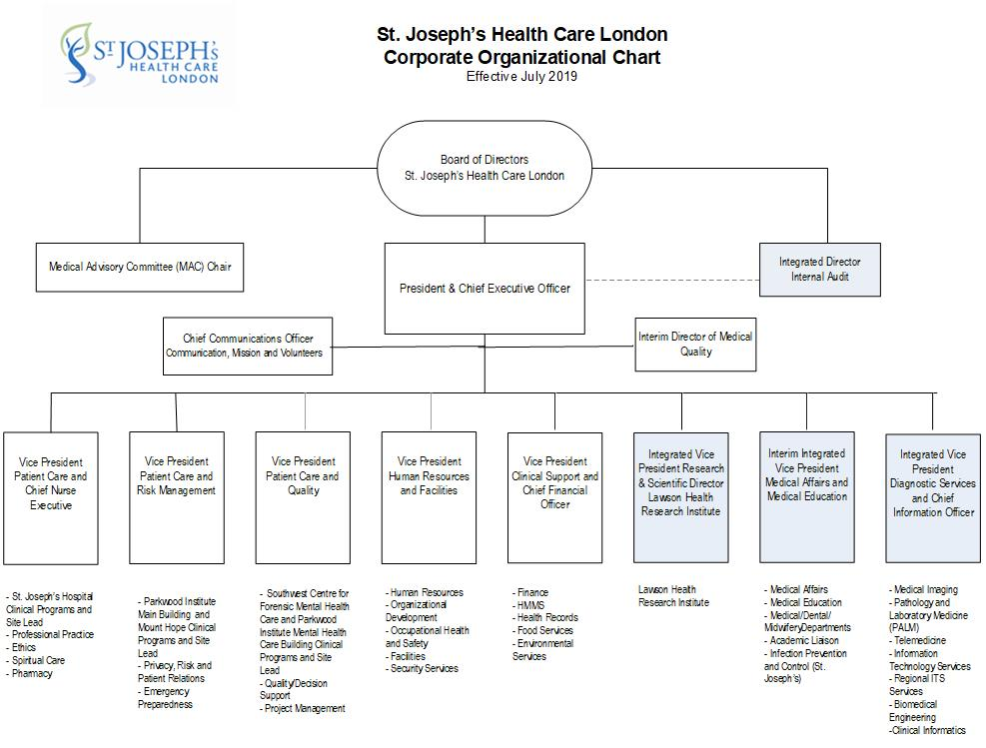

Source: Company information.

EXHIBIT 3: Engagement Scores at St. Joseph’s Health Care

**Employee and Physician Engagement Levels, 2013 to 2017 (%)**

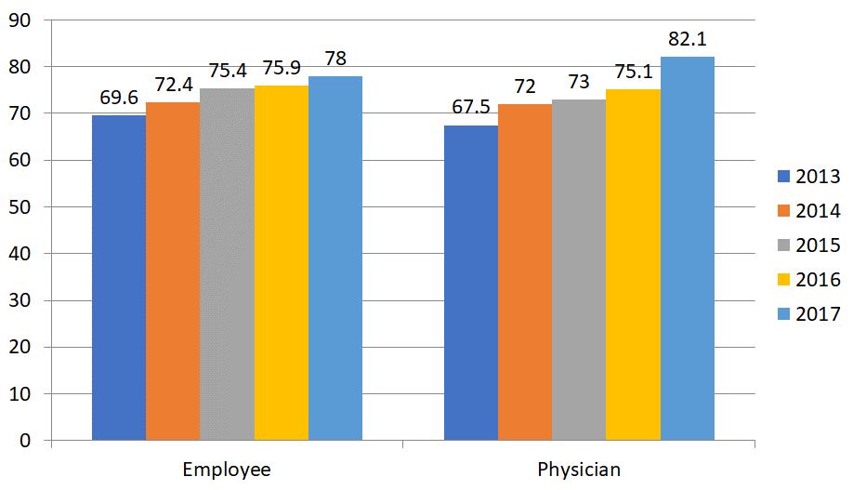

**Response to Employee Engagement Questions, 2013 to 2017 (%)**

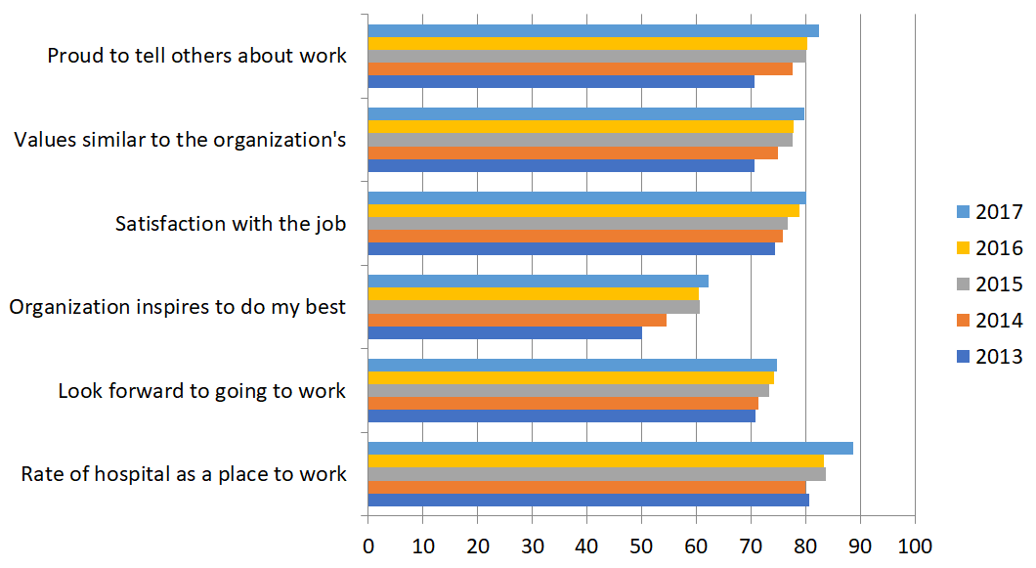

**EXHIBIT 3 (CONTINUED)**

**Response to Employee Engagement Questions versus Benchmark, 2017 (%)**

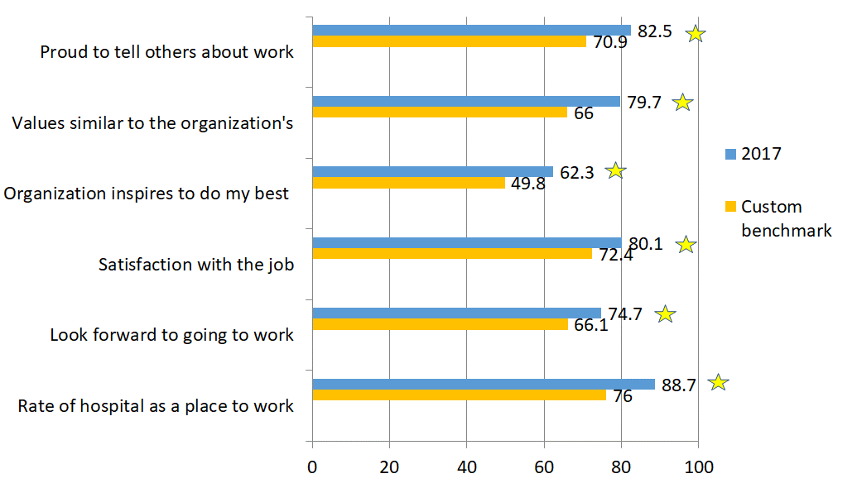

Source: Company information.

1. “Ontario’s Hospitals,” Ontario Hospital Association, accessed August 14, 2019, www.oha.com/about-oha/leadership-councils.
2. “Ontario Local Health Integration Networks,” Government of Ontario, accessed August 14, 2019, www.lhins.on.ca.
3. All currency amounts are in Canadian dollars unless otherwise specified.
4. “Hospitals,” Ministry of Health and Long-Term Care, Government of Ontario, accessed August 14, 2019, www.health.gov.on.ca/en/common/system/services/hosp.
5. Deloitte, *2021 Global Health Outlook: Accelerating Industry Change*, accessed August 14, 2019, www2.deloitte.com/global/en/pages/life-sciences-and-healthcare/articles/global-health-care-sector-outlook.html.
6. “Patients First: Action Plan for Health Care,” Ministry of Health and Long-Term Care, Government of Ontario, accessed August 14, 2019, www.health.gov.on.ca/en/ms/ecfa/healthy_change.
7. “About Us,” St. Joseph’s Health Care, accessed August 14, 2019, www.sjhc.london.on.ca/your-st-josephs/about-us.
8. “Your St. Joseph’s,” St. Joseph’s Health Care, accessed August 14, 2019, www.sjhc.london.on.ca/yourstjosephs.
9. “St. Joseph’s Facts & Figures,” St. Joseph’s Health Care, accessed August 14, 2019, www.sjhc.london.on.ca/sites/default/files/pdf/stjosephs-fact-sheet-brochure.pdf.
10. “President’s Message,” St. Joseph’s Foundation, accessed August 14, 2019, www.sjhcfoundation.org/about-us/presidents-message.
11. “President and CEO,” St. Joseph’s Health Care, accessed August 14, 2019, www.sjhc.london.on.ca/your-st-josephs/president-and-ceo.
12. “CEO Blog: Interview with Dr. Gillian Kernaghan, President and CEO of St. Joseph’s Health Care London and #LEADSFramework Expert,” Holland Bloorview: Kids Rehabilitation Hospital, Julia Hanigsberg, President and CEO Blog, February 13, 2019, accessed September 8, 2019, https://hollandbloorview.wordpress.com/2019/02/13/ceo-blog-interview-with-dr-gillian-kernaghan-president-and-ceo-of-st-josephs-health-care-london-and-leadsframework-expert.