

9B21C017

FORENSIC SERVICES AT THE CENTRE FOR ADDICTION AND MENTAL HEALTH

Lauren Iuliani wrote this case under the supervision of Gerard Seijts solely to provide material for class discussion. The authors do not intend to illustrate either effective or ineffective handling of a managerial situation. The authors may have disguised certain names and other identifying information to protect confidentiality.

This publication may not be transmitted, photocopied, digitized, or otherwise reproduced in any form or by any means without the permission of the copyright holder. Reproduction of this material is not covered under authorization by any reproduction rights organization. To order copies or request permission to reproduce materials, contact Ivey Publishing, Ivey Business School, Western University, London, Ontario, Canada, N6G 0N1; (t) 519.661.3208; (e) cases@ivey.ca; www.iveycases.com. Our goal is to publish materials of the highest quality; submit any errata to publishcases@ivey.ca. i1v2e5y5pubs

Copyright © 2021, Ivey Business School Foundation Version: 2021-05-19

Dr. Catherine Zahn, president and chief executive officer (CEO) of the Centre for Addiction and Mental Health (CAMH), sat down to reflect on the events of the past two months. Following the absconding from care of three patients in the summer of 2019 from its forensic mental health unit, one of whom left the country, CAMH found itself at the centre of a high-profile media crisis. Specifically, the incident had led to public outrage from the community, the media, and the government, putting CAMH’s reputation at risk. Dr. Zahn knew that the forensic mental health space was complex and that, more often than not, the patients were the victims of unfair stigmatization and discrimination. Dr. Zahn, her Public Affairs team, and the clinical leadership needed to work together to develop a strong communications and stakeholder response plan in order to move forward.

CAMH

CAMH was Canada’s largest mental health teaching hospital and one of the world’s leading research centres in its field, located in Toronto, Ontario. Like most Canadian hospitals, CAMH operated as a non-profit organization, with a considerable portion of its funding coming from the Ontario provincial government through the Ministry of Health. Additionally, CAMH operated as a registered charity through the CAMH Foundation, which raised and stewarded private funds. In fiscal year (FY) 2019, CAMH received roughly CA$357 million[1] and $90 million of funding through the Ontario Ministry of Health and private donations, respectively.[2]

CAMH was officially formed in 1998 through the amalgamation of four separate institutions: The Queen Street Mental Health Centre, The Clarke Institute of Psychiatry, The Addiction Research Foundation, and The Donwood Institute. However, the origins of these four institutes dated back as far as 1850.[3] CAMH’s staff of over 3,000 physicians, clinicians, researchers, educators, and support staff provided clinical care to nearly 40,000 patients each year.[4] Research, education, policy development, and advocacy were all crucial tenets to CAMH’s objective, with over $71 million in new research grants awarded and 630 articles published in peer-reviewed journals in FY 2018 alone. Suitably, Research Infosource Inc., a respected and leading source of ranking information on research universities, corporations, hospitals and colleges in Canada, identified CAMH as one of Canada’s Top 40 Research Hospitals, and the top mental health research hospital in the country.[5] Mental illness (e.g., depression, anxiety disorders, schizophrenia, substance use disorders, etc.) was the leading cause of disability worldwide, with 6.7 million Canadians experiencing it annually.[6] As such, CAMH’s purpose was clear: to position mental health at the centre of health care (see Exhibit 1).[7]

CAMH provided a wide array of mental health and addiction services to both inpatients and outpatients. An inpatient was a patient who required admission to CAMH (i.e., overnight), while an outpatient did not require hospitalization at CAMH to receive services. CAMH’s breakdown of patient diagnosis on admission in FY 2019 was as follows: schizophrenia and related disorders with psychosis (31.6 per cent), substance use disorders (31.5 per cent), depressive disorders (13.5 per cent), bipolar and related disorders (11.1 per cent), personality disorders (3.7 per cent), trauma and stressor-related disorders (2.4 per cent), anxiety disorders (1.7 per cent), and other (4.5 per cent).[8] Many cases were complex, with 50 per cent of inpatients having more than one diagnosis on admission.[9] Additionally, demand for CAMH’s services was consistently rising. Between FY 2016 and FY 2019, CAMH saw a 26 per cent increase in emergency department visits, a 10 per cent increase in outpatient visits, and a 231 per cent increase in virtual consults.[10] In order to better meet CAMH’s rising demand, a redevelopment of CAMH’s campus was underway, costing over $1 billion thus far (see Exhibit 2).[11]

Canada’s Forensic Mental Health System

One of the more complicated programs at CAMH was the forensic mental health service. In Canada, when an individual was found not criminally responsible (NCR) on account of a mental disorder, the individual was rehabilitated through the forensic mental health system rather than the traditional correctional system. Important to note was that not all people with mental illnesses who committed crimes were found NCR. In fact, Ontario Review Board (ORB) data indicated that of all individuals charged with a criminal code violation each year, only 0.001 per cent were found NCR.[12] Forensic hospitals provided psychiatric assessment, treatment, and care by psychiatrists, psychologists, nurses, social workers, and recreation and occupational therapists. These professionals worked in tandem towards a common goal of balancing patient rehabilitation and reintegration into society while maximizing community safety.[13] The likelihood of a person found NCR reoffending following treatment was relatively low, suggesting that the system was effective. For instance, for patients treated in forensic settings there was a 22 per cent rate of recidivism compared with a rate of 34 per cent for long-term Canadian prisoners and 70 per cent for mentally disordered prisoners, according to a study of individuals found NCR in Ontario, British Columbia, and Quebec.[14]

The forensic mental health system was notoriously misunderstood and stigmatized. Broadly, stigma referred to negative attitudes (i.e., prejudice) and negative behaviours (i.e., discrimination) towards a specific group of people. Mental health stigma was well researched and documented. For example, according to a survey carried out by the Canadian Medical Association, “Just 50 per cent of Canadians would tell friends or co-workers that they have a family member with a mental illness, compared to 72 per cent who would discuss a diagnosis of cancer and 68 per cent who would talk about a family member having diabetes”.[15] Similarly, “42 per cent of Canadians were unsure whether they would socialize with a friend who has a mental illness” and “55 per cent of Canadians said they would be unlikely to enter a spousal relationship with someone who has a mental illness.”[16] Forensic mental health had an added layer of complexity and stigma associated with it compared to non-forensic mental health. On top of the usual mental health stigma, individuals in the forensic mental health system were often labelled as “dangerous.” This was commonly referred to as “double stigma.”[17] While it was true that some individuals found themselves in the forensic mental health system as a result of violent crimes, many non-violent crimes such as mischief, theft, and drug use were the basis of NCR charges. Further, many Canadians simply did not understand the process of being found NCR or the treatment process that followed. Notably, “46 per cent of Canadians thought people use the term mental illness as an excuse for bad behaviour, and 27 per cent said they would be fearful of being around someone who suffers from serious mental illness.”[18]

Forensic Services at CAMH

CAMH had one of Canada’s largest forensic mental health programs and was one of Ontario’s 11 designated hospitals providing forensic services. While CAMH provided minimum and medium security-level treatment, minimum to maximum security was offered between Ontario’s 11 designated hospitals.[19] CAMH’s forensic inpatient service has 192 beds, comprised of 100 minimum secure beds, 82 medium secure beds, and 10 additional beds in non-forensic units. During 2018−2019, there were 352 unique forensic inpatients and 3,901 outpatients under the care of CAMH forensic community services.[20]

Demographically, 85 per cent of CAMH’s forensic patients were men, and they tended to enter the system in their mid-thirties. Roughly 50 per cent of patients were born in Canada. Schizophrenia or other serious mood disorders such as bipolar disorder accounted for approximately 80 per cent of patients’ primary diagnoses. Further, cases involving a violent index offence were not entirely uncommon, with about 15 per cent of total cases comprising homicide or attempted homicide and about 15 per cent comprising sexual offences (e.g., sexual exploitation, exposure, trafficking, sexual assault, aggravated sexual assault, etc.).[21] It was important to recognize that while many of the offences were violent in nature, this did not inherently mean that the majority of people experiencing mental illness were violent.

The Ontario Review Board (ORB)

In Canada, when someone was found NCR, a provincial government-appointed tribunal decided where the person would go and their level of passes and privileges, such as the ability to be in the community with or without supervision. In Ontario, the tribunal responsible for this duty was the ORB. When the ORB ordered an individual to CAMH’s forensic hospital, CAMH had an obligation to provide supervision and care according to the boundaries of the ORB’s order. By law, the ORB was required to impose the “least onerous and least restrictive” conditions necessary to ensure the individual was “not a significant threat to the safety of the public.”[22] The ORB was required to review each patient’s progress annually and decide if the previously imposed parameters regarding an individual’s reintegration into the community were still appropriate. Many factors were taken into consideration by the ORB when assessing an individual, including listening to the individual themselves and their lawyer, the Crown attorney in the case, and a psychiatrist. It was also common for family members to provide testimonies. Further, the hospital where the individual was receiving care reported to the ORB on the patient’s history and progress. After taking all of these perspectives into account, the ORB ultimately made decisions based on a majority vote rooted in the following four considerations:[23] (1) whether the individual was deemed a risk to members of the public; (2) the current state of the individual’s mental health and the state of it over the past year; (3) how integrated the individual was into society, for instance whether they had good connections to friends or family and could successfully live outside of the hospital; and (4) any other needs of the individual that should be considered.

Members of the ORB were appointed by the lieutenant governor in council, and the board had to contain no fewer than five people.[24] The *Criminal Code of Canada* outlined that there had to be at least one psychiatrist on the board. Additionally, if there was only one such member, at least one other member had to be a practising physician or psychologist with training and expertise in mental health.[25] The board had to have a chairperson, who was required to be a judge of the Federal Court or of a superior, district, or county court of a province.[26] In practice, the board typically consisted of five members: one chair (a judge), one lawyer, two psychiatrists, and one member of the public. Members were appointed for a term of two, three, or five years.[27]

Forensic Unauthorized Leaves of Absence

A forensic patient could be granted a pass to access the hospital grounds (i.e., for fresh air, exercise, etc.) or to go into the broader community. The use of one of these passes in a manner that resulted in an unauthorized leave was referred to as a forensic unauthorized leave of absence (F-ULOA). Being granted leave was a crucial part of the rehabilitation process. Although granting leave naturally came with some level of risk, it was generally seen as a method of ensuring long-term community protection, as it allowed forensic patients to navigate their communities while under a form of care and supervision. As such, most patients were permitted some form of leave during their time in forensic care.[28] In fact, it was highly unlikely that a patient would be discharged from a forensic hospital unless they had been granted leave and proven that they could use it appropriately.[29] While patients were under the care and supervision of a hospital, it was ultimately up to the ORB to mandate what levels of passes and privileges each individual would receive. This was determined using the aforementioned criteria in order to establish the least onerous and least restrictive measures, as required by law.

Research indicated that F-ULOA events were typically short in duration (i.e., as short as a few minutes and generally not longer than a few hours), uncommon, and involved no harm to the public.[30] In practice, most F-ULOAs were simply a late return, where a patient did not return on time while using an unaccompanied pass.[31] While criminal offences and acts of violence (e.g., assault, sexual assault, offences using a weapon, etc.) during an F-ULOA event were very rare, F-ULOAs reported in the media were shown to cause increased stigma around mental illness. The media attention also assessed risk during an F-ULOA event typically by focusing on the patient’s original index offence⎯even though it may have taken place several years earlier⎯and did not consider the patient having received clinical care and support. This further stigmatized the individual involved in the event and all patients in the forensic service. F-ULOAs also impacted police resources, as police officers were delegated to respond to what was often a patient arriving only minutes late following the use of a pass into the community. Further, the negative publicity associated with F-ULOA events significantly lowered hospital staff morale, as the front-line staff often found themselves scapegoated by the media.[32]

F-ULOA Events at CAMH

The use of passes was frequent at CAMH, with approximately 250 passes issued to forensic patients daily, nearly half of which were issued to enable patients to get fresh air on hospital grounds.[33] The percentage of passes that resulted in an F-ULOA event in the most recent period of study (of three months in FY 2019) was 0.03 per cent, with one-third of the events being a late return and the majority of the remainder being behaviour such as drug, alcohol, or tobacco seeking. The entire CAMH campus, including outdoors, was tobacco-free (see Exhibit 3).[34] As such, patients had to leave the campus if they wanted to obtain and/or smoke cigarettes.

However, the summer of 2019 saw three F-ULOA events across less than eight weeks. The media frenzy that subsequently followed amplified attention to the events and negatively impacted CAMH’s profile. How could Canada’s most renowned mental health hospital have let this happen not once, not twice, but three times?

On June 1, 2019, a 44-year-old man was on an unsupervised pass when he was arrested and charged with robbery.[35] Surveillance footage showed the man go behind the counter of a bakery near CAMH, attack a female worker, and force her to open the till. He then emptied the contents of the till and pushed past another customer to get out the door.[36] While concerning, this incident marked CAMH’s first violent offence during an F-ULOA event in over a decade. This man had been found NCR of aggravated assault with a weapon in 2009.[37]

The second incident, on July 3, 2019, involved the escape of a 47-year-old man who never returned following the use of a short-term pass into the community. The man had been found NCR in a second-degree murder charge after the killing of his roommate with a meat cleaver in 2014.[38] Before he could be located, he managed to leave the country on an international flight⎯also atypical for an F-ULOA event.

Unsurprisingly, the media quickly caught wind of the two concerning events. Members of the local community responded with fear. Many local residents and businesses began to express their apprehension and concern for public safety. The community trust that CAMH had spent decades building was growing increasingly fragile with every additional news article. Days after the July incident, the heated conversations were only further fuelled when Ontario Premier Doug Ford delivered a distressing public statement on the events:

What is the family thinking of the poor victim that got chopped up with a meat cleaver by this nutcase and then they let him loose on the streets. . . . Someone’s going to be answering because if you’re calling this low risk, what is high risk? . . . These crazy, crazy people that want to go around chopping people up, they’re out on the streets.[39]

On the opposite side of the debate, many mental health advocates were outraged by the premier’s language, including the CEO of the Canadian Mental Health Association, Camille Quenneville, who said, “We understand the concerns about the safety of all of our citizens and I share the premier’s concerns on that front, but we’re in the business of breaking down stigma and raising the narrative of how we talk about mental illness as a society.”[40]

Each of the two opposing discourses gained traction, with one side largely arguing safety concerns and the other side advocating for patient well-being and rehabilitation. With each new public statement, Dr. Zahn and the executive team were acutely aware of the implications for both the forensic mental health stigma and the morale of patients and hospital staff.

With public confidence decreasing, and to the dismay of both CAMH and the broader Toronto community, the above events were quickly followed by an F-ULOA of a third patient. A 27-year-old man who had been found NCR of a string of violent robberies absconded from care on July 22, 2019. He was on an accompanied pass at the time of the event and was returned safely to CAMH without incident the same day.[41] The event was amplified given the previous two events. The response by the media, community, and government continued to be negative towards CAMH.

Conclusion

The F-ULOA events demanded a nimble and public response, which would be complicated, given the nature of the forensic mental health system. The ORB ultimately decided on the levels of patient passes and privileges. And patient reintegration into the community was an important means of rehabilitation⎯a critical part of the care plan. The response needed to strike a balance between ensuring that patients received the best-practice care and support, and addressing the concerns of the community. The stigmatizing statements of the community, the media, and the premier⎯the leader of CAMH’s largest funding partner⎯also needed to be taken into consideration. These statements had the propensity to set back the work the mental health sector had been leading for decades to address the prejudice and discrimination associated with mental illness. The reputation risk to the organization could also have a negative impact on funding for the delivery of critical services, research, and education to Ontarians. A strong communications and stakeholder response plan was needed in order to move forward. CAMH’s CEO, Public Affairs team, and clinical leadership would have to work together to develop a response.

The Ivey Business School and the Ian O. Ihnatowycz Institute for Leadership gratefully acknowledge the generous support of Bill and Kathleen Troost in the development of this case.

Exhibit 1: Excerpt from CAMH’s 4-Year Strategic Plan, “One CAMH”

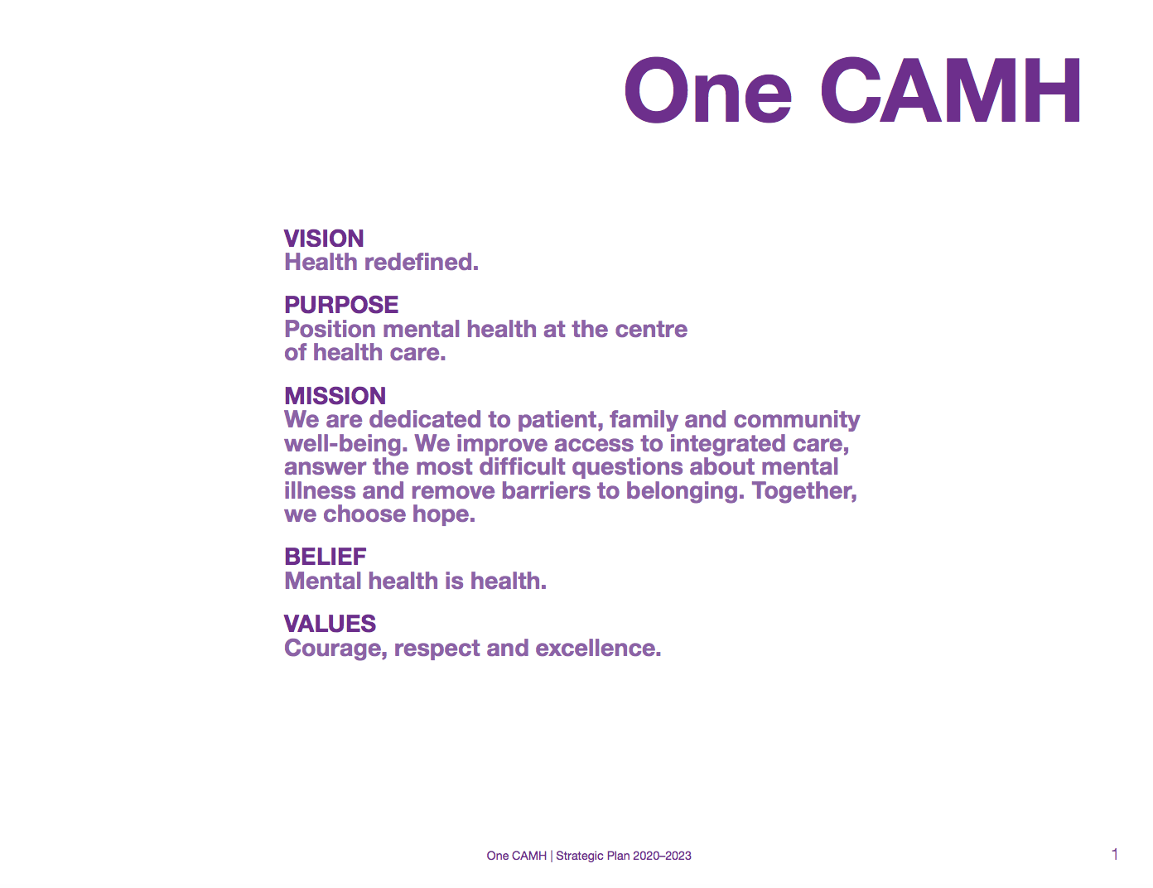

Note: CAMH = Centre for Addiction and Mental Health.

Source: Company files.

Exhibit 2: CAMH’s Redevelopment Project

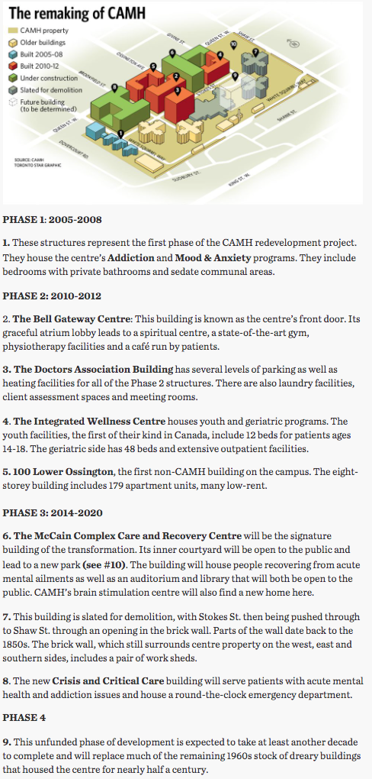

Note: CAMH = Centre for Addiction and Mental Health.

Source: Company files.

Exhibit 3: CAMH’s Tobacco-Free Campus Map

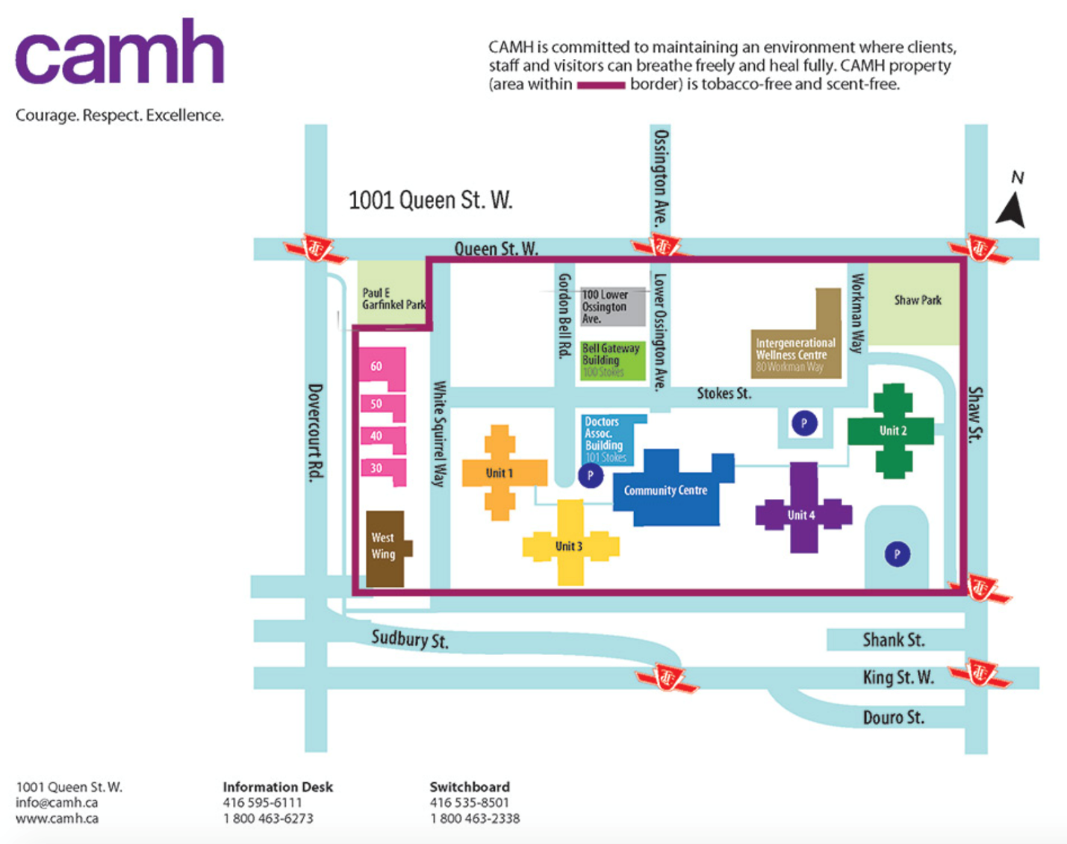

Note: CAMH = Centre for Addiction and Mental Health.

Source: Company files.

ENDNOTES

1. All dollar amounts in the case are in Canadian dollars.
2. “Financial Statements,” CAMH, accessed April 1, 2021, [www.camh.ca/-/media/files/camh-financial-statements-2020-pdf.pdf?la=en&hash=81624B02B692C2297DD6E34D371DEB7A72B227AB](https://www.camh.ca/-/media/files/camh-financial-statements-2020-pdf.pdf?la=en&hash=81624B02B692C2297DD6E34D371DEB7A72B227AB); “Annual Report to the Community,” CAMH, accessed April 1, 2021, www.camh.ca/en/driving-change/about-camh/performance-and-accountability/annual-report-and-financial-statements.
3. “Annual Report to the Community,” op. cit.
4. “About CAMH,” CAMH, accessed April 1, 2021, www.camh.ca/en/driving-change/about-camh.
5. “Annual Report to the Community, op. cit.
6. “About CAMH," op. cit.
7. Ibid.
8. Ibid.
9. Ibid.
10. Ibid.]
11. Joseph Hall, “‘I Walked Out and the World Had Transformed’: As CAMH Remakes Itself, Patients Feel the Difference,” *Toronto Star*, January 13, 2018, accessed April 1, 2021, www.thestar.com/news/insight/2018/01/13/i-walked-out-and-the-world-had-transformed-as-camh-remakes-itself-patients-feel-the-difference.html.
12. Centre for Addiction and Mental Health, *Mental Health and Criminal Justice Policy Framework*, October 2013, accessed March 31, 2021, www.camh.ca/-/media/files/pdfs---public-policy-submissions/mh_criminal_justice_policy_framework-pdf.pdf.
13. Independent Review Panel, *External Review of the Centre for Addiction and Mental Health’s Forensic Services: Passes and Privileges for Patients*, CAMH, accessed March 31, 2021, https://camh.ca/-/media/files/external-review-report-for-camh-pdf.pdf.
14. Yanick Charette, Anne G Crocker, Michael C Seto, Leila Salem, Tonia L Nicholls, and Malijai Caulet, “The National Trajectory Project of Individuals Found Not Criminally Responsible on Account of Mental Disorder in Canada. Part 4: Criminal Recidivism,” *The Canadian Journal of Psychiatry* 60, no. 3 (March 2015): 127–134. <https://doi.org/10.1177/070674371506000307>.
15. Canadian Medical Association, *8th Annual National Report Card on Health Care*, August 2008, accessed March 31, 2021, www.bc-psychologist.com/downloads/other/National_Report_Card_EN.pdf.
16. Ibid.
17. Shannon Bettridge, “The Forensic Mental Health System in Ontario,” 2004, accessed March 31, 2021, http://bcm.connexontario.ca/Resource Library/Mental Health and Justice/The Forensic Mental Health System in Ontario - An Information Guide - 2004.pdf.
18. Ibid.
19. “About Us,” Ontario Review Board, accessed April 1, 2021, www.orb.on.ca/scripts/en/about.asp#hospitals.
20. Independent Review Panel, op. cit.
21. Ibid.
22. Barnier, [1980] 1 S.C.R. 1124; Winko v. Forensic Psychiatric Institute (B.C.) (1996), 79 B.C.A.C.
23. “About Us,” op. cit.
24. Ibid.
25. Ibid.
26. Ibid.
27. “Ontario Review Board,” Province of Ontario, accessed April 1, 2021, www.pas.gov.on.ca/Home/Agency/342.
28. Independent Review Panel, op. cit.
29. Marc Lyall and Annie Bartlett, “Decision Making in Medium Security: Can He Have Leave?,” *The Journal of Forensic Psychiatry & Psychology* 21 (2010): 887−901.
30. Mezey, Gillian & Kavuma, Michael & Turton, Penelope Penny & Demetriou, Alexia & Wright, Christine, “Perceptions, Experiences and Meanings of Recovery in Forensic Psychiatric Patients,” *Journal of Forensic Psychiatry & Psychology* 21 (2010): 683−696.
31. Independent Review Panel, op. cit.
32. Ibid.
33. Ibid.
34. “Visiting CAMH,” CAMH, accessed April 1, 2021, www.camh.ca/en/your-care/visiting-camh.
35. Independent Review Panel, op. cit.
36. Katherine DeClerq, “Man Charged after Walking Away from Mental Health Facility, Allegedly Robbing Two Stores,” CTV News, June 3, 2019, accessed April 1, 2021, https://toronto.ctvnews.ca/man-charged-after-walking-away-from-mental-health-facility-allegedly-robbing-two-stores-1.4450166.
37. Ibid.
38. Salmaan Farooqui, “Police Find Another Man Who Escaped Mental Health Facility in Downtown Toronto,” CTV News, November 30, 2019, accessed April 1, 2021, https://toronto.ctvnews.ca/police-find-another-man-who-escaped-mental-health-facility-in-downtown-toronto-1.4709837.
39. Allison Jones, “Doug Ford Disgusted’ over Escape of Killer Mental Health Detainee, Calls Man a ‘Nutcase,’” *National Post*, July 18, 2019, accessed April 1, 2021, https://nationalpost.com/news/canada/premier-wants-answers-on-mental-health-detainee-who-fled-calls-man-a-nutcase.
40. Ibid.
41. Salmaan Farooqui, op. cit.