

9B21C027

Venture Capitalism versus Indigenous Human Resource Management

Per Hintze and Stephen Grainger wrote this case solely to provide material for class discussion. The authors do not intend to illustrate either effective or ineffective handling of a managerial situation. The authors may have disguised certain names and other identifying information to protect confidentiality.

This publication may not be transmitted, photocopied, digitized, or otherwise reproduced in any form or by any means without the permission of the copyright holder. Reproduction of this material is not covered under authorization by any reproduction rights organization. To order copies or request permission to reproduce materials, contact Ivey Publishing, Ivey Business School, Western University, London, Ontario, Canada, N6G 0N1; (t) 519.661.3208; (e) cases@ivey.ca; www.iveycases.com. Our goal is to publish materials of the highest quality; submit any errata to publishcases@ivey.ca. i1v2e5y5pubs

Copyright © 2021, Ivey Business School Foundation Version: 2021-08-31

In 2014, Bill and Mary Miller sailed out of San Francisco Bay on their 42-foot (13-metre) sloop, *Everdream*. They had lived in their boat secured to the wharf for eight years and now wanted to escape from their pressured, expensive lifestyle as architects and pursue their desire to do something more meaningful in the world. The next four years saw them experience a portfolio of wonderful experiences, people, and places as they sailed the Pacific. By 2018, circumstances had led them to build a life in Bali, Indonesia, where they managed a cruise company for well-travelled and well-to-do Western tourists. Their cruises primarily visited remote islands and magnificent reefs in the Indonesian archipelago while hosting interactions with islanders and their unique cultures.

Background

Until September 2018, the Millers had been working under a short-term contract in Jakarta, when they met an old friend, Mark Nesmith, who was the general manager of a small-ship cruise company named Spice Island Cruises (SIC). Over several meetings and dinners, Nesmith invited the Millers to work together with him in Bali, to develop SIC. Nesmith described to the Millers how the company had been poorly managed and allowed to decay in quality, standards, clientele, and income. Nesmith proposed that by combining their various expertise, they could take SIC in a new successful direction. The Millers accepted Nesmith’s invitation; however, when they arrived nine months later, they discovered SIC was in trouble financially, with a negative cash flow. It was also being directed by venture capitalist George Barrington, SIC’s managing partner. Barrington owned 50 per cent of the company shares, while the original founders, Nancy and Tim Walsh, a couple from the United States, owned the remaining half of the company.

To further complicate matters, three weeks after they arrived, Nesmith, who had initially invited them to come to Bali, accepted an offer to work for another company. When he informed the Millers, he said the conditions were too good to refuse and as a result, apologized and promptly left to pursue the opportunity.

The Millers found SIC to be a sailing company with two ships, including a small Phinisi-style ship (see Exhibit 1) that had been active in East Indonesia for more than 20 years. SIC offered small, intimate group cruises with a mandate to provide “peak experiences”:[1] trekking, diving, and swimming while engaging with the islands’ people and immersing themselves in local culture. As a complement to these experiences, tour leaders also taught guests about marine conservation and the archipelago’s natural history. The two ships in the SIC fleet were the 43-metre *Handayani*, which provided space for up to 24 guests in 12 cabins, and *Jayanti* with accommodation for 12 guests in six cabins.

The SIC market demographic consisted primarily of customers who were 55 years and older and who had both the time and the financial capacity to invest in luxurious adventure travel. The cost of a one-week tour with full accommodation provisions was priced at approximately US$4,000;[2] the two-week tour was approximately $8,500. The guests were also encouraged to tip SIC employees at the end of their voyage, which provided a significant portion of the compensation for the indigenous Indonesian crew who were paid in cash outside of SIC accounts.

SIC customers were individuals and couples who had a desire for active vacations. They were seasoned travellers, and many had a strong interest in learning about the cultures, history, and politics of the places they were visiting. They enjoyed the cultural tourism aspect of the trip, and were well-educated, sophisticated, and curious tourists. They maintained a reasonable standard of fitness and had an interest in marine biology, natural history, and birdwatching. Approximately 40 per cent of guests were from North America, 40 per cent from Europe, and 20 per cent from the Asia-Pacific, primarily Australia. The SIC voyages were especially unique in that they offered access to diverse cultures, remote historical sites, and unusual tropical landscapes.

One SIC guest wrote the following account of one specific journey:

We are midway through a cruise in Indonesia with [S](https://seatrekbali.com/)pice Island Cruises, which runs eight- and 10-day trips on majestic, two-masted Phinisi sailing ships. These enchanting Indonesian sailing ships have been used for centuries by sailors, merchants, and explorers who ventured to some of the archipelago’s most remote islands. If you just love being on the water, there’s no better place in the world for an intimate sailing adventure. Tourists are still few and far between and a wide range of adventurous voyages are offered year-round to the Spice Islands including cruises focused on seabirds, tribal building and weaving techniques among the archipelago’s 17,000 islands and the volcanic Ring of Fire.

On board, the SIC tour leader (TL), as the key person responsible for executing the program, required the skills to network and the capability to organize and manage wildlife encounters with animals such as whale sharks, manta rays, flying foxes, birds, sea turtles, blue-spotted stingrays, and garden eels. On the islands, the TL produced and directed activities, including Phinisi boat-building workshops and visits to waterfalls, villages, and conservation farms. The TLs were connected to the critical network of island leaders who could grant permission and allow access to these sites and events in a respectful, culturally sensitive, and successful way. The TL needed to be a knowledgeable, caring mediator who was both inclusive and enjoyed a sense of fun. On each evening of each tour, the TL would provide a briefing before dinner regarding the “unique peak experiences” that were in store for the following day, the time the events would occur, where to be, and how to prepare.

The TL needed to ensure that all guests’ special interests and physical abilities were taken into consideration when planning each tour and each day’s events. In remote locations, the TL would need to negotiate with local island leaders regarding permission to bring guests ashore and also make payments to the village head and the local guides. These negotiations usually happened while guests were having breakfast or lunch at anchor, prior to the activity. The TL was essentially a diplomat or go-between for guests and the local island village dwellers. Safety was a priority. In the unfortunate circumstance that a guest fell ill or had an accident, it was difficult to evacuate them as the locations were very isolated and remote. The knowledge and experience of the TL was therefore critical to the success of the journey and the company.

The ship captain also worked behind the scenes to ensure that the voyage was a success. The ship’s departure from a port could be delayed due to administrative matters with local port authorities; therefore, the captain’s diplomatic abilities and experience were needed to ensure the ship maintained its planned schedule and could access all items on the promised itinerary.

Problems: Short-Term Profit and Shareholder Value

After the Millers’ friend and contact Nesmith had left, Bill Miller found himself on the management team of SIC, a company he knew very little about. From that moment, a steep learning process began that included reading, discussion, consultations, and meeting employees. He soon discovered that the managing partner, Barrington, had a short-term financial perspective on life and little experience in running a business. Barrington was more concerned with finance and splitting up companies, and had only limited interest in the intimate details of the company, such as the employees and the daily operations. As a consequence of Barrington’s role as general manager, the company was losing staff and customers—and had gained a negative cash flow.

Barrington had a background in venture finance based out of Hong Kong and had made his fortune from selling companies after restructuring them. He became a 50 per cent partner at SIC with the intention to market the cruises to rich, fashionable customers from the financial capitals of Asia. He wanted to use the ships as venues for negotiating mergers and acquisitions and for hosting parties for his friends. His business philosophy emphasized short-term profit and shareholder value.

Barrington had taken control as general manager of SIC in January 2018 and, after becoming familiar with operations, began eliminating all long-term contracts of non-essential staff, including the downgrading of several long-serving TLs who were primarily in charge of taking care of the guests. He wanted to minimize costs and believed that eliminating full-time employees could reduce the fixed costs for salaries. Instead, he wanted to hire the TLs as consultants on short-term contracts.

This policy affected the TLs significantly, including Ketut Agung, one of the most experienced and respected TLs in the industry, who had been working for SIC since 1998. He had an outstanding record for service and was a master at providing guests with peak experiences, being sensitive to customers’ needs, and generating value-added sales. A few months after Barrington’s takeover, Agung had been called into Barrington’s office for a meeting, where he was told that his status would shift immediately from being a full-time employee to a consultant on a needs basis. Agung was disappointed. The change in status meant an almost 50 per cent reduction in income, and he was given no reason for it. After the change in policy by Barrington, all former full-time TLs found themselves in this position.

The consequence of this decision was that the SIC crew started to search for more secure opportunities. Agung and several other TLs started working for other operators. This shift in employment led to increased competition to find secure work, and Barrington and SIC began having difficulties in finding quality TLs to staff their cruises for their planned cruising schedules. The quality of trust that previously existed between SIC’s TLs and Nesmith had begun to decay.

Another of Barrington’s guiding principles was to minimize mistakes in operations. To achieve this goal, he tried to micromanage the tours. As a consequence of this change, crew members became reluctant to make any decisions, as they were afraid to make mistakes and get in trouble. The previous level of trust and loyalty between SIC management, the TLs, the crew, and the ship captains continued to decline, and many new problems arose. One day, a SIC cruise ran into bad weather, and the skipper had to adjust its schedule. Some of the passengers demanded the captain stick to the plan, whereas the typical safety plan would have required the captain to dock in a secluded bay for a few hours. Because of lack of communication with the head office due to isolation, the uncertain captain therefore followed the demands of the guests. As a result, the boat sustained damage, serious delays occurred, and the ship’s altered arrival time to port resulted in many guests missing their scheduled return flights.

Contrasting Visions

In contrast to venture capitalist Barrington’s short-term financial approach, Miller was a passionate person. By the end of 2019, he had worked for a significant length of time with the SIC staff, the TLs, the crew of the ships, and the villages’ inhabitants, becoming sensitive and educated on their culture and code of ethics. Two examples of his caring attitude occurred not long after his arrival: a new corporate social responsibility program to help educate islander children in environmental awareness and a free water-filter distribution project to provide clean water to isolated villages. These initiatives generated a good feeling about SIC among his team members. Philosophically, Miller found himself at the opposite end of the organization management spectrum from Barrington.

Miller strongly believed that staff in the hospitality industry needed to be happy and secure to provide good service to guests. From a marketing perspective, the SIC employees’ focus was to provide special moments that guests would remember and recount to their friends and peers. Miller knew customer satisfaction was being measured by the number of customer referrals, repeat customers, and the level of reviews on online travel forums such as TripAdvisor. In all of these categories, SIC had been performing well. Most reviews were excellent, the percentage of repeat customers was between 40 and 50 per cent, and marketing was in large part driven by referrals from satisfied guests.

Pricing was similar to the competition and by using locals as TLs rather than expensive foreigners, Miller knew he could lower the cost of operations. Snorkelling also did not require dive masters and expensive diving equipment, which further lowered the cost of operations. The offering of peak experiences encouraged participants to step out of their comfort zone and try something different that would generate wonderful memories. To achieve this goal Miller knew he needed his team’s trust, professional application, and support. A happy team caring for the customers was a critical part of achieving success. The resultant customer online reviews made by customers regarding their peak experiences was a very important part of the marketing strategy to generate future business.

In contrast, Barrington’s vision of the target group of potential customers of SIC included wealthy jet-setters who wanted an exclusive vacation where they could have fun with friends. He believed that the trips should include activities such as scuba diving, surfing, and cocktail parties. He hired young Westerners as tour guides to host parties on board during the cruises and to have fun together with the guests. This strategy strongly contrasted with that of Miller, who wanted guests to have fun in a unique (non-Western) way based on the culture and relationships with the local Indonesian people and locations that SIC visited.

Barrington had a shorter-term perspective and wanted to generate profits by charging high fees for exclusive short trips. He wanted to maximize shareholder value and create a profitable potential exit for himself. Miller, on the other hand, had a long-term view with his primary focus being on all the stakeholders in the business, including guests, shareholders, and the equally important marketing staff, ship crew, and local villagers.

Mistakes, Conflicting Strategies, and Correction

As part owner and general manager, Barrington had ordered a complete refit of *Jayanti*, the company’s smaller ship, with the objective of converting it into a luxury schooner. Unfortunately, due to his limited experience, his budget did not take into account all the costs for the refit. Additionally, the renovation took much longer than expected. As a consequence, the *Jayanti* was in dry dock, the company cash flow dried up, and SIC was struggling to pay the staff, which resulted in many valuable employees resigning. SIC shareholders were beginning to realize that a change in strategy was necessary.

A meeting was called between the partners: Barrington, who owned 50 per cent of the shares, and the original founders, Nancy and Tim Walsh from the United States, who owned the remaining half of the company. The Walshes had told Barrington that they had requested that Miller present a proposal to the partners regarding SIC’s future and the steps he thought were needed to recover profitability, employee confidence, and future growth.

At the meeting, Miller presented his vision and five-year plan on how to develop the company. Barrington sat quietly during the presentation. After the conclusion and some discussion, the Walshes proposed that Miller should become the new general manager and that the shareholders should follow his vision for recovery. In addition, Miller introduced a new investor who was willing to take over Barrington’s share. When this proposal was made, Barrington accepted the offer, stood up, and exited the room.

Miller and the Walshes looked at each other, knowing that much hard work and the development of new ideas were needed to get the company back on track, restore general confidence, and become profitable again. They planned to make a decision on the best recovery strategy within two weeks. Miller assumed his new role as general manager. By that point, he had become knowledgeable of SICs problems and potential. What actions and strategy should Miller follow to restore SIC to a growing profitable company?

Exhibit 1: A Phinisi-Style Ship

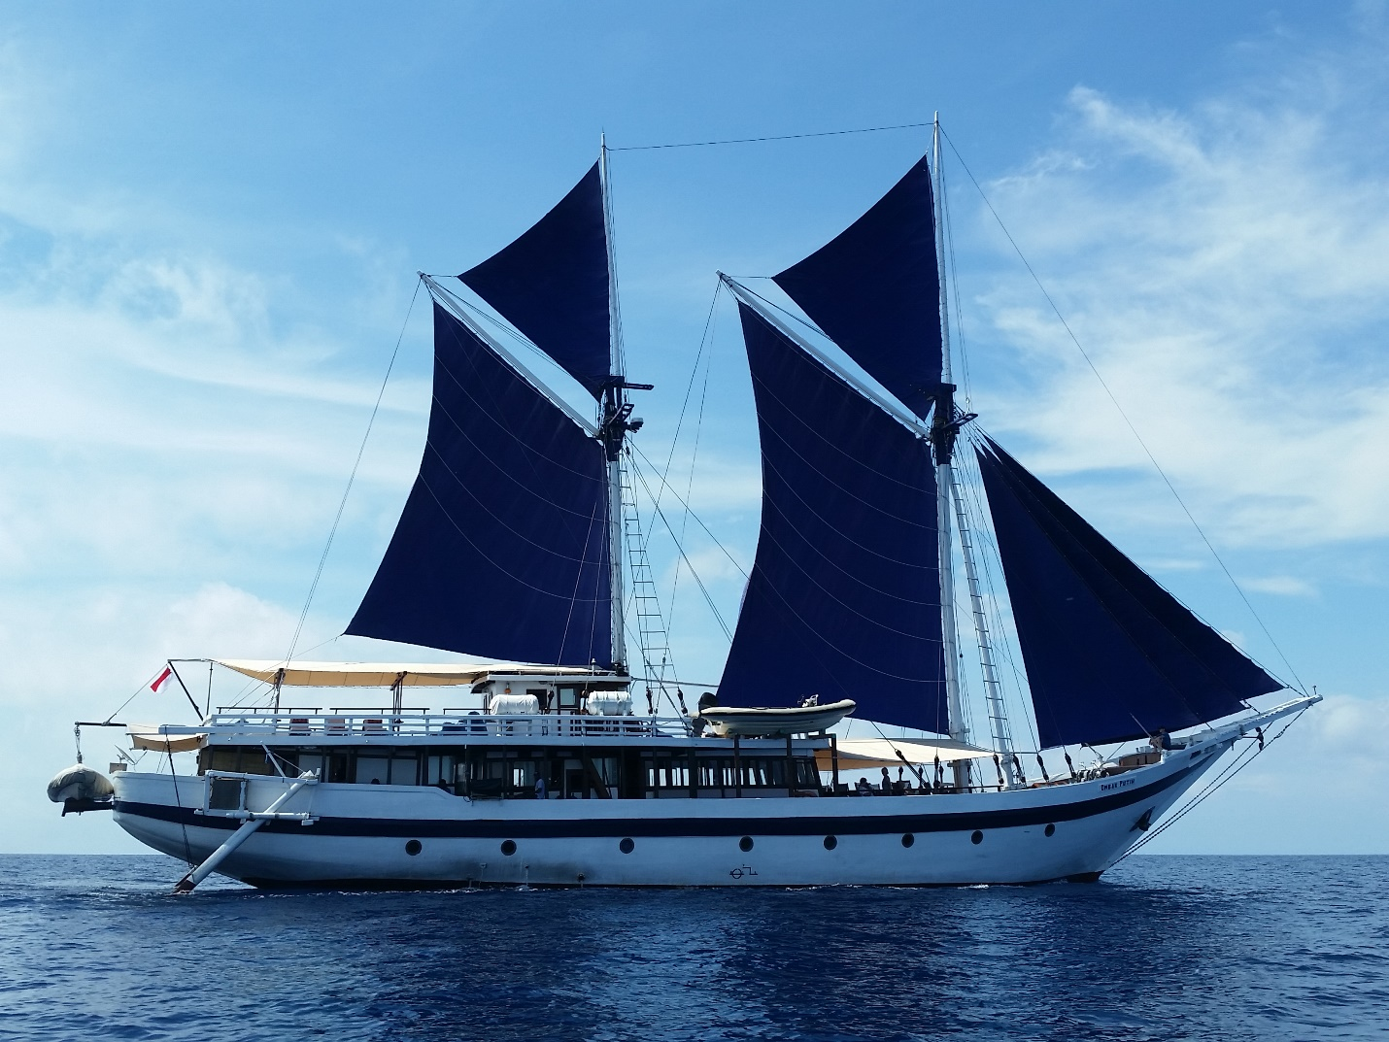

Source: Photographed by Jeffrey Mellefont, Australian National Maritime Museum. Used with permission.

1. Abraham Maslow defined *peak experience* as an ego-transcending moment more extraordinary than most others: “The World Seen in the Peak-Experiences Is Seen Only as Beautiful, Good, Desirable, Worthwhile.” Abraham H. Maslow, *Religions, Values, and Peak-Experiences* (1964; repr., New York, NY: Penguin, 2014), 63.
2. All currency amounts are in US$.