

9B21D007

111 INC.: ENVISIONING THE FUTURE OF HEALTH CARE

Professor Ruomeng Cui, Professor Jian Bin Li, and Professor Xiaomeng Luo wrote this case solely to provide material for class discussion. The authors do not intend to illustrate either effective or ineffective handling of a managerial situation. The authors may have disguised certain names and other identifying information to protect confidentiality.

This publication may not be transmitted, photocopied, digitized, or otherwise reproduced in any form or by any means without the permission of the copyright holder. Reproduction of this material is not covered under authorization by any reproduction rights organization. To order copies or request permission to reproduce materials, contact Ivey Publishing, Ivey Business School, Western University, London, Ontario, Canada, N6G 0N1; (t) 519.661.3208; (e) cases@ivey.ca; www.iveycases.com. Our goal is to publish materials of the highest quality; submit any errata to publishcases@ivey.ca. i1v2e5y5pubs

Copyright © 2021, Ivey Business School Foundation Version: 2021-05-17

Long wait in the hospitals and expensive drugs have long been complaints of Chinese patients.

What we are doing now is to make health care more accessible and affordable for patients in China.

It’s a great cause.

Gang Yu, co-founder and chairman, 111 Inc.

In May 2020, Gang Yu, the co-founder and executive chairman of 111 Inc., was standing by the window of his office in Shanghai, China, pondering the future of his company. By 2016, 111 Inc. had become China’s largest online, direct-sales pharmacy by gross merchandise volume (see Exhibit 1). Founded in July 2010, 111 Inc. went public in September 2018 to become the first Chinese online health care company listed on the Nasdaq Stock Market. The company offered integrated pharmacy retail items and online consultation services to 24 million customers across China. Visitors could use the 111 Inc. platform to connect with doctors, receive prescriptions, and place pharmacy orders for delivery.

Although 111 Inc. had made great progress during the 2020 COVID-19 pandemic, with year-on-year revenue growth of 140.3 per cent in the first quarter of 2020, challenges still remained. By 2013, China had become the world’s second-largest health care market, and it was still growing rapidly. Current estimates projected its market value to reach ¥16 trillion[1] by 2030.[2] Such enormous potential quickly attracted the largest Chinese technology companies to the industry, including Alibaba Group Holding Limited (Alibaba), JD.com Inc., Pinduoduo Inc., and Tencent Holdings Ltd. (Tencent). In comparison to such Internet-based global giants with vast customer bases, cutting-edge technology, and large amounts of capital, 111 Inc. seemed to be a small start-up. Yu wondered how to build 111 Inc.’s competitive advantage.

CHINA’S HEALTH CARE MARKET

China’s traditional health care market offered patients limited resources. In 2016, China’s annual health expenditure per capita was US$398.33, compared to US$9,869.74 in the United States and US$1,026.24 worldwide.[3] Health expenditure accounted for only 4.98 per cent of the gross domestic product in China, compared to 17.07 per cent in the United States and 10.2 per cent worldwide.[4] The Chinese government was working to improve the situation in the country, but the health care market remained underdeveloped. In 2018, health expenditure per capita in China was ¥4,148.1, or 6.4 per cent of the gross domestic product.[5]

Health care resources were not only limited overall, they were also unevenly allocated. Hospitals in China were classified as primary, secondary, or tertiary based on their mission and function.[6] Each level was subdivided into A (Jia), B (Yi), and C (Bing), from highest to lowest quality. The ratings were based on the equipment available at the hospital and on capabilities such as service quality and number of beds.[7] For example, tertiary A hospitals had access to superior resources—such as better medical facilities and more professional staff—compared to tertiary B hospitals. There were 33,009 hospitals in China, of which 1,442 were tertiary A hospitals equipped with high-quality resources.[8] Most of these hospitals were concentrated in economic hub cities such as Beijing.

Chinese pharmacies all faced the same difficulties—low profit margins and high inventory, sourcing costs, and cycle time—because the drug supply chain was fragmented, non-transparent, and inefficient. By the end of 2018, China had approximately 489,000 pharmacies,[9] compared to 70,000 in the United States.[10] China’s top four pharmacy wholesalers accounted for 37.6 per cent of the market, while six pharmacy retail chains held a 12.7 per cent market share.[11] The market was much more concentrated in the United States, where the three largest pharmacy wholesalers controlled 90 per cent of the market[12] and only two pharmacy retail chains accounted for more than 75 per cent of the market.[13]

Originally, the Chinese government prohibited online sales of drugs, but during the 2010s these became increasingly acceptable through a series of deregulation initiatives. Ultimately, in March 2020, a new policy authorized certain online health care activities to be paid for by the medical insurance system.[14] The online integration of the health care market, from doctor consultation to drug prescription, thus became an open market that even allowed payment through the medical insurance system. From 2012 to 2015, hundreds of online pharmacies were founded to serve consumers.[15] As Internet-based technology giants such as Alibaba and JD.com Inc. unleashed their massive customer bases, online health care development reached unprecedented scale, scope, and speed.

In China, public hospitals had been the primary source of drug transactions for some time. In 2019, they controlled 67 per cent of the market,[16] although two years earlier, in January 2017, the government had explicitly bolstered the outflow of prescription drugs from hospitals to other channels. The market value of this outflow in 2020 was expected to reach ¥400 billion,[17] with the main beneficiaries expected to be both online and physical pharmacies.

Four factors drove the need to expand China’s health care market.[18] The first factor was an aging population. In 2017, the number of people over 65 reached 158.31 million, or 11.4 per cent of China’s population.[19] That number was expected to rise at an annual rate of 4.7 per cent, estimated to reach 199.6 million in 2022.[20] The second factor was chronic diseases, such as hypertension, diabetes, heart disease, and cerebrovascular disease. These diseases were becoming more prevalent due to various reasons including aging, pollution, and unhealthy lifestyles. In 2018, the number of patients with chronic diseases in China reached 300 million.[21] The number of people with diabetes alone was 116.4 million in 2019, estimated to reach 140.5 million in 2030 and 147.2 million in 2045.[22] The third factor was increasing consumer power, which meant that people could more easily afford to stay healthy. China’s per-capita disposable annual income in 2018 was ¥28,228, an increase of 8.7 per cent over 2017.[23] The fourth factor was increased health awareness. People had become more aware of their health needs and condition. A wide spectrum of media and technology provided health information to consumers, which was readily available through television, the Internet, and a selection of health-monitoring electronic devices and mobile applications.

**THE COMPETITIVE LANDSCAPE**

China’s overall health care market had been growing rapidly. The online segment reached ¥15.5 billion in 2017,[24] with a growth rate 19.8 per cent over 2016.[25] The pharmaceutical segment was valued at US$137 billion in 2018, second only to the United States in terms of sales.[26] Online pharmacy retail and health insurance services were the two main contributors to health care revenue, followed by online consultation services.[27]

The main challenge in the online health care business, other than government policy, was the multiplicity of transactional actors. For most products, the consumer acted as decision-maker, customer, and payer. However, the health care business required a doctor to be the decision-maker, a patient to be the customer, and an insurance system to be the payer.[28] The challenge was to create an optimal situation for all three parties. To achieve this goal, 111 Inc. connected doctors with patients via its consultation service and patients with drug suppliers via its retail platform. This allowed patients to see doctors more conveniently and buy drugs at a lower cost, while also allowing doctors to see patients more efficiently. Patients with relatively minor medical issues did not need to visit a hospital to be prescribed medicine. This alleviated capacity constraints and improved the effectiveness of health care facilities.

China’s e-commerce pharmacy industry was highly fragmented, with 693 online pharmacies spread out across the country.[29] According to Yu, 111 Inc. controlled about 20 per cent of the total online pharmacy market in 2018. By April 2020, the company had 2.087 million active buyers per month, making it the top online pharmacy company in China.[30] One of 111 Inc.’s main competitors was Jianke.com, which was founded in 2009 and focused on using physical pharmacies to boost online sales. It had opened 30 stores in Guangzhou and acquired several hospitals nationwide, collaborating with them to offer online consultation services.[31] Around that same time, several traditional pharmacy chains opened online stores. For example, Haoyaoshi Pharmacy introduced the online service Ehaoyao.com in 2011. The pharmacy was a subsidiary of Jointown Pharmaceutical Group Co. Ltd., one of the four largest drug distributors in China, and used its distribution network to expand its business online. By 2019, Ehaoyao.com had reached revenues of ¥676 million.[32]

Pharmacy retailers also had to compete with general retailers, three of which dominated China’s e-commerce industry: Alibaba’s Tmall and Taobao platforms, with 55.9 per cent of the market; JD.com Inc., with 16.7 per cent of the market;[33] and Pinduoduo Inc., with 7.7 per cent of the market.[34] All three online retail giants showed great interest in entering the health care sector.

Alibaba’s health care initiatives included AliHealth and Yao.Tmall.com. AliHealth managed an online pharmacy retailer that sold medicine on Alibaba’s Tmall platform, with access to Alibaba’s customer base of 726 million active buyers.[35] AliHealth also partnered with approximately 15,000 senior doctors to offer online consultation services on its Tmall platform.[36] Yao.Tmall.com, introduced in 2011 by Alibaba, was an independent platform that connected online pharmacies with customers.

JD Pharmacy, JD.com Inc.’s health care division, was founded in 2015. It competed directly with 111 Inc. on several fronts. In 2019, JD Pharmacy held over 15 per cent of the market.[37] JD.com Inc. built its own distribution network—fulfillment centres, delivery stations, and delivery vehicles—allowing it to quickly deliver drugs to small cities. Tier 3 cities[38] and smaller accounted for half of JD Pharmacy deliveries.[39] The company was able to benefit from JD.com Inc.’s customer base of 362 million annual active buyers.[40] Despite being a late entrant in the market, JD Pharmacy was able to grow four times more quickly than the industry average.[41]

Pinduoduo Inc., the third-largest e-commerce platform, entered the online health care market in October 2018. By 2019, it had 300,000 pharmacy retailers, 1,000 pharmacy flagship stores, 100 branded flagship stores, and over 15 million stock-keeping units.[42] The growth was fuelled by Pinduoduo Inc.’s customer base of 429.6 million monthly active buyers.[43]

Tencent and Ping An Insurance Group Co. of China Ltd., China’s top insurance company, offered online consultation services. In 2014, Tencent’s WeDoctor service connected over 200 million patients to doctors.[44] In 2015, Ping An Insurance Group Co. of China Ltd.’s Good Doctor worked with 1,409 in-house doctors, and by June 2020, it was working with 5,324 co-operating doctors from hospitals. Good Doctor accounted for 80 per cent of the total online consultation market, with 315 million registered users and 2.97 million monthly paid users.[45]

Consumer behaviour

Patients who needed over-the-counter (non-prescription) drugs could purchase them from hospitals, physical pharmacies, or online pharmacies. Purchasing drugs from a hospital was inconvenient. Patients were required to visit the hospital and wait for registration, diagnosis, and payment. Moreover, doctors only recommended drugs that were available within the hospital, regardless of whether these were the best drugs for the patient. Traditional pharmacies were more convenient, but their products were usually expensive and the stores had limited availability due to space constraints. Online pharmacies, such as 111 Inc., provided a wide selection of drugs at lower prices and offered home delivery.

Patients who needed prescription drugs had fewer options. They first had to visit a licensed source to prescribe the medicine, such as a hospital. However, hospital prescriptions were generally valid only for up to one month. Therefore, many patients faced the frequent inconvenience of visiting hospitals that were often understaffed and overcrowded. The emergence of digital health care promised to relieve the congestion in the Chinese health care system. Recent developments in government policy allowed online pharmacies such as 111 Inc. to sell prescription drugs to patients who had a prescription from a doctor, whether in a hospital or on an online service with remote access enabled by online pharmacies. This system made it possible for patients to conveniently receive a prescription from a doctor, purchase the required medicine online, and wait for delivery without ever having to leave their home.

HISTORY OF 111 Inc.

Knowing that patients were subjected to congested hospitals, expensive drugs, and limited and unevenly distributed resources, Yu decided to make a difference. Improving the customer experience was a critical component of Yu’s mission to change how medication was delivered, as he explained: “The demand for medicine is huge and not well satisfied. That’s why we choose to focus on health care, which is a promising industry.” The ultimate goal of 111 Inc. was to provide high-quality, low-priced medicine to patients.

In 2019, 111 Inc. earned a net revenue of US$567.677 million, with year-on-year growth of 121.3 per cent for the year[46] and 140.3 per cent in the first quarter of 2020[47] (seeExhibit 2). The company operated both in the business-to-consumer and the business-to-business models (see Exhibit 3). To reach consumers, 111 Inc. operated an online pharmacy retail platform known as 1 Drugstore and an online consultation service known as 1 Clinic. Customers could purchase both prescription and over-the-counter drugs through 1 Drugstore. When buying prescription drugs, patients first used the integrated online consultation service to secure a prescription from a doctor (see Exhibit 4). For its business-to-business operations, 111 Inc. acted as a wholesaler known as 1 Drug Mall that supplied drugs to both online and traditional pharmacy stores.

According to Yu, 1 Drugstore was the top pharmacy in China in 2015, with sales of ¥1 billion. In 2019, its sales quadrupled to ¥4 billion.[48] It operated both as a direct-sales retailer and a marketplace for third-party retailers. The direct-sales business model allowed 111 Inc. to cut costs by sourcing products directly from 188 leading pharmaceutical companies and 275 distributors, with the added benefit to customers of lower prices by 15–25 per cent, compared to traditional pharmacies. The third-party retail business helped 111 Inc. expand its product variety, which accounted for approximately 20 per cent of sales. By July 2018, 1 Drugstore had more than 290,000 stock-keeping units in prescription and over-the-counter drugs, health care products, and home care medical devices. To assure its customers of high product quality, 111 Inc. procured drugs directly from well-known brands such as Bayer AG, Menarini Group, Johnson & Johnson, Tong Ren Tang, Xiuzheng Pharmaceutical Group Co. Ltd., and Jointown Pharmaceutical Group Co. Ltd. By 2020, 111 Inc. had developed strategic partnerships with 214 domestic and overseas brands.

Introduced in 2016, 1 Clinic had more than 80 full-time in-house medical professionals and collaborated with 2,000 external doctors. It allowed any user, with or without a 1 Clinic account, to consult doctors over China’s largest social media network, WeChat. When purchasing drugs on 1 Drugstore, customers could connect to 1 Clinic’s doctors and receive prescriptions online. Customers who preferred the experience of a physical store could visit a 111 Inc. partner pharmacy to buy medicines after scanning a Quick Response (QR) code on their smartphone to receive instructions from 1 Clinic’s doctors (see Exhibit 5).

In 2017, 111 Inc. introduced 1 Drug Mall, its business-to-business distributor, to pharmacy retailers. By March 31, 2020, 111 Inc. had already worked with more than 260,000 traditional pharmacies, more than half of the nation’s 450,000 outlets.[49] This created the world’s largest virtual pharmacy network, according to Yu. The business-to-business segment contributed only 9.1 per cent of 111 Inc.’s revenue in 2017, but grew exponentially to increase to 80.1 per cent within only two years. By 2019, it had become a crucial force in 111 Inc.’s revenue growth.[50]

Yu had always positioned 111 Inc. as a technology company, as he explained: “Our platform has a very high conversion rate, because our technology allows us to know our customers very well. Once they purchase on our platform, they will find us trustworthy. We provide a wide variety of high-quality drugs and professional doctor consultation services.” The online consultation service had a strong positive effect on attracting new customers. For purchasers who did not use the online consultation service, Yu found that the conversion rate from first-time user to regular clients was only 7.8 per cent, compared to a conversion rate of 42.8 per cent for visitors who used the consulting service. The company developed and adopted smart information systems that used a large amount of data on user behaviour and engagement to help 111 Inc. learn about its customers and improve their user experience. Timely recommendations provided by 111 Inc. helped its sales representatives and in-house medical professionals to quickly identify customers who had a strong intention to buy.

SMART SUPPLY CHAIN

As of 2020, 111 Inc. had built five large-scale central warehouses in China, in the cities of Kunshan, Guangzhou, Chongqing, Tianjin, and Wuhan, to serve the east, south, west, north, and central areas of the country. To fulfill orders accurately and promptly, 111 Inc. constructed regional warehouses nearby its customers (see Exhibit 6). The company’s smart supply chain was formed by integrating the logistics network and big data technologies (see Exhibit 7). The process controlled every step of the supply chain and provided valuable data insight at every point. When operating as a direct-sales retailer, 111 Inc. owned and managed its own inventory. Managing medicine inventory was a challenging task due to the perishability and strict temperature requirements of the products. The smart system supported inventory-related decisions, including assortment, replenishment, storage location, sorting, packaging, and delivery. When a customer placed an order, the system automatically forwarded it to the nearest warehouse, which then sent specific instructions on the packaging requirements and expected delivery speed to an employee who processed the order. This precise system made deliveries quicker and more efficient. The process reduced inventory turnover to approximately 24 days, which Yu claimed was well below that of competitors.

To provide customers with options for delivery and speed, 111 Inc. partnered with various third-party logistic companies, including SF Express, JD Logistics, and Deppon Express. Shipping was free for online orders over ¥69 and mobile orders over ¥59. The company’s smart system assigned appropriate third-party carriers based on the order’s urgency and value. The company was able to deliver products to customers in over 300 cities within 24 hours and in other cities within 48 hours. Customers were encouraged to inspect packages upon receipt and return any products received in unsatisfactory condition.

Drug storage was subject to strict conditions. Therefore, 111 Inc. used cold supply and logistics chains across all its warehouses and measured drug temperatures upon receipt to ensure product quality and safety. The company also partnered with third-party carriers who were certified to operate cold chains and who closely monitored real-time temperatures during transportation. If the temperature dropped or rose beyond acceptable limits, the driver would be notified immediately to adjust the temperature and report the incident to 111 Inc. The company also used dynamic pricing to determine discounts and adjusted its prices to remain competitive. An intelligent pricing system that could incorporate price elasticity and inventory logic to further optimize pricing was also planned. The new system was expected to help 111 Inc. achieve a customer conversion rate (from first-time user to regular client) of 8 per cent for online orders, 13 per cent for mobile orders on the Apple iOS platform, and 11 per cent for customers on the Android platform. By comparison, the industry average customer conversion rate was 2–3 per cent, according to Yu.

The company’s smart supply chain, which empowered manufacturers (upstream) and third-party retailers and physical pharmacies (downstream), helped manufacturers integrate their own supply chains and better understand 111 Inc. customer preferences. The company also made its logistics system and smart supply chain available to 1 Drugstore’s marketplace retailers, offering them the flexibility and service of delegating their logistics management to 111 Inc.

BIG DATA

Over the years, 111 Inc. developed artificial intelligence and big-data capabilities to customize service and products for customers. The company gathered data on the location, searching behaviour, and shopping behaviour of its customers and then used machine learning to categorize the information. For example, in 2018, 111 Inc. developed a medical symptom dictionary that helped patients with mild symptoms identify and learn about their medical issues.

To advance medical education, 111 Inc. launched the Shizhen platform (named after the famous Chinese physician Shizhen Li), which provided customers with professional medical videos and live broadcasts. In 2019, 111 Inc. introduced its Long-Term Prescription Management System to track customers with chronic diseases and automatically remind them when their prescription medication needed to be refilled. In 2019, the system increased the product repurchase rate from 30 per cent to 70 per cent within only a few months, according to Yu. The company was also planning to add a subscription service to help patients receive regular drug deliveries automatically, based on their required schedule.

OMNICHANNEL Strategy

Online pharmacies still faced the disadvantage of slow fulfillment. It took 24 hours for drugs to be delivered from a 111 Inc. warehouse to the customer, which was an issue for time-sensitive requirements. In addition, the lack of medical insurance support for online purchases resulted in the loss of potential customers. To improve customer experience, the company developed an omnichannel strategy that connected the online system with the physical store. Like many of its giant e-commerce competitors, 111 Inc. expanded its reach to numerous physical pharmacy stores and served as a virtual distributor for more than 260,000 pharmacies. The company also provided services to facilitate the stores’ inventory management, helping them decide what products should be in stock, when to restock items, and how much stock to replenish. With access to 111 Inc.’s smart supply chain, traditional stores could use its data to place the right products at the right locations, provide customized services, and reduce inventory costs. As Yu remarked, “We helped offline pharmacies increase inventory turnover rate from one or two a year to 10 or 20 a year, and in this way, the revenue of our partners has increased [by] at least 10 per cent.”

To increase physical pharmacy options for customers, 111 Inc. launched an online consultation and e-prescription service. After receiving an e-prescription from 1 Clinic, customers could choose to pick up the medicine at a store, have it delivered from the nearest pharmacy within two hours, or wait a little longer for 111 Inc. to deliver it within 48 hours. Insurance options were also available to customers at physical pharmacies for partial or full coverage. This partnership between online and physical services helped both 111 Inc. and retailers increase sales and improve customer service (see Exhibit 8).

**THE ROAD AHEAD**

During the COVID-19 pandemic, 111 Inc. offered free online diagnoses for the COVID-19 coronavirus. This made it possible to preliminarily screen patients and send those who were most in need to hospitals. Patients could also see doctors on 1 Clinic, then purchase drugs on 1 Drugstore and have them delivered to their home, thus avoiding any human contact and potential spread of the virus. Free online refill services were provided to patients with chronic diseases, who could upload their prescription to 1 Clinic and have a doctor check the prescription and approve the drug purchase. After the patient placed the order online, the requested drugs would be delivered. These services reduced cross-infection risks, met new demand, and delivered value to more customers.

Yu recognized the threat from the market entry of technology giants such as Alibaba, JD.com Inc., Pinduoduo Inc., and Tencent, as well as the trend of traditional pharmacy chains moving online. Therefore, the company was exploring new business opportunities to build into its ecosystem. For example, by collaborating with insurance companies and leveraging its rich customer data, 111 Inc. could personalize insurance plans. Yu also noted that trust was a key factor for customers choosing health care products and thus considered building physical stores to enhance 111 Inc.’s reputation and trust.

However, Yu wondered if these actions would help 111 Inc. sustain its competitive advantage, or if other strategies should be considered. He needed to understand 111 Inc.’s competitive differentiator and devise a set of steps to move forward. With Chinese customers, companies, and investors fully recognizing the importance of health care, Yu saw this as a critical moment for 111 Inc.’s strategic planning, which would determine its growth over the next few years.

Jian Bin Li was funded by the National Natural Science Foundation of China (Grant No. 71831007, 72071085, and 71821001), and Xiaomeng Luo was funded by the Education and Teaching Reform Special Funds for Central Universities (Grant No. 2021YJG027).

EXHIBIT 1: 111 Inc. GROWTH IN GROSS MERCHANDISE VOLUME, 2013–2018

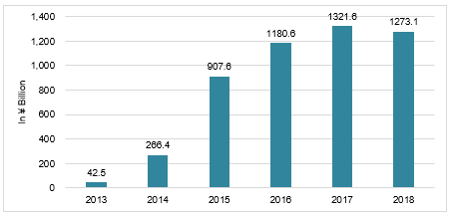

Note: ¥ = RMB = Chinese yuan renminbi.

Source: Adapted by the authors from company data.

EXHIBIT 2: 111 Inc. QUARTERLY GROWTH IN NET REVENUE, from the Third Quarter of 2018 to the First Quarter of 2020 (in ¥ Million)

Exceeded the limit of revenue guidance for six consecutive quarters since the IPO launch.

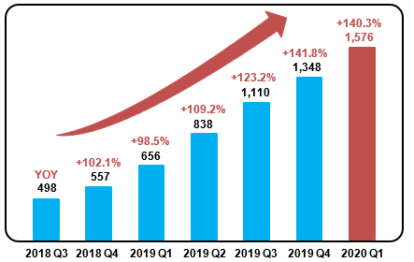

Note: ¥ = RMB = Chinese yuan renminbi; IPO = initial public offering; YOY = year-on-year.

Source: Adapted by the authors from company data.

ExhIBIT 3: 111 INC. BUSINESS MODEL

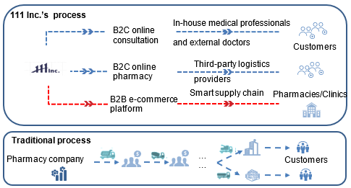

Note: B2C = business-to-consumer; B2B = business-to-business.

Source: Adapted by the authors from company documents.

EXHIBIT 4: 111 Inc. PURCHASING PROCESS FOR PRESCRIPTION DRUGS ON 1 DRUGSTORE

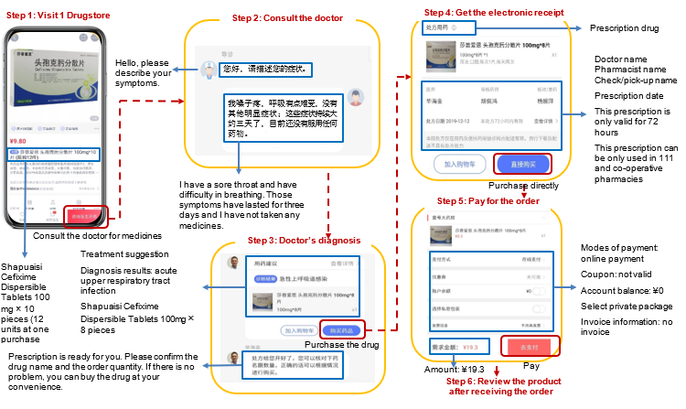

Note: ¥ = RMB = Chinese yuan renminbi; mg = milligram.

Source: Adapted by the authors from company documents.

EXHIBIT 5: CONSULTATION PROCESS ON 1 CLINIC

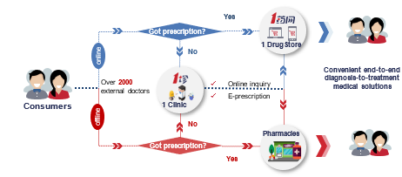

Source: Adapted by the authors from company documents.

EXHIBIT 6: 111 Inc. NATIONWIDE LOGISTICS NETWORK, AS OF 2019

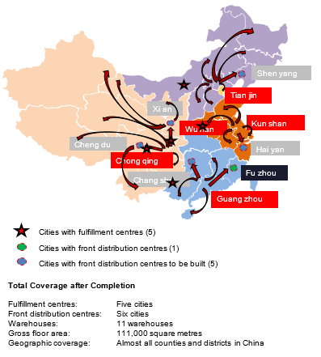

Source: Adapted by the authors from company documents.

**EXHIBIT 7: 111 INC. SMART SUPPLY CHAIN**

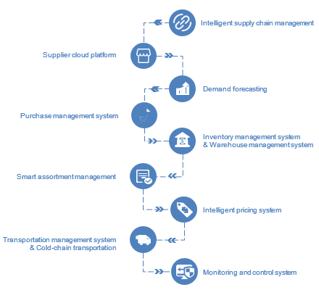

Source: Adapted by the authors from company documents.

EXHIBIT 8: Currently Available 111 Inc. OMNICHANNEL SERVICEs

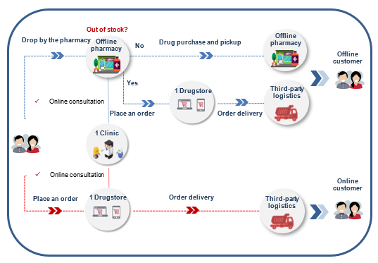

Source: Adapted by the authors from company documents.

endnotes

1. ¥ = RMB = Chinese yuan renminbi; US$1 = ¥7.06 on May 1, 2020; all currency amounts are in ¥ unless otherwise specified.
2. Dezan Shira, “China’s Healthcare Reforms Underscore Market Growth,” *China Briefing*, February 19, 2018, accessed November 26, 2020, www.china-briefing.com/news/healthcare-reforms-underscore-market-growth-china.
3. “Current Health Expenditure Per Capita (Current US$),” World Bank Group, accessed November 26, 2020, www.data.worldbank.org/indicator/SH.XPD.CHEX.PC.CD.
4. “Current Health Expenditure (% GDP),” World Bank Group, accessed November 26, 2020, www.data.worldbank.org/indicator/SH.XPD.CHEX.GD.ZS.
5. “2018 Statistical Communique on the Development of Health Industry in China” [in Chinese], National Health Commission of the People’s Republic of China, May 22, 2019, accessed November 26, 2020, www.nhc.gov.cn/guihuaxxs/s10748/201905/9b8d52727cf346049de8acce25ffcbd0.shtml.
6. Primary hospitals were township hospitals with fewer than 100 beds, providing preventive care, minimal health care, and rehabilitation services. Secondary hospitals were typically located in medium-sized cities and had between 100 and 500 beds, providing comprehensive health services as well as medical education and research. Tertiary hospitals were hospitals in cities, provinces, or across the country with more than 500 beds that provided specialized health care services, played a major role in medical education and research, and served as medical hubs for multiple regions.
7. “Basic Standards of Medical Institutions (Trial Draft)” [in Chinese], National Health Commission of the People’s Republic of China, September 1994, accessed November 26, 2020, www.nhc.gov.cn/cms-search/xxgk/getManuscriptXxgk.htm?id=4d84820f321144c290ddaacba53cb590.
8. Ibid.
9. “2018 Annual Statistical Report of Drug Regulation” [in Chinese], National Medical Products Administration of the People’s Republic of China, May 9, 2019, accessed November 26, 2020, www.nmpa.gov.cn/WS04/CL2151/337665.html.
10. “Number of Stores of the Leading Drug Stores in the United States in 2018,” Statista, November 12, 2019, accessed November 26, 2020, www.statista.com/statistics/197848/number-of-stores-of-top-drug-stores-in-the-us.
11. “2017 Statistical Report on the Operation of Drug Distribution Industry” [in Chinese], Ministry of Commerce of the People’s Republic of China, May 2018, accessed November 26, 2020, http://images.mofcom.gov.cn/sczxs/201806/20180622090409090.pdf.
12. Danny Hakim, William K. Rashbaum, and Roni Caryn Rabin, “The Giants at the Heart of the Opioid Crisis,” *The New York Times*, April 22, 2019, accessed November 26, 2020, www.nytimes.com/2019/04/22/health/opioids-lawsuits-distributors.html.
13. Sonya Bells, “An Overview of the US Drugstore Industry,” *Market Realist*, January 20, 2016, accessed November 26, 2020, https://marketrealist.com/2016/01/overview-us-Drugstore-industry.
14. “Guidance on Promoting ‘Internet+’ Medical Insurance Service during the Prevention and Control of COVID-19” [in Chinese], National Healthcare Security Administration of the People’s Republic of China, March 2, 2020, accessed November 26, 2020, www.nhsa.gov.cn/art/2020/3/2/art_37_2750.html.
15. “2015-2020 Industry Analysis and Investment Prospects Forecast Report on Medical Industry of China" [in Chinese], People’s Republic of China, December 2014, accessed November 26, 2020, www.chinairr.org/report/R10/R1002/201412/01-171810.html.
16. Yu Wan, “China’s Terminal Market Sales of Drugs Reaches 908.7 Billion Yuan in the First Half of 2019, with a Year-on-Year Growth of 5.8%” [in Chinese], China Securities Journal, August 9, 2019, accessed November 26, 2020, www.cs.com.cn/ssgs/gsxw/201908/t20190809_5976343.html.
17. “The Age of Prescription Outflow Is Coming with the Profits of 400 Billion Yuan to be Reallocated” [in Chinese], iYiou, August 9, 2019, accessed November 26, 2020, www.iyiou.com/p/108366.html.
18. Franck Le Deu, Rajesh Parekh, Fangning Zhang, and Gaobo Zhou, “Health Care in China: Entering ‘Uncharted Waters,’” McKinsey & Company, November 2012, accessed November 26, 2020, www.mckinsey.com/industries/healthcare-systems-and-services/our-insights/health-care-in-china-entering-uncharted-waters.
19. “China’s Economy Performed Steadily in 2017, Which Was Better Than Expected” [in Chinese], National Bureau of Statistics of China (NBSC), January 18, 2018, accessed November 26, 2020, www.stats.gov.cn/tjsj/zxfb/201801/t20180118_1574917.html.
20. “Annual Report on Health Management and Health Industry in China No. 1 (2018)” [in Chinese], *Social Sciences Academic Press (China)*, April 2018.
21. “Report on Development of China Smart Elderly Care Industry (2018)” [in Chinese], *Social Sciences Academic Press (China)*, November 2018.
22. “IDF Diabetes Atlas: 9th Edition 2019,” International Diabetes Federation, accessed November 26, 2020, www.diabetesatlas.org/en/sections/demographic-and-geographic-outline.html.
23. “The 14th Report on the Achievements of Economic and Social Development for the 70th Anniversary of the Founding of the People’s Republic of China” [in Chinese], National Bureau of Statistics of China, August 9, 2019, accessed November 26, 2020, www.stats.gov.cn/tjsj/zxfb/201908/t20190809_1690098.html.
24. “Online Healthcare Market Size in China from 2012 to 2020,” Statista, November 5, 2019, accessed November 26, 2020, www.statista.com/statistics/941888/china-online-healthcare-market-size.
25. “Online Healthcare Market Size Growth Rate in China 2013–2020,” Statista, November 5, 2019, accessed November 26, 2020, www.statista.com/statistics/941909/china-online-healthcare-market-size-growth-rate.
26. “Fast Growth in China's Pharmaceutical Market to Benefit Foreign Firms: Report,” *China Daily*, September 29, 2019, accessed November 26, 2020, www.chinadaily.com.cn/a/201909/29/WS5d901f4ca310cf3e3556e1cc.html.
27. iResearch Global, “Growth of China's Internet Healthcare Market Decelerates to 20%–30%,”iResearch, April 3, 2019, accessed November 26, 2020, www.iresearchchina.com/content/details7_53507.html.
28. In China, citizens could join the basic social medical insurance program, which paid partial amounts of the patient’s health care expenses.
29. “Data query” [in Chinese], National Medical Products Administration of the People’s Republic of China, accessed November 26, 2020, www.app1.nmpa.gov.cn/datasearchcnda/face3/dir.html.
30. “Drug Distribution-App Analysis” [in Chinese], Analysys, April 17, 2020, accessed November 26, 2020, qianfan.analysys.cn/refine/view/pageApp/pageApp.html?pageType=industry&tradeIds=1351265.
31. “The Thirtieth Offline Drugstore of Jianke Was Opened in Guangzhou Huangpu Aoyuan Square” [in Chinese], Jianke, press release, March 15, 2019, accessed November 26, 2020, www.jianke.com/xwpd/5713310.html.
32. Jointown Pharmaceutical Group, “2019 Financial Report” [in Chinese], April 28, 2020, accessed November 26, 2020, www.sse.com.cn/assortment/stock/list/info/announcement/index.shtml?productId=600998.
33. Man-Chung Cheung, “Retail Ecommerce Stays Strong as Geopolitical and Economic Headwinds Dampen Overall Retail Sector,” *eMarketer*, June 27, 2019, accessed November 26, 2020, www.emarketer.com/content/china-ecommerce-2019.
34. Ethan Cramer-Flood, “Despite Decline, China Will Become the World’s Largest Retail Market This Year,” eMarketer, June 10, 2020, accessed November 26, 2020. www.emarketer.com/content/china-ecommerce-2020.
35. Alibaba Group, “Alibaba March Quarter 2020 and Full Fiscal Year 2020 Results,” May 22, 2020, accessed November 26, 2020, www.alibabagroup.com/cn/news/article?news=p200522.
36. Bloomberg News, “China’s Tech Giants Take a Shot at Reinventing Health Care,” Bloomberg Businessweek, September 25, 2019, accessed November 26, 2020, www.medium.com/bloomberg-businessweek/chinas-tech-giants-take-a-shot-at-reinventing-health-care-5b14f705762d.
37. “As the Largest Pharmaceutical Retail Platform, JD’s Intention Is Not Just Retail” [in Chinese], Caijing, October 10, 2019, accessed November 26, 2020, www.tech.caijing.com.cn/20191029/4623917.shtml.
38. China’s city tier system categorized and measured cities based on gross domestic product, politics, income level, population, and other factors. Tier 1 cities included Beijing, Shanghai, Guangzhou, and Shenzhen, which had a gross domestic product over $300 billion, compared to between US$68 billion and US$299 billion for Tier 2 cities. “China’s Tiered System Explained,” *South China Morning Post*, accessed July 2020, http://multimedia.scmp.com/2016/cities.
39. “As the Largest Pharmaceutical Retail Platform, JD’s Intention Is Not Just Retail” [in Chinese], op. cit.
40. JD.com, “2019 Financial Reports,” April 15, 2020, accessed November 26, 2020, ir.jd.com/static-files/fc93d5dd-9437-4141-9191-f960ba46874b.
41. “As the Largest Pharmaceutical Retail Platform, JD’s Intention Is Not Just Retail,” [in Chinese], op. cit.
42. “The War between Alibaba and Pinduoduo Extends to Online Pharmacy,” [in Chinese], Sina Finance, November 11, 2019, accessed November 26, 2020, www.finance.sina.com.cn/stock/usstock/c/2019-11-11/doc-iicezuev8651041.shtml.
43. Pinduoduo Inc. “3Q 2019 Financial Report,” November 20, 2019, accessed November 26, 2020, investor.pinduoduo.com/financial-information/quarterly-results.
44. Bloomberg News, op. cit.
45. “2020 Analysis Report of Internet Healthcare in China” [in Chinese], Analysys, June 24, 2020, accessed November 26, 2020, www.analysys.cn/article/detail/20019817.
46. 111 Inc., *Annual Report Pursuant to Section 13 or 15(d) of the Securities Exchange Act of 1934 for the fiscal year ended December 31, 2019*, April 16, 2020, accessed November 26, 2020, http://ir.111.com.cn/Annual-Reports.
47. “111 Inc. Announces First Quarter 2020 Unaudited Financial Results,” May 21, 2020, accessed November 26, 2020, http://ir.111.com.cn/2020-05-21-111-inc-announces-first-quarter-2020-unaudited-financial-results.
48. 111 Inc., *Annual Report Pursuant to Section 13 or 15(d) of the Securities Exchange Act of 1934 for the fiscal year ended December 31, 2019*, op. cit.
49. “111 Inc. Announces First Quarter 2020 Unaudited Financial Results,” op. cit.
50. 111 Inc., *Annual Report Pursuant to Section 13 or 15(d) of the Securities Exchange Act of 1934 for the fiscal year ended December 31, 2019*, op. cit.