

9B21D008

Atal Indore City Transport: MANAGING VEHICLE SCHEDULING IN PUBLIC TRANSPORTATION

Saurabh Chandra, Sanyam Maheshwari, and Amit Kumar Vatsa wrote this exercise solely to provide material for class discussion. The authors do not intend to illustrate either effective or ineffective handling of a managerial situation. The authors may have disguised certain names and other identifying information to protect confidentiality.

This publication may not be transmitted, photocopied, digitized, or otherwise reproduced in any form or by any means without the permission of the copyright holder. Reproduction of this material is not covered under authorization by any reproduction rights organization. To order copies or request permission to reproduce materials, contact Ivey Publishing, Ivey Business School, Western University, London, Ontario, Canada, N6G 0N1; (t) 519.661.3208; (e) cases@ivey.ca; www.iveycases.com. Our goal is to publish materials of the highest quality; submit any errata to publishcases@ivey.ca. i1v2e5y5pubs

Copyright © 2021, Ivey Business School Foundation Version: 2021-05-27

In March 2020, Sanyam Maheshwari, an intern at Atal Indore City Transport Service Limited (AICTSL), met with the technical and operations manager, Rahul Shrouti. He wanted Maheshwari to use the management science tools he had learned in his engineering course to determine the bus frequencies and number of buses required to meet passenger demand between various stops. Maheshwari needed to consider reliability, cost, and safety and how these aspects might be improved. Shrouti suggested that Maheshwari begin by studying the operational planning used by the Indore Bus Rapid Transit System (Indore BRTS).

URBAN TRANSIT IN INDIA

India was one of the fastest growing economies of the world with a gross domestic product (GDP) growth rate of 5.024 per cent per year.[1] The majority of India’s population lived in rural areas (68.8 per cent), although the share of the urban population was expected to increase substantially, rising to 58 per cent of the population (875 million people) by 2050, according to 2011 estimates.[2]

With urbanization increasing, improving public transport was a priority, especially because ownership of private vehicles was also increasing in India, leading to city congestion and pollution. In urban areas, buses were the most efficient and easiest mode of transport. India was reported to have over 1.75 million registered buses in 2016.[3] Of those, the public sector operated 170,000, which transported approximately 70 million people per day.[4]

In an annual survey of household spending on utility and sustainable products in India, both rural and urban buses were reported as the most used form of transport with 62 per cent of urban households and 66 per cent of rural spending on this form of transit. Auto rickshaw was noted as the second most common means of transportation in both urban (47 per cent) and rural households (38 per cent).[5]

Public bus transport was not responding quickly to the rising travel demand. India’s Ministry of Housing and Urban Affairs provided financial assistance to 11 cities for the construction of 504 kilometres of bus rapid transit (BRT), of which about 245 kilometres were operational and the remaining still under construction.[6]

Bus Rapid Transit

BRT was the most common mode of public transportation in mid-size cities around the world. The system relied on a segregated infrastructure with dedicated lanes, busways, and stations, efficient fare collection, rapid and frequent bus operations, and easy boarding and alighting facilities for the passengers. BRT vehicles travelled in exclusive lanes—a corridor, “where busses run on a dedicated right-of-way, such as a bus lane reserved for busses on an arterial road or a freeway.”[7] The exclusive travel lanes and fewer stations than used in standard networks helped the buses to escape congestion on mixed roads, considerably reducing their travel times, variability in scheduling, and rate of accidents. The bus service blended the efficiency of rail with the versatility of buses, making the system fast and safe, yet cost effective. BRT was also a flexible system, which could be enhanced incrementally.[8]

The BRT could be an effective transport service particularly for cities in developing countries with large transit-dependent populations and minimal financial capital. Many urban centres around the world—for example, Bogotá, Colombia; Guangzhou, China; Jakarta, Indonesia; and Delhi, Pune, and Ahmedabad, India—had developed BRT networks. The system also helped to address environmental concerns. One-fourth of greenhouse gas emissions were attributable to the transport industry. To reduce the associated environmental and health challenges and to decrease energy consumption in travel, public transport services needed to be provided as an alternative to private cars, providing a service that was safer, more accessible, convenient, and economically attractive. Another advantage to public transit systems was that they allowed economically vulnerable sections of society who could not afford their own vehicles to travel safely and comfortably at affordable rates.

To make public transit attractive, government agencies needed to plan and manage the infrastructure so the service could cope with increasing demand. However, according to studies, an ability to accommodate passenger capacity at peak hours was the most significant issue in developing countries. The dilemma could be resolved by increasing fleet size and service frequency at peak hours,[9] but the solution required a trade-off between public service and increased expenses for the operator. Sustainability of the service required that both be taken care of. When planning operations for BRT networks, many of the options concerned how the public bus service was developed: (1) sufficient capacity to handle expected passenger demand, (2) speed of service to minimize travel times, and (3) frequency of service to limit waiting time.

Meticulous scheduling was needed to maintain the high quality of a BRT service. BRT operations managers usually scheduled the frequency of service for each of the bus routes. To achieve a certain frequency, the *headway*—the time between two consecutive buses leaving the initial station—was calculated at periodic intervals for specified periods of time and operators decided on and maintained this headway on each bus route. The important performance characteristics for a BRT were *reliability, frequency, capacity, safety,* and *costs*. Reliability was measured as a percentage of bus arrivals within a stipulated delay time and was dependent on traffic conditions on the route. Frequency was the main factor in maintaining reliability and was managed by keeping an appropriate headway. Capacity utilization was the third performance characteristic; optimal capacity utilization could reduce operating costs. The fourth performance characteristic was the total cost of operations, which comprised both the investment and operating costs. Operating costs included transportation (the direct costs of operating the buses, vehicle maintenance, and garages), general and administration costs, marketing and advertising, taxes and licences, and insurance.[10] Last but not least, safety was a high priority performance characteristic.

Indore BRTS: BACKGROUND

The Indore BRTS, branded as iBUS, was started in 2007 under the Jawaharlal Nehru National Urban Renewal Mission (JNNURM), a city modernization scheme launched by the Government of India.[11] The city of Indore, the commercial and educational hub of the central Indian state of Madhya Pradesh, was plagued with poor traffic conditions, including modest road infrastructure, erratic traffic, and insufficient public transportation. Increasing commercial and trade-related activities had resulted in a remarkable growth in population and a consequent demand for efficient and reliable public transportation (see Exhibit 1). The BRTS was thus launched to enhance the city’s roads, improve traffic conditions, encourage the public to use public transportation, and reduce the reliance on private vehicles.[12]

AICTSL initiated the development of Indore BRTS on a public–private partnership model through the legal entity known as a special purpose vehicle. AICTSL submitted the proposal for approval to India’s Ministry of Housing and Urban Affairs. In August 2007, the Indore Development Authority issued a construction work order for the selected bidder after funding of ₹984.5 million[13] was approved. A single BRT corridor was constructed on the Agra–Bombay (AB) Road in Indore—a project that experienced several delays. Reasons for the delay included acquiring the land for the corridor’s development, completing the parallel underground drinking water trunk line and sewage trunk line, and dealing with encroachments and the need to remove illegal constructions on the proposed corridor. After the deadline was extended eight times, the corridor was completed in May 2013.

Indore BRTS started from Niranjanpur, a locality on the northern edge of Indore, and ran to Rajiv Gandhi Square in south central Indore. The route ran along the AB Road, which connected vital business and residential locations. Hence, the route was strategically critical and carried the most city traffic (see Exhibit 2). The corridor was 11.57 kilometres long, with 21 bus stops (see Exhibits 3–4). The BRT buses travelled one route, in two directions: from Niranjanpur to Rajiv Gandhi and in the opposite direction from Rajiv Gandhi to Niranjanpur (see Exhibit 3).

BUS SCHEDULING AT INDORE BRTS

Maheshwari met with Shrouti to learn about the operation of Indore BRTS. Maheshwari learned that Indore BRTS had a dedicated team that managed the schedules for buses that ran from 6:00 a.m. to 10:00 p.m. Operations started with dispatching five buses from each end of the route at 6:00 a.m. Initially, within the first one to two hours, they tried to dispatch enough buses running both directions on the BRT corridor to achieve the desired frequency. At any given time, 25–35 buses were in active operation; the remaining buses were used to keep operations running smoothly. Some of the buffer buses were kept at intermediate stops so that if a running bus went out of service on the corridor, a buffer bus could replace the out of service bus as soon as possible.

The schedulers determined peak and non-peak hours of demand based on data from the previous few days (see Exhibits 5–6). The hourly demand for transit followed a normal distribution with a standard deviation close to 20 per cent of the mean. Ridership on weekdays was greater than it was on weekends.

All buses had a global positioning system (GPS) for navigation with radio-frequency identification (RFID). Information from the RFID tags and from live cameras at each bus stop allowed the schedulers to continuously track all buses from the control station. A headway of approximately 3–5 minutes was maintained during peak hours and 7–10 minutes during non-peak hours. Based on the live information, the scheduling team could coordinate bus dispatch from their respective depots and guide the drivers in maintaining appropriate headway. The bus drivers were also trained to adjust their speeds to align with the bus ahead to maintain the required headway.

Indore BRTS had two groups of bus drivers: one group worked in 12-hour shifts and the other worked 8-hour shift. Drivers on the 12-hour shifts normally began their day at 8:00 a.m., specifically to work peak hours. Drivers who worked 8-hour shifts began at 6:00 a.m. on most days. Drivers worked approximately six days a week, getting four days of leave each month.

At the end of each day, the buses were docked at the Niranjanpur depot where crews washed and sanitized the buses, then did a general technical and safety checkup. If an issue arose with a bus while in operation, a team of mechanics was available at each end of the BRT corridor to respond to the problem and carry out small repairs. According to the company’s contract with the bus leasing agency, each bus could be operated up to 1,200 kilometres per week.

Maheshwari was satisfied with the information he gathered. He was excited to develop workable solutions for Indore BRTS’s operational problems, although the complexity of the problem did worry him. His priority was to develop a solution based on management science using the sample demand data he was given to estimate headway and bus deployment for both directions of the route.

EXHIBIT 1: INDORE Bus Rapid Transit System DETAILS

| Project Initiation Date | 2007 |
| --- | --- |
| Route Length | 11.57 kilometres |
| Road Section (Road Width) | 31.6–60.0 metres |
| System Type | Closed roadway with median stations; open for feeder buses |
| Stops | 21 |
| Buses in the System | 46 |
| Bus Capacity | 36 (seating) + 15 (standing) |
| Ridership | Over 52,000 passengers per day (on average) |
| Bus Specifications | 12 metres long; air conditioned; 900 mm floor height from ground; |
|  | 245 BHP BS III engine |

Note: mm = millimetres; BHP = brake horsepower; BS = Bharat Stage

Source: Company files.

EXHIBIT 2: INDORE Bus Rapid Transit System MAP

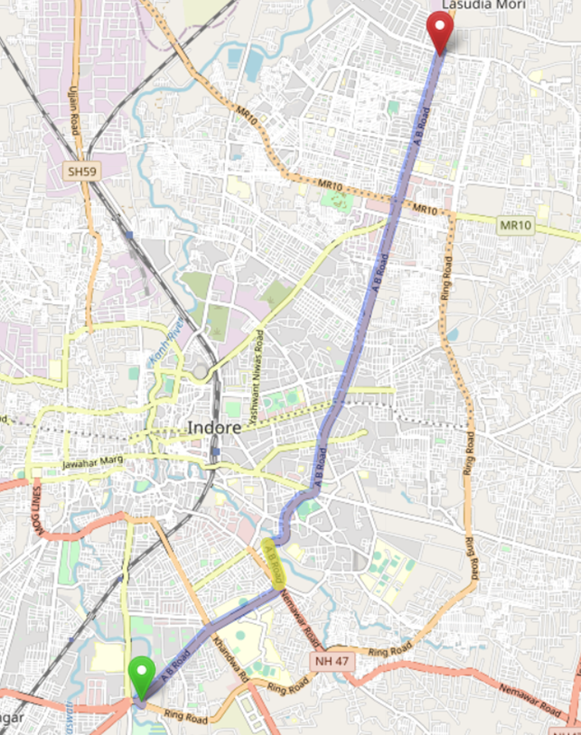

Note: The yellow-coloured stretch of the Bus Rapid Transit corridor indicates slow moving traffic.

Source: Open Street Map contributors, Open Street Map, under Creative Commons licence CC BY-SA 2.0, accessed March 22, 2021, https://www.openstreetmap.org/directions? engine=fossgis_osrm_car&route=22.6828%2C75. 8574%3B22. 7708%2C75. 9015#map=13/22.7282/75.8848.

EXHIBIT 3: Indore Bus Rapid Transit System BUS STOPS

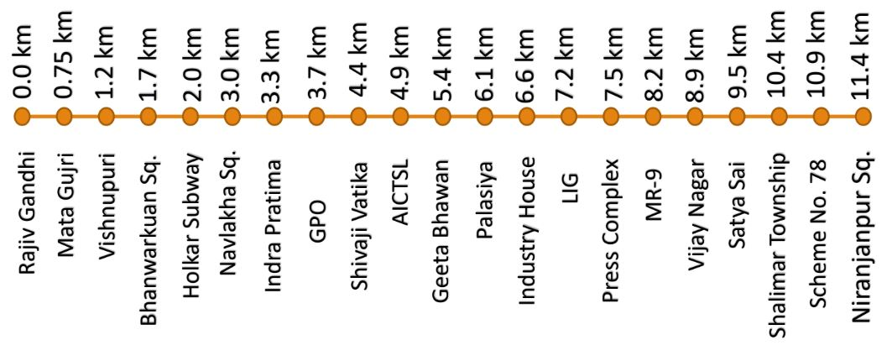

Note: km = kilometres; AICTSL = Atal Indore City Transport Service Limited; Sq. = Square

Source: Company files.

EXHIBIT 4: Indore Bus Rapid Transit System Bus STOP Features

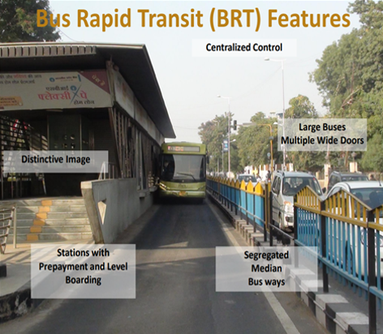

Source: Company files.

EXHIBIT 5: Origin–Destination DEMAND MATRIX For PEAK HOURS (7:30 A.M. to 11:30 A.M.) in number of passengers

| **Bus Stop Number** | | **1** | **2** | **3** | **4** | **5** | **6** | **7** | **8** | **9** | **10** | **11** | **12** | **13** | **14** | **15** | **16** | **17** | **18** | **19** | **20** | **21** |
| --- | --- | --- | --- | --- | --- | --- | --- | --- | --- | --- | --- | --- | --- | --- | --- | --- | --- | --- | --- | --- | --- | --- |
|  | **Bus Stop Name** | **Rajiv Gandhi** | **Mata Gujri** | **Vishnupuri** | **Bhanwarkuan Square** | **Holkar Subway** | **Navlakha Square** | **Indra Pratima** | **GPO** | **Shivaji Vatika** | **AICTSL** | **Geeta Bhawan** | **Palasiya** | **Industry House** | **LIG** | **Press Complex** | **MR-9** | **Vijay Nagar** | **Satya Sai** | **Shalimar Township** | **Scheme No. 78** | **Niranjanpur Square** |
|  | **Distance* (in km)** | **0** | **0.75** | **1.2** | **1.7** | **2.0** | **3.0** | **3.3** | **3.7** | **4.4** | **4.9** | **5.4** | **6.1** | **6.6** | **7.2** | **7.5** | **8.2** | **8.9** | **9.5** | **10.4** | **10.9** | **11.4** |
| **1** | **Rajiv Gandhi** | 0 | 7 | 5 | 52 | 19 | 30 | 16 | 71 | 24 | 40 | 100 | 80 | 30 | 61 | 16 | 50 | 39 | 9 | 13 | 16 | 23 |
| **2** | **Mata Gujri** | 15 | 0 | 4 | 43 | 8 | 24 | 14 | 24 | 15 | 15 | 43 | 37 | 12 | 23 | 5 | 30 | 22 | 8 | 9 | 11 | 10 |
| **3** | **Vishnupuri** | 8 | 6 | 0 | 21 | 10 | 17 | 9 | 25 | 8 | 16 | 45 | 31 | 0 | 20 | 6 | 21 | 16 | 5 | 4 | 4 | 8 |
| **4** | **Bhanwarkuan Square** | 24 | 11 | 7 | 0 | 22 | 53 | 27 | 119 | 32 | 73 | 232 | 176 | 40 | 169 | 13 | 91 | 82 | 12 | 18 | 20 | 26 |
| **5** | **Holkar Subway** | 8 | 4 | 3 | 31 | 0 | 12 | 5 | 18 | 10 | 11 | 26 | 38 | 14 | 30 | 4 | 9 | 12 | 5 | 6 | 6 | 5 |
| **6** | **Navlakha Square** | 25 | 20 | 20 | 182 | 47 | 0 | 66 | 145 | 33 | 58 | 299 | 316 | 58 | 223 | 29 | 201 | 133 | 24 | 23 | 42 | 46 |
| **7** | **Indra Pratima** | 18 | 11 | 9 | 66 | 20 | 52 | 0 | 69 | 21 | 47 | 89 | 78 | 39 | 87 | 13 | 55 | 36 | 15 | 9 | 20 | 25 |
| **8** | **GPO** | 17 | 11 | 6 | 127 | 21 | 72 | 16 | 0 | 30 | 43 | 152 | 131 | 24 | 140 | 12 | 79 | 67 | 8 | 11 | 13 | 15 |
| **9** | **Shivaji Vatika** | 6 | 4 | 3 | 26 | 14 | 13 | 7 | 31 | 0 | 11 | 32 | 20 | 15 | 21 | 4 | 11 | 8 | 4 | 6 | 9 | 7 |
| **10** | **AICTSL** | 14 | 5 | 3 | 57 | 19 | 20 | 23 | 39 | 18 | 0 | 61 | 43 | 18 | 47 | 7 | 27 | 21 | 5 | 6 | 16 | 10 |
| **11** | **Geeta Bhawan** | 21 | 10 | 9 | 246 | 34 | 75 | 28 | 102 | 36 | 49 | 0 | 231 | 53 | 169 | 22 | 88 | 36 | 12 | 13 | 17 | 17 |
| **12** | **Palasiya** | 30 | 13 | 10 | 243 | 33 | 119 | 31 | 128 | 26 | 44 | 205 | 0 | 35 | 150 | 12 | 112 | 82 | 8 | 13 | 20 | 22 |
| **13** | **Industry House** | 9 | 5 | 0 | 44 | 14 | 21 | 10 | 40 | 10 | 26 | 53 | 42 | 0 | 41 | 8 | 18 | 13 | 6 | 5 | 10 | 9 |
| **14** | **LIG** | 21 | 11 | 9 | 141 | 22 | 77 | 26 | 95 | 31 | 44 | 186 | 172 | 43 | 0 | 15 | 97 | 75 | 5 | 10 | 19 | 17 |
| **15** | **Press Complex** | 13 | 7 | 6 | 43 | 25 | 35 | 18 | 32 | 18 | 24 | 46 | 51 | 15 | 48 | 0 | 26 | 28 | 11 | 10 | 10 | 13 |
| **16** | **MR-9** | 32 | 20 | 17 | 150 | 40 | 220 | 60 | 146 | 27 | 58 | 364 | 188 | 77 | 268 | 26 | 0 | 124 | 26 | 30 | 37 | 50 |
| **17** | **Vijay Nagar** | 30 | 23 | 13 | 220 | 39 | 122 | 46 | 201 | 50 | 49 | 174 | 287 | 57 | 214 | 27 | 162 | 0 | 16 | 28 | 45 | 43 |
| **18** | **Satya Sai** | 7 | 6 | 9 | 38 | 16 | 21 | 12 | 23 | 11 | 16 | 44 | 29 | 18 | 27 | 4 | 22 | 15 | 0 | 12 | 10 | 10 |
| **19** | **Shalimar Township** | 15 | 8 | 7 | 30 | 20 | 19 | 11 | 43 | 13 | 25 | 56 | 39 | 12 | 50 | 12 | 32 | 24 | 7 | 0 | 8 | 16 |
| **20** | **Scheme No. 78** | 26 | 11 | 7 | 85 | 25 | 42 | 13 | 36 | 17 | 34 | 41 | 70 | 36 | 71 | 10 | 45 | 38 | 8 | 14 | 0 | 22 |
| **21** | **Niranjanpur Square** | 20 | 9 | 9 | 63 | 21 | 29 | 27 | 56 | 16 | 28 | 85 | 45 | 17 | 51 | 16 | 45 | 40 | 10 | 17 | 25 | 0 |

Note: *distance is measured from the origin (Rajiv Gandhi) to the specified stop; the number of passengers is the total number of passengers travelling between an origin (row) and destination (column) over the measured period; km = kilometres; AICTSL = Atal Indore City Transport Service Limited

Source: Company files.

EXHIBIT 6: Origin–Destination DEMAND MATRIX For NON-PEAK HOURS (11:30 a.M. to 14:30 p.m.) in number of passengers

| **Bus Stop Number** | | **1** | **2** | **3** | **4** | **5** | **6** | **7** | **8** | **9** | **10** | **11** | **12** | **13** | **14** | **15** | **16** | **17** | **18** | **19** | **20** | **21** |
| --- | --- | --- | --- | --- | --- | --- | --- | --- | --- | --- | --- | --- | --- | --- | --- | --- | --- | --- | --- | --- | --- | --- |
|  | **Bus Stop Name** | **Rajiv Gandhi** | **Mata Gujri** | **Vishnupuri** | **Bhanwarkuan Square** | **Holkar Subway** | **Navlakha Square** | **Indra Pratima** | **GPO** | **Shivaji Vatika** | **AICTSL** | **Geeta Bhawan** | **Palasiya** | **Industry House** | **LIG** | **Press Complex** | **MR-9** | **Vijay Nagar** | **Satya Sai** | **Shalimar Township** | **Scheme No. 78** | **Niranjanpur Square** |
|  | **Distance* (in km)** | **0** | **0.75** | **1.2** | **1.7** | **2.0** | **3.0** | **3.3** | **3.7** | **4.4** | **4.9** | **5.4** | **6.1** | **6.6** | **7.2** | **7.5** | **8.2** | **8.9** | **9.5** | **10.4** | **10.9** | **11.4** |
| **1** | **Rajiv Gandhi** | 0 | 2 | 1 | 10 | 3 | 8 | 5 | 5 | 4 | 4 | 8 | 16 | 6 | 8 | 3 | 10 | 8 | 3 | 4 | 7 | 4 |
| **2** | **Mata Gujri** | 2 | 0 | 2 | 5 | 1 | 5 | 3 | 6 | 2 | 4 | 4 | 7 | 3 | 5 | 2 | 7 | 4 | 3 | 3 | 2 | 3 |
| **3** | **Vishnupuri** | 2 | 1 | 0 | 6 | 2 | 4 | 3 | 4 | 2 | 3 | 3 | 7 | 0 | 5 | 1 | 3 | 4 | 1 | 2 | 2 | 2 |
| **4** | **Bhanwarkuan Square** | 12 | 7 | 5 | 0 | 6 | 34 | 12 | 34 | 9 | 14 | 44 | 54 | 10 | 47 | 8 | 47 | 40 | 7 | 6 | 17 | 12 |
| **5** | **Holkar Subway** | 3 | 2 | 2 | 8 | 0 | 5 | 4 | 6 | 2 | 5 | 4 | 7 | 2 | 10 | 1 | 4 | 4 | 2 | 2 | 4 | 4 |
| **6** | **Navlakha Square** | 10 | 6 | 3 | 60 | 6 | 0 | 16 | 32 | 5 | 13 | 56 | 32 | 13 | 31 | 7 | 70 | 21 | 4 | 7 | 9 | 5 |
| **7** | **Indra Pratima** | 8 | 3 | 1 | 17 | 3 | 13 | 0 | 11 | 1 | 6 | 11 | 13 | 3 | 17 | 5 | 15 | 7 | 4 | 4 | 5 | 5 |
| **8** | **GPO** | 11 | 4 | 3 | 34 | 7 | 28 | 13 | 0 | 5 | 13 | 33 | 32 | 3 | 20 | 6 | 31 | 25 | 3 | 4 | 9 | 12 |
| **9** | **Shivaji Vatika** | 5 | 1 | 1 | 12 | 3 | 5 | 6 | 6 | 0 | 4 | 10 | 8 | 4 | 8 | 1 | 10 | 3 | 2 | 3 | 3 | 2 |
| **10** | **AICTSL** | 4 | 2 | 3 | 12 | 4 | 9 | 11 | 13 | 3 | 0 | 15 | 7 | 6 | 15 | 3 | 12 | 6 | 3 | 4 | 7 | 4 |
| **11** | **Geeta Bhawan** | 3 | 5 | 6 | 71 | 4 | 74 | 19 | 37 | 7 | 12 | 0 | 64 | 7 | 50 | 10 | 81 | 34 | 7 | 8 | 11 | 13 |
| **12** | **Palasiya** | 17 | 7 | 6 | 84 | 3 | 47 | 22 | 33 | 9 | 17 | 42 | 0 | 12 | 23 | 10 | 19 | 19 | 9 | 8 | 12 | 10 |
| **13** | **Industry House** | 3 | 3 | 0 | 15 | 3 | 15 | 4 | 12 | 4 | 6 | 17 | 4 | 0 | 4 | 4 | 8 | 7 | 2 | 5 | 5 | 5 |
| **14** | **LIG** | 15 | 5 | 3 | 55 | 6 | 45 | 9 | 41 | 9 | 14 | 7 | 49 | 11 | 0 | 9 | 25 | 32 | 4 | 7 | 7 | 8 |
| **15** | **Press Complex** | 0 | 3 | 2 | 10 | 3 | 8 | 6 | 4 | 3 | 4 | 10 | 6 | 2 | 9 | 0 | 9 | 7 | 3 | 2 | 3 | 4 |
| **16** | **MR-9** | 10 | 2 | 3 | 41 | 6 | 61 | 10 | 37 | 8 | 13 | 57 | 47 | 11 | 48 | 6 | 0 | 24 | 5 | 10 | 13 | 14 |
| **17** | **Vijay Nagar** | 13 | 5 | 2 | 23 | 5 | 30 | 9 | 28 | 6 | 15 | 38 | 48 | 6 | 30 | 5 | 37 | 0 | 3 | 6 | 4 | 8 |
| **18** | **Satya Sai** | 2 | 2 | 1 | 6 | 2 | 6 | 2 | 6 | 1 | 3 | 8 | 6 | 3 | 8 | 3 | 4 | 6 | 0 | 1 | 2 | 2 |
| **19** | **Shalimar Township** | 5 | 2 | 1 | 7 | 2 | 10 | 4 | 7 | 2 | 2 | 9 | 8 | 3 | 6 | 2 | 5 | 9 | 2 | 0 | 1 | 3 |
| **20** | **Scheme No. 78** | 6 | 2 | 2 | 18 | 5 | 8 | 5 | 9 | 6 | 6 | 9 | 10 | 6 | 10 | 5 | 8 | 8 | 3 | 2 | 0 | 5 |
| **21** | **Niranjanpur Square** | 4 | 2 | 3 | 7 | 4 | 9 | 6 | 9 | 4 | 9 | 17 | 12 | 8 | 16 | 3 | 7 | 7 | 2 | 4 | 6 | 0 |

Note: *distance is measured from the origin (Rajiv Gandhi) to the specified stop; the number of passengers is the total number of passengers travelling between an origin (row) and destination (column) over the measured period; km = kilometres; AICTSL = Atal Indore City Transport Service Limited

Source: Company files.

1. “GDP Growth (Annual %)—India,” as reported by World Bank National Accounts Data and OECD National Accounts Data Files, World Bank, accessed July 25, 2020, https://data.worldbank.org/indicator/NY.GDP.MKTP.KD.ZG?locations=IN.
2. C. Chandramouli, “Census of India 2011: Rural Urban Distribution of Population,” slide presentation, Ministry of Home Affairs, July 15, 2011, https://censusindia.gov.in/2011-prov-results/paper2/data_files/india/Rural_urban_2011.pdf.
3. “India Number of Buses: 2005–2016,” as reported by the Ministry of Road Transport and Highways, CEIC Data, accessed July 25, 2020 https://www.ceicdata.com/en/india/number-of-buses-by-public-and-private-sector/number-of-buses.
4. Jaspal Singh, “City Public Transportation Developments in India,” Intelligent Transport, December 14, 2016, https://www.intelligenttransport.com/transport-articles/21458/city-public-transportation-india.
5. National Sample Survey Office, “NSSO Data: Key Indicators of Household Expenditure on Services and Durable Goods,” Hindu Centre for Politics and Public Policy, July 1, 2016, https://www.thehinducentre.com/resources/article8792114.ece.
6. Minister of Housing and Urban Affairs, “National Urban Transport Policy,” Question No. 3721, Parliament of India, August 9, 2017, https://loksabha.nic.in/Members/QResult16.aspx?qref=57236.
7. Quang Thuan Nguyen and Nguyen Ba Thang Phan, “Scheduling Problem for Bus Rapid Transit Routes,” in *Advanced Computational Methods for Knowledge Engineering* 358 (2015): 69–79.
8. “What is BRT?,” Institute for Transportation and Development Policy, accessed March 18, 2021, https://www.itdp.org/library/standards-and-guides/the-bus-rapid-transit-standard/what-is-brt.
9. Huseyin Ceylan and Tayfun Ozcan, “Optimization of Headways and Departure Times in Urban Bus Networks: A Case Study of Çorlu, Turkey,” in “Artificial Intelligence Applications in Civil Engineering,” ed. Tayfun Dede, special issue, *Advances in Civil Engineering* 2018 (2018), https://doi.org/10.1155/2018/7094504.
10. Mohammad Hesam Hafezi, Amiruddin Ismail, and Ramez A. Al-Mansob, “Bus Scheduling Model: A Literature Review,” paper presented to Regional Engineering Postgraduate Conference, January 2011, https://www.researchgate.net/profile/ramez_al-mansob2/publication/260034430_bus_scheduling_model_a_literature_review/links/0c96052f24398b0e8b000000/bus-scheduling-model-a-literature-review.pdf.
11. “Jawaharlal Nehru National Urban Renewal Mission,” Government of India: Ministry of Housing and Urban Affairs, accessed March 18, 2021, http://mohua.gov.in/cms/jawaharlal-nehru-national-urban-renewal-mission.php.
12. Private vehicles in Indian cities consisted of cars and motorized two-wheelers such as scooters and motorbikes. Those who could not afford cars made extensive use of inexpensive two-wheelers for daily commutes, which put a many people at risk of accidents.
13. ₹ = INR = Indian rupee; US$1 = ₹75.62 on March 20, 2020; all currency amounts are in ₹ unless otherwise specified.