

9B21D009

Supply Chain Collaboration at JD.com

Xin Li and Ke Gong wrote this case under the supervision of Professor Yinan Qi and Professor Paul W. Beamish solely to provide material for class discussion. The authors do not intend to illustrate either effective or ineffective handling of a managerial situation. The authors may have disguised certain names and other identifying information to protect confidentiality.

This publication may not be transmitted, photocopied, digitized, or otherwise reproduced in any form or by any means without the permission of the copyright holder. Reproduction of this material is not covered under authorization by any reproduction rights organization. To order copies or request permission to reproduce materials, contact Ivey Publishing, Ivey Business School, Western University, London, Ontario, Canada, N6G 0N1; (t) 519.661.3208; (e) cases@ivey.ca; www.iveycases.com. Our goal is to publish materials of the highest quality; submit any errata to publishcases@ivey.ca. i1v2e5y5pubs

Copyright © 2021, Ivey Business School Foundation Version: 2021-06-14

On November 20, 2019, Hau L. Lee was attending the Open Day conference held by the smart supply chain Y business division at JD.com (JD). Lee was a member of the US National Academy of Engineering and widely considered the father of the modern supply chain. Speaking at the event, Lee stated that there were three challenges facing commerce today: increasing uncertainty; changing technological, political, and economic environments; and more partners with varying interests.

Over the previous 15 years, JD had remained committed to independently operated products and logistics. It had put in place a digital supply chain powered by its business and technological capabilities. Retail currently featured diverse consumption scenarios, personalized consumption needs, and a shift of consumption upgrades to rural areas. These changes in consumption presented new challenges for the supply chain. How could it cope with these challenges?

During the Open Day conference, JD’s vice-president, Chen Lin, who was also the head of the company’s platform ecosystem department, its boundaryless retail division, and its smart supply chain Y business division,[1] stated that “the only way out for the supply chain is collaboration. Nothing else can increase supply chain efficiency.”[2]

In the age of boundaryless retail, JD claimed that its retail platform was closest to the consumer, and had started to shoulder the responsibility of initiating collaboration across the supply chain. JD was attempting to reconstruct and standardize the complex supply chain ecosystem through technology. At the Open Day event, the company released a blueprint titled “End-to-End Supply Chain Control Tower 2.0” (see Exhibit 1 and Exhibit 2). Through this future-oriented platform, JD and its partners could collaboratively plan the supply chain and visualize its key nodes and performance. They could collaborate in aspects such as procurement and sales, inventory, logistics, and channels. They would also be able to optimize costs, efficiency, and user experience.

Still, end-to-end collaboration faced difficult and complicated challenges. This was especially true for enterprises from traditional industries because their digital capabilities were very uneven. Chen’s team had been building a collaboration platform and mechanism that allowed mutually beneficial outcomes and sustainable development for both retailers and suppliers. However, two major difficulties had arisen in the process. What should be the focus of collaboration between JD and its suppliers, and how could JD enable upstream suppliers to perceive the value in collaboration to lead them to increase their participation?

Accumulation of Supply Chain Management Capabilities

To power intelligent transformation, JD’s Y business division was established on November 25, 2016 (originally, as a business unit). With a focus on building the technological capabilities needed for the smart supply chain, Y aspired to drive the intelligent transformation of traditional retail through artificial intelligence (AI) and big data. Strategies for optimizing supply chain decision-making were proposed based on big data analysis and optimization algorithms for operations. These strategies were then translated into smart supply chain software and solutions with assistance from JD’s procurement and sales departments.

Over the years, JD had brought intelligent decision-making, backed by big data and AI algorithms, to all nodes of the supply chain to empower its partners. With big data and AI algorithms, JD’s Y business division had built three platforms: intelligent forecasting, operation optimization, and simulation. These three platforms supported Y’s smart supply chain management capabilities.

JD’s Y intelligent forecasting platform leveraged approximately seven years of experience in sales forecasting. Through in-depth research on various forecasting models and applicable scenarios, its experience and models could be replicated in other fields and gradually opened up. The operation optimization platform fed a wealth of data, algorithms, models, and business experience related to inventory optimization, selection, pricing, and performance to the simulation platform. The simulation platform could generate solutions to improve supply chain and e-commerce performance. Existing inventory models and the dynamic pricing system could be a starting point for developing collaboration simulation solutions that covered multiple scenarios throughout the supply chain. All stages of the supply chain could be combined in the same model to connect it with marketing. At the same time, common simulation solutions were presented for typical scenarios.

Intelligent Forecasting

JD’s Y business division could forecast output at the stock-keeping unit (SKU) level to help managers make sales strategies and inventory plans for JD self-operated products. This way, products that users wanted could be transported to nearby warehouses in advance.

With accumulated big data on consumer portraits, Y had created over 20 forecasting algorithms used in machine training, including hot products, seasonal fluctuations, long-tail segments, and new product recommendations. This allowed the company to select the best method to forecast consumer needs. By incorporating factors such as sales, gross merchandise volume,[3] and sales margin, daily sales of SKUs in the next 91 days could be forecast and updated for each regional distribution centre.

Intelligent Replenishment

JD’s Y business division had mastered an array of common replenishment models that were suitable for all products, including best sellers with low and high demand fluctuations, products with seasonal life cycles, and long-tail products with low sales. With sales forecasting and current inventory information, the intelligent replenishment system could automatically calculate the suggested daily replenishment quantity for each SKU in each regional distribution centre for the next 91 days. The system would then automatically place purchase orders. Employees only needed to set parameters, such as the replenishment position, cycle, and date for each SKU. The system would automatically place orders for the optimal quantity as necessary. By the end of 2018, JD had been automatically placing more than 85 per cent of its purchase orders.

Dynamic Pricing

Different models were tailored for millions of SKUs using price-to-volume flexible-pricing models and AI algorithms. This meant that optimal prices were dynamically set for many products. Automatic pricing for all long-tail products allowed the system to handle over 80 per cent of day-to-day non-promotional price adjustments.

Based on this capability, JD had a series of software-as-a-service platform services targeting internal purchase and sales departments as well as external suppliers. These services included supply chain collaboration, supply chain trend analysis, and intelligent forecasting and planning.

Development of the Supply Chain Collaboration Platform

When JD started its intelligent transformation in 2017, it adopted a vision of boundaryless retail. At the back end, boundaryless retail referred to an integrated supply chain or a complete system that combined the supply chain with products, inventory, and commodities. This system facilitated the operations of brand suppliers. At the front end, boundaryless retail meant that JD could meet consumer needs anytime, anywhere.[4] This required more partners to join forces in the ecosystem. How could JD bring together the widest range of partners and remain an attractive operation? While advancing the boundaryless retail strategy, JD began constructing a platform and mechanism for supply chain collaboration.

JD had over 30,000 registered suppliers, which were categorized under two types by purchase amount: small and medium-sized suppliers and strategic suppliers (mostly major brands). While improving consumer experience, JD continued to meet the differentiated demands of suppliers. JD’s Y business unit worked to thoroughly consider all aspects when planning the supply chain collaboration platform on the basis of Y’s accumulated technological capabilities.

The blueprint “End-to-End Supply Chain Control Tower 2.0” was released during JD’s Open Day conference to set out the overall design of the platform. To plan and monitor the operation of the entire supply chain, the control tower served as the brain that would build a digital, visualized platform for precision management. This process allowed suppliers to monitor sales; forecast replenishment; and manage inventory, orders, and logistics.

The platform provided different functions for three types of suppliers. For suppliers with strategic collaboration, the functions provided included collaborative planning, forecasting, and replenishment (CPFR); joint business planning (JBP); vendor-managed inventory; and just-in-time production. For suppliers with efficient collaboration, the functions provided included electronic data interchange (EDI), manufacturer drop-shipping, and automatic supplier selection. For suppliers with end-to-end collaboration, the functions provided included end-to-end supply chain services (e.g., product introduction, product selection, and purchase), financial services (e.g., settlement, payment, and marketing), and reverse supply chain services (e.g., trial and after-sales services).

The vendor collaboration (VC) platform integrated end-to-end supply chain services and was recommended for small and medium-sized suppliers, whereas CPFR was promoted for major brands.

Enabling: Collaboration with Small and Medium-sized Suppliers

Approximately 80 per cent of suppliers were small and medium-sized enterprises, but their contribution to the total purchase volume was only 20 per cent. To ensure a consistently favourable shopping experience for users, these suppliers had to be well maintained. Their own technological and operational capabilities varied greatly.

In the past, purchase and sales management had largely been manual processes. JD mainly focused on strategic suppliers. Therefore, it sometimes failed to carefully manage small and medium-sized suppliers. In turn, the suppliers felt overwhelmed when doing business with a giant organization such as JD. For example, in 2019, JD registered a total turnover of over ¥2 trillion and a net income of ¥576.9 billion.[5] Small and medium-sized suppliers were forced to deal with JD’s various divisions, marketing systems, finance systems, and logistics groups at the same time.

The issue was finding a solution for lean collaborative management. JD’s solution was to allow basic collaboration by offering end-to-end supply chain services including product introduction, product selection, and purchase through the VC platform. This enabled the suppliers with certain capabilities to manage smart supply chains.

The VC platform allowed small and medium-sized suppliers and JD to work together on data sharing and collaborate on product, price, and purchase. For data sharing, theVC platform provided inventory, out-of-stock, and sales forecasting data to help suppliers introduce and select products. For product collaboration, JD provided product attribute tags that allowed suppliers to create and maintain product information on the VC platform. For price collaboration, suppliers could manage price maintenance, confirmation, and other aspects. For purchase collaboration, automatic replenishment was enabled when purchase orders were placed. Suppliers could access forecasting and replenishment information, and purchase suggestions were sent to suppliers for independent processing. The automatic replenishment system could only provide the replenishment position and quantity. However, when multiple suppliers were qualified, the purchase and sales systems might not know how to evaluate and choose between different suppliers.

Earlier problems faced in the collaboration between JD and small and medium-sized suppliers were resolved by the VC platform, which presented the entire purchase collaboration process in a unified interface. With no manual labour required from either JD or the supplier, capabilities such as sales forecasting, intelligent replenishment, and supply chain trend analysis could be offered to small and medium-sized suppliers.

Still, several questions remained. How could JD effectively enable suppliers and collaborate with them? What was the right level for enabling small and medium-sized suppliers and to collaborate with them? The answers to these questions depended on the willingness and capabilities of suppliers to become more connected and integrated, which JD was exploring.

Integration: Collaboration with Strategic Suppliers

According to Chen, the supply chain had gone through three stages of development. In the beginning, the manufacturers dominated the supply chain. Then, the distributors took the lead. Eventually, user demand had become the driver. Against such a backdrop, the retailer–supplier relationship was expected to see drastic changes. All parties were exploring the future development of the supply chain and their roles in it. Strategic suppliers, which mainly consisted of major brands, comprised only 20 per cent of over 30,000 JD suppliers but accounted for 80 per cent of all purchases by value. Similarly, in the computer, consumer electronics, and communication sector (known as 3C products) and home appliances, 10 per cent of suppliers accounted for over 90 per cent of purchases by value.

Unlike small and medium-sized suppliers, most major brands had established practices in production, marketing, and supply chain operations. What was the best way for JD and strategic suppliers to integrate their capabilities? JD had to find a way to bridge the disconnect between strategic suppliers and the platform in the supply chain (see Exhibit 3), and then translate those back-end capabilities into front-end applications. JD also had to gain consumer insights through big data and AI to increase supply chain efficiency and value for major brands. This would reduce the multiplier impact on strategic suppliers caused by a so-called “bullwhip effect.”[6]

After the establishment of the Y business division, JD enhanced its collaboration with strategic suppliers through technology that used different forms of co-operation at all levels, including EDI, CPFR, joint business planning, and consumer-to-manufacturer strategies. In January 2015, JD and the global technology group Meda[7] began connecting their systems to share basic data such as orders, sales, and inventory. By the end of April, the two companies had transferred 5 million pieces of data. In 2016, JD began co-operating with global food and beverage giant Nestlé S.A. (Nestlé) on collaborative forecasting and replenishment.

In 2016, this project received the Efficient Consumer Response China platinum award. In addition to data sharing, the two companies co-operated on forecasting and replenishment. Specifically, they worked on precisely adjusting supply frequency and quantity, improving online availability rates, and optimizing inventory. Nestlé’s forecasting was 85 per cent correct during China’s Singles’ Day (or Double 11) shopping event in November of that year. JD focused on solving issues such as uneven distribution among warehouses, redundant stock, and shortages during promotions. JD’s availability rate increased by 12 per cent, and Nestlé’s order fulfillment by 27 per cent. The improved availability rate resulted in an annual gross merchandise value boost of over ¥3 million for Nestlé.

In 2017, JD and Lenovo Group Limited established smooth collaboration in terms of EDI, CPFR, order acceptance, and palletized transportation. EDI enabled smooth exchange of purchase orders between the two companies. When an order was placed, the purchase information was automatically displayed on the suppliers’ system, without requiring complex and repetitive operations. The time required to place an order was reduced by at least 66 per cent. As for account checking, EDI allowed the prompt sharing of invoice information and solved a problem that had made sales discount not visible during manual account checking.

That same year, JD and Aux Group Co. Ltd. started collaborating in demand planning, supply scheduling, replenishment planning, and order execution. In 2019, JD and Vinda Paper Co. Ltd. launched a consumer-to-manufacturer co-operation program that resulted in favourable sales of a kitchen paper product customized for JD users, thanks to online data insights.

Among the suppliers that worked closely with JD, two major companies followed considerably different paths after adopting systematic solutions of supply chain collaboration with JD. The two notable companies were Boge[8] and Meda.

Collaboration with BOGE

Beginning: Perfect Match

JD’s supply chain collaboration with Boge, one of JD’s earliest strategic suppliers, was an ideal example. The EDI model was gradually replaced by CPFR during a transition that was not that difficult because both companies had powerful technological capabilities, according to Davis Zhao, Boge’s supply chain director. Boge was one of the first brands to adopt CPFR across the globe. With sufficient technological capabilities, it implemented functions such as automatic reply and appointment through EDI, while many domestic brands could only reply manually. The CPFR model was first adopted in the fast-moving consumer goods (FMCG) market, which featured full stock and short purchase lead time. If a customer placed an order 14 days in advance, Boge promised to promptly supply products 99.5 per cent of the time. CPFR driven by market-side information was a great fit for the FMCG industry.

Practice: Market-Oriented Collaborative Forecasting and Replenishment

Executives at JD and at Boge would set annual sales goals offline at the start of the year. The CPFR system would then run online using standard procedures for automatic collaborative forecasting and replenishment.

Collaborative Forecasting

The goals of major brands always differed from those of retailers. For example, the brand might have been focused on one product to advance its strategy, while JD could decide that another product had a better selling ability after intelligent forecasting based on historical data. Collaborative forecasting required both parties to share data and agree on the goal. Boge would start by sending key information, such as product lifecycles and brand promotion campaigns, to JD through system synchronization. Information connectivity was a premise for collaborative forecasting. The information and data Boge provided was directly transferred to JD via EDI. New data provided by strategic suppliers, plus JD’s own data, was imported into the intelligent forecasting system. The product the supplier wished to promote was then matched with a suitable sales forecasting model. The system could then export a 91-day dynamic sales forecast.

Boge’s own decision model mainly targeted enterprise businesses. For the e-commerce industry, its computational accuracy was inferior to that of JD, but the accuracy of collaborative forecasting was 8–10 per cent higher compared to JD’s independent forecasting. Boge was able to directly exploit the benefits of high collaborative forecasting results.

Automatic Replenishment and Supply

Collaborative forecasting results were also provided to the intelligent replenishment system as source data. Unlike one-side replenishment by JD, when using the CPFR model Boge set parameters such as lead time, safety stock, supplier delivery time, multi-warehouse support relationships, and purchase frequency in the system. Information input by the strategic supplier could increase the accuracy of the 91-day replenishment plan. When a purchase order was placed, the availability rate based on Boge replies was higher. The replenishment information and logic would also be synchronized to Boge’s decision-making system. With the automatic reply function, Boge could automatically make an appointment for warehousing.

Boge’s supply chain director Zhao spoke about the successful collaboration of the two companies at JD’s Y business division Open Day conference. Zhao stated that Boge and JD had upgraded to an end-to-end operations system that enabled fully automated lifecycle operations that covered forecasting, ordering, appointments, and account checking. Operations had become more reliable, while incidents of out-of-stock and platform inventory were significantly reduced. Consumers were enjoying a better experience with optimized platform operation efficiency and reduced costs. More importantly, Zhao noted, system and data connectivity had become the foundation for intelligent technologies to assist in making operational decisions (see Exhibit 4).

Collaboration with MeDa

Meda was one of the first brands to benefit from exchanging historical data, such as orders, sales, and inventory, with JD through EDI. For example, sales of a machine called the Meda Mite Controller[9] kept decreasing despite no customer complaints or negative reviews being received. The reason for a decline in sales was discovered in the JD customer service records. The records indicated that a specific filter was not included with the Mite Controller, but when a complimentary filter was offered to customers, sales of the machine rebounded.

After the EDI system was launched, Meda adopted a more intensive level of end-to-end collaboration and digital co-operation with JD, aiming for collaborative forecasting and replenishment. Meda hoped to drive the supply chain with consumer data and to solve various problems in its supply chain operations (see Exhibit 5, Exhibit 6, and Exhibit 7). Despite a solid foundation for collaboration,[10] however, new problems surfaced as the two parties intensified their collaboration.

Beginning: Mismatch between E-commerce Demand and Product Supply

The first barrier to a strong collaboration resulted from the characteristics of the home appliance industry. Inaccurate demand forecasting was a common problem facing this industry. Unlike the FMCG industry, the consumption frequency of major appliances was low and repurchase time was difficult to forecast. Seasonal factors resulted in high swings in demand for major appliances. As consumer demand diversified, the practice of matching production to demand replaced the traditional model of setting sales targets based on production. Along with inaccurate demand forecasting, inventory management became a key issue. Overproduction resulted in an inventory backlog. Unable to confirm its e-commerce sales volume, Meda chose to simply replenish out-of-stock items.

Special requirements for logistics added uncertainty to the supply chain of major appliances. Many major appliances had special storage requirements. For example, some could only be laid flat and could not be stacked. Some trucks arriving in JD warehouses could not be docked and unloaded. Procedures for manufacturing home appliances were much more complicated than production of FMCG. Using a flexible supply strategy to match e-commerce sales was difficult because it involved a series of adjustments to production scheduling, mould replacement, and new mould construction. Although most traditional home appliance manufacturers could only support monthly rolling planning, Meda used a T+3 (i.e., transaction date plus three days) model, but it still was no match for the fast turnaround time required by e-commerce.

There was an obvious mismatch in production schedules between home appliances and e-commerce platforms. Appliance manufacturers hoped to lock in long-term demand to ensure smooth production scheduling. However, e-commerce platforms wanted flexible replenishment that fluctuated with market demand. The result was a conflict of systems.

Practice: From Collaborative Forecasting to Collaborative Planning

JD and Meda had to find a solution to their conflicting systems, but it was difficult to improve the accuracy of demand forecasting for major appliances in the short term. Therefore, the two companies focused on optimizing the supply plan in an effort to balance demand and supply over a certain period. The new system was completed and became operational in June 2019. Through a data platform that connected both systems, JD shared its future sales and purchase plans with Meda, while Meda showed its supply plans to JD.

JD and Meda executives met to set annual goals at the start of the year. Through collaborative planning, the two companies could modify forecasts in real time and integrate the software system with human experience.

Communication and Adjustment Based on Supply Plan Collaboration

The first step was for the JD system to calculate a 91-day dynamic sales forecast and corresponding replenishment plan with information and data provided by both enterprises, which would then be synchronized with Meda. Next, Meda would create a three-month rolling supply plan, an M+1 (i.e., one month plus one more month) monthly long-term plan, and a T+3 (i.e. transaction date plus three days) weekly short-term plan. The schedules were based on annual sales goal breakdowns and on managing upstream suppliers and production lines. Meda then synchronized these plans with JD. Finally, purchasing and sales employees from both JD and Meda focused on the supply and demand for the next two weeks. They manually adjusted the supply and demand plan to compensate for market demand fluctuations over the week. The software system also assisted in the decision-making process.

Inventory Collaboration and Replenishment

With advance communication concerning supply and demand for the next two weeks, no major errors occurred when JD purchasing and sales employees placed purchase orders. This new model was first applied to refrigerator sales, which saw forecasting accuracy significantly increase from 55 per cent to 85 per cent. JD and Meda also made detailed purchase adjustments based on various temporary factors. When overages in supply occurred, the inventory was increased in JD warehouses or collaborative warehouses. When supply was low, JD would focus on selling products of other brands or launch pre-order sales for Meda. To facilitate real-time adjustments, Meda transmitted most of its real-time process data, including production data, to the new system via an application programming interface. The system allowed JD workers at the front end to learn about production status and issues at the back end.

JD warehouses had limited capacity, so Meda followed JD’s example and expanded its own storage network. Wherever JD set up a large warehouse, Meda also built or rented a similar facility to serve as a collaborative warehouse. Meda installed the JD logistics system so that when major appliances entered a Meda warehouse, they were immediately registered as being available for sale on the JD e-commerce platform, JD.com. Small discrepancies in supply and demand could be easily resolved through inventory adjustments.

Delivery information sharing between JD and Meda had increased order fulfillment by 3 per cent and shortened the financial turnover period by 20 per cent. However, according to Zhao Zhiming, Meda’s director of e-commerce supply chain and experience, collaboration was not a straightforward task. It required joint efforts by departments both inside and outside the enterprise (see Exhibit 5, Exhibit 6, and Exhibit 7).

Challenges: Bumpy Road to Integration

Collaboration with different suppliers required technological capabilities and various other elements unique to JD and its suppliers. Chen and his team had been studying the key elements of supplier collaboration by communicating with suppliers. Reviewing mistakes made in the past could help ensure smoother co-operation in the future. The Y business division Open Day conference was a great chance to listen to all parties involved. In particular, five main challenges needed to be discussed.

Challenge 1: Different Positions versus Smooth Collaboration

Suppliers and JD departments had different points of view because their positions varied. Each department had its own set of key performance indicators (KPIs) and concerns. A brand supplier commented that the main difficulty in collaboration was that JD had only one team responsible for both procurement and sales, while the supplier had two teams. The supply chain team focused more on procurement, while the marketing team dealt with sales. When JD team members communicated with the supply chain team or the marketing team, they were unable to reach an agreement because the two teams had different views. According to Zhiming, it was wrong to talk with sales representatives about supply chain KPIs such as inventory turnover and lead time. They needed to know how much money they could make. In other words, supply chain KPIs had to be translated into sales KPIs to persuade these workers.

Challenge 2: Organizational Reform versus Stable Co-operation

The market was continuously evolving. To better satisfy market demand, JD would adjust its organizational structure. In a closed meeting with JD, a supplier’s head of the supply chain complained that JD’s organizational reforms of the previous year had had a major impact on brands. JD’s Y business division had changed its contact people several times, forcing the supplier’s business specialists to explain the same story over and over again. But due to different understandings of the same information, the execution could be at odds with the original goal. This issue weakened project continuity and increased communication costs. Supply chain collaboration required stable and intensive co-operation over the long term. Stability was needed not only in the organizational structure but also at the staff level. How could JD and its suppliers balance the uncertainty in organizational reforms and the need to maintain long-term relationships?

Challenge 3: Standard Procedures versus Flexible Adjustment

JD’s purchasing and sales employees would sometimes slightly adjust the standard system to meet business needs, which would sometimes annoy suppliers. There were standards for ordering products, but the system rules might not necessarily be followed and adjustments would be made when JD placed orders. If the system rules were observed, it was possible to optimize the system logic. However, manual adjustment indicated a lack of understanding of the underlying logic. The random logic that was introduced made it impossible to optimize the system’s logic. This resulted in poor forecasting and unclear directions for optimization.

Challenge 4: Diverse Scenarios versus Staff Capabilities

The effect of the collaboration system was maximized when it ran in specific business scenarios. However, there were countless scenarios involved in supply chain collaboration. This required higher capabilities from product developers and business decision makers. Product developers were required to have a business mindset, whereas business leaders responsible for making decisions had to be familiar with the products. All decisions had to be made in a systematic and forward-looking manner, taking account of system availability, ease-of-use, and scalability.

Challenge 5: Long-term Benefit versus Short-term Cost

The main concern of suppliers could be summed up in two short questions: Is it profitable? How can we make a profit? Small and medium-sized suppliers placed a higher value on short-term profits and input–output ratios, which would impact the level of engagement in collaboration. When it came to large strategic suppliers, JD worked mainly with supply chain management departments, which were generally viewed as cost centres. These departments faced pressure from decision makers and other internal collaborative departments. From a financial perspective, collaboration was a cost-optimization project. It was very important to come up with quantitative indicators and show the collaborative departments and decision makers the actual profits and benefits.

New Journey: How to Think About Collaboration

Chen believed that JD’s Y supply chain Open Day conference was a chance to review supply chain collaboration and innovation and start a new journey. In addition to listening to various voices, Chen was also thinking about how the supply chain would change amid current uncertainties. Specifically, he had to determine how to cope with three new challenges.

First, JD needed to lower costs, increase efficiency, and increase profits by optimizing the supply chain. The JD business team hoped to strike a balance among cost, efficiency, and experience by optimizing inventory management while ensuring availability rate and sales. How could the company evaluate over 30,000 suppliers, find the right suppliers for collaboration, and determine the right level of collaboration? How could team members impress suppliers who were lukewarm about collaboration with potential improvements?

Second, each product category had unique characteristics. How could the company enable precision management based on the collaboration performance of suppliers? How could team members master the dimensions and levels of precision management to achieve lean supply chain management?

Third, how could the company prove to suppliers that effective collaboration achieved better financial performance, and help them realize that collaborating with JD would lead to higher profitability?

Exhibit 1: JD.com End-to-End Supply Chain Control Tower 1.0

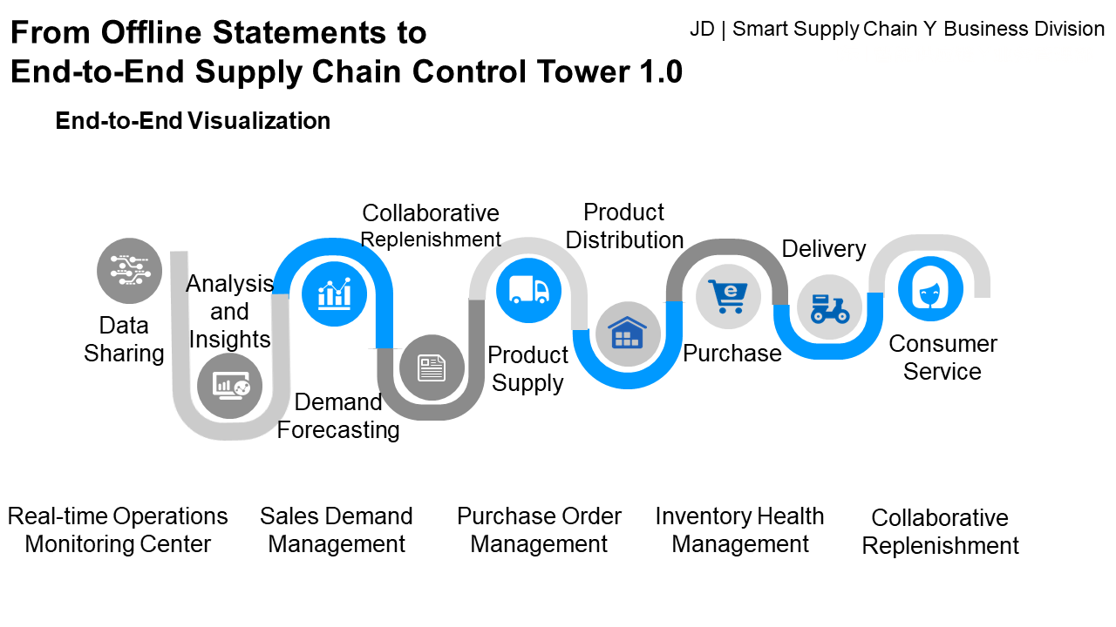

Note: JD = JD.com.

Source: Company information (Y business division Open Day conference, November 19, 2019).

Exhibit 2: JD.com End-to-End Supply Chain Control Tower

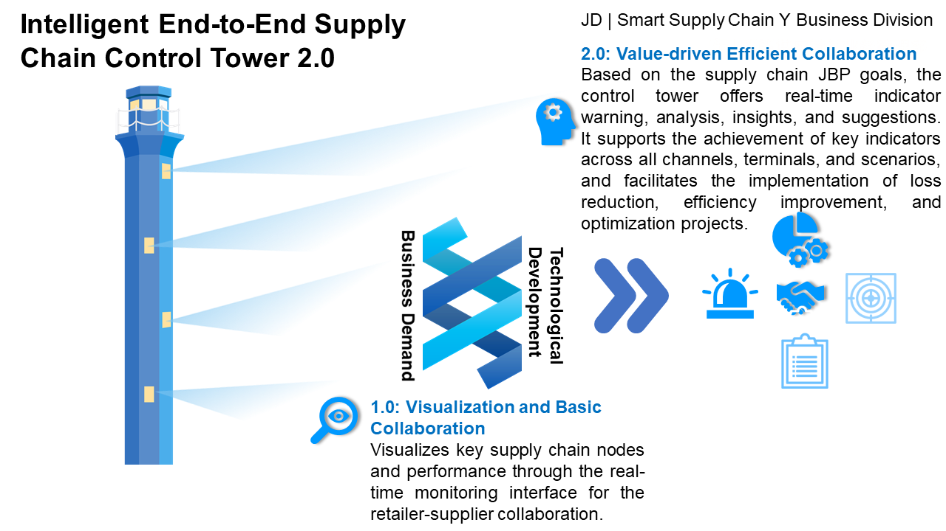

Note: JD = JD.com; JBP = joint business planning.

Source: Company information (Y business division Open Day conference, November 19, 2019).

Exhibit 3: Difficulties Brand Faced before Supply Chain Collaboration—Supply Chain Disconnects

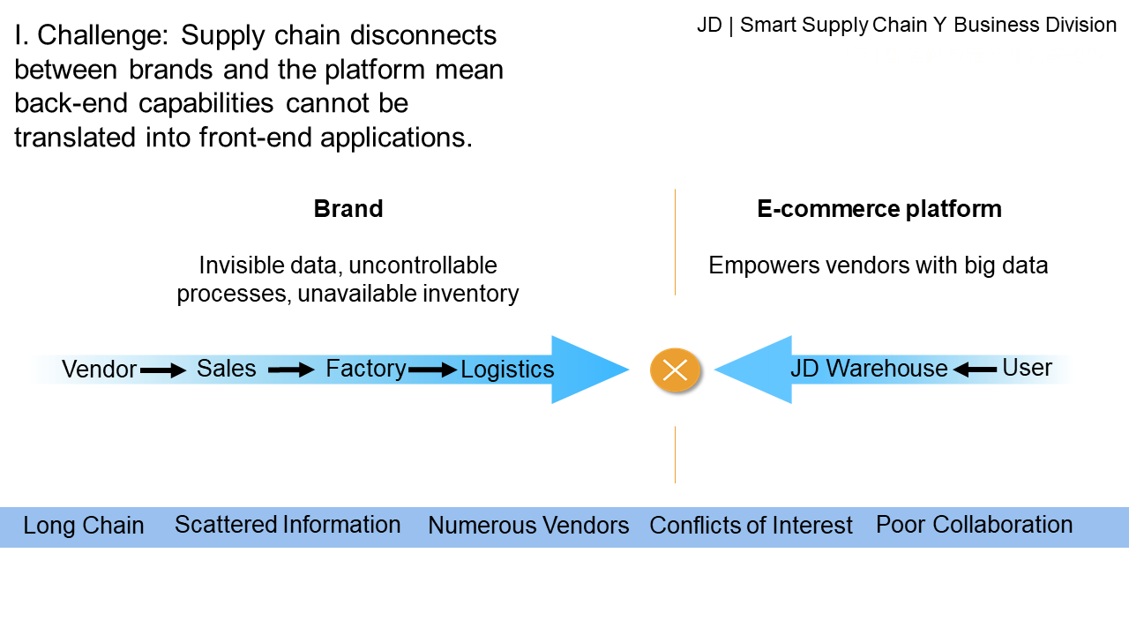

Note: JD = JD.com.

Source: Company information (Meda’s supply chain director Zhao Zhiming at the Y business division Open Day conference, November 19, 2019).

Exhibit 4: JD.com and BOGE Supply Chain Collaboration

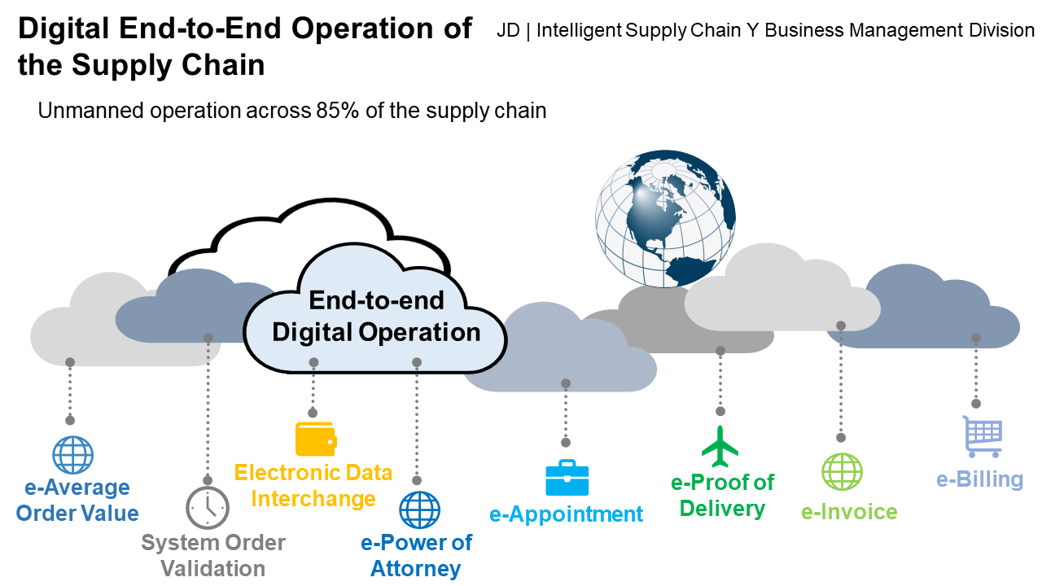

Note: In 1988, Boge launched its Chinese business in Guangzhou as China’s largest manufacturer of consumer goods, with one research centre, nine factories, eight supply centres, and 7,000 employees in the Greater China Region; operating 18 brands in 10 categories, including market leading brands Rejoice, Safeguard, Olay, Pampers, Tide, and Gillette; growing its e-commerce business with JD.com by a factor of 1,000; by the end of 2019, Boge and JD.com had achieved unmanned operations across 85 per cent of the supply chain, covering categories such as maternity products, baby care goods, shampoos and conditioners, oral hygiene products, and cosmetics; in April 2019, the JD.com and Boge digital end-to-end co-operation solution for e-commerce won China Chain Store & Franchise Association’s 2019 CCFA Retail Technological Innovation Award; JD = JD.com; e = electronic.

Source: Company information (Boge at the Y business division Open Day conference, November 19, 2019).

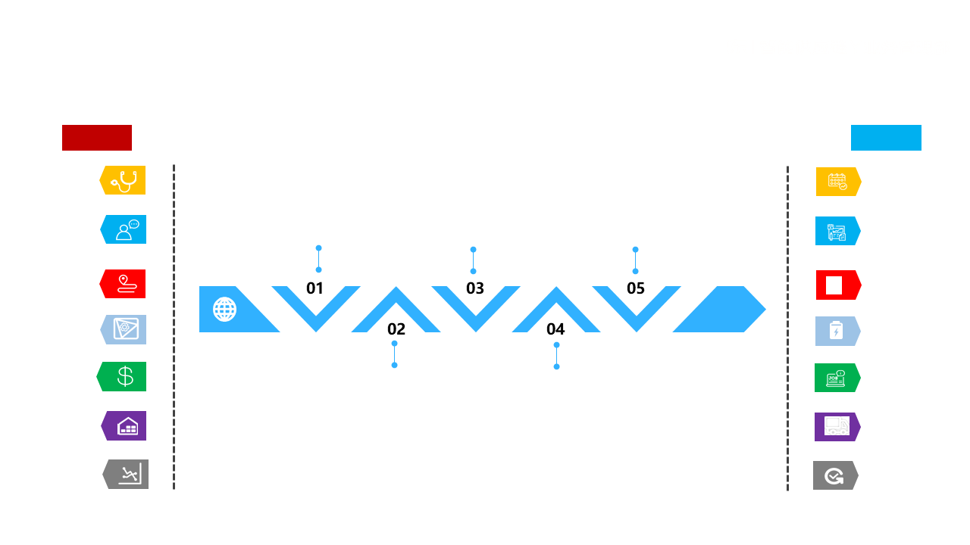Exhibit 5: JD.com and MEDA Supply Chain Collaboration—Breakthrough

**Automatic  
Replenishment**

Each warehouse is replen­ished intelligently, with less labour needed. Inventory is made visual, controllable, and available throughout the entire process.

**II. Breakthrough: Facilitating end-to-end in-depth collaboration and digital operations by information system connection for empowerment and higher efficiency.**

**Collaborative  
Forecasting**

Comprehensive data shar­ing and collaborative fore­casting by the platform and vendors improve opera­tional efficiency throughout the supply chain.

**Collaborative  
Ordering**

JD models are used to calculate the replen­ishment plan and im­prove stocking accura­cy for each warehouse.

**Collaborative  
Planning**

Ordering plans are made based on comprehensive inventory and sales fore­casting to assist in ware­house planning by Meda and JD.

JD | Smart Supply Chain Y Business Division

**Automatic Warehousing Appointments**

Delivery information shar­ing between Meda and JD enables automatic ware­housing appointments and improves turnover efficien­cy.

Sales Diagnosis

Shopping Path

Selection Strategy

Pricing Strategy

Inventory Management

Collaborative Forecasting

User Demand

T+3 Orders

Order Status

Delivery Notice

Transit Management

Warehouse Receipt

Meda

JD

M+1 Monthly Plan

3-Month Rolling Plan

Note: JD = JD.com; M+1 = one month plus one more month; T+3 = transaction date plus three days.

Source: Company information (Meda’s supply chain director Zhao Zhiming at the Y business division Open Day conference, November 19, 2019).

Exhibit 6: JD.com and MEDA Supply Chain Collaboration—Stage and Pain points

|  |  |  |
| --- | --- | --- |
| **Stage** | **Pain Points** | |
| Forecasting | Black box algorithms | |
| Feed preparation | Collaborative planning of commodity and production capacity | |
| T+3 order review | * Order restraint | * Accuracy required for major promotion campaigns |
| Production | * Manual pre-orders | * Limited SKUs |
| Logistics and storage | * Appointment time mismatch/invisible warehouse capacity * Poor experience due to long delivery times of pre-orders | |

Note: T+3 = transaction date plus three days; SKU = stock-keeping unit.

Source: Company information (Meda’s supply chain director Zhao Zhiming at the Y business division Open Day conference, November 19, 2019).

Exhibit 7: JD.com and MEDA Supply Chain Collaboration—Information stream, Logistics, and Capital Flow

|  |  |  |
| --- | --- | --- |
| **Information Stream** | **Logistics** | **Capital Flow** |
| In-depth operations  ↓  Automatic availability | Unified inventory  ↓  Picked up in base warehouses | Inventory loan  and warehouse incentives  ↓  Advance loans for industrial chain financing |
| * Man–machine deep collaboration algorithm * Collaborative product line planning * Optimized order quantities to suit major promotions and full-truck deliveries * Improved accuracy of automatic appointments * End-to-end automatic availability | * Online expansion of unified inventory * *To be* online and offline unified inventory * Picked up at doorstep:   - to B centralized pick-up  - to C pre-order delivery | * In-warehouse and circulation: Inventory loan and warehouse incentives * Financing and manufacturing: 1+N advance financing solution |

Note: 1+N = 1 stands for the focal company in the supply chain; N stands for the other players in the supply chain, such as suppliers, distributors, retailers, etc.

Source: Company information (Meda’s supply chain director Zhao Zhiming at the Y business division Open Day conference, November 19, 2019).

1. JD aimed to become “a technological and service enterprise with supply chain as its foundation” and had four core businesses: retail, digital technology, logistics, and technological services. Committed to “customer-oriented value creation built on trust,” JD constantly created value for users and partners through innovation. JD had over 300 million active users so far. Through powerful supply chain, data, technology, and marketing capabilities, it aimed to provide, at the right times and in the right locations, the most suitable products and services for customers, covering different terminals and scenarios. “Company Profile [in Chinese],” JD.com, accessed May 1, 2020, https://about.jd.com.
2. Tan Jing, “JD: What Is Key to the Smart Supply Chain?,” Dear Data, December 13, 2019, accessed January 16, 2020, https://user.guancha.cn/main/content?id=206472.
3. Gross merchandise volume was a term used mainly in e-commerce that referred to the total turnover within a certain period. It included the number of orders placed, both paid and unpaid.
4. The idea of boundaryless retail was proposed by JD in response to the new retail concept promoted by Alibaba Group Holding Limited. JD founder Richard Liu mentioned the core philosophy of boundaryless retail in a 2018 China Central Television program discussing economic and financial issues.
5. ¥ = RMB = Chinese yuan; US$1 = ¥7.04 on November 20, 2019; all currency amounts are in ¥ unless otherwise specified.
6. When information flowed upstream along the supply chain from the end customer to the supplier, poor information sharing increasingly distorted interpretation of demand and disrupted the supply chain. The result was supplier backlog or retailer stockouts. This phenomenon was referred to as the “bullwhip effect.” The high risk in supply chain operations added to the instability in supplier production, supply, inventory management, and marketing. When a problem occurred along the supply chain, the risk would multiply.
7. Established in 1968, Media was a global technology group that integrated consumer appliances (e.g., kitchen appliances, refrigerators, washing machines), heating and air conditioning systems, robotics and automation systems, and digital business. Its products and services benefited approximately 400 million users across the world.
8. Founded in 1837, Boge was one of the world’s largest consumer goods companies. It operated more than 300 brands of products in various markets including fabrics, home care, beauty, health care, food, and beverages. Its products were sold widely across the world.
9. The Mite Controller was a very popular machine in China used to remove dust mites from bedding and mattresses.
10. A solid foundation for collaboration with JD included Meda connecting basic information systems to JD, using JD’s intelligent business analysis platform to build user portraits and support new media marketing, and deploying production lines exclusively for JD.