

9B21E003

Rajarambapu Patil Sugars: Not so sweet conundrum

Amol S. Dhaigude and Shantanu S. Maheshwari wrote this case solely to provide material for class discussion. The authors do not intend to illustrate either effective or ineffective handling of a managerial situation. The authors may have disguised certain names and other identifying information to protect confidentiality.

This publication may not be transmitted, photocopied, digitized, or otherwise reproduced in any form or by any means without the permission of the copyright holder. Reproduction of this material is not covered under authorization by any reproduction rights organization. To order copies or request permission to reproduce materials, contact Ivey Publishing, Ivey Business School, Western University, London, Ontario, Canada, N6G 0N1; (t) 519.661.3208; (e) cases@ivey.ca; www.iveycases.com. Our goal is to publish materials of the highest quality; submit any errata to publishcases@ivey.ca. i1v2e5y5pubs

Copyright © 2021, Ivey Business School Foundation Version: 2021-03-01

On March 11, 2017, at 11.30 p.m., Suraj Patil, the general manager of Rajarambapu Co-operative Sugar Factory (known in India as Rajarambapu Patil Sahakari Sakhar Karkhana), was restlessly flipping through the company’s past annual production reports. The proposed meeting with the chairman for approval of the aggregate production plan was scheduled to take place on March 12, 2017. Nevertheless, Suraj was still contemplating whether to recommend a chase, level, or subcontracting strategy for the production cycle. Moreover, company management wanted Suraj to plan for the overhauling season by optimizing the cost of the required labour. Improper planning could lead to an increase in the overall costs and the loss of production and other valuable resources. The stakes were high, and Suraj was aware of the gravity of the situation.

RAJARAMBAPU PATIL Sahakari Sakhar Karkhana

Rajarambapu Co-operative Sugar Factory (RPCSF) was a co-operative sugar factory founded in 1969 with a benevolent view of providing employment to the local people of a small town, Wulwa, in the Sangli district of Maharashtra, India. RPCSF’s mission was to provide the best-quality sugar to its customers. The company began operating in 1970 under the name Wulwa Taluka SSK. A plant that had started with a capacity of a mere 1,250 tons crushing per day (TCD) had grown to a capacity of nearly 7,500 TCD by January 2017. RPCSF had a consistent average recovery rate of 10–13 per cent from sugar cane juice, which surpassed the industry standards. Since the sugar plant also produced by-products, it had strategically diversified into the production of extra neutral alcohol, ethanol, fertilizer, and liquor. After establishing a cogeneration plant in 2006, RPCSF started to use its in-house electricity; it also began exporting surplus electricity to the Maharashtra government. For liquor manufacturing, RPCSF partnered with India’s industry-leading liquor-producing company, United Spirits Ltd. Bengaluru.

With a never-ending focus on quality, RPCSF had also won numerous prestigious awards in the past decade, including best factory, best cane development, best financial management, and best technical efficiency. Moreover, RPCSF had also registered several patents. The company proudly announced itself as Maharashtra’s biggest country liquor–producing company with 12 patents under its banner. RPCSF still stood strong with the support of more than 40,000 cane-farming families.[1]

SUGAR PRODUCTION

Zero wastage was a unique characteristic of a sugar plant, where every by-product was utilized in some way. A typical year for a sugar production plant was divided in two halves. The first was the production cycle from October to March, and the second was the maintenance cycle from May to September. RPCSF’s production of sugar was based on sugar cane (see Exhibit 1). The primary step in producing sugar was using trucks and trolleys to unload fully ripened sugar canes, which were grown in a nearby farming community. After unloading was completed, the sugar canes moved to a cutter that ran on a turbine or a high-power motor. After the sugar canes were cut in small pieces, they were moved to be crushed between rollers in four stages of mills with increasing power to extract juice.[2] Two by-products emerged from the crushing process: sweet sugar cane juice and bagasse, the remains of the canes. Bagasse was a dry, yellowish, pulpy, fibrous [residue](https://en.wikipedia.org/wiki/Crop_residue) that served as fuel for the boiler.[3] A separate conveyor belt carried bagasse to the boiler’s combustion chambers.

The other by-product, the sweet sugar cane juice, was passed through strainers to capture impurities and foreign particles. After passing through the clarifier, chemicals such as lime and phosphate were added, which thickened the juice. The thickened juice then passed through a clarifier for a second time, and phosphoric acid was added. In that stage, sludge was formed, which stayed at the top of mixture. This sludge was removed carefully by using clarifiers, and the resulting pure juice was sent to the crystallization process. The sludge was sent to further processing to produce the filter cakes that were then used as fertilizers on the farms.[4]

The crystallization process was the transformation phase where liquid sugar cane juice was transformed into solid sugar particles using centrifugal machines. These machines used two drums to separate sugar from molasses. The juice from the clarifier entered these centrifugal machines and rotated at 1,200 revolution per minute. Due to centrifugal force, sugar crystals fell into the inner drum, whereas the molasses, due to its heavier weight, fell into the outer drum. Conveyor belts moved the sugar crystals to the hopper and the molasses to a storage tank. Molasses was then used to make ethanol or liquor, depending on the market demand.[5]

Proper sugar crystals were separated from crushed crystals in the hopper, and then moved to the dispenser tank. From there, the sugar was packed in bags of varying sizes based on market requirements and pre-orders. Sugar bags were then lifted by forklift and taken to a storage room or yard where they were stored until dispatch.[6]

OPERATIONAL AND MAINTENANCE CYCLE

Apart from the actual sugar production, other departments supported the sugar plant’s operations, including the powerhouse station, water treatment, sustainability, waste management, human resource management, and accounts. Good coordination among all these departments was the prime factor in optimizing sugar production. The failure of one department would eventually lead to either a stoppage or delay in the production of sugar. RPCSF had done well in terms coordinating the various departments to achieve significant efficiency.

The production season started in October and lasted until March, and the overhauling season started in May and ended in September. April was reserved for production planning, forecasting, and developing a detailed plan for the next season. Many transactions dealt with buying or procuring the spare parts that were needed during overhauling. All the machinery in the factory needed to be overhauled during the maintenance season. The time required for overhauling each piece of machinery varied significantly (see Exhibit 2).

MEETING 1

On March 2, 2017 at 11:00 a.m., Suraj was having a cup of tea along with other the area managers in the boardroom, as they waited for the managing director to arrive. The wait did not last long. The managing director entered the room while talking on his phone, and soon all the chairs were occupied.

The agenda of the meeting was known to everyone. Vikhe Patil was the managing director and son of the founder, profit-oriented, and in his late 50s. Suraj was the general manager, target-oriented, extremely good with numbers, and in his early 50s. Satej was the production manager, trustworthy, a long-time RPCSF employee, labour-friendly, approachable, and in his late 40s. Jagdish was the quality manager, calm and compassionate, process-oriented, analytical, and in his late 40s. Laxmi was the finance manager, with close family ties, outspoken, profit-oriented, and in her early 40s. Anoop was the human resources manager, a “people person” who enjoyed family relations, and in his mid-40s.

Vikhe opened the meeting discussion:

Vikhe: Good afternoon, everyone! Thanks for joining this meeting. We will first have a look at our past year’s performance to build on the planning for this year.

Suraj: Sure. Last year had been comparatively good with Maharashtra receiving an above-average rainfall (163 centimetres). It resulted in an excellent yield of sugar canes, and we did not run short on canes anytime during the season. We had maintained our recovery rate (11 per cent) higher than industry standards. The quality of the sugar produced was also better when compared with others in the industry. However, we had a little problem regarding the staffing requirements during the overhauling season. Although the production cycle was satisfactory, I feel that it can be further optimized to reduce the cost and improve the bottom line.

Anoop: [Suddenly speaking up.] Well, you have never told us about the staffing problem earlier. We could have investigated the matter.

Suraj: Not exactly a problem with staffing but with the requirements, Anoop. We are working on a theory and running some calculations. We have all intentions to keep you in the loop.

Vikhe: Okay! Good to know about our past performance, but can you please tell us more about the problems and your plans for improvement?

Suraj: Sure. I will put forth the idea for optimizing production, and Satej can drill down on technicalities further. I am proposing to implement aggregate production planning (APP) strategies namely, chase, level, and subcontracting. Furthermore, during the overhauling season, we had the problem of fluctuating staffing requirements primarily because of non-uniform workload. To tackle this problem, I am designing a plan for staffing requirements by looking at past trends.

Vikhe: It is easy to be wise after the event. I am hoping the idea, or the underlying concepts are not as fancy as the name suggests. Please tell us more about it.

Suraj: [Projects a slide on the screen, see Exhibit 3.] APP will streamline the overall process and contribute to the bottom line as well. In the chase strategy, the demand is met by varying the production quantity and the labour workforce. In the level strategy, the same quantity is produced every month. The shortage or the surplus in quantities is managed by the warehouse. In the subcontracting strategy, the quantity equivalent to the lowest demand across all the months is produced in-house every month. We can also consider running the plant in two shifts of 12 hours each instead of three shifts of eight hours.

Laxmi: Why are we trying to fix something that has not been broken? Books show satisfactory numbers, and this is no time for experiments.

Suraj: If we can improve by experimenting then, why not?

Vikhe: We should look before we leap. Tell us about each of the strategies in detail.

Suraj looked up at Satej in anticipation that he would speak up. Looking at the mood of the room, Satej was reluctant at first but mustered the courage and started speaking.

Satej: Good afternoon, everyone! First, we will look at the chase strategy in which the exact quantity is produced for that month to meet the demand by hiring and laying off of labourers. It eliminates the need for a dedicated warehouse or yard to store the sugar. It also helps in achieving a higher customer service level. There will be no back orders, ensuring almost zero inventory. We also will save inventory holdings and carrying costs. Moreover, we are equipped on the manufacturing front for this strategy.

Anoop: Are we overlooking the fact that once labourers have been laid off, we may lose them permanently? Please realize the labour market is competitive, and other opportunities are readily available. Labourers will not return to possibly be laid off again. Furthermore, the chase strategy requires a constant scrutiny of staffing to adjudge performance. It will demoralize the labourers along with creating a culture of distrust. Finally, this strategy would create an added burden on specific departments.

Suraj: The intention is not to burden the departments with extra work but to optimize the overall process. We are at the ideation stage so far, and nothing has been finalized. We are working on all the possibilities here.

Satej: In the level strategy, the average monthly quantity will be produced every month irrespective of the demand. The surplus will be stored in the warehouse, and will be used when there is a shortage. We can run the plant with the same set of workers, which might help in increasing the overall efficiency, reducing the chances of accidents, and facilitating excellent coordination between all the departments.

Laxmi: [Shifting her eyes from the mobile screen to Satej.] Isn’t it ironic? When our purpose is to improve the bottom line, we are adding to the total cost. I do not see any merit in this level strategy. You proposed a strategy to optimize the production, completely ignoring the costs. What about the various costs such as warehouse costs and the inventory holding cost, to name a few? There is no such thing as a free lunch.

Jagdish: I second Laxmi. In the level strategy, we may sometime face stock-out situations and lose out on the sales. It is not just the loss of sales but the potential loss of customers and the brand.

Suraj: True! However, we have not finalized any of the strategies yet. They are the available alternatives that could behove and channelize our production process.

Vikhe: Well, tell us about your third strategy.

Satej: In subcontracting, the quantity equivalent to the lowest demand across all the months is produced in-house every month. The difference is subcontracted to a third party. The few benefits that come along with it are higher operational efficiency of the plant and eliminating the need of a dedicated warehouse. This strategy demands the minimum yet constant workforce, which might reduce the chances of clashes and accidents. We could have better supervision of the whole process of sugar manufacturing.

Jagdish: But there is always the risk of compromise on the quality of sugar. Also, during the peak in the demand season, subcontracting would not really work as every other plant will try to fulfill their demand first.

Laxmi: Satej, who would bear the cost of transportation, the logistics from the vendors’ place to the warehouse or the point of distribution? We cannot at any point in season increase the cost of sugar. It will leave our books in a very bad shape.

Suraj: We are considering that aspect before coming to the final cost. We might use your help in preparing a final budget. I hope it will be okay.

Vikhe: Whatever strategy has been discussed and detailed here, never forget the underlying goal of increasing the profits. Furthermore, what about the staffing requirements during the overhauling that you mentioned? Do we have any plan for that?

Suraj looked at Jagdish, noting that they had discussed the staffing requirements earlier. Jagdish responded to the cues and answered:

Jagdish: We do have a plan for that. However, we are still running some calculations to align the plan with the company’s values and goals. We plan to retain a group of regular labourers, and part-timers will do the rest of the work. The idea is to maintain the quality of the work, along with reducing the cost of operations. Regular labourers will make sure the quality is never compromised. We intend to retain 25 per cent of the regular labourers.

Anoop: [In a frustrated tone.] There happens to be a trade-off between cost and quality, and from what I understood, you have already chosen the side. It is better said than done. Hiring and laying off are not easy tasks. A comprehensive detailed report is required before firing 75 per cent of the workforce. Also, we do need them again in the production cycle. The whole compensation structure will need to be redesigned.

Suraj: [Looking at Vikhe.] We know that, and we will compare the strategies only after factoring in all the costs. Regarding compensation structure, we really do not have any plan, but we believe our HR [human resources] department is competent enough to support us on this front.

Anoop: Our department has always supported the new initiatives for the betterment of the organization, and we intend to continue the same in this case. But correct me if I am wrong, we need 140–150 labourers throughout the year, and we have been working with those numbers in the past few years. We need to redesign our recruitment process to replace 75 per cent of the regular labourers with part-timers. It will be a challenging task, but we are open to it, provided the production department is competent enough to work primarily with the part-timers.

Vikhe: Sort out all the inter-departmental issues and come up with a final plan, including all the costs and the impact on the bottom line. Suraj, we are counting on you to present the final plan in the next meeting, on March 12. I would really want to see an increase in the bottom line. If you have any more alternatives, feel free to present them in the next meeting.

Suraj, not so convinced and unhappy, walked toward his office. He was followed by Satej and Jagdish. All three of them were worried because they knew that, as the common adage stated, “blood was always thicker than water,” which meant that family relations ranked far higher in importance than other relationships. Therefore, they would probably be held responsible for improper planning if anything went wrong. They decided to hold a second meeting of their own.

MEETING 2

At the second meeting, the three managers discussed several key elements from the previous meeting:

Satej: [In a frustrated tone.] Finance and HR do not look to be on our side. What can be done to convince them before the next meeting?

Suraj: We should let them add their perspective and validate how feasibly we can incorporate the strategy. Final costing and staffing requirements would ultimately need their approvals. Only strong numbers will bridge the gap.

Jagdish: I agree. They will question every detail if it is not backed by the numbers. I even doubt that they will agree to the plan with numbers.

Satej: I was surprised that there was no discussion about the seasonal trends in sugar consumption [see Exhibit 4]. We must consider the seasonal trends before cementing an actual demand plan.

Suraj: The bottom line is much brighter than the seasonal trends. Anyway, we can incorporate seasonality in the APP, can’t we? You proceed with the calculations and let me know the final details once you are done.

Jagdish: What about the costs that every strategy comes with?

Suraj: See, I think it will be difficult to calculate all the costs per se. But we can list the benefits and constraints attached to each strategy in a detailed manner. Thereafter, we leave the decision with management to choose one of the strategies.

Jagdish: I heard that the labour market is tight this year. Is that true?

Satej: Very true. I have been informally talking to workers in the factory. All I could gather is the labour market was becoming challenging owing to multiple factors such as a limited pool of labourers, the unavailability of skilled labourers, poaching by competitors/allied manufacturers in nearby vicinities, and availability of jobs in the metro cities. Moreover, the labour union, knowing these factors, would play hard to increase wages and other benefits.

Jagdish: We have discussed the part-timers, but there was no mention of their efficiency of working and the wages paid to them. There will be a different compensation structure for part-timers. We must incorporate those details in our calculations [see Exhibit 5].

Suraj: Can you work around with those calculations? Satej will provide you with any assistance if needed. We must really pull this through before the next meeting. The market condition gives me the essence of pink slip. We shall circle back on March 7 to check the progress. I hope that is fine with both of you.

Satej: Sure. We shall reach out to you once we are done.

Suraj: We can also check on the option of running the plant in two shifts of 12 hours each against three shifts of eight hours [see Exhibit 5].

Jagdish: We can do that. We shall discuss the constraint in the meeting on March 7.

Suraj was deeply involved in the thought process of selecting the best alternative that would optimize the returns. The sudden sound of the rooster’s crow interrupted his thoughts. He smiled and decided it was time to rise up with the day’s sunrise.

Amol S. Dhaigude is faculty in operations and decision science management at the T A Pai Management Institute India. Shantanu Maheshwari is a PGDM student at the T A Pai Management Institute India.

**EXHIBIT 1: SUGAR PRODUCTION PROCESS FLOW**

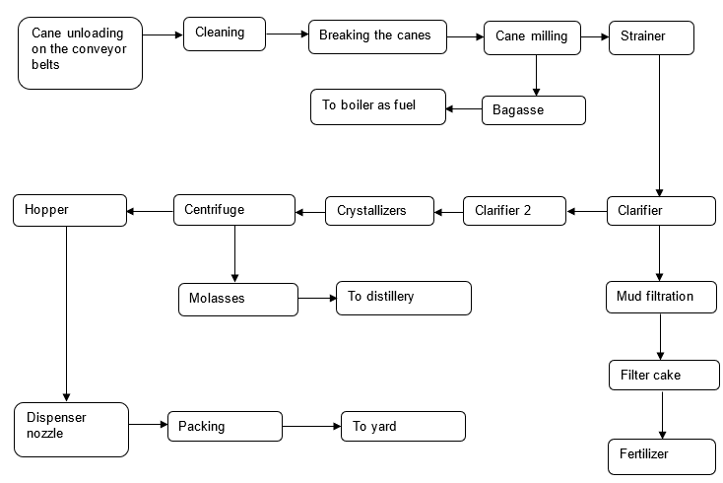

Source: Developed by the case authors using company information.

**EXHIBIT 2: HOURS REQUIRED FOR OVERHAULING MACHINERY IN THE MAINTENANCE CYCLE**

| **Equipment** | **Number of Hours** |
| --- | --- |
|  |  |
| Loader conveyor | 2,500 |
| Cutter turbine | 9,500 |
| Mills | 6,300 |
| Bagasse’s carrier conveyor | 3,500 |
| First clarifier | 4,230 |
| Second clarifier | 3,500 |
| Evaporator | 2,650 |
| Crystallizer | 6,500 |
| Filter cake conveyor | 3,500 |
| Mud separator roller | 4,500 |
| Molasses carrying conveyor | 2,630 |
| Storage tank and dispenser nozzles | 3,850 |
| Overhead cranes | 2,750 |
| Forklifts | 2,500 |
| Hopper conveyor | 4,300 |
| Turbine-generator set | 8,650 |
| Boiler | 14,900 |
| Sewage treatment plant | 8,500 |
| Sub-station | 7,300 |
| Cooling tower | 7,600 |
| **Total** | **109,660** |

Source: Developed by the case authors using company information.

**EXHIBIT 3: GRAPHICAL REPRESENTATION OF LEVEL AND SUBCONTRACTING STRATEGIES**

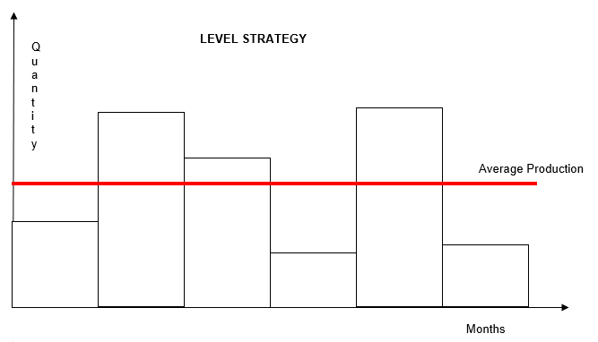

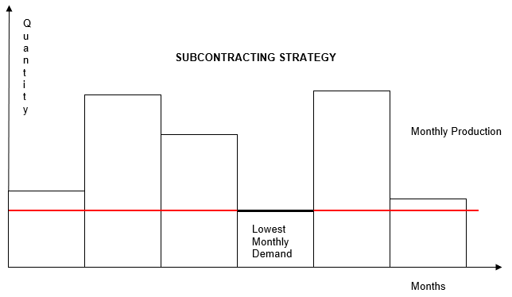

Source: Developed by the case authors using company information.

EXHIBIT 4: sugar consumption DEMAND, 2012–2016, by month (in metric tonS)

|  |  |  |  |  |  |
| --- | --- | --- | --- | --- | --- |
| **Month** | **2012** | **2013** | **2014** | **2015** | **2016** |
| October | 26,500 | 26,250 | 26,850 | 26,400 | 26,150 |
| November | 21,050 | 21,000 | 21,450 | 21,300 | 21,650 |
| December | 23,000 | 24,500 | 28,500 | 24,500 | 25,700 |
| January | 50,000 | 52,300 | 54,100 | 52,900 | 53,700 |
| February | 41,700 | 40,300 | 41,700 | 42,300 | 45,600 |
| March | 31,500 | 32,800 | 30,700 | 31,900 | 32,600 |

Source: Developed by the case authors using company information.

EXHIBIT 5: LABOUR and other COSTS in PRODUCTION and MAINTENANCE periods (in ₹)

Production Period

| **Particular** | **Value** |
| --- | --- |
| Average salary of labourers in off-season | 8/hour |
| Average salary of labourers in season | 10/hour |
| Maintenance period | May–September |
| Production cycle | October–March |
| Firing cost | 1,500/labourer |
| Hiring cost | 1,350/labourer |
| General shifts | 3 (8 hours each) |
| Provision for shifts | 2 (12 hours each) |
| Efficiency in 12-hour shifts | 100% for 8 hours, then 50% |
| Efficiency in regular shifts | 100% for 8 hours |
| Subcontracting cost | 45/ton of sugar |
| Subcontracting labourers’ cost | 15/hour |
| Labour cost in 8-hour shifts | 10/hour |
| Labour cost in 12-hour shifts | 15/hour |
| Inventory carrying cost | 40/ton |
| Non-fulfillment of order cost | 150/ton |
| Labour–hour ratio for one ton | 1.3 |
| Factor of safety for containing errors in forecasting | 20% |

Maintenance Period

| **Particular** | **Value** |
| --- | --- |
| Regular labourer cost | 10/hour |
| Part time labourer cost | 7/hour |
| Efficiency of part-time labourers | 70% |
| Firing cost | Negligible |
| Hiring cost | Negligible |
| Shift | 8/day |
| Total number of labourers | 140–150 |
| Minimum regular labourers | 25% of total |
| Total number of labour hours | 109,660 hours |

Source: Developed by the case authors using company information.

1. “Patents,” Rajarambapu Patil Co-operative Sugar Factory, accessed April 30, 2020, www.rajarambapusugar.com/achivements/patents/.
2. Nikita D, “Steps Involved in Manufacturing Cane-Sugar (with Diagram),” BiologyDiscussion, accessed May 3, 2020, www.biologydiscussion.com/economic-botany/steps-involved-in-manufacturing-cane-sugar-with-diagram/52872.
3. “Sugarcane and Its By-Products,” Dawn, January 30, 2006, accessed May 3, 2020, www.dawn.com/news/176372#:~:text=The%20main%20by%2Dproducts%20are,by%20sugar%20industry%20and%20distillery.
4. “Sugar | How It’s Made,” YouTube video 7:54, posted by “Discovery UK,” July 21, 2018, accessed May 20, 2020, www.youtube.com/watch?v=jCKt02NGjfM.
5. Siva Alluri, “White Sugar Making Process | How to Make Plantation White Sugar,” Sugar Process Technology, accessed May 3, 2020, www.sugarprocesstech.com/white-sugar/.
6. “Sugar,” How Products Are Made, accessed February 25, 2021, www.madehow.com/Volume-1/Sugar.html.