

9B21M014

World Health organization: Facilitating covid-19 vaccines for the world[1]

Michelle (Chau Minh) Doan wrote this case under the supervision of Klaus E. Meyer solely to provide material for class discussion. The authors do not intend to illustrate either effective or ineffective handling of a managerial situation. The authors may have disguised certain names and other identifying information to protect confidentiality.

This publication may not be transmitted, photocopied, digitized, or otherwise reproduced in any form or by any means without the permission of the copyright holder. Reproduction of this material is not covered under authorization by any reproduction rights organization. To order copies or request permission to reproduce materials, contact Ivey Publishing, Ivey Business School, Western University, London, Ontario, Canada, N6G 0N1; (t) 519.661.3208; (e) cases@ivey.ca; www.iveycases.com. Our goal is to publish materials of the highest quality; submit any errata to publishcases@ivey.ca. i1v2e5y5pubs

Copyright © 2021, Ivey Business School Foundation Version: 2021-02-11

Within just a few months of the first confirmed case of COVID-19, the virus had changed lives around the world. Lockdowns and travel restrictions forced people to work from home, cancel their vacations, and avoid indoor events. Many people pinned their hopes on a vaccine to combat the disease. Pharmaceutical companies and research laboratories raced to bring safe and effective vaccines to market.[2] Stakeholders such as governments, businesses, and non-governmental organizations (NGOs) joined the efforts, but disagreed on how best to ensure the widespread availability of vaccines.[3] The pharmaceutical industry viewed intellectual property (IP) protection as a means to earn a satisfactory return on their high-risk investments.[4] Others argued that upholding patent laws in times of crisis would make life-saving medications prohibitively expensive for many people, especially those in developing countries.[5]

As COVID-19 turned into a global pandemic, the World Health Organization (WHO) initiated a COVID-19 Technology Access Pool (C-TAP) that would help countries around the world access technologies, specifically vaccines and treatments. This initiative aimed to promote equitable access to, among other related technologies, coronavirus vaccines.[6] However, industry insiders viewed C-TAP as a threat to the patent system for medical products and, therefore, as a threat to future research and development (R&D).[7] Given the conflict, how should pharmaceuticals, university medical departments, NGOs, and governments engage in this global effort?

THE GLOBAL PANDEMIC

On December 30, 2019, the Wuhan Municipal Health Commission issued an urgent notice to health care institutions under its jurisdiction, advising them of cases of pneumonia from unknown causes. The notice received immediate attention on the Internet and from the WHO China Country Office. Medical experts initially linked the new disease to viral pneumonia due to the disease symptoms, which included fever, dry cough, shortness of breath, and, in some cases, invasive lesions in both lungs. Further investigations found that all infected patients had visited or had been in contact with someone who had visited the Huanan Seafood Market in Wuhan, a city of 11 million people and the capital of Hubei Province in central China.[8]

In the early phase of the disease, Hubei authorities downplayed the threat.[9] Based on information provided by local investigators, the WHO reported on January 5, 2020, that it had no evidence of human-to-human transmission.[10] The disease spread, and on January 20, the Chinese authorities changed their position. Central government authorities took control and announced a far-reaching lockdown of the city of Wuhan, commencing on January 23rd, with mobility restrictions that confined many people to their residential compounds.[11]

WHO withdrew its earlier statement and pointed to rising infections among health care workers as evidence of human-to-human transmission. Health authorities in Thailand, Japan, South Korea, and the United States flagged cases of people infected with the virus arriving from Wuhan. In February, Italy reported a major outbreak, which soon spread to neighbouring countries.[12] Within a month, COVID-19 had spread globally to 18 countries, with 7,818 recorded cases (see Exhibit 1).

The virus swept through the world at an unprecedented pace. Confirmed cases reached 1 million on April 3rd and continued to increase exponentially, with an additional million cases every two weeks (see Exhibit 2). By July 31st, there were 17.3 million cases worldwide. The United States, Brazil, and India were the hardest-hit countries, reporting more than half of all confirmed cases. The case fatality rate (CFR)—the proportion of deaths among confirmed cases—was far in excess of other common diseases; early estimates by WHO suggested a CFR of 3.4 per cent. However, CFR varied across patient demographics, with the elderly and those with underlying health conditions most at risk.[13]

Despite warnings from WHO about the severity of the novel coronavirus, initial reactions were mixed. Some governments, notably those in Asia Pacific, quickly implemented far-reaching lockdowns, while others followed a more relaxed approach (see Exhibit 3). Locations with low levels of testing, absence of contact tracing, or mistrust in the government experienced larger and more sustained surges of infection.[14] The rapid spread of the outbreak prompted WHO to declare a global pandemic on March 11, 2020.[15]

The pandemic and the lockdowns had a major impact on the economy. Domestically, many businesses moved to home-based operations, while other businesses, especially those in the hospitality industry, were forced to close. Internationally, restrictions on travel inhibited international trade and services such as tourism and education. In June, the World Bank forecasted the deepest global recession since the Second World War: a contraction of 5.2 per cent in global gross domestic product in 2020, with deeper recessions in Europe and the Americas (see Exhibit 4). Lower consumption, unemployment, erosion of human capital, and fragmentation of supply chains were feared to have a long-term impact on the global economy.[16]

THE QUEST FOR A VACCINE

To combat the public health and economic consequences of the pandemic, the development of vaccines became a high priority. Pharmaceutical companies and governments around the world joined efforts to develop COVID-19 vaccines. However, scientists warned against premature release of a new vaccine before the vaccine’s safety and efficacy had been documented because even rumours of side effects could cause distrust in vaccines.[17]

The established process for developing new medications involved five stages: discovery research, preclinical tests, three clinical trial phases, regulatory review and approval, and manufacturing and distribution (see Exhibit 5). In phase 1 of the three-stage clinical trial process, the safety of the vaccine was assessed on a small number of healthy volunteers. Phase 2 studied the efficacy of the vaccine on several hundred patients and normally lasted two to three years. Phase 3 involved thousands of patients and aimed to provide pharmaceutical companies with large-scale statistical data on the drug’s effectiveness as well as its possible side effects. The data generated in phase 3 would be presented to the United States Food and Drug Administration (FDA) and its counterparts in other countries to obtain approval for marketing the drug. Phase 3 trials could take two to four years, depending on the availability of a suitable patient pool. Altogether, a vaccine development process could take more than 10 years.[18]

The urgency of the COVID-19 pandemic, however, did not leave much time for research. Over a period of eight months (January to August 2021), scientists advanced 36 vaccines to the clinical trials stage, and at least 90 preclinical vaccines were under investigation on animals. Of those vaccines in clinical trials, 23 were in phase 1, 14 were in phase 2, eight were in phase 3, and three had been approved for limited use by August 31st. Most of these research projects involved international partnerships, especially for the clinical trials.[19] Only through international collaboration could a large and diverse population of patients be found in a short time.

The eight vaccine candidates leading the race were using three main pharmaceutical platforms: non-replicating viral vector, inactivated virus, and ribonucleic acid (RNA) (see Exhibit 6).[20] The non-replicating viral vector platform leveraged research on related coronaviruses such as severe acute respiratory syndrome (SARS) and Middle East respiratory syndrome (MERS). Of the three non-replicating viral vector candidates in phase 3, the vaccine developed by the University of Oxford and AstraZeneca plc was regarded as the most promising. The public–private partnership (PPP) had managed to secure US$1.2 billion[21] in funding from the United States, $85.5 million from the UK government, and $396 million from the European Commission—all in exchange for supplying early doses.[22]

The inactivated virus platform was led by Chinese enterprises. Sinovac Biotech Ltd. (Sinovac), a Chinese biotechnology firm, had made the most notable progress and was successful in acquiring international funding, including $16 million from Brazil to conduct vaccine trials[23] and a technology licensing deal in Indonesia.[24] Sinovac launched phase 3 trials in the United Arab Emirates and Argentina. However, its decision to inoculate its own employees prior to completing phase 3 trials worried experts due to potential side effects.[25]

The medical community and investors placed high expectations on messenger RNA (mRNA) vaccines, a novel approach to help cells generate proteins that in turn led to the development of antibodies.[26] Leading players in this technology included Moderna Inc., a US-based biotechnology firm, and a partnership between German start-up company BioNTech SE and Pfizer Inc. (Pfizer) that had signed a $1.95 billion contract with the US government for 600 million doses.[27]

While the availability of a coronavirus vaccine largely depended on phase 3 outcomes, companies were optimistic about an early 2021 release.[28] Once a vaccine was approved, the next challenges would be ramping up production capacity, building cold-chain logistics to bring vaccines to hospitals, and managing large-scale vaccination campaigns.

THE INSTITUTIONAL ENVIRONMENT FOR MEDICAL RESEARCH

IP protection was a fundamental element of the institutional framework for the pharmaceutical industry; patents governed the rights to use knowledge created or acquired by pharmaceutical companies around the world. Specifically, patents gave companies a temporary monopoly over their medications and thereby provided them with an opportunity to earn an appropriate return given the financial risks associated with investment in R&D.

Patent laws around the world defined IP and enshrined the importance of protecting inventors’ rights. Granting inventors a period of exclusivity was believed to foster innovations and thereby create public benefits. During their temporary monopoly, inventors were legally entitled to exclude others from making, using, or selling their inventions. Patents were normally granted by national authorities, and their protection was principally limited to national boundaries. Traditionally, national patent rules varied in terms of the scope and breadth of the patent, exemptions to patent rights, and the duration of the patent. Many developing countries historically did not allow patents for pharmaceuticals.[29]

International treaties gradually aligned patent protection. In particular, the Agreement on Trade-Related Aspects of Intellectual Property Rights (TRIPS Agreement), created with the launch of the World Trade Organization (WTO) in 1995, established minimum standards for IP protection for all WTO member countries. The TRIPS Agreement contained specific prescriptions and proscriptions for national patent policy that resulted in an international convergence of patent terms on disclosure matters and patent rights, as well as the means for enforcing those rights. Developing countries were given extra time to implement the new rules, but their access to patented technologies became limited unless they committed to TRIPS standards.[30]

The pharmaceutical industry regarded long-running patents as essential because the development and testing of medical products and pharmaceutical compounds were both costly and time-consuming. One study estimated that the cost of bringing a new medication to market was between $500 million and $800 million, the majority of which was incurred during clinical trials. Industry experts estimated that in 2006, the cost of bringing new medications to market (including the cost of post-approval clinical trials) was up to $1.2 billion. Pharmaceutical companies were willing to undertake such big investments with the hope of earning quasi-monopolistic rents over the lifetime of the patent.[31]

The combination of rigorous approval processes and long-running patent protection transformed the pharmaceutical industry into one of the most profitable sectors. A study in the *Journal of the American Medical Association* found a significant gap in profit metrics between 35 large pharmaceutical companies and a benchmark of 357 companies in other sectors. Specifically, the margins for earnings before interest, taxes, depreciation, and amortization were 29.4 per cent compared to 19.0 per cent in the benchmark, and net income margins were 13.8 per cent versus 7.7 per cent in the benchmark. However, the study also noted smaller gaps in the margin for more recent time periods.[32]

Industry representatives argued that these high margins were the result of highly effective products being sold at prices that would allow companies to recoup R&D costs.[33] Thus, pharmaceutical firms needed strong IP protection and high prices to continue innovating for the greater good. Without protection, companies would not be able to justify their risky upfront investment to shareholders. This, in turn, would stifle innovation and eventually cause irreversible damages. However, critics alleged a lack of transparency with respect to the actual investment in R&D and marketing.[34]

CONCERNS ABOUT THE PATENT SYSTEM

The TRIPS Agreement was pushed by developed countries, particularly the United States, and remained unpopular among developing countries, who viewed the agreement as a barrier to their economic catch-up. A particular concern was IP rights to medications, which became a public health concern for countries that could not afford world market prices for critical medications to combat pandemics such as acquired immune deficiency syndrome (AIDS). Before the TRIPS Agreement, developing countries could resort to compulsory licences that paid the patent owners a government-set fee that was typically much lower than what the pharmaceutical company would demand elsewhere. This allowed local drug companies to produce generic versions of patented drugs at a significantly reduced price.[35]

Under the TRIPS Agreement, compulsory licences were permitted, but only under specific conditions—conditions that developing countries without domestic pharmaceutical manufacturing capacity could rarely fulfill.[36] Thus, the TRIPS Agreement created major challenges for developing countries by triggering exponential price hikes for life-saving drugs.[37] This barrier to access was detrimental to the health and well-being of these populations and seemed to go against the original intention of the patent system: to make innovations available for public use.

The COVID-19 crisis renewed the debate over the merits of the patent system. Central to the debate were the high prices and the consequent limited access for major population groups. For the United States, a vaccine was expected to cost between $20 and $145 per dose,[38] a price that would put the vaccine out of reach especially for people in developing countries. This was of particular concern given increasing inequality in many societies that was a consequence of the economic fallout from the pandemic. There was also evidence that the pandemic hit ethnic minorities and lower-income socio-economic groups particularly hard.[39] Further, an inability to vaccinate certain populations had consequences that reached beyond the immediately affected group: vaccinations not only benefited the individuals receiving the vaccination by reducing their risk of infection, they also benefited everyone else in the society by reducing their risk of being exposed to infected individuals. Thus, high prices would limit access by those who could not afford the vaccine (or who lacked appropriate health insurance coverage) and would also thereby slow the pace at which widespread immunity would be achieved in a society.

A related concern was vaccine nationalism. The early months of the pandemic saw several governments hoarding drugs believed by some to be effective in treating COVID-19 patients. In June 2020, the Trump administration struck a deal with Gilead Sciences Inc. to secure the full supply of remdesivir—an antiviral medication believed to shorten hospital stays of admitted COVID-19 patients. This unilateral approach worried experts due to its implication for eventual access to a coronavirus vaccine.[40]

Developing countries were particularly concerned by the combination of corporate control over key medications and preferential or exclusive access agreements signed by developed countries. Industry representatives promised, in principle, to provide access at affordable prices, but developing countries were reluctant to build their emergency response solely on such goodwill. Thus, in April 2020, the United Nations (UN) Committee on Economic, Social and Cultural Rights (CESCR) highlighted the importance of international assistance and co-operation in combating the COVID-19 pandemic. Specifically, sharing research, medical equipment, supplies, and best practices was considered essential “to mitigate the impact of the disease and to expedite the discovery of effective treatments and vaccines.”[41]

The struggle to access personal protective equipment (PPE) at the onset of the pandemic led many countries to take extra caution in their health care strategy. The battle for PPE revealed an uncooperative, protectionist attitude of several rich nations and triggered a global loss of confidence. As a result, developing countries feared that access to vaccines may be limited and prioritized for those willing to pay the highest price.[42] The UN, the International Committee of the Red Cross, and several NGOs thus advocated a “people’s vaccine” that would be accessible for everyone, including the most distant and least advantaged communities.[43]

WHO’s PATENT POOL INITIATIVE

On May 29, 2020, the WHO launched C-TAP to make coronavirus-related technologies widely accessible. President Carlos Alvarado Quesada of Costa Rica, one of the initiators of C-TAP, argued that the initiative would “free up the power of science. There is no point in achieving these amazing technological developments if we cannot guarantee access.”[44] A WHO policy statement proclaimed,

The single most important priority of the global community is to stop the COVID-19 pandemic in its track; to halt its rapid transmission and reverse the trend of consequential global distress. We know that this goal is only achievable when everyone, everywhere can access the health technologies they need for COVID-19 detection, prevention, treatment and response.[45]

C-TAP aimed to establish a single repository for sharing scientific knowledge, data, and IP in the global community. It was envisaged to draw on existing mechanisms, notably the Medicines Patent Pool (MPP) and the Tech Access Partnership (TAP)—both UN-sponsored platforms supporting access to and the development of life-saving medicines for low- and middle-income countries. The objective was to facilitate collective efforts to advance health-related science through sharing of knowledge, IP, and data. WHO invited all relevant stakeholders to join the initiative.[46]

The initiative had five elements: (1) public disclosure of viral gene sequences and data; (2) transparency surrounding the publication of all clinical trial results; (3) encouragement of governments and other funders to include clauses in funding agreements with pharmaceutical companies and other innovators about equitable distribution, affordability, and the publication of trial data; (4) the licensing of potential treatment, diagnostic, vaccine, or other health technology to the MPP; and (5) the promotion of open innovation models and technology transfer that would increase local manufacturing and supply capacity.[47]

Even though participation was voluntary, mass adoption of the program could accelerate the discovery of health technologies, fast-track development processes, and ensure equitable distribution. For developing countries, the option to request a licence from the MPP to manufacture patented medicines for their respective market at a lower price was particularly attractive. Similar to compulsory licensing, the C-TAP initiative aimed to promote access to medicines by eliminating the price barrier. The program also bypassed the drug-by-drug, country-by-country negotiations required by the patent system for drug purchase. If successful, the initiative could achieve the dual goal of guarding against vaccine nationalism among developed nations and alleviating the strain placed on developing countries’ resources.

By August 2020, C-TAP was supported by 39 countries and several UN agencies and NGOs. Of the European Union member states, only Belgium, Luxembourg, Norway, Portugal, and the Netherlands expressed interest in joining the initiative. Many wealthy countries such as France, the United Kingdom, China, Russia, Germany, and Canada were absent.[48] Most notably, on the same day that the program was launched, the United States, which was absent from the platform, announced that it would terminate ties with WHO, claiming that WHO had failed to timely and accurately warn of the dangers of COVID-19.[49] Because success was contingent on the participation of large economies and leading pharmaceutical firms, the political pushbacks could undermine C-TAP’s efforts.

RESPONSES BY THE INDUSTRY

Industry leaders expressed their opposition to the idea of a patent pool and, along with it, compulsory licensing. Many advanced economies shared this sentiment, pointing to the endeavour’s threat to innovation. With billions of dollars invested in R&D, executives were not prepared to give away vaccines at discounted prices. For example, the chief executive officer of Pfizer, Albert Bourla, called C-TAP “nonsense” and “dangerous.”[50]

Pharma executives were concerned that the patent pool would become mandatory and thereby promote free riding by increasing the motivation to wait for the availability of vaccines and reducing incentives to spearhead development. Moreover, many companies saw price setting as a major problem and cited it as a reason for not joining C-TAP. Traditionally, the temporary monopolistic control over pricing had been a key motivation for pharmaceutical companies to invest in R&D. Lacking this incentive, companies would lack the motivation to bring life-saving products to market, and innovation would dry up, eventually leading to major consequences for public health.[51]

C-TAP was designed to allow firms owning the vaccine IP to earn a licensing fee for all uses of the vaccine, including situations where a third party would manufacture the vaccine. However, it remained unresolved as to who would set the licensing fee: WHO, participating country leaders, or some other entity. Faced with a potential erosion of profits, industry experts disputed the negative association between IP and accessibility. Thomas Cueni, director general of the International Federation of Pharmaceutical Manufacturers & Associations (IFPMA), argued that “intellectual property has not been an impediment to the common goal of this pandemic and rather has enabled the development of several medicines and vaccines that are now being tested for additional use in the fight against the COVID-19.”[52]

Industry spokespersons were concerned that amending IP laws to improve accessibility would set a dangerous precedent.[53] If medical technologies were considered as public goods, formidable obstacles would be created for big pharma. This concern went beyond the COVID-19 vaccine. Without ownership of inventions, businesses would lack incentives to invest in R&D when preparing for outbreaks. Because pharmaceutical businesses were valued on their current product portfolios, the IP rights associated with those products, and the pipelines of new medications, alterations to any of these levers could greatly affect a company’s value. This was a natural concern to top executives, whose compensation was typically tied to stock price.

The industry announced its own initiatives. For instance, Novartis AG announced in July 2020 that it would provide 15 drugs that had been shown to be effective in treating symptoms of COVID-19 at cost to developing countries.[54] Similar actions were announced by other major pharmaceutical companies, such as Sanofi SA and GlaxoSmithKline plc.[55] Others pledged to sell vaccines at a break-even price if IP rights were kept intact. Johnson & Johnson and AstraZeneca were among the first to propose such a no-profit approach, stating they would sell vaccines at the cost of production—at least until the pandemic subsided.[56]

Instead of C-TAP, industry leaders supported other initiatives to license drugs to developing countries. For example, MPP—a product of the hard-fought battle between pharmaceuticals and NGOs during the AIDS epidemic—provided a platform for IP sharing. MPP was a UN-backed public health organization that coordinated licensing of life-saving medicines to developing countries. It had facilitated the development of generic drugs for the human immunodeficiency virus, tuberculosis, and hepatitis C. On March 31, 2020, MPP was extended to include treatments for COVID-19, including vaccines, diagnostics, and medical equipment.[57]

IFPMA was also concerned that C-TAP would potentially duplicate the efforts of the Access to COVID-19 Tools (ACT) Accelerator, an industry-sponsored platform founded in April 2020 to build manufacturing capabilities and distribution networks. COVAX, the vaccine pillar of the ACT Accelerator, had attracted interest from 64 higher-income countries and 92 other low- and middle-income countries, representing two-thirds of the global population.[58] COVAX’s key differentiating factor was its commitment to share financial risks associated with vaccine development and to pool procurement and purchasing power to ensure sufficient dosage by 2021.[59] Countries could participate in COVAX either through a committed purchase agreement (pay upfront for a guaranteed volume of doses) or optional purchase agreement (pay upfront with the choice to opt out). The total cost of the vaccine for members was the price negotiated by COVAX plus a speed premium and a fee for the operation of the facility.[60]

Countries without the ability to pay for the vaccine could be considered for a funding mechanism within the COVAX facility, called the Gavi COVAX Advance Market Commitment (AMC), an agreement funded by official development aid. The scheme guaranteed demand from low-income and lower-middle-income countries, thereby giving participating manufacturers the confidence to scale up production. The organization then used funds from donors in developed economies to procure vaccines and assist with delivery.[61] Industry representatives argued that the Gavi COVAX AMC platform provided sufficiently equitable access for all three groups: lower-income nations that were unable to afford vaccines, higher-income nations without bilateral deals with manufacturers, and the wealthiest nations that had bilateral deals in place but wanted to increase their chances of securing vaccine dosage. On June 4, 2020, AstraZeneca became the first manufacturer to join the Gavi COVAX AMC, with the company guaranteeing 300 million doses of the vaccine upon licence approval or WHO pre-qualification.[62]

REsPONSES BY NGOs

NGOs such as Oxfam, the International Rescue Committee, and Action Against Hunger highlighted how the virus particularly affected poor and disadvantaged communities and people in middle- and low-income countries. Only massive and immediate solidarity efforts from developed countries could help alleviate the burden on these communities. However, because COVID-19 ravaged every country, irrespective of its economic power, international aid to combat the pandemic was in short supply. In developing countries, lockdowns were placing special hardships on those at the bottom of the pyramid who depended on daily wages for survival. The cascading effect of low or no income further exacerbated health and wealth inequalities, creating breeding grounds for future viruses to emerge. Additionally, the resurgence of cases in countries that had seemingly succeeded in controlling the first wave of the virus showed that global access to vaccines was crucial to ending the pandemic. Thus, many NGOs welcomed the C-TAP initiative as the first international initiative empowering domestic drug industries and mitigating the dependence on foreign big pharma.[63]

Many important pharmacological research projects were in part government sponsored, combining private and public funding. Therefore, NGOs demanded a systematic review of public benefits associated with the introduction of potential vaccines. Vaccines developed under a PPP would normally generate private IP rights. A study published in *Nature Biotechnology* found that almost half of the PPPs conducting early-phase research used a partnership-focused strategy with a private ownership structure, limiting access to partners within the project.[64]

Therefore, government funding of health care research, though widely accepted in normal times, was hotly debated during the pandemic. By August 2020, over $34.6 billion had been spent worldwide on vaccines and treatments for COVID-19, the majority of which was spent on vaccine development.[65] This unprecedented financial support by governments renewed arguments regarding the application of the usual rules regarding IP generated through such collaborations. “IP is a social construct designed to promote innovation, but in this particular case governments are taking a key role in financing research,” said the Nobel Prize–winning economist Joseph Stiglitz. Stiglitz strongly advocated the patent pool on the basis that “knowledge [should be] used quickly, for the benefit of all.”[66] The patent pool would eliminate barriers to scientific progress by encouraging governments to attach clauses for equitable distribution and affordability to funding agreements with pharmaceutical companies.

The public distrust of the pharmaceutical industry and its volunteer schemes was in part fuelled by a history of scandals involving pharma companies. In August 2019, a work and education poll conducted by Gallup Inc. found that Americans were twice as likely to rate pharma negatively (58 per cent) as positively (27 per cent), rendering the pharmaceutical industry the most poorly regarded industry by Americans.[67] The industry was often criticized for its lack of transparency, high drug prices, and massive government lobbying. Recent scandals including the opioid epidemic and the over-prescription of antibiotics, painkillers, and antidepressants were fresh in consumers’ minds. With respect to patents, distrust had arisen due to tactics that secured effective control over products beyond the expiry of the patent. These included paying generic manufacturers to *not* bring lower-cost alternatives to market,[68] inhibiting the development of generics by restricting access to data from original clinical trials, or evergreening (i.e., making minor changes to branded drugs, such as changes to modes of administration or dosages, to extend the effective protection period).[69]

OUTLOOK

While the development of COVID-19 vaccines had become a top priority for businesses, academic researchers, governments, and NGOs, there was disagreement on how best to regulate the process and distribute the vaccine once it became available. WHO’s C-TAP initiative appeared to provide an equitable route forward; yet, many stakeholders remained reluctant to become involved because of the perceived threat to the IP system. They were likely wondering what other initiatives they might undertake to act ethically, retain (or regain) public trust, and join the effort to combat the global pandemic.

The controversy brought the industry back in the public limelight, and executives as well as their critics had to engage with critical questions from journalists. Businesses had to decide how, and with what arguments, they would partake in the political discussions, At the same time, NGOs were considering how they could promote changes in the rules governing the pharmaceutical industry.

The Ivey Business School gratefully acknowledges the generous support of Pierre Lapointe, MBA ’83, in the development of this case.

EXHIBIT 1: MAP OF CONFIRMED CASES AS OF FEBRUARY 29, 2020

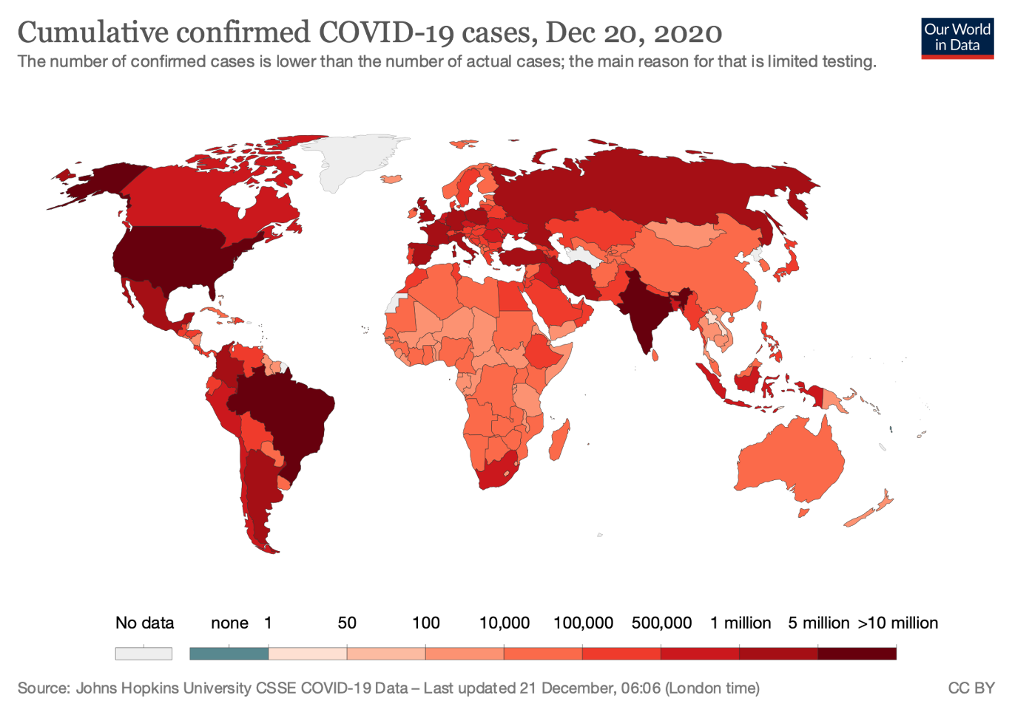

Note: The number of confirmed cases is lower than the number of actual cases; the main reason for that is limited testing.

Source: Created by the case authors using information obtained and reproduced under CC-BY licence from “Coronavirus Pandemic (COVID-19): Statistics and Research,” Our World in Data, accessed December 21, 2020, https://ourworldindata.org/covid-cases.

EXHIBIT 2: Weekly New COVID-19 CASES IN SELECTED AREAS,

DECEMBER 31, 2019–August 31, 2020

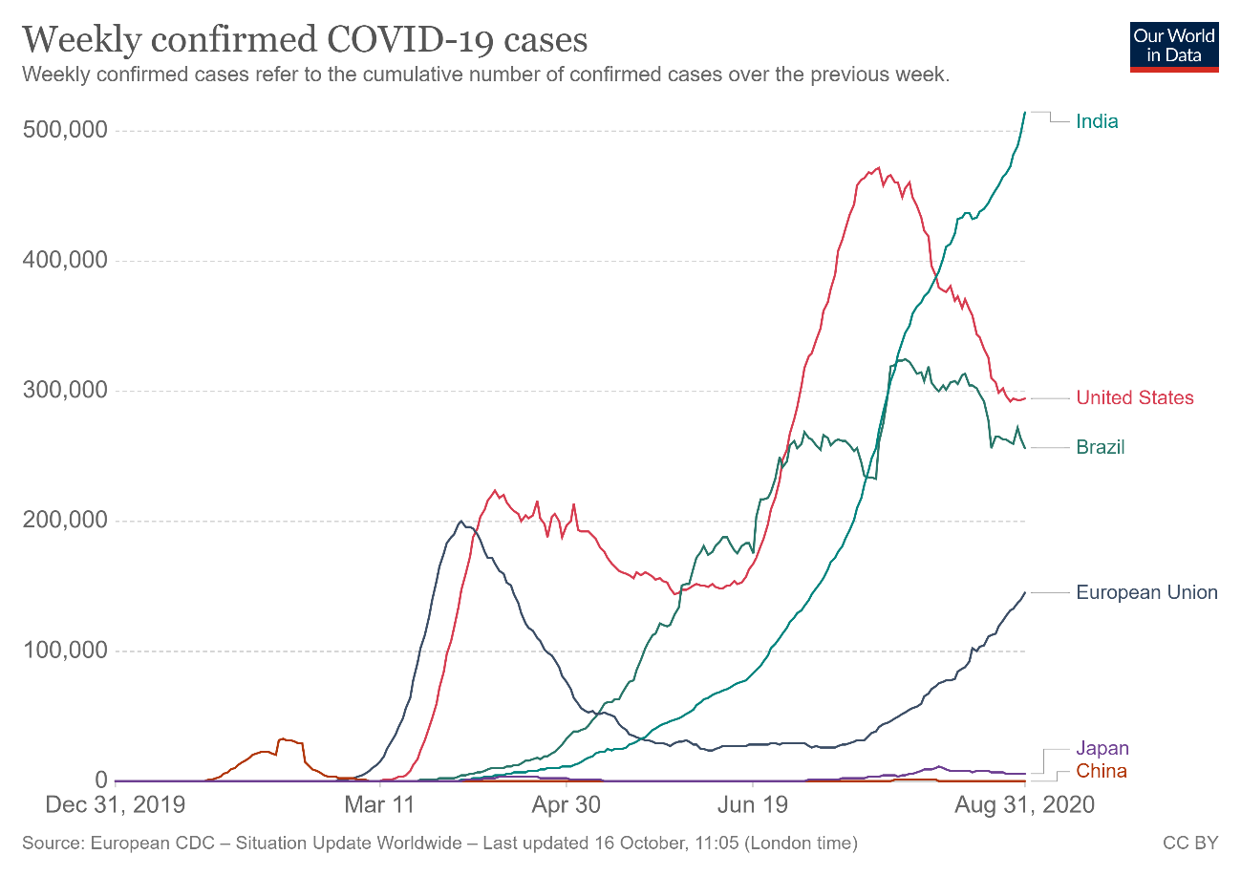

Note: Weekly confirmed COVID-19 cases referred to the cumulative number of confirmed cases over the previous week.

Source: Reproduced under CC-BY licence from “Coronavirus Pandemic (COVID-19): Statistics and Research,” Our World in Data, accessed October 16, 2020, https://ourworldindata.org/coronavirus; original data from European CDC—Situation Update Worldwide, last updated October 16, 2020, 11:05 GMT.

EXHIBIT 3: GOVERNMENT RESPONSE STRINGENCY INDEX as of JULY 31, 2020

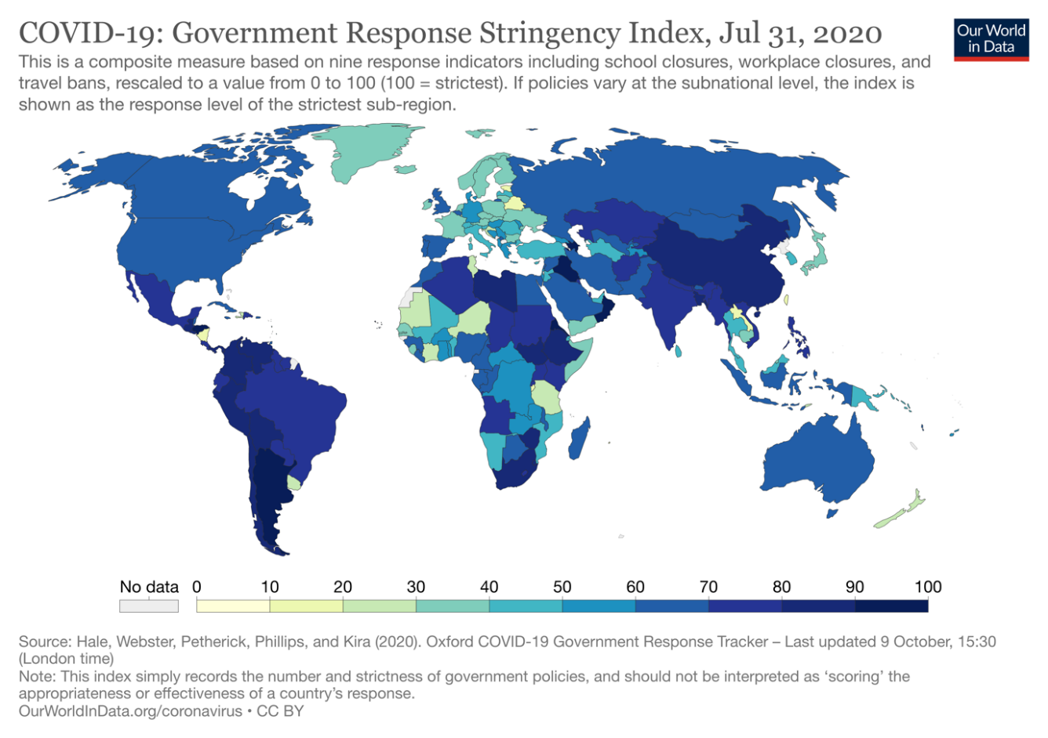

Note: This is a composite measure based on nine response indicators, including school closures, workplace closures, and travel bans, rescaled to a value from 0 to 100 (100 = strictest). If policies varied at the subnational level, the index was shown as the response level of the strictest sub-region. This index recorded the number and strictness of government policies and should not be interpreted as “scoring” the appropriateness or effectiveness of a country’s response.

Source: Reproduced under CC-BY licence from “Coronavirus Pandemic (COVID-19): Statistics and Research,” Our World in Data, accessed October 16, 2020, https://ourworldindata.org/coronavirus.

EXHIBIT 4: World Bank’s Gross Domestic Product GROWTH FORECASTS, JUNE 2020

|  |  |  |  |  |  |  |  |  |
| --- | --- | --- | --- | --- | --- | --- | --- | --- |
|  |  |  |  | **2017** | **2018** | **2019** | **2020 (F)** | **2021 (F)** |
| **World** | | | | 3.3 | 3.0 | 2.4 | −5.2 | 4.2 |
| **Advanced Economies** | | | | 2.5 | 2.1 | 1.6 | −7.0 | 3.9 |
|  |  | United States | | 2.4 | 2.9 | 2.3 | −6.1 | 4.0 |
|  |  | Euro Area | | 2.5 | 1.9 | 1.2 | −9.1 | 4.5 |
|  |  | Japan | | 2.2 | 0.3 | 0.7 | −6.1 | 2.5 |
| **Emerging Market and Developing Economies** | | | | 4.5 | 4.3 | 3.5 | −2.5 | 4.6 |
|  |  | China | | 6.8 | 6.6 | 6.1 | 1.0 | 6.9 |
|  |  | Vietnam | | 6.8 | 7.1 | 7.0 | 2.8 | 6.8 |
|  |  | Russia | | 1.8 | 2.5 | 1.3 | −6.0 | 2.7 |
|  |  | Brazil | | 1.3 | 1.3 | 1.1 | −8.0 | 2.2 |
|  |  | Mexico | | 2.1 | 2.2 | −0.3 | −7.5 | 3.0 |
|  |  | India | | 7.0 | 6.1 | 4.2 | −3.2 | 3.1 |
|  |  | South Africa | | 1.4 | 0.8 | 0.2 | −7.1 | 2.9 |

Note: (F) = forecast.

Source: Created by the authors using data extracted from World Bank, Global Economic Prospects (Washington, DC: World Bank, June 2020), 5, www.worldbank.org/en/publication/global-economic-prospects.

EXHIBIT 5: STAGES OF VACCINE DEVELOPMENT

Discovery Research & Preclinical Development

Before testing drugs on humans, scientists assessed the safety and immunogenicity of a target antigen or cell in a cell culture or in animal disease models to establish a safe starting dose for human clinical studies. This stage was often small scale and contained crude extracts or purchased antigens. When applying for authorization to conduct human clinical studies, companies needed to outline all critical manufacturing steps and analytical methods used to produce and release the product and placebo, including all reagents, components, specifications, and acceptable limits, to manufacture and release the product in a manner that ensured its quality and purity.

Clinical Development

*Phase 1*. The goal of phase 1 was to assess the safety of the candidate vaccine and to determine the type and extent of immune response that the vaccine provoked. The vaccine was tested on 20–100 healthy adult volunteers, preferably young people. All human clinical materials were recommended to be made under current good manufacturing practice guidelines. Complete process optimization was often deferred until after proof of concept in humans; however, all process changes needed to be qualified prior to advancing to the next clinical stage, and deferring development could delay the next stages or risk vaccine failure for unforeseen consequences of these changes.

*Phase 2*. The goal of phase 2 was to assess candidate vaccine safety, immunogenicity, dose response, schedule of immunizations, and method of delivery. The vaccine was tested on several hundred volunteers from different geographical areas and of different ages (and any other aspects that could have an impact on the development of the vaccine). Prior to initiating phase 2 studies, application processes should be finalized because significant changes at a later time risked having to redo phase 1 and phase 2 studies.

*Phase 3*. The goal of phase 3 was to assess the candidate vaccine in the target populations for safety and possible adverse events. At this stage, the vaccine was tested on thousands of volunteers. Vaccine efficacy was estimated, and vaccine manufacturing was confirmed. Concomitant testing with other prescribed vaccines was possibly required. All processes were finalized and validated at this stage. Analytical tests for manufacturing and release were completed and validated.

Regulatory Review and Approval

Companies needed to submit and gain approval for a biological product application, which was submitted to and approved by the corresponding medicines regulatory authorities (in the United States, the Food and Drug Administration; in Europe, the European Medicines Agency). Approval was granted when a vaccine’s benefits were deemed greater than its risks. To determine this, regulatory authorities conducted a comprehensive review of the manufacturing and analytical methods for licensed production, full shelf-life stability, process and facility validation, release validation testing, development of production, and release protocols.

Source: Stanley Plotkin, James M. Robinson, Gerard Cunningham, Robyn Iqbal, and Shannon Larsen, “The Complexity and Cost of Vaccine Manufacturing—An Overview,” *Vaccine* 35, no. 33 (2017): 4064–4071.

EXHIBIT 6: HIGHLIGHTS OF COVID-19 VACCINES IN PHASE 3, AS OF AUGUST 31, 2020

|  |  |  |
| --- | --- | --- |
| **Non-Replicating Viral Vector**  In principle, the common-cold virus—a particular kind of adenovirus called Ad5—was modified by tweaking its genetic properties to resemble the coronavirus. Weakened and unable to replicate, the Ad5 vector had the potential to trigger a cellular immune response in a safe and stable environment. This technology drew on experience with related coronaviruses such as severe acute respiratory syndrome (SARS) and Middle East respiratory syndrome (MERS). | | |
| **Research Partners** | **Funding** | **Progress** |
| University of Oxford (United Kingdom), AstraZeneca (United Kingdom) | $1.2 billion from the US government for 300 million doses; similar deals in the United Kingdom and the European Union | Evidence of antibodies against the coronavirus as well as other immune diseases |
| CanSino Biologics Inc. (China and Canada),* Beijing Institute of Biotechnology (China) | Supported by China’s Academy of Military Medical Sciences | Phase 3 reported to elicit strong immune response |
| Gamaleya Research Institute (Russia) | Financial details not disclosed | Russian government approved “conditional registration certificate” |
| **Inactivated Virus**  Inactivated virus was the most common method of vaccine development and had been used in the development of vaccines for measles, chicken pox, and influenza. The pathogen was attenuated by a protein-denaturation treatment to make the pathogen non-infectious. Once the vaccine was injected, the immune system could recognize the virus’s protein pattern and create antibodies. | | |
| **Research Partners** | **Funding** | **Progress** |
| Sinovac Biotech Ltd. (China) | $16 million in funding in Brazil (for 60 million doses); technology licensing deal in Indonesia (for 40 million doses) | Emergency approval in China in July 2020 for limited use |
| Wuhan Institute of Biological Products (China) | Internal funding of approximately $142 million to support R&D efforts | Phase 3 in the United Arab Emirates; phase 2 trials in Peru and Morocco |
| Beijing Institute of Biological Products, Sinopharm (China) | Financial details not disclosed (Sinopharm was a state-owned company) | Phase 3 trials in the United Arab Emirates and Argentina |
| **mRNA**  The mRNA platform was a novel technology that promised shorter time to market and broader applications. mRNA vaccines worked by telling cells to create the viral spike protein. While these proteins were solitary and could not combine to form the virus, they could elicit an immune system response once the body detected them. | | |
| **Research Partners** | **Funding** | **Progress** |
| Moderna, National Institutes of Health (United States) | R&D funding of nearly $1 billion from US government, plus a $1.5 billion contract for 100 million doses | Received fast-track designation from FDA on May 12, 2020 |
| BioNTech SE (Germany), Pfizer Inc. (United States) | $1.9 billion contract with the US government for 600 million doses of vaccine; agreement to supply 120 million doses to Japan | Phase 3 trials in the United States, Argentina, Brazil, and Germany |

Note: All dollar amounts are in US dollars; FDA = US Food and Drug Administration; mRNA = messenger ribonucleic acid; R&D = research and development; Sinopharm = Sinopharm Group Co. Ltd.; *Canada pulled out of the CanSino project in August 2020.

EXHIBIT 6 CONTINUED

Sources: Fraser Kansteiner, “AstraZeneca Nets $396M Down Payment from EU for 300M-Plus COVID Vaccines,” FiercePharma, August 28, 2020, www.fiercepharma.com/manufacturing/az-nets-396m-downpayment-for-300m-plus-eu-vaccine-doses; Pedro M. Folegatti et al., “Safety and Immunogenicity of the ChAdOx1 nCoV-19 Vaccine against SARS-CoV-2: A Preliminary Report of a Phase 1/2, Single-Blind, Randomised Controlled Trial,” *Lancet* 396, no. 10249 (2020): 467–478; Feng-Cai Zhu et al., “Immunogenicity and Safety of a Recombinant Adenovirus Type-5-Vectored COVID-19 Vaccine in Healthy Adults Aged 18 Years or Older: A Randomised, Double-Blind, Placebo-Controlled, Phase 2 Trial,” *Lancet* 396, no. 10249 (2020): 479–488; Patrick Reevell and Sony Salzman, “Russia Announces Expanded Trials for Coronavirus Vaccine Approved 10 Days Ago,” ABC News, August 20, 2020, https://abcnews.go.com/International/russia-announces-expanded-trials-coronavirus-vaccine-approved-10/story?id=72497297; Lisandra Paraguassu, Pedro Fonseca, and Eduardo Simões, “Brazil, Hotbed for COVID-19 Vaccine Testing, May Struggle to Produce Its Own,” Reuters, August 4, 2020, www.reuters.com/article/us-health-coronavirus-brazil-vaccine-ana/brazil-hotbed-for-covid-19-vaccine-testing-may-struggle-to-produce-its-own-idUSKCN25028L; “Sinovac Signs Agreement with Bio Farma Indonesia for COVID-19 Vaccine Cooperation,” Business Wire, August 25, 2020, www.businesswire.com/news/home/20200825005451/en/Sinovac-Signs-Agreement-Bio-Farma-Indonesia-COVID-19; “Sinovac’s COVID-19 Vaccine Gets Emergency Use Approval in China,” Pharmaceutical Technology, August 31, 2020, www.pharmaceutical-technology.com/news/sinovac-vaccine-emergency-use; “Sinopharm Group (China National Biotech Group, Beijing Institute of Biological Products) and Chinese Center for Disease Control and Prevention,” *Genetic Engineering & Biotechnology News*, May 18, 2020, www.genengnews.com/covid-19-candidates/sinopharm-group-china-national-biotech-group-beijing-institute-of-biological-products-and-chinese-center-for-disease-control-and-prevention; “China’s Sinopharm Launches Phase III Trial of COVID-19 Vaccine in UAE,” Clinical Trials, July 17, 2020, www.clinicaltrialsarena.com/news/sinopharm-covid-vaccine-uae-trial; “Peru, Morocco to Test China Sinopharm’s COVID-19 Vaccine in Phase 3 Trial,” Reuters, August 20, 2020, www.reuters.com/article/us-health-coronavirus-vaccine-sinopharm/peru-morocco-to-test-china-sinopharms-covid-19-vaccine-in-phase-3-trial-idUSKCN25G0G9; Eric Sagonowsky, “After Nearly $1B in Research Funding, Moderna Takes $1.5B Coronavirus Vaccine Order from U.S.,” Fierce Pharma, August 12, 2020, www.fiercepharma.com/pharma/after-nearly-1b-research-funding-moderna-takes-1-5b-coronavirus-vaccine-order-from-u-s; Moderna, “Moderna Receives FDA Fast Track Designation for mRNA Vaccine (mRNA-1273) against Novel Coronavirus,” press release, May 12, 2020, https://investors.modernatx.com/news-releases/news-release-details/moderna-receives-fda-fast-track-designation-mrna-vaccine-mrna; Noah Weiland, Denise Grady, and David E. Sanger, “Pfizer Gets $1.95 Billion to Produce Coronavirus Vaccine by Year’s End,” *New York Times*, July 22, 2020, www.nytimes.com/2020/07/22/us/politics/pfizer-coronavirus-vaccine.html; Pfizer Inc. and BioNTech SE, “Pfizer and BioNTech to Supply Japan with 120 Million Doses of Their BNT162 mRNA-Based Vaccine Candidate,” press release, July 31, 2020, www.pfizer.com/news/press-release/press-release-detail/pfizer-and-biontech-supply-japan-120-million-doses-their; Nathan Vanderklippe and Ivan Semeniuk, “CanSino Blames Chinese Officials for Abandonment of Joint Vaccine Program with Canada,” *Globe and Mail*, August 25, 2020, www.theglobeandmail.com/world/article-cansino-blames-chinese-officials-for-abandonment-of-joint-vaccine.

ENDNOTES

1. This case has been written on the basis of published sources only. Consequently, the interpretation and perspectives presented in this case are not necessarily those of the World Health Organization or any of its employees.
2. Carl Zimmer, Jonathan Corum, and Sui-Lee Wee, “Coronavirus Vaccine Tracker,” *New York Times*, updated December 18, 2020, www.nytimes.com/interactive/2020/science/coronavirus-vaccine-tracker.html.
3. Committee on Economic, Social and Cultural Rights, *Statement on the Coronavirus Disease (COVID-19) Pandemic and Economic, Social and Cultural Rights* (United Nations Economic and Social Council, April 17, 2020), 5.
4. Janet Spitz and Mark Wickham, “Pharmaceutical High Profits: The Value of R&D, or Oligopolistic Rents?,” *American Journal of Economics and Sociology* 71, no. 1 (2012): 1–36.
5. Laura Entis, “Why Does Medicine Cost So Much? Here’s How Drug Prices Are Set,” *Time*, April 9, 2019, https://time.com/5564547/drug-prices-medicine.
6. “COVID- 19 Technology Access Pool,” World Health Organization, accessed January 18, 2021, www.who.int/emergencies/diseases/novel-coronavirus-2019/global-research-on-novel-coronavirus-2019-ncov/covid-19-technology-access-pool.
7. Ed Silverman, “Pharma Leaders Shoot Down WHO Voluntary Pool for Patent Rights on COVID-19 Products,” STAT, May 28, 2020, www.statnews.com/pharmalot/2020/05/28/who-voluntary-pool-patents-pfizer.
8. Ma Xiaohua, “China Virus: A 20-Day Special Review,” Yicai Global, January 22, 2020, www.yicaiglobal.com/news/china-virus-a-20-day-special-review; and World Health Organization “Pneumonia of Unknown Cause—China,” public bulletin, January 5, 2020, www.who.int/csr/don/05-january-2020-pneumonia-of-unkown-cause-china/en.
9. Xueguang Zhou, “Organizational Response to COVID-19 Crisis: Reflections on the Chinese Bureaucracy and Its Resilience,” *Management and Organization Review* 16, special issue 3 (2020): 473–484.
10. World Health Organization, “Pneumonia of Unknown Cause.”
11. Yue Qian and Amy Hanser, “How Did Wuhan Residents Cope with a 76-Day Lockdown?,” *Chinese Sociological Review* (2020), https://doi.org/10.1080/21620555.2020.1820319.
12. Derrick Bryson Taylor, “A Timeline of the Coronavirus Pandemic,” *New York Times*, August 6, 2020, www.nytimes.com/article/coronavirus-timeline.html.
13. Tedros Adhanom Ghebreyesus, “WHO Director-General’s Opening Remarks at the Media Briefing on COVID-19—3 March 2020,” World Health Organization, March 3, 2020, www.who.int/director-general/speeches/detail/who-director-general-s-opening-remarks-at-the-media-briefing-on-covid-19---3-march-2020.
14. Roberto Rocha, “What Countries Did Right and Wrong in Responding to the Pandemic,” CBC News, June 22, 2020, www.cbc.ca/news/canada/covid-19-coronavirus-pandemic-countries-response-1.5617898.
15. Helen Branswell and Andrew Joseph, “WHO Declares the Coronavirus Outbreak a Pandemic,” STAT, March 11, 2020, www.statnews.com/2020/03/11/who-declares-the-coronavirus-outbreak-a-pandemic.
16. World Bank, “Pandemic, Recession: The Global Economy in Crisis,” ch. 1 in *Global Economic Prospects* (Washington, DC: International Bank for Reconstruction and Development/The World Bank, June 2020), 5.
17. Roxanne Khamsi, “Here’s How We’ll Know When a COVID-19 Vaccine Is Ready,” *National Geographic*, June 30, 2020, www.nationalgeographic.com/science/2020/06/how-we-will-know-when-coronavirus-vaccine-is-ready-cvd.
18. Stanley Plotkin et al., “The Complexity and Cost of Vaccine Manufacturing—An Overview,” *Vaccine* 35, no. 33 (2017): 4064–4071.
19. Carl Zimmer, Jonathan Corum, and Sui-Lee Wee, “Coronavirus Vaccine Tracker,” op. cit.
20. World Health Organization, *Draft Landscape of COVID-19 Candidate Vaccines*, December 2, 2020, www.who.int/publications/m/item/draft-landscape-of-covid-19-candidate-vaccines; and Ewen Callaway, “Coronavirus Vaccines Leap through Safety Trials—but Which Will Work Is Anybody’s Guess,” *Nature*, July 21, 2020, www.nature.com/articles/d41586-020-02174-y.
21. All dollar amounts are in US dollars unless otherwise specified.
22. Francesco Guarascio, “EU Pays €336-Million to Secure AstraZeneca’s Potential COVID-19 Vaccine,” *Globe and Mail*, August 27, 2020, www.theglobeandmail.com/business/international-business/european-business/article-eu-signs-contract-with-astrazeneca-on-supply-of-potential-covid-1.
23. Lisandra Paraguassu, Pedro Fonseca, and Eduardo Simões, “Brazil, Hotbed for COVID-19 Vaccine Testing, May Struggle to Produce Its Own,” Reuters, August 4, 2020, www.reuters.com/article/us-health-coronavirus-brazil-vaccine-ana/brazil-hotbed-for-covid-19-vaccine-testing-may-struggle-to-produce-its-own-idUSKCN25028L.
24. Sinovac Biotech Ltd., “Sinovac Signs Agreement with Bio Farma Indonesia for COVID-19 Vaccine Cooperation,” press release, Business Wire, August 25, 2020, www.businesswire.com/news/home/20200825005451/en/Sinovac-Signs-Agreement-Bio-Farma-Indonesia-COVID-19.
25. Chao Deng, “China Injects Hundreds of Thousands with Experimental COVID-19 Vaccines,” *Wall Street Journal*, September 12, 2020, www.wsj.com/articles/china-injects-hundreds-of-thousands-with-experimental-covid-19-vaccines-11599834029.
26. Nsikan Akpan, “Moderna’s mRNA Vaccine Reaches Its Final Phase. Here’s How It Works,” *National Geographic*, July 27, 2020, www.nationalgeographic.com/science/2020/05/moderna-coronavirus-vaccine-how-it-works-cvd.
27. Noah Weiland, Denise Grady, and David E. Sanger, “Pfizer Gets $1.95 Billion to Produce Coronavirus Vaccine by Year’s End,” *New York Times*, July 22, 2020, www.nytimes.com/2020/07/22/us/politics/pfizer-coronavirus-vaccine.html.
28. Josephine Ma, “Hopes for a Covid-19 Vaccine in Early 2021, but That’s Only the Start of the Story, Experts Say,” *South China Morning Post*, August 10, 2020, www.scmp.com/news/china/science/article/3096643/coronavirus-hopes-high-covid-19-vaccine-early-2021-thats-only.
29. Suma Athreye, Lucia Piscitello, and Kenneth C. Shadlen, “Twenty-Five Years since TRIPS: Patent Policy and International Business,” *Journal of International Business Policy*, 3, no. 3 (2020): 315–328.
30. Athreye, Piscitello, and Shadlen, “Twenty-Five Years.”
31. Janet Spitz and Mark Wickham, “Pharmaceutical High Profits: The Value of R&D, or Oligopolistic Rents?,” op. cit.
32. Fred D. Ledley, et al., “Profitability of Large Pharmaceutical Companies Compared with Other Large Public Companies,” *Journal of the American Medical Association* 323, no. 9 (2020): 834–843.
33. Laura Entis, “Why Does Medicine Cost So Much? Here’s How Drug Prices Are Set,” op. cit.
34. Ellen 't Hoen, “Strong Call for Transparency on Medicine Prices, Cost of R&D at WHO Fair Pricing Forum,” *Medicines Law & Policy*, April 19, 2019, https://medicineslawandpolicy.org/2019/04/strong-call-for-transparency-on-medicine-prices-cost-of-rd-at-who-fair-pricing-forum.
35. Athreye, Piscitello, and Shadlen, “Twenty-Five Years.”
36. Eduardo Urias and Shyama V. Ramani, “Access to Medicines after TRIPS: Is Compulsory Licensing an Effective Mechanism to Lower Drug Prices? A Review of the Existing Evidence,” *Journal of International Business Policy* 3, no. 3 (2020): 367–384.
37. John H. Barton, “TRIPS and the Global Pharmaceutical Market,” *Health Affairs* 23, no. 3 (May/June 2004): 146–154.
38. Gillian Rutherford, “Multiple Factors Will Influence Pricing for COVID-19 Vaccine in Canada, Says Health Economist,” Medical Xpress, September 3, 2020, https://medicalxpress.com/news/2020-09-multiple-factors-pricing-covid-vaccine.html.
39. Andrea N. Polonijo, “How California’s COVID-19 Surge Widens Health Inequalities for Black, Latino and Low-Income Residents,” The Conversation, July 30, 2020, https://theconversation.com/how-californias-covid-19-surge-widens-health-inequalities-for-black-latino-and-low-income-residents-143243.
40. Sarah Boseley, “US Secures World Stock of Key COVID-19 Drug Remdesivir,” *Guardian*, June 30, 2020, www.theguardian.com/us-news/2020/jun/30/us-buys-up-world-stock-of-key-covid-19-drug. Scientific evidence about the benefits of remdesivir was not available at the time the deal was struck, with some studies finding no beneficial effects.
41. Committee on Economic, Social and Cultural Rights, op. cit.
42. Devon E. McMahon et al., “Global Resource Shortages during COVID-19: Bad News for Low-Income Countries,” *PLOS Neglected Tropical Diseases* 14, no. 7 (2020): e0008412, https://doi.org/10.1371/journal.pntd.0008412.
43. International Committee of the Red Cross, “Uniting for a People’s Vaccine against COVID-19,” news release, June 3, 2020, www.icrc.org/en/document/uniting-peoples-vaccine-against-covid-19.
44. Nuala Moran, “WHO Launches COVID-19 Patent Pool, Backed by 35+ Countries,” BioWorld, May 29, 2020, www.bioworld.com/articles/435437-who-launches-covid-19-patent-pool-backed-by-35-countries.
45. “Take Action Now,” World Health Organization, accessed August 20, 2020, www.who.int/emergencies/diseases/novel-coronavirus-2019/global-research-on-novel-coronavirus-2019-ncov/covid-19-technology-access-pool/take-action-now.
46. World Health Organization, “International Community Rallies to Support Open Research and Science to Fight COVID-19,” news release, May 29, 2020, www.who.int/news/item/29-05-2020-international-community-rallies-to-support-open-research-and-science-to-fight-covid-19.
47. World Health Organization, “International Community Rallies.”
48. “Endorsements of the Solidarity Call to Action,” World Health Organization, accessed September 10, 2020, www.who.int/emergencies/diseases/novel-coronavirus-2019/global-research-on-novel-coronavirus-2019-ncov/covid-19-technology-access-pool/endorsements-of-the-solidarity-call-to-action.
49. Jason Hoffman and Maegan Vazquez, “Trump Announces End of US Relationship with World Health Organization,” CNN, May 29, 2020, www.cnn.com/2020/05/29/politics/donald-trump-world-health-organization/index.html.
50. Ed Silverman, “Pharma Leaders Shoot Down WHO Voluntary Pool for Patent Rights on COVID-19 Products,” op. cit.
51. Silverman, “Pharma Leaders.”
52. Abi Millar, “Intellectual Property in the Time of COVID-19,” *Pharma Technology Focus* 96 (July 2020), https://pharma.nridigital.com/pharma_jul20/intellectual_property_covid-19.
53. Steve Brachmann, “WHO’s C-TAP Initiative Pushes for Non-Exclusive Global Licensing amid Pharma Industry Concerns,” IP Watchdog, May 31, 2020, www.ipwatchdog.com/2020/05/31/whos-c-tap-initiative-pushes-non-exclusive-global-licensing-amid-pharmaceutical-industry-concerns/id=122041.
54. John Miller, “Novartis to Provide ‘No Profit’ COVID-19 Drugs to Low Income Countries,” *National Post*, July 16, 2020, https://financialpost.com/pmn/business-pmn/novartis-to-provide-no-profit-covid-19-drugs-to-low-income-countries-2.
55. Callum Keown, “Sanofi COVID-19 Vaccine to Cost below €10 and Drug Ingredients IPO Planned within Months, Its France Chief Says,” MarketWatch, September 8, 2020, www.marketwatch.com/story/sanofi-covid-19-vaccine-to-cost-below-10-and-drug-ingredients-ipo-planned-within-months-its-france-chief-says-11599486409.
56. Jared S. Hopkins and Peter Loftus, “Pharma Companies Split on Coronavirus Vaccine Pricing Plans,” *Wall Street Journal*, July 21, 2020, www.wsj.com/articles/pharma-companies-split-on-coronavirus-vaccine-pricing-plans-11595367562.
57. “About Us,” Medicines Patent Pool, accessed September 23, 2020, https://medicinespatentpool.org/who-we-are/about-us.
58. Gavi, World Health Organization, and Coalition for Epidemic Preparedness Innovations, “Boost for Global Response to COVID-19 as Economies Worldwide Formally Sign Up to COVAX Facility,” press release, September 23, 2020, www.gavi.org/news/media-room/boost-global-response-covid-19-economies-worldwide-formally-sign-covax-facility.
59. Seth Berkley, “COVAX Explained,” Gavi, September 3, 2020, www.gavi.org/vaccineswork/covax-explained.
60. Berkley, “COVAX Explained.”
61. Gavi, *The Gavi Covax AMC: An Investment Opportunity*, accessed September 30, 2020, www.gavi.org/sites/default/files/2020-06/Gavi-COVAX-AMC-IO.pdf.
62. Gavi, “Gavi Launches Innovative Financing Mechanism for Access to COVID-19 Vaccines,” press release, June 4, 2020, www.gavi.org/news/media-room/gavi-launches-innovative-financing-mechanism-access-covid-19-vaccines.
63. “Collection of Statements, News, and Other Documents Showing Some Examples of Our Members’ Work Related to the Current COVID-19 Pandemic,” VOICE, accessed September 30, 2020, https://voiceeu.org/ngo-members-response-to-the-covid-19-pandemic.
64. Hilde Steven, “Intellectual Property Policies in Early-Phase Research in Public-Private Partnerships,” *Nature Biotechnology* 34, no. 5 (2016): 504–506.
65. “Funding the Response to COVID- 19,” Devex, accessed November 18, 2020, https://public.tableau.com/views/COVIDFundingvisualisation/COVID-19funding.
66. Moran, “WHO Launches COVID-19 Patent Pool.”
67. “Gallup Poll Social Series: Work and Education,” Gallup News Service, accessed August 14, 2020, https://news.gallup.com/poll/266060/big-pharma-sinks-bottom-industry-rankings.aspx.
68. “Pay for Delay,” Federal Trade Commission, accessed October 18, 2020, www.ftc.gov/news-events/media-resources/mergers-competition/pay-delay.
69. Allie Nawrat, “From Evergreening to Thicketing: Exploring Manipulation of the Pharma Patent System*,” Pharma Technology Focus*, no. 88 (November 2019), https://pharma.nridigital.com/pharma_nov19/from_evergreening_to_thicketing_exploring_manipulation_of_the_pharma_patent_sys.