

9B21M015

SCENIC FLORAL InC.: GROWING A START-UP

Susan J. Van Weelden, Laurie George Busuttil, and Emma Vander Ploeg wrote this case solely to provide material for class discussion. The authors do not intend to illustrate either effective or ineffective handling of a managerial situation. The authors may have disguised certain names and other identifying information to protect confidentiality.

This publication may not be transmitted, photocopied, digitized, or otherwise reproduced in any form or by any means without the permission of the copyright holder. Reproduction of this material is not covered under authorization by any reproduction rights organization. To order copies or request permission to reproduce materials, contact Ivey Publishing, Ivey Business School, Western University, London, Ontario, Canada, N6G 0N1; (t) 519.661.3208; (e) cases@ivey.ca; www.iveycases.com. Our goal is to publish materials of the highest quality; submit any errata to publishcases@ivey.ca. i1v2e5y5pubs

Copyright © 2021, Ivey Business School Foundation Version: 2021-02-17

It was May 22, 2020, and Ben Van Weelden, manager of Scenic Floral Inc. (Scenic), located in Beamsville, Ontario, had just finished reviewing the company’s Mother’s Day results. Sales for Mother’s Day, typically one of the busiest days in the floral industry, had started out very slowly that year as the floral industry—similar to all other industries in Canada and worldwide—began to find its way out of the difficulty caused by the coronavirus (COVID-19) pandemic. Fortunately, there had been a flurry of last-minute orders from Scenic’s two largest customers, and sales for the holiday had been strong overall. Van Weelden turned his attention to issues he had put to the side after opening a new processing facility in February 2020. There were multiple potential directions for growth, including expanding the product line, expanding retail sales, performing processing services, serving as a sub-supplier, exporting to the United States, and venturing into e-commerce. With so many opportunities available to the company, it was important to strike a careful balance between focusing on Scenic’s main existing customers and planning for future growth.

COMPANY BACKGROUND

Scenic Bouquet Company Inc. was incorporated in January 2018 with four shareholders, namely Ben Van Weelden (Van Weelden); Joel Van Weelden (Van Weelden Sr.); Hendrik Reinink, a business associate of Van Weelden Sr.; and a cousin. Van Weelden, who had spent four years working for a floral farm in Colombia, spoke Spanish fluently and had good relationships with both Colombian farms and Canadian retailers. Van Weelden Sr. and Reinink brought decades of sales experience to the company as well as crucial connections with retailers, including Metro Inc. (Metro).

In June 2019, Petals West Inc. (Petals) purchased a significant interest in Scenic Bouquet Company Inc., thereby providing an injection of cash, machinery, and experience. Petals was a floral wholesaler headquartered in Winnipeg with four locations in Western Canada. For Petals, whose major customer was Loblaw Companies Limited (Loblaw),[1] the purchase of an interest in Scenic Bouquet Company Inc. was intended to help the company achieve its goal of expanding into Ontario. Petals was to operate in Ontario under the “Fresh Market” banner and pursue Loblaw stores in the province, while Scenic Bouquet Company Inc. was to continue selling to Metro. Petals would also pass on flower-processing contracts to Scenic Bouquet Company Inc.. Combining Petals’ purchasing volume with that of Scenic Bouquet Company Inc. would also enable the latter company to benefit from lower airline shipping rates.

After a successful 2019, during which Van Weelden secured most of Scenic Bouquet Company Inc.’s business from Metro and Food Basics,[2] the company moved into a 557-square-metre rented facility in Beamsville, Ontario, in February 2020. The on-site cooler ensured that cut flowers imported from Colombia would be fresh when they were shipped to grocery stores. The facility also provided the flexibility to process additional flowers in anticipation of growing the business. Moreover, the company name was changed to Scenic Floral Inc. to reflect an expanded product line.

INDUSTRY ENVIRONMENT

The Canadian Floral Industry

The Canadian floral industry was divided into two main segments. The first segment consisted of flower and nursery wholesale and involved all the buying and redistributing of both cut flowers and potted plants. In 2019, this was a $1 billion industry,[3] distributed over roughly 400 companies, none of which held more than five per cent of the market. The second segment consisted of plant and flower growing, which involved either growing or buying and treating plants and flowers prior to resale. In 2019, this was a $2 billion industry that involved roughly 1,600 companies, none of which held more than five per cent of the market.[4]

In 2019, the largest distributor of flowers and plants in Canada was the mass market and chain store sector, which distributed 27.4 per cent of all sales and resales, followed by domestic wholesalers at 20.3 per cent, direct-to-consumer sales at 14.0 per cent, retail florists at 11.3 per cent, and other greenhouses at 11.1 per cent. Export sales represented 13.4 per cent of all sales (see Exhibit 1).[5]

While wholesalers obtained flowers from both Canadian and foreign growers, some growers also sold directly to mass market and chain stores or to florists. In addition, wholesalers and growers sometimes sold directly to the end consumer. Thus, some of the 1,591 Canadian greenhouse operations that specialized in flowers and plants in 2019[6] competed against the wholesalers.

Overall, Canadian sales and resales of greenhouse flowers and plants (potted plants, cuttings, cut flowers, and ornamental bedding plants) grew from $1,506 million in 2014 to $1,565.8 million in 2019. From those figures, flower and plant resales shifted from $220.8 million in 2015 down to $169.4 million in 2019.[7] This suggested that more growers were selling on a direct-to-consumer basis.

Potted plants accounted for over 68.0 per cent of greenhouse flower and plant sales in 2019, while cut flowers accounted for 10.7 per cent. Sales of cut flowers had fallen from a 10-year high of $150.1 million in 2014 to a low of $127.8 million in 2017. Yet they rebounded to reach $133.5 million in 2019. The trends in Ontario, which typically represented the market for two-thirds of Canada’s cut flower sales, were similar, although the growth rates there were higher in 2018 and 2019 than they were nationally (see Exhibit 2). Except for 2017, sales of potted plants had grown steadily from a 10-year low of $653.4 million in 2012 to a high of $853.0 million in 2019. The trends in Ontario, which represented around half of Canada’s potted plant sales, were similar, although Ontario again experienced higher growth rates in 2018 and 2019 (see Exhibit 3).[8]

Imports

Although plant and flower growing remained a significant industry in Canada, both the number of Canadian and Ontario-based floriculture greenhouse operations and their areas had been declining since 2011. The number of floriculture operations in Ontario had declined from 820 in 2011 to 550 in 2019 (see Exhibit 4), while the total greenhouse area had declined from over 3.93 million square metres in 2011 to 3.48 million square metres in 2019.[9]

Increasingly, Canadian flower growers were losing ground to cheaper imports from countries with climates suitable for growing flowers outdoors rather than in greenhouses. From early 2000 to the present day, the cut flower sector had found it “extremely difficult to compete with cheaper imported ‘bread and butter’ cut flowers (rose, carnation, chrysanthemum, alstroemeria) from South America and Africa for use in mass market mixed flower bouquets and florists’ arrangements.”[10] Many Canadian growers, especially those with older and less efficient greenhouses, were forced to leave the industry due to their inability to compete with the price and perceived higher quality of South American flowers. By 2012, only a small group of Southern Ontario–based growers remained, each specializing in just one or two crops, and exports were critical to the viability of large wholesale growers located in Niagara and surrounding regions.[11] While this trend toward grower consolidation meant the closure of some long-standing Southern Ontario-based greenhouse operations, it created certain opportunities, such as that being pursued by Scenic: importing flowers from South America for the mass market.

Imports of cut flowers and flower buds for bouquets or ornamental purposes were worth $170 million in 2018, up from $156 million in 2014. This compared to exports amounting to $80 million and $51 million in 2018 and 2014, respectively. Over the same five-year period, the trade balance changed from a net import position of $105 million in 2014 to $90 million in 2018.[12]

In terms of the broader floriculture and nursery industry, the United States was the most important import source, being responsible for 47.8 per cent of all imports, followed by Colombia with 20.4 per cent (see Exhibit 5).[13] Some imports, including the flowers that Scenic imported from Colombia, received further processing in Canada prior to being sold to mass markets or florists.

END-CUSTOMER Market

Cut flowers and flowering potted plants were generally purchased by consumers using their discretionary income. This prompted Flowers Canada to note that it was important to communicate the benefits of flowers and plants at the point of sale. These benefits included improved mental health (e.g., they made people happier), purified air, and enhanced decor. The biggest barriers to purchasing flowers were cost and the perception that “they don’t last.” The barriers to owning house plants included a lack of knowledge about their care, the need for light, and the perception that “no matter what I do, they seem to die.”[14]

A Flowers Canada study sampled 400 millennial women (aged 25 to 35), 100 post-millennial women (aged 35 to 55), 100 millennial men, and 100 post-millennial men. Across all of the groups, 68 to 77 per cent of respondents reported buying a houseplant as a gift, while 73 to 83 per cent reported buying flowers as a gift. The millennial men were the least likely to have purchased such items as gifts, while the post-millennial women were the most likely.[15]A gift of flowers was reported to be the second most appreciated gift, with wine being the most appreciated. Other gifts, such as wine, gift cards, chocolates, and beer, were perceived to be easier to give because they could be purchased in advance.[16] Plants or flowers were typically given as gifts at housewarmings (most popular for plants), birthdays (most popular for flowers), anniversaries, and dinner parties; to sick or hospitalized family or friends; and at funerals.[17]

The frequency of purchasing houseplants at least once every three months varied, from a low of 8 per cent for post-millennial women to a high of 17 per cent for millennial women. There was more variation across the four groups with regard to purchasing flowers for themselves. Post-millennial women led the way: 74 per cent of them reported purchasing flowers for themselves, compared to 25 per cent of millennial men.[18]

The respondents were all apt to spend more on flowers they purchased as gifts than on those they purchased for themselves. For themselves, the most common price point was $10.00 to $19.99 for all four groups. For someone else, the most common price point was $20.00 to $29.99 for all groups except for the millennial women (for whom it was $10.00 to $19.99). A significant proportion of all groups (11 to 19 per cent) were willing to spend from $30.00 to $30.99.[19]

The women who purchased flowers usually bought them from grocery stores, while the men usually bought them in person from florists. Online purchasing from a florist was the third most common means of purchase for all but the post-millennial men, who were more likely to call a florist than to purchase online.[20]

Winsight Grocery Business reported that cut flowers (arrangements, bouquets, fresh-cut flowers, and roses) accounted for 54 per cent of grocery store floral department sales in the United States in 2018. Potted plants and outdoor plants accounted for 18 per cent and 19 per cent, respectively, with the balance of sales stemming from other products.[21] Van Weelden Sr. estimated that cut flowers made up as much as two-thirds of all grocery store floral department sales in Canada.

Mass market chains in both Canada and the United States had changed their purchasing patterns to reflect consumer purchasing trends. They focused on key holiday sales (Easter, Mother’s Day, Memorial Day, Thanksgiving, and Christmas) and the spring market, as many chains experienced high levels of product loss (“poor sell through”) throughout the rest of the year.[22] For both holiday sales and regular sales, Van Weelden found that being featured in grocery store flyers had a significant effect on final sales and the demand for bouquets.

SCENIC FLORAL INC.

Business Model and Basic Operations

Scenic imported cut flowers and sold them to grocery stores in Canada. The flowers arrived in flat “drypacks” (i.e., without water). They were unpacked and sorted into the colour assortments required to fill orders. Next, they were cut using one of two cutting machines and then placed into pails of water that included floral solution. The number of bouquets per pail varied from, for example, eight of the popular “10-day bouquets” to 15 bunches of carnations. The pails, or “wetpacks,” were taken on a cart to the packing line (see Exhibit 6), where the pails were sleeved and placed into boxes that were labelled and placed on pallets. The pallets were loaded onto refrigerated trucks for transport to their final destination.

Initially, Scenic offered only mixed bouquets and mini-arrangements sourced from the farm that Van Weelden had worked for in Colombia. Scenic’s unique value proposition was that sourcing flowers from Colombia enabled the company to assemble distinct bouquets and mini-arrangements for Canadian grocery stores and other retailers. Scenic relied heavily on Van Weelden’s fluency in Spanish as well as his direct relationships with the farm in Colombia. Van Weelden had a creative bent, and he had secured much of his business by designing specialty arrangements for traditional holidays, other special occasions (e.g., St. Patrick’s Day, Canada Day, and Thanksgiving), and feature items in weekly flyers. Whereas competitors relied on catalogues, Van Weelden created live samples so that store buyers could see what their customers would actually be getting for their money.

Prior to the COVID-19 pandemic, Van Weelden had been selling over 500 cases of cut flowers each week to Metro and Food Basics, with the majority going to Metro. In fact, the volume was frequently in the 600 to 700 range. Scenic’s average price per case was approximately $60. Metro and Food Basics each had their own procurement team. Metro had a full floral program with in-store staff who merchandised the products and upgraded them by making their own arrangements. Food Basics offered a very limited product line geared toward the $5 to $8 price range, although there were occasional opportunities for higher retail prices, such as $12 or $15 for special promotions.

Over time, Scenic had broadened its suppliers from one farm in Colombia to four farms. It had increased its product line from two items to a dozen items, adding chrysanthemums bouquets, alstroemeria, carnations and mini-carnations, and other flowers. It had retained an emphasis on the mass market model, focusing its efforts on Metro and Food Basics. Selling to the mass market enabled Scenic to obtain high volumes, which were associated with favourable payment terms and few collection issues. (Scenic’s comparative statement of income for 2018 and 2019 can be seen in Exhibit 7.) Dollar-wise, Scenic had been on target to achieve $2.7 million in sales in 2020. Even with the interruption caused by COVID-19, the company was projected to reach $1.9 million in sales in 2020. In contrast, selling to retail florists, as Van Weelden Sr. had done for many years, would have required selling to 50 or more customers to achieve the same volume, and it would also have entailed much higher labour costs as well as the risk of collection difficulties.

Scenic had started processing 300 cases of roses per week for another farm in Colombia. The company earned $9 to $10 per case to take in the product, chop it, put it in pails of water, box it, and deliver it to Metro’s warehouse. Scenic used the same freight company to deliver its own products, which helped to pay for the fixed trucking fees. The volume rose to 500 to 1,000 cases per week when Metro ran promotions.

THE OPPORTUNITIES

Scenic was considering multiple ways to grow its business.

Grow the Core Cut Flower Business with Existing Customers

Scenic could have opted to focus on increasing sales to its two main customers by working closely with them and continuing to expand its product lines. For several months, the COVID-19 pandemic had made it difficult to obtain both warehouse space and meetings with buyers. However, as the economy opened up, Van Weelden’s established relationships would present opportunities to suggest additional product offerings.

Product-line expansion involved importing a more varied and larger quantity of flowers. Despite most Colombian cut flower exporters being limited to a single flower type or variety—mostly roses, carnations, and chrysanthemums—there were myriad less common cut flowers that Scenic could procure if it expanded its Colombian supply network. Scenic could also source flowers, such as kalanchoes, from local growers in the Niagara Peninsula. Together, the Van Weeldens had decades of experience in the region, which had resulted in an excellent reputation among local growers.

If the company chose to pursue this strategy, Van Weelden estimated that Scenic could expand its revenue from Metro and Food Basics from the $2.5 million it had been on target to achieve in 2020 before the pandemic struck to between $3 million and $5 million per year over the next five years. He also believed that a net margin of 15 to 20 per cent would be attainable in time by achieving economies of scale in the form of reduced purchasing prices from Colombian farms and Niagara growers, lower processing costs from larger orders, lower freight-in costs, and lower freight-out costs and by spreading the fixed costs of the facilities over a larger volume. However, he also envisioned having to add a full-time staff member each year—either for procurement or sales—in order to successfully handle the higher sales volumes.

Offering more product choices would help to grow Scenic’s core wholesale business with both Metro and Food Basics, thereby leveraging the time and energy Van Weelden had invested in developing these relationships as well as his network of growers in Colombia. It would be especially attractive to Metro, due to its full floral program. Scenic had already seen a large increase in the volume of stems and dollars with Metro as a result of building its product line. While Scenic had sought an exclusive relationship with its two key customers, it had not succeeded in gaining such a commitment. The expansion of its product line could help to protect Scenic from competitors moving into its product offerings, and it could also allow the company to increase its market share in the mass market. However, direct-to-store delivery was becoming more popular, creating a risk that Metro would buy directly from growers in an effort to reduce its costs.

Enhance Product Offering by Adding Potted Plants

Product-line expansion could also be accomplished by adding a small line of locally sourced potted plants. Sourcing plants locally would avoid complications due to legal restrictions regarding the transportation of soil across borders.[23] Moreover, potted plants did not require processing in the same way that cut flowers did. In essence, Scenic would buy, sell, and ship the product.

Scenic considered starting with four-inch gerberas and six-inch orchids. The average cost per case of gerberas was $34, while the average cost per case of orchids was $101. If Scenic sold these products by the pallet, the average prices per case would be $50 and $150, respectively. If Scenic sold a full truckload, the discounted prices per case would be $45 and $135, respectively. Truckload sales resulted in economies of scale in terms of transportation. The initial goal was to ship a full truckload to Metro’s warehouse once per month.

This strategy would capitalize on the time and energy Van Weelden had invested in Scenic’s two main customers, although it also required developing relationships with local growers. Buying habits were different for potted plants than for cut flowers, and it would be harder to distinguish Scenic’s product offering.

Pursue Other Mass Marketers

Increasing the order size could prove more economical than obtaining more orders, but Scenic’s reliance on its two main customers—and predominantly on Metro—was risky. While Scenic could not compete directly with Petals for Loblaw stores, it could target retailers such as Sobeys/Foodland or Longo’s, offering the same expanded product line as Van Weelden contemplated for Metro and Food Basics. If Scenic could secure a spot as a key vendor, each major retailer would generate between $1 million and $3 million in revenue per year.

This approach would yield economies of scale in terms of processing, although separate trucks would likely have to be sent out for each retailer. Additionally, while Van Weelden was eager to grow the company, he also recognized the danger of trying to grow too quickly and being unable to fill all customer orders. He could only focus on stores within the Greater Toronto Area, even though some chains preferred to source floral products nationally.

Perform Processing for Other Companies

Performing processing services for other organizations would add a steady albeit small revenue stream and help ease Scenic’s entry into the marketplace. It would help to defray freight costs and contribute to covering Scenic’s fixed costs. However, processing contracts utilized both processing capacity and valuable cooler space. Additionally, Scenic could end up processing flowers for other companies while offering the same product lines, thereby assisting its competitors.

Serve as a Sub-Supplier for Petals

Petals had recently started to pursue Loblaw’s Real Canadian Superstore in Ontario, leveraging its prior relationships with Loblaw in Western Canada as well as Reinink’s track record with Loblaw (from his time as a salesperson in Eastern Canada). If successful, this “Fresh Market” venture would be run as a separate business line for Petals, and Scenic would provide processing and distribution services. As with Petals’ other dealings with Loblaw, this would follow a “pay-by-scan” model whereby Scenic (on behalf of Fresh Market) assumed responsibility for driving sales and managing inventory in exchange for the possibility of an exclusive relationship covering specific product lines. Loblaw, despite working with multiple suppliers, preferred to deal with as few distribution channels as possible. In contrast, Metro and Food Basics, Scenic’s key customers, dealt with multiple floral options because they had their own distribution systems.

For Scenic, there would be risks involved in buying and processing flowers for its western shareholder, as it was uncertain how quickly and to what extent Loblaw would migrate its Ontario Superstore cut-flower purchases to Fresh Market. Moreover, Scenic would bear the risk of not being paid for merchandise supplied to the Superstore. Van Weelden would have to decide how much of his time and energy should be spent on this venture—where he would only get paid for flowers actually sold to end customers—versus selling to Metro and Food Basics, where he was paid for 100 per cent of flowers ordered.

Van Weelden predicted that Scenic would need a 48 per cent sell-through rate just to cover the cost of goods sold, leaving processing costs and freight still to be covered. It would require careful analysis and management of the Superstore sales to achieve the targeted 60 to 70 per cent sell-through rate. Van Weelden expected the gross margins to be similar to those for Metro and Food Basics. If he carefully managed how much product he shipped to the Superstore, even with losses stemming from unsold product, he expected to achieve net margins of between six and eight per cent. If Fresh Market succeeded in becoming the sole cut-flower supplier for the Ontario Superstore, sales could quickly jump to the $5 million to $7 million mark within a two- to three-year period. After that, growth would be minimal unless opportunities with other Loblaw banners, such as Fortinos and No Frills, presented themselves.

The Export Market

As Van Weelden Sr. sold orchids to the mass market in Canada and the United States, exporting to the United States was another logical local growth opportunity to consider. If Scenic exported flowers and potted plants grown in the Niagara region to the mass market in nearby border states, it would diversify Scenic’s revenue and risk. It would be prudent to bring in some US dollars since Scenic paid its South American growers and air freight companies in that currency.

Scenic had shipped potted plant samples to a customer in Michigan that supplied the 248 Meijer Superstores in six states. There was sufficient interest that Scenic could test the export market by shipping several varieties of potted plants for a few weeks in the early spring of 2021. The growth potential was immense—perhaps even too large for Scenic to handle from its current facilities. However, there were many large competitors in the United States, and Scenic would have to be careful not to cannibalize the market of Van Weelden Sr.’s employer.

Scenic hoped to obtain a net margin of 20 to 25 per cent on the initial shipment of $200,000 of potted plants in 2021, recognizing that value-added inputs of potted plants were low and that foreign exchange fluctuations could have a significant impact. Ultimately, Van Weelden estimated that Scenic could reach an annual sales volume of $1 million per year over the course of the next five years, for the short outdoor spring season and the chrysanthemum season in the fall.

e-Commerce

Finally, Scenic was exploring e-commerce opportunities, starting with potted plants grown in the Niagara region. While the volumes would be low, the prices would be higher than wholesale prices. Further, as the economy recovered from the COVID-19 pandemic, it would be sensible to pay close attention to consumer buying trends that had developed during the pandemic.

Scenic could sell potted plants via 1-800-FLOWERS or the Bouqs Company. Another avenue would be Amazon Marketplace. Van Weelden Sr.’s experience told him that the selling prices would be about two to three times what Scenic would charge to the mass market, making the margins very attractive. If Scenic started with a few product lines, such as gerberas and orchids, it anticipated garnering sales of $200,000 within a year or two, at a gross margin of approximately 70 to 75 per cent. Although customers would pay the shipping costs, by the time Scenic had picked up the plants from local growers and paid for both packaging materials and labour, the net margins would be down to 30 to 50 per cent, due to the small size of each order. Although the initial sales would not match those associated with Scenic’s current mass market strategy, waiting too long might make it difficult to compete in the e-commerce marketspace at all.

This alternative would require careful consideration, as Scenic could potentially find itself dealing with an influx of thousands of small e-commerce orders during peak times, such as Mother’s Day and Easter. It would likely require the addition of a team member who specialized in e-commerce. In general, Canada lagged behind the United States in e-commerce sales. For instance, in 2019, roughly 75 per cent of Canada’s population shopped online, and they spent an average of $900 each. In comparison, roughly 80 per cent of the United States’ population shopped online, and their average expenditure was $1,400.[24]

Consumer research conducted in 2016 by Royal FloraHolland reported that it was becoming more customary for consumers in Germany, the United Kingdom (UK), France, and the Netherlands to buy flowers or plants via webshops. The UK was leading the way with eight per cent by volume and 13 per cent by money spent on purchases via webshops. When orders placed via the websites of florists and supermarkets were added, the percentage of money spent online was already 23 per cent for the UK.[25] While comparable numbers were not available for Canada, following the COVID-19 pandemic, it was certain that e-purchases of flowers would also increase in Canada. With five shipping locations (Beamsville, Winnipeg, Calgary, Edmonton, and Vancouver), Scenic would have a lot to offer an e-commerce partner.

OTHER CONSIDERATIONS

Some 27 pails of cut flowers fit onto a pallet, and a truckload held 26 pallets. The cost of a truck from Beamsville to Metro’s Etobicoke warehouse was $500. Scenic was currently sending a truck on Tuesdays and Saturdays, with an occasional additional truck on Thursdays if Metro or Food Basics needed extra product. The company sometimes rented a smaller truck for $450 on weekends from a different carrier that charged an extra $50 per hour for any wait time after two hours.

A truckload also held 26 pallets of potted plants. A case of gerberas consisted of 15 plants, and there were 30 cases to a pallet. A case of orchids consisted of 13 plants, and there were 15 cases to a pallet. The shipping costs were estimated to be $300 per pallet and $2,000 per truckload.

Scenic had an estimated processing capacity of 2,000 pails per day, with a 10-hour shift and two teams of processors. If necessary, the company could expand to either a 12-hour shift or two shifts per day in order to extend its capacity. The variable labour processing costs were three per cent of sales, assuming an average of eight bouquets/bunches per box. The additional variable costs per pail were approximately $0.40 for the pail box, pail, and pail sleeve.

Aside from labour, Scenic’s key limitation was cooler space, although this constraint could be reduced by loading pallets directly into a refrigerated truck. An additional cooler would cost around $100,000.

Van Weelden estimated that Scenic could increase its sales to $6 million before it would have to increase its warehouse space. Moreover, there was room to add another 836 square metres at a cost of $1,076 per square metre.

THE DECISION

Van Weelden certainly had a lot to consider, and his mind was also on the upcoming birth of his second child. What would be the best way to grow Scenic? While Van Weelden was not risk averse, and he definitely wanted to seize new opportunities when the time was right, he also wanted to fully capitalize on his existing relationships with Metro and Food Basics and with the Colombian farms.

Would Van Weelden be wise to focus on expanding the cut flower product lines within this core business for the time being? Should he add potted plants in order to offer the two main customers more variety? Should he pursue new customers for his cut flower business? How many processing contracts could he accept without compromising his ability to build the Scenic brand? How much time should he devote to managing Petals’ pay-by-scan contracts with Loblaw as a way of penetrating the big-box market? Would it be wise to diversify Scenic by moving into the export market and/or e-commerce?

There were a lot of questions needing answers, and the other shareholders had asked for Van Weelden’s analysis and recommendations by the end of August 2020. It was time to roll up his sleeves and get to work.

Exhibit 1: Flower and Plant Sales and Resales in Canada (2015–2019) and their Distribution Channels (in CA$ Millions)

|  | **2015** | **2016** | **2017** | **2018** | **2019** |
| --- | --- | --- | --- | --- | --- |
| Flower and Plant Sales to Mass Market Chain Stores | $ 451.8 | $ 476.1 | $ 488.7 | $ 474.3 | $ 429.2 |
| Domestic Wholesalers | 289.6 | 278.8 | 283.1 | 309.6 | 317.4 |
| Direct Sales to the Public | 215.7 | 224.1 | 201.4 | 218.9 | 219.9 |
| Exported | 213.2 | 144.4 | 141.9 | 158.9 | 210.1 |
| Retail Florists | 191.4 | 171.1 | 165.7 | 183.8 | 176.8 |
| Other Greenhouses | 167.8 | 161.2 | 175.2 | 160.0 | 173.2 |
| Government and Public Agencies | 20.2 | 13.1 | 11.7 | 12.1 | 10.9 |
| Other Channels | 46.3 | 41.3 | 36.2 | 38.0 | 28.3 |
| Total Flower and Plant Sales | $ 1,506.0 | $ 1,510.1 | $ 1,503.9 | $ 1,555.7 | $ 1,565.8 |

Source: Statistics Canada, “Table 32-10-0022-01 Channels of Distribution for Horticulture Product Sales and Resales,” Statistics Canada, accessed May 22, 2020, www150.statcan.gc.ca/t1/tbl1/en/tv.action?pid=3210002201.

Exhibit 2: Sales of Cut Flowers in Canada (in CA$ millions), 2010–2019

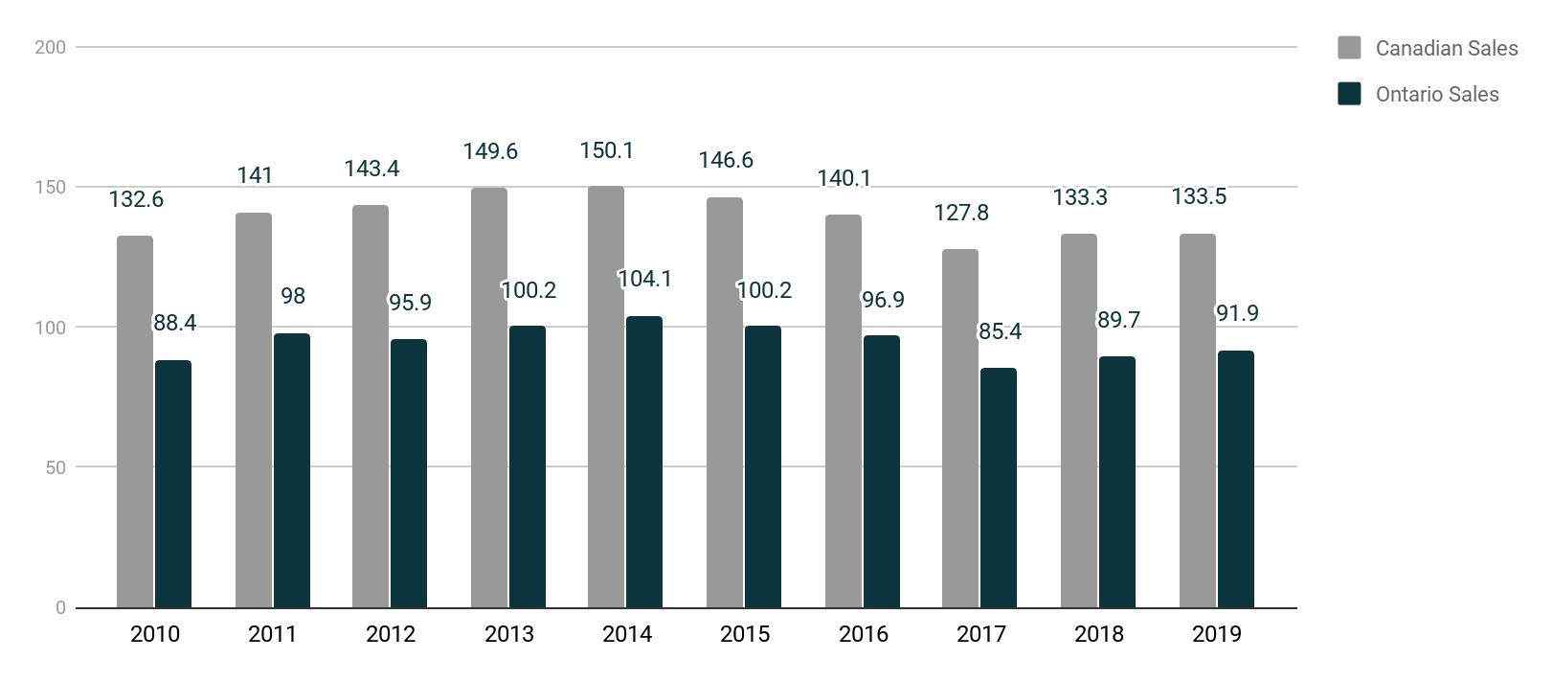

Source: Statistics Canada, “Table 32-10-0246-01 Production and Sale of Greenhouse Flowers and Plants,” Statistics Canada, accessed May 22, 2020, [www150.statcan.gc.ca/t1/tbl1/en/cv.action?pid=3210024601](https://www150.statcan.gc.ca/t1/tbl1/en/cv.action?pid=3210024601).

Exhibit 3: Sales of Potted Plants in Canada (in CA$ millions), 2010–2019

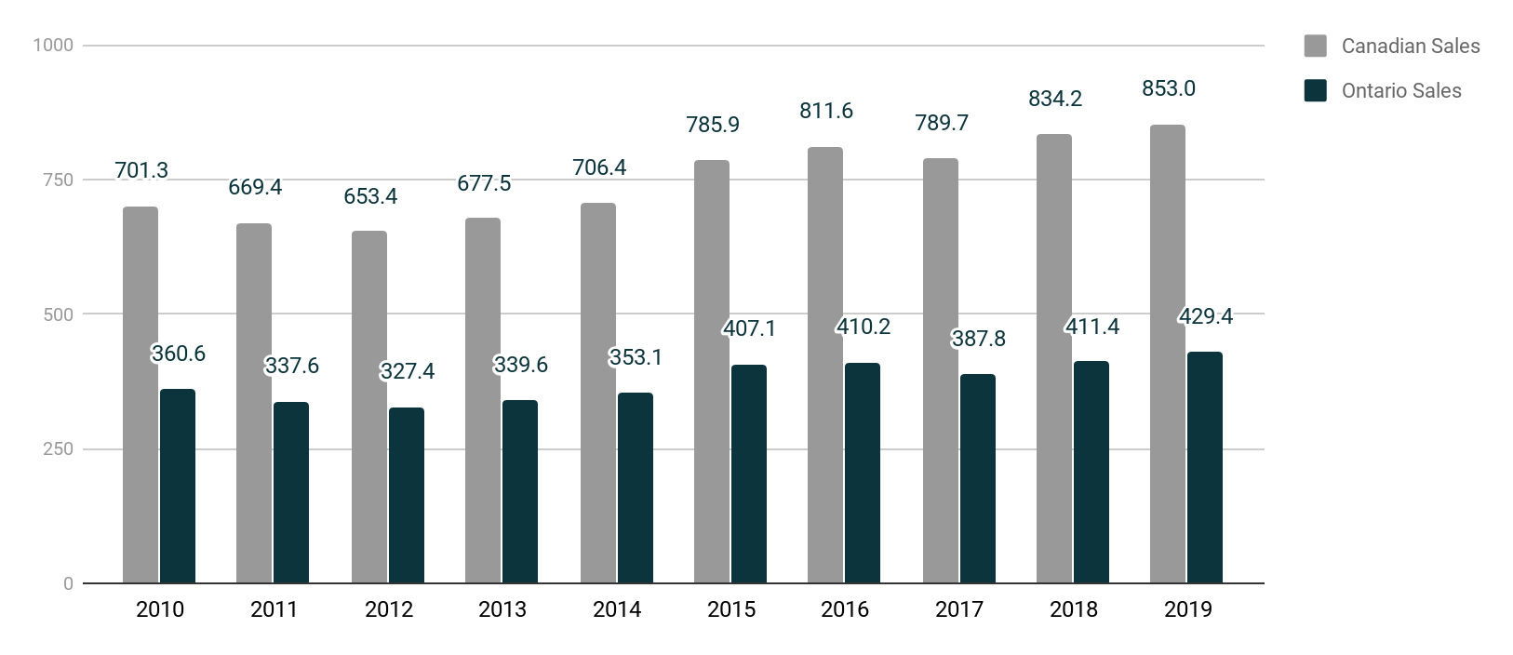

Source: “Statistics Canada, Table 32-10-0246-01 Production and Sale of Greenhouse Flowers and Plants,” Statistics Canada, accessed May 22, 2020, www150.statcan.gc.ca/t1/tbl1/en/cv.action?pid=3210024601.

Exhibit 4: Number of Greenhouse Operations Across Canada Between 2010 and 2019

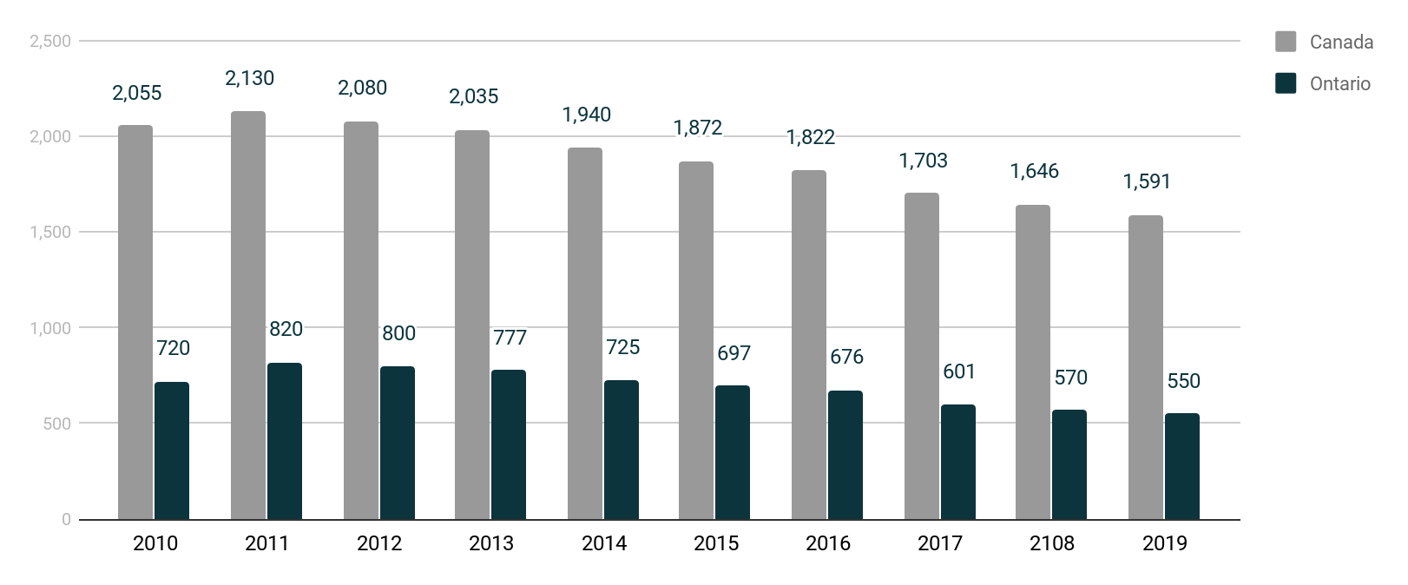

Source: Statistics Canada, “Table 32-10-0019-01 Estimates of Specialized Greenhouse Operations, Greenhouse Area, and Months of Operation,” Statistics Canada, accessed May 25, 2020, www150.statcan.gc.ca/t1/tbl1/en/cv.action?pid=3210001901.

**Exhibit 5: Top ten sources of Canada’s floriculture and nursery imports In 2018 (IN CA$ Millions)**

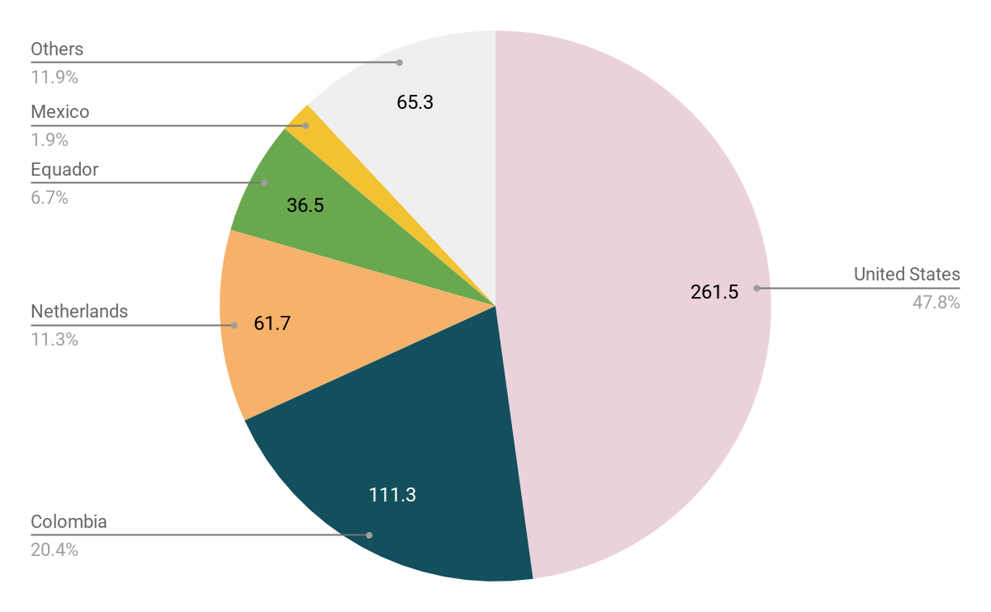

Source: Government of Canada, “Table 6.3.2. Top Ten Sources of Canada’s Floriculture and Nursery Imports,” Agriculture and Agri-Food Canada, accessed May 21, 2020, www.agr.gc.ca/eng/horticulture/horticulture-sector-reports/statistical-overview-of-the-canadian-ornamental-industry-2018/?id=1575470259743#a2.2.

Exhibit 6: Bouquet and Pail Examples

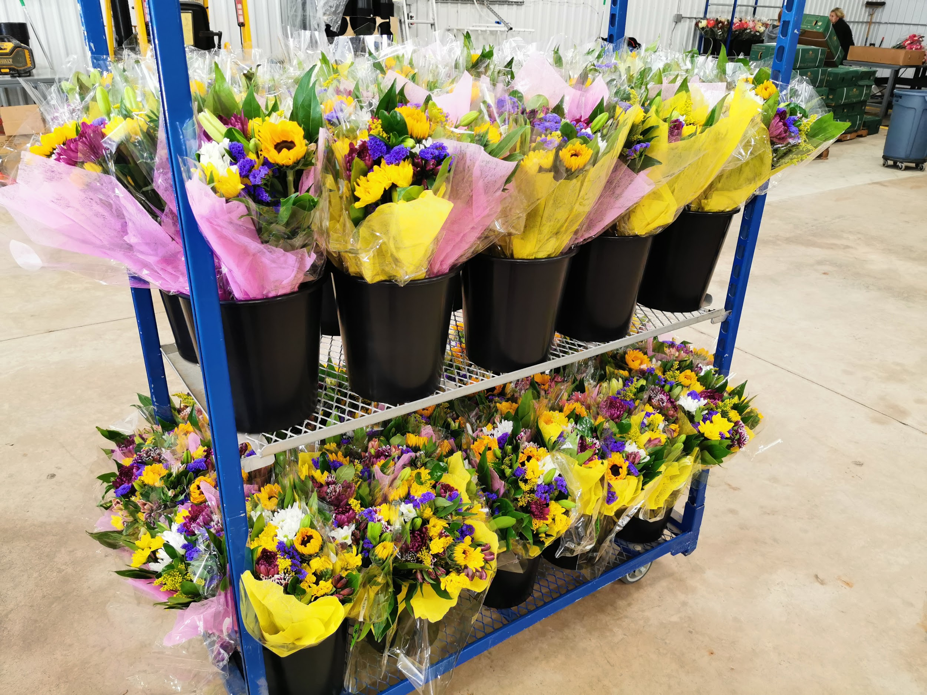

Source: Susan J. Van Weelden.

Exhibit 7: Income Statement

|  |  |  |  |  |
| --- | --- | --- | --- | --- |
| **SCENIC BOUQUET COMPANY INC.** | | | | |
| **Statement of Income** | | | | |
| **Year Ended December 31, 2019** | | | | |
|  | | **2020 Projected** | **2019 Actual** | **2018 Actual** |
| **SALES (PROCESSING REVENUES ESTIMATED AT 15% OF TOTAL SALES)** | | $1,955,000 | $1,627,304 | $307,417 |
| **COST OF SALES** | | 1,309,850 | 1,083,428 | 234,051 |
| **GROSS PROFIT** | | $645,150 | $543,876 | $73,365 |
| **EXPENSES** | |  |  |  |
|  | Advertising and promotion | $ 10,925 | $ 11,093 | $ 112 |
|  | Delivery | 270,250 | 268,763 | 50,545 |
|  | Depreciation of equipment | 5,750 | 5,236 | 1,030 |
|  | General and administrative expenses | 18,400 | 18,147 | 2,980 |
|  | Professional fees | 32,200 | 32,106 | 7,863 |
|  | Rental, utilities, and maintenance | 110,400 | 6,407 | 0 |
|  | Salaries, wages, and benefits | 172,500 | 56,935 | - |
|  | Vehicle (sold in 2020) | 4,000 | 10,275 | - |
|  |  | $624,425 | $408,962 | $62,529 |
| **INCOME FROM OPERATIONS** | | $20,725 | $134,915 | $10,836 |
| **OTHER INCOME (EXPENSES)** | |  |  |  |
|  | Net interest and banking charges | $2,300 | $(2,085) | $(2,588) |
|  | Foreign exchange gain (loss) | 2,300 | 1,804 | - |
|  |  | $4,600 | $(281) | $(2,588) |
| **INCOME BEFORE INCOME TAXES** | | $25,325 | $134,634 | $8,249 |
| **INCOME TAXES (ESTIMATED AT 13%)** | | 3,300 | 16,183 | 1,119 |
| **NET INCOME** | | $22,025 | $118,451 | $7,130 |
|  | |  |  |  |

Source: Compiled by the case authors based on data provided by the company. Some data have been disguised to maintain confidentiality.

Endnotes

1. Loblaw had a 23.8 per cent share of the Canadian grocery market, making it the largest player in the market, ahead of Empire Company (Sobeys, Foodland, and others) at 16.9 per cent. “Leading Grocery Retailers in Canada in 2018, by Market Share,” Statista, 2019, accessed May 25, 2020, www.statista.com/statistics/481019/leading-grocery-retailers-by-market-share-canada/.
2. Metro, which also operated under both the Metro and Food Basics banners, held nine per cent of the Canadian grocery market; Ibid.
3. All currency amounts are given in Canadian dollars unless otherwise specified.
4. IBISWorld Inc., “Flower & Nursery Stock Wholesaling in Canada—Market Research Report,” IBISWorld, accessed June 6, 2020, [www.ibisworld.com/canada/market-research-reports/flower-nursery-stock-wholesaling-industry/](https://www.ibisworld.com/canada/market-research-reports/flower-nursery-stock-wholesaling-industry/).
5. “Statistics Canada, Table 32-10-0022-01 Channels of Distribution for Horticulture Product Sales and Resales,” Statistics Canada, accessed May 22, 2020, www150.statcan.gc.ca/t1/tbl1/en/tv.action?pid=3210002201.
6. Statistics Canada, “Table 32-10-0019-01 Estimates of Specialized Greenhouse Operations, Greenhouse Area, and Months of Operation,” Statistics Canada, accessed May 25, 2020, [www150.statcan.gc.ca/t1/tbl1/en/cv.action?pid=3210001901](https://www150.statcan.gc.ca/t1/tbl1/en/cv.action?pid=3210001901).
7. Statistics Canada, “Table 32-10-0023-01 Total Value of Greenhouse Products,” Statistics Canada, accessed May 22, 2020, [www150.statcan.gc.ca/t1/tbl1/en/tv.action?pid=3210002301](https://www150.statcan.gc.ca/t1/tbl1/en/tv.action?pid=3210002301).
8. Statistics Canada, “Table 32-10-0246-01 Production and Sale of Greenhouse Flowers and Plants,” Statistics Canada, accessed May 22, 2020, www150.statcan.gc.ca/t1/tbl1/en/cv.action?pid=3210024601.
9. Statistics Canada, “Table 32-10-0019-01 Estimates of specialized greenhouse operations, greenhouse area, and months of operation,” op. cit.
10. Government of Ontario, “The Ontario Greenhouse Floriculture Industry,” 10, Ontario Ministry of Agriculture, Food and Rural Affairs, accessed May 23, 2020, [www.omafra.gov.on.ca/english/crops/facts/greenflor.htm#sector](http://www.omafra.gov.on.ca/english/crops/facts/greenflor.htm#sector).
11. Ibid., 3, 5.
12. Agriculture and Agri-Food Canada, “Statistical Overview of the Canadian Ornamental Industry, 2018,” 22, Government of Canada, accessed May 22, 2020. <http://192.197.71.76/eng/horticulture/horticulture-sector-reports/statistical-overview-of-the-canadian-ornamental-industry-2018/?id=1575470259743&>.
13. Statistics Canada, “Table 6.3.2. Top Ten Sources of Canada’s Floriculture and Nursery Imports,” in Agriculture and Agri-Food Canada, “Statistical Overview of the Canadian Ornamental Industry, 2018,” Government of Canada, accessed May 21, 2020, [www.agr.gc.ca/eng/horticulture/horticulture-sector-reports/statistical-overview-of-the-canadian-ornamental-industry-2018/?id=1575470259743#a2.2](http://www.agr.gc.ca/eng/horticulture/horticulture-sector-reports/statistical-overview-of-the-canadian-ornamental-industry-2018/?id=1575470259743#a2.2).
14. Flowers Canada (Ontario) Inc., “Consumer Research Study: Usage & Attitude Survey among Millennial Women,” Flowers Canada Growers, accessed May 23, 2020, [www.flowerscanadagrowers.com/resources-and-media/consumer-research-study-usage-attitude-survey-among-millennial-women](https://www.flowerscanadagrowers.com/resources-and-media/consumer-research-study-usage-attitude-survey-among-millennial-women).
15. The Strategic Counsel, *Usage and Attitude Survey among Millennial Women*, 21, 24, Flowers Canada Ontario, 2016, accessed May 23, 2020, www.flowerscanadagrowers.com/uploads/2016/11/usage%20and%20attitude%20survey%20among%20millennial%20women.pdf.
16. Flowers Canada (Ontario) Inc., “Consumer Research Study: Usage & Attitude Survey among Millennial Women,” op. cit.
17. The Strategic Counsel, op. cit., 36, 40.
18. Ibid., 20, 25.
19. Ibid., 42.
20. Ibid., 41.
21. Jonna Parker, “Floral Research Reveals What Retailers Need to Know Now,” Winsight Grocery Business, October 17, 2018, accessed June 4, 2020, [www.winsightgrocerybusiness.com/fresh-food/floral-research-reveals-what-retailers-need-know-now](https://www.winsightgrocerybusiness.com/fresh-food/floral-research-reveals-what-retailers-need-know-now).
22. Government of Ontario, op. cit., 9.
23. Canadian Food Inspection Agency, “D-08-04: Plant Protection Import Requirements for Plants and Plant Parts for Planting,” Government of Canada, 2020, accessed May 28, 2020, [www.inspection.gc.ca/plant-health/plant-pests-invasive-species/directives/horticulture/d-08-04/eng/1323752901318/1378910413423](https://www.inspection.gc.ca/plant-health/plant-pests-invasive-species/directives/horticulture/d-08-04/eng/1323752901318/1378910413423).
24. “E-commerce in Canada - Statistics & Facts,” Statista, accessed May 28, 2020, [www.statista.com/topics/2728/e-commerce-in-canada/](https://www.statista.com/topics/2728/e-commerce-in-canada/); “E-commerce in the United States—Statistics & Facts,” Statista, accessed May 28, 2020, [www.statista.com/topics/2443/us-ecommerce/](https://www.statista.com/topics/2443/us-ecommerce/).
25. Royal FloraHolland, “Florists Need to Innovate to Compete with E-Commerce,” Floral Daily, March 14, 2017, accessed June 2, 2020, [www.floraldaily.com/article/9009256/florists-need-to-innovate-to-compete-with-e-commerce](http://www.floraldaily.com/article/9009256/florists-need-to-innovate-to-compete-with-e-commerce).