

9B21M034

ora: The power of the Pivot

Tate Cao and Tyler Case wrote this case solely to provide material for class discussion. The authors do not intend to illustrate either effective or ineffective handling of a managerial situation. The authors may have disguised certain names and other identifying information to protect confidentiality.

This publication may not be transmitted, photocopied, digitized, or otherwise reproduced in any form or by any means without the permission of the copyright holder. Reproduction of this material is not covered under authorization by any reproduction rights organization. To order copies or request permission to reproduce materials, contact Ivey Publishing, Ivey Business School, Western University, London, Ontario, Canada, N6G 0N1; (t) 519.661.3208; (e) cases@ivey.ca; www.iveycases.com. Our goal is to publish materials of the highest quality; submit any errata to publishcases@ivey.ca. i1v2e5y5pubs

Copyright © 2021, Ivey Business School Foundation Version: 2021-04-08

In September 2019, Serese Selanders was at a pivotal point in the development of ORA, her personal emergency response systems (PERS) company. Selanders had started her business several years earlier in Saskatoon, in the Canadian province of Saskatchewan. At the time, she created a customized hardware and software solution that was intended to disrupt the growing PERS industry and help improve the lives of older adults and their caregivers. Despite considerable positive feedback and publicity, however, sales had not met the founder’s expectations.

Selanders was a skilled and innovative business manager. With her keen market sense, she had identified a promising new consumer segment for her product. However, she was well aware that technology start-ups were notoriously challenging to grow and sustain.[1] To ensure the success of ORA, Selanders would need to consider all market opportunities and threats and determine if her company had a sustainable competitive advantage. Having reached a turning point in her business, she had to make a critical decision. Should she grow the company by focusing on the new market segment, follow another strategic move, or raise another round of funding to stimulate growth? Or should she instead sell ORA’s technology, or the entire company, and resume her executive position in the financial industry? It was time to decide.

The Inspiration for ora

ORA was an extension of Selanders’s personal philosophy and passion. By 2012, Selanders had built a successful and rewarding career in the financial services industry, but she had always longed to fulfill her entrepreneurial spirit and create a venture of her own. Then a tragic family event led her to make a major change in her career and personal life. Confronted with the death of her mother and the debilitation of her father shortly afterward, Selanders decided to focus on the health and safety of her father. For the next six months, she cared for her father while he continued to live independently in his own home.[2]

During that time, Selanders’s role shifted from daughter to caregiver. She experienced the stress and tension that comes from the dual responsibility of caring for an ailing older parent while pursuing a career—in her case, as a busy corporate executive. When potential injury became a threat for her father at home, Selanders suggested that he should have an emergency alert device to get immediate help in the event of a medical emergency. However, her father resisted, claiming that such devices were not for him: “Those are for old people.”

Serese Selanders: the entrepreneur

Born in rural Val Marie, Saskatchewan, Selanders grew up in an entrepreneurial family. Her family had owned and operated several ventures in the town, ranging from the sale of bulk oil and gas, to farming products and liquor, and eventually to insurance brokerage. It seemed that an entrepreneurship pattern had clearly developed in her family. However, Selanders trained in international studies at the University of Saskatchewan and landed a job as a sales representative with a Canadian insurance company, where she quickly mastered sales skills. She excelled in her role and became a top financial services representative in her organization. Selanders then accepted a position in the financial industry, where she managed several financial planning offices. Eventually, she joined FirstSask Credit Union (later rebranded as the Affinity Credit Union) as vice-president of financial services—the company’s youngest ever vice-president.[3]

Making effective use of her business experience and family history, Selanders developed a strong work ethic and exceptional skills in sales, management, and strategic planning. As an executive in a large and progressive organization, Selanders was enthusiastic about innovation and dedicated to customer-centric services. Her abilities in strategic planning were recognized in the broader community. In 2010, she became a member of the critical care patient family advisory committee and the steering committee as a family adviser for the local health care system. Later, she joined quality and safety committees at both local and national levels.[4]

While pursuing her career as a financial industry executive, Selanders took career development and training courses at Queen’s University in Kingston, Ontario. She later received an MBA from the Edwards School of Business in Saskatoon, Saskatchewan. During her MBA studies, Selanders realized that she lacked passion for financial services, despite her success in that field. What she was passionate about, she soon discovered, was creating a personal safety device that combined fashion and technology and could help older adults remain active and independent.

birth of a company

In 2013, while Selanders was pursuing her career goals in the financial industry, her family tragedy shifted her priorities. Soon after her mother died, her father fell ill and underwent surgery to regain his health and independence. However, the outcome was not as was hoped. “Things changed for me, and I went from being the daughter to the caregiver,” said Selanders, whose work kept her busy most of each day.

To offer the safest care to her ailing father, Selanders explored all available lifestyle technology and PERS products but was shocked to find a stagnating industry and meagre options. The medical alert industry had fallen far behind that of most consumer electronic technologies in the market. Compared to the convenience that the ubiquitous smart phone offered, medical alert devices came in mostly outdated unattractive designs and provided limited communication range, which was a major concern for an emergency device. The central contact centre that monitored most devices also charged high monthly fees in addition to the initial hardware cost (see Exhibit 1).[5]

Selanders was determined to resolve these shortcomings and help keep her father safe. She also saw the potential gap in the market as an opportunity to leverage existing technologies and improve the lives of older adults while offering their caregivers peace of mind. Selanders had gained new skills and fostered an interest in entrepreneurship through her MBA studies. Therefore, she assembled a team of experts to support her development of a new alert device to fill the market gap. Selanders admitted to being “not necessarily a technical person” and was aware of the high level of responsibility that would fall on her venture.

Selanders soon launched her new company, Kasiel Solutions Inc., and began to create her signature product—the ORA (a homophone of the word aura).[6] She started the company with three full-time employees, various technical consultants, and several mentors to bridge a gap in the company’s competency. Using her training and business experience, Selanders leveraged a network of potential customers and conducted targeted focus groups with over 100 participants and conducted numerous individual interviews to gather feedback and validate her assumptions.

Preliminary research confirmed that the current PERS products did not fulfill most consumer needs, so Selanders began to design her own solution to meet those needs and address four key issues. First, most PERS products had limited range—usually within the user’s home—which greatly reduced the customer’s mobility. Second, many people (such as Selanders’s father) did not regularly carry or wear technology. Third, users were reluctant to keep devices fully charged for proper use. Fourth, older adults could forget to locate the device during an emergency. Therefore, a better PERS device should be widely operational, be attractive and easy to carry, require infrequent charging, and always be within reach.[7]

Based on these design requirements, Selanders launched a stand-alone mobile application of the ORA device and verified the needs and preferences of users in a product beta test. It became obvious to Selanders that providing only a smart phone mobile application (app) would not meet the needs of older adults who might be in distress or injured during a medical emergency. Therefore, a hardware device was also needed for easy access.

Selanders and her team worked on the development of the ORA hardware. As with many technology start-ups, her team members were spread across the country, but Selanders was determined to develop and manufacture the product as locally as possible to manage its quality and facilitate sales to the large US market. The team considered using off-the-shelf options, but they proved unable to wake a smart phone from its sleep state, which was an essential function, or connect with some operating systems if the associated ORA app was not active.

In June 2016, after many iterations, the team finally designed and built a new device that used the company’s own custom circuit boards and custom ORA hardware (see Exhibit 2). The device featured a more discreet and fashionable appearance, much like a jewellery item, and could be activated with one push of a button. When activated, the device would wake a smart phone from a sleep state (on both Apple iOS or Android platforms) to transmit an emergency alert and send the user’s global positioning coordinates to a designated list of contacts in the user’s network. If the contacts failed to respond, the device would then make a 911 emergency call.[8] Only the ORA device could provide these services, so the company protected its technology using numerous related patents.

In September 2016, the ORA device was being used by a sample customer during the product’s pilot phase. The customer used the device during an emergency, and it worked perfectly, effectively saving the customer’s life.[9] At the time, Selanders was still working in the financial industry, but was encouraged by the product’s early success during the pilot phase to consider taking a more active role despite the high risks—and rewards—that were common with technology start-ups.

Selanders left her position in the financial industry and dedicated all her time to the operation of her own company. To officially launch the product internationally, Selanders decided to enter the ORA in the 2017 Consumer Electronics Show (CES) convention in Las Vegas, Nevada.[10]

A market Overview

Traditionally, PERS wearable devices and associated support services enabled at-risk individuals, such as older adults or people with disabilities, to get assistance in the event of a medical emergency. These devices were often designed in the form of wristbands or neck pendants. Although PERS devices varied greatly, they generally comprised three basic components: an electronic device in the home, a remote emergency response centre, and resulting dispatch of appropriate help.[11]

In 2016, the global PERS industry was valued at US$6.7 billion,[12] with a compound annual growth rate of 5.8 per cent. North America was the largest market, accounting for 41.75 per cent, or $2.5 billion, of the industry’s total revenue, with an annual growth rate of 2.7 per cent.[13] An aging population and increasing demand for quality health care at home to maintain independence were key drivers for this market and for the development of innovative health care technologies. It was estimated that one in three adults aged 65 and older suffered from falls or incurred other medical emergencies each year. PERS devices allowed older adults to retain their independence and call for immediate response if a problem occurred. They also provided a more affordable option than other in-person monitoring alternatives.[14]

The growth of communication technologies, combined with recent developments of Internet of Things devices, enabled more advanced implementation of PERS. Widespread use of smart phones and wearable devices, especially for health monitoring (e.g., fitness trackers and smart watches), helped boost interest in PERS devices and contributed to their market growth.[15]

The global PERS market could be segmented either by type of enabling technology or by end user. In terms of technology, PERS technology comprised land line devices (e.g., home phones), mobile devices (e.g., wireless, cellular, and global positioning systems), and stand-alone (e.g., transmitters, stand-alone voice communicators, wandering systems, and R-cube and V-cube monitoring systems). In terms of end users, the market comprised home-based users, senior living facilities, and assisted living facilities. In 2016, home-based users consisted of the largest market segment and were estimated to be the fastest-growing PERS consumer group in the next decade.[16]

PERS devices were designed to provide fast help for people who lived in isolation, had poor mobility, or were concerned for their personal safety. The target end-user profile was an elderly woman who lived alone, was in poor physical condition, and often required assistance. Many end users were over 80 years old, so a family member or caregiver usually made the purchase decision based on safety reasons, a precaution in case the end user needed emergency assistance. However, many end users who accepted a PERS device or purchased it on their own rarely wore the device. Typical reasons given for not wearing PERS devices included being “worried it will get damaged,” having “forgot[ten] to put it on,” and claiming “it is uncomfortable to wear.” A 2016 study found that all women interviewed about this issue admitted that they wore their PERS device unwillingly.[17]

Within each operating jurisdiction, PERS devices had to comply with relevant legislation, including privacy of personal data and protection of medical information. The devices also had to meet certification standards within each jurisdiction, in some cases from independent laboratories.[18]

stagnate competitors

Nearly 4,000 businesses, consisting of both large international companies and smaller regional providers, competed in the global PERS industry. Most notable among the major competitors were Koninklijke Philips N.V. (Philips) from the Netherlands and various US companies including AlertOne Services LLC, ADT Corporation, Nortek Security & Control LLC, and Bay Alarm Medical (see Exhibit 3). To expand their product portfolios and increase market share, many companies were adopting growth strategies such as acquisition of, and collaboration with, other providers.[19]

Most commonly, PERS devices consisted of technological hardware integrated with an alarm monitoring service. For example, Philips Lifeline was one of the leading providers of medical alert systems and service in North America. Lifeline Systems Company was originally founded in 1974 by the psychologist and gerontologist Dr. Andrew S. Dibner. In 2006, Lifeline Systems was acquired by Philips, a global leader in health care, for a total value of $750.[20] Headquartered in the Netherlands, the company had approximately 118,000 employees and provided sales and services in more than 100 countries. Philips Lifeline Systems held 85 per cent of the Canadian market share of PERS in Canada[21] and 60 per cent of the market in North America.[22] Since 1974, the Philips Lifeline device had more than 7 million subscribers, offering an in-home land line service and a cellular service with global positioning system monitoring.[23] The cost of the in-home land line version ranged from $30 to $40 per month for the service plus $90 to $199 for installation. The cellular service total cost comprised both a device fee of $149 and a subscription fee of $55 to $65 per month.[24]

The technology offered by most companies in the industry had not changed much over the years. Pendants were the most dominant design, although some other formats were being introduced.[25] Drawbacks of current products included slow response, flimsy construction, limited range, unattractive design, and high cost.[26] Another drawback was resistance from users who did not readily accept the devices, claiming the products “were for old people” or the users “didn’t want to bother anyone.”[27] Market leaders depended on the reoccurring revenue stream from the subscription model.[28] Feeling that the industry was ripe for disruption, Selanders set out to reframe the consumer’s relationship with personal safety devices.

a little too early and a little too late

With its reliable function and appealing look, Selanders and ORA found significant success at the 2017 CES convention in Las Vegas. The ORA device was well received by many potential customers and industry partners. Selanders and her team decided that they could build on this momentum and attempted to launch the product using only funding that would be raised using the crowdfunding platform Indiegogo.[29]

The ORA system would be launched as a lightweight, fashionable device that could reliably connect with a network of user contacts or provide a 911 call as a backup. Its cost would be $200 for the device and—unlike its competitors—no monthly subscription fees. However, despite promising early indications, the Indiegogo fundraising campaign fell well short of Selanders’s expectations, receiving only 35 per cent of the required funding, contributed by 101 backers that included family members and friends.

Selanders was thus forced to bootstrap the venture with her own funds plus a variety of other sources that included competition winnings (e.g., Seeds for Dreams),[30] industry support from the National Research Council of Canada’s Industrial Research Assistance Program, innovation support from the Made in Saskatchewan Technology program,[31] and additional support from various other mentorships and incubators (e.g., Co.Labs and the Conexus Business Incubators).[32]

For the launch, the company decided to use a direct sales approach through the ORA website, accompanied by online advertisements on Google Ads and on Facebook. However, the consumer response again fell short of expectations. Sales generated from the online direct-to-consumer channel were low for the next several months.

Within six months of the product launch, Selanders found herself embroiled in a paradoxical phenomenon. Both the product and her company received consistent recognition, acclaim, media coverage, awards, and prizes.[33] However, all that fame and publicity had failed to translate into sales. The typical highs and lows of a technology start-up were in full view.

The business-to-consumer market was proving difficult to break into. It seemed necessary to pursue and convince individual users before any sales could be realized. However, typical customers were adults in their late seventies or eighties, who rarely shopped online for personal health and safety products. Even if the children or relatives of the target customers made the device purchase, many users did not own or carry a smart phone, which was a requirement for the ORA device to function properly.[34] Therefore, ORA employees would have to spend a significant amount of time training and onboarding end users, in addition to providing ongoing support. The next generation of potential ORA customers were baby boomers, who were currently in their fifties and sixties and would be more technology-savvy.[35] However, these users would also be unlikely to accept PERS devices for reasons similar to their reluctance to wear hearing aids—they made users feel old.[36]

Selanders and her team were facing considerable difficulties. Challenges included creating customized hardware and software, managing consumer behaviour, and affording the high cost of online advertising such as Google Ads, which had been driven out of the reach of a start-up company by capital rich competitors. These companies were wealthy, well established, and widely spread throughout the PERS market. Selanders felt as if the ORA product was too early for users and too late for the market.

a New Market

In 2017, an unexpected and tragic event made Selanders realize that her product could help another consumer segment. A local female realtor, who was attacked while showing a home to a potential buyer, later contacted Selanders for safety advice. At that point, Selanders realized that her product could help provide safety and assistance in a new market, where consumers worked mainly alone. These people were sometimes referred to as “lone workers.” In North America, over 25 million people held positions that required them to work mainly on their own,[37] including taxi drivers, realtors, delivery people, security guards, and convenience store workers. These workers, among others, typically spent most hours alone and often outside business hours.[38] The ORA device could fulfill an important need by helping to keep these workers safe.

With a $200 price point for the device, Selanders saw this as a potentially untapped opportunity with a total addressable market of $5 billion and far less existing competition. Therefore, she launched a new version of the ORA product for this target group, called the ORA PRO (see Exhibit 4). Unlike with older adults, who usually only used a PERS product after a caregiver or family member made the purchase, employers and lone worker employees were legally required to have a monitoring service in place for safety. The ORA PRO device offered such a solution for the initial $200 device cost plus a monthly fee of $5 for continuous support to consumers in this market segment.[39]

However, Selanders was again disappointed (somewhat surprisingly) at the lower-than-expected success of the ORA PRO. Potential customers who visited the ORA website were greeted by two versions of the ORA product: the new ORA PRO device for able professionals of all ages and the regular ORA device for older ailing adults who needed care. However, consumers were confused about the intended user of each device. Selanders found that many professional users ended up purchasing the regular version of ORA to avoid the monthly subscription fee. Another issue she confronted was corporate image. Despite the device’s efficiency, companies were reluctant to admit and publicize their need for the safety that the device provided given the sensitive nature of the situations (e.g., assaults and injuries).[40]

Eventually, as the company’s financial situation was becoming tenuous, Selanders set herself a target date of September 2019 to make a decisive strategic decision regarding the future of her company (see Exhibits 5 and 6).

the future

Keeping seniors safe was Selanders’s personal passion and the reason she had left her executive position to pursue her own venture in the first place. However, as much as she wanted to keep the ORA device solely as a product for older adults, she was finding that slow sales, high competition, and market cannibalization with the ORA PRO version was hurting the company financially. Selanders was also well aware that technology start-ups had notoriously high failure rates, so she felt that the odds were stacked against her. To give up on the ORA product now would mean giving up on a dream, but funds were running low.

Selanders felt that she had reached the end of the line and had to make a decision about her future and that of her company. She had to identify the market opportunities and threats, as well as her company’s sustainable competitive advantage. Should she focus entirely on the new lone worker market segment that she had identified, make another strategic move, or raise additional funding to grow her company? Or should she instead sell the technology, or the entire business, and resume her executive position in the financial industry? It was time to make an important decision.

For the development of this case, the authors gratefully acknowledge the support of the Bob & Raye Briscoe Centre in Business Ownership Studies, John Molson School of Business, Concordia University.

EXHIBIT 1: Existing Personal Emergency Response System Devices

with GSM Support

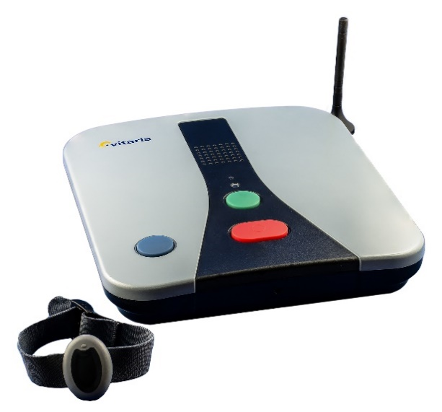

Note: GSM = Global System for Mobile Communications, a standard for digital cellular networks.

Source: Reproduced under Creative Commons licence CC BY 3.0 from Florian Fuchs, “Rufhilfegerät-vitaris S.A.M. 4 GSM,” June 7, 2012, via Wikimedia Commons, https://commons.wikimedia.org/wiki/File:Rufhilfegerät-vitaris_S.A.M._4_GSM.jpg..

EXHIBIT 2: development of THE ORA Device

(A) An image of a circuit board.

 (B) 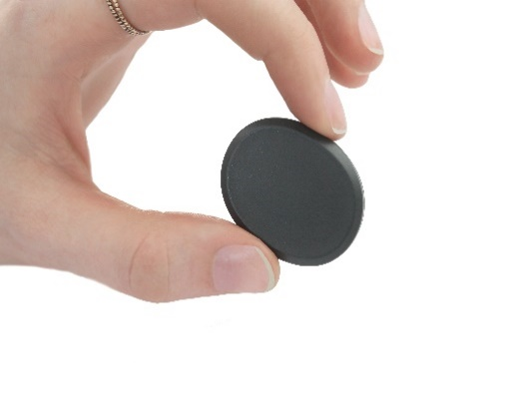

(C) 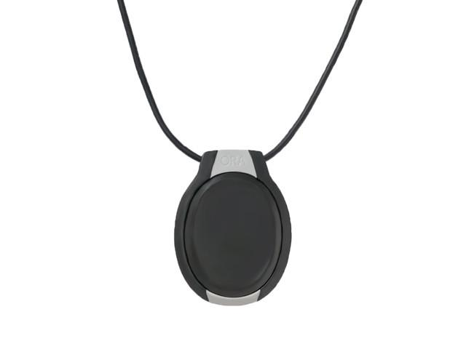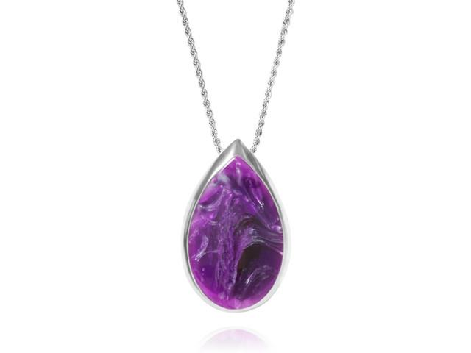

Source: Company files.

EXHIBIT 3: Exisiting Personal Emergency Response System Providers

| **Provider** | **Product** | **Features** | **Pricing Model (in US$)** | **Fashionable** | **Website** |
| --- | --- | --- | --- | --- | --- |
| ADT Security Services | Pendent, wristband, or button | Fall detection, GPS | Subscription fee  ($30–40/month) | No | www.adt.com/senior-safety |
| Philips Lifeline | Pendant or wristband | Fall detection, two-way voice | One-time device fee ($50–100);  Subscription fee  ($30–50/month) | No | www.lifelinesys.com |
| AlertOne Services Inc. | Pendant, wristband, button,  or base unit | 911, fall detection, speaker | Subscription fee  ($20–53/month) | No | www.alert-1.com |
| Alertcast | Toll-free call | Broadcast message | Subscription fee | N/A | www.alertcast.com |
| Bay Alarm Medical | Pendent, bracelet, button, in car | Smartwatch, in car | Subscription fee  ($20–30/month) | Yes | www.bayalarmmedical.com |
| Medi-Alert Systems Inc. | Pendant, wristband, or watch | Two-way speaker, GPS, two-way voice, 24/7 monitoring | One-time device purchase ($200);  Subscription fee  ($30–35/month) | No | www.medi-alert.com |
| Senior Medical Alert Systems | Pendant or wristband | Two-way speaker | Subscription fee  ($20–35/month) | No | www.seniorsafety.  com |
| Medical Alert | Pendent, wristband, button, or home system | Two-way speaker, monitoring, app | Subscription fee  ($20–41/month) | No | www.medicalalarm.  com |
| Nortek Security & Control | Pendant, wristband, watch, or button | Fall detection, monitoring | Not available | No | www.nortekcontrol.  com/products/personal-emergency-systems |
| Life Alert | Button, pendent, or wristband | GPS, monitoring | Subscription fee  ($50–95/month) | No | www.lifealert.com |
| Life Fone | Pendant, wristband, or home system | Waterproof, fall detection | Subscription fee  ($25–43/month) | No | www.lifefone.com |
| Medi-Call Canada | Home button or pendant | Indoor or outdoor | Not available | No | www.medi-call.ca |

Note: app = mobile application; GPS = global positioning system.

Source: Created by the case authors with information from company websites (see above, accessed October 10, 2020) and Sandi Hirst, Personal Emergency Response Systems: Disaster Management (Public Health Agency of Canada, 2010), https://ccsmh.ca/wp-content/uploads/2016/03/Personal-Emergency-Response-Systems.pdf; ReportLinker, “Global Personal Emergency Response Systems (PERS) Industry,” press release, Global Newswire, March 11, 2020, http://www.globenewswire.com/news-release/2020/03/11/1998522/0/en/Global-Personal-Emergency-Response-Systems-PERS-Industry.html; K. Sambit, “Global Personal Emergency Response Systems (PERS) Market Size in 2020,” Daily Chronicle, August 26, 2020, https://thedailychronicle.in/news/439421/global-personal-emergency-response-systems-pers-market-size-in-2020-new-report-top-countries-analysis-and-manufacturers-with-impact-of-domestic-and-global-market-manufacturers-data: and “Global Personal Emergency Response System Market 2016–2020,” TechNavio, April 2016, https://www.technavio.com/report/personal-emergency-response-system-market-industry-analysis.

EXHIBIT 4: HOW ORA Pro WORKs

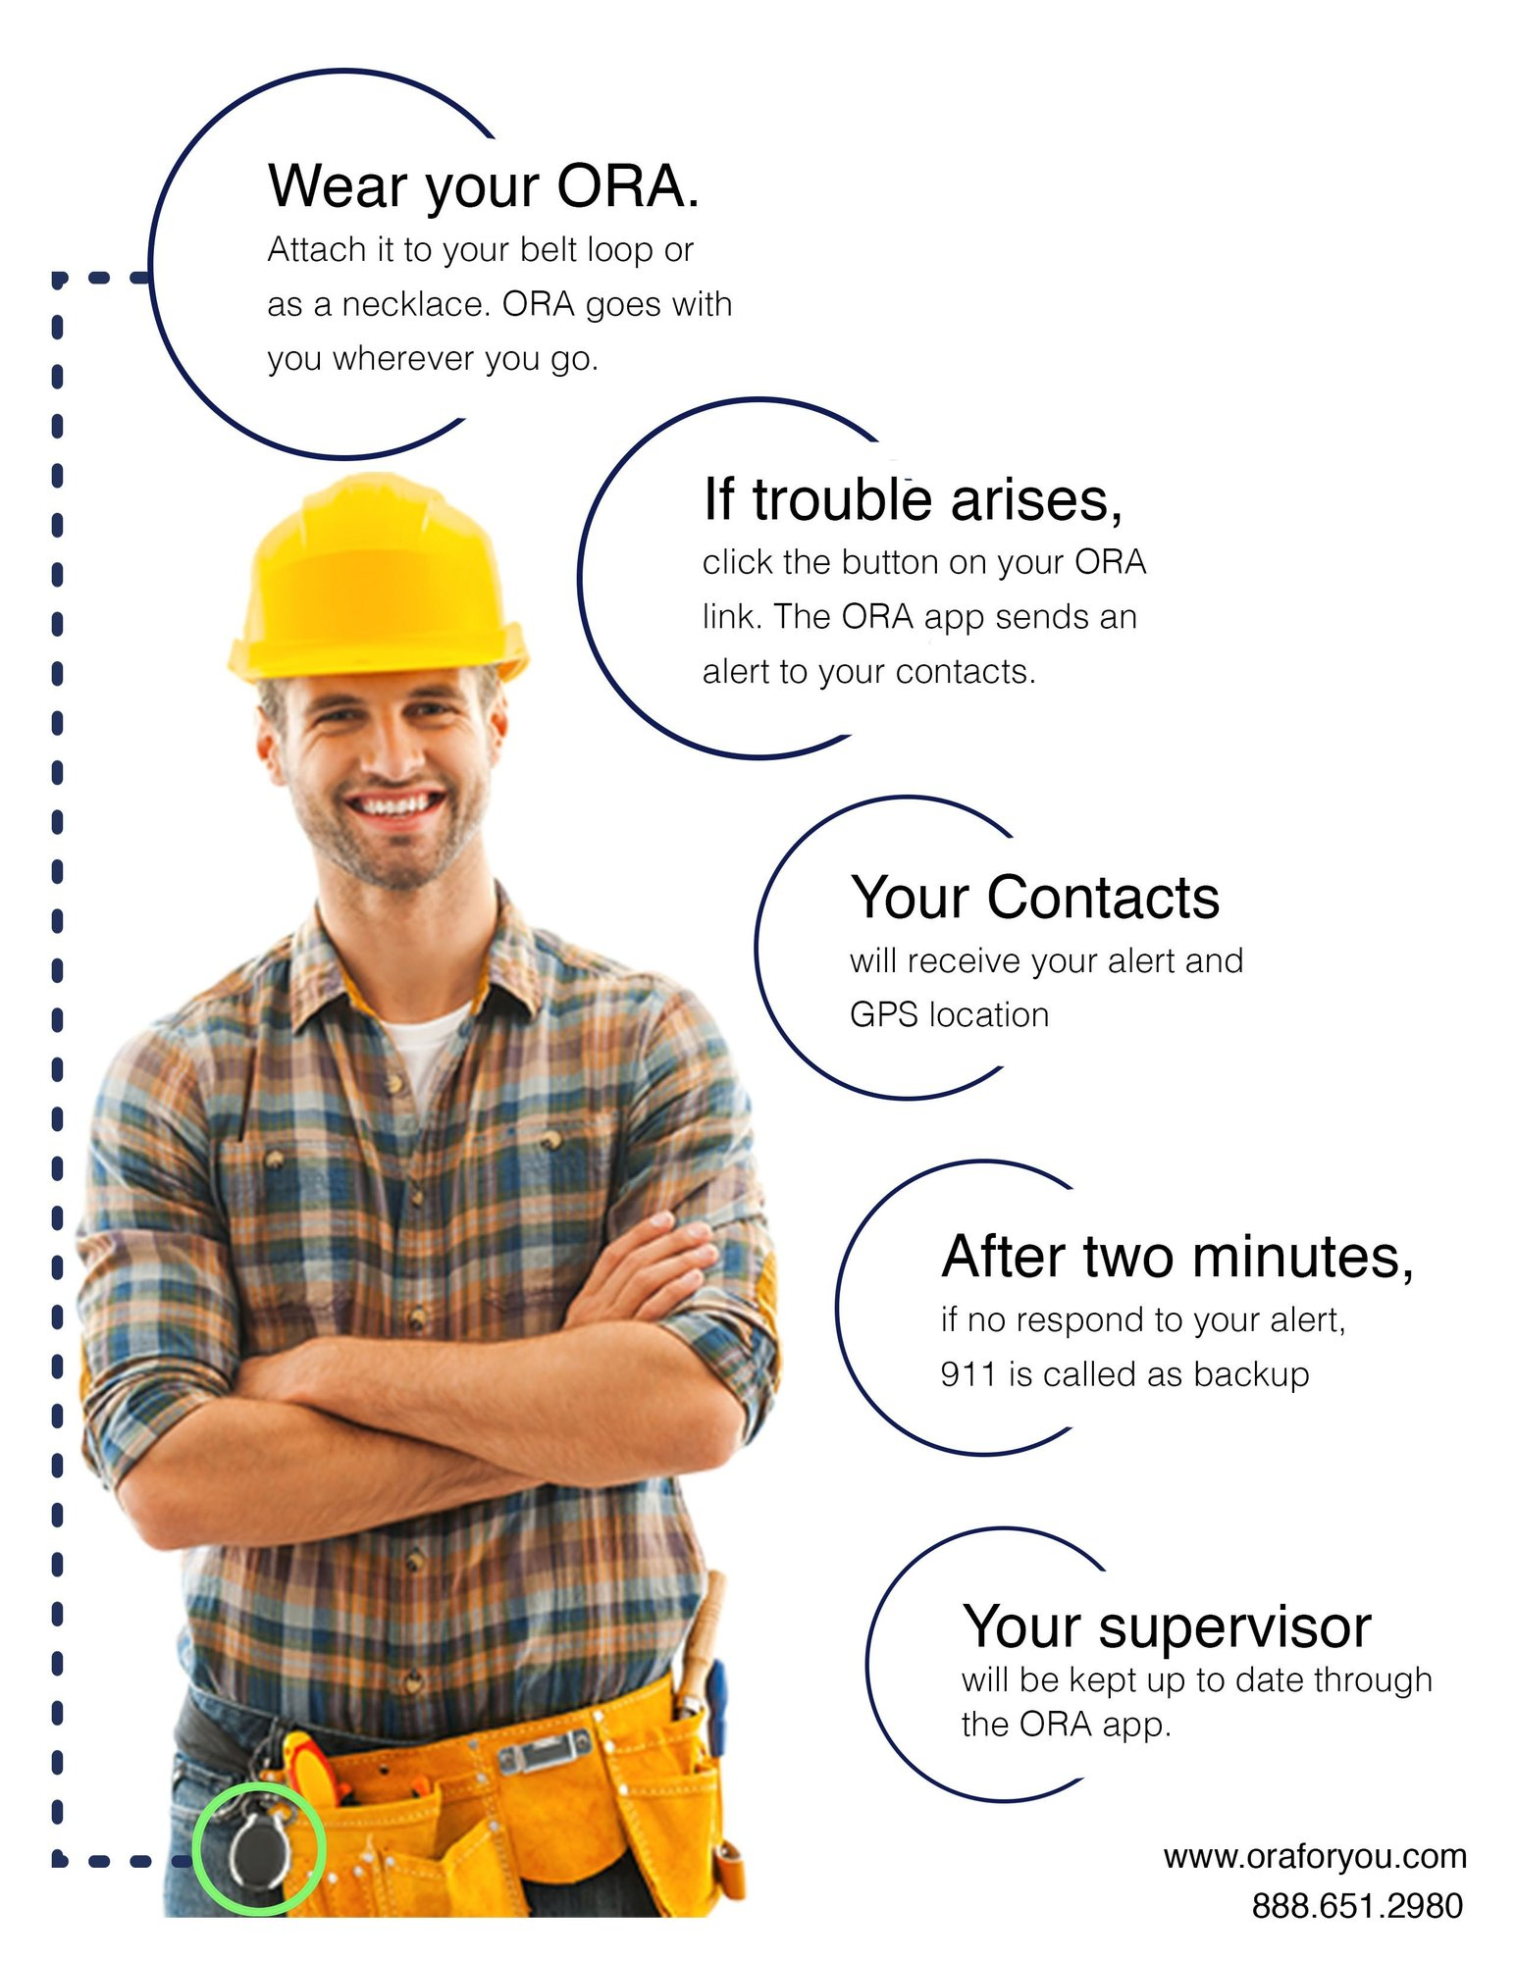

Source: “How ORA PRO Works,” ORA, accessed December 1, 2020, www.oraforyou.com/pages/workplace-safety.

Exhibit 5: ORA income statement, 2016–2018 (in CA$)

| **Revenue** | **2018** | **2017** | **2016** |
| --- | --- | --- | --- |
| Total revenue | 219,886 | 130,241 | 57,094 |
| Total sales | 74,886 | 33,241 | 22,094 |
| ORA | 27,112 | 24,362 | 22,094 |
| ORA PRO | 47,774 | 8,879 | 0 |
| Grant revenue | 145,000 | 97,000 | 35,000 |
| **Cost of sales** |  |  |  |
| Opening inventory | 12,006 | 11,865 | 11,618 |
| Purchases | 14,249 | 12,276 | 11,915 |
| Freight | 11,989 | 11,243 | 9,860 |
|  | **38,244** | **35,384** | **33,393** |
| Closing inventory | (12,983) | (12,006) | (11,865) |
| Total cost of sales | 25,261 | 23,378 | 21,528 |
| Gross profit | 194,625 | 106,863 | 35,566 |
| **Expenses** |  |  |  |
| Credit card charges | 1,997 | 2,776 | 1,288 |
| Salaries, wages, and benefits | 107,651 | 52,112 | 14,680 |
| Insurance, licences, and rentals | 3,327 | 3,495 | 2,178 |
| Amortization | 1,543 | 1,238 | 1,889 |
| Interest | 2,678 | 1,619 | 2,174 |
| Supplies, office, utilities, and other | 9,161 | 4,622 | 3,291 |
| Advertising | 17,608 | 10,307 | 7,187 |
| Rent and repairs | 33,177 | 30,623 | 22,684 |
| **Total expenses** | 177,142 | 106,792 | 55,371 |
| **Income from operations** | 17,483 | 71 | (19,805) |
| Loss carry forward | (32,346) | (32,417) | (12,612) |
| **Net income (loss)** | **(14,863)** | **(32,346)** | **(24,543)** |

Note: Financial information altered for confidentiality.

Source: Created by the case authors with information from company files.

Exhibit 6: ORA balance sheet, 2016–2018 (in CA$)

|  |  |  |  |
| --- | --- | --- | --- |
|  | **2018** | **2017** | **2016** |
| **Assets** |  |  |  |
| Total current assets | 14,656 | 12,298 | 11,416 |
| Total assets | 140,591 | 109,059 | 88,715 |
| **Liabilities and Equity** |  |  |  |
| Total current liabilities | 13,354 | 11,085 | 3,227 |
| Total long-term debt | 43,403 | 29,228 | 22,340 |
| Total liabilities | 56,757 | 40,313 | 25,567 |
| Total equity | 83,834 | 68,746 | 63,148 |

Note: Financial information altered for confidentiality.

Source: Created by the case authors with information from company files.

endnotes

1. Patrick Henry, “Why Some Startups Succeed (and Why Most Fail),” *Entrepreneur*, February 18, 2017, www.entrepreneur.com/article/288769.
2. Nina Livelo, “Aging in Place—The Trend among Baby Boomers,” Top 5 Medical Alert Systems, July 25, 2019, https://top5-medicalalertsystems.com/articles/aging-in-place-the-trend-among-baby-boomers.
3. Joanne Paulson, “Affinity Makes the Move to New Broadway Branch,” *Saskatoon Star Phoenix*, July 22, 2009, www.pressreader.com/canada/saskatoon-starphoenix/20090722/281951718817720.
4. Jenny Basran, “Kasiel Solutions: A Fully Mobile Medical Alert Device that Looks Like Jewelry Called ‘Ora,”’ Saskatchewan Chamber of Commerce, October 19, 2016, www.healthops.ca/event/details/test_event4.html.
5. Sandi Hirst, *Personal Emergency Response Systems: Disaster Management* (Public Health Agency of Canada, 2010), https://ccsmh.ca/wp-content/uploads/2016/03/Personal-Emergency-Response-Systems.pdf; Doug Lett, “Saskatoon Company Launches ORA, a Personal Safety Alert Device,” Global News, October 5, 2016, https://globalnews.ca/news/2985007/saskatoon-company-launches-ora-a-personal-safety-alert-device.
6. Basran, “Kasiel Solutions.”
7. Bart-Jan van Putten, “Recommendations for the Development of Mobile Personal Emergency Response Systems,” SeniorWise, January 10, 2016, www.seniorwise.eu/en/mobile-personal-emergency-response.
8. “Canada’s Leader in Personal Safety,” Innovation Saskatchewan, November 27, 2017, https://innovationsask.ca/success-stories/ora.
9. Alex MacPherson, “‘Everything Went into Action: Senior Citizen Credits New Medical Alert Device with Saving Her Life,” *Saskatoon* *Star Phoenix*, October 5, 2016, https://thestarphoenix.com/business/local-business/everything-went-into-action-senior-citizen-credits-new-medical-alert-device-with-saving-her-life.
10. Kasiel Solutions, “International Launch of ORA Innovative Personal Alter at CES,” press release, Intrado Global Newswire, January 6, 2017, www.globenewswire.com/news-release/2017/01/06/1113351/0/en/International-Launch-of-ORA-Innovative-Personal-Alert-at-CES.html.
11. Hirst, *Personal Emergency Response Systems*.
12. All dollar amounts are in US$ unless otherwise specified.
13. “Medical Alert Systems Market Analysis by Type (Landline, Mobile, Standalone), by End-Use (Home-Based Users, Nursing Homes, Assisted Living Facilities, Hospices), and Segment Forecasts, 2018–2025,” Grand View Research, October 2017, www.grandviewresearch.com/industry-analysis/medical-alert-personal-emergency-response-system-pers-market.
14. Kim Boudiny, “‘Active Ageing:’ From Empty Rhetoric to Effective Policy Tool,” *Ageing and Society* 33. no. 6 (2016): 1077–1098.
15. Sara Bersche Golas, Niles Fischer, Stephen Agboola, Kamal Jethwani, Mariana Simons-Nikolova, Jorn op den Buijs, and Linda Schertzer, *Reasons Patients Are Using Personal Emergency Response Services . . . and It’s Not Just Falls*, white paper by Partners Connected Health and Philips Lifeline, August 2017, http://incenter.medical.philips.com/doclib/enc/16015470/PL_WP_PERS_0217_Sprds__7-7-17.pdf%3ffunc%3ddoc.Fetch %26nodeid%3d16015470.
16. “Medical Alert Systems Market Analysis by Type.”
17. Randi Stokke, “The Personal Emergency Response System as a Technology Innovation in Primary Health Care Services: An Integrative Review,” *Journal of Medical Internet Research* 18, no. 7 (July 2016): e187.
18. Catherine Roberts, “How to Choose a Medical Alert System,” *Consumer Reports*, February 7, 2019, www.consumerreports.org/medical-alert-systems/how-to-choose-a-medical-alert-system.
19. “Global Personal Emergency Response System Market 2016–2020,” TechNavio, April 2016, www.technavio.com/report/global-health-and-wellness-personal-emergency-response-system-market.
20. Lifeline Personal Response and Support Services, “Lifeline Systems to be Acquired by Royal Philips Electronics,” press release, accessed March 26, 2021, https://www.sec.gov/Archives/edgar/data/1302676/000119312506008556/dex991.htm.
21. Wendy M. Fallis, Diane Silverthorne, Jonathon Franklin, and Susan McClement, “Client and Responder Perceptions of a Personal Emergency Response System: Lifeline,” *Home Health Care Services Quarterly* 26 no. 3 (2008): 1–21.
22. Joe, “Review Philips LifeLine,” Find the Right Alert, accessed March 27, 202, https://findtherightalert.com/review-philips-lifeline/#:~:text=Philips%20LifeLine%20is%20one%20of,have%2060%25%20of%20the%20market.
23. Philips Cares Caregiver Digital Brochure, 2020, accessed March 27, 2021, https://www.lifeline.philips.com/content/dam/PLL/

    PLL-B2C/PDFs/Philips-Cares-Caregivers-Digital-Brochure-2020.pdf.
24. Philips Lifeline Reviews 2016, Best Review, accessed March 27, 2021, https://medical-alert-systems.bestreviews.net/

    philips-lifeline-reviews/.
25. Jonathan Knoder, “PERS Market Growth Means Huge Opportunity for Dealers,” AvantGuard Monitoring, May 27, 2020, www.agmonitoring.com/blog/industry-news/pers-market-growth-means-huge-opportunity-for-dealers.
26. “From Panic Button to Advanced PERS Solutions: Providing an Extra Layer of Care,” Essence Group, accessed December 1, 2020, www.essence-grp.com/blog/1833.
27. Jane Fleming and Carol Brayne, “Inability to Get Up after Falling, Subsequent Time on Floor, and Summoning Help: Prospective Cohort Study in People over 90,” *BMJ* 337 (2008): a2227.
28. Mandee Thomas, “Professional vs. Self-Monitored PERS Systems,” AvantGuard Monitoring, January 29, 2019, www.agmonitoring.com/blog/industry-news/professional-vs.-self-monitored-pers-systems.
29. “ORA—Smart Jewelry that Keeps People Safe,” Indiegogo, accessed December 1, 2020, www.indiegogo.com/projects/ora-smart-jewelry-that-keeps-people-safe#.
30. “Event Night Winners,” Seeds for Dreams, January 15, 2019, http://seedsfordreams.ca/event-night-winners.
31. Brook Thalgott, “Innovation Saskatchewan Introduces the Made in Saskatchewan Technology (MIST) Program,” Innovation Saskatchewan, January 28, 2019, www.saskatchewan.ca/government/news-and-media/2019/january/28/mist-program.
32. Paul Burch, “Wearing More than Just Your Heart on Your Sleeve,” *Industry West Magazine*, Winter 2019, 51–53, https://industrywestmagazine.com/wp-content/uploads/2019/02/iw_winter2019-proof.pdf.
33. Courtney Markewich, “Saskatoon Woman Creates Fashionable Medical Alert Option,” CBC News, October 15, 2016, www.cbc.ca/news/canada/saskatoon/saskatoon-woman-ora-medical-alert-1.3804272; “ORA/SolusGuard CEO Profiled as Woman Leader in STEM,” Innovation Place, October 1, 2019, http://innovationplace.com/thescene/features/2019/10-ora.php; and Denise Deveau, “Saskatoon Women, Take Collective Approach to Entrepreneurship,” *Financial Post*, September 24, 2018, https://business.financialpost.com/entrepreneur/saskatoon-women-take-collective-approach-to-entrepreneurship.
34. “Comprehensive Guide to Personal Emergency Response Systems,” Aging in Place, May 2020, www.aginginplace.org/comprehensive-guide-to-personal-emergency-response-systems.
35. “5 Trends Impacting Your Aging Baby Boomer Patients,” Philips Lifeline, July 10, 2015, www.lifeline.philips.com/resources/blog/2015/07/5-trends-impacting-your-aging-baby-boomer-patients.html.
36. Amy Hoak, “Never Call a Baby Boomer ‘Old,’” *MarketWatch*, June 17, 2013, www.marketwatch.com/story/never-call-a-baby-boomer-old-2013-06-17.
37. Paul Turner, “What Is a Lone Worker? Four Questions to Ask,” Aware360, accessed December 1, 2020, https://aware360.com/lone-worker-four-questions-ask.
38. Mathew Colley, “7 Types of Lone Workers You Should Be Identifying in Your Company,” LoneAlert, accessed December 1, 2020, www.lonealert.co.uk/lone-working/blog/7-types-of-lone-workers-you-should-be-identifying-in-your-company.
39. Turner, “What Is a Lone Worker?”
40. “Canada’s Regulatory Requirements on Lone Worker Safety: How to Stay Compliant,” SolusGuard, accessed December 1, 2020, https://solusguard.com/canadas-regulatory-requirements-lone-worker-safety.