

9B21M055

The Yukon Soaps Company: Indigenous Business Growth

Victor Lal wrote this case under the supervision of Professor Dominic Lim solely to provide material for class discussion. The authors do not intend to illustrate either effective or ineffective handling of a managerial situation. The authors may have disguised certain names and other identifying information to protect confidentiality.

This publication may not be transmitted, photocopied, digitized, or otherwise reproduced in any form or by any means without the permission of the copyright holder. Reproduction of this material is not covered under authorization by any reproduction rights organization. To order copies or request permission to reproduce materials, contact Ivey Publishing, Ivey Business School, Western University, London, Ontario, Canada, N6G 0N1; (t) 519.661.3208; (e) cases@ivey.ca; www.iveycases.com. Our goal is to publish materials of the highest quality; submit any errata to publishcases@ivey.ca. i1v2e5y5pubs

Copyright © 2021, Ivey Business School Foundation Version: 2021-06-10

It was February 2019, and Joella Hogan sat down in her dining room chair after a long day of production. Hogan, the owner of the Yukon Soaps Company (Yukon Soaps), lived and worked in Mayo, Yukon, a small town north of Whitehorse. Like many in her community, Hogan, belonged to the Na-Cho Nyäk Dun First Nation, and she was proud of her Indigenous heritage.

Founded in 1998, Yukon Soaps provided high-quality, hand-crafted, artisanal soap made in the Yukon. The business offered products ranging from everyday, functional soaps to special-purpose soaps that featured Indigenous artwork. Yukon Soaps had been experiencing remarkable, double-digit annual sales growth over the past several years, and Hogan felt that the business had reached a critical point.

Orders kept coming in, and demand for her product steadily exceeded supply. Due to the limited scale of her business, Hogan was forced to either delay or reject large orders, turning away prospective customers. Hogan knew that, in order to grow the business, she would have to addresses certain pressing issues related to the current distribution network and limited brand awareness throughout Canada. Similarly, she would need to develop a new strategy regarding the entire supply chain of the business; she was currently sourcing ingredients via air freight, and this in particular significantly drove up costs. Lastly, Hogan questioned whether an aggressive growth strategy resonated with her personal values and those of her community. How should Hogan go about growing her business?

HISTORY OF INDIGENOUS PEOPLES IN CANADA

North America was first settled roughly 20,000 to 30,000 years ago by nomadic groups of hunters and gatherers travelling from Asia.[1] For thousands of years, Indigenous peoples had lived and thrived across much of present-day Canada, the United States, and Mexico. Long before the arrival of Europeans, independent, self-governing Indigenous nations had developed advanced societies.[2] For instance, the Iroquois Confederacy—a union of the Mohawk, Oneida, Onondaga, Cayuga, and Seneca peoples—was formed in 1142 and was considered to be among the oldest participatory democracies in the world.[3] Many Indigenous nations had progressive social structures: for example, women in the Iroquois Confederacy assumed active roles in decision-making and government.[4]

The lives of Indigenous peoples changed dramatically with the arrival of European colonial powers in North America. From the 1500s, the empires of Britain and France pushed to establish control over the land and natural resources of present-day Canada. However, the early relationships between European and Indigenous powers were nation-to-nation associations. Between the 16th and 18th centuries, Indigenous nations taught Europeans how to survive the harsh North American climate, ceded lands to them through treaties, engaged in trade, and otherwise coexisted with European settlers. The Royal Proclamation of 1763, issued by King George III of Britain, recognized that Indigenous nations had absolute ownership over all lands not ceded by or purchased from them.[5] This therefore served as a formal recognition by the British Empire of Indigenous sovereignty and nationhood.

This dynamic changed following the War of 1812, particularly as British Loyalists living in the United States moved to Canada—then called British North America. The growing population of ethnically European settlers increased the need for land and built the regional strength of the colonies. The dynamic between Indigenous and European people was further strained by the rise of social Darwinism, a racist and bigoted belief that there were superior and inferior “races” within the human population.[6] Social Darwinism became a prominent force influencing Canadian policy on Indigenous relations, particularly following Canadian Confederation in 1867.

For instance, the Gradual Enfranchisement Act of 1869 was an intentional effort by the Canadian government to assimilate First Nations into British-Canadian culture.[7] The Act attempted to more narrowly define who was Indigenous and had “Indian” status. Under the Act, Indigenous women who married non-Indigenous men automatically lost their Indian status, which meant that the Canadian government would not recognize them or their children as Indigenous. As women were the traditional keepers of the Indigenous culture, this policy was incredibly damaging.

The Indian Act of 1876 gave the Canadian government far-reaching control over Indigenous communities, significantly affecting their rights of self-government.[8] The creation of “band governments” under the Act gave Indigenous communities limited power over administrative matters, while enabling the Canadian government to pursue policies of relocation. This often meant relocating entire communities from their ancestral homelands in order to enable the settlement of white Canadians or the extraction of natural resources.[9]

The creation of residential schools represented one of the most damaging policies of the Canadian government. Between 1880 and the closing of the last residential school in 1996, an estimated 150,000 Indigenous children were put through an education system that attempted to assimilate them and to destroy their Indigenous culture.[10] These children were forcefully separated from their parents and siblings, were not allowed to speak their native languages, and were given English names. The 1998 Statement of Reconciliation by the Government of Canada formally recognized this school system’s rampant abuse of children, which included physical, emotional, and sexual abuse. The legacy of residential schools continued to the present, and entire communities struggled to repair the damage that was done to their people.[11]

**INDIGENOUS PEOPLES IN MODERN CANADA**

The Canadian government had implemented various programs to address the damage done to Indigenous communities. In 2006, the Indian Residential Schools Settlement Agreement (IRSSA) established a system of payments to victims of residential schools. A common experience payment (CEP) was offered to every former student of the residential school system. By 2019, almost $2 billion had been paid out to Indigenous peoples, but the IRSSA had been heavily criticized for its complexity and for discounting a number of abuse cases.[12]

The IRSSA also established the Truth and Reconciliation Commission of Canada, an initiative that attempted to document and increase understanding of the effects of residential schools. Between 2008 and 2015, the Commission reviewed government documents, collected the stories of victims and survivors, and found evidence of gross abuse within the entire residential school system. In 2015, the Commission issued a report with 94 calls to action, which included recommendations for changes to government policy in the areas of health, education, child welfare, and justice.[13] After receiving the Commission’s report, Prime Minister Justin Trudeau gave the following statement:

The Indian residential school system, one of the darkest chapters in Canadian history, has had a profoundly lasting and damaging impact on Indigenous culture, heritage, and language. . . .

To the former Indian residential school students who came forward and shared your painful stories, I say: thank you for your extraordinary bravery and for your willingness to help Canadians understand what happened to you. . . .

Moving forward, one of our goals is to help lift this burden from your shoulders, from those of your families, and from your communities. It is to accept fully our responsibilities—and our failings—as a government and as a nation.[14]

INDIGENOUS COMMUNITIES IN THE YUKON TERRITORY

Yukon was Canada’s westernmost territory and the smallest in terms of both geographical size and population. Approximately one-quarter of Yukon’s population of over 35,000 people identified as Indigenous, with 81.6 per cent identifying as First Nations, 12.4 per cent as Métis, and 2.7 per cent as Inuit.[15] For comparison, approximately 4.9 per cent of the Canadian population—1.7 million—identified as Indigenous. Close to half of the Indigenous people in Yukon—43 per cent—were under the age of 25, compared to roughly 27 per cent for the non-Indigenous population.[16] This relatively large, young group of Indigenous people faced complex economic, political, and social issues that were challenging to address.

In 2016, the unemployment rate among Indigenous people in the Yukon was 11.4 per cent—more than twice the unemployment rate for non-Indigenous people, which was 4.5 per cent.[17] This difference was largely driven by differences in education: Indigenous students were less likely to complete their high school educations or to pursue post-secondary education. While 35.3 per cent of non-Indigenous Yukoners had a university certificate, diploma, or degree, only 10.7 per cent of Indigenous Yukoners had these credentials.[18] This meant that many Indigenous people worked in jobs and industries that required lower skill levels and education; many of these industries were susceptible to threats from economic downturns. For instance, unemployment among Indigenous people in Yukon spiked in 2009, reaching levels above 23 per cent, as a direct consequence of the global financial crisis, which damaged local industries.[19] In Yukon, there was a clear need for greater investment in the education system and for the creation of job opportunities for both Indigenous and non-Indigenous residents.

Encouraging entrepreneurship had been identified as an opportunity for economic growth in Yukon. Several organizations, including the Yukon government’s Department of Economic Development and the Yukon First Nations Chamber of Commerce, were committed to encouraging Indigenous entrepreneurship by supporting educational initiatives, providing business mentorship, and connecting entrepreneurs with grants. However, there were still significant challenges for Indigenous entrepreneurs. Finding access to loans at affordable interest rates, hiring qualified skilled workers, and generating enough demand from a highly fragmented market were challenges that defined the Indigenous entrepreneurial experience and created frustrations for many current and prospective business owners.

MAYO, YUKON

Mayo was a small community located more than 400 kilometres north of Whitehorse, with a population of about 500. The village was home to the First Nation of Na-Cho Nyäk Dun, who made up approximately half of the community. The economy of the town was largely focused on two areas: government services and mining. The government provided half of the local jobs, many of which were focused on providing government and social welfare services to the local population.[20] Mining also provided significant opportunities in the community. For instance, the shovel-ready Eagle Gold project, financed by Victoria Gold Corp., would establish the largest gold mine in Yukon’s history just 85 kilometres away from Mayo. The mine was expected to employ 350–400 people, bringing enormous value to the region.[21]

However, the employment of Indigenous people often forced these workers to make difficult choices between their work and traditions. For instance, the spring and summer were important times for Indigenous people to take part in traditional hunting and fishing. This also represented a key weather window for mining corporations, which took advantage of this period to push their projects forward. As the deputy minister of Yukon’s Department of Economic Development, Justin Ferbey, commented, “You have to flip the paradigm around and not force-fit people into jobs that won’t work for them. . . . You have to make jobs fit the people, not people fit the jobs.”[22] A unique cultural balance therefore had to be realized.

The First Nation of Na-Cho Nyäk Dun held the unique status of having been self-governing since 1993. Through an agreement with the territorial government of Yukon and the federal government of Canada, Na-Cho Nyäk Dun had the power to propose, enact, and amend laws that governed the community.[23] In this sense, the nation was sovereign and independent—a scenario that represented a return to the original status of Indigenous communities in Canada.

THE YUKON SOAPS COMPANY

Yukon Soaps, originally founded in 1998 under the name The Essential Soap Bar, served Mayo as a small-scale producer of natural, artisanal soap. The business acted exclusively as a manufacturer of soap, which it sold to retail locations in Yukon for sales to end-consumers. The Essential Soap Bar remained local, with a relatively low sales volume, yet it soon found a group of passionate followers who loved the high quality of the soap. One of those customers was Joella Hogan. In 2012, when the two original owners decided they had had enough of running the business, Hogan leapt to purchase it.

Hogan was born and raised in Yukon and was a member of the First Nation of Na-Cho Nyäk Dun. Prior to purchasing the Essential Soap Bar, she had created and led Na-Cho Nyäk Dun’s heritage and culture department, which had a mandate to preserve and share the nation’s long history. Hogan was very involved in her hometown of Mayo, Yukon, and was passionate about giving back to her community. She held degrees as both a bachelor of science in environmental planning and a master of arts in rural and native development.

Hogan brought her strong energy and entrepreneurial drive to the business. She was motivated by goals that went beyond her long-time desire to own a business. First, as a member of the Na-Cho Nyäk Dun, Hogan had been raised on the teachings of her ancestors and hoped to embed First Nations traditions into her business. This meant not only using the business to share her nation’s culture but also being true ideals, such as giving back to members of her community. Second, she saw an opportunity to clearly connect the company with the Yukon territory. The Essential Soap Bar had a strong local reputation, but this could still be shared throughout the territory, the rest of Canada, and the world. Hogan took the first step by renaming the business as the Yukon Soaps Company (Yukon Soaps), identifying it with the territory and setting out toward the ambitious goal of becoming the best provider of soap in the Yukon.

Lastly, and most significantly, Hogan looked to her business as a chance to bring wealth and opportunity to Mayo and Na-Cho Nyäk Dun. Employment was a key concern in her community, and Hogan saw that the success of Yukon Soaps could support the employment of locals, empowering them and providing invaluable skills. Hogan firmly believed that the goals of the business were not just about her bottom line. Yukon Soaps was much more than that. Besides Hogan, the business currently employed two part-time workers, but it had the potential to employ several more in both production and sales, should it grow further.

THE ARTISINAL SOAP INDUSTRY AND RELEVANT COMPARABLES

The broader soap and cleaning compound market, valued at US$46 billion in the United States alone, remained dominated by large consumer packaged goods (CPG) names such as the Procter and Gamble Company.[24] These large players produced lower-priced, lower-quality soap than Yukon Soaps. However, growing disposable income among North American consumers had contributed to an increased demand for artisanal soap, creating a new sub-industry characterized by many small, local players. The number of producers in the United States alone was estimated to be over 300,000, with most selling small quantities of soap through limited channels such as farmer’s markets.[25] No dominant player had emerged from among the large number of artisanal soap producers.

The rise in demand for artisanal soap was also due to the broader trend of ethical consumerism, particularly in beauty and personal care products. Ethical consumerism was marked by an increased awareness among consumers of the ethical and moral aspects of the products they bought,[26] from the ways products were manufactured to how they were distributed and how profits were divided. Ethical consumerism had created a demand for beauty and personal care companies that operated with a social focus. Organizations that capitalized on this trend included The Honest Company Inc.,[27] Lush Cosmetics,[28] and Aesop Retail Pty. Ltd.[29]

THE ARTISINAL SOAP-MAKING PROCESS AND PROCUREMENT CHALLENGES

Hogan took pride in her production process, which allowed her to produce a differentiated product in a highly commoditized market. She ordered base ingredients, such as oils and lye, from distributors in western Canada, who shipped to her via airline freight delivery to Whitehorse. Airline freight significantly increased Yukon Soaps’s cost of goods sold, but this was a cost challenge faced by all players in the artisanal soap industry in the Canadian territories and by any business that depended on shipped inputs. To address this cost disadvantage—and to build on the value proposition of the product’s association with the territory of Yukon—Hogan sourced certain ingredients locally. She and her family and friends often picked wildflowers from local forests and included them in the product. Although this made for a time-consuming process, Hogan believed in the core importance of these natural ingredients to her customers and business.

Hogan currently produced the majority of her soap by herself. Her basement was filled, wall to wall, with soap production equipment and in-progress product. To make the soap, Hogan began by first combining lye and water, then heating and mixing the resulting solution. After the base set, she added ingredients such as essential oils and flowers to differentiate the product in terms of qualities such as scent, texture, function (e.g., by including certain oils with health benefits), and environmental sustainability (e.g., by using eco-friendly ingredients).

Hogan then put the mixture in wooden moulds for 24 hours for hardening. After 24 hours, the now-solid mixture was cut into individual soap bars, which then entered a curing process. This lasted between four and six weeks; an ideal six-week timeline allowed the soap to properly harden. Hogan’s current capacity allowed her to have eight batches of soap in process, each at a different stage of the curing process, at any one time. Each batch contained 48 bars of soap. However, the finite space available in Hogan’s basement remained a key challenge: she would need to find additional capacity in order for her production capabilities to keep pace with the growing demand.

PRODUCT RANGE AND INNOVATION

Yukon Soaps offered a wide assortment of soap and accessory products. Its most popular and original product, the Essential soap, was meant to be used on a daily basis and had become a staple in customers’ households. Customers highly valued the natural, hand-picked ingredients used in this soap, and they were also drawn to the fact that the soap was produced in Mayo by a local entrepreneur, in a small batch, and in a way that reflected First Nations values. For this reason, customers were willing to pay upwards of CA$7 for a bar of soap—greater than the price of large CPG company products but below those of other high-end artisanal soap manufacturers.

Hogan had introduced several new and innovative product types, including soap that featured images of beadwork by local Indigenous artists (see Exhibit 1). The artwork, which created a beautiful aesthetic for the soap, was accompanied by stories of the artists and various members of the Yukon Indigenous community. This gave a spotlight to local Indigenous culture and strongly benefitted many local community artists. Demand for this product line had grown significantly. The beadwork soaps sold for roughly CA$12, and there was currently no other product on the market that similarly presented Yukon and First Nations stories. Production time for this soap line was similar to that for the Essential soap.

Generating demand was not a challenge for Yukon Soaps. In fact, demand exceeded supply: Hogan received large orders from retailers across Yukon that she had to either turn down or delay. The necessary four- to six-week production time, as well as the limited capacity of Hogan’s current production system, meant that additional resources and capital would need to be invested in order for Hogan to grow the business.

A key concern for Hogan was the accessibility of the product, particularly from a pricing perspective. Although she already offered her product at prices above those for CPG brand products, she could potentially increase prices further until demand matched supply to drive increased revenue and profit. However, Hogan believed that doing so would go against her values and those of the company. She therefore chose to define success for her business in a strictly non-financial sense, instead, making it the focus of Yukon Soaps to provide a quality product, to tell the story of Yukoners and First Nations, and to help bring employment to Hogan’s community.

choosing a primary SALES CHANNEL

Hogan sold the prepared product through three distinct channels: through retailers across Yukon, via direct sales at local fairs and markets, and through online channels.

The retail channel accounted for the majority of product sales, with roughly 60 per cent of dollar sales generated through retail locations. Once the product was ready, Hogan herself or someone from her community would personally deliver the soap to the retail location. The retailers were largely independent gift or lifestyle shops, and they often featured an assortment of other soaps along with Yukon Soaps products. Yukon Soaps marketed directly to some of these retailers, and others came themselves to Yukon Soaps to place orders. Hogan had seen success primarily with retailers in Yukon and a handful of locations in British Columbia, but she faced difficulty potentially expanding into other provinces and territories due to the current distribution system and limited brand awareness. Selling through retailers also made it more difficult to communicate the story of the product, particularly the beadwork soap, which limited a key differentiating factor for Hogan.

The second channel included various local art and farmers’ markets spread across Yukon. Hogan and/or a part-time employee attended these events, where they set up a booth. Hogan was in her element in this context: using her passion for the product and telling the stories of her nation and community, she was able to effectively convince customers to pay more for a product that meant more to them. Hogan attended approximately eight to 10 farmer’s market events per year, earning between $200 and $300 at each one, and four to five art fairs per year, earning between $2,000 and $5,000 at each one. However, there was a limit to how many events Hogan could attend personally, and this limited scalability meant this channel accounted for only about 35 per cent of sales.

Yukon Soaps also operated an e-commerce channel via its website, yukonsoaps.com. The website allowed potential customers to view the full product offering and read the stories of Hogan, her business, and each of her soaps. The website also offered the only current opportunity for customers around Canada and the world to learn about and purchase the product. However, driving traffic to the website remained a large challenge. Consequently, the website currently drove only 5 per cent of sales.

Hogan wondered about the three current channels: which represented the best opportunity for Yukon Soaps? Each one appeared to have trade-offs. With the retail channel, exposure across Yukon was possible, but the inability to effectively communicate the story behind the product took away a key advantage for Hogan. Selling directly to customers via fairs solved this issue but represented a high-effort, poorly scalable growth strategy. Finally, selling on the website offered an attractive opportunity to reach new customers. However, Hogan wasn’t sure if average Canadians would relate to or appreciate a brand that tried to be synonymous with Yukon and First Nations values.

THE CHALLENGE OF GROWTH

Hogan realized that she had a great opportunity to grow Yukon Soaps. The product was loved by those who used it, and it stood for something that both First Nations and non-First Nations people valued. Furthermore, her business was becoming known as the leader in Yukon artisanal soap. However, in order to grow, Hogan had to deal with several key challenges: addressing procurement costs, choosing the best sales channel, and adjusting to changing customer demands.

Sourcing ingredients and shipping them to Mayo was a prohibitive challenge. Although other players in Yukon faced the same problem, entering the wider Canadian or global market would mean competing against players who could easily under-price Yukon Soaps. Was there a way for Hogan to address this significant procurement cost?

Of the three current channels—selling to retailers, selling directly through fairs and farmers’ markets, and selling on e-commerce channels—which should Hogan focus on? If the chosen channel expanded Yukon Soaps’s scope into other regions of Canada, would Canadians value and relate to the First Nations stories behind many of her products, and would this be enough to persuade them to make single or repeated purchases? What was the best way to communicate these stories to new Canadian customers?

Hogan also wondered how her business should adjust to the values of new markets. For instance, she knew that the use of palm oil, an ingredient in many Yukon Soaps products, was heavily criticized among certain Canadian customers because of the environmental impact of the oil. Appealing to the values and culture of an increasingly diverse set of customers could potentially force Yukon Soaps to significantly change its current product line and identity. Hogan wondered whether pursuing growth in new markets was the right path forward for her business. Should Yukon Soaps instead remain local and focus on being a small-batch, high-quality manufacturer of soap?

**DECIDING ON A PATH FORWARD**

This last thought made Hogan pause to reflect. What was the purpose of expanding and going after aggressive growth? Hogan knew that her focus was not on financial gain—either for herself or for her business. Rather, her priorities were maintaining the values of Yukon Soaps and the Na-Cho Nyäk Dun First Nation and helping to provide economic opportunity for Mayo. Couldn’t she also achieve these goals by focusing on the Yukon market, keeping her business at its current size, and avoiding the complex problems that would come from growing a manufacturing business in Mayo?

EXHIBIT 1: Sample of soap with ARTISINAL BEADWORK

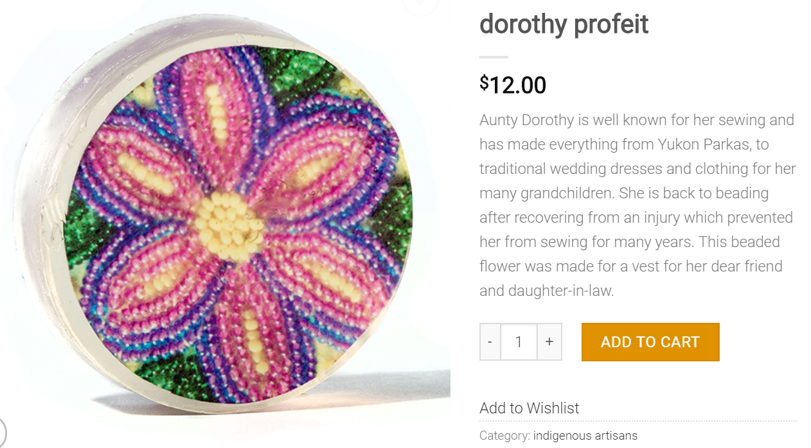

Source: “Dorothy Profeit,” The Yukon Soaps Company, accessed February 7, 2020, https://yukonsoaps.com/shop/dorothy-profeit/.

EXHIBIT 2: RETAIL STORE SHELF LAYOUT

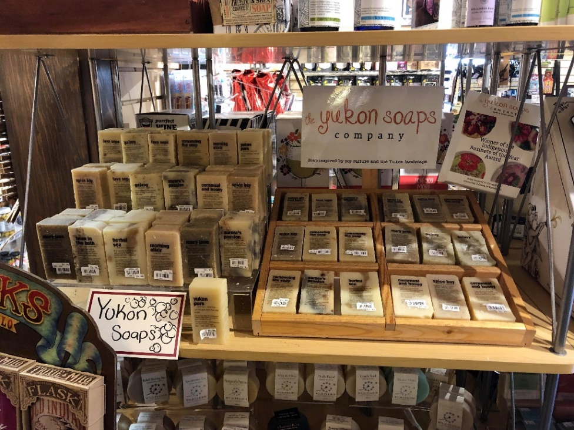

Source: Image of Yukon Soaps products at a small-scale Whitehorse retailer.

ENDNOTES

1. Simon Worrall, “When, How Did the First Americans Arrive?,” *National Geographic*, June 9, 2018, accessed February 15, 2019, www.nationalgeographic.com/news/2018/06/when-and-how-did-the-first-americans-arrive--its-complicated.
2. The term *Indigenous* referred to several distinct groups, but in Canada included primarily First Nations, Inuit, and Metis. *Inuit* referred to groups living in the far north. *Metis* referred to people of both Indigenous and European ancestry. *First Nations* referred to all Indigenous peoples who were neither Inuit nor Metis. Indigenous peoples might also be called Aboriginal. It is important to be respectful of differences and conscious of the names, titles, or descriptors groups choose to use to define themselves.
3. A participatory democracy was a system of government in which individual citizens participated in policy decisions that affected their lives. This contrasted with representative democracies, in which individuals elected political representatives to speak for them.
4. Jessica Nordell, “Millions of Women Voted This Election. They Have the Iroquois to Thank,” *Washington Post*, November 24, 2016, accessed February 17, 2019, www.washingtonpost.com/posteverything/wp/2016/11/24/millions-of-women-voted-for-hillary-clinton-they-have-the-iroquois-to-thank/?utm_term=.532ba5c09102.
5. Anthony J. Hall, “Royal Proclamation of 1763,” *The Canadian* *Encyclopedia*, February 7, 2016, accessed February 17, 2019, www.thecanadianencyclopedia.ca/en/article/royal-proclamation-of-1763.
6. A. Brian McKillop, “Social Darwinism,” *The Canadian Encyclopedia*, December 16, 2013, accessed February 17, 2019, www.thecanadianencyclopedia.ca/en/article/social-darwinism.
7. “Stolen Lives: The Indigenous Peoples of Canada and the Indian Residential Schools,” *Facing History and Ourselves*, accessed February 17, 2019, www.facinghistory.org/stolen-lives-indigenous-peoples-canada-and-indian-residential-schools/chapter-3/historical-background.
8. “Indian Act.” *Government of Canada,* August 15, 2019, accessed February 17, 2019, https://laws-lois.justice.gc.ca/eng/acts/i-5/.
9. Erin Hanson, “The Indian Act,” Indigenous Foundations, First Nations & Indigenous Studies, University of British Columbia, 2009, accessed February 18, 2019, https://indigenousfoundations.arts.ubc.ca/the_indian_act.
10. J.R. Miller, “Residential Schools in Canada,” *The Canadian Encyclopedia*, October 10, 2012, accessed February 18, 2019, https://thecanadianencyclopedia.ca/en/article/residential-schools.
11. Ibid.
12. Tabitha Marshall, “Indian Residential Schools Settlement Agreement.” *The Canadian Encyclopedia,* July 11, 2013, accessed February 18, 2019,https://www.thecanadianencyclopedia.ca/en/article/indian-residential-schools-settlement-agreement.
13. “Truth and Reconciliation Commission of Canada.” *Government of Canada*, December 15, 2020, accessed February 18, 2019, https://www.rcaanc-cirnac.gc.ca/eng/1450124405592/1529106060525.
14. Justin Trudeau, “Statement by Prime Minister on release of the Final Report of the Truth and Reconciliation Commission,” Justin Trudeau, Prime Minister of Canada, December 15, 2015, accessed February 19, 2019, https://pm.gc.ca/eng/news/2015/12/15/statement-prime-minister-release-final-report-truth-and-reconciliation-commission.
15. Statistics Canada, “Focus on Geography Series, 2016 Census: Yukon,” Statistics Canada, 2017, accessed February 19, 2019, www12.statcan.gc.ca/census-recensement/2016/as-sa/fogs-spg/Facts-PR-Eng.cfm?TOPIC=9&LANG=Eng&GK=PR&GC=60.
16. Statistics Canada, “Aboriginal Peoples: Fact Sheet for Yukon,” Statistics Canada, March 29, 2016, accessed February 19, 2019, www150.statcan.gc.ca/n1/pub/89-656-x/89-656-x2016012-eng.htm.
17. Yukon Bureau of Statistics, *Yukon Employment Annual Review 2016*, Government of Yukon, February 2017, accessed February 19, 2019, www.eco.gov.yk.ca/stats/pdf/employment_2016.pdf.
18. Yukon Bureau of Statistics, *Education: Census 2016*, Government of Yukon, February 2017, accessed February 19, 2019, www.eco.gov.yk.ca/pdf/Education.pdf.
19. “Aboriginal Labour Force Characteristics, Yukon, 2007 to 2016,” in Yukon Bureau of Statistics, *Yukon Employment Annual Review 2016*, Government of Yukon, Bureau of Statistics, February 2017, accessed February 19, 2019, www.eco.gov.yk.ca/stats/pdf/employment_2016.pdf.
20. “About Mayo.” *Village of Mayo,* accessed February 19, 2019, https://villageofmayo.ca/about-mayo/.
21. “Eagle Gold Mine,” *Victoria Gold Corporation,* accessed February 19, 2019, https://vgcx.com/development/eagle-gold-project/.
22. Lori Fox, “For Mining Companies, Hiring Indigenous Workers ‘About Nation-Building’ Panel Hears,” *Yukon News*, November 27, 2017, accessed February 19, 2019, www.yukon-news.com/business/for-mining-companies-hiring-indigenous-workers-about-nation-building-panel-hears/.
23. “History,” *First Nation of Na-Cho Nyäk Dun,* accessed February 19, 2019, https://www.nndfn.com/history/.
24. IBISWorld, “Soap & Cleaning Compound Manufacturing Industry in the US–Market Research Report,” IBISWorld, August 2019, accessed August 18, 2019, www.ibisworld.com/industry-trends/market-research-reports/manufacturing/chemical/soap-cleaning-compound-manufacturing.html.
25. Joanne Kaufman, “Want to Sell Handmade Soap? Join the Crowd,” *New York Times*, February 8, 2017, accessed August 18, 2019, www.nytimes.com/2017/02/08/business/smallbusiness/soap-making.html.
26. Michelle Soliman, “Ethical Consumerism,” BusinessWorld, October 6, 2018, accessed August 18, 2019, www.bworldonline.com/highlife-ethical-consumerism/.
27. The Honest Company, https://www.honest.com/.
28. Lush Cosmetics, https://www.lush.ca/en/home.
29. Aesop Retail Pty. Ltd., https://www.aesop.com/ca/en/.