

9B21M066

Dropbox: A digital firm’s journey abroad[1]

Noman Ahmed Shaheer Siddiqui, Mirea Woo, Maximilian Stallkamp, Sali Li, and Liang Chen wrote this case solely to provide material for class discussion. The authors do not intend to illustrate either effective or ineffective handling of a managerial situation. The authors may have disguised certain names and other identifying information to protect confidentiality.

This publication may not be transmitted, photocopied, digitized, or otherwise reproduced in any form or by any means without the permission of the copyright holder. Reproduction of this material is not covered under authorization by any reproduction rights organization. To order copies or request permission to reproduce materials, contact Ivey Publishing, Ivey Business School, Western University, London, Ontario, Canada, N6G 0N1; (t) 519.661.3208; (e) cases@ivey.ca; www.iveycases.com. Our goal is to publish materials of the highest quality; submit any errata to publishcases@ivey.ca. i1v2e5y5pubs

Copyright © 2021, Ivey Business School Foundation Version: 2021-06-23

Every knowledge worker needs an organized place for their content that works with all other platforms  
 . . . and it’s an . . . even bigger need now that we’re working from home.

Drew Houston, chief executive officer of Dropbox[2]

The year 2020 had been a roller-coaster ride for Dropbox Inc. (Dropbox) and its shareholders. The COVID-19 pandemic had swept the globe, and stocks—including those of technology companies such as Dropbox—had plummeted. After the initial financial tumble, however, shareholders of Dropbox saw light at the end of the tunnel. As companies and schools across the world shifted to remote working, teaching, and learning, cloud service providers such as Dropbox seemed well positioned to benefit from this transition. In a period of two months, Dropbox stocks jumped over 50 per cent, and shareholders’ expectations skyrocketed. However, this hype soon fizzled, and the company’s value returned to pre-COVID levels.[3]

By comparison, cloud collaboration and storage tools offered by Dropbox’s competitors, including Zoom Video Communications Inc. (Zoom), Google LLC (Google), and Microsoft Corporation (Microsoft), gained substantial ground across the world in 2020. Zoom, for instance, became a household name practically overnight, and the company was able to establish its presence in the cloud communications market by increasing its user base by 40 per cent[4] and its stock value by 600 per cent in a six-month period.[5] Dropbox, despite being one of the early leaders in cloud storage services, had been unsuccessful in establishing such prominent status.[6] Although it had a long, reliable service history, the company struggled to generate excitement among users and the general public.[7] As the infrastructure and service integrity provided by Dropbox was highly valued by companies and other large organizations, Dropbox was successful in establishing a large user base in the business-to-business (B2B) market. However, as competitors rolled out similar services—such as Google Drive, which came with a convenient suite of products and seamless cloud integration between these—Dropbox was at risk of losing out in the business-to-consumer (B2C) cloud storage market. In the past, the company had successfully competed in the consumer market by leveraging the network effects provided by existing users. Unlike in the B2C market, further growth in the B2B market would require the company to invest substantially in establishing and maintaining infrastructure.[8] Despite Dropbox’s numerous attempts to regain momentum, the question remained: Would these efforts be enough to boost the company’s growth and allow it to seize the golden business opportunity created by the rapid transition to a virtual society?

About Dropbox

Dropbox, a pioneering file-sharing service platform, was operated by the US company Dropbox Inc., founded in 2007 by two Massachusetts Institute of Technology students, Drew Houston and Arash Ferdowsi. They launched the platform in 2008, during the TechCrunch50 annual conference, and received numerous positive reviews for its simplicity and free service.[9]

Over the years, Dropbox had undergone rapid growth in the cloud market. In 2011, the company consisted of only 65 employees,[10] but that number grew to 2,851 in 2019.[11] The company had received numerous rounds of funding from leading venture capitalists,[12] and in March 2018, it went public through an initial public offering on the Nasdaq exchange, with an initial market capitalization exceeding $8 billion.[13] In addition, it had been able to increase its customer base not only through its file-sharing services but also by collaborating with companies such as Zoom, Facebook, and Instructure Inc. (Canvas) to provide seamless file-sharing services to users in corporate, private, and academic environments. The rapid business expansion and the addition of multiple functionalities, such as cross-platform availability for Windows, Apple, Linux, and Android devices, allowed the company to evolve from a start-up to a global corporation with over 600 million registered users in 180 countries.[14] In the second quarter of 2020, Dropbox serviced 15 million paying users and 500,000 business users.[15]

The Cloud Storage Industry

The concept of cloud computing was initially introduced in the 1960s by Joseph Carl Robnett Licklider.[16] Cloud storage had the advantages of availability, security, and safety. The stored data could be accessed from anywhere with access to an Internet connection, so working from remote locations away from the data source became possible, and online collaboration with people was less challenging. Furthermore, data encryption could reduce the risk of security breaches and mitigate concerns around confidential information. In addition, to mitigate data corruption or losses from natural disasters, data could be backed up in multiple locations, providing for data redundancy and integrity.

These merits led to high demand from businesses for file-sharing services, and multiple providers could meet these needs. Box Inc. (Box) announced its online file-sharing service in 2005; Amazon.com Inc. (Amazon) introduced its Amazon Web Services AWS S3 cloud storage service in 2006; and Dropbox joined the cloud storage industry in 2007. Dropbox had initially relied on Amazon’s S3 storage system for its hardware infrastructure, but it built its own independent hardware infrastructure, Magic Pocket, between 2014 and 2016.[17] This move allowed Dropbox to join Amazon, Google, and Microsoft in the cloud storage infrastructure competition. It no longer needed to pay a commission to Amazon to provide cloud computing capabilities to Dropbox users, and the potential threat of Amazon increasing the infrastructure usage fees in favour of its own cloud storage business was alleviated. This transition to its own infrastructure allowed Dropbox to achieve its company goal: “Dropbox was envisioned as a place where you keep all your stuff, it doesn’t get lost, and you can always access it.”[18]

Market Competitors

Over the past 13 years, Dropbox had established a prominent presence in the cloud storage industry through product reliability, support, marketing, and collaboration with other businesses. However, the competition in the cloud storage market was fierce, and as the fundamental service of data storage was not differentiable for many users, Dropbox had multiple competitors (see Exhibit 1). Dropbox had 24 per cent of the file-sharing market and was ranked second—behind Google Drive (39 per cent) and ahead of Microsoft OneDrive (14 per cent).[19] Notably, Microsoft had bundled OneDrive with the popular Office 365 suite and offered complementary collaboration tools such as Microsoft Teams, which made it a popular choice in the B2B segment.[20] Google Drive, on the other hand, was a clear market leader in the B2C file-sharing market, and Google also held dominant positions in many other consumer-facing services with its core apps, including Gmail, Google Play, Chrome, and YouTube.[21]

dropbox’s Business Model

Dropbox operated a freemium business model, which provided users with access to basic features and limited storage for free, while offering premium services such as additional features and more storage capacity at extra costs. When a customer registered, the Dropbox Basic plan was offered free of charge, but the storage capacity was limited to 2 gigabytes (GB). However, users could upgrade to a plan that provided a greater amount of storage and user capability. Individuals could purchase premium options such as Plus or Family, which provided up to 2 terabytes (TB) of personal or shared storage for annual payments of $119.88 ($9.99 per month) or $203.88 ($16.99 per month), respectively, or for monthly payments of $11.99 or $19.99 per month (see Exhibit 2).[22]

Dropbox Business was a paid service used by more than 500,000 teams across the world, such as the University of Florida, Expedia Group Inc., and Lonely Planet Global Inc. Businesses had access to three Dropbox Business options: 3 TB storage for one user, 5 TB storage for three or more users, or unlimited storage for three or more users, for yearly payments of 198.96 for one user ($16.58 per month), $150 for each of three or more users ($12.50 per month), or $240 for each of three or more users ($20 per month), respectively, or for monthly payments of $19.99 for one user, $15 for each of three or more users, or $25 for each of three or more users (see Exhibit 3).[23] Non-profit organizations and educational institutions also had access to volume discounts. During the COVID-19 pandemic, a trial version of the service was provided to institutions free of charge, and options to upgrade to the full version were provided at the end of the one-month trial. In terms of functionality, large businesses valued features of the unlimited team plan, such as the single sign on and seamless integration with other business systems such as emails or company intranets. Dropbox Business also allowed teams to centralize digital content, provided collaboration tools through connections to Slack and Zoom, and provided secure platforms that were easily managed by the designated administrators. If companies wished to convert from free or trial plans or to upgrade to higher-priced plans, the transition was simple, and the efforts required from users were minimal.[24]

Strategic Alliances

Dropbox improved its services by entering into strategic alliances with technology partners such as Zoom, Facebook, Canvas, and Google Cloud; these alliances involved the development of a series of cross-platform functions that would use shared Dropbox content to facilitate seamless real-time communication. In October 2018, Dropbox announced a strategic partnership with Zoom that would enhance remote collaboration for users by allowing Zoom conference attendees to share files and data inside meetings instead of having to use additional platforms such as email or independent file-sharing clients.[25]

Dropbox had also recently announced an integration with Canvas, a market-leading learning management system used by universities and educational institutions around the world.[26] This business partnership allowed Dropbox to manage the file-sharing components of the education platform for increased data security and integrity. Furthermore, this partnership was expected to improve Dropbox’s relationships with universities, which could potentially generate additional business opportunities.[27]

The collaboration between Dropbox and Facebook was based on Dropbox’s ability to serve as a data archive for the social network services platform. This arrangement provided a convenient archiving opportunity for Facebook users and overcame Facebook’s limitations on archiving photos and videos offline. Furthermore, Facebook owned another major social network services platform, Instagram, which presented additional opportunities for Dropbox to seamlessly integrate into the everyday lives of a wider user community.[28]

In 2018, Dropbox also announced a new partnership with Google Cloud that would help Dropbox and G suite users to utilize Dropbox more efficiently with Google productivity and collaboration tools. By accessing a unified platform for work, users would be able to create, edit, and share Google Docs, Sheets, and Slides directly from Dropbox. In addition, an integration with Gmail and Google Hangout Chat fostered more effective communications among users.[29]

Other digital services supported through cross-platform functions provided by Dropbox included Microsoft Office, WordPress, Adobe Inc., HubSpot Inc., Nintex Inc., and Hootsuite Inc.[30]

Unfortunately, a symbiotic relationship between Dropbox and Samsung came to an end as of October 2019, when Dropbox was no longer automatically supported on Samsung devices; to access files after this date, Samsung users needed to install the Dropbox application themselves.[31] Although this change did not mean that Dropbox was no longer available on Samsung devices, which made up about 20 per cent of the smartphone market,[32] the advantage of seamless integration and increased product exposure was no longer available.

Expanding the customer base: business-to-consumer (B2C) and business-to-business (B2B) users

Dropbox competed in both the business-to-consumer (B2C) and the business-to-business (B2B) markets. On the B2C side, Dropbox had successfully leveraged tactics such as word of mouth and social media to achieve viral growth. Further, the Dropbox file-sharing service benefited from network effects, becoming more useful to individual users as more of their colleagues, friends, or collaborators also used Dropbox. By combining these tactics with a freemium business model and a self-service distribution model—where users downloaded the program and paid for subscriptions online without the involvement of salespeople[33]—Dropbox was able to add large numbers of users quickly and cost-effectively.[34]

Compared with B2C, the B2B segment promised to be a more stable source of revenue, as it often involved long-term relationships.[35] Once a business adopted a platform, switching to another program was often challenging, as it would require training and education on the new program and could potentially create costly business disruptions.[36] In addition, Dropbox offered business clients a trial period of only 30 days, while individual customers could utilize 2 GB of free storage without any time limits.[37] Despite the network effects associated with the freemium model, the free trial strategy employed in the B2B segment had a higher conversion rate. In the B2C segment, conversion rates for Dropbox were estimated to be 4 per cent, suggesting that only a very small portion of customers turned into paying customers.[38]

However, the B2B side of the business required a different approach to sales, marketing, and customer service. Notably, different strategies were required for businesses of various sizes. For small companies (fewer than 250 users), and mid-tier companies (250–1,000 users), reliable support and marketing were seen as key requirements. Therefore, Dropbox invested in technical support and salespeople who could support these businesses, resolve problems, and answer questions—largely remotely, via phone and the Internet. However, the so-called enterprise sector (companies or organizations with more than 1,000 users)[39] required an even more hands-on approach. Here, Dropbox added outbound sales representatives, who actively sought out potential new customers and negotiated high-value deals such has multi-year agreements with large companies or universities. These large customers had more complex needs than individuals and small businesses, requiring integration of the Dropbox platform with the company’s existing systems, workflows, and security features. Therefore, specialists were required to meet (either virtually or in person) with these important enterprise clients to establish seamless, compatible systems and to address any unique concerns.[40] Although this approach required substantial investments of time and resources, the potential for product loyalty and long-lived relationships provided greater long-term incentives.

International Expansion

As a US company, Dropbox initially focused its attention on the US market. However, executives soon noticed that their product was being adopted by people around the world, driven by word-of-mouth promotion among users. According to ChenLi Wang, head of product and business operations at the time, international users already accounted for 30–40 per cent of the user base before Dropbox began crafting more deliberate strategies for foreign markets.[41] Wang explained: “The user base itself was international, and so, in some ways our localization strategy and plan was a ‘follow the users’ approach as opposed to a ‘create growth from scratch’ approach.”[42] Comparing Dropbox with other software-based technology companies, Wang observed,

It’s definitely more the exception than the rule. In my previous role at Workday, which uses a sales-driven top-down enterprise strategy, international was much more about a disciplined, planned growth approach. It wasn’t already there, waiting for us to do something more with it. In fact, the Workday product itself, which includes HR [human resources], payroll, and financials, must be tailored to comply with the laws and regulations of different countries. [For] Dropbox, the product has the benefit of being pretty homogeneous and universal.[43]

However, Dropbox was able to incorporate many changes that allowed it to become one of the global leaders in the cloud storage industry, with 12 offices around the world[44] (see Exhibit 4).

Gaining Local Popularity in International Markets

Until May 2011, one of the primary barriers holding Dropbox back from its global expansion was its language support. Although many users were able to use the product with only English support, the lack of language support for users in European and Asian countries posed problems for individual consumers and businesses. Therefore, French-, German-, Spanish-, and Japanese-language versions were added in 2011 and later followed by other languages.[45]

Dropbox went a step further and started setting up offices overseas to gain a presence in local communities. Although it was already a global business, the presence of physical offices in foreign countries facilitated interaction with local consumers and businesses. There were many possible candidates for the first expansion location, but Dublin was selected due to the popularity of Dropbox in Europe and Ireland’s large number of fixed-broadband subscriptions, which indicated greater market potential.[46] In addition, Ireland had one of the lowest corporate tax rates in Europe.[47]

Although establishing offices in less developed countries such as Thailand, where Dropbox had been adopted by fewer people, could potentially drive user growth there, Dropbox executives noted that “monetization is very much correlated with GDP per capita.”[48] Dropbox instead focused on more mature markets in which it had already achieved a substantial foothold through viral, user-driven growth. The company was able to leverage data from these early adopters to determine which countries would offer large addressable markets and reliable user growth.[49]

The establishment of offices outside of the United States also had cultural and linguistic benefits. Dropbox team members in Dublin, who served the European market, were often asked by customers where they were based. When they replied either “Europe” or “Dublin,” there would be “a noticeable warming and a drop of the other side’s guard.”[50] Dropbox was considered to be local rather than another foreign company doing selling its product from afar. Recognizing their value, the Dropbox headquarters in San Francisco treated these foreign offices as independent entities rather than satellite counterparts. Another key consideration in setting up European offices was the availability of talent in the area. Potential employees in different regions had their unique strengths. For example, in Europe, Dublin had many highly experienced sales and support individuals, London and Paris had salespeople experienced in brand advertising and outbound sales, and Zurich had engineering teams that could drive large complex technical projects.[51] Dublin had the most to offer Dropbox as its first outpost, with favourable tax benefits and location. Therefore, Dropbox opened its first European headquarters in Dublin in 2013, followed by two offices in Paris and London in 2015.[52]

Not only did Dropbox expand its offices; it also started setting up servers in Europe and around the world. One reason why many international companies were initially hesitant to use Dropbox for their businesses was because Dropbox originally used US-based servers.[53] The transfer of data to US servers raised significant concerns among foreign businesses and governments, which worried that these data could be subject to US government surveillance. Existing legislation such as the *USA Patriot Act* provided sweeping powers to US intelligence and law enforcement agencies such as the National Security Agency, and these powers were viewed with deep suspicion in Europe and elsewhere. To reassure its foreign customers and to avoid invoking the wrath of foreign regulators, Dropbox established local servers in major markets. For instance, data for German customers could now be stored on a local server in Frankfurt, Germany (see Exhibit 5).

Challenges in Entering a New Market

Despite the many benefits to entering new local markets, there were also challenges, such as cultural differences. For example, Japanese consumers were more comfortable making purchases in stores rather than online.[54] Therefore, in Japan, Dropbox began selling subscriptions through physical stores, in the form of prepackaged access codes that buyers could redeem online. Furthermore, to increase its presence in various platforms across the world, Dropbox signed contracts with international product manufacturers such as Samsung,[55] which meant that Dropbox was pre-installed on devices, or marketing coupons for free Dropbox subscriptions were provided with the offline products. Competitors also used this marketing tactic. For example, Google provided Google Drive and Google services such as Gmail with all Google devices such as Android systems and Chromebooks,[56] and Microsoft provided access to OneDrive with all Microsoft Office products.[57]

Another method that Dropbox used to gain international favour was by supporting multiple currencies, setting prices, and accepting payments in the local currencies of each major foreign market. By allowing foreign customers to pay with their own currency, Dropbox eliminated currency conversion costs and exchange rate volatility for customers.[58]

Looking forward

Due to the COVID-19 pandemic, many businesses, government agencies, and academic institutions had transitioned from offline collaboration to online or hybrid environments. Following this shift, cloud networking became a household term. File sharing and virtual meetings became commodities. As a prominent cloud storage service provider, Dropbox was seemingly well positioned to benefit from the resulting growth in demand for file sharing, cloud storage, and related online collaboration tools. However, some of its rivals were widely seen as more successful in capitalizing on this unprecedented opportunity.[59] The accelerated shift to digitalization and remote work also raised another concern: Dropbox had been focusing on global expansion over the past few years. The pandemic-induced growth opportunity was primarily in the B2B market. Pursuing it would require substantial investment in technical infrastructure, sales force, and customer support—especially when compared with previous growth in the B2C segment. Considering these investment needs, should Dropbox keep investing its capital in globalization? Should Dropbox keep focusing on the B2C model or shift its focus to B2B?

COVID-19 had not only accelerated demand for cloud-based products but also intensified competition. As mentioned earlier, Dropbox faced strong competitors, such as Microsoft OneDrive and Google Drive. Due to their diversified product offerings, both rivals had large numbers of users, which provided data and user relationships they could leverage to encroach upon Dropbox’s market share. What could Dropbox do to defend its market position against such fierce competition?

As a part of its effort to internationalize, Dropbox had opened several physical offices in foreign markets. However, on October 13, 2020, Dropbox announced that it would become a Virtual First company[60] and would move toward a work-from-home (WFH) model, where remote work would be the primary experience for all Dropbox employees. This announcement raised substantial questions about the future role of the company’s existing offices in the United States and internationally. A study conducted by the Economist Intelligence Unit and commissioned by Dropbox suggested that WFH could have substantial downsides, such as economy-wide productivity losses of up to $400 billion, but it could also increase flexibility and lead to cost savings, creating a potential $1.2 trillion opportunity for businesses.[61] However, in terms of internationalization, how would this new policy affect Dropbox’s performance? Would Dropbox need to reshape its international expansion strategy to cope with the “new normal” of COVID-19?

It was clear that Dropbox could not rest on its past successes.[62] Dropbox shareholders were expecting a compelling strategy for future growth that would capitalize on new opportunities while defending against increasingly aggressive rivals.[63]

EXHIBIT 1: Dropbox Market share

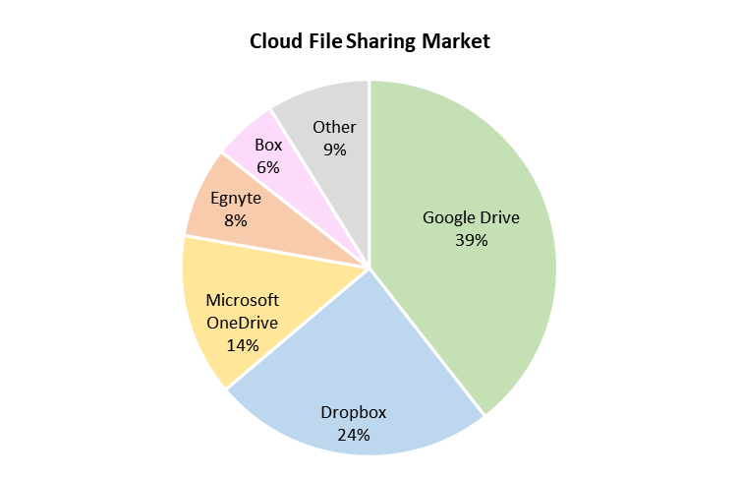

Source: Created by the case authors, based on Datanyze, “Dropbox,” accessed September 18, 2020, www.datanyze.com/market-share/file-sharing--198/dropbox.

EXHIBIT 2: dropbox Pricing for Individuals, billed monthly and yearly

|  |  |  |  |
| --- | --- | --- | --- |
| **Personal** | | | |
|  | Basic | Plus | Family |
| Billed yearly | Free | US$9.99/mo. | US$16.99/mo. |
| Billed monthly | Free | US$11.99/mo. | US$19.99/mo. |
|  | Storage and Access | | |
| Storage | 2 GB | 2 TB (2,000 GB) | Share 2 TB (2,000 GB) |
| Users | 1 user | 1 user | Up to 6 users |

Notes: mo. = month; GB = gigabyte; TB = terabyte.

Source: Created by the case authors, based on Datanyze, “Dropbox,” accessed September 18, 2020 www.datanyze.com/market-share/file-sharing--198/dropbox.

EXHIBIT 3: dropbox Pricing for BUSINESSes, billed monthly and yearly

|  |  |  |  |
| --- | --- | --- | --- |
| **Business** | | | |
|  | Professional | Standard | Advanced |
| Billed yearly | US$16.58/mo. | US$12.50/user/mo. | US$20/user/mo. |
| Billed monthly | US$19.99/mo. | US$15/user/mo. | US$25/user/mo. |
|  | Storage and Access | | |
| Storage | 3 TB (3,000 GB) | 5 TB (5,000 GB) | As much as needed |
| Users | 1 user | 3+ users | 3+ users |

Notes: mo. = month; GB = gigabyte; TB = terabyte.

Source: Created by the case authors, based on Dropbox Business, “Choose the Right Dropbox for You,” 2020, accessed January 12, 2021, www.dropbox.com/plans.

EXHIBIT 4: Dropbox Office Locations

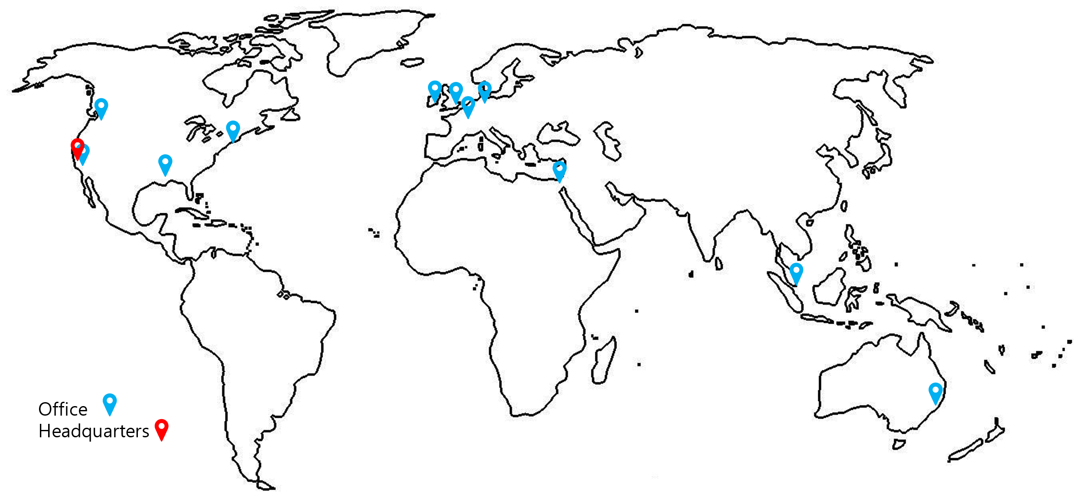

Source: Created by the case authors, based on Craft, “Dropbox Headquarters and Office Locations,” accessed October 12, 2020, https://craft.co/dropbox/locations.

EXHIBIT 5: Dropbox Data CentRE Locations

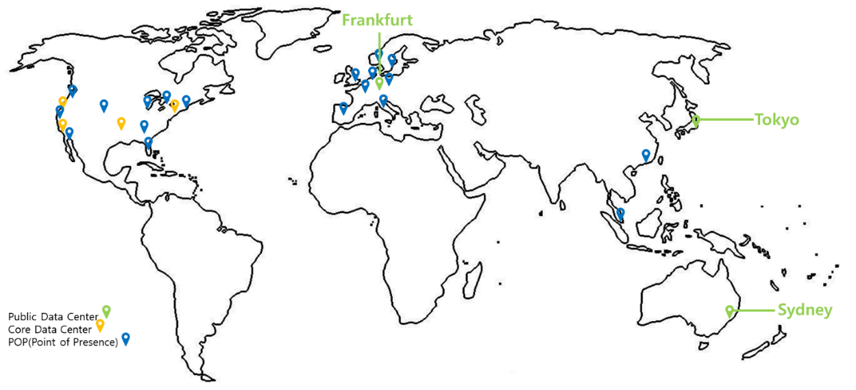

Source: Created by the case authors, based on Dropbox Inc., “Dropbox Company Presentation,” presentation slide deck, November 2020, accessed November 5, 2020, <https://investors.dropbox.com/static-files/a3cdf92d-90aa-4958-ba00-f424431785c1>.

ENDNOTES

1. This case has been written on the basis of published sources only. Consequently, the interpretation and perspectives presented in this case are not necessarily those of Dropbox or any of its employees.
2. Stephanie Condon, “Are Dropbox’s Work-from-Home Growth Rates Sustainable?,” ZDnet, August 7, 2020, accessed December 29, 2020, www.zdnet.com/article/are-dropboxs-work-from-home-growth-rates-sustainable/.
3. “Dropbox, Inc. Class A Common Stock (DBX),” Nasdaq, accessed September 11, 2020, www.nasdaq.com/market-activity/stocks/dbx.
4. Zoom Video Communications Inc., “Zoom Reports Second Quarter Results for Fiscal Year 2021,” news release, August 31, 2020, accessed September 15. 2020, https://investors.zoom.us/news-releases/news-release-details/zoom-reports-second-quarter-results-fiscal-year-2021.
5. “Dropbox, Inc. Class A Common Stock (DBX),” Nasdaq, accessed September 11, 2020, www.nasdaq.com/market-activity/stocks/dbx.
6. Datanyze, “Dropbox,” accessed September 11, 2020, www.datanyze.com/market-share/file-sharing--198/dropbox.
7. “Dropbox, Inc. Class A Common Stock (DBX),” Nasdaq, accessed September 11, 2020, www.nasdaq.com/market-activity/stocks/dbx.
8. Susan Su, “Dropbox’s Playbook for International Expansion, with ChenLi Wang,” Reforge, December 7, 2016, accessed September 1, 2020, www.reforge.com/blog/dropbox-international-growth-chenli-wang.
9. Matthew Wong and Darren Meister, *Dropbox: Go-to-Market Sales Strategy* (London, ON: Ivey Publishing, 2017), 6. Available from Ivey Publishing, product no. 9B17M053.
10. Jason Kincaid, “Dropbox Leases Giant New SF Office, Plans to Grow to 400+ Employees,” Techcrunch, July 27, 2011, accessed October 12, 2020, https://techcrunch.com/2011/07/27/dropbox-leases-giant-new-sf-office-plans-to-grow-to-400-employees/.
11. “100 Best Companies to Work For: Dropbox,” *Fortune*, 2019, accessed September 11, 2020, https://fortune.com/best-companies/2020/dropbox/.
12. Douglas MacMillan, “Dropbox’s New COO Has a $350 Million War Chest,” *Wall Street Journal*, February 13, 2014, accessed October 21, 2020, www.wsj.com/articles/BL-DGB-32826.
13. Sara Salinas, “Dropbox Closes More than 35 Percent Higher at $28.48 a Share on First Day of Trading,” CNBC, March 23, 2018, accessed September 17, 2020, www.cnbc.com/2018/03/23/dropbox-dbx-ipo-stock-starts-trading-on-the-nasdaq.html; All currency amounts are in US$.
14. Dropbox Inc., “Dropbox Investor Relations,” accessed September 9, 2020, https://investors.dropbox.com/.
15. Dropbox Inc., “Dropbox Announces Fiscal 2020 Second Quarter Results,” news release, Business Wire. August 6, 2020, accessed September 17, 2020, www.businesswire.com/news/home/20200806005916/en/.
16. Internet Hall of Fame, “Internet Hall of Fame Pioneer,” accessed April 15, 2021, www.internethalloffame.org/inductees/jcr-licklider.
17. Akhil Gupta, “Scaling to Exabytes and Beyond,” Dropbox.Tech, March 14, 2016, accessed November 1, 2020, https://dropbox.tech/infrastructure/magic-pocket-infrastructure.
18. Cade Metz, “The Epic Story of Dropbox’s Exodus from the Amazon Cloud Empire,” *Wired*, March 14, 2016, accessed September 3, 2020, www.wired.com/2016/03/epic-story-dropboxs-exodus-amazon-cloud-empire/.
19. Datanyze, op. cit.
20. Dominic Kent, “Microsoft Teams Statistics,” Tom Talks, December 14, 2020, accessed January 2, 2021, https://tomtalks.blog/2020/12/microsoft-teams-statistics/.
21. Daniel Condorelli and Jorge Padilla, “Harnessing Platform Envelopment in the Digital World,” *Journal of Competition Law & Economics* 16, no. 2 (2020): 143–187.
22. Dropbox Inc., “Choose the Right Dropbox for You.” 2020, accessed September 13, 2020, www.dropbox.com/individual/plans-comparison.
23. Dropbox Business, “Choose the Right Dropbox for You,” 2020, accessed January 12, 2021, www.dropbox.com/plans.
24. Ibid.
25. Drop Dropbox Team, “Dropbox and Zoom Announce Strategic Partnership to Expand Remote Collaboration,” Work in Progress (blog), Dropbox, October 11, 2018, accessed September 10, 2020, https://blog.dropbox.com/topics/business/dropbox-and-zoom-announce-strategic-partnership-to-expand-remote.box Team, “Dropbox and Zoom Announce Strategic Partnership to Expand Remote Collaboration,” *Work in Progress* (blog), Dropbox, October 11, 2018, accessed September 10, 2020, https://blog.dropbox.com/topics/business/dropbox-and-zoom-announce-strategic-partnership-to-expand-remote.
26. Dropbox Team, “Connect Students and Faculty with Canvas Integration,” *Work in Progress* (blog), Dropbox. August 27, 2020, accessed September 12, 2020, https://blog.dropbox.com/topics/product-tips/canvas-integration.
27. Ibid.
28. Dropbox Inc, “Easily Transfer Your Photos and Videos from Facebook,” September 3, 2020, accessed September 12, 2020, https://blog.dropbox.com/topics/product-tips/facebook-photos-video.
29. Lisa Stromer, “Working with Google Cloud to Bring All Your Work Together,” Dropbox, March 1, 2018, accessed April 5, 2021, https://blog.dropbox.com/topics/company/google-cloud-integrations.
30. Dropbox Inc., “Keep Your Marketing Team in Sync,” accessed January 3, 2020, www.dropbox.com/business/solutions/marketing.
31. Dropbox Inc., “Samsung Device App and Dropbox,” accessed November 16, https://help.dropbox.com/installs-integrations/mobile/samsung-device-app.
32. Gartner Inc., “Gartner Says Global Smartphone Sales Declined 5.7% in Third Quarter of 2020,” news release, November 30, 2020, accessed January 2, 2020, www.gartner.com/en/newsroom/press-releases/2020-11-30-smartphone-market-share-3q20#:~:text=Worldwide%20smartphone%20sales%20to%20end,%25%20year%2Dover%2Dyear.
33. Gennaro Cuofano, “Dropbox Self-Serve Business Model In a Nutshell,” accessed April 6, 2020, https://fourweekmba.com/dropbox-business-model/.
34. Dropbox Inc., “Dropbox Announces Fiscal 2020 Second Quarter Results,” op. cit.
35. Chuck Cohn, “Differences in Selling B2B Vs. B2C,” *Forbes*. June 16, 2015, accessed September 23, 2020, www.forbes.com/sites/chuckcohn/2015/06/16/differences-in-selling-b2b-vs-b2c/?sh=3f0d02ff4fb2.
36. Jochen Wirtz, Shaukat Brah, Venkata Yanamandram, and Lesley White, “Switching Barriers in Business‐to‐Business Services: A Qualitative Study,” *International Journal of Service Industry Management* 17, no. 2: (2006): 158–192.
37. Dropbox Inc., “Choose the Right Dropbox for You,” op. cit.
38. Benjamin Brandall, “Freemium Conversion Rate: Why Spotify Destroys Dropbox by 667%,” Process.st, June 28, 2018, accessed May 16, 2021, https://www.process.st/freemium-conversion-rate/.
39. Matthew Wong, and Darren Meister, Dropbox: Go-To-Market Sales Strategy. (London, ON: Ivey Publishing, July 7, 2017, 6, Product no. 9B17M053.
40. Susan Su. “Dropbox’s Playbook for International Expansion, with ChenLi Wang.” Reforge, December 7, 2016, accessed September 1, 2020, www.reforge.com/blog/dropbox-international-growth-chenli-wang.
41. Ibid.
42. Ibid.
43. Ibid.
44. Craft, “Dropbox Headquarters and Office Locations,” accessed October 12, 2020, https://craft.co/dropbox/locations.
45. Dan Wheeler, “Dropbox in Your Language! (Well, If You Speak French, Japanese, German or Spanish),” *Work in Progress* (blog), Dropbox, April 18, 2011, accessed October 16, 2020, https://blog.dropbox.com/topics/product/dropbox-in-your-language-well-if-you-speak-french-japanese-german-or-spanish.
46. Susan Su. “Dropbox’s Playbook for International Expansion, with ChenLi Wang.” Reforge, December 7, 2016, accessed September 1, 2020, www.reforge.com/blog/dropbox-international-growth-chenli-wang.
47. Offshore Protection, “International Offshore Jurisdiction Review: Is Ireland an Offshore Tax Haven?,” August 28, 2020, accessed September 17, 2020, www.offshore-protection.com/ireland-tax-havens.
48. Susan Su. “Dropbox’s Playbook for International Expansion, with ChenLi Wang.” Reforge, December 7, 2016, accessed September 1, 2020, https://www.reforge.com/blog/dropbox-international-growth-chenli-wang.
49. Ibid.
50. Ibid.
51. Ibid.
52. Thomas Hansen, “Dropbox Is Growing in Europe,” *Work in Progress* (blog), Dropbox, February 11, 2016, accessed September 1, https://blog.dropbox.com/topics/company/dropbox-is-growing-in-europe.
53. Susan Su. “Dropbox’s Playbook for International Expansion, with ChenLi Wang.” Reforge, December 7, 2016, accessed September 1, 2020, www.reforge.com/blog/dropbox-international-growth-chenli-wang.
54. Ibid.
55. Christine Moon, “We’re Doing Even More with Samsung,” *Work in Progress* (blog), Dropbox, September 3, 2014, accessed November 1, https://blog.dropbox.com/topics/product/dropbox-doing-even-more-with-samsung.
56. Daniel Condorelli and Jorge Padilla, “Harnessing Platform Envelopment in the Digital World,” *Journal of Competition Law & Economics* 16, no. 2 (2020): 143–187.
57. Dominic Kent, “Microsoft Teams Statistics,” Tom Talks, December 14, 2020, accessed January 2, 2021, https://tomtalks.blog/2020/12/microsoft-teams-statistics/.
58. Susan Su. “Dropbox’s Playbook for International Expansion, with ChenLi Wang.” Reforge, December 7, 2016, accessed September 1, 2020, www.reforge.com/blog/dropbox-international-growth-chenli-wang.
59. Zoom Video Communications Inc., “Zoom Reports Second Quarter Results for Fiscal Year 2021,” news release, August 31, 2020, accessed September 15. 2020, https://investors.zoom.us/news-releases/news-release-details/zoom-reports-second-quarter-results-fiscal-year-2021.
60. Dropbox Inc., “Out of Office: Potential $1.2 Trillion Opportunity in Improving Focus in Knowledge Work, Shows Study Commissioned by Dropbox,” news release, Business Wire, October 13, 2020, accessed October 28, 2020, www.businesswire.com/news/home/20201013005371/en/.
61. Economist Intelligence Unit, “In Search of Lost Focus: The Engine of Distributed Work,” 2020, accessed October 7, 2020, https://lostfocus.eiu.com/.
62. David Pierce, “Dropbox’s Drew Houston Is Betting Everything on a New Future for Work,” Protocol, November 17, 2020, accessed January 2, 2020, www.protocol.com/dropbox-spaces
63. Daren Fonda, “Not Every Cloud Stock Has Soared. Here’s 1 Way to Still Play the Trend,” *Barron’s*, May 22, 2020, accessed January 2, 2020, www.barrons.com/articles/dropbox-stock-has-lagged-behind-zoom-video-slack-and-microsoft-why-it-deserves-better-51590192000.