

9B21M071

CAFÉZIA COFFEE: bREWING ENTREPRENEURIAL SUCCESS

Martin Eidenberg wrote this case under the supervision of Julie Gosse solely to provide material for class discussion. The authors do not intend to illustrate either effective or ineffective handling of a managerial situation. The authors may have disguised certain names and other identifying information to protect confidentiality.

This publication may not be transmitted, photocopied, digitized, or otherwise reproduced in any form or by any means without the permission of the copyright holder. Reproduction of this material is not covered under authorization by any reproduction rights organization. To order copies or request permission to reproduce materials, contact Ivey Publishing, Ivey Business School, Western University, London, Ontario, Canada, N6G 0N1; (t) 519.661.3208; (e) cases@ivey.ca; www.iveycases.com. Our goal is to publish materials of the highest quality; submit any errata to publishcases@ivey.ca. i1v2e5y5pubs

Copyright © 2021, Ivey Business School Foundation Version: 2021-02-01

In July 2020, Natalie White, the co-owner and manager of CaféziaCoffee Inc. (Cafézia), was reflecting on the past few months. She had been navigating her small, growing business through a global health pandemic, and she wondered whether the timing was right to buy out the other co-owners of the company in order to assume full control. She was also considering whether to invest further time and capital towards growing the business. If she did, what would be the best way to do so? Since both time and capital were scarce resources in her entrepreneurial business, White knew that it was critical to make a decision that would lead to a practical, financially sustainable model for Cafézia.

COMPANY BACKGROUND

White began managing Cafézia in the summer of 2019. She had come across the idea through a chance encounter with the product’s inventor, a neuroscience researcher, on a trail run. Cafézia’s concept was to create a coffee that everyone could enjoy—coffee that would provide the well-documented, all-important caffeine energy boost without the negative side effects of jitters, caffeine crashes, and sleep troubles. The company achieved this through the combination of premium, organic Fairtrade coffee beans with three key herbs: cleavers, hyssop, and yerba mate. Cafézia was sold in both ground and whole-bean form in dark, medium, and light roasts.

Before launching Cafézia, White had graduated from the prestigious Honours Business Administration (HBA) program at the Ivey Business School, had gained work experience at a large consumer packaged goods firm, and then had spent two years as a lecturer for the business school’s popular first-year Business Administration 1220E course. Upon starting Cafézia, White quickly began to expand distribution. Now, one year later, Cafézia was sold by over 40 retailers across Southwestern Ontario—from small retailers such as Angelo’s Italian Market and Grocery Checkout to various locations of larger grocery chains such as Valu-mart and Sobeys Inc. White truly enjoyed her work, which was important since she often found herself working long days and many weekends.

**LONDON, ONTARIO**

White lived and worked in London, Ontario. Located in the industrial corridor between Toronto and Windsor, London was the largest city in Southwestern Ontario. Its population of 383,822 had grown by 4.8 per cent in the previous five years.[1] The city was the central hub of the Southwestern Ontario region and was close to smaller towns and cities such as St. Thomas, Tillsonburg, Stratford, Woodstock, and Sarnia. The urban centres of Windsor, Hamilton, and Kitchener-Waterloo were located over one hour away by car. In order to grow her business, White knew that she had to expand to more retail partners in more urban centres in the region.

THE COFFEE INDUSTRY

The Canadian coffee and tea production industry had annual revenues of $2.9 billion.[2] While the industry had grown at an annualized rate of 8.5 per cent over the past five years, this growth was projected to slow to 1 per cent per year in the coming five years.[3] Revenues in the industry were strongly correlated to the world price of coffee, which had historically been a volatile commodity, as it was often grown in locations associated with a high degree of political and environmental risk. While coffee was a staple product for many Canadian consumers, increasing per capita disposable income had historically led consumers to increasingly prefer more expensive, premium coffee brands. Companies in the industry relied on their contracts and connections with retailers, especially supermarkets and grocery stores, for success and growth.[4]

COVID-19 PANDEMIC

On March 11, 2020, the World Health Organization declared a global pandemic of the novel coronavirus disease (COVID-19).[5] By mid-July, there were over 13.6 million confirmed cases worldwide, 108,000 of which were in Canada.[6] During the course of the pandemic, governments introduced many restrictions to limit the spread of the virus. Beginning on March 23, the province of Ontario ordered all non-essential stores and services to close.[7] As many of Cafézia’s retail partners fell into this category, the company’s sales declined dramatically. To combat this, White quickly set up an online sales portal on the Cafézia website and began to fulfill these orders herself (see Exhibit 1). While these online sales did not make up for all of the company’s lost revenue, they did partially fill the void. By eliminating retailers from the supply chain, White was also able to achieve increased margins with each online sale. She had no plans to discontinue the online sales platform even as Ontario moved to reopen the province’s economy in a phased manner.

COMPETITION

Competition in the coffee industry was strong and included companies ranging from global conglomerates to small start-up ventures like Cafézia. White believed her competitors’ products could be grouped into three categories: comparable products, small-batch craft coffees, and mass-manufactured premium coffees. Each of these groups posed its own challenges and opportunities for Cafézia.

Comparable Products

The comparable products category was made up of competitors that, like Cafézia, claimed to remove the negative side effects of coffee. However, none of these companies were local to the Canadian market, and their products were more expensive than Cafézia’s premium product. Four Sigmatic, originating in Finland, combined “the magic of mushrooms” with coffee.[8] This business had grown substantially since its founding in 2012, and it now sold a wide variety of products in 65 different countries around the globe. In Canada, its products were sold across a variety of outlets, including Walmart Inc., Healthy Planet, and Nutrition House Canada Inc. The other major comparable product was Wildcrafter, a US brand that marketed itself by stating that its coffee added “the power of botanicals to 100% organic Arabica coffee, so you get more health benefits from every sip.”[9] However, Wildcrafter’s distribution was limited in Canada, with the product available only via online purchase from the US-based website.

Small-Batch Craft Coffees

The category White defined as small-batch craft coffees included brands that were local to the Ontario market and often sold alongside Cafézia’s products in stores. It included well-known local brands such as Detour Coffee, Patrick’s Beans, and Fire Roasted Coffee. These products were generally slightly less expensive than Cafézia’s blends, yet these companies still had a sustainable image and produced high-quality coffee. However, they did not mitigate the negative side effects of coffee, a hallmark of Cafézia’s product.

Mass-Manufactured Premium Coffees

Mass-manufactured premium coffees were widely sold nationally and internationally. However, they were not produced in small batches like Cafézia’s coffee or those of some of its local craft competitors. Many carried organic and Fairtrade labels, but they did not have any extra ingredients that negated coffee’s negative side effects. These coffees were sold in large grocery and supermarket chains at prices that were lower than those of Cafézia. Brands in this segment included Kicking Horse Coffee Co. Ltd, Ethical Bean Coffee, and Starbucks Corporation.

CONSUMERS

White understood the importance of considering the demographics of her customer base and selecting a target customer group. However, in conversations with friends and informal advisors, she had come across some disagreement on this particular topic. On the one hand, the herbal, organic, and Fairtrade qualities of Cafézia were thought to appeal to a younger group of customers, who had a heightened sense of social and health awareness. However, some of White’s confidants were concerned that this group might not yet have the disposable income necessary to purchase coffee that was priced well above even the local small-batch and mass-manufactured premium competitors. Instead, this group argued that a middle-aged, higher-income demographic was more likely to splurge on Cafézia. White thought this group of consumers would include a high proportion of women, who would better appreciate the holistic health appeal of the herbs in Cafézia’s coffee and who were often the main purchasers in families. To ensure she selected the right target market for her marketing efforts, White considered these and other customer groups in her analysis.

During her first year of running Cafézia, White’s primary source of information about her customers had been informal conversations with her retail partners. However, implementing an online sales channel during the COVID-19 pandemic had provided her with more specific data on who was purchasing Cafézia. Of all of Cafézia’s online customers, 77 per cent were female and 23 per cent were male. While White did not collect any data on online customers’ ages, she recognized many of the names on the list as family, friends, and other connections in both the younger and middle-aged generations.

COMPANY BUY-OUT?

As part of her deal with Cafézia’s founding partners, White had received a 10 per cent equity stake when she began to manage the company. However, after managing the company on her own for a year, she wondered if now might be the right time to purchase the other 90 per cent of the company’s equity so she could own the company outright. Purchasing the company now would enable White to benefit from her independent efforts at further expanding the business. It would also make the business decision-making process faster and easier. However, she was unsure of how the three other owners would feel about a proposal for her to buy them out. She knew it would be critical to carefully consider how best to manage such an endeavour to ensure success and to avoid any potential future animosity or legal complications.

In addition to her concerns about whether or not the other owners would be amenable to selling their shares in the company, White was also unsure about what price she should offer. The company had yet to make a profit, sales were still fairly limited, and Cafézia had not expanded outside of London and the surrounding areas (see Exhibits, 2, 3, and 4) . Therefore, determining and agreeing on a fair purchase price would be difficult.

ALTERNATIVES

Along with the decision about whether or not to purchase Cafézia outright, White also had to consider how best to grow the business and the brand. Continuing to grow the company organically herself—pursuing the status quo—was one option. She was also considering two other alternatives. First, she considered making investments in the company’s marketing, with new packaging and a new website design. Second, she also considered partnering with a distributor or a broker to more quickly secure new retail partners in new geographies.

Status Quo

Since Cafézia was already on a solid growth trajectory due to the significant effort White was putting into increasing sales and retail partnerships, the option to continue along the same path was something White wanted to consider. As a baseline, she expected that Cafézia would continue to organically grow its customer base and add new retailers in the Southwestern Ontario region. As White had been able to obtain over 40 retail partnerships during just one year of running Cafézia, she expected further organic growth to occur at a similar pace to what the business had experienced so far in its short existence.

In her financial projections for the next six months, White felt it was realistic to assume that wholesale sales would increase by 50 per cent and online sales would double over the previous six-month period. In projecting Cafézia’s expenses for the coming six months, White wanted to account for $1,000 worth of miscellaneous expenses. All other expenses were expected to remain at the same dollar amounts or proportions of total revenue for the upcoming period.[10]

New Packaging and Website

Cafézia’s product packaging and website design had been determined prior to White’s entry into the business. However, White believed that the packaging was visually unappealing and did a poor job of demonstrating Cafézia’s value proposition. She thought replacing the old plastic packaging with paper bags with a plastic liner specifically designed for coffee would do a better job of differentiating Cafézia on store shelves and would demonstrate the business’s commitment to sustainability. The bag’s manufacturer stated that the bag’s “defined edges and flat bottom will surely make your product stand up and stand out nicely on the shelf. The kraft paper outer layer gives it a wholesome, organic look; perfect to reflect your product’s natural goodness. It is a high barrier bag against moisture and oxygen.”[11] White planned to add custom-designed adhesive labels to the front and back of the bags (see Exhibit 5). The total investment cost for the new packaging would be $7,000. White also planned a one-time marketing spend of $1,500 to advertise the new packaging and an additional $2,000 per year in advertising to maintain the anticipated sales momentum. The new packaging would cost $0.10 less per bag than Cafézia’s current fully plastic bags.[12]

White was also dissatisfied with Cafézia’s current website design and functionality. A redesign to match the new packaging was another investment she was strongly considering. Having discussed her ideas with a few friends in the technology space, White estimated that this would cost $8,000. The new website would offer an improved user experience for Cafézia’s online customers. White also believed that adjustments to the website’s language by applying search engine optimization (SEO) techniques would help ensure that it appeared in the first few listings of major search engine results, thereby increasing website traffic.[13] This would cost an additional $2,000 to implement. White estimated that it would cost $1,000 annually to maintain the website and SEO.

White expected that making these strategic marketing investments would cause Cafézia’s sales to increase. As a result of the new packaging, wholesale sales for the coming year would increase by 50 per cent over the last six-month period. Online sales would see the same percentage increase because of the website redesign and SEO optimization. All of this sales growth would be in addition to the growth White expected to see just from maintaining the status quo. White wondered which investment she should pursue, or if pursuing all of them at once was the right move. She expected to be able to obtain equity financing from a new outside investor that would cover the required costs.

Distributor or Broker?[14]

White knew that Cafézia would need to grow substantially in order to achieve improved economies of scale and become profitable. While she had already had great success getting into smaller retailers in the London region, this method of growth might be unsustainable for further geographic expansion. She had read about the benefits and drawbacks of using distributors or brokers to assist with this growth.

A distributor would handle the sales, inventory holding, shipping, and servicing of Cafézia’s products to retailers in a specific geographic area. The distributor would purchase the products from Cafézia and resell them to retailers. White’s research indicated that the distributor would take a 20 per cent commission of the wholesale price[15] at which they purchased the goods. Additionally, the distributor would take a flat annual inventory-holding fee of about $4,000. Each distributor normally focused on a specific food and beverage category. Using a distributor would mean that White would lose control of some of the product’s promotion and branding, and her relationships with retailers in the regions covered by the distributor would be limited. However, the distributor would have established relationships with many retailers that White had no previous knowledge of or relationship with. The distributor’s logistical and inventory management systems were also superior to those White could establish on her own. While distributors were known to be reluctant to stock untested product lines, White had engaged in preliminary conversations with a distributor who had indicated they would carry the product. As promising as this was, she was concerned that Cafézia could be dropped quickly by a distributor who had agreed to carry the product if sales did not meet expectations.

While there were many similarities between brokers and distributors, there were also some key differences. Brokers handled a limited number of food companies and succeeded by placing the products of these companies on the shelves of key retailers, with whom they often had fruitful, long-term relationships. Rather than entering into a distribution agreement, Cafézia would enter into a sales agreement with a broker. This meant the broker would merely facilitate the relationship between Cafézia and the retailer but would never actually take ownership of the product. This operating model meant that brokers took lower commission. White’s research indicated that commission would be 5 per cent. However, a broker would also take a larger flat fee ($1,500 per month) as a retainer so long as they were promoting the Cafézia product.

White was unsure whether Cafézia required the assistance of either a broker or a distributor. If she did pursue one of these avenues, she planned to reduce her advertising expenditure by $2,200 in the next year, as she would now have the promotional assistance that a distributor or broker would provide. If she were to work with a broker or a distributor, which of the two would be best for Cafézia? How much coffee would she need to sell in order for a broker or distributor to help Cafézia’s bottom line?

CONCLUSION

After a long day of managing the day-to-day operations of the business, White turned off her phone and sat down at her desk in her home office, with a freshly brewed cup of Cafézia in hand. She began to go over her notes and contemplate the next steps, both for herself and for her entrepreneurial venture. She knew that delaying these decisions would hurt the business, as the company needed to grow in order to achieve improved economies of scale and, most importantly, profitability. The gradual reopening and recovery of Ontario’s economy as COVID-19 cases began to slow provided additional urgency. Additionally, White believed that if she was going to pursue the option to buy out her co-owners, it would be beneficial to do so sooner rather than later.

EXHIBIT 1: Cafézia WEBSITE and ONLINE SALES PORtAL

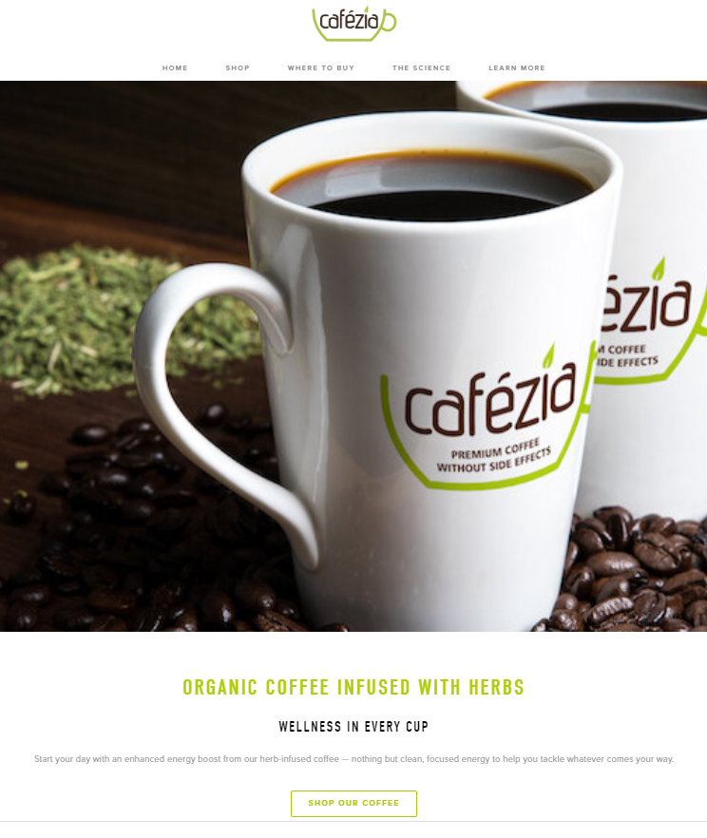

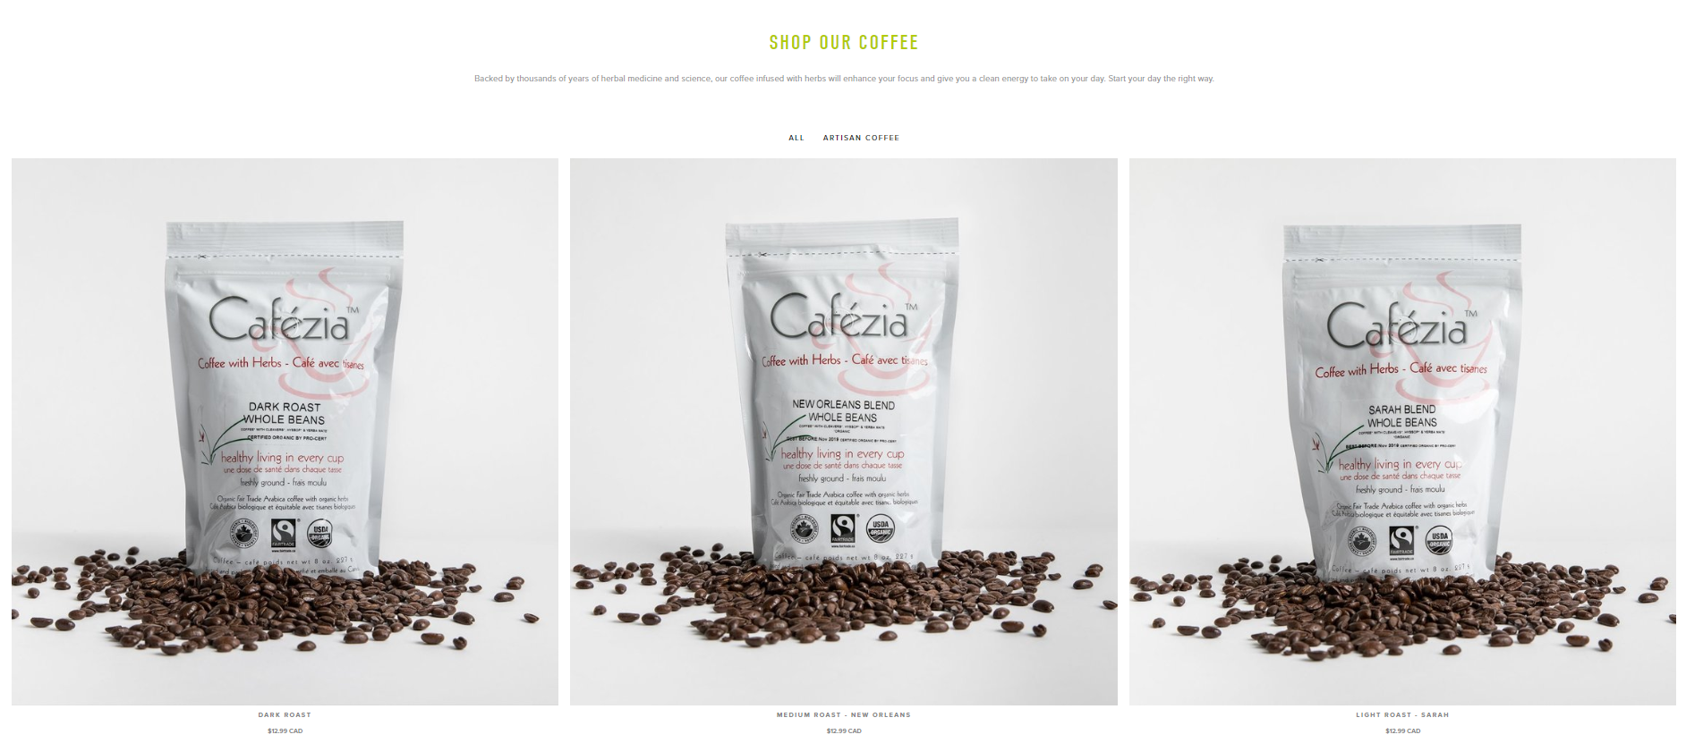

Source: Company website.

EXHIBIT 2: INCOME STATEMENTS AND FINANCIAL RATIOS (Unaudited)

for the SIX MONTHS ending June 30, 2020, and DECEMBER 31, 2019

|  | | **2020** | | | **2019** | | |
| --- | --- | --- | --- | --- | --- | --- | --- |
|  | |  |  | |  |  |
| **Revenue** | |  |  | |  |  |
| Wholesale Sales | $ 9,981 | | | 70.8% | $ 19,930 | 100.0% | | |
| Online Sales | 4,112 | | | 29.2% | - | 0.0% | | |
| **Total Revenue** | **$ 14,093** | | | 100.0% | **$ 9,930** | 100.0% | | |
|  |  | | |  |  |  | | |
| Cost of Goods Sold[16] | 4,395 | | | 31.2% | 7,105 | 35.6% | | |
|  |  | | |  |  |  | | |
| **Gross Profit** | **$ 9,698** | | | 68.8% | **$ 12,825** | 64.4% | | |
|  |  | | |  |  |  | | |
| **Expenses** |  | | |  |  |  | | |
| Advertising | $ 1,283 | | | 9.1% | 2,218 | 11.1% | | |
| Bank Charges | 46 | | | 0.3% | 44 | 0.2% | | |
| Depreciation | 250 | | | 1.8% | 250 | 1.3% | | |
| Insurance | 498 | | | 3.5% | 166 | 0.8% | | |
| Miscellaneous | 648 | | | 4.6% | 1,495 | 7.5% | | |
| Office Expenses | 324 | | | 2.3% | 459 | 2.3% | | |
| Professional Services | 350 | | | 2.5% | 153 | 0.8% | | |
| Salaries | 15,000 | | | 106.4% | 15,000 | 75.3% | | |
| **Total Expenses** | **$ 18,399** | | | 130.6% | **$ 19,785** | 99.3% | | |
|  |  | | |  |  |  | | |
| **Net Income** | **$ (8,701)** | | | (61.7%) | **$ (6,960)** | (34.9%) | | |

Source: Company files (financial information has been adapted for case purposes).

EXHIBIT 3: BALANCE SHEETS (Unaudited)

At the PERIODs Ended June 30, 2020, and DECEMBER 31, 2019

|  | **2020** | **2019** |
| --- | --- | --- |
| **ASSETS** |  |  |
| **Current Assets** |  |  |
| Cash | $ 1,834 | $ 74 |
| Accounts Receivable | 412 | 551 |
| Inventory | 624 | 940 |
| Prepaid Expenses | 83 | 83 |
| **Total Current Assets** | $ 2,953 | $ 1,648 |
|  |  |  |
| **Fixed Assets** |  |  |
| Computer Equipment | $ 2,500 | $ 2,500 |
| Less: Accumulated Depreciation | (500) | (250) |
| **Total Fixed Assets (Net)** | $ 2,000 | $ 2,250 |
|  |  |  |
| **TOTAL ASSETS** | **$ 4,953** | **$ 3,898** |
|  |  |  |
| **LIABILITIES** |  |  |
| Accounts Payable | $ 514 | $ 758 |
| Due to Shareholders | 20,000 | 10,000 |
|  |  |  |
| **TOTAL LIABILITIES** | $ 20,514 | $ 10,758 |
|  |  |  |
| **EQUITY** |  |  |
| Common Stock | $ 100 | $ 100 |
| Retained Earnings | (15,661) | (6,960) |
|  |  |  |
| **TOTAL EQUITY** | $ (15,561) | $ (6,860) |
|  |  |  |
| **TOTAL LIABILITIES & EQUITY** | **$ 4,953** | **$ 3,898** |

Source: Company files (financial information has been adapted for case purposes).

EXHIBIT 4: SELECTED FINANCIAL RATIOS

|  | **2020** | **2019** |
| --- | --- | --- |
|  |  |  |
| **Liquidity** |  |  |
| Current Ratio | 5.75 : 1 | 2.17 : 1 |
| Acid Test | 4.37 : 1 | 0.82 : 1 |
|  |  |  |
| **Efficiency** |  |  |
| Days of Accounts Receivable | 5.3 days | 5.0 days |
| Days of Inventory | 25.8 days | 24.1 days |
| Days of Accounts Payable | 21.3 days | 19.4 days |
|  |  |  |
| **Stability** |  |  |
| Net Worth to Total Assets | N/A | N/A |
| Interest Coverage | N/A | N/A |
|  |  |  |
| **Growth** |  |  |
| Sales | (29.3%) |  |
| Net Income | (25.0%) |  |
| Equity | (126.8%) |  |
| Total Assets | 27.1% |  |

Source: Company files (financial information has been adapted for case purposes).

EXHIBIT 5: CUSTOM-DESIGNED ADHESIVE LABELS

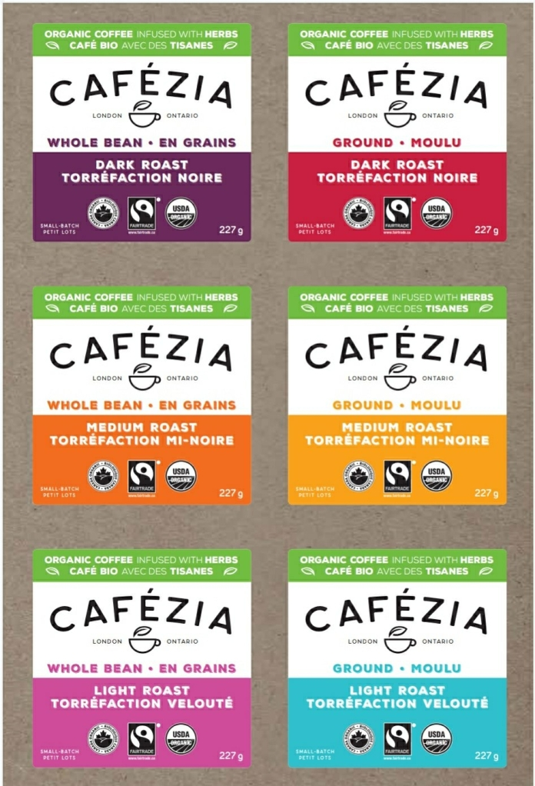

Source: Company files.

1. Community Profile, City of London, October 10, 2018, accessed July 7, 2019, [www.london.ca/About-London/community-statistics/city-profiles/Pages/City-Profile.aspx](http://www.london.ca/About-London/community-statistics/city-profiles/Pages/City-Profile.aspx).
2. All figures are in Canadian dollars unless otherwise stated.
3. “Coffee & Tea Production in Canada: Market Research Report,” IBISWorld, December 31, 2019, accessed July 15, 2020, https://www.ibisworld.com/canada/market-research-reports/coffee-tea-production-industry/.
4. Ibid.
5. Jamie Ducharme, “World Health Organization Declares COVID-19 a 'Pandemic.' Here's What That Means,” *Time,* March 11, 2020, accessed July 15, 2020, https://time.com/5791661/who-coronavirus-pandemic-declaration/.
6. “Covid-19 Coronavirus Pandemic,” Worldometers, July 15, 2020, accessed July 15, 2020, www.worldometers.info/coronavirus/.
7. Ryan Rocca and Nick Westoll, “Coronavirus: All Non-Essential Workplaces Ordered to Close in Ontario,” Global News, March 23, 2020, accessed July 15, 2020, https://globalnews.ca/news/6717022/ontario-doug-ford-coronavirus-covid-19-march-23/.
8. “Make Your Everyday Magic,” Four Sigmatic, accessed July 20, 2020, https://us.foursigmatic.com/.
9. “Wildcrafter Botanicals: Discover Your Daily Ritual,” Wildcrafter Botanicals, accessed July 20, 2020, www.wildcrafter.com/.
10. Cafezia’s corporate tax rate was 20 per cent.
11. “1 lb Block Bottom Bag,” Lynnpak Packaging Ltd., accessed July 23,2020, https://lynnpak.com/collections/block-bottom-bag/products/1-lb-block-bottom-bag-natural-kraft.
12. Cafezia had sold approximately 1,500 bags in total over the last six-month period. An additional 1,500 bags were expected to be sold in the next year due to sales growth.
13. “SEO,” TechTerms, accessed July 23, 2020, https://techterms.com/definition/seo.
14. The information in this section was largely obtained largely from Agriculture Council of Saskatchewan Inc., *Canadian Grocery Retail Guide: – Section 1: Size Demographic Characteristics and Customer Profiles*, accessed July 23, 2020, https://agcouncil.ca/wp/wp-content/uploads/2017/03/GRGuide041313Section1.pdf.
15. Cafézia’s wholesale price was $8.60 per 8 oz bag. The suggested retail price was $12.99.
16. In 2020, wholesale cost of goods sold (COGS) was 34.6% of wholesale sales, while online COGS was 23% of online sales.